  - Review of the
  - Aged Care Quality
  - Standards
  - Consultation Summary Report


Contents
Contents 3
Acknowledgements 5
Introduction 7
Development of the draft strengthened Quality Standards 9
Participation in the public consultation 9
Demographics – focus groups 10
Demographics – survey 13
Overview 19
Strengths 19
Improving outcomes in focus areas 21
Gaps or areas requiring stronger focus 22
Key areas of contention 24
Application of the Quality Standards 24
Level of prescription 25
Standard 1: The Person 28
Broad feedback on Standard 1 28
Person-centred and culturally safe care 28
Dignity of risk and choice 28
Communication and decision-making 29
Standard 2: The Organisation 31
Broad feedback on Standard 2 32
Culture and partnering 32
Accountability and quality systems 33
Feedback and complaints management 33
Workforce planning 33
Human resource management 34
Standard 3: The Care and Services 37
Broad feedback on Standard 3 37
Assessment and planning 37
Supporting people living with dementia 38
Communication and coordination 38
Standard 4: The Environment Standard 41
Broad feedback on Standard 4 41
Equipment 41
Home environment 41
Service environment 42
Infection prevention and control 42
5: Clinical Care Standard 45
Broad feedback on Standard 5 45
Clinical governance 46
Medication safety 46
Comprehensive care 47
Advance care planning and palliative care 47
6: Food and Nutrition Standard 50
Broad feedback on Standard 6 50
Partnering with older people on food and nutrition 50
Provision of food and drink 51
Dining experience 51
7: The Residential Community 54
Daily living 54
Planned transitions 54
Intersections with broader reforms 57
Guidance 57
Transition 57
Audit 58
Implementation of the Quality Standards 60
Pilot 60

Acknowledgements
The Department of Health and Aged Care (department) would like to thank everyone who took the time to contribute to the public consultation on the strengthened Aged Care Quality Standards (Quality Standards).
Your experiences, thoughts and expert advice are valued, and will help to deliver a better aged care system for our future.
We would like to thank the aged care services and technical experts who generously offered their insights and helped the department to understand what good service provision looks like.
In particular, we would like to thank older people with lived experience of aged care, their families and carers for their valuable insights about improving the quality of aged care.
The department engaged mpconsulting to support the development of the strengthened Quality Standards including development of this resource and facilitating focus groups.
The development of the strengthened Quality Standards was undertaken in collaboration with the Australian Commission on Safety and Quality in Health Care (ACSQHC) who assumed responsibility for the clinical care components of the Quality Standards on 1 July 2021.
The Aged Care Quality and Safety Commission (Commission) is the national regulator of aged care services and was consulted throughout the development of the strengthened Quality Standards.

- Table number  - Table number  - Table number | Table paragraph: Use this style for all text within a table. | Table paragraph: Use this style for all text within a table. | Table paragraph: Use this style for all text within a table.

1
Introduction

Introduction
The strengthened Aged Care Quality Standards (Quality Standards) are designed to improve outcomes for older people and clarify expectations for providers to deliver quality aged care. They will be a foundation piece of the proposed new regulatory model, which is continuing to be developed in close consultation with stakeholders. While the strengthened Quality Standards are being developed, including being tested through a pilot and implemented through the new Aged Care Act, the current Quality Standards remain active and in force.
The strengthened Quality Standards have been developed by the department in collaboration with the Commission and the ACSQHC. Importantly, the draft was informed by the valuable input and advice of older people, their families and carers, academics, aged care providers, health professionals, peak bodies and other
technical experts.
Since the commencement of the urgent review of the Quality Standards in July 2021, the department has commissioned an independent review of the current Quality Standards, led codesign workshops on specific subject matters and held ongoing meetings with a number of reference groups. This culminated in a six-week public consultation in late 2022, where stakeholders were invited to provide feedback on a set of draft strengthened Quality Standards.
During public consultation, the department undertook a range of activities to raise awareness and encourage stakeholders to share their views on the strengthened Quality Standards.
A high volume of feedback was received on the strengthened Quality Standards, which illustrates the strong interest Australians have in improving the quality of aged care. People are eager to see change and were generous in sharing their thoughts on ways to improve outcomes for older people.
This report summarises feedback from the public consultation held 17 October 2022 to 25 November 2022 and describes how that feedback has informed further changes and refinements to the Quality Standards which will be piloted by the Commission
in mid-2023. 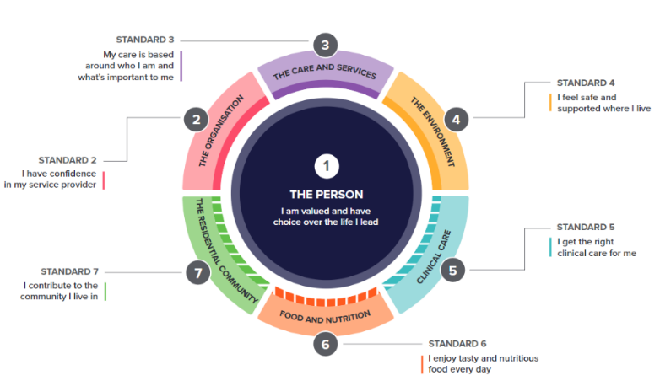

2
Consultations

Development of the draft strengthened Quality Standards
The first step in the urgent review of the Quality Standards was an independent evaluation of the current Quality Standards, undertaken from July to October 2021.
This included significant consultation with key stakeholders, including older Australians, aged care providers and peak sector organisations. During this time, nearly 1,400 people completed online surveys and 325 people took part in 35 focus groups.
From December 2021 to September 2022, the department held 15 targeted codesign sessions with expert groups across the focus areas of diversity, food and nutrition, dementia, governance and clinical care. The department received 152 submissions over the course of these sessions, which informed ongoing revisions to the draft strengthened Quality Standards. Progress on developing the strengthened Quality Standards was tested with a Consumer Reference Group and Sector Reference Group each month from February to August 2022. The National Aged Care Advisory Council and the Council of Elders were also engaged at key points over this period.

Participation in the public consultation
On 17 October 2022, a webinar launched the public consultation, providing an overview of the review, the strengthened Quality Standards and a panel style question and answer session. This had high engagement with over 1,000 participants and over 520 subsequent views of the recording.
A range of consultation papers and explanatory resources, including the draft strengthened Quality Standards were released to support the consultation. These documents were translated into the seven most common languages spoken in Australia (other than English) to assist culturally and linguistically diverse people to provide their views. Feedback was sought through a range of activities, including an online survey and targeted online focus groups. Stakeholders could also provide feedback through detailed written submissions or hardcopy surveys. A total of 873 survey responses and 119 submissions were received, and 230 hardcopy surveys were sent to older people and those with limited ability to use technology.
The department held 18 focus groups, with sessions designed for specific audiences and topics to enable in-depth discussions on different aspects of the strengthened Quality Standards. Sessions were targeted to different standards and settings, with separate sessions for older people and aged care providers, and specific sessions for Aboriginal and Torres Strait Islander people, home care providers and rural and remote providers. There were over 900 focus group attendees, including broad demographic representation across regions, cultural backgrounds and stakeholder groups.

Demographics – focus groups
The department collected data through a series of questions asked at registration for the focus group sessions.
It is important to note these results are only indicative and not representative of all focus group participants, as the registration questions were not compulsory. Additionally, there is likely duplication where participants may have registered for multiple focus groups and responded to the questions each time. Participants were also able to select multiple options, so responses such as location and diverse groups do not add to 100 per cent.
Aged care providers were the highest represented group, making up 33 per cent of registrations. The second highest representation was from someone using aged care services, their family, carer or representative. This made up 15 per cent of registrations (Figure 1). New South Wales had the highest number of focus group attendees (Figure 2 – over page). 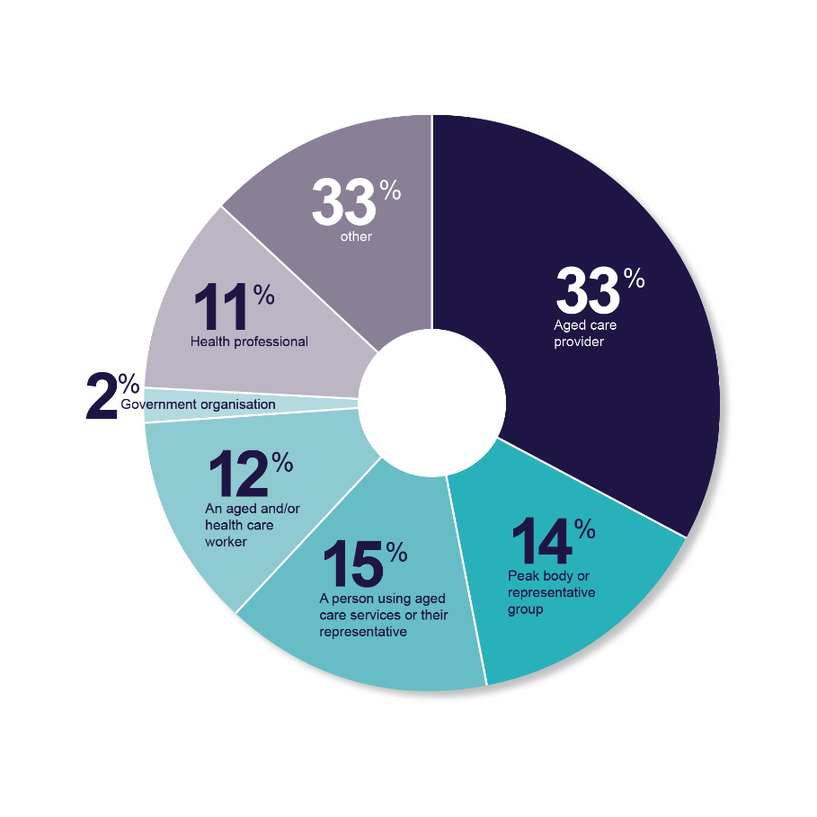
Figure 1. What stakeholder category do you most identify with?

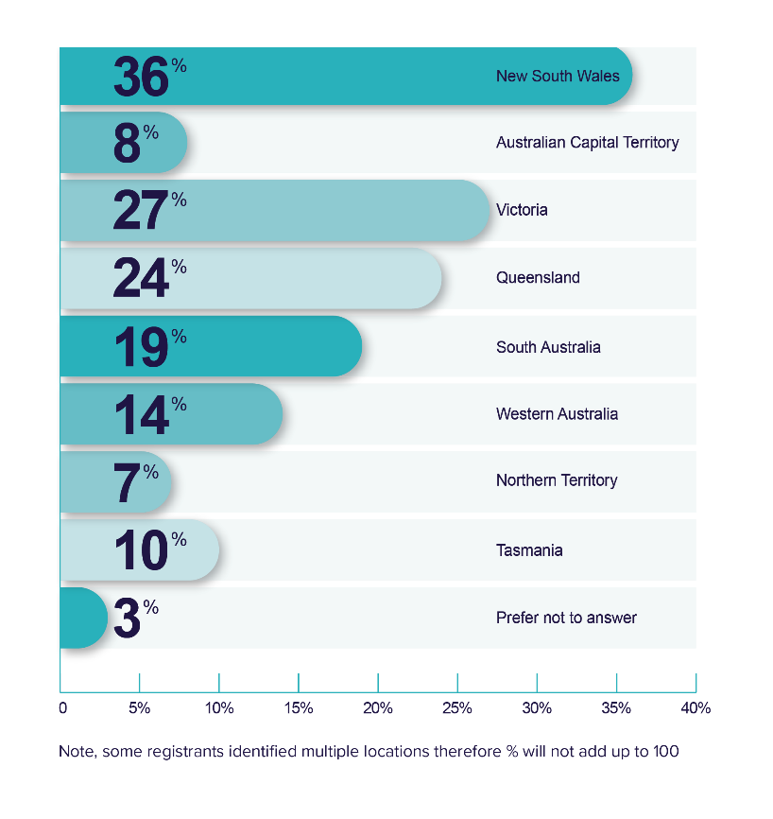
Figure 2. What state or territory do you, or the person/s you care for or represent, live in?

The department reached a broad range of stakeholders (Figure 3), with particularly strong representation for the following groups:
  - People living with dementia (51 per cent)
  - People from culturally and linguistically diverse backgrounds (44 per cent)
  - People with disabilities (37 per cent).
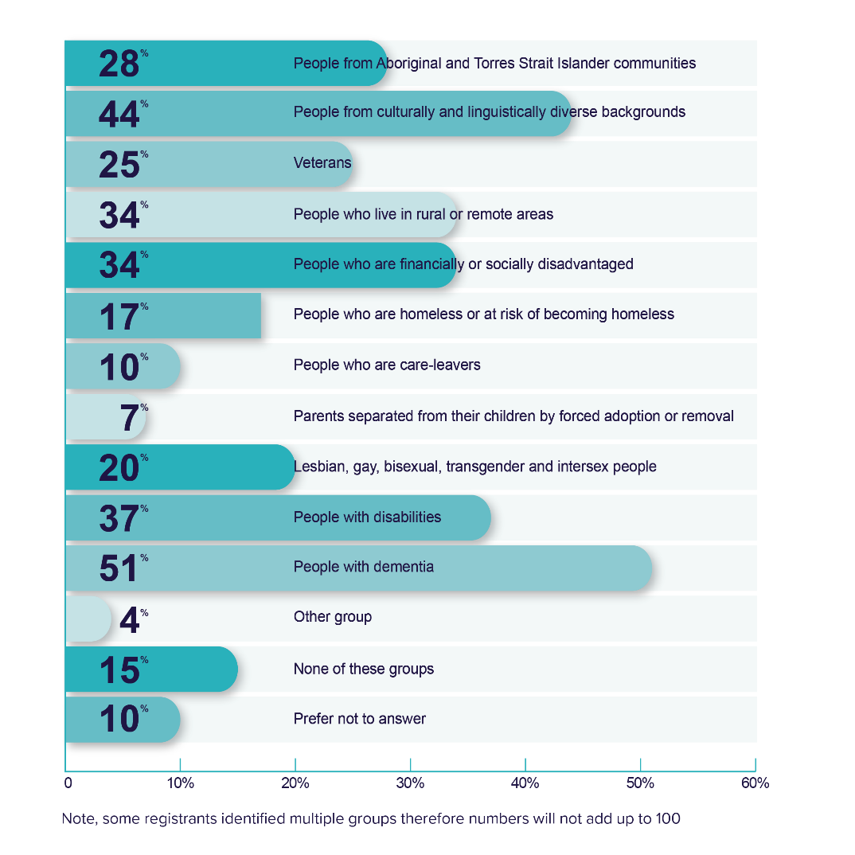Figure 3. Do you, or the person/s you care for or represent, identify with or belong to one or more of the following groups?

Demographics – survey
The stakeholder category with highest number of survey participants was the aged care industry. It was positive to see good engagement from older people and families who together made up one third of participants (Figure 4). 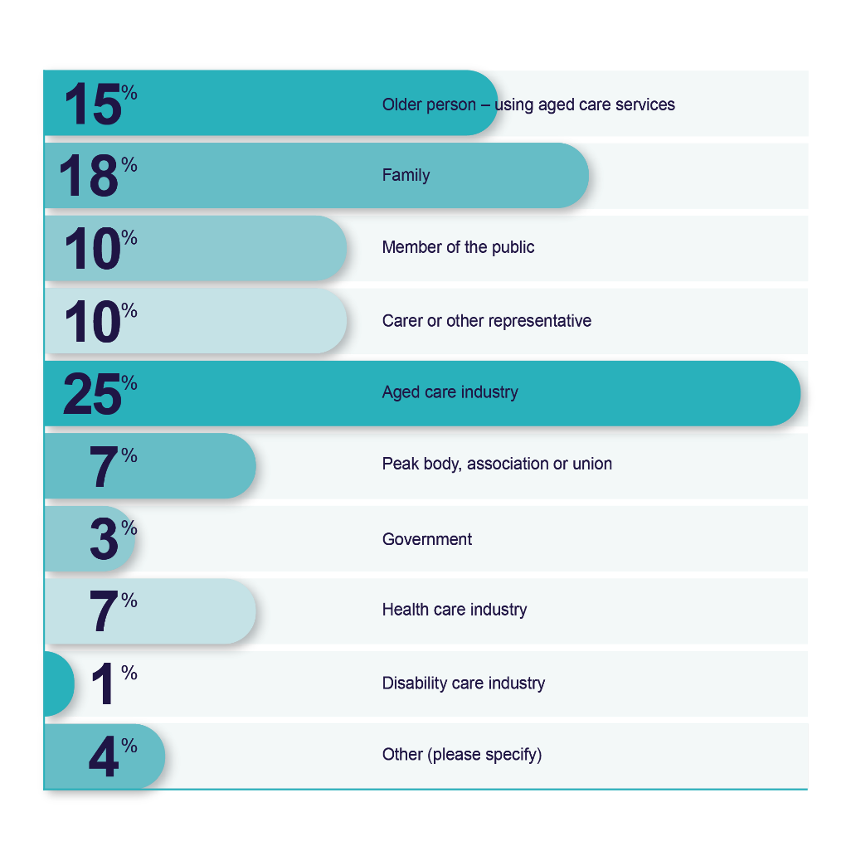
Figure 4. What group do you identify with?

Those who identified in the aged care industry were prompted to provide further detail of their role. The largest group was workers of aged care providers, followed by aged care providers and health professionals (Figure 5). 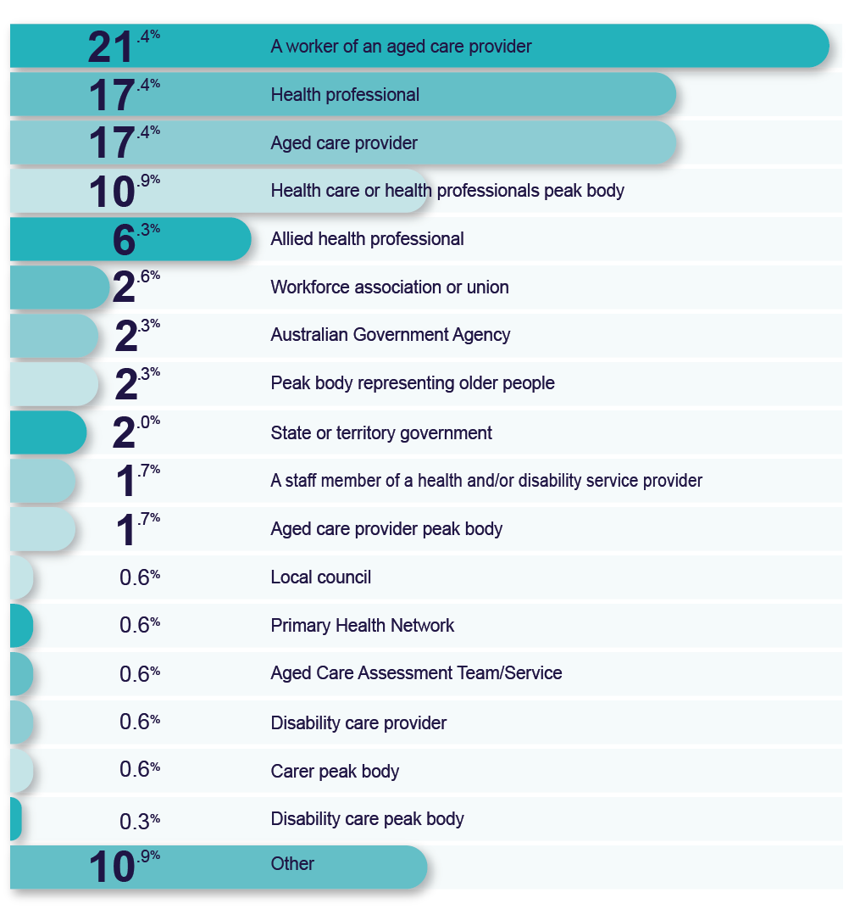
Figure 5. What category best describes you or your organisation?

It is important to note these results are not representative of all survey participants, as all the survey questions were not compulsory. Only about a quarter of survey participants responded to the question about diverse groups.
However, similar to the representation at the focus groups, the categories with the highest number of responses were people with dementia and people with disability (Figure 6). 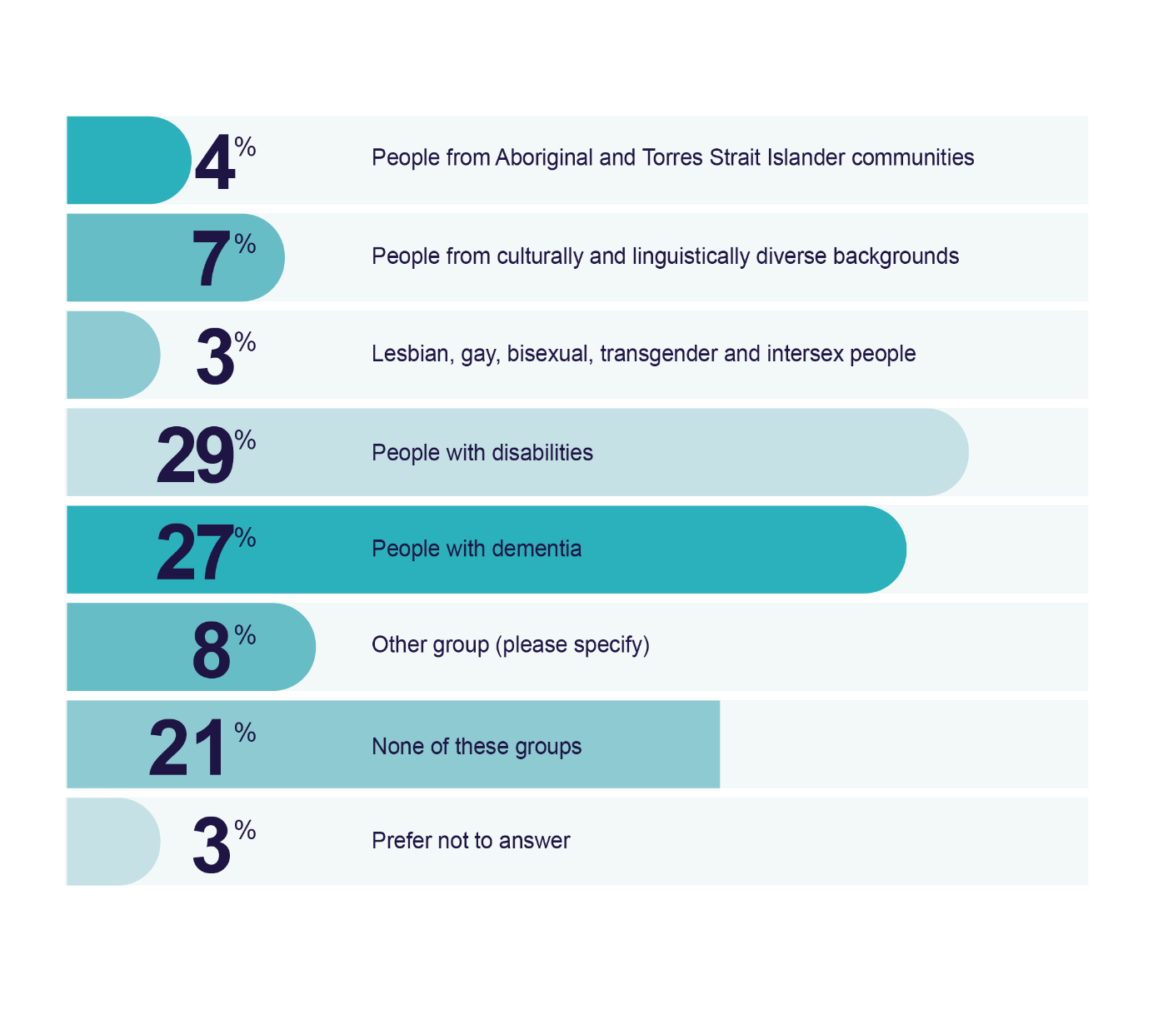
Figure 6. Do you, or the person/s you care for or represent, identify with or belong to one or more of the following groups?

The jurisdiction with the highest representation of survey respondents was New South Wales at 24.2 per cent, followed by Victoria at 21.9 per cent (Figure 7). The majority of respondents were from metropolitan areas, however the survey reached stakeholders from a range of areas including remote and rural communities (Figure 8 – over page).
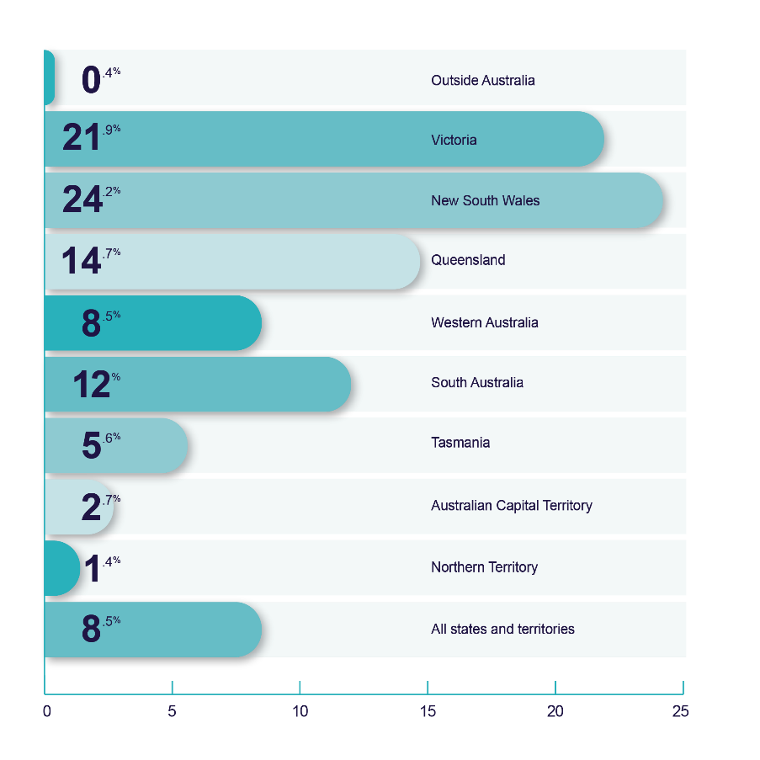Figure 7. Location – where are you located/where does your service operate?

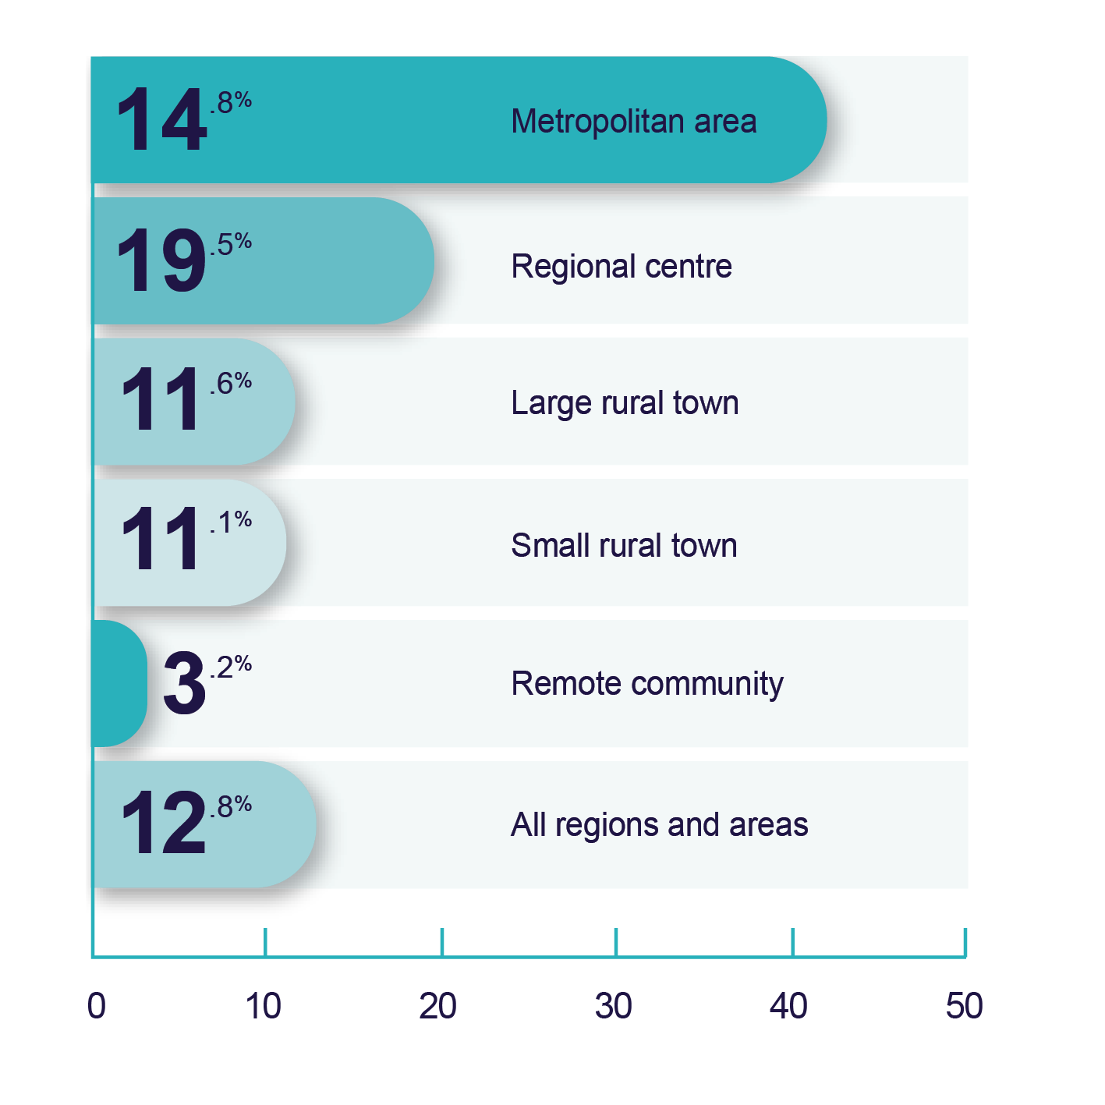
Figure 8. Rurality - where are you located/where does your service operate?

- Table number  - Table number  - Table number | Table paragraph: Use this style for all text within a table. | Table paragraph: Use this style for all text within a table. | Table paragraph: Use this style for all text within a table.

3

Broad feedback on the strengthened Quality Standards

Overview
Overall, feedback received during the public consultation was positive and constructive, with many people contributing ideas for further improvements. Stakeholders commented on the ‘well formulated’ strengthened Quality Standards, noting they ‘give much greater clarity’ than the current Quality Standards. Feedback broadly supported the strengthened Quality Standards meeting community expectations, with comments they are easier to understand, more measurable and able to be implemented. People were particularly pleased to see the continued and strengthened focus on person-centred care, diversity and cultural safety. People also commended the inclusion of detailed requirements regarding caring for people living with dementia, provider governance, food and nutrition and clinical care.
A range of detailed ideas were offered to bolster requirements in the Quality Standards, including ways to improve clarity of language, strengthen requirements, ensure actions are practical and achievable for providers and better address the needs and priorities of older people receiving aged care.

Strengths
The majority of stakeholders considered that the strengthened Quality Standards represented an improvement on the current Quality Standards (See survey result at Figure 9).
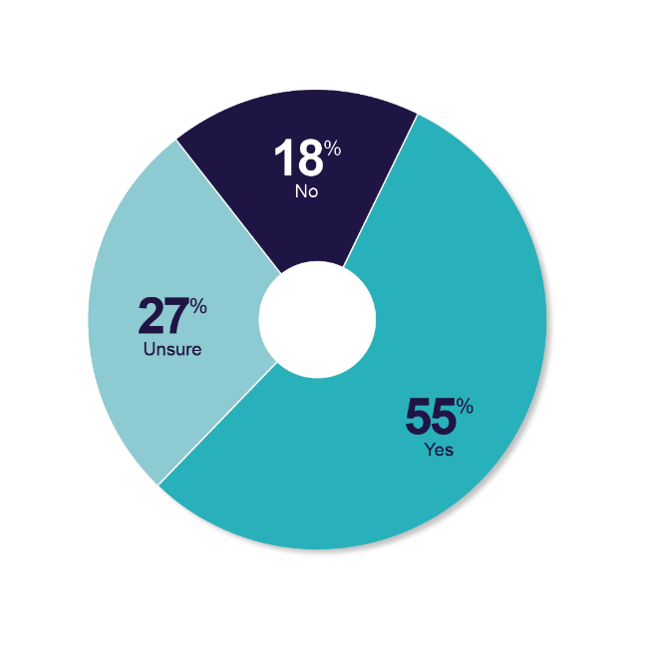
Figure 9. ‘Do you think the strengthened Quality Standards are an improvement on the current Quality Standards?’
Many stakeholders recognised the need for strengthened Quality Standards, including in response to the Royal Commission into Aged Care Quality and Safety (Royal Commission). However, some queried why they were being revised so shortly after the introduction of the current Quality Standards in 2019.
Stakeholders supported the overarching structure of the strengthened Quality Standards, including the broad subject matters covered by the Quality Standards, the ability to apply different standards based on service type, and the inclusion of detailed actions, outcomes and expectation statements for older people.
Many stakeholders expressed their satisfaction with the strengthened Quality Standards and how the proposed changes respond to the issues raised by the Royal Commission. Stakeholders noted the strengthened Quality Standards:
- Are rights-based and person-centred
- Recognise the importance of culturally safe, trauma aware and healing informed care
- Emphasise choice, autonomy and dignity of risk for older people
- Have a specific focus on dementia and older people of diverse backgrounds, including Aboriginal and Torres Strait Islander people
- Include robust and detailed requirements regarding provider governance, supporting people living with dementia, clinical care and food and nutrition
- Meet the expectations of older people, having ‘clearly been informed by active engagement with older people’.
While most respondents found the strengthened Quality Standards relatively clear and easy to read, there were some who felt the wording was complex and required simplification.
While some stakeholders expressed dissatisfaction with the strengthened Quality Standards in responding to the online survey, associated comments indicated their dissatisfaction was about the broader aged care system, current workforce shortages and/or the regulation of the Quality Standards, rather than the content of the Quality Standards themselves.
Response to feedback:
- The broadly positive feedback on the structure of the strengthened Quality Standards – including the ability to apply standards based on service type, the broad subject matters covered in the strengthened Quality Standards and the inclusion of detailed actions, outcomes and expectation statements for older people – the overarching structure and composition of the strengthened Quality Standards has been retained.
- While noting most respondents found the strengthened Quality Standards relatively clear and easy to read, some comments about language being too complex and a need for further clarity have been addressed throughout the strengthened standards. Outcome statements across the strengthened Quality Standards have also been reviewed to ensure they use language that resonates with older Australians and clearly describe provider expectations. Changes have also been made to rationalise and streamline language, and a glossary has been added to define key or commonly used terms.

Improving outcomes in focus areas
In relation to areas identified by the Royal Commission as critical areas for improvement, stakeholders were generally satisfied with the improvements made by the strengthened Quality Standards (see Figure 10).
- There was widespread support for inclusion of a dedicated standard for food and nutrition. Stakeholders expressed their strong support for the requirements set out in Standard 6 for residential services, with many noting that similar requirements were needed for aged care in the home.
- Stakeholders supported the inclusion of a clinical care standard and felt that it included the key safety and quality issues identified by the Royal Commission. Feedback on the level of prescription in Standard 5 was mixed, with some respondents reporting that Standard 5 provides improved detail about the requirements and expectations of providers, while others queried the prescriptive nature of the actions in this standard. Stakeholders also queried how the actions would apply to aged care in the home.
- The need to improve support for people living with dementia receiving aged care was widely acknowledged. Stakeholders commended the inclusion of specific requirements for supporting people living with dementia.
- There was broad consensus that acknowledging and valuing each person’s diversity is important. Stakeholders supported the inclusion of requirements to this effect, particularly those relating to culturally safe, trauma aware and healing informed care.
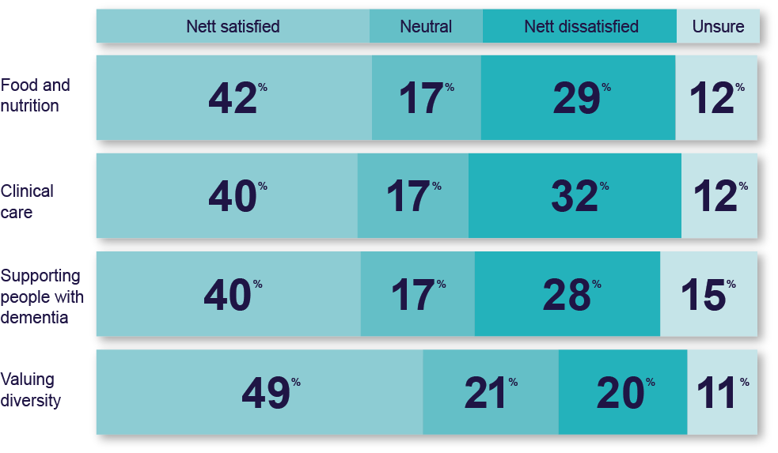
Figure 10. Stakeholder satisfaction with strengthened expectations in focus areas

Gaps or areas requiring stronger focus
Feedback was received from a diverse range of stakeholders, resulting in polarised views about the matters to be included in the strengthened Quality Standards and how to achieve the outcomes sought. For example:
- Some stakeholders supported the level of prescription included in the strengthened Quality Standards, others sought greater prescription (including specific Key Performance Indicators (KPIs) or targets so providers could be ‘held to account’) and others felt they needed to be less prescriptive and more outcomes-focused
- Health professionals from different disciplines sought a greater emphasis on different aspects of clinical and personal care (such as nursing, allied health, oral health, etc.)
- Older people with diverse experiences of aged care also had different views about whether the strengthened Quality Standards should be ‘protective’ of vulnerable older people, or more enabling and supportive of older people’s autonomy
- While a number of stakeholders were critical of the volume of actions included in the strengthened Quality Standards, there were almost no suggestions on ways to reduce content or advice that the actions were unreasonable. Many stakeholders provided in-depth proposals for additional matters to be addressed in the strengthened Quality Standards.
Stakeholders broadly sought a greater focus on:
- The role of carers and families in a person’s care, including the need to involve those who are important to the older person in decision-making and to collaboratively support the older person
- Reablement, independence and quality of life and supporting older people to maintain function and live well (particularly to enable them to live at home for as long as possible)
- The role of a multidisciplinary care team, with many stakeholders highlighting the important role various health professionals play in a person’s care
- Preventative care and the need for providers to educate older people in ways they can prevent, or limit risk of, disease and functional / cognitive decline as they age
- Promoting mental health and wellbeing, including a holistic approach to the person’s spiritual, cultural, emotional and psychosocial needs.
Response to feedback:
Consistent with the strong feedback received, changes have been made throughout the strengthened Quality Standards to strengthen the focus on:
- The role of family and carers, including by referencing family and carers throughout the strengthened Quality Standards and including a new action in Standard 1 requiring providers to engage with family and carers to support decision making
- The quality of life of older people, by drawing this out throughout the strengthened Quality Standards and defining this in the glossary to include a person’s physical, mental, spiritual and wellbeing
- Reablement and prevention, including by adjusting actions in Standards 3 and 5 to require providers to deliver care (including clinical care) in a way that optimises the older person’s quality of life, reablement and maintenance of function
- The role of the multidisciplinary care team, including by defining health professionals to include allied health professionals and others.

Key areas of contention
While stakeholders expressed opposing views across many issues, there were two key areas with implications across the strengthened Quality Standards.

Application of the Quality Standards
Stakeholders broadly supported the structure and intended application of the strengthened Quality Standards, including the approach where individual standards are applied based on the services a provider is registered to deliver.
However, stakeholders expressed disparate views on how the strengthened Quality Standards should apply to:
- Providers delivering low risk services – while some felt these providers should be subject to the Quality Standards, others favoured a more proportionate risk-based approach where the Quality Standards would not apply to lower risk services (such as gardening and cleaning) and that other consumer protection measures such as worker registration, Code of Conduct for Aged Care requirements and other conditions of registration would provide adequate safeguards
- Providers who are sole traders or small and medium enterprises (SMEs) – some suggested that the Quality Standards may represent over regulation for such providers (particularly requirements in Standard 2 – The Organisation)
- Providers who are allied health professionals or nurses – some felt that these health professionals should not be subject to the Quality Standards, noting that such professions are typically regulated by the Australian Health Practitioner Regulation Agency (AHPRA) or other established profession specific organisations. Others felt that they should be subject to the Quality Standards and that Standard 5 (Clinical care) was most relevant to nurses and allied health professionals
- Providers supporting the delivery of care and services through digital platforms – a number of stakeholders suggested the strengthened Quality Standards were not well suited to such providers.

Application in the home services context
A key issue for stakeholders was trying to understand how the outcome statements and actions would apply in the home services context, particularly to smaller providers (such as sole traders or SMEs), providers delivering a single service type (such as podiatry), providers delivering episodic care, etc. For example, stakeholders queried matters such as:
- The level of coordination required between providers where there are multiple providers delivering services in the home and particularly where the older person self manages their care and services
- The extent of care planning required, particularly for low-risk service types, where episodic care and services are being delivered or where multiple providers are delivering care. Noting that the older person is unlikely to want to go through a full assessment and planning process with each provider (where there are multiple providers), or to access a single episode of care)
- The appropriateness of governance requirements (set out in Standard 2 – The Organisation), particularly for SMEs and sole traders delivering home services.

Level of prescription
An ongoing tension in stakeholder feedback was related to the level of prescription in the Quality Standards. While a range of stakeholders reiterated the need to move towards a culture of quality, many stakeholders also described the need for prescriptive measures.
One cohort of stakeholders felt that the strengthened Quality Standards were too prescriptive, commenting that the detailed actions could limit innovation, would continue to foster a culture of compliance (rather than of quality) and represented additional compliance burden and cost for providers.
Another cohort of stakeholders felt the Quality Standards need to be more detailed, directive and include specific measures to ensure providers are accountable. They suggested that subjective terms needed to be defined or removed from the Quality Standards and that KPIs should be developed to measure provider performance and objectively identify non-compliance.
Response to feedback:
- While, on balance, the strengthened Quality Standards are considered to contain an appropriate level of detail to address the Royal Commission recommendation to make them more specific and measurable, this will be further tested through the pilot noting polarised feedback. This will help to determine what information or content is best placed within the Quality Standards themselves and what may be better placed in guidance or addressed through alternative mechanisms.
- Many stakeholders emphasised the need for detailed and fit-for purpose guidance, effective communications and education for the sector and a robust audit methodology for assessing compliance with the Quality Standards (that can both account for differing contexts and readily identify where outcomes are not being met). Guidance materials will be informed by the pilot and will also be subject to further consultation with stakeholders.
- In response to strong stakeholder concerns regarding application of the Quality Standards (particularly the applicability of Standard 5 for aged care in the home), the Commission will be testing this with providers as part of the pilot in mid-2023. Concerns about application in home care particularly will be closely examined as the new In-Home Aged Care Program is developed.

- Table number  - Table number  - Table number | Table paragraph: Use this style for all text within a table. | Table paragraph: Use this style for all text within a table. | Table paragraph: Use this style for all text within a table.

4

Detailed feedback on each Standard


Standard 1: The Person

Broad feedback on Standard 1
Stakeholders broadly supported the key concepts included in Standard 1, including person-centred care, culturally safe care and trauma aware and healing informed care. Stakeholders sought further strengthening of some themes, including independence, quality of life and dignity of risk.
Stakeholders were keen to emphasise (either by strengthening requirements within Standard 1 or in guidance/supporting materials) the importance of:
- Supporting people to feel safe to disclose their identity
- Supporting mental health and emotional wellbeing, including use of social workers and people with pastoral care or counselling experience to provide psychological, emotional and spiritual support to older people
- Supporting each individual’s sense of purpose and meaning
- Prioritising the choices of the older person, i.e. providers may recommend certain services but ultimately the person’s choice must be respected
- Communicating with people who may have significant challenges communicating.

Person-centred and culturally safe care
People felt that person-centred care and culturally safe care were critical concepts for inclusion in the strengthened Quality Standards. Stakeholders noted that the delivery of trauma aware and healing informed care was important to all older people and particularly Aboriginal and Torres Strait Islander people and veterans.
However, a number of stakeholders commented that while these terms are relatively widely used, they are not always well understood and can be complex (and resource-intensive) to achieve in practice. Stakeholders warned against ‘merely offering lip-service to the subject’, noting that delivery of truly person-centred and culturally safe care requires close and ongoing engagement with the person to understand what’s important to them and build trusting relationships between providers, workers, the person and the people important to them.
Submissions emphasised the need for good guidance and definitions on these concepts, including practical examples and how it could be evidenced.

Dignity of risk and choice
Stakeholders commented on the tension between respecting individual choice / dignity of risk and ‘doing what is good for the person’.
Many felt that dignity of risk needed to be strengthened in the Quality Standards to help providers get better at ‘enabling and empowering risk’, noting that some providers tend to take a risk averse, ‘protective’ approach rather than dedicating resources to engaging in challenging conversations, problem-solving and exploring alternative approaches to delivering care and services.
Responses highlighted some inherent tension between the desire to protect older people and the critical importance of them being able to exercise autonomy and choice in their services and the way that they are provided.

Communication and decision-making
Stakeholders supported the inclusion of requirements regarding communication, decision-making and informed consent. However, a number of stakeholders suggested there was opportunity to strengthen these requirements, including to ensure:
- Effective communication with people who experience challenges communicating
- Requirements regarding supported decision-making and use of substitute decision-makers are clear (i.e. to position supported decision-making as the primary mechanism where a person has limited decision-making capacity, and substitute decision-making as a final resort).
Stakeholder feedback reiterated the need for clear guidance on this matter, including to clarify the varying jurisdictional requirements, who determines capacity (noting that peoples’ decision-making capacity can fluctuate over time) and how to manage disagreements between the older person, the substitute decision-maker, carer and the family.
Stakeholders noted that regardless of capacity, older people often don’t know what is available to them or what they are entitled to (in terms of their care and services). As such, providers need to clearly set out the options so people can make informed choices.
Some stakeholders expressed concerns around the operational impacts associated with requiring providers to give older people time to seek advice prior to entering into an agreement, noting that this may not always be within the provider’s control and may have financial impacts for providers (e.g. where they are ‘holding a bed’ for a person indefinitely).

Response to feedback on Standard 1:
- Implementation supports such as detailed guidance and other resources will be developed to provide further detail on how to implement key concepts such as person-centred care, culturally safe care and dignity of risk.
- Strengthened requirements (in Standard 1) regarding communication and supported decision-making to emphasise that providers must understand individual communication needs and provide older people with the support needed to make decisions (using substitute decision-making only after all options to support decision-making are exhausted).
- Enhanced dignity of risk, including by adjusting actions in Standards 1, 3 and 6 to require providers to understand the older person’s goals and preferences and enable positive risk-taking that promotes the person’s autonomy and quality of life.


Standard 2: The Organisation

Broad feedback on Standard 2
Stakeholders broadly supported the requirements set out in Standard 2 though many wanted to ensure that the requirements allowed flexibility for varying governance structures based on the size and nature of the organisation (for example, for a small single service provider versus a large multi-site national provider).
Stakeholders highlighted the importance of requirements around workforce planning and human resource management, with some suggesting that these required greater visibility, particularly given the importance of workforce and the significant workforce challenges the sector is currently facing. Stakeholders from across all groups commented that a strong workforce was critical to the delivery of quality care.

Culture and partnering
Stakeholders commented positively on the shift towards ‘partnering’ with older people, commenting that partnerships should be ‘meaningful and empowering’, rather than ‘surface level communication’ or ‘tokenistic engagement’. It was acknowledged that Aboriginal and Torres Strait Islander people experience challenges accessing aged care services that go beyond other cohorts and close engagement with older people receiving services who are from Aboriginal and Torres Strait Islander communities is necessary to deliver culturally safe care.
Stakeholders felt that a culture of quality was critical to effective governance, with some stakeholders commenting that current practice is more compliance focused, where providers aim to meet baseline expectations only. Stakeholders suggested various factors were critical for a shift towards quality and continuous improvement, including:
- Acknowledging the high-risk and complex nature of delivering aged care
- Ensuring workers feel safe and supported to raise concerns, including by ensuring a blame-free environment where people can report errors or near misses without fear of reprimand
- Collaborating across all areas and levels of an organisation to seek solutions and improve the quality of care
- Willingness to direct resources to deal with safety and quality concerns.
One stakeholder also noted this culture of quality must ‘permeate all levels of an organisation’.

Accountability and quality systems
While stakeholders supported requirements directed to the governing body, some queried how these would work in practice in organisations where there is no Board (for example, a sole trader). Others queried how the governing body would be held accountable for non-compliance with any requirements attributed to them.
Stakeholders broadly supported the inclusion of requirements around open disclosure in the Quality Standards, noting that this isn’t always done well currently and that practising open disclosure is key to embedding a culture of quality throughout the organisation. Some stakeholders suggested that better education regarding open disclosure was needed for providers, workers and older people.
Stakeholders supported the inclusion of requirements around risk and incident management, noting these are critical to improving the safety and quality of service delivery to older people.

Feedback and complaints management
Stakeholders emphasised the importance of transparent, timely and effective complaints reporting and resolution mechanisms, noting that effective complaints management and resolution can significantly improve care and services and the experiences of older people. Many stakeholders also highlighted the need for people to feel safe making complaints and suggested including requirements to ensure providers support people to make complaints without fear of reprisal.
Some stakeholders sought specific KPIs or measures in relation to a provider’s complaints management systems/processes (e.g. to specify timeframes for responding to complaints) while others recognised that different timeframes would be appropriate based on the nature of the complaint and the risk to the older person.

Workforce planning
The need for adequate staffing (including mandated worker to resident ratios and having a nurse on duty) was a strong theme across different groups of stakeholders, with queries about whether such requirements should appear in the Quality Standards.
Stakeholders expressed strong concerns regarding current workforce shortages and the impact of these on the ability of providers to meet requirements regarding workforce planning and human resource management. There was strong feedback that prescriptive requirements for workforce would disadvantage providers in rural and remote context. Across all the standards, workforce availability and capability were viewed as challenge areas for implementation. Some suggested that requirements to ‘engage suitably qualified and competent workers’ may impede provider ability to engage workers (where providers may support workers to become competent through on the job training).
Some stakeholders expressed concerns regarding requirements to ‘engage workers as employees whenever possible and minimise the use of independent contractors’. While many felt this was important to support continuity of workers, a number of stakeholders suggested this has potential to limit the ability of providers to meet their workforce needs and to engage workers as contractors where this is preferable. For example, allied health professionals are often engaged as independent contractors.
A number of stakeholders commended the inclusion of requirements for providers to take steps to support the health and resilience of their workforce, highlighting the importance of a supported workforce. Others felt this requirement was aspirational but unclear, seeking clarity regarding what providers were expected to do in practice to meet this requirement.

Human resource management
A common theme across all stakeholder groups was the importance of well-resourced, skilled and supported staff.
Some stakeholders suggested the inclusion of actions requiring providers to implement strategies to ensure workers deliver services within their scope of practice (noting that resource constraints may drive the use of unqualified workers to undertake tasks outside of their scope of practice).
Stakeholders had mixed views about whether the Quality Standards should prescribe specific training that all workers must complete. Some stakeholders expressed concerns regarding requirements mandating specific training for all workers, noting this could reduce the ability of providers to determine the training needs of their workforce based on each person’s role, or that providers would concentrate on mandatory training at the expense of other training needs.
Others felt it was important for the Quality Standards to be specific about the areas in which workers must be trained, with some suggesting additional areas for mandatory training (such as palliative care).

Response to feedback on Standard 2:
- Concerns about the impact of workforce issues are acknowledged and are being addressed through a range of separate regulatory reform activities and initiatives resulting from the Royal Commission.
- Strengthened expectations about cultural change including for governing bodies leading quality and continuous improvement cultures.
- Enhanced worker training requirements to require competency-based training for core matters. In addition to the core matters, other specific training and education recommended for staff will be detailed through guidance.
- Strengthened expectations around incident management and feedback and complaints.
- Requirements to ‘use direct employment to engage workers whenever possible and minimise the use of independent contractors’ have been retained, given Australian Government election commitments to improve continuity of care and recommendation 87 of the Royal Commission (that providers should be required to have policies and procedures that preference the direct employment of workers).



Standard 3: The Care and Services

Broad feedback on Standard 3
While stakeholders broadly supported the requirements included in Standard 3, some commented on the generalised nature of requirements (noting that Standard 3 is intended to be applicable regardless of the service type being delivered) and suggested more detailed, specific requirements needed to be developed for each service type.
Some stakeholders queried the scope of provider responsibility for certain outcomes within this standard (such as assessment and planning and care coordination) where there are multiple providers delivering aged care to an older person. It was noted that such requirements should be proportionate to risk and relevant to the service being provided.

Assessment and planning
Some stakeholders expressed confusion about the intersections between assessment for the purposes of determining eligibility for services and funding and assessment undertaken by a provider for the purposes of care planning. Stakeholders were concerned that assessment to access services under the new In-Home Aged Care Program may duplicate provider assessment or result in misalignment.
Some stakeholders suggested that assessment and planning needed to be proportionate to the service type being delivered. It was noted that some service types are ‘quite transactional’ (e.g. episodic home or garden maintenance) and that in this instance it is not always relevant nor appropriate to have in-depth assessment or a detailed care and services plan.
Stakeholders highlighted the need for assessment and planning to be undertaken in partnership with older people, their carers and families and involve a broad multidisciplinary team. Some felt this was critical to ensuring assessments are evidence-based and that older people understand the array of services available to meet their needs and support them to achieve their goals.
Stakeholders felt that requirements under the Quality Standards to provide a copy of a person’s care and services plan to them were unclear and needed to be strengthened. Stakeholders suggested that care and services plans should be offered to the person (rather than ‘able to be accessed by the older person’).
It was noted that the opportunity to access a person’s care and services plan, and the level of detail provided, should be in accordance with the older person’s wishes, as some people may not want a copy of their care and services plan - some may only want a summary and some may want the detail.
Stakeholders noted that developing care and services plans can be challenging, as providers need to differentiate between what information the provider and different workers need and what the older person and their family and carers need. Some stakeholders sought a care and services plan template however others felt that the format and content of care and services plans should be driven by the person and the types of services they are receiving.
Stakeholders noted the need for care and services plans to be a dynamic, ‘living’ document.

Supporting people living with dementia
Overall, stakeholders strongly supported the inclusion of requirements regarding delivering care and services to people living with dementia.
Some stakeholders felt that requirements regarding supporting people living with dementia should be separated into a discrete standard or outcome while others felt it was appropriate to include requirements regarding dementia throughout the Quality Standards, noting it is ‘core business’ and shouldn’t be separated out.
A range of stakeholders commented that worker rapport and continuity was important for many older people, particularly those living with dementia. However, some stakeholders suggested that Action 3.2.8 (requiring providers to make reasonable efforts to involve the older person in selecting their workers and maximise continuity) may not be feasible in practice and would not be appropriate in a residential setting.

Communication and coordination
Stakeholders emphasised the importance of effective communication and coordination of care and services, including between workers within a provider, with other providers or organisations, health professionals involved in the person’s care and with the older person, their carers and family.
Stakeholders broadly acknowledged that service fragmentation is a significant risk, particularly in a multi-provider environment under the new In-Home Aged Care Program, and that effective coordination will be needed to address this. However, many queried how care coordination would operate in practice, and what the expectation would be on providers, noting that the new In-Home Aged Care Program is expected to include a care management service type.
Stakeholders noted that transitions in care are a key point of risk to older people. Submissions highlighted the importance of effective communication between providers (and other parties involved in a person’s care) to transfer relevant information about the person’s needs and preferences.
A number of stakeholders suggested that actions under Outcome 7.2 be included under Outcome 3.4, given they both relate to coordination and continuity of care.

Response to feedback on Standard 3:
- Strengthened partnerships with family, carers and health professionals involved in care in planning and delivery.
- Strengthened requirements about multidisciplinary team approach, preventative health and the delivery and format of care and services plans.
- Work will be undertaken to ensure alignment and limited duplication with the In-Home Aged Care Program being developed, particularly for assessments.
- Retained Outcome 7.2 under Standard 7 – The Residential Community as these requirements are specific for residential care while Standard 3 would apply to all providers subject to the Quality Standards.



Standard 4: The Environment Standard

Broad feedback on Standard 4
A number of stakeholders commented positively on the structure of Standard 4, where Outcome 4.1 is split into discrete requirements targeted for home services and the residential environment. People felt this appropriately acknowledged the extent of responsibility and control the provider has over each environment. Some suggested this approach could be replicated in other areas throughout the Quality Standards.

Equipment
Some stakeholders suggested that requirements relating to equipment could be separated into a standalone outcome, rather than being repeated under both 4.1(a) and (b).
In relation to equipment, stakeholders noted that consideration needed to be given to the provider’s scope of control / responsibility where the older person is responsible for purchasing equipment (including to ensure their personal equipment is well maintained, clean and meets their needs).

Home environment
Some stakeholders expressed concern that requirements regarding the home environment may be perceived to place responsibility on providers for the safety of an older person’s home environment. Stakeholders noted that providers may have limited ability to address identified risks in a person’s home.
Stakeholders queried who was expected to undertake screening of environmental risks and whether this needed to be an Occupational Therapist, noting that this would entail a cost and would not be appropriate where an older person doesn’t want or request this service. It was suggested that the purpose of screening needed to be made clearer. Stakeholders also queried whether – where multiple providers are delivering services in a person’s home – each provider needed to undertake environmental screening.
Stakeholders highlighted that providers may also identify opportunities for the older person to make their home environment more supportive to enable them to live safely at home for longer (such as home modifications), and that this should be encouraged.

A number of stakeholders commented that requirements to ensure a safe environment for workers may duplicate existing work health and safety obligations, suggesting this requirement should focus more on the holistic screening for risks to the safety of older persons.

Service environment
Some stakeholders queried how Outcome 4.1(b) would intersect with work being undertaken on the design of residential aged care environments currently being undertaken by the department.
Some felt that references to the environment being ‘fit-for-purpose’ and ‘safe, welcoming and comfortable’ were subjective and sought further description of what this meant or minimum requirements regarding furnishings.
Stakeholders suggested that service environments must be accessible and enable people with a physical disability to move around easily (including space for transfers for people who use a wheelchair or electric scooter), support social connections and engagement and be at a comfortable temperature.
Some stakeholders felt that requirements regarding dementia enabling environments needed to be stronger or more overt (e.g. through directly referencing the dementia enabling environment principles). Some stakeholders highlighted relevant requirements for people living with dementia, including in relation to freedom of movement, navigation, colours and visibility, easy to use tapware, sufficient space, appropriate flooring and furnishings, etc.

Infection prevention and control
Some felt that requirements relating to infection prevention and control (IPC) should be elevated or more visible within the Quality Standards, noting the importance of effective IPC in light of COVID-19 and other outbreaks common in aged care (such as influenza, gastroenteritis, etc.).
Some highlighted that providers must balance IPC measures with the human rights of older people, citing the social isolation older people experienced due to lockdowns of residential services in response to COVID-19.
In relation to requirements to appoint an appropriately qualified and trained IPC lead, stakeholders commented that the requirements of this role needed to be clarified (particularly for home services).
Some stakeholders felt that all requirements regarding infection prevention and control should be grouped together under a single outcome or standard (noting that actions with specific regard to clinical care are included in Standard 5).

Response to feedback on Standard 4:
- Revised expectations for screening for environmental risks.
- Strengthened requirements about service environments being accessible, including for people with disability.
- Additional information to clarify requirements such as IPC leads and ‘fit for purpose environments’ will be included in the guidance. Guidance will also include further references to evidence-based resources and documents (e.g. dementia enabling environment principles).



5: Clinical Care Standard

Broad feedback on Standard 5
Stakeholders strongly supported the inclusion of a discrete standard that focused on clinical care and addressed key safety and quality issues identified by the Royal Commission.
A number of stakeholders felt that the structure, language and tone of Standard 5 was different to other standards, in particular, that it was not as person-centred. Conversely, others supported the strengthening of the language in Standard 5, noting a preference for alignment to the National Safety and Quality in Health Service Standards and that the language reflected the recommendations of the Royal Commission.
Stakeholders commented on the volume of detailed requirements and the lack of clarity regarding the application of various requirements in different settings, particularly where clinical care is being delivered in the home. Some felt that Standard 5 needed separate outcomes or extra guidance to explain how it would apply to providers delivering aged care in the home or where there are limited resources. There was concern about the ability to implement Standard 5 in a rural and remote context where resource allocation is a critical factor in retaining aged care services in local communities.
Some queried the split of outcome topics – including why some clinical safety matters had a dedicated outcome or were confined to a single action. Some suggested that the detailed focus on discrete areas of risk (specifically ‘technical nursing’ list under Outcome 5.4) was task-focused and inconsistent with the person-centred intent of the strengthened Quality Standards.
Stakeholders provided strong feedback on ensuring workers deliver clinical services within their scope of practice, with mixed views whether regulation through external service providers is sufficient. Stakeholders also provided feedback on the role of providers in coordinating care and enabling referrals. Respondents expressed concern about gaps in training for key risk areas including oral health, unqualified staff delivering clinical care and delineation of roles and responsibilities.
Some stakeholders felt that Standard 5 was too ‘acute care or nursing focused’ and did not adequately speak to preventative care, reablement or the role of allied health professionals in delivering clinical care. There was strong feedback that specific allied health practitioners should be named and allied health should be more involved, but this was balanced with the concern that being prescriptive would make compliance difficult for rural and remote providers with fewer resources.
Many of the survey respondents and focus group participants were positive about the greater health focus in the clinical care standard.

Clinical governance
A number of stakeholders suggested that clinical governance would best fit under Standard 2, as it is closely tied to broader organisational governance. However, noting that the Clinical Care standard would not apply to all providers, clinical governance has been retained in Standard 5.
Many stakeholders queried requirements for providers to input information into nationally agreed electronic health and aged care record systems. Some highlighted that currently, there is no interface between My Health Record and My Aged Care and many aged care providers cannot currently access the My Health Record system. Some expressed concerns regarding the privacy of older peoples’ information.
Others recognised the critical importance of integrated digital systems for safety and quality and the timely and accurate access to clinical information. Staff training in digital information systems was identified as an issue. Implementing digital systems including funding and resources are also barriers.
There was strong feedback relating to provider accountabilities for health professionals involved in providing clinical care. There were concerns that the requirement to agree roles and responsibilities with health professionals was too onerous but equally the importance of co-ordinated, well managed clinical care was seen as an essential component of aged care.
Feedback suggested the links to other standards could be strengthened, in particular to Standard 2.

Medication safety
Feedback clearly stated that medication management is not only about identifying and mitigating risk of harm in the use of medicine but should also include the safe and quality use of medicines to enhance clinical outcomes for the older person. Stakeholders suggested the intent should be better reflected in the title of the outcome.
Some stakeholders were pleased to see a focus on medications, including expectations regarding medication reviews and the strategy of deprescribing and reducing inappropriate use of psychotropics. There was some concern about implementing medicine reviews however, stakeholders acknowledged these issues could be considered when the strengthened Quality Standards are piloted.
Some stakeholders questioned how the medicine safety outcome would apply in services with part responsibility for medicine management. For example, a provider who is responsible for only some aspects of an older person’s medication management.
Stakeholders also had mixed views on the types of workers that may be able to undertake medicine-related tasks in a person’s home, including whether personal care workers can administer medicines under the supervision of a registered or enrolled nurse. Some stakeholders commented that actions in this outcome did not adequately address medication interactions including interactions with food, vitamins and supplements and side effects.

Comprehensive care
Many stakeholders expressed concern regarding the content and structure of Outcome 5.4, suggesting that the process elements of comprehensive care should be separated from the clinical safety topics. The need to strengthen reablement, restoration and maintenance was identified.
Feedback from stakeholders identified the importance of comprehensive assessment on commencement of care, emphasising the critical role of the general practitioner, along with collaborating with health professionals. While stakeholders supported the inclusion of detailed requirements regarding management of clinical risks, some additional feedback was provided to ensure best practice management of the identified issues.

Advance care planning and palliative care
Stakeholders (across all stakeholder groups) strongly supported the inclusion of requirements specific to advance care planning and palliative care. Many stakeholders suggested that ‘care at the end of life’ be replaced with ‘palliative care’, noting that palliative care is not always only provided at the end of life.
Some stakeholders sought clarity regarding the application of Outcome 5.5 in the home environment, noting that palliative care goes beyond clinical care and may comprise a range of different service types (such as nursing, allied health, personal care, social supports, respite care, etc.) and may be delivered by multiple providers.
In relation to advance care planning, stakeholders felt it was important that there is a consistent definition of advance care planning, and that providers and workers understand legal frameworks and laws governing medical decision-making.
It was acknowledged that, while all providers may not deliver palliative care services, all providers should be required to support older people with advance care planning, where the person wishes. Stakeholders felt this should be explicitly called out as part of Outcome 3.2.
In relation to end of life care, stakeholders suggested that the focus should be on maximising dignity and comfort rather than ‘processes to minimise harm’, and actions should align with national best practice guidelines.
Response to feedback on Standard 5:
- Substantial changes made to Standard 5, including to make it more person-centred and holistic.
- Emphasised the importance of planning and delivering coordinated and comprehensive clinical care in partnership with older people, their family and carers, in line with the other standards.
- Separated the processes of comprehensive care into a new outcome on clinical safety topics and removed the technical nursing action.
- Addressed scope of practice issues, including by requiring providers to ensure workers providing clinical care work within their defined scope of practice.
- Simplified language, removed inconsistencies and clarified terminology.
- Emphasised the importance of optimising function and reablement.
- Highlighted linkages between Standard 5 and other standards, for example in relation to governance, assessment and planning and delivery of care and services.
- Added a new outcome for cognitive impairment to enhance requirements for addressing clinical risks and changed behaviour.
- Enhanced concepts around:
- Multidisciplinary approach to care including references to allied health, medical, specialists and advisory services and explicit reference to general practitioners, dentists and oral health practitioners
- Facilitation of access to health professionals and specialists when required
- Requirements for the safe and quality use of medicines including to ensure regular review and improving the effectiveness of systems.
- Detailed guidance will further support understanding of key concepts.


6: Food and Nutrition Standard

Broad feedback on Standard 6
Stakeholders (across all stakeholder groups) strongly supported the inclusion of a discrete food and nutrition standard, commenting on the importance of food in contributing to quality of life, health and wellbeing.
Many stakeholders queried why Standard 6 applied only to residential care and not to services provided in the home, strongly expressing that there should be requirements guiding the provision of meals in older peoples’ homes. It was noted that there is a wide variety of food provided in the home – from a worker preparing a person a sandwich, helping people to shop for groceries and cook meals in their own home to delivering pre-prepared meals – such that it may be challenging to identify requirements that appropriately cover all of these.
A number of stakeholders highlighted the overlaps between Standards 5 and 6, noting the relationship between food and clinical care. Some felt that monitoring a person for malnutrition and dehydration should be part of Standard 6, while others felt it was best positioned in the clinical care standard citing the importance of not ‘medicalising’ food.
Stakeholders noted the prevalence of texture-modified diets in residential aged care and provided suggestions on how to enhance the expectations in standard 6 relating to the presentation of texture modified foods.
A number of people commented that dignity of risk should be emphasised within Standard 6, as food and drink is one of the key areas where older people commonly have competing safety needs and preferences for enjoyment.

Partnering with older people on food and nutrition
People generally supported the inclusion of requirements for providers to partner with older people to ensure a quality food service. Stakeholders suggested various ways providers could work with older people to seek feedback and collaboratively develop menus.
In assessing people’s dietary needs, stakeholders variously suggested additional or specific factors to be considered as part of assessment (including the person’s cultural needs, ability to swallow, etc.).

Provision of food and drink
Stakeholders generally supported requirements to review menus with the input of an Accredited Practising Dietitian.
Stakeholders debated the level of choice that should be provided to older people in residential care, noting that it is difficult to quantify how much choice is sufficient. People generally felt that it is unacceptable for an older person to be ‘forced to eat what’s on offer or go without’, suggesting that providers needed to ensure a wide variety of foods are offered to residents, including different options at each meal, seasonal menus and special occasion meals.
Stakeholders commented on the importance of food being appealing to older people and enjoyable. However, some stakeholders suggested this requirement is subjective, noting that food taste and appeal is personal and food preferences can be affected by various factors. People suggested it would be impossible for providers to deliver meals that are appealing and flavourful to all older people at all times, but that providers must aim for this.
Stakeholders commented on the need for providers to ensure food and drinks are readily accessible to older people. For example, by ensuring snacks and drinks are readily available and able to be consumed by older people (including where they may have limited dexterity) and enabling people to prepare their own basic snacks and meals when they want to.

Dining experience
Some stakeholders sought additional clarity regarding what was included in the ‘dining experience’ and clear measures around how providers demonstrate they are meeting these requirements.
A number of stakeholders noted that worker shortages often impact on the ability of older people to meet their nutritional requirements, particularly where there are insufficient workers to assist older people to eat at a pace and time that meets their needs. Stakeholders commented that having the right number of staff is crucial to support people to eat and to monitor and understand each person’s food intake.
Stakeholders noted the importance of enabling older people to share food and drinks with their loved ones and strongly supported the inclusion of Action 6.4.3. A number of stakeholders noted that providers can be quite risk averse in relation to sharing food, suggesting that providers must learn to engage with risk in a healthy way and empower older people to do the things that bring meaning to their day.

Response to feedback on Standard 6:
- Strengthened expectations for ensuring meals, including texture modified meals, are presented in an appealing way and meet each older person’s assessed needs.
- Strengthened requirements requiring menus to be annually reviewed by Accredited Practising Dietitians and for meals provided to reflect the menu.
- Enhanced clarity of expectations for foods to be nutritious, and for expectations in the standards to apply to all foods and drinks (i.e. meals, drinks and snacks).
- Enhanced expectations for the dining experience and supporting older people to eat and drink in line with their needs and preferences.
- Acknowledging the strong feedback to include food and nutrition requirements in home care, the department is undertaking further work to explore options in this area. This will include further consultation with food and nutrition experts and representative groups. Possible options may include nutritional requirements for meal delivery and greater requirements to screen and manage malnutrition in the home.


7: The Residential Community

Daily living
Stakeholders noted the importance of a welcoming and inclusive residential community and opportunities to engage in activities that are of interest and provide meaning to older people. Some stakeholders suggested that similar requirements should be developed regarding social supports and lifestyle activities provided in the home and community.
While many stakeholders appreciated the simple, straightforward wording of ‘minimising boredom and loneliness’, others felt this was subjective and couldn’t easily be measured.
Stakeholders generally supported requirements to support older people to contribute to their community, commenting on the sense of purpose and enjoyment derived from participating in activities such as cooking and gardening (which are often a big part of peoples’ lives before they enter residential care).
While some stakeholders felt that requirements regarding maintaining relationships of choice were adequately covered by Standard 1, others felt that explicit requirements for the residential care setting were necessary to combat potential ageism and judgement. Some stakeholders felt that diversity and inclusion could be more strongly called out throughout this Outcome.
Stakeholders suggested that additional requirements could be included under this Outcome, including to recognise peoples’ connections outside the residential service (supporting people to engage in activities outside the service and actively inviting peoples’ families and friends into the service) and supporting older people and workers to manage grief and bereavement.

Planned transitions
Stakeholders emphasised the need for careful management of transitions, noting these are a key point of risk for older people.
Stakeholders queried whether Outcome 7.2 was most appropriately placed under Standard 7 or would be better included in Standard 3 or Standard 5 (as relevant to transitions between clinical settings). Some suggested separate requirements should be developed relating to transitions between the aged care provider and other health services and transitions between the aged care provider and the community (e.g. into the care of family or friends).
A number of stakeholders highlighted that the scope of provider responsibility in relation to ensuring planned and coordinated transfers is somewhat limited by the other parties involved in the transfer (i.e. the receiving or discharging organisation).
It was noted that older people can be discharged from hospital with limited notice and the quality of information provided by discharging organisations is not always sufficient.
Stakeholders highlighted the importance of effective information transfer between organisations / workers to ensure continuity of care, with some suggesting standardised protocols for sharing an older person’s information between organisations as part of clinical care transitions. Stakeholders also noted that medications and prescriptions need to be transferred with the person to ensure continuity of important therapeutic treatments.
Some stakeholders queried the feasibility of requirements for providers to maintain connections with specialist dementia care providers, particularly for services in rural and remote locations.

Response to feedback on Standard 7:
- Enhanced expectations about supporting diversity and inclusion.
- Revised language to clarify the types of transition, and the organisations and individuals involved.
- Broader work is underway to better support transition between aged care and health care systems under the Residential Aged Care Quality and Safety (Pillar 3 of the Royal Commission response) – Improving access to primary care and other health services measure.

- Table number  - Table number  - Table number | Table paragraph: Use this style for all text within a table. | Table paragraph: Use this style for all text within a table. | Table paragraph: Use this style for all text within a table.

5
Implementation considerations

Intersections with broader reforms
Stakeholders were keen to understand how the strengthened Quality Standards fit in with broader reforms to aged care, including the new Aged Care Act, In-Home Aged Care Program, provider governance requirements, National Aged Care Mandatory Quality Indicator Program (QI Program), Code of Conduct for Aged Care, and the new regulatory model.
Some suggested that the strengthened Quality Standards be further reviewed and refined when the broader context (including program requirements and the registration model) is more settled.

Guidance
Stakeholders consistently emphasised the important role of guidance materials to support providers, workers and older people, their carers and families to understand, interpret and apply the strengthened Quality Standards. Others noted that guidance is considered optional and not always engaged in as a matter of routine.
Many providers sought examples and case studies (demonstrating both good and poor practice), self-assessment tools, links to best practice resources, materials tailored to specific service types and examples of the types of evidence providers can use to demonstrate compliance.
A number of stakeholders suggested tailored guidance also be developed for different types of workers, highlighting that education and training for workers would be critical.
Stakeholders emphasised the importance of guidance for older people, including communications and resources to promote the Quality Standards to older people and to ensure older people understand what to expect of their service provider.

Transition
Stakeholders (predominantly providers) queried the approach to transition and the support that would be available to providers, workers and healthcare professionals to transition to the strengthened Quality Standards.
Some suggested there needed to be a sector-wide transition or change management plan for providers to follow. It was proposed that this set out timings of various activities, regulatory changes and the types of provider support that would be available (such as guidance materials, education, training, etc.).
Some suggested government should offer training for providers in the intent and application of the strengthened Quality Standards.

Response to feedback:
On 31 January 2022, the Aged Care Commission appointed an Assistant Commissioner for Sector Capability and Education to support the implementation of the Quality Standards. The Assistant Commissioner will:
- Develop, implement and lead a sector education and capability uplift campaign, informed by regulatory intelligence, to address sector capability and performance
- Focus initially on corporate governance, clinical governance to improve sector leadership and capability
- Drive cultural change to transition providers from minimal compliance to continuous improvement and excellence.

Audit
Stakeholders supported the proposed pilot of the strengthened Quality Standards, noting the importance of testing their practical application – across a range of settings, service types, organisation types and cohorts of older people – to understand whether the requirements are feasible, appropriate and effective.
A large number of stakeholders (predominantly providers) sought transparency regarding the audit process. Providers supported publication of the Commission’s assessment methodology to understand how their performance will be measured and to guide continuous improvement activities.
Some stakeholders commented on the need for stronger regulation of providers, including quick responses to, and harsher penalties for, non-compliance. However, some felt the regulator should take a more collaborative approach, suggesting that a strong focus on ‘compliance’ did not drive quality or incentivise high performance but instead encouraged providers to aim for the ‘bare minimum to pass audit’.
Stakeholders felt that proportionate treatment of non-compliance was essential, noting that ‘all non-compliances should not be treated equally’. It was suggested that graded assessment would help providers to identify and rectify minor issues rather than ‘punish’ them for these.

- Table number  - Table number  - Table number | Table paragraph: Use this style for all text within a table. | Table paragraph: Use this style for all text within a table. | Table paragraph: Use this style for all text within a table.

6
Next steps

Implementation of the Quality Standards
Many stakeholders described the significant effort required to improve the aged care system and address the issues highlighted by the Royal Commission. Stakeholders consistently commented on the critical importance of an available, skilled, competent workforce and informed and empowered older people. Some reflected on the extent of the cultural shift required of providers, and many highlighted the critical role that effective regulation (and a strong regulator) would play.
A number of stakeholders commented on the challenges in providing meaningful feedback on the Quality Standards in the absence of the broader regulatory framework, including the new Aged Care Act, approach to provider regulation and the new In-Home Aged Care Program.
The department acknowledges the challenges associated with consulting on the strengthened Quality Standards in the absence of a well-developed approach to other elements of the new system. However, early insights from stakeholders on the strengthened Quality Standards (a foundation piece for the new system) have been invaluable in informing the broader reform. The department will continue to work closely with stakeholders in refining the Quality Standards to reflect outcomes from the pilot and designing broader reforms.

Pilot
The Commission will undertake a pilot to test the practical application and audit of the Quality Standards with a representative sample of providers across Australia in mid-2023. The pilot will include interviews with workers, older people, their carers and families about their experience of care. This will ensure that the Quality Standards focus on key matters of importance to older people and effectively identify risk. Further information regarding the pilot is available on the Commission website.
The department will continue to keep stakeholders informed about the progress and outcomes of the pilot, including proposed changes to the Quality Standards that occur in response to the pilot and through the legislative drafting process.

