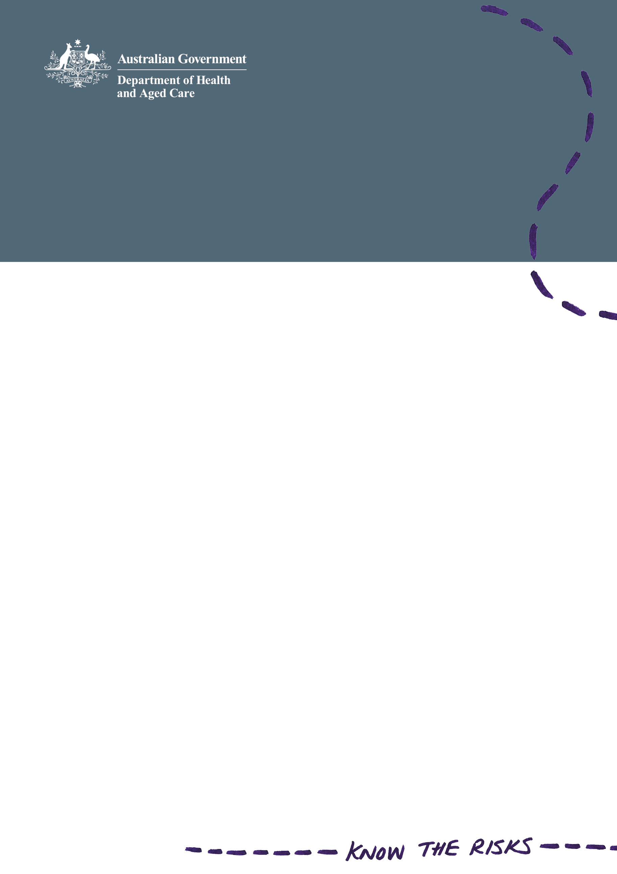

# Cosmetic surgery patient safety checklist

**Make a list.**   
Check it before you book cosmetic surgery.

I have **chosen** a qualified medical practitioner who is skilled and experienced in performing my surgery.

I **know** my surgery will take place in a licensed facility, such as a hospital or day surgery clinic.

I **understand** the risks and possible complications from my surgery.

I have **asked** for and understand the plan for my recovery and aftercare.

I **know** what to do if something goes wrong.

I will **report** any concerns to the Ahpra Cosmetic Surgery Hotline   
on 1300 361 041.

I will **visit** health.gov.au/cosmeticsurgery for more information.