# Service and Support Portal User Guide – Updating Multipurpose Services

This user guide is for the Organisation Administrators or Outlet Administrators of the My Aged Care (MAC) Service and Support Portal, to update information about multipurpose service (MPS) delivery outlets.

This information is used to match and refer clients to MPS and are publicly displayed on the Service Finder on the MAC website.

This guide contains the following topics:

Creating a MPS Service Item 2

Adding a Room Type 5

Adding and Updating Service Information 8

Activating a Service Item 11

Activating an Outlet 12

! Providers must maintain accurate service information, which will display in the service finders, and will be used by My Aged Care system users (including the contact centre and assessors) to make referrals and to share information.

## Creating a MPS Service Item

1. Select the “Outlet administration” tile from the Service and Support Portal home page.

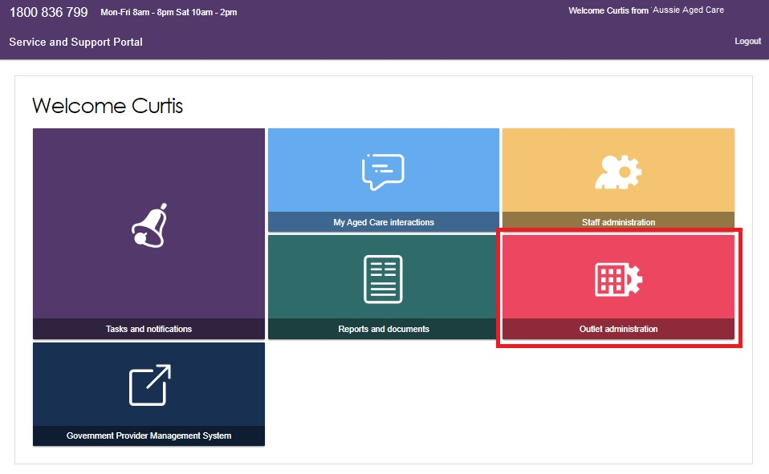

You will be taken to the “Outlet administration” screen.

1. Select the name of the outlet that you want to add a service item.

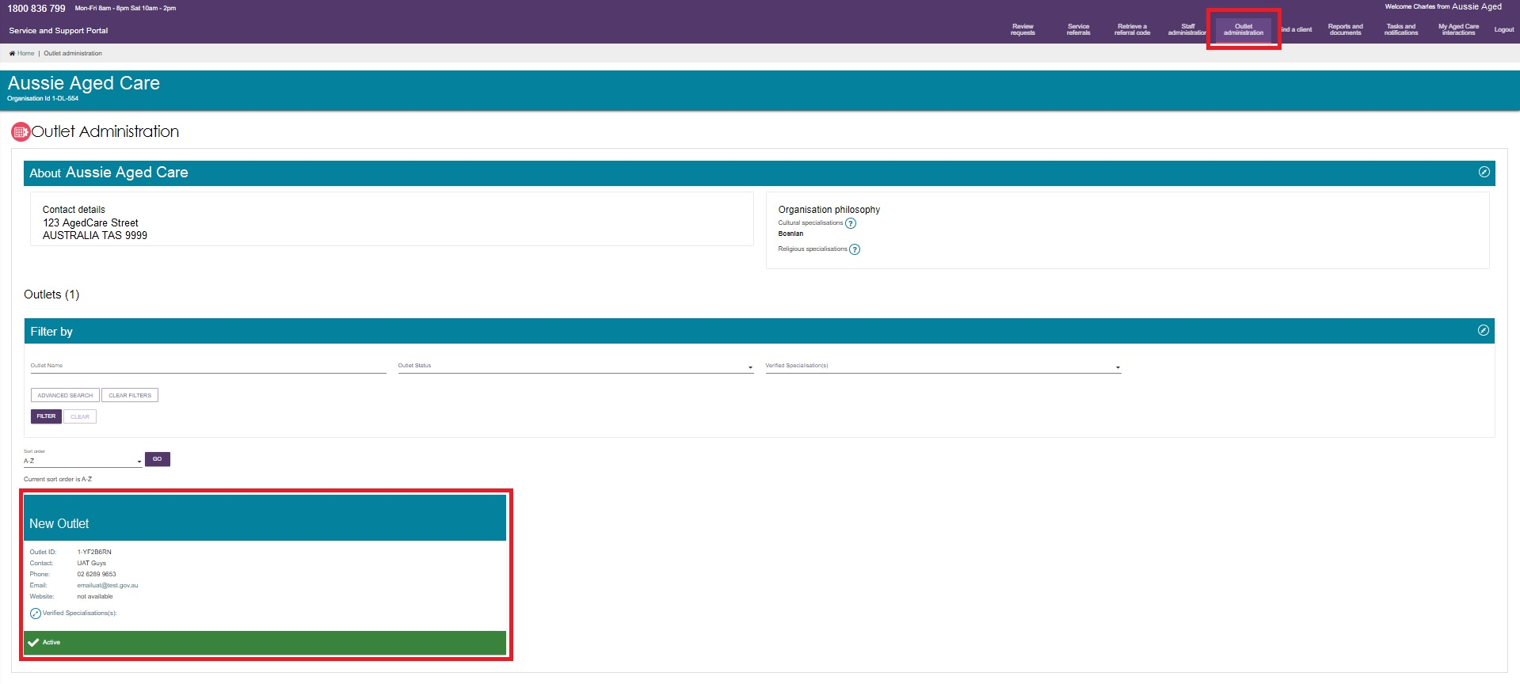

The “View Outlet” page will be displayed.

1. Select “VIEW SERVICE ITEMS”.

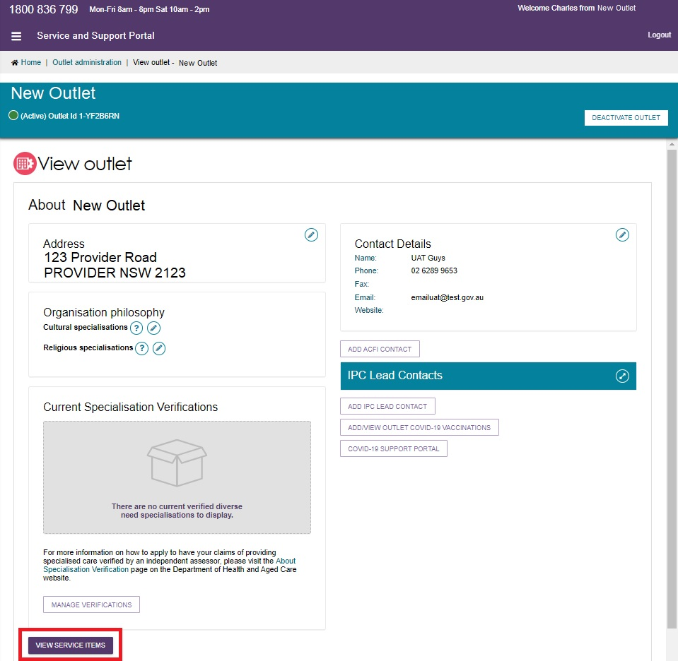

1. Select “ADD A SERVICE ITEM”.

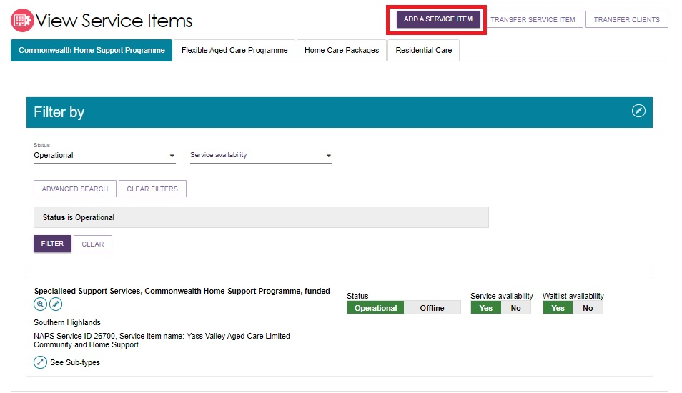

The “Add service item” page displays.

1. Select the programme that applies to the service item in the drop down menu. In this case it is “Flexible Aged Care Programme”.

Select either Funded or Non-funded.

Select the relevant service type, such as “Multi-Purpose Service – Residential” or “Multi-Purpose Service – Home Care” from the list that displays. You can also use filters: Service Provider, Service Type, Funding Regional Type, and Funding Region.

Finally, select “SAVE”.

! “Funded” services are subsidised services that are funded and approved by the Australian Government under an Aged Care programme, such as the Multi-Purpose Services Programme.

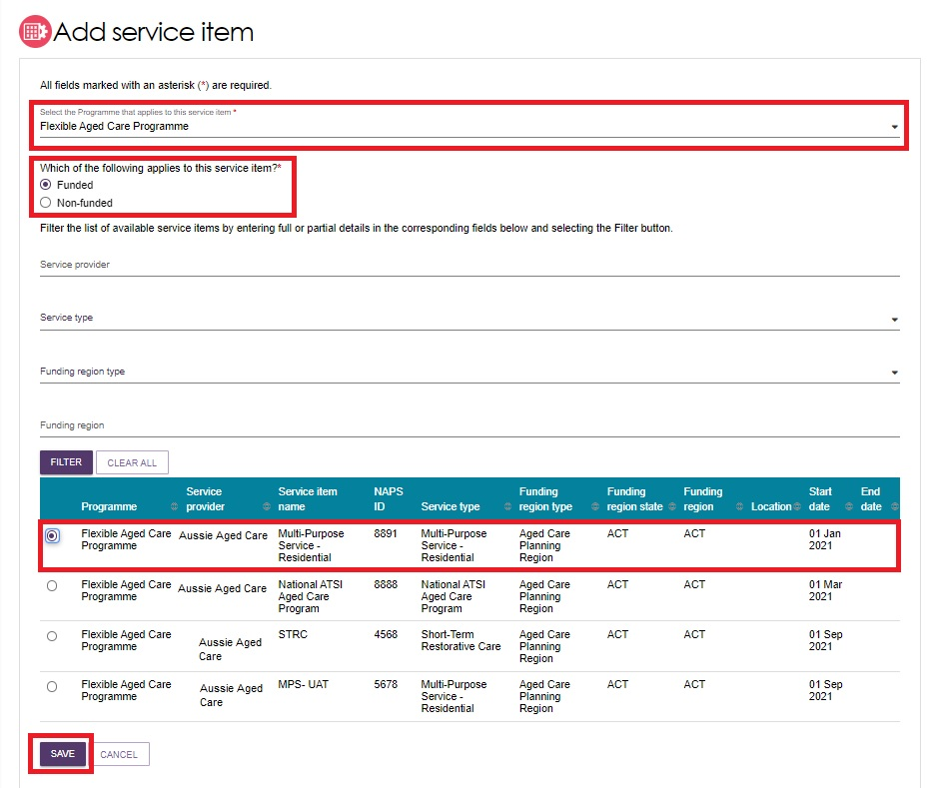

1. A banner will appear to confirm that you have successfully added a service to the outlet.

The newly added services will be defaulted to “Offline”. Refer to “Activating A Service Item” for more information on putting your service online.

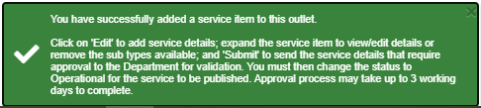

## Adding a Room Type

1. From the “View Outlet” page, select “VIEW SERVICE ITEMS” then at your chosen MPS service, expand the double arrow icon next to “See room types”.

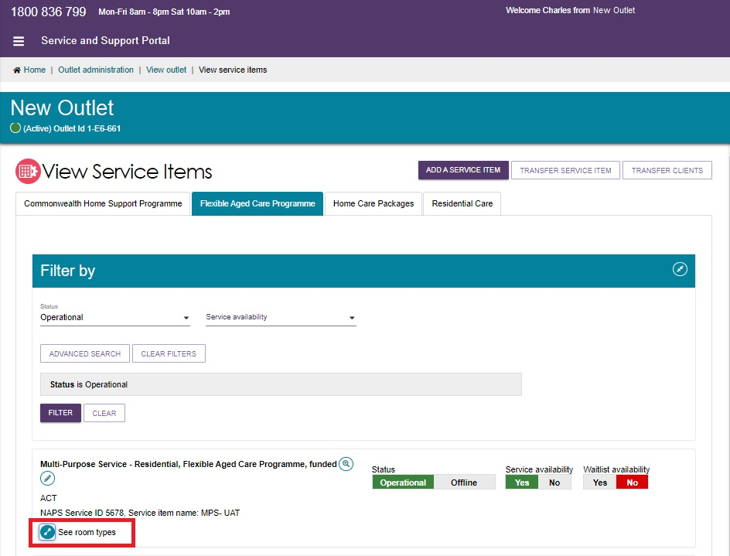

1. Select “ADD ROOM TYPE”.

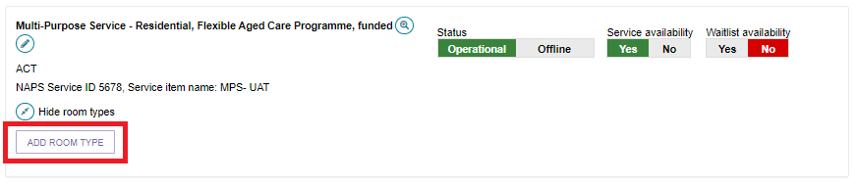

The Room type screen appears. There are three sections: General room information, Pricing information, and Key feature statement.

1. In the General Room Information section, enter Room name, room type and numbers of rooms of type. All fields marked with a red asterisk (*) are mandatory.

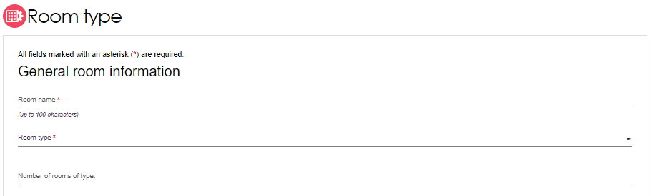

1. In the Pricing Information section, enter the maximum refundable deposit. The maximum daily payment will be calculated and displayed.

To edit your explanation of payment options, select “ADD DIFFERENT TEXT”.

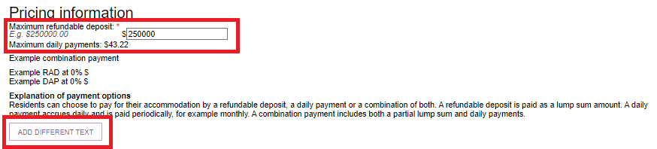

1. In the Key Feature Statement section, enter room description, room size, common areas description, answer the four questions and then select “SAVE”.

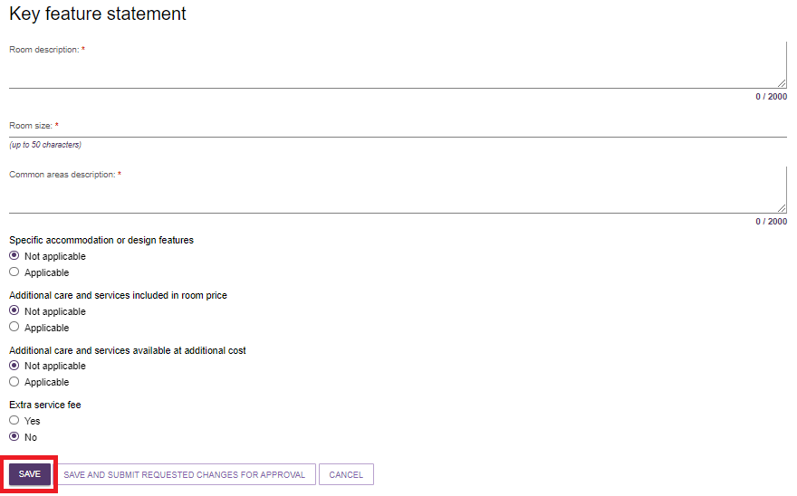

1. A banner appears to confirm that you have successfully added a room to your MPS service. You can now either select the Edit (pencil) icon to go back to the form, or select “SUBMIT” to send the room detail that require approval to the Department for validation, prior to the information being published. The approval process may take up to 3 working days.

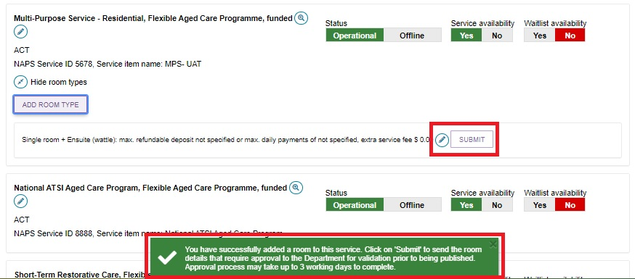

After selecting “SUBMIT”, another banner displays confirming that the room details have been sent to the Department.

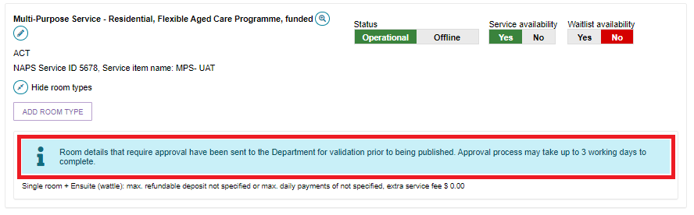

## Adding and Updating Service Information

1. On the “View Outlet” page, select “VIEW SERVICE ITEMS”. Then at your chosen MPS service, select the Edit (pencil) icon to add service information.

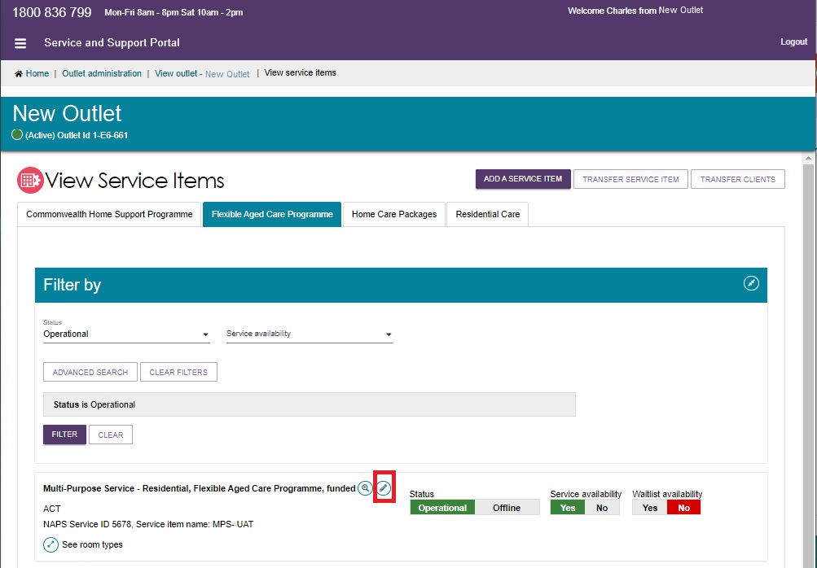

1. Enter service information, such as:

* Service item name
* Service Delivery, and service delivery location
* Delivery hours
* Specialisations, including diverse needs, specialised services, and languages
* Promotional information
* Additional service information.

All fields that are marked with a red asterisk (*) are mandatory.

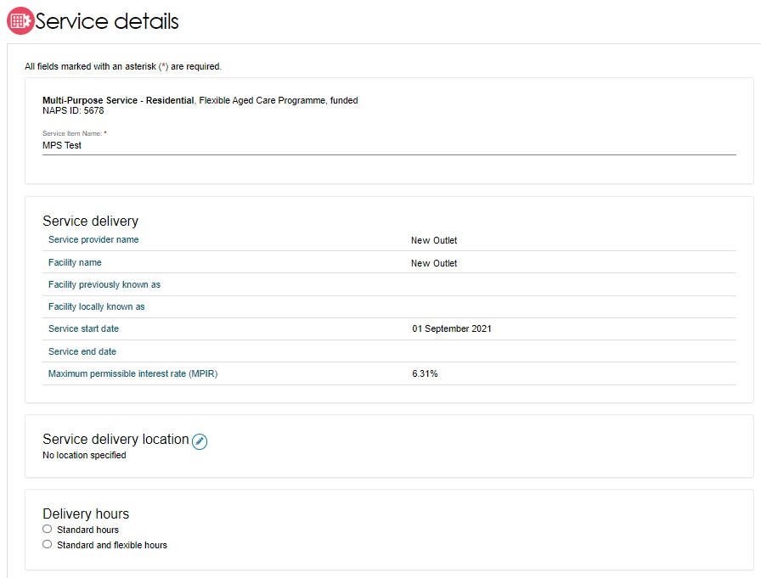

For diverse needs specialisations, select the specialisation(s) you wish to have displayed on the Service Finder. You will only be able to indicate providing diverse needs specialisation against services for which the parent outlet has been verified.

Since 27 June 2022, no new specialisation claims are being published on My Aged Care unless they have been verified by an independent assessor. Successful verification depends on the Outlet’s ability to demonstrate they provide specialised care. The [Specialisation Verification Framework](https://www.health.gov.au/sites/default/files/documents/2022/06/specialisation-verification-final-framework-specialisation-verification-framework_1.pdf) sets out the criteria providers are required to meet, and expected forms of evidence.

For more information about the verification process please see: [[About Specialisation Verification](https://www.health.gov.au/topics/aged-care/providing-aged-care-services/delivering-quality-aged-care-services/about-specialisation-verification-framework)](https://www.health.gov.au/topics/aged-care/providing-aged-care-services/delivering-quality-aged-care-services/about-specialisation-verification-framework).

Specialised Services and Languages do not have the same verification requirements as Diverse Needs specialisations.

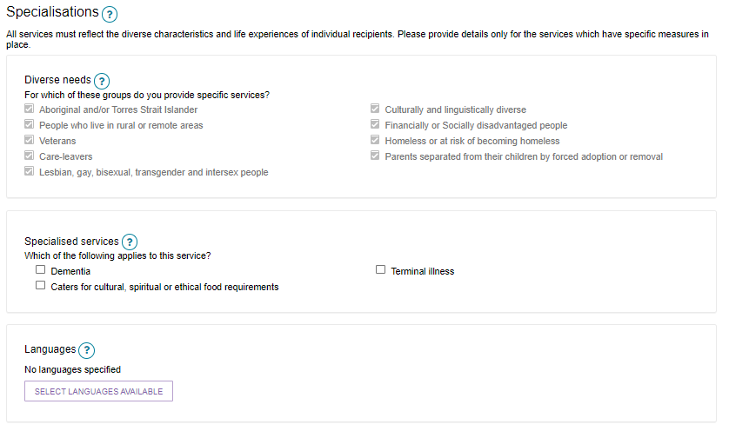

Promotional material will need to be approved by the Department before it is displayed on the Service Finder. Allow 5 business days.

Select “SAVE” when completed.

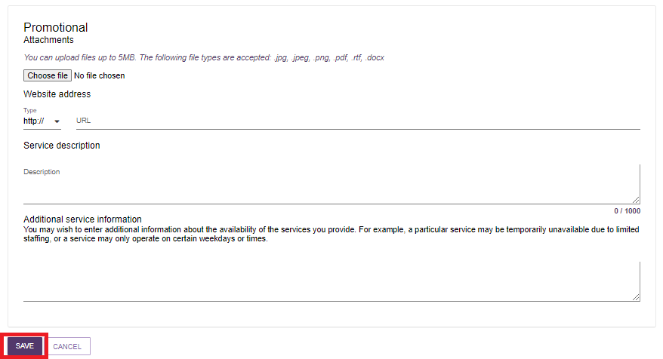

1. A banner appears confirming that the service has been updated successfully.

Example fo the green banner confirming the service item was updated successfully. 

1. Your service will now have an extra Submit button next to the Edit icon. Select the “SUBMIT” button. After this, the banner “Service item updated successfully” will appear again.

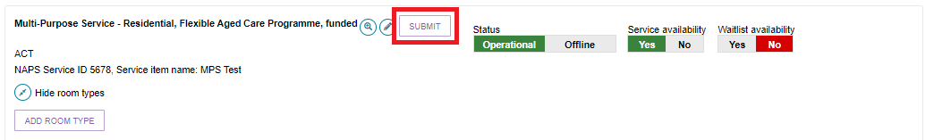

## Activating a Service Item

To ensure that the MPS will be visible on the Service Finder, you will need to activate the service item first, then the outlet.

1. From the “View Outlet” page, select the name of the outlet, then select “Operational” to activate the service.

Also, select the relevant “Yes/No” box under “Service availability” and “Waitlist availability”.

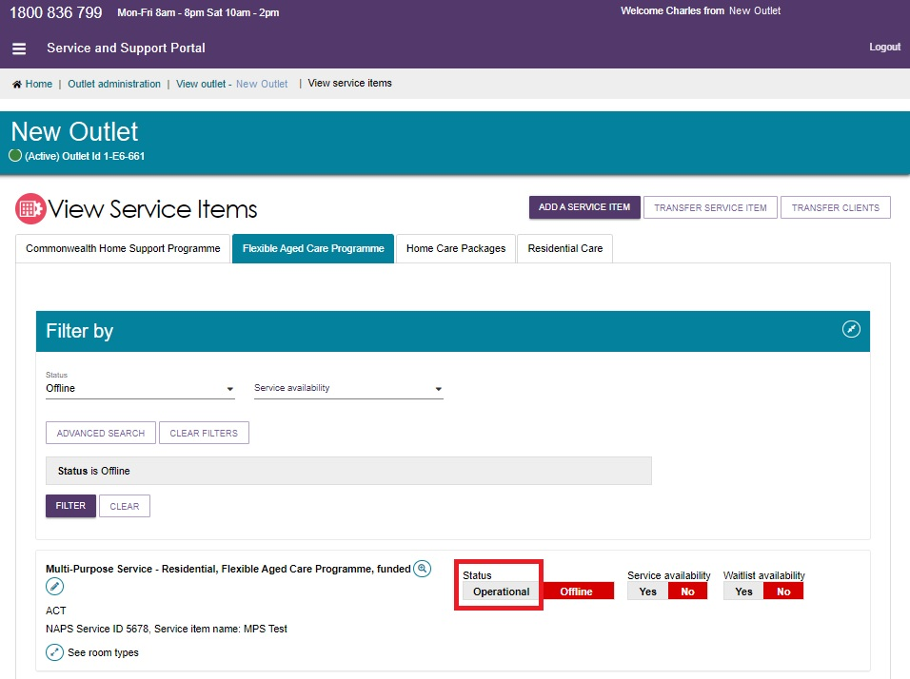

1. An activated service will show the status as Operational (Green background and white text). Availability of “Yes” is also shown as green background and white text. “No” or “Offline” are shown as red background and white text.

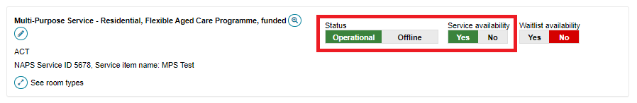

## Activating an Outlet

To ensure that the MPS will be visible on the Service Finder, you will need to activate the service item first, then the outlet.

Mark the outlet as “Active” so that the service items display in the service finder, and that the Contact Centre staff and the assessors can send referrals to the appropriate outlet.

1. From the “View Outlet” page, select the name of the inactive outlet that you want to activate, and then select “ACTIVATE OUTLET”.

! Only outlets that are not yet activated (or deactivated) will have the “ACTIVATE OUTLET” option available.

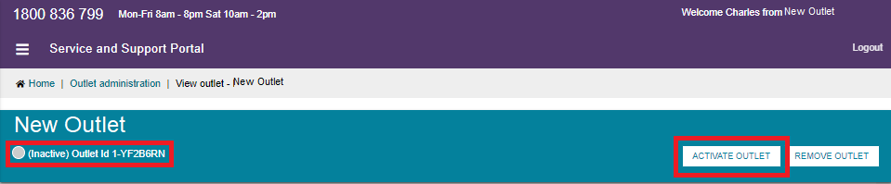

1. A pop up appears warning this outlet will be activated. Select “ACTIVATE OUTLET” to continue.

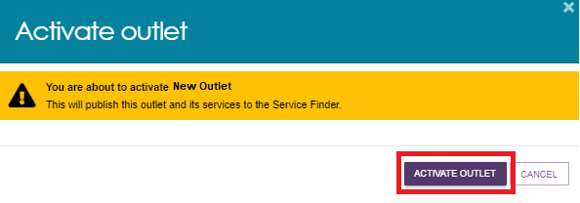

1. A banner appears to confirm that your outlet is now active, and the information will be displayed in the Service Finder.

Check that the outlet is active by viewing the outlet on the “View Outlet” page, and/or the “Outlet Administration” page:

The outlet card from the Outlet Administration page has a green Active banner.

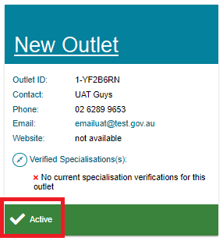

In the View Outlet page, the Active (green circle) status is displayed under the outlet’s name.

