# Service and Support Portal User Guide - Creating service delivery outlets and adding service information

This User Guide is for Administrators within the My Aged Care Service and Support Portal. It explains how to create and maintain information about service delivery outlets.

Information about aged care services provided by each service provider is publicly displayed in the service finder on the My Aged Care website. This information is also used by My Aged Care contact centre staff and assessors to refer clients for service(s).

This Guide is divided into the following topics:

Notes 2

Viewing Outlets 2

Creating or adding a new outlet 3

Editing the Organisation philosophy 6

Maximum Exit Amount and other prices 7

What are Home Care Package Specialisations attributes? 8

Specialisations 8

Diverse needs 9

Editing Home Care Package attributes 9

Diverse Needs specialisations and their verification 9

Specialised Services 17

Languages 17

Hours of operation 18

Service Description 20

Adding pricing information to a Home Care Package service item or outlet 20

Additional home care pricing features 26

Adding service items to an outlet 29

Editing a service item 31

Adding and removing service sub-types to service items 32

Maintaining availability of services and their waitlists 33

Maintaining availability of service sub-types and their waitlists 34

Editing a service delivery area 36

Adding a room type to a residential facility 38

Activating or deactivating a service item 40

Activating an outlet 41

Deactivating an outlet 43

Removing an outlet from the Service and Support Portal 43

For more information or support 44

## Notes

* Service information must be maintained by providers to ensure appropriate referrals are sent.
* Only Organisation Administrators in the Portal can create outlets. Staff can then be assigned to outlets and service delivery information can be added for each outlet.
* Only Organisation Administrators or Outlet Administrators can add or update service information.
* An outlet identifies the location or area from which service providers deliver a specific service(s). Each outlet can have different staff, service information, locations and contact details.
* You will need to set up one or more outlets in the Portal to add and maintain information about the services that your organisation delivers. To ensure that your services will be displayed on the service finders, you must set up an active outlet with an address and a service item under an operational outlet.
* Home Care Package service providers will be required to complete home care pricing information. Residential Respite Care and Home Care Package service providers will be required to complete home care pricing information.
* For detailed information on the process to transferring services between outlets and clients between services refer to the [Service and Support Portal User Guide - Advanced Outlet and Service Management - Transferring Clients and Services.](https://www.health.gov.au/resources/publications/my-aged-care-service-and-support-portal-user-guide-advanced-outlet-and-service-management-transferring-clients-and-services?language=en)

## Viewing Outlets

To view outlets, follow the procedure below.

1. Select 'Outlet administration' from the home page. If you are assigned the role of Staff Member or Team Leader only, your home page will not display the ‘Outlet administration’ tile.

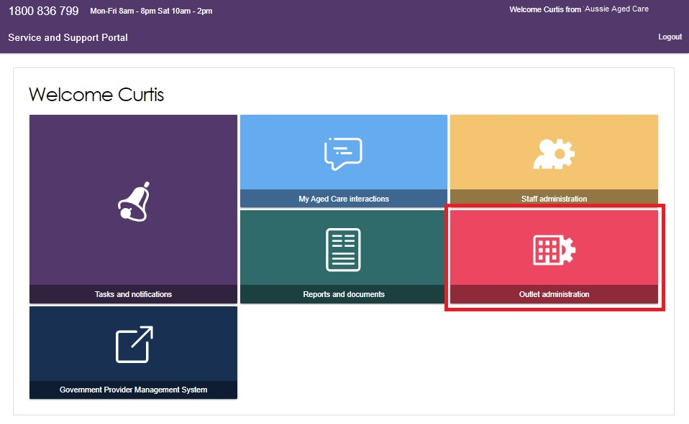

1. You can now view all of the outlets for your organisation.

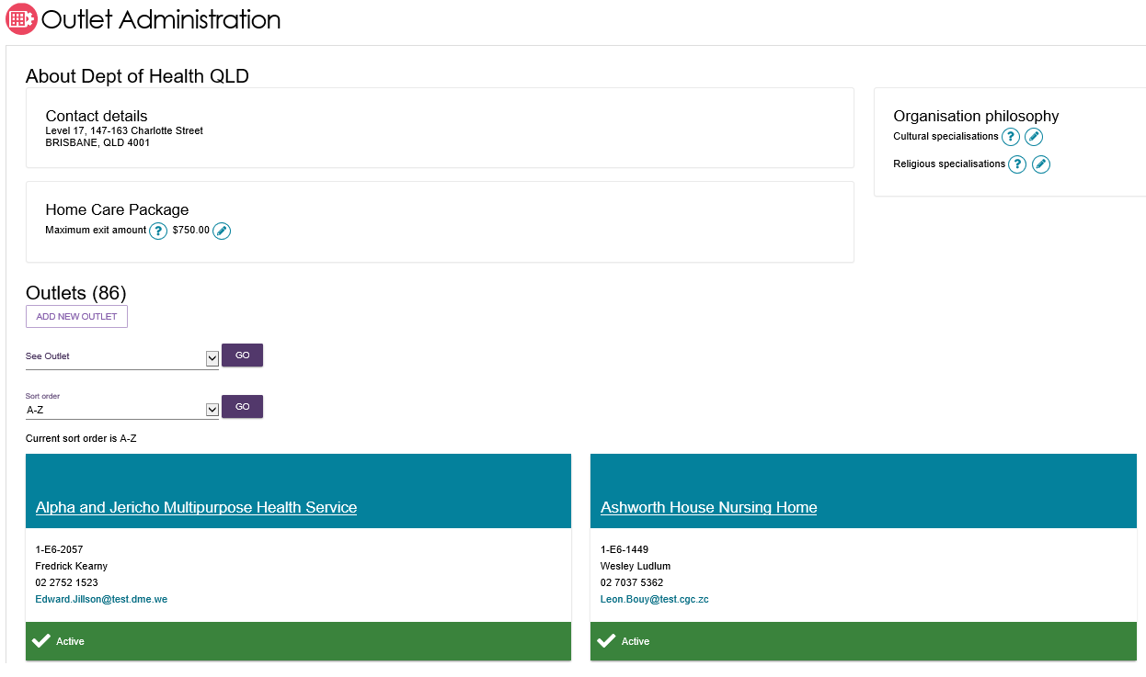

## Creating or adding a new outlet

Administrators need to set up outlets in the Service and Support Portal before service information can be added.

! When you create an outlet, the status is set to ‘Inactive’ by default. You must activate the outlet and create service items in an outlet before it can be made operational. The process for activating an outlet is described later in this User Guide.

1. Select 'Outlet administration' from the home page.



1. From the Outlet administration page, select 'ADD NEW OUTLET'.

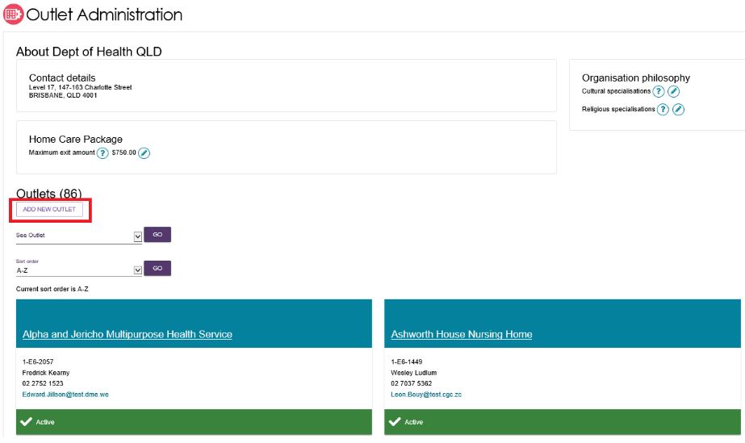

1. Enter outlet details. To add an outlet address, select 'ADD OUTLET ADDRESS'.

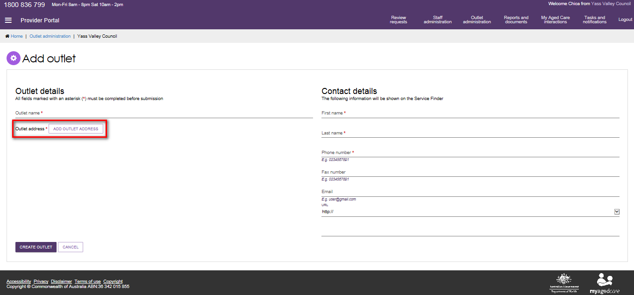

1. Fill out your address details, then select 'VALIDATE THIS ADDRESS'.

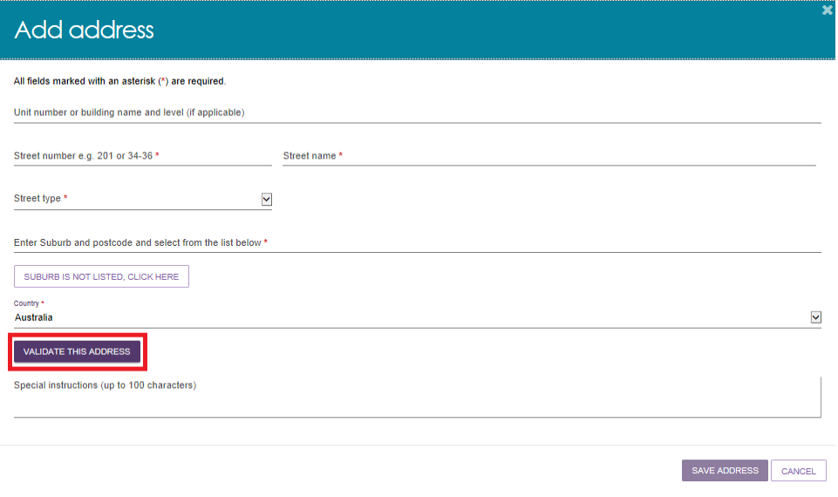

1. Confirm that the address is displayed correctly, then select 'SAVE ADDRESS'. If the address has been entered correctly but is not returned as a result, select 'Not found use entered address anyway'.

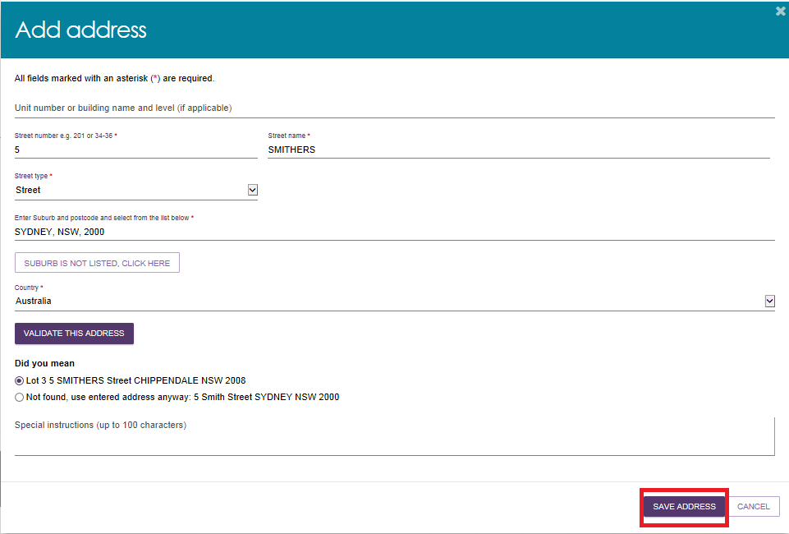

1. Complete the remaining fields. Select 'CREATE OUTLET' in order to save the record and create the outlet.

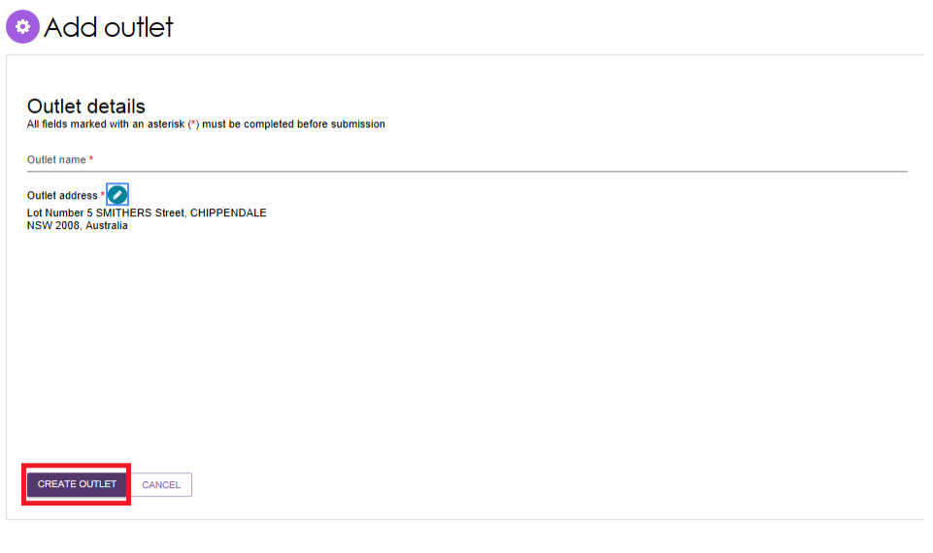

1. The outlet has now been created and the details for the outlet have been saved. Repeat this process for remaining outlets, if required.

## Editing the Organisation philosophy

! Cultural Specialisations are not the same as [Specialisations for Diverse Needs Groups,](https://www.health.gov.au/health-topics/aged-care/providing-aged-care-services/delivering-quality-aged-care-services/about-specialisation-verification) and are not verified. Both types of specialisations are displayed in the service finder results.

1. Add/edit cultural specialisations.

Click the ‘‘Edit’ icon  next to ‘Cultural specialisations’ to select those groups that you have a focus on providing culturally specific care to.

   Organisation philosophy attributes will be shown in the service finder results and displayed as part of the detailed information for each of your services.

1. Add/edit cultural specialisations. 
Click the ‘‘Edit’ icon   next to ‘Cultural specialisations’ to select those groups that you have a focus on providing culturally specific care to. 


You can choose to apply this to all services in your organisation by using the ‘SAVE AND APPLY TO ALL OUTLETS’ option or save as a default for all new services added by using the ‘SAVE AND DON’T APPLY TO ALL OUTLETS’ option.

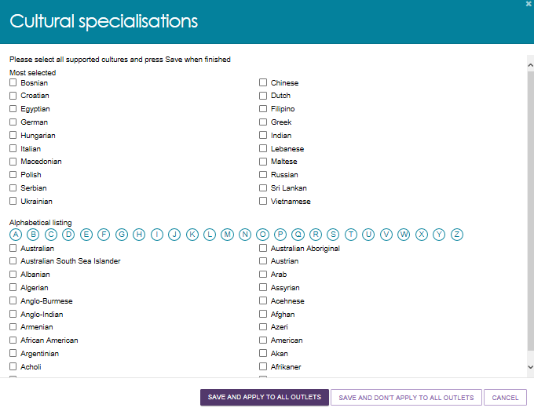

1. Add/edit religious specialisations.

Click the ‘edit’ icon next to ‘Religious specialisations’ to indicate if you have a focus on delivering care that aligns with particular religious needs or values.

You can choose to apply this to all current services in your organisation by using the ‘SAVE AND APPLY TO ALL OUTLETS’ option, or save as a default for all new services added by using the ‘SAVE AND DON’T APPLY TO ALL OUTLETS’ option.

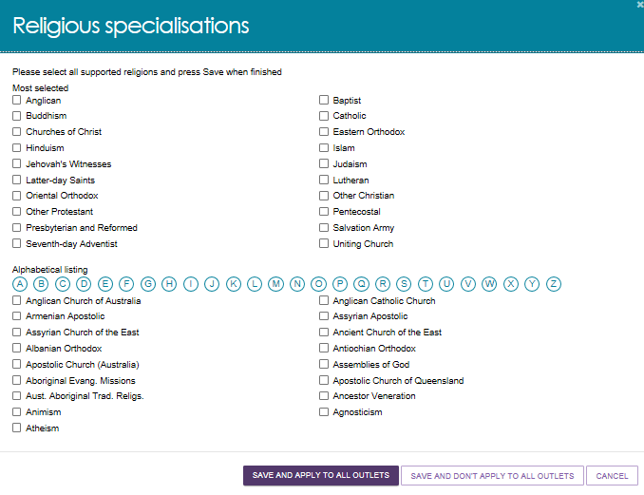

## Maximum Exit Amount and other prices

From 1 January 2023, the Australian Government removed a provider’s ability to charge an exit amount, even if the care recipient previously agreed. Providers are also no longer able to charge a separate fee when engaging third party service; instead, service charges must now be all inclusive. These changes ensure that more funds are available to meet the direct care needs of My Aged Care recipients.

This means that:

* Exit amounts cannot be seen or edited in the My Aged Care Service and Support portal, and the Assessor Portal service finder.
* Providers cannot charge separately for third party services. Third-party related charges cannot be seen or edited in the My Aged Care Service and Support portal, and the Assessor Portal service finder.
* For newly generated Home Care Pricing Schedule Reports after March 2023, none of the capped prices (above) will appear. Old (historical) reports that are generated after March 2023 will continue to display the exit amount and the “separate cost when you want to receive services from a different provider” value.

For more information, visit the following Departmental websites:

* [Pricing for Home Care Packages](https://www.health.gov.au/our-work/home-care-packages-program/pricing)
* [Third Party services for Home Care Packages](https://www.health.gov.au/our-work/home-care-packages-program/managing/third-party-services)
* [Exiting People from your Home Care Service](https://www.health.gov.au/our-work/home-care-packages-program/managing/exiting-people)

## What are Home Care Package Specialisations attributes?

If you are configuring a Home Care Package service in Outlet Administration or in View Outlet, attributes related to this service type are available to select and display on the service finder. These are explained below.

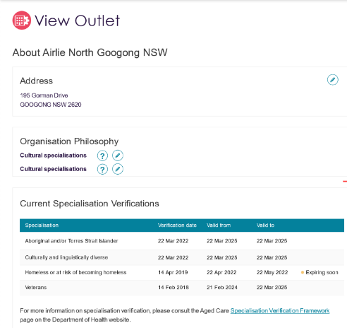

### Specialisations

Specialisations under the Organisation Philosophy heading are related to culture and language, and do not need to be verified. See Editing the Organisation Philosophy for more details.

### Diverse needs

Diverse Needs are a special group of Specialisations. These are also known as the “special needs group” in the *Aged Care Act 1997*. These are:

1. people from Aboriginal and Torres Strait Islander communities
2. people from culturally and linguistically diverse backgrounds
3. people who live in rural or remote areas
4. people who are financially or socially disadvantaged
5. veterans
6. people who are homeless or at risk of becoming homeless
7. care-leavers
8. parents separated from their children by forced adoption or removal
9. lesbian, gay, bisexual, transgender and intersex people. (LGBTI)

Providers who wish to make claims that their outlet specialises in the care of people identifying with one or more of the Diverse Needs groups will need to apply to have these claims verified by a third-party assessor. While all providers must demonstrate that they meet the Aged Care Quality Standards, providing specialised services for the Diverse Needs groups is an optional and additional step.

No new unverified specialisation claims are published on My Aged Care from June 2022. Successful verification depends on the outlet’s ability to demonstrate they provide specialised care. The [Specialisation Verification Framework](https://www.health.gov.au/sites/default/files/documents/2022/06/specialisation-verification-final-framework-specialisation-verification-framework_1.pdf) sets out the criteria providers are required to meet, and expected forms of evidence.

Verified specialisations will be published on the My Aged Care Provider profile. Providers who have not had their specialisation claim(s) verified will have those claims removed from their My Aged Care Provider profile from March 2023.

For more general information on the verification process, please refer to [About Specialisation Verification](https://www.health.gov.au/health-topics/aged-care/providing-aged-care-services/delivering-quality-aged-care-services/about-specialisation-verification).

## Editing Home Care Package attributes

Home Care Package attributes are located in the Service Details section of the Outlet Administration tile. This section is located in View Outlet, then View Service items.

The attributes listed in the Home Care Service Details tab include service details, service delivery, service delivery area, specialisations. hours of operation, and service description.

The Specialisations section are further divided into Diverse Needs, Specialised Services, and Languages. They are explained below.

### Diverse Needs specialisations and their verification

To indicate if your outlet or service has a focus on providing access to specific specialised services, submit a verification of specialisation application as follows.

1. Select 'Outlet administration' from the home page.



1. From the Outlet Administration page, select the outlet you wish to submit a verification of specialisation application for.

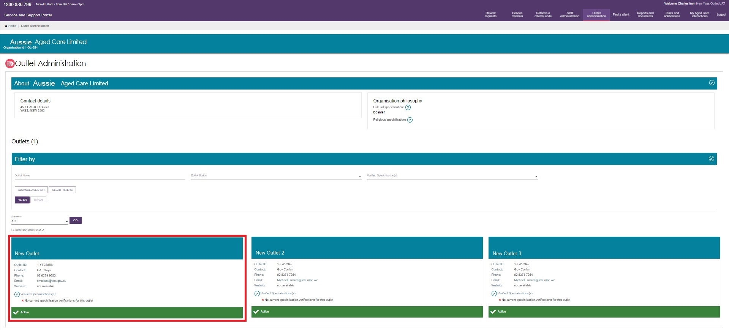

1. Select ‘MANAGE VERIFICATIONS’.

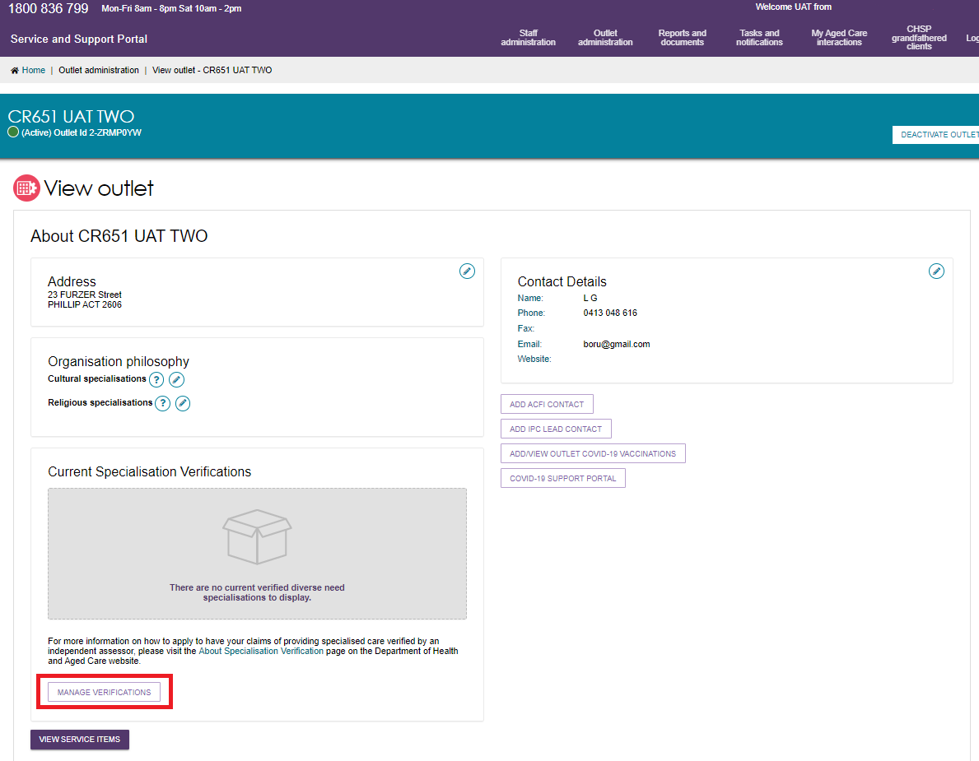

1. Select ‘LODGE A NEW APPLICATION’.

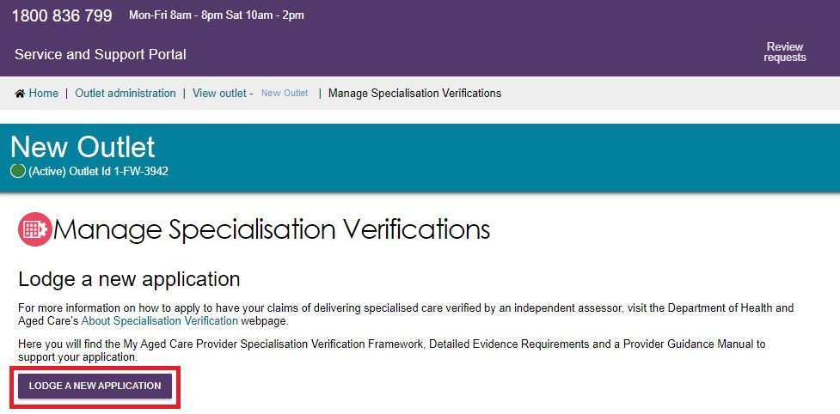

1. After reading the information, scroll to the bottom of the screen and select ‘NEXT’ to move to the next step.

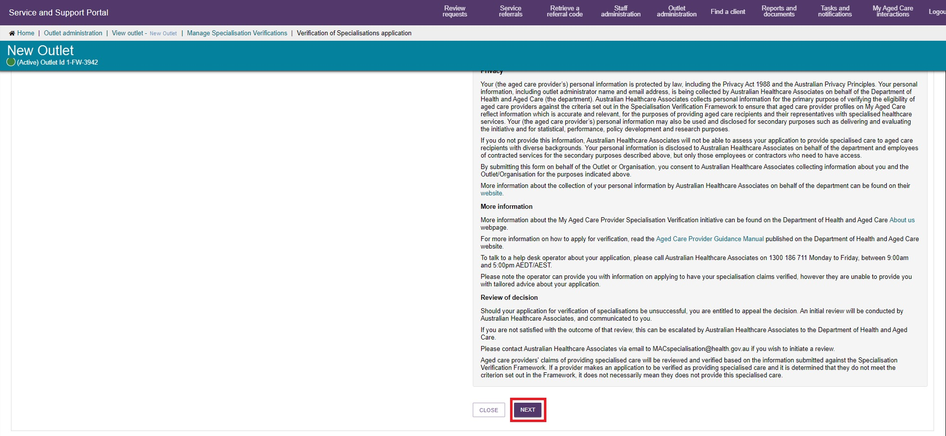

1. Select the specialisation/s you wish to apply for verification, then select “Next”**.**

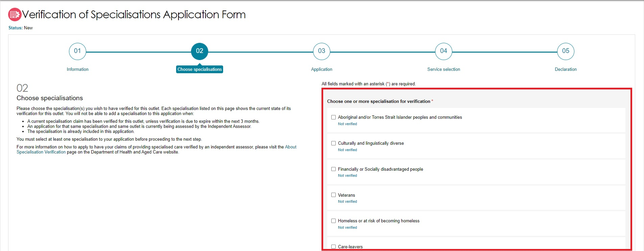

1. Instructions on how to provide evidence for your chosen specification/s are shown. For further information refer to [Specialisation Verification Framework – Detailed Evidence Requirements for Providers](https://www.health.gov.au/resources/publications/specialisation-verification-framework-detailed-evidence-requirements-for-providers).

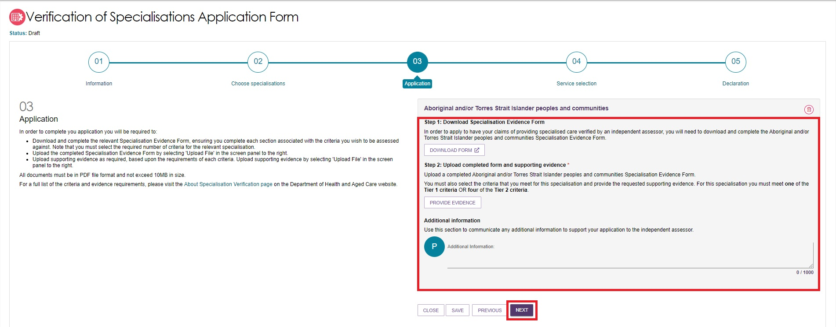

1. Select ‘Download Form’ and fill out the form.
2. Upload the completed form by selecting ‘Provide Evidence’. A pop up called ‘Evidence of Specialisation’ will appear. For each specialisation, there are specific requirements for the number of Tier 1 and/or Tier 2 criteria that you must satisfy. In the drop down menu, select the criterion that you wish to be assessed against.

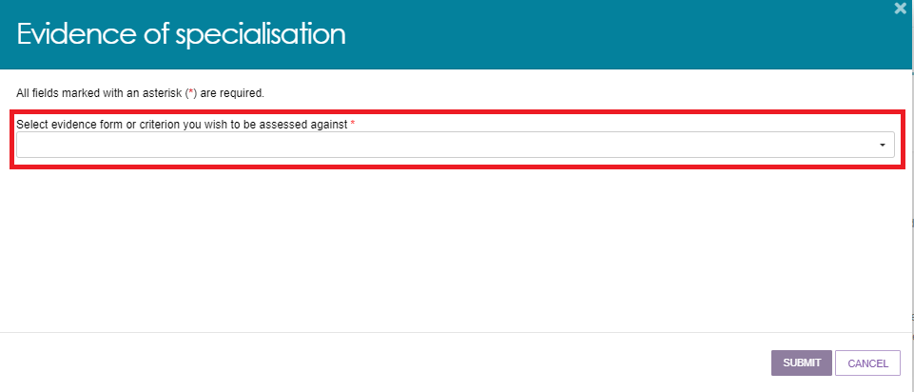

This is an example of the Tier 1 and Tier 2 criteria available for a specialisation, which is being displayed in the drop-down menu.

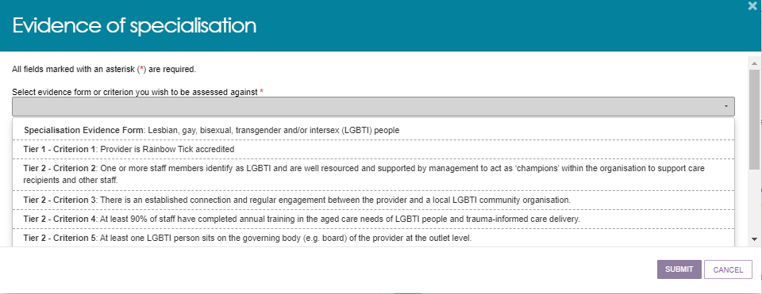

1. Follow any instructions that appear (for example, uploading a PDF file), then select ‘SUBMIT’. Please note that the Submit button will not be available until you have finished following the instructions.

There are some criteria that do not require any further input - select Submit to progress to the next step.

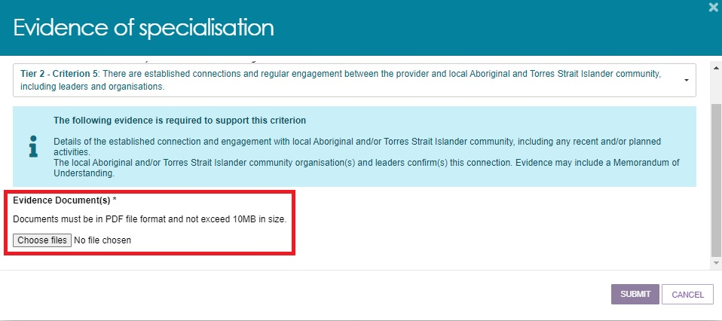

1. Your chosen criteria and any evidence will be shown.

To view the evidence required to support the criterion again, expand by selecting the double arrow icon double arrow (expand) icon.

To delete any uploaded files, select the rubbish bin icon rubbish bin (delete) icon next to the file name.

To delete the entire criterion, select the rubbish bin icon that is to the right of the criterion name.

To provide evidence against another criterion, select the ‘Provide Evidence’ button.

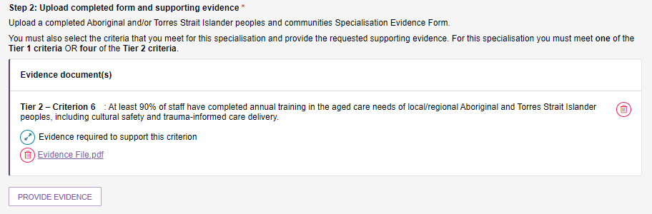

1. You can also use the space in the Additional Information section to provide any additional information to support your application. This is limited to 1000 characters and will be sent to the independent assessor.

Then, select ‘NEXT’.

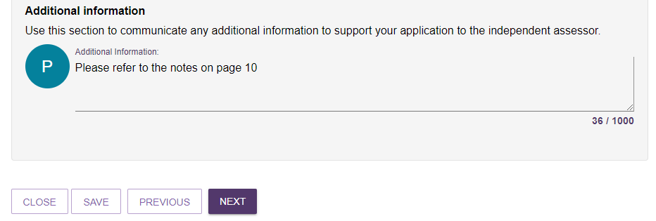

1. Select all or any of your organisation or outlet’s services which the specialisation application will apply, then select ‘NEXT’.

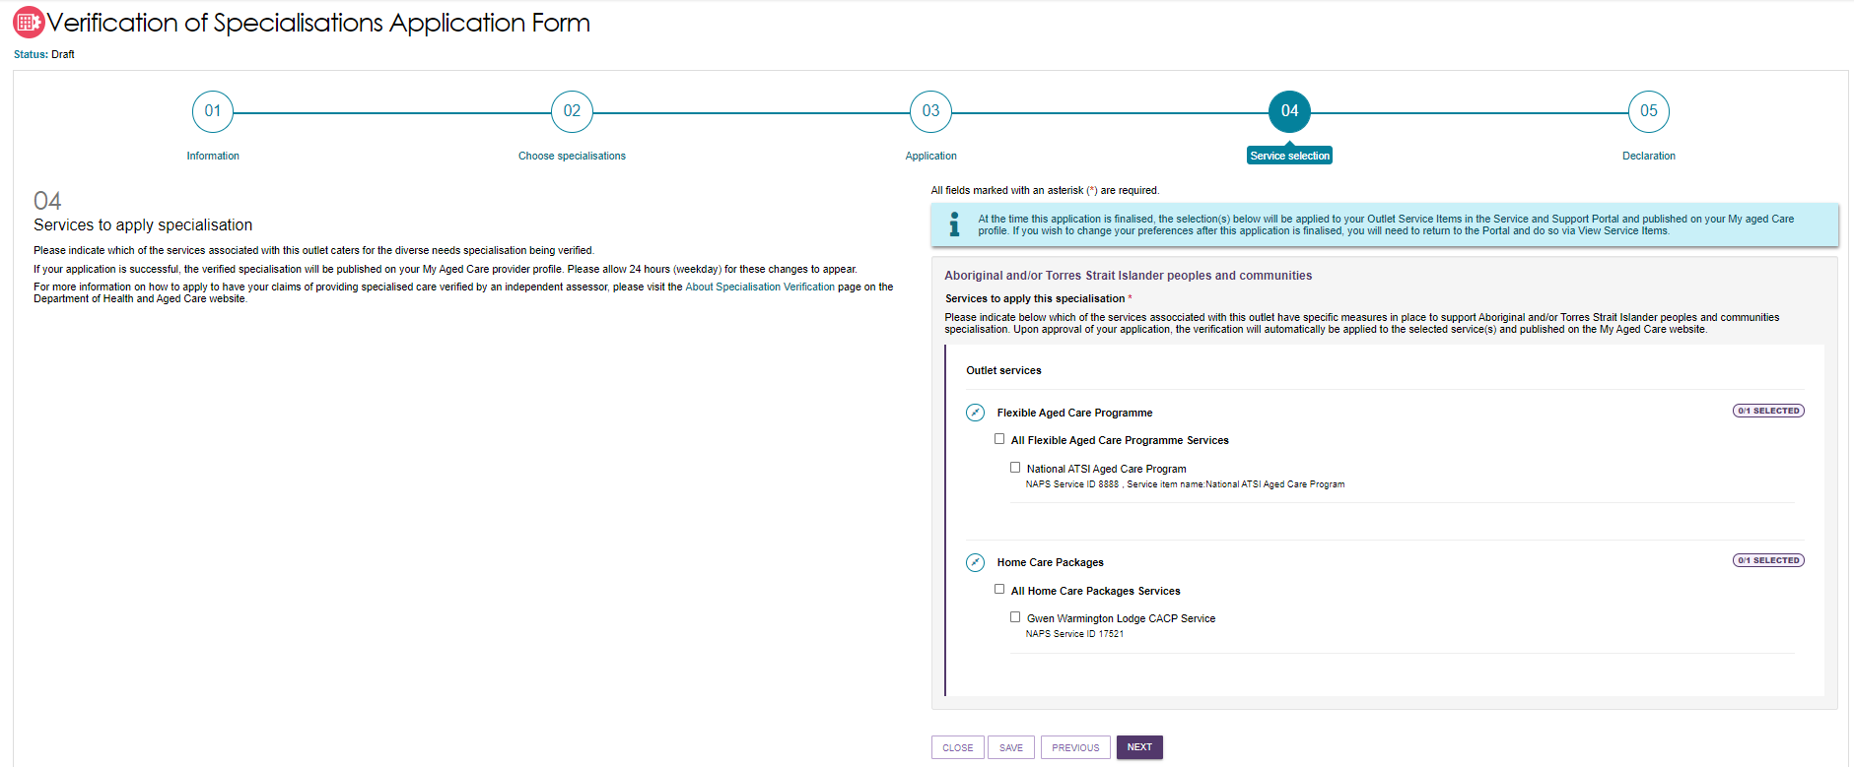

The next screenshot is an example close up of the services available to be selected. There are 2 out of 3 Home Care Package services selected.

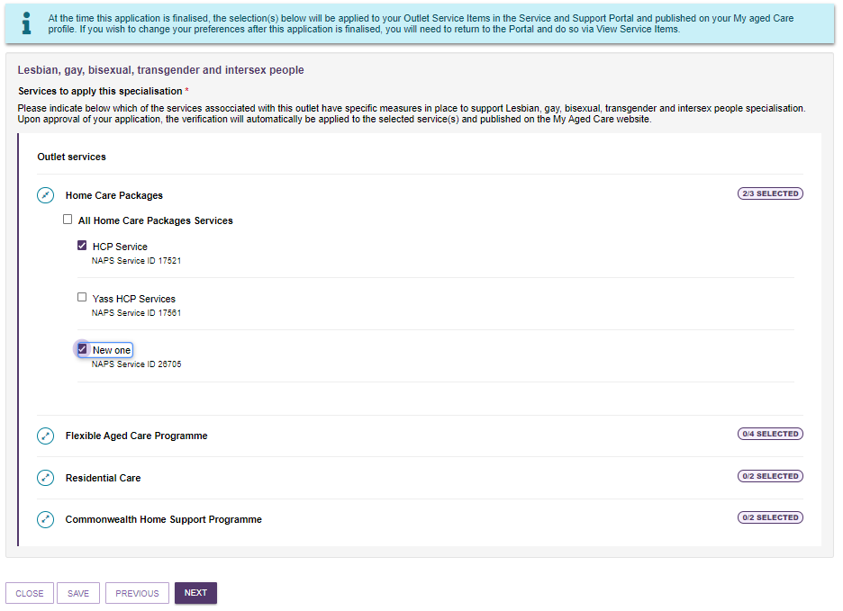

1. To submit your application you must agree with the declaration and then select ‘SUBMIT’.

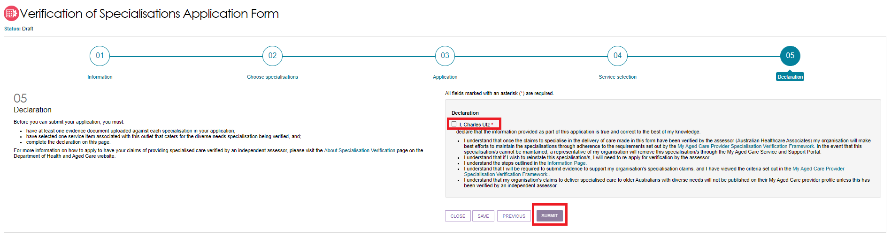

1. You can view submitted applications by returning to the ‘Manage Specialisation Verifications’ page.

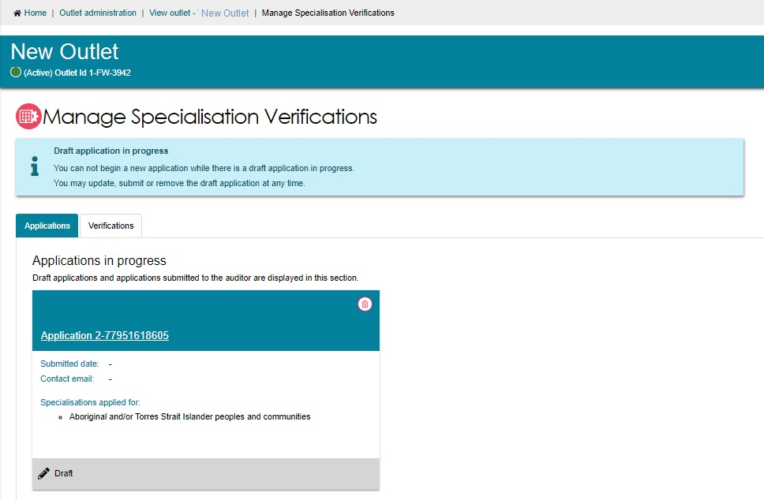

1. To edit a submitted application, click on the application title. If an application requires additional information, you may be required to update and resubmit an application.

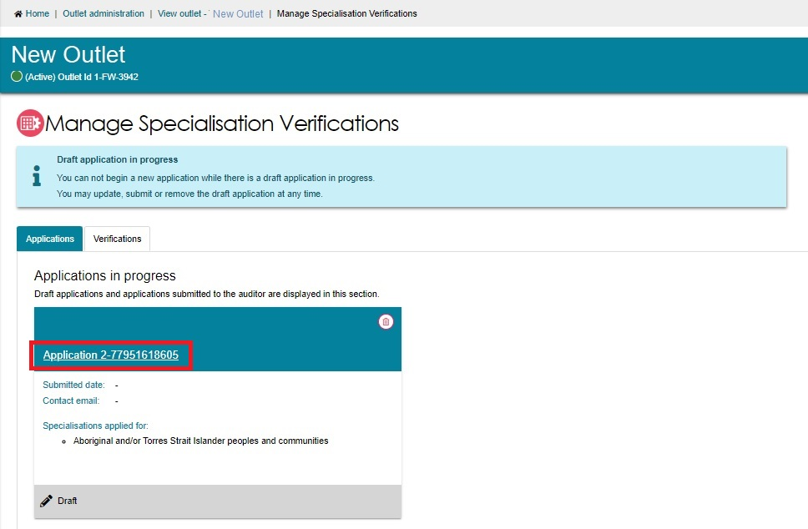

1. To remove an application, select the Delete (bin) symbol.

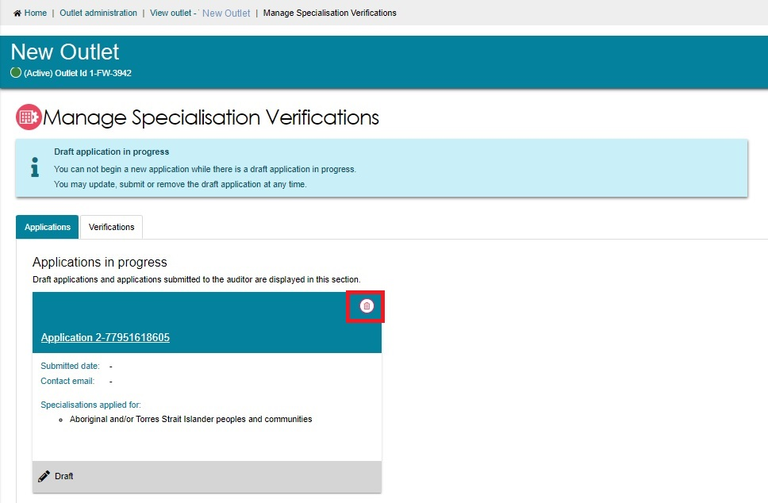

1. Once your services are verified and approved by the independent assessing authority, the corresponding ticks will appear in your My Aged Care profile (allow 1 business day). Your verified specialisations will be displayed in the Find A Provider Tool of the My Aged Care website, as well as in the My Aged Care Portals., as white ticks in a purple square.

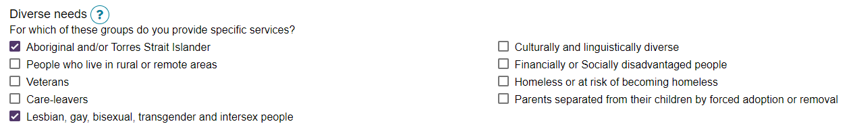

! Under the [Specialisation Verification Initiative](https://www.health.gov.au/health-topics/aged-care/providing-aged-care-services/delivering-quality-aged-care-services/about-specialisation-verification):

* Aged care providers can no longer add any self-nominated (tick) specialisations from their Services and Support Portal – Diverse Needs section.
* They can remove pre-existing specialisations.
* Diverse Needs that are not successfully verified in the Portal will be removed from the Services Finder.
* Selected and Verified services are shown by white ticks in a purple square.
* Services that are eligible to be listed in the Service Finder are shown by white squares with a black border.
* Services that are not eligible because they have not been verified, or no longer eligible to be listed in the Service Finder are shown by grey squares. Providers are unable to select or unselect them.

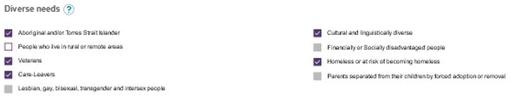

### Specialised Services

There are other specialised services that are not part of Diverse Needs, which you can indicate that a service or outlet offers. You should only select those with specific measures in place that demonstrate your specialised service offering, however they are not verified like the specialisations listed in Diverse Needs.

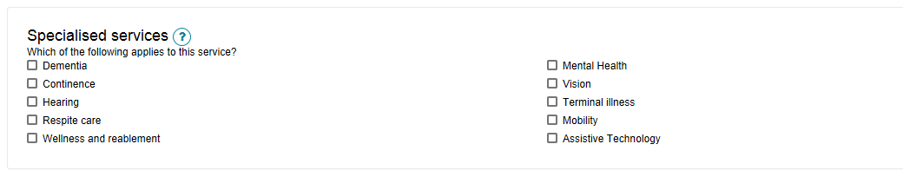

### Languages

To indicate if this service caters for specific language requirements, select the languages in the ‘Languages’ section. Select ‘SELECT LANGUAGES AVAILABLE’ to bring up the selection and select ‘SAVE’ to save the configuration.

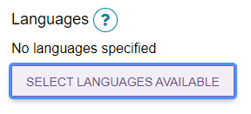

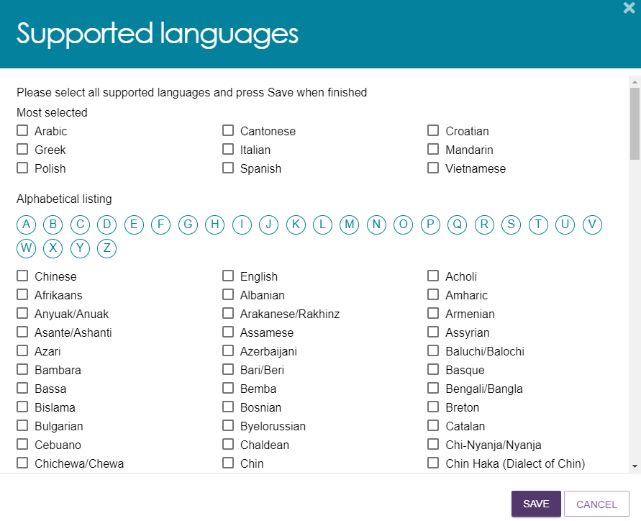

Once the language/s are selected and saved, they are shown under the ‘List of languages’.

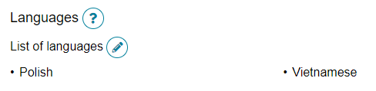

### Hours of operation

You can outline standard hours of operation for your service. By default, you can enter specific Monday to Friday, Saturday and Sunday hours. You can also specify individual working days by using the ‘Customise’ option.

To edit your hours of operation:

1. Select 'Outlet administration' from the home page.



1. From the Outlet Administration page, select the outlet you wish to set the hours of operations.

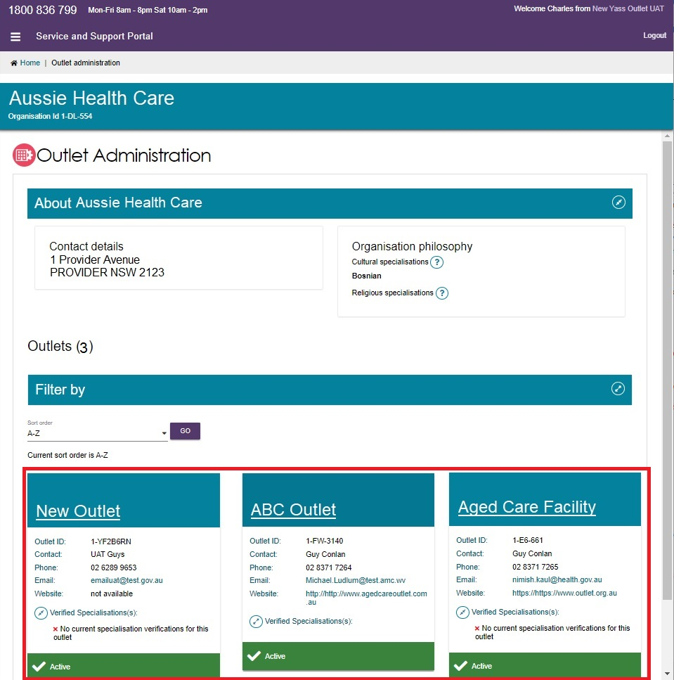

1. Select ‘VIEW SERVICE ITEMS’.

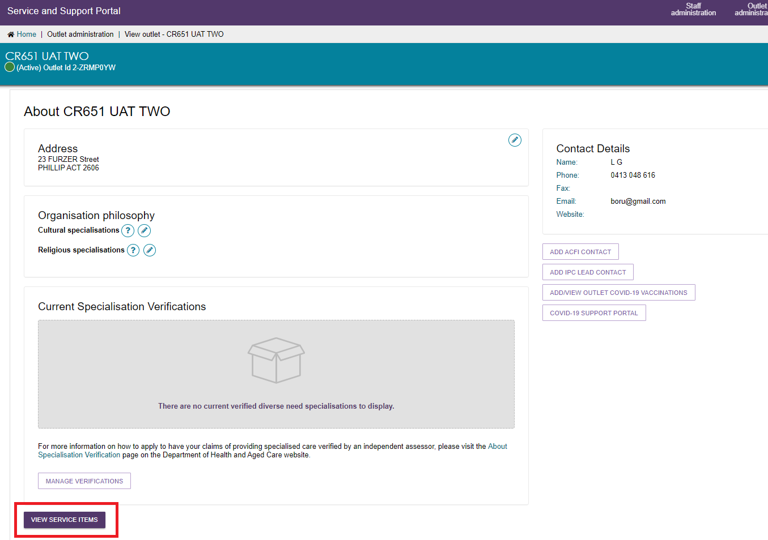

1. Select the service you want to edit the hours of operation by clicking on the corresponding edit icon.

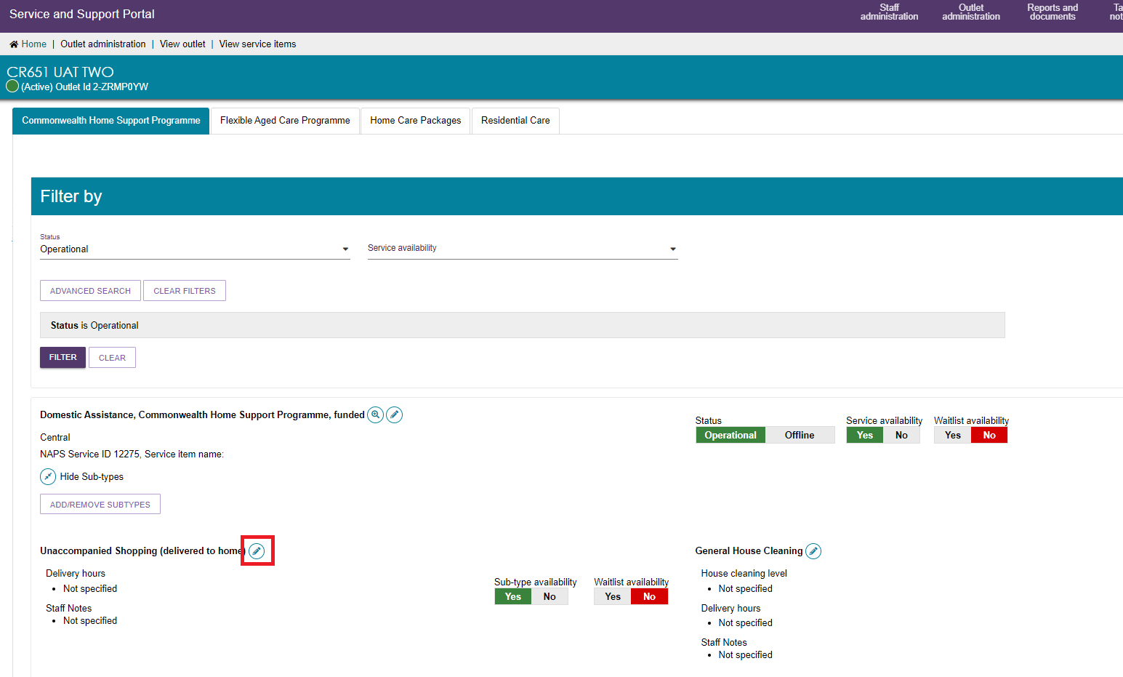

1. Input the hours and save.

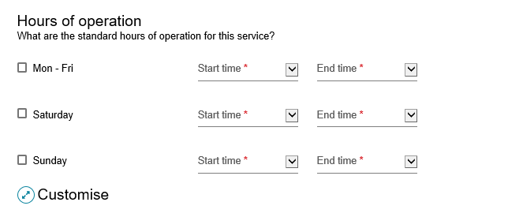

You can also indicate the average number of hours-of-service provision you provide each week per level of home care package.

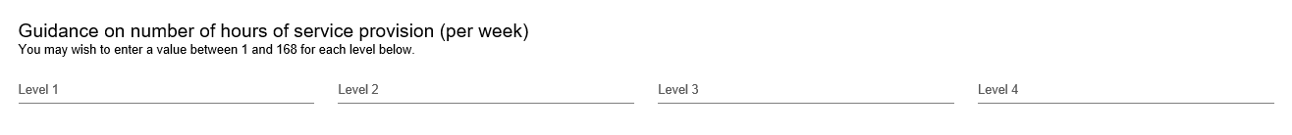

### Service Description

You can input a description of your service and add any additional service information up to 1000 characters.

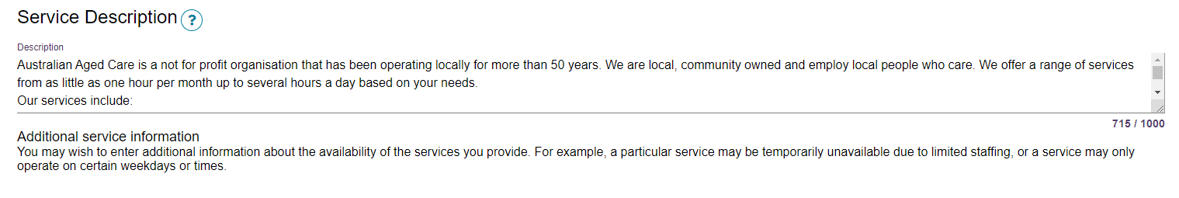

## Adding pricing information to a Home Care Package service item or outlet

! Publishing pricing information is mandatory for all Home Care Package services and outlets. You will not be able to save a new service and make it ‘Operational’, save changes to partially complete existing pricing information, edit waitlist information or confirm if you have reviewed pricing information if the service does not have the mandatory pricing information.

All pricing information saved, including pricing schedule attachments, will appear by the next day on the My Aged Care service finder on the My Aged Care website, and do not require approval from the Department.

The help text against each pricing attribute provides further guidance on what specific information providers should be entering.

1. From the ‘Home Care Packages’ tab in the ‘View Service Items’ page, select the ‘Edit’ icon next to the Home Care Package services you wish to add pricing information to.

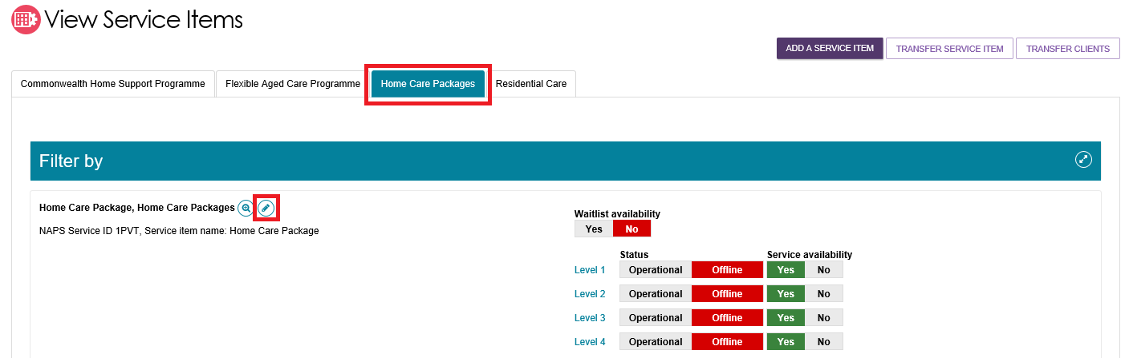

Alternatively, from the View Outlet page, select the ‘Edit’ icon next to Home Care Pricing to edit the pricing information at the outlet level.

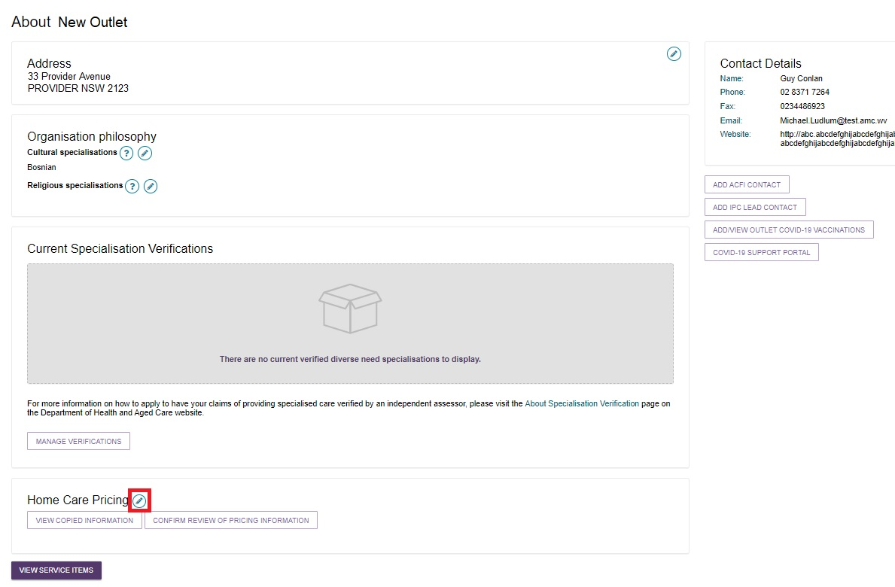

! When you edit pricing information at the outlet level, this is a pricing template that you can save and apply to the services within a single outlet or all outlets in your organisation. This is best used when the pricing information for a number of your services is the same.

Pricing template - when pricing is the same for all services acros the outlet - highlighting the button 'Save and apply to service items of this outlet'

Only information saved at the service item level will display on the My Aged Care service finder. If you select ‘SAVE’ at the outlet level this will save the information locally and will not display in the My Aged Care service finder. Select ‘SAVE AND APPLY TO ALL SERVICE ITEMS OF THIS OUTLET’ to display your changes in the My Aged Care service finder.

1. The ‘Home care pricing service details’ page will be displayed. Select the ‘Home Care Pricing’ tab to add or edit pricing information for that service.

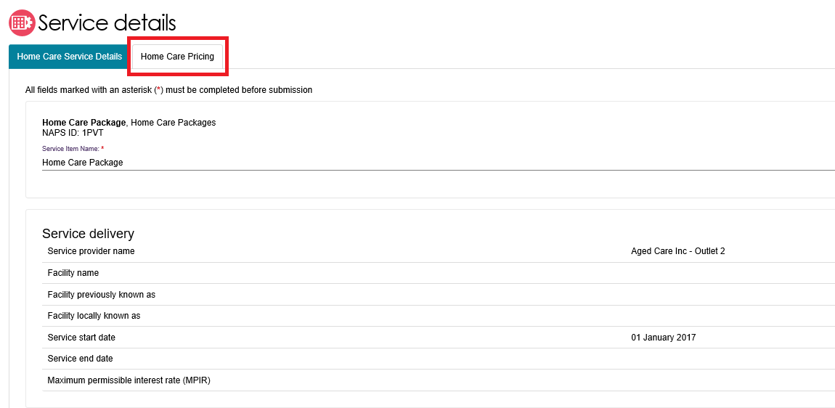

1. From the Home Care Pricing tab, providers are able to enter detailed information for home care services about:
2. Information about service offering and value statements

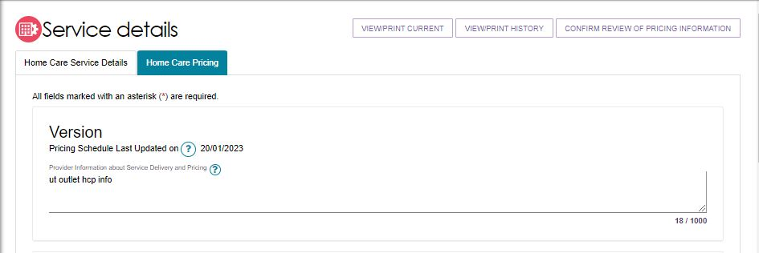

1. Approximate Home Care Package Amounts

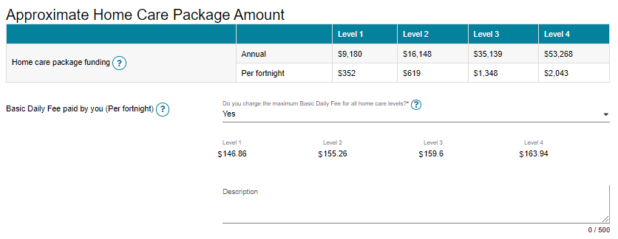

! If you do not charge the maximum basic daily fee you will be required to indicate a price for each package level. If you do not charge any basic daily fee you will still be required to note a price, for example $0.

1. Care Management Approach and relevant prices and number of hours of service. Only select ‘N/A’ where you do not provide care management for that specific level of Home Care (e.g. Level 1).

Providers must publish a care management price in a clear dollar amount, so that care recipients can better understand and compare prices, and to understand what service they will receive for this charge.

If providers bundle the cost of care management with other costs, such as package management charges or in an all-inclusive service cost, this may mean that the provider is not providing the required care management services. It will also make understanding and comparing prices difficult for care recipients and the public. Providers that list $0 for a service that they intend to charge for (such as Care Management) may be breaking the Australian Consumer Law.

To ensure funds meet the direct care needs of older Australians, some prices are capped and there are new rules of charging for providers. For more information visit [the Department’s website](https://www.health.gov.au/resources/publications/home-care-packages-pricing-update?language=en).

Note: From January 2023, care management prices will be capped at 20% of the package level.

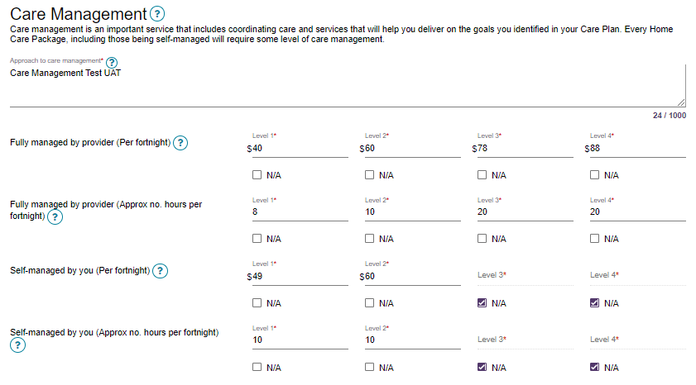

1. Details and prices for Common Services that are offered under each level of Home Care Package. The five common services are: Personal care, Nursing, Cleaning and household tasks, Light gardening, and In-home respite.

An approved provider of home care must provide the price for each of the common types of care and services (standard hours). Only select ‘N/A’ where you do not provide this particular service, for example on Public Holidays. If you provide the service but do not charge an extra amount, enter in the standard hours price.

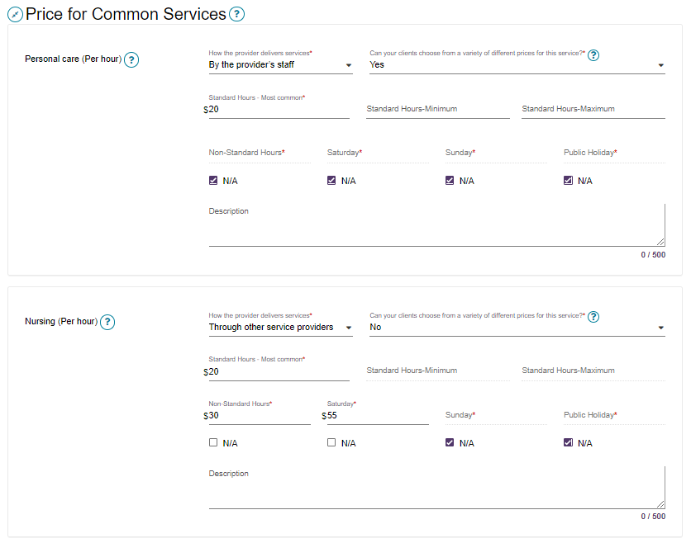

1. Other pricing information that may be charged by the provider – Package management. Only select ‘N/A’ where you do not charge for package management for that specific level of home care (e.g. Level 1).

Similar to care management, you must publish a distinct package management price in a clear dollar amount so that care recipients can better understand and compare prices – see 3c above for further information.

From 1 January 2023, package management prices will be capped at 15% of the package level.

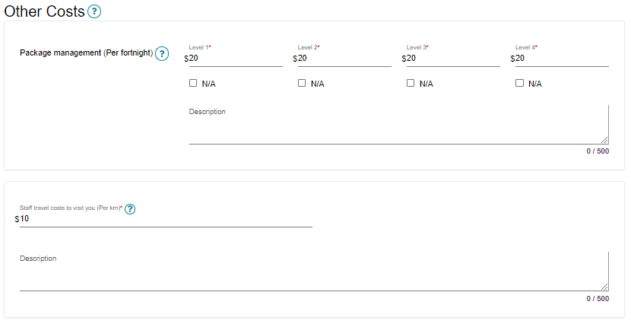

1. Under the ‘Full Price List’ section, a pricing schedule website link (URL) and/or a pricing schedule attachment can be added.

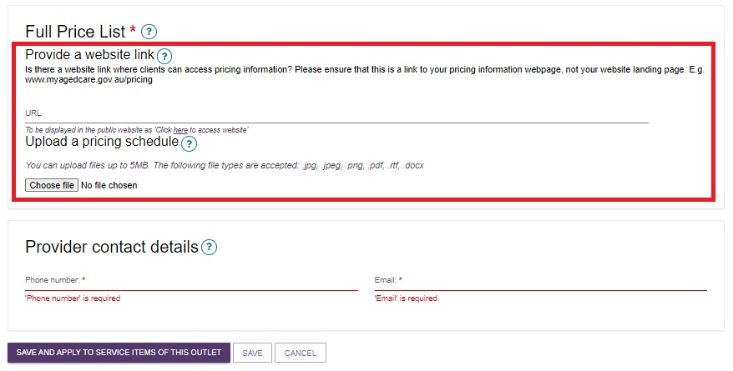

To add a pricing schedule website link type in the URL in the “Provide a website link” section.

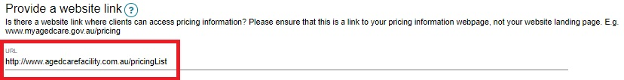

1. To upload the pricing schedule attachment you must select “Choose File” and choose the document (such as a PDF file) you wish to upload, then select “Open”. The attachment’s name will then be displayed. Name the attachment and provide a caption. You can optionally add a short description of the attachment.

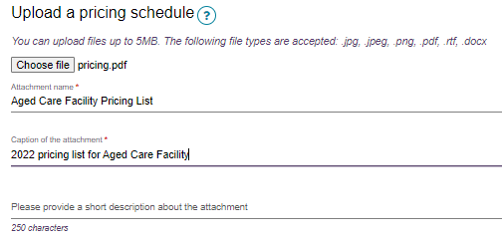

1. If you are editing an individual service item, select ‘SAVE’ to apply all pricing information you have added to the home care service.

Editing pricing for individual service items - highlighting the save button 

Alternatively, if you are an Administrator and editing pricing information at the outlet level, you can choose to save and apply the pricing information to all Home care service items in that outlet, save locally (before applying to any services), apply these details to all of your outlets (if you are an Organisation Administrator) or ‘CANCEL’ to discard any changes made.

Editing pricing information at the outlet level - button for 'Save and apply to service items of this outlet' 

## Additional home care pricing features

Home care service providers are required to review and if required, update their pricing information annually. In the scenario where no changes need to be made to any of the pricing information, providers can confirm that they have reviewed their pricing.

Home care providers will be reminded to review or update home care pricing schedules for operational home care service items if they have not been reviewed or updated in the last 11 months.

Outlet and organisation administrators will receive a ‘HCP annual pricing review’ task notifying them which services (in the outlet or organisation) are required to be reviewed. The task will close once all relevant services have been reviewed.

To assist providers in identifying all services requiring review, a ‘Review pricing information – Home Care Service Items’ report is available from the ‘Reports and documents’ tile. This report can be generated at the outlet or organisation level, respectively.

Please see ‘[Service and Support Portal User Guide – Tasks and Notifications](https://www.health.gov.au/resources/publications/my-aged-care-service-and-support-portal-user-guide-tasks-and-notifications?language=en)’ for guidance on viewing and managing your tasks and notifications, including setting up email notifications.

1. To confirm pricing, select 'CONFIRM REVIEW OF PRICING INFORMATION’

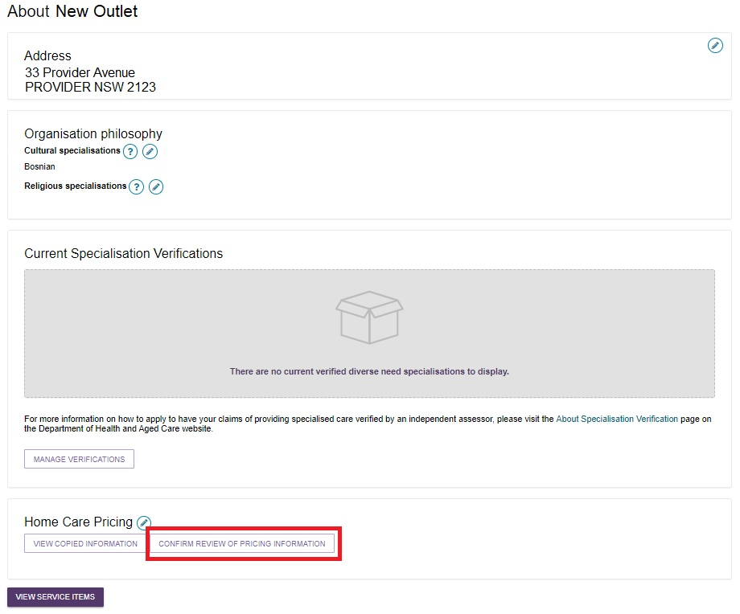

1. Select the service(s) that you wish to confirm, and select ‘CONFIRM REVIEW’.

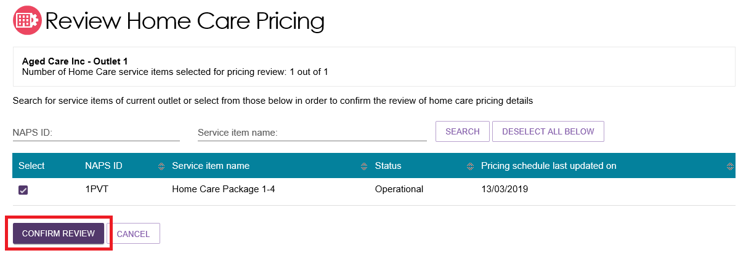

Select “CONFIRM REVIEW” again, at the pop up.

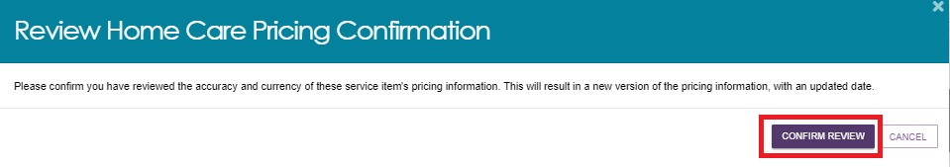

A confirmation banner will appear.

Refer to the following step on how to view copied pricing information.

blue banner "The copy of your home care pricing information has started and should be completed shortly. For details - please check VIEW COPIED INFORMATION under the outlet details page"

1. Home care service providers can also view a history of copied pricing information that has been applied to services within an outlet. Select ‘VIEW COPIED INFORMATION’ to view this history.

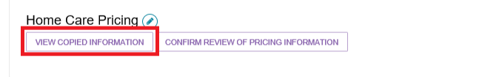

1. Both review and copy actions are shown in the “Home Care Pricing Copy Information” page, along with which outlet (for Administrators), state and end dates and times, and the status. Select “View” (Magnifying glass with plus symbol) to see more details. Select “RETURN TO OUTLET” to return to the View Outlet page.

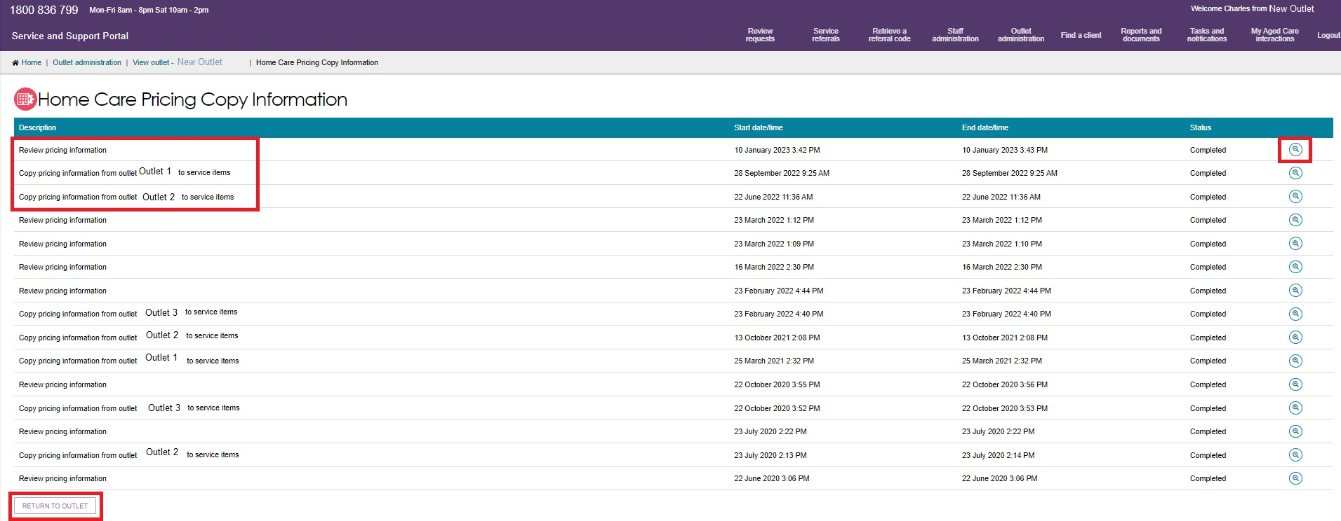

1. Home care service providers can also view and print a copy of the pricing information they have added to individual services, which can then be attached to clients’ Home Care Agreements.

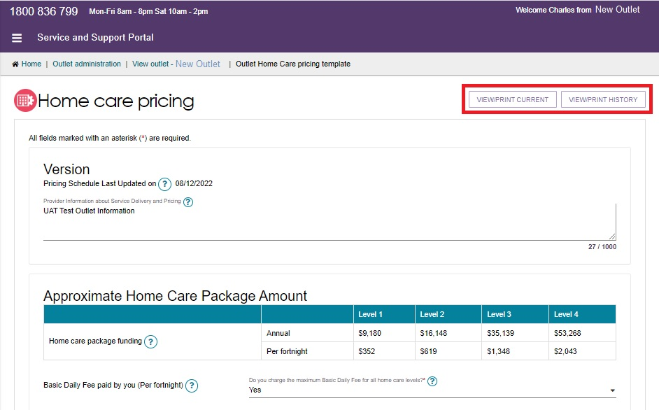

## Adding service items to an outlet

1. From the Outlet Administration page, select the name of the outlet on the outlet card that you want to add a service item to.

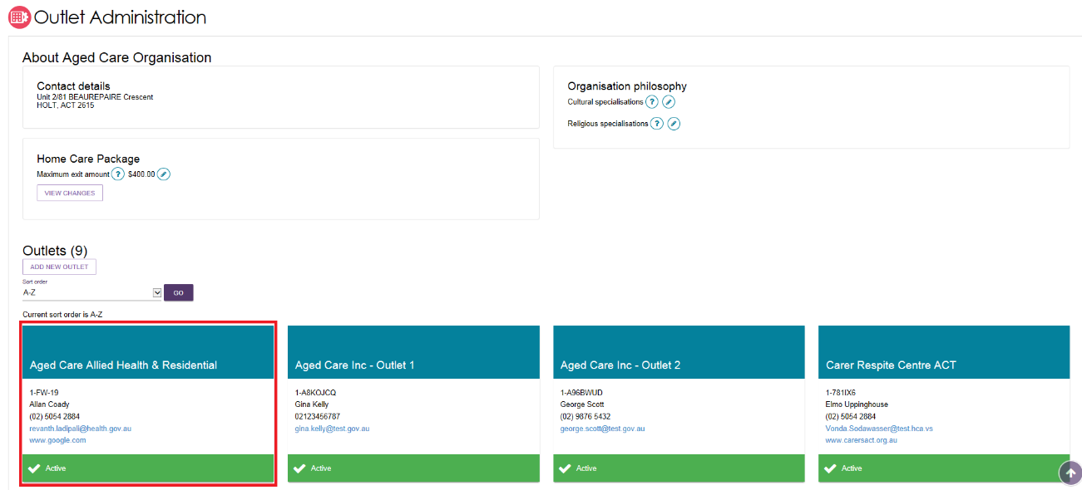

The 'View outlet' page will be displayed.

1. From the 'View outlet' page, select ‘VIEW SERVICE ITEMS'.

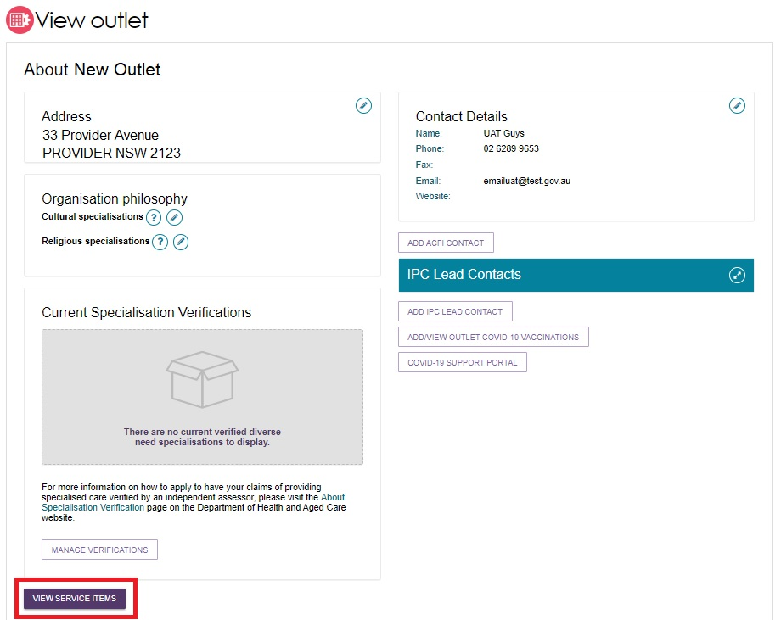

1. From the View Service Items page, select ‘ADD A SERVICE ITEM’.

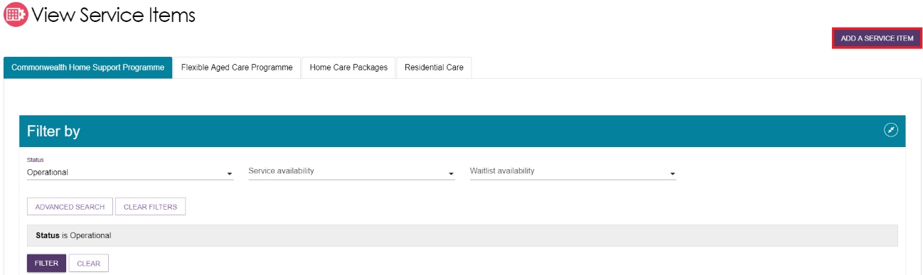

1. Select the program for the service that you wish to add.

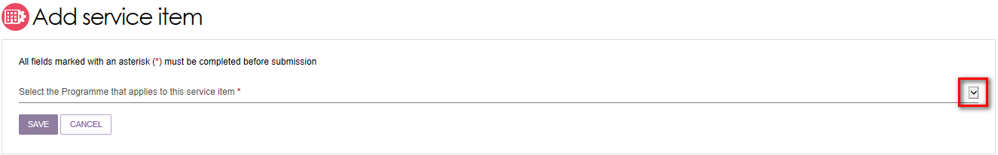

1. Select ‘Funded’ for the service item you are adding. '**Funded**' refers to government subsidised services that are funded and approved by the Australian Government under a Commonwealth aged care programme. Although the functionality currently exists in the Service and Support Portal to add non-funded services, non-funded services will not display on the My Aged Care website.

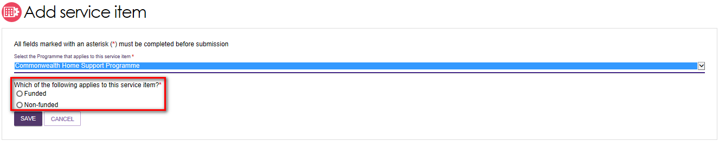

! For Home Care Package services this option will not be available as all services must be Commonwealth government subsidised.

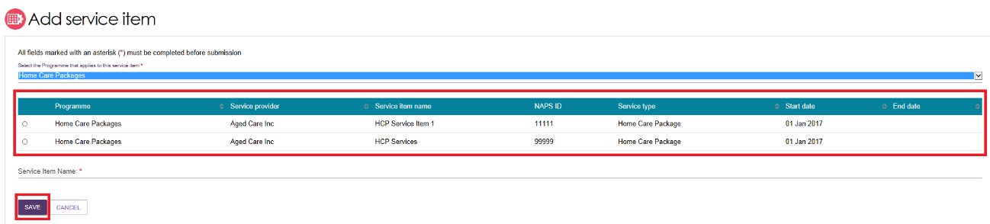

1. Select the funded service you want to add to your outlet by selecting the relevant service item and then select 'SAVE'. You can refine the list of service items by entering details and using the 'FILTER' function. If you are adding a new Home Care Package service, you will be required to enter a unique name for the service in the ‘Service Item Name’ field that is displayed.

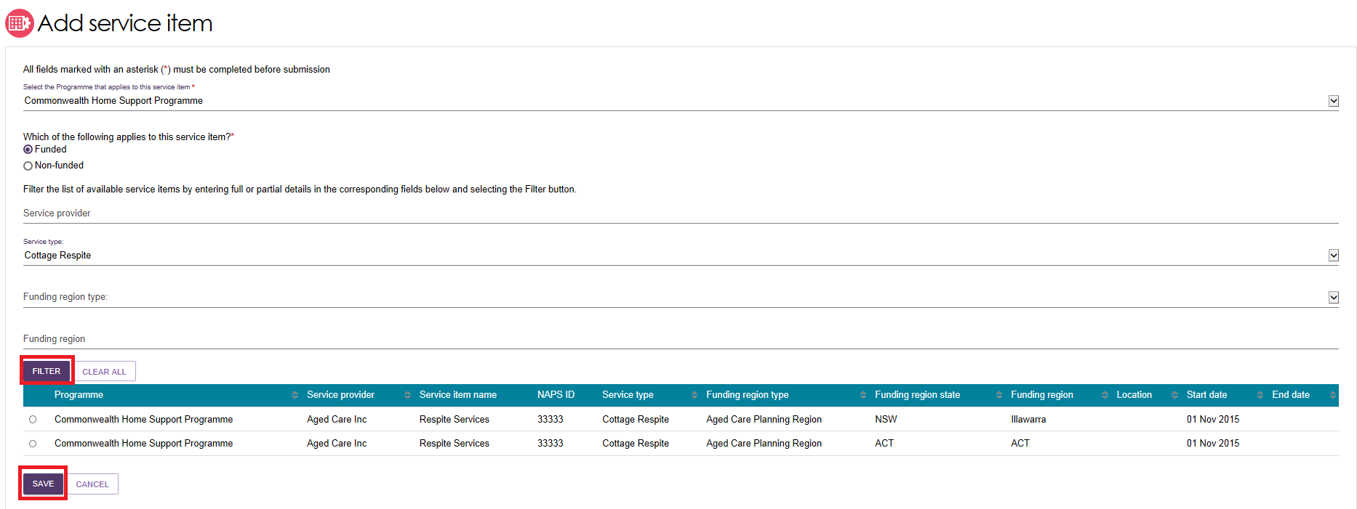

The service item will now display in the Outlet details page under ‘Services’. The service item will be defaulted to ‘Offline’ and the status will need to be changed to ‘Operational’ before it is displayed on the public service finder. The process for activating a service item is described later in this guide.

Once services have been added to an outlet, you can filter the list of services that are listed under a specific program by status, service availability and waitlist availability.

## Editing a service item

You are able to edit service details by selecting ‘Edit’ to the right of the service item you wish to amend.

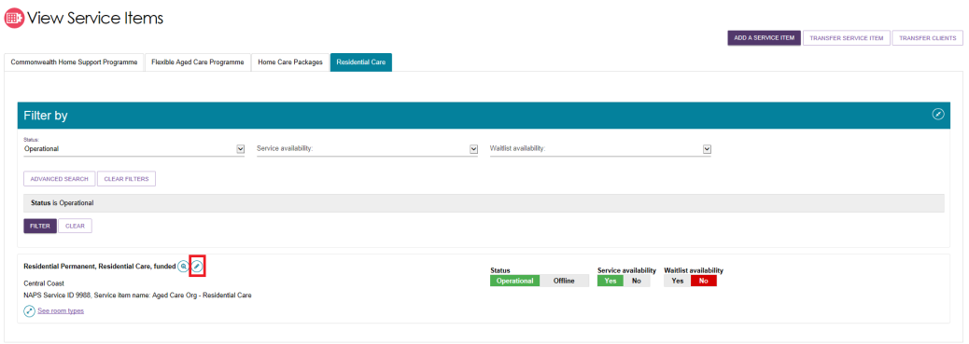

The details that can be edited include:

* Service item name
* Service delivery area
* If a service focuses on a specialised service area
* Upload promotional attachments (for residential facilities)
* Edit Home Care Package specific attributes
* Enter a detailed description for the service item.

! For details about organisation philosophies and diverse needs specialisations, refer to Editing the Organisation Philosophy, Specialisations and Diverse Needs sections.

## Adding and removing service sub-types to service items

Service sub-types can now be added or removed from the one single view screen.

1. Navigate to the ‘View Outlet’ details from the ‘Outlet administration’ page for the outlet that you want to add a service sub-type to. Then click ‘VIEW SERVICE ITEMS’.



1. Select ‘See Sub-types’ below the service to see expanded service details.

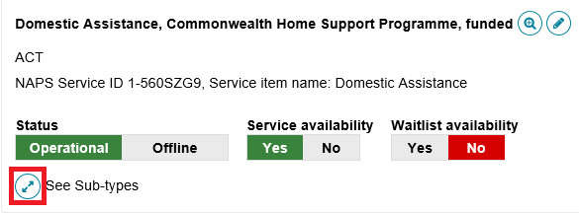

1. Select ‘ADD/REMOVE SUBTYPES’.

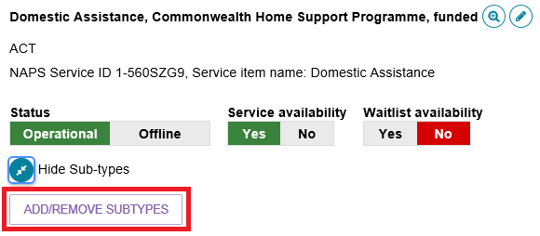

1. The Add/Remove Subtypes screen will then be displayed where you can select/deselect the relevant sub types. Click ‘SAVE’.

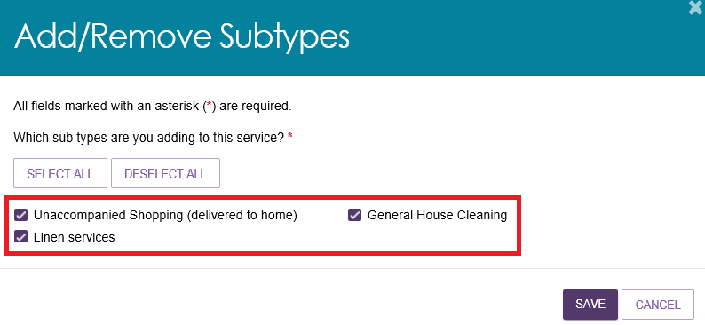

## Maintaining availability of services and their waitlists

You can maintain information about the availability of service items via the Service and Support Portal.

To maintain a waitlist, you must ensure that the waitlist availability status on the service item is set to ‘Yes’ to turn on the waitlist, or ‘No’ to turn off the waitlist. Service and waitlist availability information will be displayed on the service finder via the My Aged Care website. When you change availability information it will appear by the next day on the My Aged Care service finder on the My Aged Care website.

1. Navigate to the ‘View Outlet’ details from the ‘Outlet administration’ page for the outlet that you want to edit service and waitlist information and click on ‘VIEW SERVICE ITEMS’.



1. Select the relevant service/waitlist availability status (Yes / No)

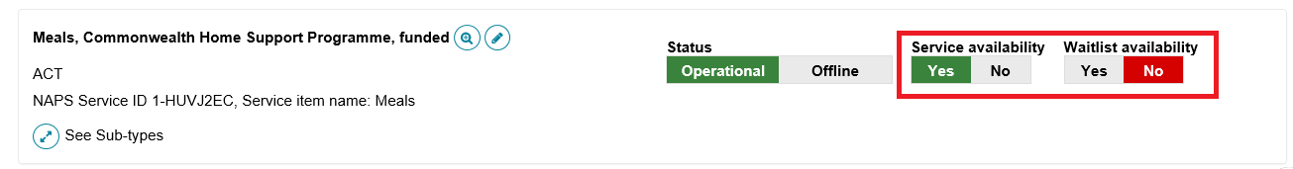

The waitlist functionality is further explained in the [guide for *Manage referrals for service*](https://www.health.gov.au/resources/publications/my-aged-care-quick-reference-guide-manage-referrals-for-service)*.*

## Maintaining availability of service sub-types and their waitlists

You can maintain detailed information about service sub-types for a service that you offer via the Service and Support Portal. You are able to edit details about:

* Service sub-type availability (and waitlist)
* Hours of operation for the service sub-type
* Notes of staffing for the service sub-type
* Whether transport is provided as part of that service

Service sub-type information will be displayed on the service finder via the My Aged Care website. When you change this information, it will appear by the next day on the My Aged Care service finder on the My Aged Care website.

1. Navigate to the ‘View Outlet’ details from the ‘Outlet administration’ page for the outlet that you want to edit service and waitlist information and click on ‘VIEW SERVICE ITEMS’.



1. To edit availability and waitlist information for service sub-types, select the arrows next to ‘See Sub-types’ to display the sub-types that have been added to the service.

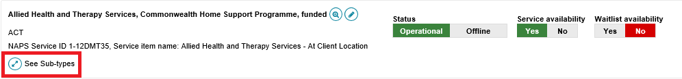

1. Here you can edit the sub-type availability and sub-type waitlist availability by clicking the toggles, and edit additional information about the service sub-type by selecting the ‘Edit’ icon.

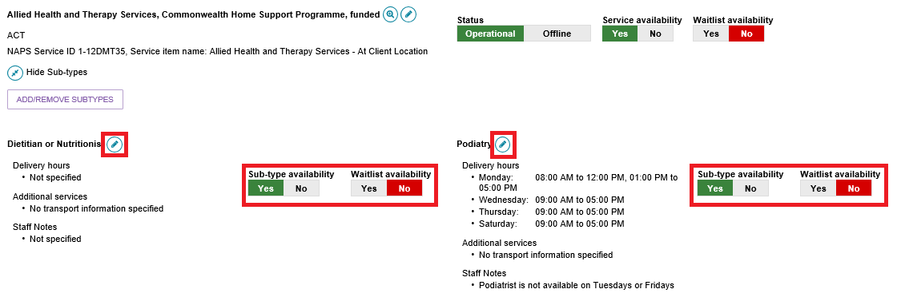

1. Add any additional information about operating hours, staffing or transport for that service sub-type and select ‘SAVE CHANGES’.

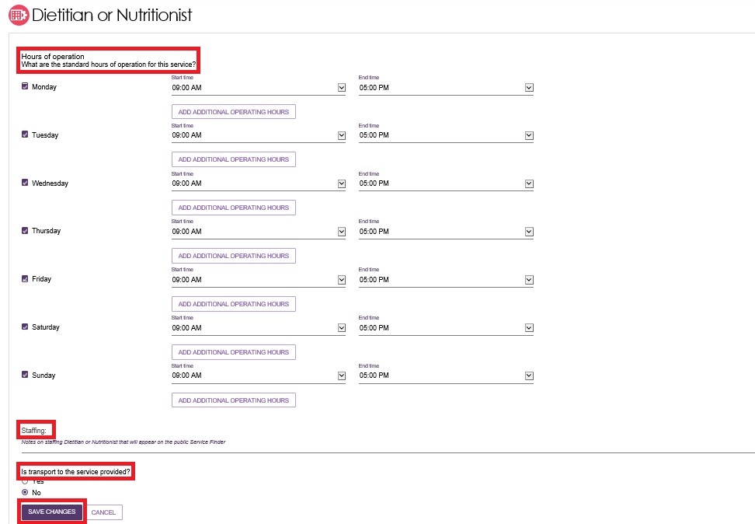

1. Your updated information will saved.

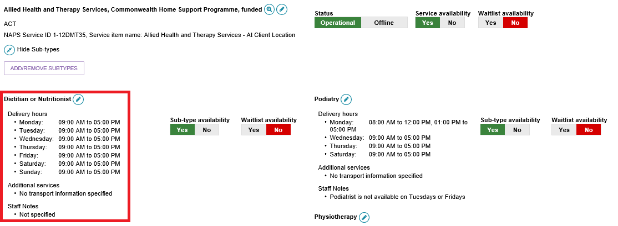

## Editing a service delivery area

Information about the areas you deliver Commonwealth-funded services in (referred to as ‘service delivery areas’ in the portal) are pre-filled, based on your contractual information. All providers (except Residential care) must review their service delivery area information and edit if required.

It is important that you ensure the service delivery area(s) is accurate. This information is publicly displayed in the service finders and forms the basis of the referrals sent by contact centre staff and assessors.

You can select service delivery areas at either the client’s location or the service provider’s location.

The steps to edit the service delivery area (if at client location is selected) are outlined below.

1. Select ‘Outlet administration’ from the homepage.
2. Select the outlet card you want to edit by selecting the outlet name. On the ‘View outlet’ page, click ‘VIEW SERVICE ITEMS’



1. On the ‘View Service Items’ page, select ‘Edit’ next to the relevant service item.

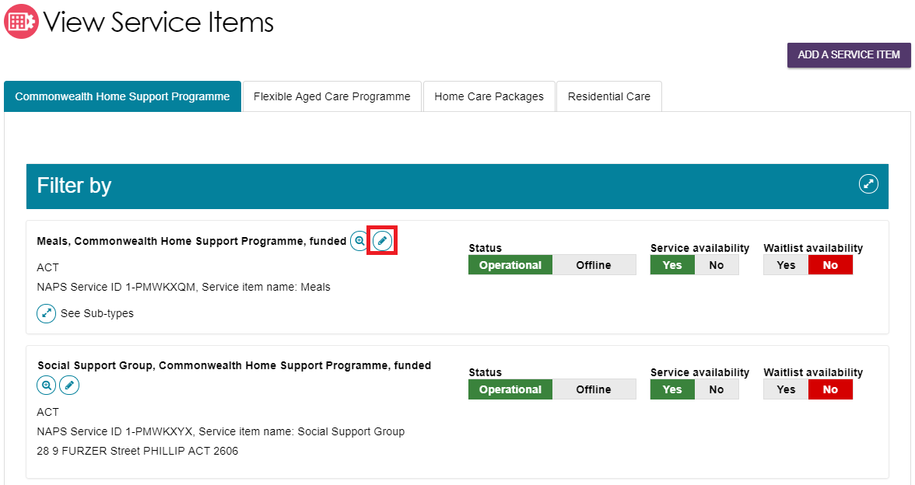

The ‘Service details’ page will display.

1. Select ‘Edit’ next to ‘Service delivery area’.

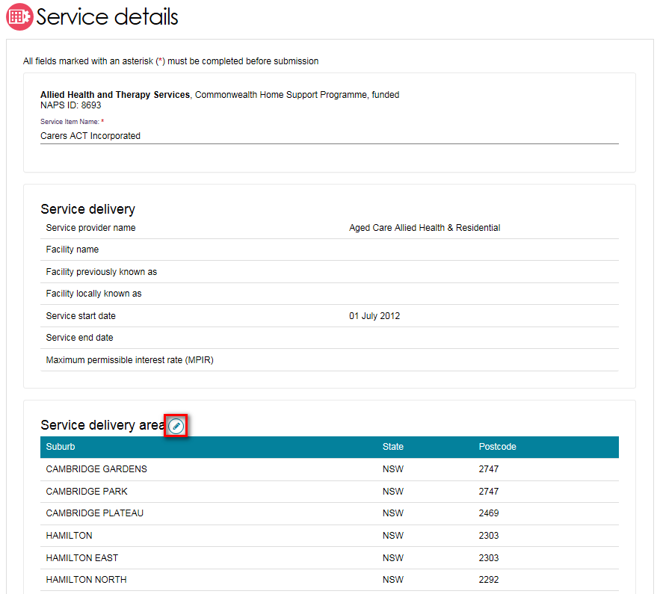

1. Select the service delivery type (At provider location/at client location).

If you have selected ‘At client location’, you can choose the suburb(s) the service is delivered in. By default, the entire region in which you are funded to provide service is selected. You can choose to search for a specific suburb to add, add all the suburbs in the selected state, or add all the suburbs in the selected region.

The ‘List of serviced suburbs’ is automatically saved upon adding new suburbs. Select ‘CLOSE’ to go back to editing the service.

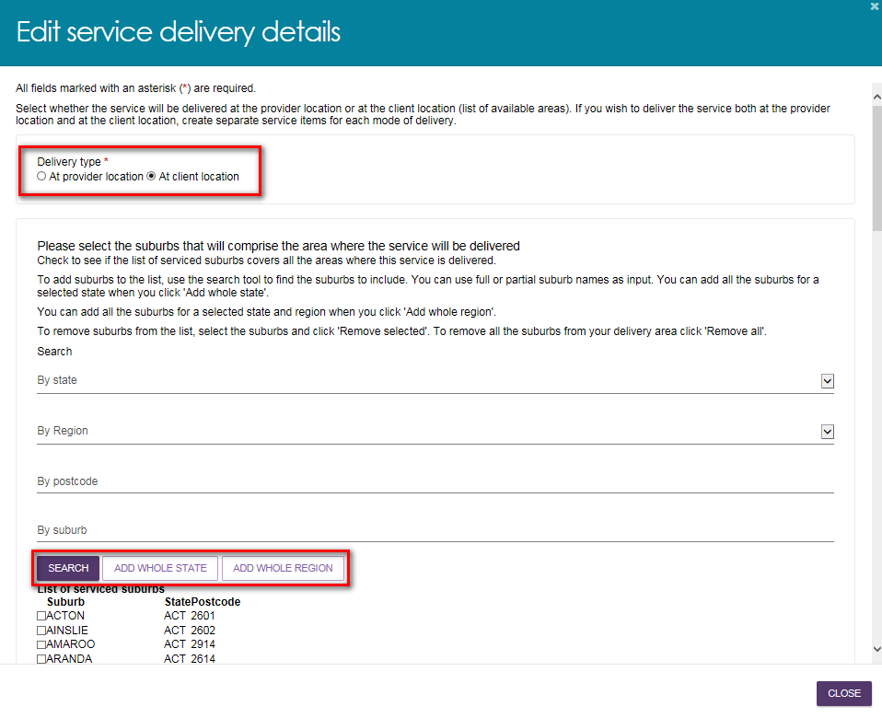

1. To remove suburbs from the list, select the suburbs you wish to remove using the checkbox and select ‘REMOVE SELECTED’, or use ‘REMOVE ALL’ to start configuring your list of suburbs from the beginning. These changes are automatically saved. Click ‘CLOSE’ to go back to editing the service.

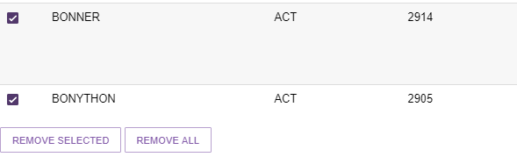

## Adding a room type to a residential facility

1. Navigate to the ‘View Outlet’ details from the ‘Outlet administration’ page for the outlet that you want to add room information to.



1. Select ‘VIEW SERVICE ITEMS’, select the ‘Residential Care’ tab then click on ‘See room types’.

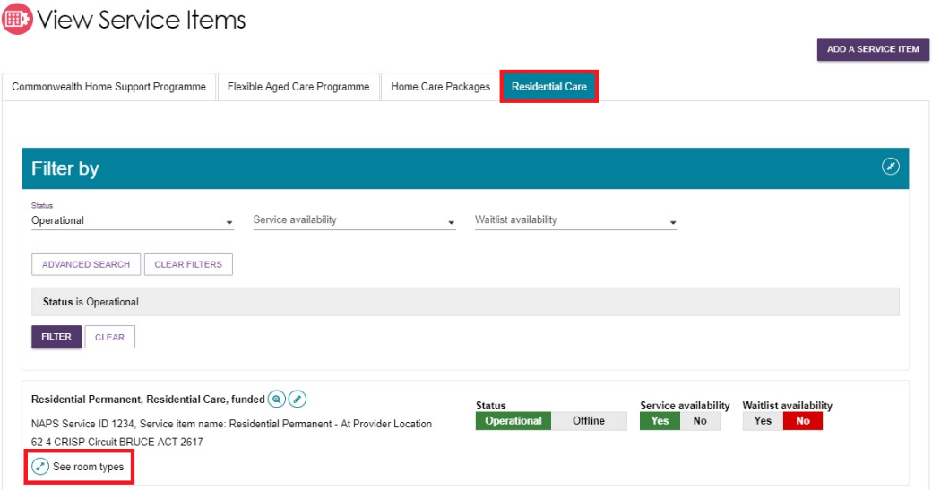

1. Then click ‘ADD ROOM TYPE’

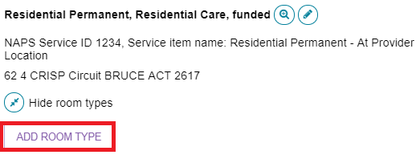

1. 'Room type' page will be displayed. Enter the required information in the 'General room information' and ‘Pricing information’ sections.

Fields marked with an asterisk (*) are mandatory.

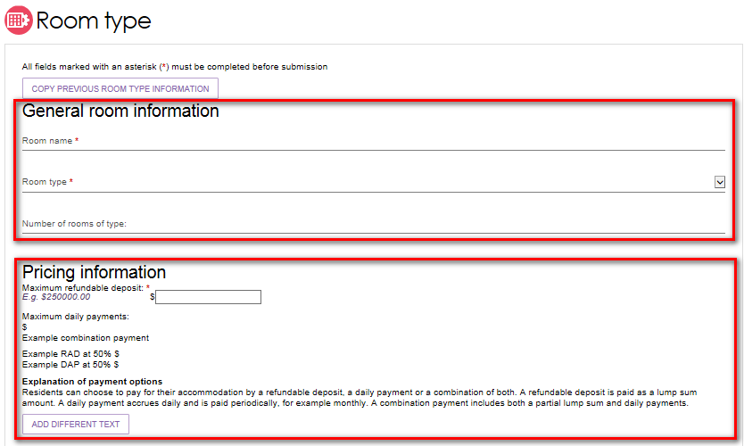

! Accommodation prices above a refundable deposit amount of $550,000 (or equivalent daily payment) must be approved by the Aged Care Pricing Commissioner.

If the Aged Care Pricing Commissioner has not approved this price, or you have not submitted an application for approval of this price, you cannot publish this price. You cannot charge this price until it is approved by the Aged Care Pricing Commissioner.

Please note that when an approval is granted by the Aged Care Pricing Commissioner, the approved amount is not automatically updated on the My Aged Care website. Providers must update their own pricing information using the Aged Care Service and Support Portal.

1. Enter the required information under 'Key feature statement'. Select ‘SAVE AND SUBMIT REQUESTED CHANGES FOR APPROVAL’’ after all required information has been entered. This room information will display on the service finder once approved by the Department (allow 3 business days).

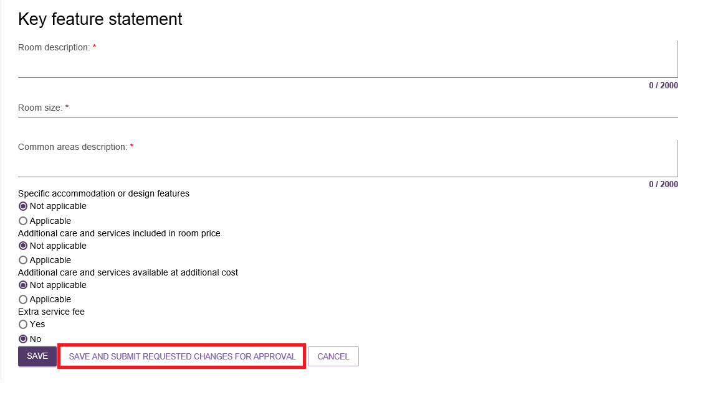

! If you save the room type but do not select ‘Submit’, you will be notified that there are room types requiring approval by the Department and be prompted to submit the room type to the Department prior to displaying on the public service finder.

If you save the room type but do not select 'Submit', you will be notified that there are room types requiring approval by the Department and be prompted to submit the room type to the Department prior to displaying on the public service finder.

## Activating or deactivating a service item

Navigate to the ‘View Outlet’ details from the ‘Outlet administration’ page for the outlet with the service item that you want to activate/deactivate and click on ‘VIEW SERVICE ITEMS’.



For the services that have been added to the outlet, select 'Operational' to activate the service item or 'Offline' to deactivate the service item under the 'Status' heading. Only ‘Operational’ services will display in the service finders. The ‘Offline’ status should be used to indicate where a funded service is not currently offered by the provider. For example, the service is at capacity.

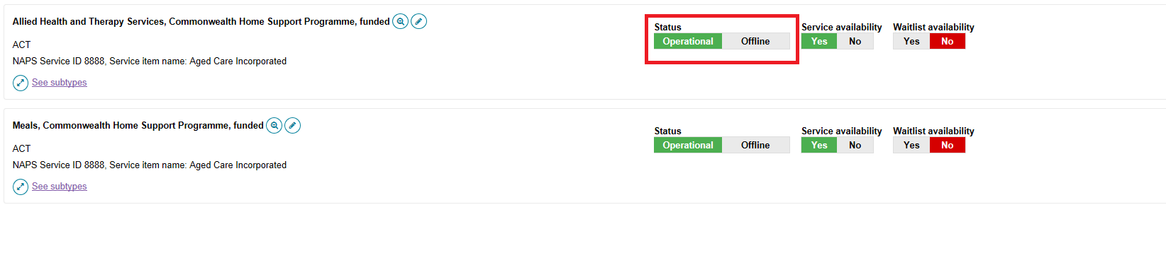

## Activating an outlet

After service items are added, outlet(s) need to be made active so that the following occurs:

* The service items display in the service finder.
* Contact centre staff and assessors can send electronic referrals to the appropriate outlet.
* Assessors can match and refer to active services.

1. Navigate to the ‘View Outlet’ details from the ‘Outlet administration’ page for the outlet that you want to activate and select ‘ACTIVATE OUTLET’.

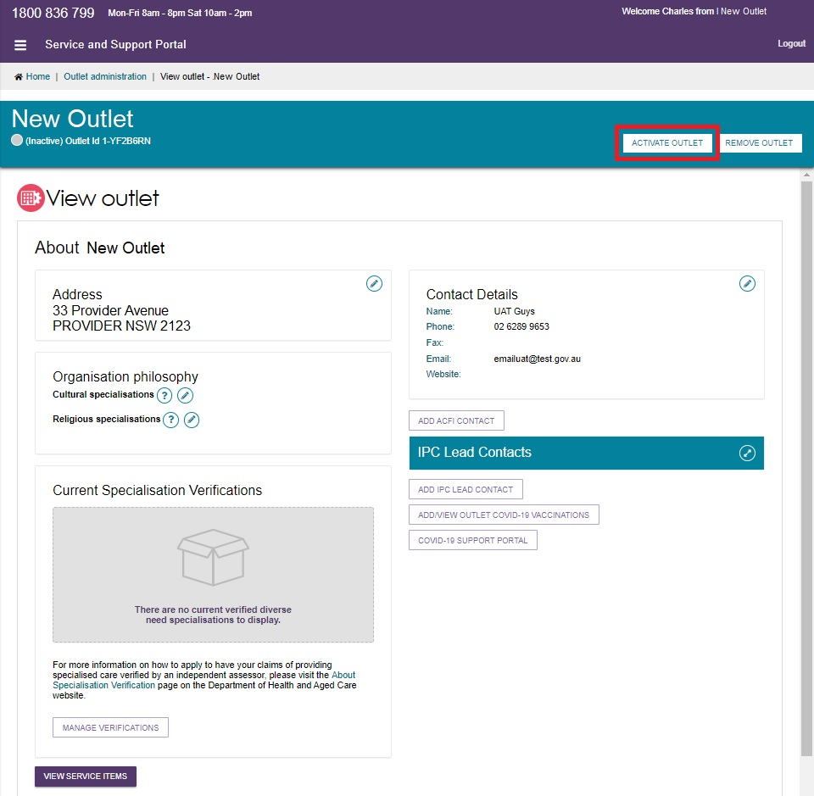

1. Select 'ACTIVATE OUTLET' to confirm that you wish for this information to be displayed in the service finder. A warning message will display.

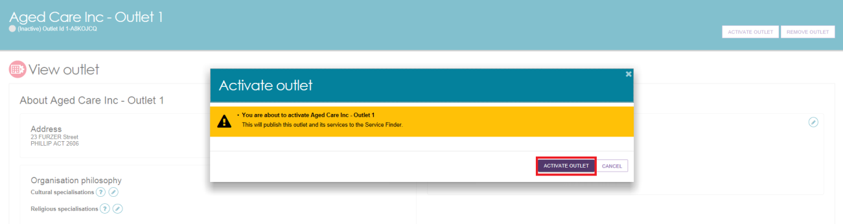

Your outlet is now active and operational service item information will display in the service finder, and will display as ‘Active’ in the Service and Support Portal.

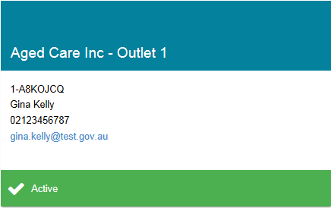 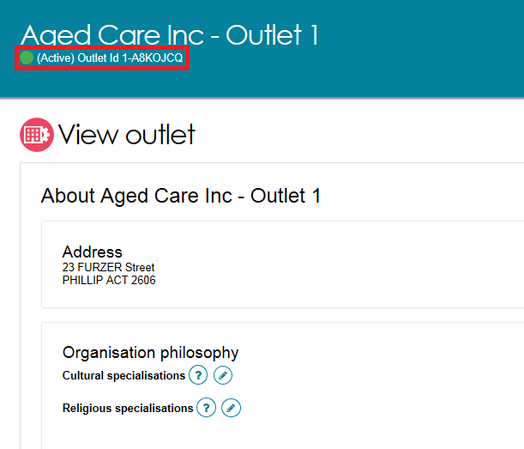

## Deactivating an outlet

To remove an outlet from the service finders and stop referrals being sent to the outlet, it must be deactivated. An outlet cannot be made inactive if there are accepted and commenced services.

1. Navigate to the ‘View Outlet’ details from the ‘Outlet administration’ page for the outlet that you want to deactivate and select ‘DEACTIVE OUTLET’.

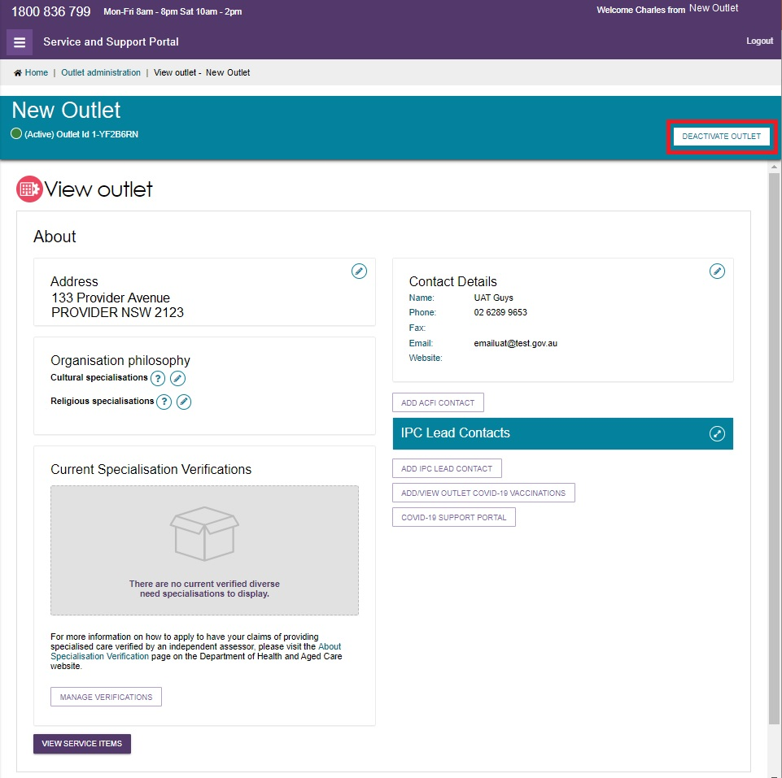

1. Select 'DEACTIVATE OUTLET' again to confirm that you wish to deactivate the outlet.

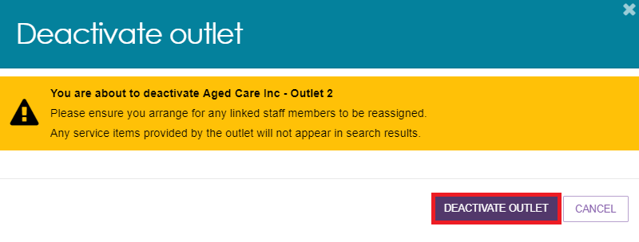

The outlet is now inactive, does not display on the relevant service finder or receive referrals, and displays as ‘Inactive’ in the Service and Support portal.

## Removing an outlet from the Service and Support Portal

To remove an outlet from the Service and Support Portal, it must be in the status of ‘Inactive’.

1. Navigate to the ‘View Outlet’ details from the ‘Outlet administration’ page for the inactive outlet you wish to remove and select “REMOVE OUTLET”.

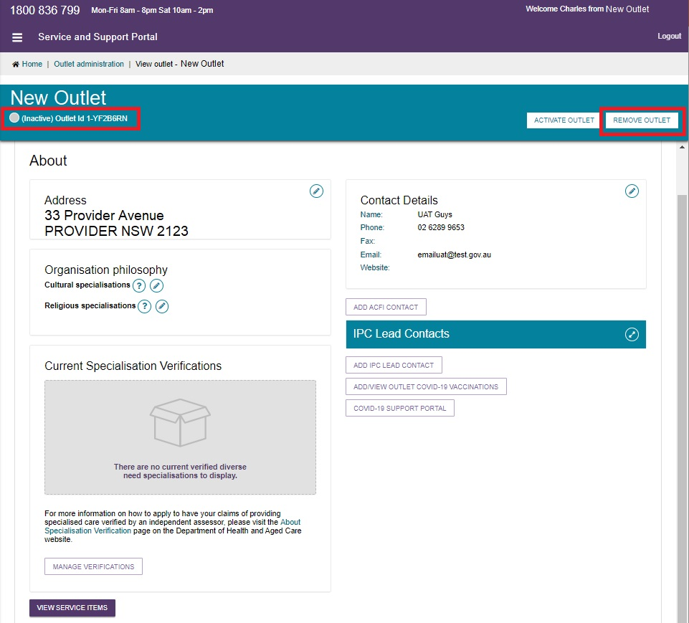

1. Select ‘REMOVE OUTLET’ to confirm you wish to remove the outlet.

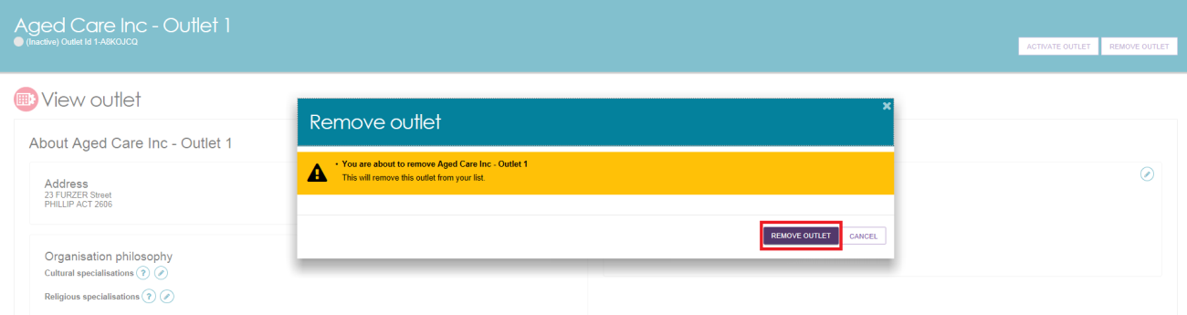

The outlet will no longer display in the Service and Support Portal.

! If you want to create an outlet with the same name as the one you removed earlier, you will need to call the My Aged Care service provider and assessor helpline on1800 836 799.

## For more information or support

Further information is available from the [Service and Support Portal Resources](https://www.health.gov.au/resources/collections/my-aged-care-service-and-support-portal-resources) page.

The My Aged Care service provider and assessor helpline is available on 1800 836 799.