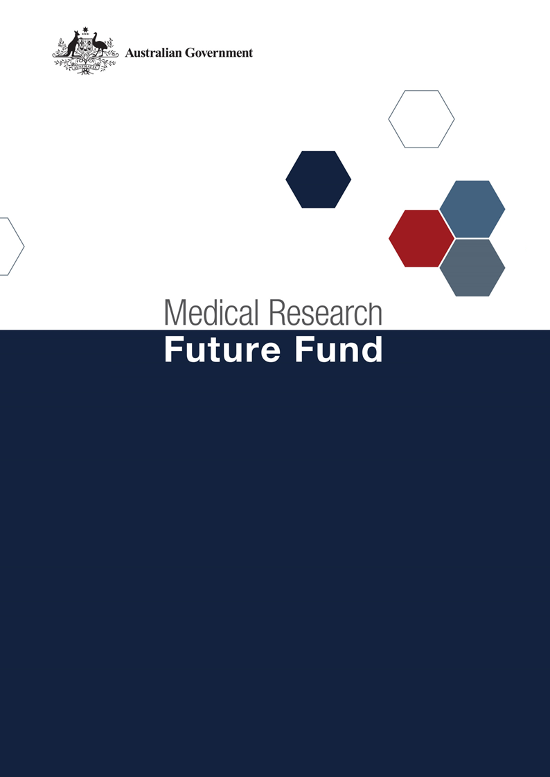

**Million Minds Mental Health Research Mission  
Roadmap and Implementation Plan  
National Consultation Report  
  
February 2023**

Table of Contents

Introduction 2

Community participation and submissions 3

Responses to national consultation submissions 4

# Introduction

The Million Minds Mental Health Research Mission (the Mission) is an initiative of the Medical Research Future Fund (MRFF). It is providing $125 million over 10 years from 2018-19 to support research into the causes of mental illness and psychological distress, and the best early intervention, prevention and treatment strategies.

The Mission’s second Expert Advisory Panel was established in 2022 to provide advice to the Minister for Health and Aged Care on the strategic priorities for future research investment through the Mission. As per the Minister’s agreed [Governance arrangements for MRFF Missions](https://www.health.gov.au/resources/publications/mrff-mission-governance), the Expert Advisory Panel has provided advice on priorities for research investment through the Mission by revising the existing Roadmap (originally developed by the Mission’s first Expert Advisory Panel in 2018) and developing an Implementation Plan.

The Roadmap is a high-level strategic document that includes the aim, vision, goal and priorities for investment for the Mission. To support the Roadmap, the Implementation Plan outlines the Mission’s investments made to date (short term) and the future priorities for investment (medium and long term), as well as the Mission’s evaluation approaches and measures, supporting activities, and collaborative opportunities. The Roadmap and Implementation Plan will be used by the Department of Health and Aged Care to design and implement Mission investments via Grant Opportunities promoted through GrantConnect ([grants.gov.au](https://www.grants.gov.au/)).

A draft Roadmap and Implementation Plan developed by the Expert Advisory Panel underwent international review on 17 November 2022; the outcome of the review is outlined in a report endorsed by the [International Review Panel](https://www.health.gov.au/our-work/million-minds-mental-health-research-mission?language=und).

A national consultation to seek feedback from the community on the Mission’s draft Roadmap and Implementation Plan was also conducted over the period 28 October to 1 December 2022, during which time submissions were accepted through the Department’s [consultation hub](https://consultations.health.gov.au).

During the consultation, the Chair of the Expert Advisory Panel hosted a public webinar on 9 November 2022. This gave an opportunity for the community to gain a greater understanding of the purpose of the Roadmap and Implementation Plan and ask questions, prior to providing written submissions to the consultation.

The following questions were provided on the Department’s consultation hub to guide submissions:

1. Are the priority areas for investment identified in the Implementation Plan the most effective way for delivering on the Mission's goal and aims?
2. Are there existing research activities which could be utilised to contribute to the Mission Roadmap and/or Implementation Plan aims and priority areas for investment? How can these be leveraged?
3. Are the ‘Evaluation approach and measures’ appropriate for assessing and monitoring progress towards the Mission's goal and aims?

This report summarises the national consultation feedback received through webinar participation and written submissions.

## Community participation and submissions

51 stakeholders (from 91 registrations) attended the webinar from across all states and territories of Australia. A diverse range of stakeholders participated including: mental health providers, mental health researchers, research organisations, advocacy groups, and individual community members.

During the consultation period, 18 written submissions were received via the consultation hub, representing research organisations (including universities and medical research institutes) and advocacy groups.

The Expert Advisory Panel considered all responses from the national consultation and, where relevant, revised the Roadmap and Implementation Plan. A summary of the feedback from the webinar participants and submissions and the Expert Advisory Panel’s responses are outlined below.

# Responses to national consultation feedback

|  |  |  |
| --- | --- | --- |
| **Consultation Question** | **Submission/Webinar Feedback / Theme** | **Action by Expert Advisory Panel** |
| **Are the priority areas for investment identified in the Implementation Plan the most effective way for delivering on the Mission's goal and aims?** | Many stakeholders expressed support for all of the identified priority areas. | Noted by the Panel. |
| Consider if the long term small-scale projects should instead be conducted in the medium term as they could feed into the large-scale long term projects. | The Panel agreed that findings from small-scale projects should inform larger-scale projects where possible. However, due to the timing and funding profile of the Mission, some smaller projects would need to occur later in the Mission. |
| A number of specific cohorts and mental health conditions were suggested to be addressed by the Mission. | The Panel agreed that there will be no barrier to funding specific cohorts or mental health conditions as long as they are relevant to a grant opportunity under the Mission. |
| There should be a greater focus on health services and systems research. This has been identified as a priority by those with lived experience. Currently there is too much of a focus on prevention, interventions and individual-level treatments. | As some priorities include a focus on models of care, and direct involvement of those with living or lived experience is a funding principle of the Mission – no amendments were determined as necessary by the Panel. |
| New mental health research institutes in every jurisdiction in Australia should be established by the MRFF more broadly. | This was supported by the Panel but was determined to be outside of the scope of the Mission. |
| Ensure that research to be funded has genuine co-design with people with lived or living experience, and with the community more broadly. Furthermore, ensure that lived experience involvement also includes children with lived experience, and not just parents, carers and supporters of children. | The Panel strongly agreed with this recommendation, and has stated this as a funding principle of the Mission. |
| There should be a greater focus on longitudinal research and research that attempts to examine issues across the spectrum of social determinants in an integrated way. | The Panel acknowledged the importance of funding longitudinal research, and that there was no barrier to funding such research as long as it was relevant to a grant opportunity under the Mission. The Panel also agreed that the consortium to be established under Aim 2 would build on existing longitudinal research. |
| Prioritisation should be given to projects that enhance mental health data collection at scale and align with state and national datasets so that interventions can be evaluated at the population level. | The Panel agreed with recommendation and has stated data harmonisation as a funding principle of the Mission. |
| There needs to be more emphasis on the clinical mental health workforce, as access and equity cannot be addressed without an adequate workforce. | Although funding for the mental health workforce is beyond the remit of the Mission, the Panel acknowledged the importance of the workforce and its involvement in research. Given this, the Panel has made workforce research a priority under Aim 3 and notes that such research could be funded through other Mission grant opportunities if relevant. |
| Ensure the needs of rural, regional and remote Australians are included in the funding priorities; prioritisation is given for researchers in these locations; and that mechanisms are put in place to ensure this focus is authentic and leads to real change for these Australians. | The Panel appreciates the importance of research focusing on rural, regional and remote Australians, and has stated this as a funding principle for the Mission. Also, rural and remote settings as well as research encompassing multiple-geographies have been set as the focus for a number of the priorities in the Implementation Plan. |
| Ensure any new consortiums established by the Mission are sustainable. | The Panel agreed that the sustainability of large research initiatives is important- and additional wording highlighting this was added to the Roadmap. |
| For the Mission to be successful, there needs to be greater investment in the research infrastructure available for mental health research. | The Panel agreed on the importance of research infrastructure. However, the Panel agreed that such support is best addressed by other initiatives. |
| **Are there existing research activities which could be utilised to contribute to the Mission Roadmap and/or Implementation Plan aims and priority areas for investment? How can these be leveraged?** | A number of additional existing initiatives, collaborations and efforts were suggested for partnership with the Mission’s activities. | The Panel noted these suggestions and acknowledged the important work being undertaken by these entities. However, as the list of these entities in the Implementation Plan is intended to be high level and not exhaustive, no changes were made to the list. |
| Integrate research and evaluation with the relevant national and state/territory health plans for mental health, alcohol and other drug use, and violence prevention. | The Panel agreed that Mission research and evaluation should be integrated with relevant national and state and territory plans, and given this has stated a commitment to key national plans in the Roadmap and makes reference to importance of alignment with national and state and territory activities in the Implementation Plan. |
| Include the sectors involved in the social determinants of mental health as collaborators and partners, such as education, justice and social care sectors. | The Panel agreed on the importance of Mission research collaborating and partnering with such sectors, and these have been added to the Implementation Plan. |
| Due to the growing interest within the philanthropic sector to fund mental health research, it is recommended that a Mental Health Research Funders government-philanthropic collaboration be established (and include entities such as Philanthropy Australia). | The Panel agreed with this recommendation and acknowledged that government and philanthropic collaborations exist outside of mental health. However, the establishment of such a collaboration is out of scope for the Mission. |
| **Are the ‘Evaluation approach and measures’ appropriate for assessing and monitoring progress towards the Mission's goal and aims?** | Many stakeholders expressed support for evaluation approach and measures. | Noted by the Panel. |
| Some stakeholders recommended that the evaluation measures should include detail such as baseline figures to be used, and the key activity milestones. | The Panel acknowledged the importance of such detail. However, agreed that the listed measures are intended to be high level to guide a future evaluation of the Mission, and such detail will be determined as part of the evaluation process. |
| As part of the evaluation of the Mission, there should be an assessment of the return on investment. | The Panel agreed on the benefits of quantifying the economic value of research. However, the Panel agreed that this should be a broader undertaking that is beyond the scope of the Mission. |
| The evaluation approach should ensure involvement by people with First Nations peoples, those with living or lived experience and the public more generally. | The Panel agreed with the importance of partnering with people of all demographics, including First Nations peoples and those with living and lived and experience, in the evaluation of research including the Mission. The importance of such partnerships has been expressed throughout the Roadmap and Implementation Plan and the Panel agreed that this applies to the evaluation of the Mission. |
| A number of additional specific measures of success were suggested by stakeholders. | The Panel appreciated the recommendation of additional specific measures, however these were not included as the Panel agreed that the list of measures are to be high level and broad, and are to guide a future evaluation of the Mission. |