Pathway to Reforming In-Home Aged Care 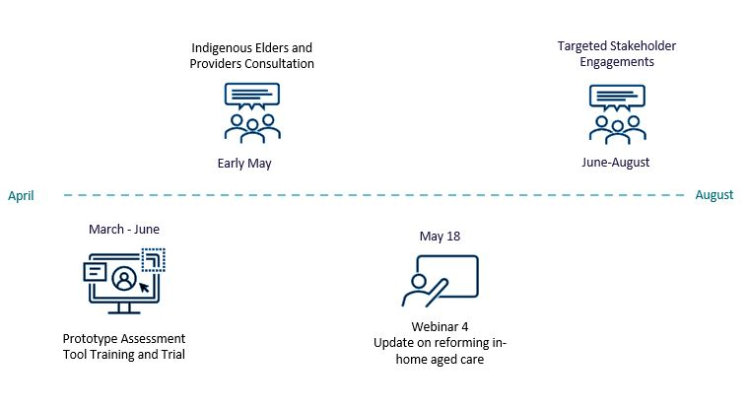

2023 Engagement Calendar
Regular newsletters and factsheets will be published to provide information, progress updates and transition processes for both older people in Australia and industry stakeholders.
To get involved with these consultations please email sah.implementation@health.gov.au, to receive regular updates please register on the Ageing and Aged Care Engagement Hub.
We are holding our 4th reforming in-home aged care update webinar on Thursday 18 May from 2:00pm until 4:00pm AEST. If you would like to attend, please register here.

Completed engagement activities
In 2022 and early 2023 we held a range of engagements with stakeholders on the below topics:
- Care Management
- Funding Model
- Payment Platform
- Assessment Model
- Allied Health
- Short Term Restorative Care (STRC)
- Residential Respite
- Service List
- Goods, Equipment, Assistive Technologies (GEAT) and Home Modifications
- Home Maintenance
The consultations assisted the development of the policy propositions put forward in the discussion paper that was released on 18 October 2022.

