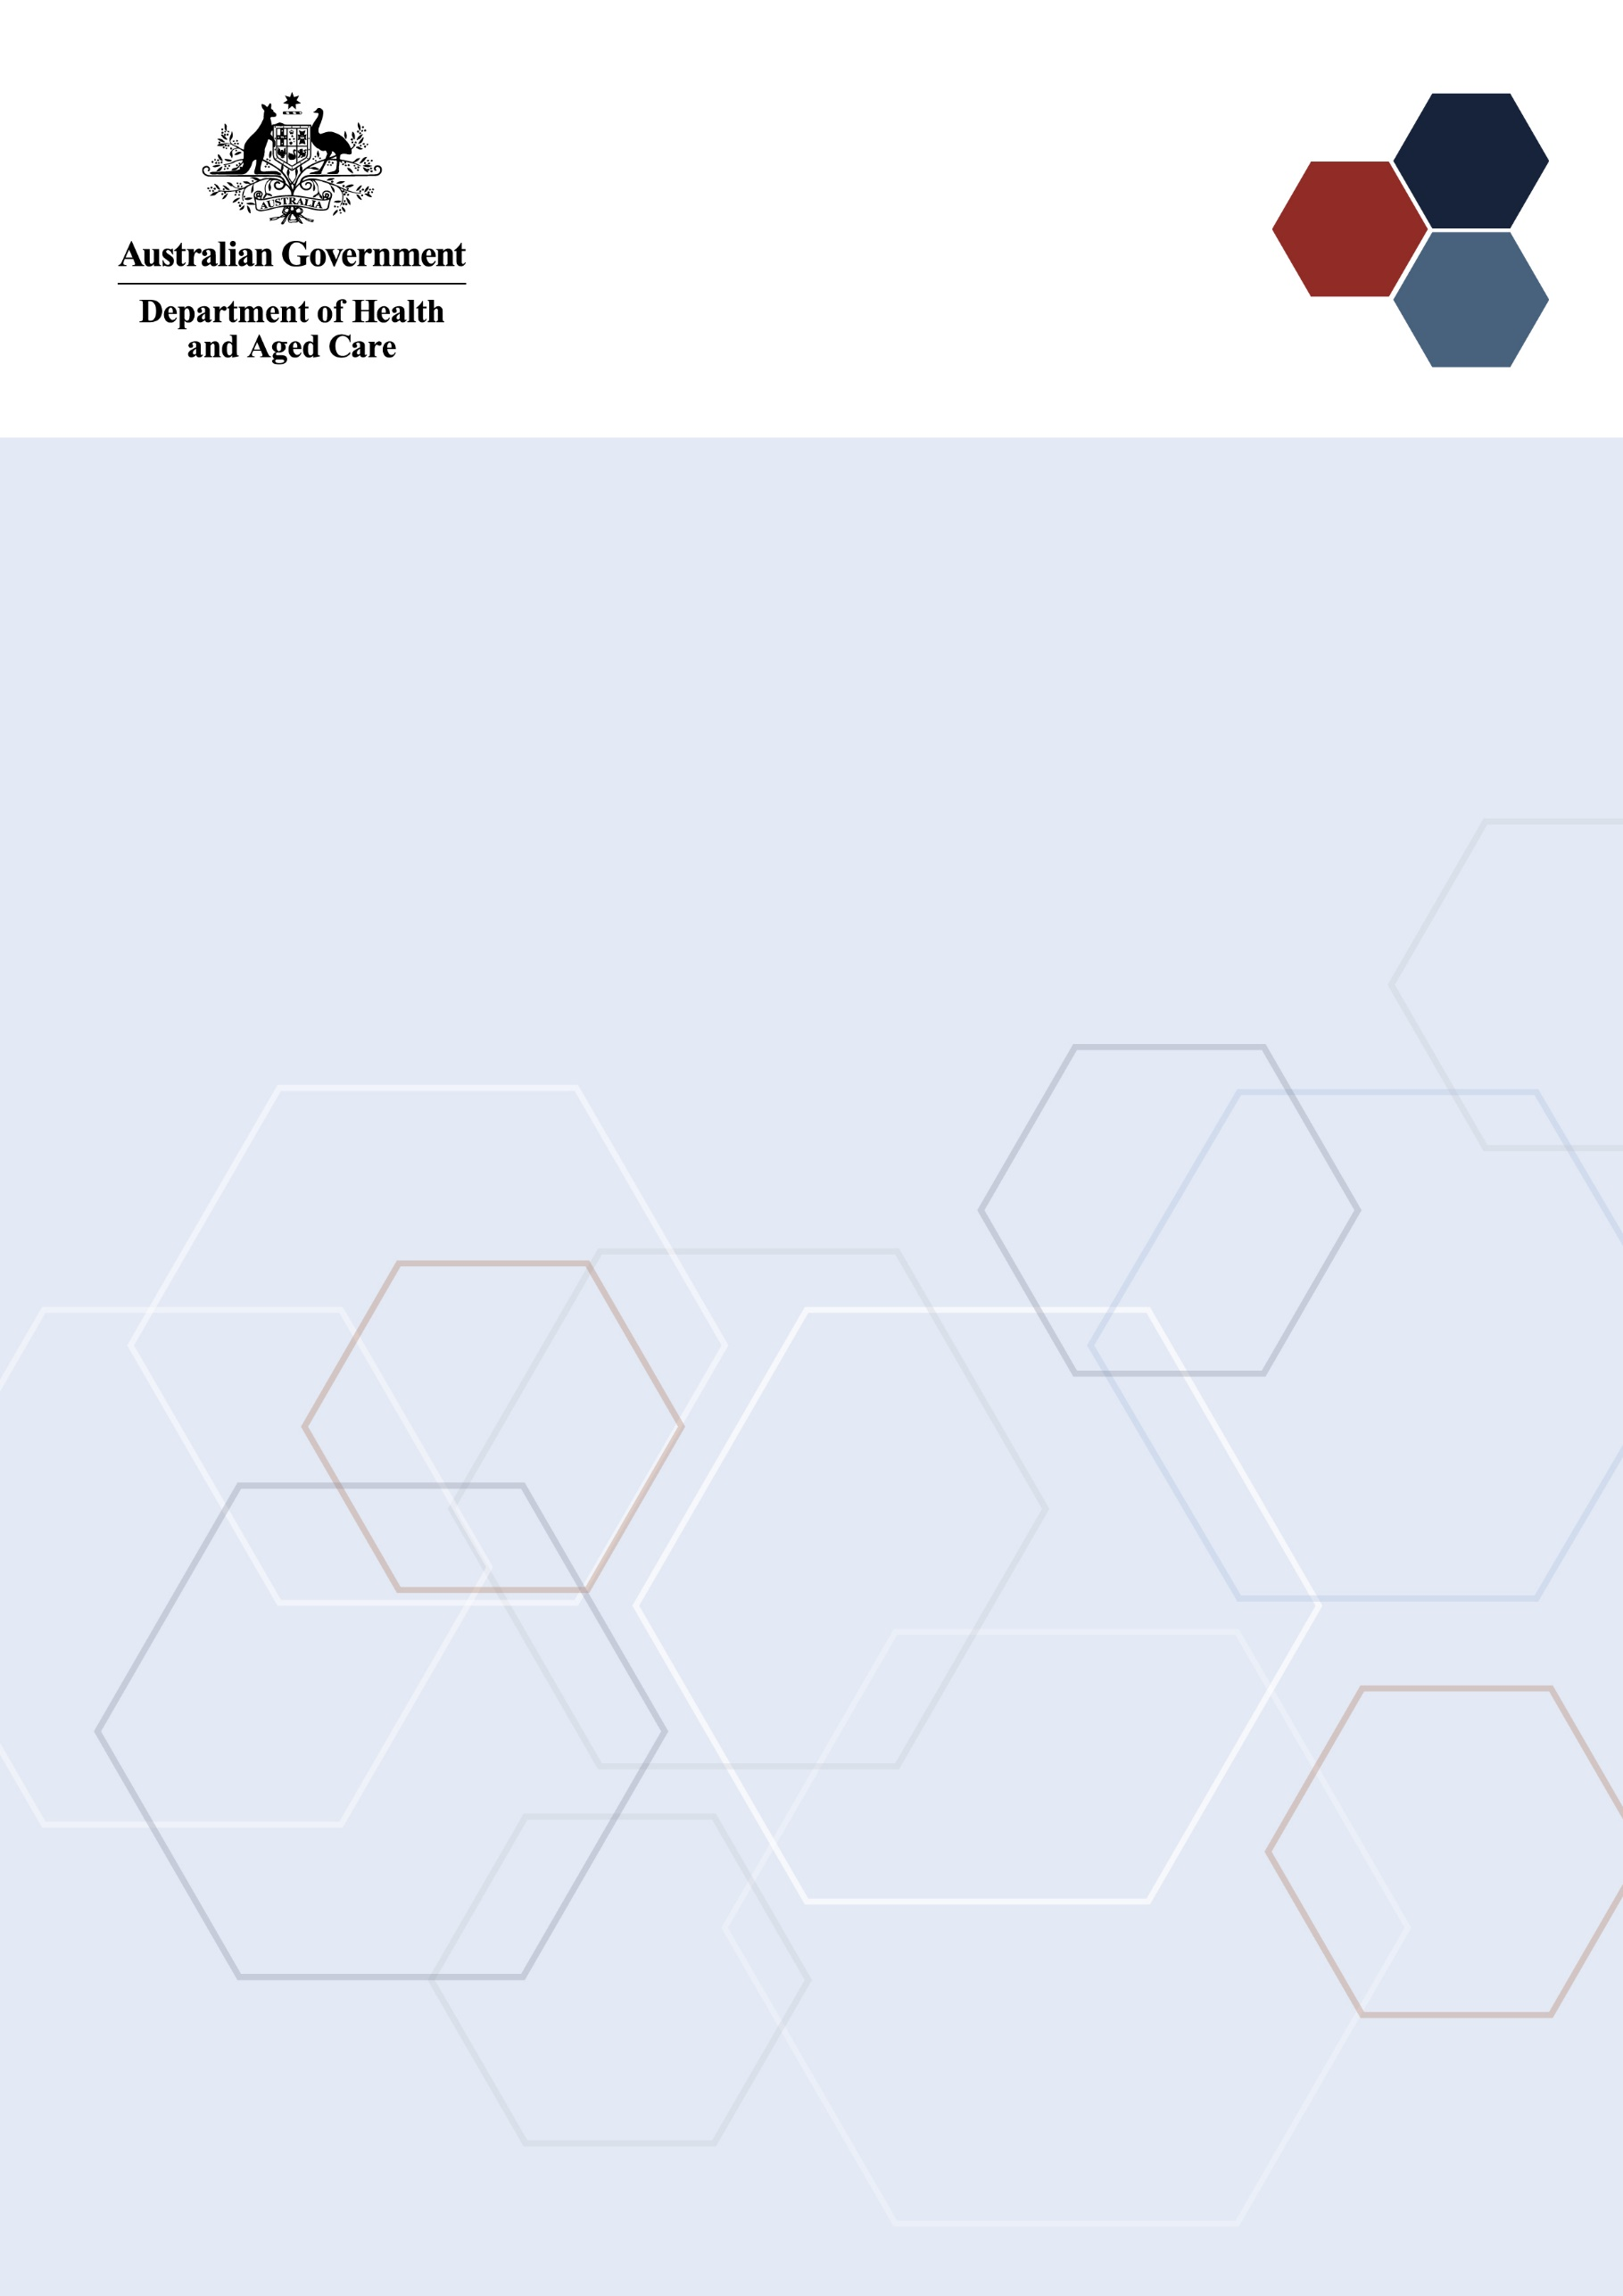Medical Research  
Future Fund

Data about the MRFF - 2021 Early to Mid-Career Researchers Grant Opportunity Outcomes

**April 2023**

# Contents

Contents i

Introduction 1

Summary of funding awarded from the 2021 Early to Mid-Career Researchers Grant Opportunity 3

Progression of applications through the 2021 Early to Mid-Career Researchers Grant Opportunity 4

Topics of Research by Stream 5

Applications by broad research area by Stream 5

Applications by Fields of Research by Stream 6

Characteristics of Chief Investigators 7

Gender of CIA 7

Years post-PhD of CIA 8

First Nations CI status 9

Size of CI teams 9

Gender of CI teams 9

Years post-PhD of CI teams 10

Applications by states and territories 11

Applications by organisation 12

Appendix A. The MRFF Early to Mid-Career Researcher Initiative 13

Appendix B. Table of grants awarded 14

Appendix C. Focus of the 2023 Early to Mid-Career Researchers Grant Opportunity 16

Glossary 17

# Introduction

Early to Mid-Career Researchers (EMCR) are researchers in the first 10 years of employment since completing postgraduate research training. The Medical Research Future Fund (MRFF) [Early to Mid-Career Researchers initiative](https://www.health.gov.au/our-work/early-to-mid-career-researchers-initiative?language=en) will invest $384.2 million over 10 years from 2022-23 in EMCRs. The EMCR initiative will aim to address the needs of emerging leaders by providing targeted funding that enables EMCRs to lead research projects as named investigators.

The first grant opportunity opened under the EMCR initiative was the 2021 Early to Mid-Career Researchers Grant Opportunity, which opened on 20 December 2021 and closed on 20 July 2022. A total of 23 grants have been awarded to a combined value of $42.8 million by the 2021 Early to Mid-Career Researchers Grant Opportunity. Full details of the 2021 grant opportunity including the Grant Opportunity Guidelines are available on [GrantConnect](https://www.grants.gov.au/Go/Show?GoUuid=dfbdbdbe-c2c6-4001-9faf-5ef47fb1e137&keyword=GO5339).

**The objective of** **the 2021 Early to Mid-Career Researchers Grant Opportunity**

Consistent with the *Medical Research Future Fund Act 2015*, the objective of this grant opportunity is to provide grants of financial assistance to support Australian medical research and medical innovation projects that:

* Stream 1 (Incubator): conduct early stage, small scale research, led by early-career researchers, that seeks to assess the potential and feasibility of novel strategies to address a critical or intractable health issue.
* Stream 2 (Accelerator): establish a large-scale interdisciplinary research program, led by mid-career researchers, that drives implementation of substantial improvements to health care and/or health system effectiveness.
* Stream 3 (Targeted Call for Research): utilise co-funding between the MRFF, a sponsoring academic organisation and partner organisation(s) to accelerate translation of research led by early to mid-career researchers.

Each Stream had specific eligibility requirements for the career stage of the CI team that were specified in the [Grant Opportunity Guidelines](https://www.grants.gov.au/Go/Show?GoUuid=dfbdbdbe-c2c6-4001-9faf-5ef47fb1e137&keyword=GO5339) . Additionally, each stream used a different MRFF grant model.

**Eligibility for the 2021 EMCR Grant Opportunity**

For the purpose of the 2021 Early to Mid-Career Researchers Grant Opportunity:

* an early-career researcher is defined as an individual who is within five years post PhD (i.e., within five years of their PhD conferral date), excluding career disruptions.
* a mid-career researcher is defined as an individual who is between five and ten years post PhD (i.e., between five and ten years of their PhD conferral date), excluding career disruptions

The 2021 Early to Mid-Career Researchers Grant Opportunity was designed to support teams of EMCRs working on projects together and to encourage EMCRs to collaborate and embed a wider range of perspectives in health and medical research.

Stream 1 of this Grant Opportunity supported ECRs by having the CIA who is an ECR working along a team of CIs comprised of at least 80% ECRs. Stream 2 supported teams of MCRs to establish large-scale interdisciplinary research programs by having the CIA who is an MCR working along a team of CIs comprised of at least 80% MCRs and provided funding for up to 5 years. The CIA on Stream 3 applications had to be an EMCR, but more experienced researchers could be part of the CI team.

* Stream 1 used the [Incubator model](https://www.health.gov.au/resources/publications/mrff-incubator-grants) and allowed grants between $200,000 and $1.0 million with a maximum duration of two years. Up to $7.0 million was allocated to Stream 1.
* Stream 2 used the [Accelerator model](https://www.health.gov.au/resources/publications/mrff-accelerator-grants?language=en) and allowed grants between $3.0 million and $5.0 million with a maximum duration of 5 years. Up to $25.8 million was allocated to Stream 2.
* Stream 3 used the Targeted Call for Research model and required co-funding. The MRFF will contribute 50% (up to $2.0 million) of overall project costs with a maximum duration of four years. Additional details about the co-funding requirements are available in the Grant Opportunity Guidelines. In the analysis within this report only the contribution from the MRFF is listed. Up to $10 million was allocated to Stream 3.

For each Stream, applications were funded based on rank until the total funding available for the Stream had been reached. The remaining applications across all Streams were then pooled into a combined ranked merit list, with funding allocated until the total funding available for this grant opportunity was reached.

**The intended outcomes of the 2021 Early to Mid-Career Researchers Grant Opportunity**

The intended outcomes of the research funded by this grant opportunity is to improve the health and wellbeing of Australians by:

* Stream 1 - supporting early-career researchers to develop innovative solutions for addressing significant health challenges.
* Stream 2 - supporting mid-career researchers to transform health practice and/or policy.
* Stream 3 - supporting early to mid-career researchers to translate new therapies and/or products into practice.

**2023** **Early to Mid-Career Researchers Grant Opportunity**

Up to $44.8 million of funding is available over 5 years from 2023-24 from the [2023 Early to Mid-Career Researchers Grant Opportunity](https://www.grants.gov.au/Go/Show?GoUuid=02f5570e-16a1-4def-af34-e25773bd578c) which opened on 15 February 2023 and will close on 21 June 2023.

See Appendix A for further details of the MRFF Early to Mid-Career Researchers initiative.

# Summary of funding awarded from the 2021 Early to Mid-Career Researchers Grant Opportunity

The grant opportunity was well subscribed and received 418 eligible applications. A total of 23 grants have been awarded to a combined value of $42.8 million by the 2021 Early to Mid-Career Researchers Grant Opportunity. Table 1 provides a breakdown of the funded amounts by Stream and Appendix B lists details of all funded applications.

Table 1 – Grants awarded

|  |  |  |  |  |  |
| --- | --- | --- | --- | --- | --- |
| Stream | Number of grants awarded | Total amount awarded | Mean amount awarded | Highest amount | Lowest amount |
| Stream 1 | 9 | $6,416,096 | $712,900 | $958,404 | $289,870 |
| Stream 2 | 6 | $28,196,959 | $4,699,493 | $4,899,779 | $4,063,177 |
| Stream 3 | 8 | $8,186,945 | $1,023,368 | $1,589,171 | $590,135 |
| All Streams | 23 | $42,800,000 | $1,860,870 | $4,899,779 | $289,870 |

Figure 1 shows the proportion of funding awarded against the criteria of Broad Research Area, gender and years post-PhD completion of CIA[1], and state or territory of the eligible organisation. Further details of these and other aspects are discussed within the report.

Figure 1 – Proportion of funding awarded by different characteristics

1. Broad Research Area

Clinical medicine and science research 56%
Health services research 20%
Public health research 13%
Basic science research 11%

1. Gender of lead chief investigator (CIA)

Woman 60%
Man 40%

1. Years post-PhD of lead chief investigators (CIA) - without adjustment for career disruption

6 to 10 years 46%
0 to 5 years 28%
Over 10 years 26%

1. States and territories

Vic 31%
WA 25%
Qld 20%
NSW 18%
ACT 4%
SA 2%

# Progression of applications through the 2021 Early to Mid-Career Researchers Grant Opportunity

Applications for funding under the MRFF undergo rigorous assessment processes by an independent [grant assessment committee (GAC)](https://www.health.gov.au/resources/publications/mrff-grant-assessment-committees?language=en). The 2021 Early to Mid-Career Researchers Grant Opportunity was administered by the National Health and Medical Research Council (NHMRC) and 187 independent experts were involved in the assessment of this grant opportunity. The grant opportunity was well subscribed and received 428 applications, which demonstrates the significant demand amongst early to mid-career researchers for funding that allows them to lead research projects. Ten applications were found to be ineligible based on the criteria outlined in the Grant Opportunity Guidelines.

The eligible applications underwent initial assessment and scoring by 3 independent experts. A total of 99 eligible applications progressed for consideration by the GAC (Figure 2 displays the numbers per Stream). The number of applications that advanced to the GAC was determined to ensure that the combined value of the requested budgets in each Stream represented at least 1.5 times the available funding for that Stream. After full assessment and scoring at the GAC, 33 applications did not meet the minimum score and overall value and risk rating required to receive MRFF funding.[2]

Figure 2 – Number of applications at each stage

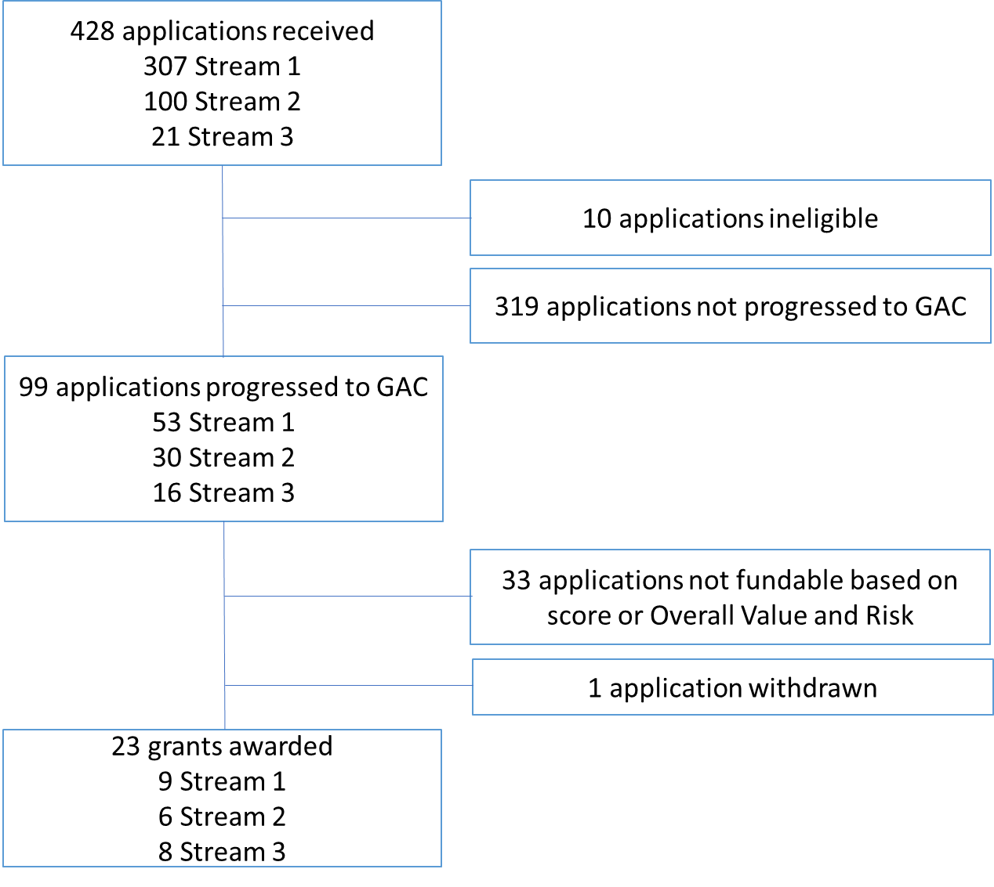

For each Stream, applications were funded based on rank (as assessed by the GAC) until the total funding available for the Stream had been reached. The remaining applications across all Streams were then pooled into a combined ranked merit list, with funding allocated until the total funding available for this grant opportunity was reached. An additional application from Stream 2 was funded through this process resulting in the total value awarded from this Stream being higher than the allocation (see Table 2).[3] The 2021 Early to Mid-Career Researchers Grant Opportunity led to the award of 23 grants with a total value of $42.8 million.

Table 2 – Number of applications received and considered by the GAC, and grants awarded per Stream

|  |  |  |  |  |  |  |  |
| --- | --- | --- | --- | --- | --- | --- | --- |
| **Stream** | Number of applications | **Number assessed at GAC** | Number of grants awarded | Overall  funded rate | Funded rate after GAC | Stream Allocation | Amount awarded |
| Stream 1 | 307 | 53 | 9 | 2.9% | 17.0% | $7 M | $6,416,096 |
| Stream 2 | 100 | 30 | 6 | 6.0% | 20.0% | $25.8 M | $28,196,959[4] |
| Stream 3 | 21 | 16 | 8 | 38.1% | 50.0% | $10 M | $8,186,945 |
| All Streams | 428 | 99 | 23 | 5.4% | 23.2% | $42.8 M | $42,800,000 |

# Topics of Research by Stream

The 3 Streams of the 2021 Early to Mid-Career Researchers Grant Opportunity were designed to support EMCR researchers across a range of scientific topics. Each Stream had a somewhat different focus as specified by the objectives and outcomes for that Stream, and different potential grant sizes and grant periods.

## Applications by broad research area by Stream

Grants awarded from the 2021 Early to Mid-Career Researchers Grant Opportunity covered all 4 broad areas of research. The largest proportion of funding was awarded to Clinical Medicine and Science Research, representing 56% of all funding awarded. Stream 1 funded grants for Basic Science and Clinical Medicine and Science Research, while Stream 2 funded grants for Clinical Medicine and Science, Health Services and Public Health research (Table 3).

Table 3 – Grants awarded by broad area of research per Stream

|  |  |  |  |  |  |  |  |  |
| --- | --- | --- | --- | --- | --- | --- | --- | --- |
| **Broad Research Area** | **Stream 1** | | **Stream 2** | | **Stream 3[5]** | | **All grants** | |
| **Grants awarded** | **Amount** | **Grants awarded** | **Amount** | **Grants awarded** | **Amount** | **All awarded** | **Total amount** |
| Basic Science Research | 4 | $2,976,114 | 0 | $0 | 2 | $1,580,156 | 6 | $4,556,270 |
| Clinical Medicine and Science Research | 5 | $3,439,982 | 3 | $14,674,963 | 5 | $5,801,533 | 13 | $23,916,479 |
| Health Services Research | 0 | $0 | 2 | $8,767,812 | 0 | $0 | 2 | $8,767,812 |
| Public Health Research | 0 | $0 | 1 | $4,754,183 | 1 | $805,256 | 2 | $5,559,439 |
| All research areas | 9 | $6,416,096 | 6 | $28,196,959 | 8 | $8,186,945 | 23 | $42,800,000 |

The largest number of applications (193) were submitted on the area of Clinical Medicine and Science Research, with most (129) of these being submitted to Stream 1 (Table 4).

Table 4 - Applications by broad area of research and funding rate by broad research area

|  |  |  |  |  |
| --- | --- | --- | --- | --- |
| Broad Research Area | Stream 1 applications  (funded rate) | Stream 2 applications  (funded rate) | Stream 3 applications  (funded rate) | All applications  (funded rate) |
| Basic Science Research | 72 (5.6%) | 8 (0 %) | 3 (66.7%) | 83 (7.2%) |
| Clinical Medicine and Science Research | 129 (3.9%) | 49 (6.1%) | 15 (33.3%) | 193 (6.7%) |
| Health Services Research | 70 (0%) | 26 (7.7%) | 1 (0) | 97 (2.1%) |
| Public Health Research | 36 (0%) | 17 (5.9%) | 2 (50.0%) | 55 (3.6%) |

## Applications by Fields of Research by Stream

Grants were awarded across 9 different Fields of Research[6] with the largest number of grants being awarded within clinical sciences (9 grants), followed by public health and health services (4 grants). The largest number of applications were received within these two Fields of Research, with 105 and 97 applications, respectively (see Table 5). Applications received by the 2021 Early to Mid-Career Researchers Grant Opportunity covered 29 Fields of Research (see Table 5 and 6).

Table 5 – Number of applications for Fields of Research per Stream

|  |  |  |  |  |  |  |
| --- | --- | --- | --- | --- | --- | --- |
| **Field of Research** | **Stream 1** | | **Stream 2** | | **Stream 3** | |
| **Applications** | **Grants awarded** | **Applications** | **Grants awarded** | **Applications** | **Grants awarded** |
| Biomedical engineering | 0 | 0 | 0 | 0 | 2 | 1 |
| Cardiorespiratory medicine and haematology | 24 | 1 | 0 | 0 | 2 | 1 |
| Clinical sciences | 79 | 3 | 22 | 3 | 4 | 3 |
| Genetics | 7 | 1 | 4 | 1 | 0 | 0 |
| Medical biotechnology | 8 | 1 | 0 | 0 | 1 | 1 |
| Medical microbiology | 5 | 1 | 0 | 0 | 0 | 0 |
| Pharmacology and pharmaceutical sciences | 8 | 1 | 0 | 0 | 0 | 0 |
| Paediatrics and reproductive medicine | 0 | 0 | 0 | 0 | 3 | 1 |
| Public health and health services | 64 | 1 | 31 | 2 | 2 | 1 |

Table 6 - Number of applications for Fields of Research where no grants were awarded

|  |  |  |
| --- | --- | --- |
| **Field of Research** | **Applications** | **Grants awarded** |
| Neurosciences | 23 | 0 |
| Oncology and carcinogenesis | 23 | 0 |
| Psychology | 16 | 0 |
| Biochemistry and cell biology | 7 | 0 |
| Immunology | 7 | 0 |
| Nursing | 6 | 0 |
| Human movement and sports science | 5 | 0 |
| Applied economics | 4 | 0 |
| Ophthalmology and optometry | 4 | 0 |
| Dentistry | 3 | 0 |
| Medical biochemistry and metabolomics | 3 | 0 |
| Cognitive science | 2 | 0 |
| Library and information studies | 2 | 0 |
| Nanotechnology | 2 | 0 |
| Nutrition and dietetics | 2 | 0 |
| Statistics | 2 | 0 |
| Econometrics | 1 | 0 |
| Medical physiology | 1 | 0 |
| Medicinal and biomolecular chemistry | 1 | 0 |
| Other medical and health sciences | 1 | 0 |

# Characteristics of Chief Investigators

## Gender of CIA

An almost even number of grants were awarded based on the gender of the CIA with 12 grants awarded to women and 11 grants awarded to men. The funded rate was somewhat higher for men, however the total value of the grants awarded to women was higher (see Table 7). The MRFF 2021 Early to Mid-Career Researchers Grant Opportunity received a large proportion of applications led by women (61%).

Table 7 – Gender of CIA on applications and awarded grants

|  |  |  |  |  |  |  |  |
| --- | --- | --- | --- | --- | --- | --- | --- |
| Gender | Applications | Grants awarded | Funded rate | Total amount | Proportion of grants awarded | Proportion of $ awarded | Mean amount awarded |
| Woman or female | 255 | 12 | 4.7% | $25,470,903 | 52.2% | 59.5% | $2,122,575 |
| Man or male | 162 | 11 | 6.8% | $17,329,097 | 47.8% | 40.5% | $1,575,372 |
| Non-binary | 0 | - | - | - | - | - | - |
| Not reported | 1 | 0 | 0 | $0 | 0 | 0 | 0 |
| All genders | 418 | 23 | 5.5% | $42,800,000 | 100% | 100% | $1,860,870 |

The analysis of gender was based on data provided by Chief Investigators (CIs) captured through self-identification as male or man, female or woman, non-binary, or not reported. No data on gender was provided for the 10 applications deemed ineligible. Data on gender were captured via the CIA's profile within the NHMRC grants management platform.

The differences between female and male chief lead investigators were not the same in the different Streams of the 2021 Early to Mid-Career Researchers Grant Opportunity. Men were awarded a greater number and value of grants from Stream 3 compared to women (see Table 8), but a markedly lower number and value for Streams 1 and 2.

Table 8 - Gender of CIA on applications (apps) and awarded grants by Stream

|  |  |  |  |  |  |  |  |  |  |
| --- | --- | --- | --- | --- | --- | --- | --- | --- | --- |
| **Gender CIA** | **Stream 1** | | | **Stream 2** | | | **Stream 3** | | |
| **Apps** | **Grants awarded** | **Total amount** | **Apps** | **Grants awarded** | **Total value** | **Apps** | **Grants awarded** | **Total amount** |
| Woman or female | 191 | 5 | $4,086,814 | 57 | 4 | $18,399,528 | 7 | 3 | $2,984,562 |
| Man or male | 111 | 4 | $2,329,283 | 42 | 2 | $9,797,431 | 9 | 5 | $5,202,383 |
| Non-binary | 0 | - | - | 0 | - | - | 0 | - | - |
| Not reported | 1 | 0 | $0 | 0 | - | - | 0 | - | - |

## Years post-PhD of CIA[7]

The largest proportion (46%) of the available funding was awarded to individuals who were between 5 and 10 years post-PhD completion. The largest number of grants was awarded to individuals who had completed their PhDs less than 5 years ago (Table 9).

The years post-PhD in Tables 9 and 10 have not been adjusted to account for career disruption, so some of the individuals in the 6 to 10 category will have had career disruptions that qualify them as ECRs. All the individuals in the over 10 years category will have had career disruptions that qualify them as MCRs.

Table 9 – Years post PhD of CIA (without career disruption)

|  |  |  |  |  |  |  |  |
| --- | --- | --- | --- | --- | --- | --- | --- |
| Years post-PhD | Applications | Grants awarded | Funded rate | Total value | Proportion of grants awarded | Proportion of $ awarded | Mean value |
| 0 to 5 | 284 | 12 | 4.2% | $12,046,000 | 52.2% | 28.1% | $1,003,833 |
| 6 to 10 | 110 | 8 | 7.3% | $19,582,661 | 34.8% | 45.8% | $2,447,833 |
| Over 10[8] | 18 | 3 | 16.7% | $11,171,339 | 13.0% | 26.1% | $3,723,780 |

The CIA for Stream 3 could be an ECR or an MCR, and at least two grants from Stream 3 are being led by early-career researchers (see Table 10). All CIAs awarded funding from Stream 1 had been awarded their PhD less than 5 years ago without adjustment for career disruption.

Table 10 – Years post PhD of CIA (without career disruption)[9] on applications (apps) and awarded grants by Stream

|  |  |  |  |  |  |  |  |  |  |
| --- | --- | --- | --- | --- | --- | --- | --- | --- | --- |
| **Years post-PhD** | **Stream 1** | | | **Stream 2** | | | **Stream 3** | | |
| **Apps** | **Grants awarded** | **Mean amount** | **Apps** | **Grants awarded** | **Mean amount** | **Apps** | **Grants awarded** | **Mean amount** |
| 0 to 5 | 272 | 9 | $712,900 | 6 | 1 | $4,063,177 | 6 | 2 | $783,364 |
| 6 to 10 | 23 | 0 | 0 | 78 | 3 | $4,850,538 | 9 | 5 | $1,006,209 |
| Over 10 | 2 | 0 | 0 | 15 | 2 | $4,791,084 | 1 | 1 | $1,589,171 |
| Not reported | 6 | 0 | 0 | - | - | - | - | - | - |

## First Nations CI status

Three applications with First Nations CIAs were received but none of these applications were awarded funding. A total of 31 First Nations CIs were included in the applications, of which 1 became a CI on an awarded grant. One project focussed on First Nations health. See Appendix B.

## Size of CI teams

The largest number of grants were awarded to teams with between 6 and 10 members (see Table 11). All grants from Stream 2 had a team of more than 5 CIs, which is in line with the objective of Stream 2 (see page 1).

Table 11 – Team size on applications (apps) and awarded grants by Stream

|  |  |  |  |  |  |  |  |  |  |
| --- | --- | --- | --- | --- | --- | --- | --- | --- | --- |
| **Team size** | **Stream 1** | | | **Stream 2** | | | **Stream 3** | | |
| **Apps** | **Grants awarded** | **Funded rate** | **Apps** | **Grants awarded** | **Funded rate** | **Apps** | **Grants awarded** | **Funded rate** |
| 1-5 | 180 | 5 | 2.8% | 25 | 0 | 0 | 4 | 2 | 50.0% |
| 6-10 | 100 | 4 | 4.0% | 52 | 4 | 7.7% | 3 | 3 | 100% |
| 11-15 | 23 | 0 | 0 | 22 | 2 | 9.1% | 9 | 3 | 33.3% |

## Gender of CI teams

Of the CI teams who were awarded funding, 99 CIs were women, and 79 CIs were men. Data on gender was not reported for 8 CIs who were awarded funding (Table 12). Two CIs included on applications were non-binary, but these applications were not awarded funding.

Table 12 – Gender of the CI team

|  |  |  |  |  |
| --- | --- | --- | --- | --- |
| Gender | CIs on Applications | CIs on grants awarded | Funded rate | Proportion of CIs awarded |
| Woman or female | 1578 | 99 | 6.3% | 53.2% |
| Man or male | 994 | 79 | 8.0% | 42.5% |
| Non-binary | 2 | 0 | 0 | 0 |
| Not reported | 109 | 8 | 7.3% | 4.3% |
| All genders | 2683 | 186 | 6.9% | 100% |

The analysis of gender was based on data provided by Chief Investigators (CIs) captured through self-identification as male or man, female or woman, non-binary, or not reported. Data on gender were captured via the CIA's profile within the NHMRC grants management platform.

## Years post-PhD of CI teams

Over 80% of the 186 CIs who received funding through the 2021 Early to Mid-Career Researchers Grant Opportunity had completed their PhDs less than 11 years ago. In Figure 3 many of the researchers who are close to 10 years post-PhD will have declared career disruptions and qualified as MCRs. The CIA on Stream 3 applications had to be an ECR or MCR, however more experienced researchers could be part of the CI team in other positions.

Figure 3 - Years post-PhD of CI team members on awarded grants, unadjusted for career disruption

# Applications by states and territories

Applications were received from eligible organisations from all states and territories. The highest proportion of grants was awarded to researchers from Queensland; however, the highest proportion of funding was awarded to researchers from Victoria (see Table 13).

Table 13 - Applications and grants by states and territories

|  |  |  |  |  |  |  |  |
| --- | --- | --- | --- | --- | --- | --- | --- |
| State / Territory | Applications | Grants awarded | Funded rate | Total amount | Proportion of grants awarded | Proportion of $ awarded | Mean amount |
| ACT | 4 | 1 | 25.0% | $1,553,569 | 4.4% | 3.6% | $1,553,569 |
| NSW | 149 | 5 | 3.4% | $7,796,091 | 21.7% | 18.2% | $1,559,218 |
| NT | 3 | 0 | 0 | $0 | 0 | 0 |  |
| QLD | 77 | 7 | 9.1% | $8,727,368 | 30.4% | 20.4 % | $1,246,767 |
| SA | 26 | 1 | 3.9% | $758,438 | 4.4% | 1.8% | $758,438 |
| TAS | 4 | 0 | 0 | $0 | 0 | 0 |  |
| VIC | 144 | 6 | 4.2% | $13,352,738 | 26.1% | 31.2% | $2,225,456 |
| WA | 21 | 3 | 14.3% | $10,611,797 | 13.0% | 24.8% | $3,537,266 |
| All states and territories | 428 | 23 | 5.4% | $42,800,000 | 100% | 100% | $1,860,870 |

# Applications by organisation

Applications were received from 42 different eligible organisations. Grants were awarded to 12 different organisations.

Table 14 – Applications and grants by eligible organisation

|  |  |  |  |
| --- | --- | --- | --- |
| **Organisations** | **Applications** | **Grants** | **Total value** |
| University of Sydney | 57 | 3 | $2,136,508 |
| The University of Queensland | 53 | 5 | $7,676,026 |
| University of Melbourne | 45 | 1 | $4,897,653 |
| University of New South Wales | 44 | 2 | $5,659,583 |
| Monash University | 39 | 4 | $7,884,341 |
| The University of Newcastle | 23 | 0 | $0 |
| Murdoch Children's Research Institute | 16 | 0 | $0 |
| Deakin University | 14 | 0 | $0 |
| Flinders University | 11 | 0 | $0 |
| The University of Adelaide | 10 | 1 | $758,438 |
| Griffith University | 9 | 1 | $761,471 |
| University of Western Australia | 9 | 2 | $9,631,715 |
| University of Technology Sydney | 8 | 0 | $0 |
| Curtin University | 7 | 1 | $980,081 |
| The Council of the Queensland Institute of Medical Research | 6 | 1 | $289,870 |
| The Walter and Eliza Hall Institute of Medical Research | 6 | 0 | $0 |
| Western Sydney University | 6 | 0 | $0 |
| La Trobe University | 5 | 0 | $0 |
| Macquarie University | 5 | 0 | $0 |
| Queensland University of Technology | 5 | 0 | $0 |
| University of Wollongong | 5 | 0 | $0 |
| Baker Heart and Diabetes Institute | 4 | 0 | $0 |
| Edith Cowan University | 4 | 0 | $0 |
| RMIT University | 4 | 0 | $0 |
| University of South Australia | 4 | 0 | $0 |
| University of Tasmania | 4 | 0 | $0 |
| Burnet Institute | 3 | 0 | $0 |
| Menzies School of Health Research | 3 | 0 | $0 |
| Australian National University | 2 | 1 | $1,553,569 |
| Central Queensland University | 2 | 0 | $0 |
| Commonwealth Scientific and Industrial Research Organisation | 2 | 0 | $0 |
| Swinburne University of Technology | 2 | 0 | $0 |
| Victoria University | 2 | 0 | $0 |
| Australian Catholic University | 1 | 0 | $0 |
| Cancer Council Victoria | 1 | 0 | $0 |
| Centre for Eye Research Australia Limited | 1 | 0 | $0 |
| Institute for Breathing and Sleep | 1 | 0 | $0 |
| James Cook University | 1 | 0 | $0 |
| Murdoch University | 1 | 0 | $0 |
| Royal Brisbane and Women's Hospital Foundation | 1 | 0 | $0 |
| South Australian Health and Medical Research Institute Limited | 1 | 0 | $0 |
| St Vincent's Institute of Medical Research | 1 | 1 | $570,744 |
| All Organisations | 428 | 23 | $42,800,000 |

# Appendix A. The MRFF Early to Mid-Career Researcher Initiative

The Medical Research Future Fund (MRFF) is a $20 billion long-term investment supporting Australian health and medical research. The MRFF aims to transform health and medical research and innovation to improve lives, build the economy and contribute to health system sustainability.

Early to Mid-Career Researchers (EMCR) are researchers in the first 10 years of employment since completing postgraduate research training (excluding career disruptions). The Department started consultation with EMCRs in early 2021 to find out what might support the next generation of health and medical research leaders to meet the challenges of improving the health of Australians. Subsequently two roundtables were held, and the outcomes were published on the Department’s website.

* [MRFF Health and Medical Research Early to Mid-Career Researchers Roundtable – 6 May 2021](https://www.health.gov.au/resources/publications/mrff-health-and-medical-research-early-to-mid-career-researchers-roundtable-6-may-2021?language=en)
* [MRFF Health Early to Mid-Career Researchers Stakeholder Roundtable – 14 October 2021](https://www.health.gov.au/resources/publications/mrff-health-early-to-mid-career-researchers-stakeholder-roundtable-14-october-2021?language=en#:%7E:text=Description%3A,roundtable%20on%2014%20October%202021.)

These consultations helped shape the Early to Mid-Career Researchers initiative which was [announced as part of the 2nd 10-year Investment Plan for the Medical Research Future Fund](https://www.health.gov.au/resources/publications/new-mrff-funding-empowers-early-to-mid-career-researchers-to-tackle-significant-health-challenges?language=en). The Early to Mid-Career Researchers initiative is one of 21 initiatives under the [2nd 10-year plan of the MRFF](https://www.health.gov.au/resources/collections/medical-research-future-fund-mrff-2nd-10-year-investment-plan-2022-23-to-2031-32).

The Early to Mid-Career Researchers initiative will invest $384.2 million over 10 years from 2022-23 in early to mid-career researchers (EMCRs). The EMCR initiative will address the need of emerging leaders by providing targeted funding that enables EMCRs to lead research projects as named investigators. The funding will also encourage EMCRs to collaborate and embed a wider range of perspectives in health and medical research. The initiative will build and grow research capacity and capability in Australia by supporting EMCRs to continue their health and medical research careers.

This initiative will support emerging health and medical research leaders to:

* make breakthrough discoveries
* address intractable health issues
* accelerate research translation
* develop their skills and progress their careers in Australia

This initiative provides dedicated funding streams to capitalise on the new ideas and emerging talent of EMCRs by enabling them to:

* address significant health challenges
* undertake novel research
* develop new ideas and approaches

There are 3 streams within this initiative:

1. $84 million for early career researchers to develop and test novel solutions for challenging health issues. The incubator grants model will support early-stage small-scale research projects
2. $206 million for mid-career researchers to lead large interdisciplinary teams to drive improvements in health care and/or the health system. The accelerator grants model will fund large-scale programs of work
3. $95 million for EMCRs to lead co-funded projects that will accelerate the translation of research outcomes. The targeted call for research model will support collaboration and translation into practice.

# Appendix B. Table of grants awarded

|  |  |  |  |
| --- | --- | --- | --- |
| Project | Recipient | Funding | Stream |
| Treatment of Obsessive-Compulsive Disorder with Transcranial Focused Ultrasound | The Council of the Queensland Institute of Medical Research | $289,870.25 | 1 |
| Broad-spectrum vaccine design for flaviviruses and henipaviruses | The University of Queensland | $936,701.61 | 1 |
| Running for Health: community-based adaptive exercise for cardiorespiratory health in young people with moderate to severe cerebral palsy | The University of Queensland | $768,886.64 | 1 |
| Plasma Flush- translating cold plasma technology as an antimicrobial wound irrigation towards clinical trials | The University of Adelaide | $758,437.60 | 1 |
| Reducing medication-related harm in people living with dementia through community action: Development and testing of novel codesigned medication management resources across care settings | University of Sydney | $664,384.24 | 1 |
| Repurposing approved drugs for Friedreich’s ataxia heart disease | St Vincent's Institute of Medical Research | $570,744.47 | 1 |
| Developing a promoter-less gene therapy approach for haemophilia A | University of Sydney | $513,720.11 | 1 |
| Harnessing nanopore sequencing technology to improve diagnosis of human disease | University of New South Wales | $954,947.75 | 1 |
| Learning health systems approach to the diagnosis and management of lower respiratory tract infections in children | University of Sydney | $958,403.57 | 1 |
| MandEval: Effectiveness and Consequences of Australia's COVID-19 Vaccine Mandates | University of Western Australia | $4,754,183.37 | 2 |
| A national critical care research platform to ensure high-quality sepsis care in Australian ICU’s | Monash University | $4,899,778.81 | 2 |
| Transition Compass - Optimising transition from paediatric to adult healthcare services: A randomised controlled trial | University of New South Wales | $4,704,635.53 | 2 |
| The missing heritability of human disease: discovery to implementation | University of Western Australia | $4,877,532.00 | 2 |
| MEGA-dose aSCORbatE for Sepsis (MEGASCORES): An interdisciplinary research program to transform management of sepsis in intensive care units | University of Melbourne | $4,897,652.65 | 2 |
| Obstructive sleep apnoea diagnosis and management in First Nations communities: community co-design, local capacity building and place-based models for sustainable success | The University of Queensland | $4,063,176.88 | 2 |
| Better biomarkers for dementia diagnosis: NfL and Voice Acoustic analysis In Dementia Diagnosis (NAVAIDD) | Monash University | $1,589,171.41 | 3 |
| A biological nerve bridge device for repairing spinal cord injury in humans | Griffith University | $761,471.40 | 3 |
| Personalising Innate-immunotherapy for Superior Treatment Outcomes with Large anticancer applicability (PISTOL) | The University of Queensland | $990,020.97 | 3 |
| Personalised medicine in the treatment of complex autoimmunity and autoinflammatory disease | Australian National University | $1,553,568.84 | 3 |
| “Max Up” Trial – Maximising uptake of lung cancer screening and smoking cessation outcomes | The University of Queensland | $917,239.91 | 3 |
| Expanded umbilical cord blood cells for neuroprotection in extremely preterm infants | Monash University | $590,134.71 | 3 |
| TRACKERx: Biomarkers to predicting relapse in early stage hepatocellular carcinoma | Curtin University | $980,081.41 | 3 |
| Zest – A personalised, digital intervention for sleep and wellbeing in Australian shift workers | Monash University | $805,255.87 | 3 |

# Appendix C. Focus of the 2023 Early to Mid-Career Researchers Grant Opportunity

The second grant opportunity under the Early to Mid-Career Researchers initiative is the 2023 Early to Mid-Career Researchers Grant Opportunity which opened on 15 February 2023 and will close on 21 June 2023. Outcomes are anticipated to be announced in Quarter 1 2024. Up to $44.8 million of funding is available over 5 years from 2023-24 from the 2023 EMCR Grant Opportunity.

The 2023 Early to Mid-Career Researchers Grant Opportunity includes a focus on Priority Populations, which is reflected in the objectives and intended outcomes of the 2023 grant opportunity. This focus has carried through to adjustments made to Streams 1 and 2 (but not Stream 3) of the grant opportunity, as follows (text new to the 2023 grant opportunity is underlined):

* Consistent with the *Medical Research Future Fund Act 2015*, the objective of this grant opportunity is to provide grants of financial assistance to support Australian medical research and medical innovation projects that:
  + Stream 1 (Incubator): conduct early stage, small scale research, led by early-career researchers, that seeks to assess the potential and feasibility of novel strategies to address a critical or intractable health issue in one or more Priority Populations.
  + Stream 2 (Accelerator): establish a large-scale interdisciplinary research program, led by mid-career researchers, that drives implementation of substantial improvements to health care and/or health system effectiveness for one or more Priority Populations.
* There has been no change in focus on Stream 3 in the 2023 grant opportunity, which is to:
  + Stream 3 (Targeted Call for Research): utilise co-funding between the MRFF, a sponsoring academic organisation and partner organisation(s) to accelerate translation of research led by early to mid-career researchers.[10]
    - Requiring commercialisation projects to focus on priority populations may increase challenges on the research team and risk delivery of the projects
    - The eligibility requirements for this Stream were also updated to ensure that at least 50% of all Chief Investigators must be early-career researchers or mid-career researchers.

For the purposes of the grant opportunity, Priority Populations are defined as Aboriginal and/or Torres Strait Islander people, older people experiencing diseases of ageing, people with rare or currently untreatable diseases/conditions, people in remote/rural communities, people with a disability, individuals from culturally and linguistically diverse communities, LGBTIQ+ people, and youth. These are the Priority Populations identified by AMRAB in the Australian Medical Research and Innovation Priorities 2022-24.

The 2023 Early to Mid-Career Researchers Grant Opportunity is intended to support excellent early and mid-career researchers to start, or continue to, focus on and build capacity in working with Priority Populations. Full details are available on [GrantConnect](https://www.grants.gov.au/Go/Show?GoUuid=dfbdbdbe-c2c6-4001-9faf-5ef47fb1e137&keyword=GO5339).

## Glossary

|  |  |
| --- | --- |
| **Term** | **Definition** |
| Career disruption | A prolonged interruption to an applicant’s capacity to work, due to pregnancy, major illness/injury or carer responsibilities. Interruptions must involve either a continuous absence from work for periods of 90 calendar days or more and/or a long-term partial return to work that has been formalised with the applicant’s employer. Full details are available in the Grant Opportunity Guidelines. |
| Early Career Researcher | An early-career researcher is defined as an individual who is within five years post PhD (i.e., within five years of their PhD conferral date), excluding career disruptions. |
| Eligible application | An application or proposal for services or grant funding under the program that the Program Delegate has determined is eligible for assessment in accordance with the relevant guidelines. |
| Eligible expenditure | The expenditure incurred by a grantee on a project, which is eligible for funding support as set out in section 4 of the Grant Opportunity Guidelines. |
| Eligible Organisation | An organisation that meets the eligibility requirements for receiving and administering MRFF funding and has been approved as an MRFF Eligible Organisation by NHMRC. |
| Mid-career Researcher | A mid-career researcher is defined as an individual who is between five and ten years post PhD (i.e., between five and ten years of their PhD conferral date), excluding career disruptions. |
| Grant activity/activities | Refers to the project/tasks/services that the grantee is required to undertake. |
| Grant agreement | Sets out the relationship between the parties to the agreement and specifies the details of the grant. |
| Grant funding or grant funds | The funding made available by the Australian Government to grantees under the program. |
| Grant Opportunity | Refers to the specific grant round or process where a Commonwealth grant is made available to potential grantees. A grant opportunity is aimed at achieving government policy outcomes under a Portfolio Budget Statement Program. |
| GrantConnect | The Australian Government’s whole-of-government grants information system, which centralises the publication and reporting of Commonwealth grants in accordance with the Commonwealth Grants Rules and Guidelines. |
| Grantee | The individual/organisation which has been selected to receive a grant. |
| Project | A project described in an application for grant funding under the grant opportunity. |

Health.gov.au

All information in this publication is correct as at April 2023

1. The analysis is based on the difference between the year of PhD awarded and the year the grant opportunity closed as captured on the NHMRC grants management platform. This period may include career disruptions. As a result, some researchers who completed their PhD more than 10 years ago may meet eligibility requirements as an early to mid-career researcher.
2. To be awarded MRFF funding applications must receive a score of 4 or higher against each of the weighted technical assessment criteria and rating of ‘Good’ or ‘Excellent’ for the non-weighted assessment criterion. See Section 7.1 Assessment of grant applications of the [Grant Opportunity Guidelines](https://www.grants.gov.au/Go/Show?GoUuid=dfbdbdbe-c2c6-4001-9faf-5ef47fb1e137&keyword=GO5339)
3. Information about funding allocations was provided in the Grant Opportunity Guidelines.
4. A greater amount of funding was awarded to Stream 2 than initially allocated due to an application in Stream 2 being the highest ranking application that had not received funding when the funds remaining from each Stream were pooled.
5. Only MRFF funding listed
6. Where multiple Fields of Research are nominated in the application, only the first/primary Field of Research is used in this analysis.
7. The analysis in this section is based on the difference between the year of PhD awarded and the year the grant opportunity closed as captured on NHMRC grants management platform. This is distinct to data used for eligibility and may include discrepancies due to rounding.
8. In order to be eligible as CIAs applicants who were more than 10 years post-PhD must have declared career disruption.
9. To be eligible as CIA, applicants who were >10 years post-PhD must have declared career disruption. The applicant awarded a grant from Stream 2 listed in the 0-5 years post-PhD category has a PhD date in 2017 and was ruled eligible based on the guidelines. It is the responsibility of the Eligible Organisation to certify that the Chief Investigators meet the definition of early-career researcher and mid-career researcher and holds evidence of their PhD conferral dates.
10. The co-funding arrangements under Stream 3 has been adjusted for the 2023 Grant Opportunity so that the sponsoring academic organisation and the partner organisation(s) will jointly contribute 50% or more of total project costs, rather than this being capped at 50%.