COVID-19 outbreaks in Australian residential aged care facilities

# National snapshot

As at 8:00 am 6 April 2023 there are 1,513 active COVID-19 cases in 234 active outbreaks in residential aged care facilities across Australia. There have been 121 new outbreaks, 20 new resident deaths and 1,207 combined new resident and staff cases reported since 30 March 2023.

Table 1: Aged Care COVID-19 data as at 8.00am 6 April 2023[1]

| Category | Active*[2]* | Previous  7 days | Cumulative  Total | Previous 7 days |
| --- | --- | --- | --- | --- |
| Outbreaks[3] | 234 | 49 | 13,615 | 121 |
| Residential Aged Care Facilities affected | 234 | 49 | 2,812 | 0 |
| Resident Cases[4] | 1078 | 188 | 133,698 | 856 |
| Resident Deaths | N/A | N/A | 5,204 | 20 |
| Staff Cases | 435 | 90 | 81,893 | 351 |

Residential aged care homes with active outbreaks are included in Appendix 1.

**Table 2: Overview of Active Outbreaks in Australia**

|  |  |  |  |  |  |  |  |  |  |
| --- | --- | --- | --- | --- | --- | --- | --- | --- | --- |
|  | ACT | NSW | NT | QLD | SA | TAS | VIC | WA | Total |
| Total Facilities with outbreaks | 2 | 77 | 1 | 42 | 27 | 3 | 57 | 25 | **234** |
| *Total number of active resident cases* | 19 | 429 | 4 | 184 | 93 | 20 | 203 | 126 | **1078** |
| *Total number of active staff cases* | 3 | 172 | 1 | 137 | 34 | 7 | 48 | 33 | **435** |
| Total Outbreaks Opened in Previous 7 Days | 2 | 37 | 0 | 22 | 6 | 4 | 33 | 17 | **121** |
| Total Outbreaks Closed in Previous 7 Days | 1 | 13 | 1 | 21 | 9 | 3 | 17 | 7 | **72** |

**Figure 1: National Outbreak Trends in Aged Care**

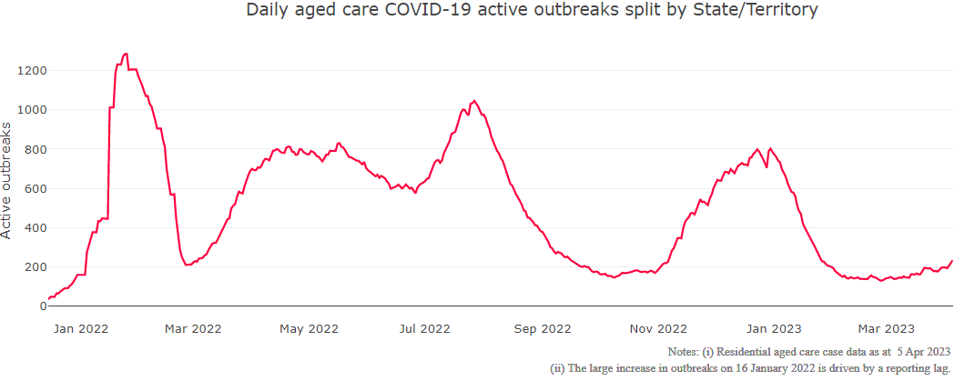

**Figure 2: Trends in Aged Care Cases – December 2021 to Present**

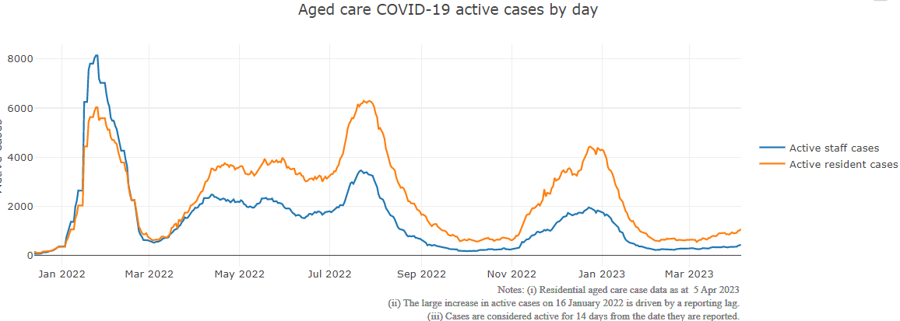

## Mortality

For the period of 1 January 2022 to 5 April 2023, COVID-19 is recorded as the cause of death in 5.5 per cent of all deaths in permanent residents in aged care facilities.

Since the beginning of the Omicron outbreak in mid December[5] 2021, there have been 80,444 deaths in residential aged care from all causes (report period from 15 December 2021 to 4 April 2023)[6]. COVID-19 deaths account for 5.4 per cent of this figure.

Over the course of the pandemic, all-cause excess mortality in Residential Aged Care was below expected numbers in 2020, and within expected range in 2021.

Figure 3: COVID-19 Deaths in Residential Aged Care Facilities overlaid with Community deaths

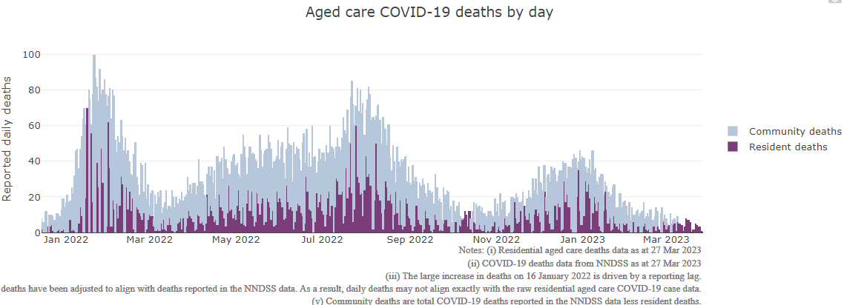

## Workforce in active residential aged care outbreaks

As at 6 April 2023, workforce surge staff have filled a total of 166,211 shifts in aged care services impacted by COVID-19, including 689 in the past 7 days. In the past 7 days (to 6 April) surge workforce providers have assisted 32 residential aged care homes. These shifts include roles for GPs, nurses, care workers, allied health workers, executive and ancillary staff. This includes:

Table 3: Workforce resources supplied to residential aged care facilities

| Workforce provider | Total Shifts | | Previous 7 days | |
| --- | --- | --- | --- | --- |
| Recruitment, Consulting and Staffing Association | 102,068 | 151 | |
| Healthcare Australia (Workforce Surge) | 13,695 | 4 | |
| Healthcare Australia (NACER) | 2,295 | N/A | |
| Mable | 2,711 | N/A | |
| Aspen Medical | 22,247 | 221 | |
| HealthX | 19,139 | 313 | |
| Torrens | 4,056 | N/A | |

The Australian Defence Force provided support to a total of 542 residential aged care homes between February and September 2022. The ADF deployment ceased on 30 September 2022.

## Oral antiviral treatments

Distribution of the oral anti-viral Lagevrio (Molnupiravir) commenced on 6 February 2022 to all RACFs with outbreak sites prioritised for delivery. The National Medical Stockpile has deployed 48,269 treatment courses of Lagevrio (Molnupiravir) to aged care facilities.

56,791 prescriptions for Lagevrio (Molnupiravir) have been issued to residents in residential aged care facilities, with a further 3,445 prescriptions for Paxlovid (nirmatrelvir + ritonavir) also issued since 28 February 2022 and up to 2 April 2023.

## Vaccination in Residential Aged Care Facilities

People living in residential aged care homes remain a high priority for the Government’s COVID-19 vaccination program, with ongoing targeted support and communications to maintain the high level of vaccination within this group.

During 2023, COVID-19 vaccines continue to be administered in residential aged care homes by primary care providers (general practitioners, registered nurses in general practices and community pharmacies).

The Department of Health and Aged Care is proactively working with Primary Health Networks to support residential aged care homes that may need assistance with facilitating COVID-19 vaccinations. In the initial phase of the 2023 booster rollout, the Government is targeting residential aged care homes that were early adopters of the fourth dose. In parallel, support is provided to individual aged care homes seeking assistance, linking them to their local Primary Health Network.

The 2023 COVID-19 vaccine booster program has moved away from dose numbers and focusses on ensuring protection for aged care residents is topped up if it has been more than 6 months since the last immunising event (an infection or a vaccine dose), regardless of the number of doses.

Based on this, at the beginning of the program in February 2023, nearly one third of aged care residents were not immediately eligible for a 2023 booster, as they had a vaccine dose or infection in the last 6 months.

As at 29 March 2023, there are:

* 57,012 (31.9%) aged care residents estimated with a vaccine dose or infection in the last 6 months (with recent immunity and not currently eligible for a 2023 booster dose).
* 14,455 (11.5%) estimated eligible aged care residents with a COVID-19 2023 booster dose.

The estimated eligible population is made up of residents who have completed their COVID-19 primary course, and had their last COVID-19 vaccine dose or infection more than 6 months ago. As residential aged care populations are fluid, and case overlay is not exact, eligible populations for vaccination are an estimate only.

**Table 4: Aged Care COVID-19 2023 Booster Doses (data as at 5 April 2023)**

| Jurisdiction | % of eligible residents vaccinated | Residents vaccinated |
| --- | --- | --- |
| National | 11.5% | 14,455 |
| ACT | 22.9% | 416 |
| NSW | 11.2% | 4,629 |
| NT | 4.0% | <200 |
| QLD | 10.1% | 2,579 |
| SA | 12.5% | 1,227 |
| TAS | 16.6% | 505 |
| VIC | 12.9% | 4,262 |
| WA | 7.3% | 826 |

Source: Matched AIR data of residents in permanent residential aged care facilities.

## Infection control and audits

The Aged Care Quality and Safety Commission (Commission) conducts a range of site and non-site activities to monitor and assess residential aged care services, including site audits and assessment contacts (site and non-site) (see Table 5 below). In August 2020, the Commission commenced an infection control monitoring (ICM) spot check program in all Australian jurisdictions.

The ICM spot check program involves on-site visits to residential aged care services, without an outbreak, to check compliance with personal protective equipment (PPE) and infection control arrangements. The purpose of the ICM spot check is to observe infection control practices, to ensure that staff, management and visitors were adhering to safe personal protective equipment protocols and to safe infection control arrangements as required under the quality standards.

As at 5 April 2023, the Commission had conducted 4,575 ICM spot checks to observe infection control practices and PPE protocols in residential aged care facilities.

Table 5: Total Quality Assessment and Monitoring Activities with residential services (including IPC), by type and month 1 March 2020 to 5 April 2023

|  |  |  |  |  |  |
| --- | --- | --- | --- | --- | --- |
| Regulatory Activities | 2019-20 (1 Mar - 30 Jun 2020) | 2020-21 | 2021-22 | 2022-23 (to 5 April) | Total |
| ****Site visits**** | 318 | 3,452 | 1,732 | 2,457 | 7,959 |
| ****Non-site activities**** | 3,709 | 8,382 | 6,630 | 1,247 | 19,968 |
| Total activities | **4,027** | **11,834** | **8,362** | **3,704** | **27,927** |

# Appendix 1: National residential aged care services with Active outbreaks COVID-19

Please note, information reported in this table has been directly reported to the Department of Health and Aged Care by residential aged care facilities. Total cases refers to all staff and resident cases associated with the active outbreak and may not reflect the count of currently active cases. Where numbers have been incorrectly reported, facilities are able to correct these in the COVID-19 Support Portal through My Aged Care. Where a facility is reporting less than six resident or staff cases or less than six deaths, data has been suppressed to protect the privacy of affected individuals (note that “n/p” indicates data is not provided to protect privacy).

| Service Name | State | Resident Deaths | Resident Cases | Staff Cases | Total Incidents |
| --- | --- | --- | --- | --- | --- |
| Bill McKenzie Gardens | Australian Capital Territory | 0 | 12 | <6 | n/p |
| RFBI Holt Masonic Village | Australian Capital Territory | <6 | 8 | <6 | n/p |
| Allambie Heights Village Residential Aged Care Facility | New South Wales | 0 | <6 | <6 | 6 |
| Alton Lodge | New South Wales | 0 | <6 | 0 | <6 |
| Anglicare Barry Marsh House | New South Wales | 0 | 11 | <6 | n/p |
| Aurrum Erina | New South Wales | 0 | <6 | 0 | <6 |
| Banksia Village | New South Wales | 0 | 9 | <6 | n/p |
| BaptistCare Bethshan Gardens Centre | New South Wales | 0 | <6 | <6 | <6 |
| Beechwood Aged Care | New South Wales | 0 | 19 | 13 | 32 |
| Beecroft House Aged Care | New South Wales | 0 | 6 | 0 | 6 |
| Berrigan Multi-Purpose Service | New South Wales | 0 | <6 | 0 | <6 |
| Bilyara Hostel | New South Wales | 0 | <6 | 7 | n/p |
| Calvary Albury & District | New South Wales | <6 | 21 | 7 | 28 |
| Calvary Corymbia | New South Wales | 0 | 13 | <6 | n/p |
| Calvary Tanilba Shores Retirement Community | New South Wales | 0 | <6 | <6 | 9 |
| CASS Residential Aged Care Facility | New South Wales | 0 | 18 | 6 | 24 |
| Catholic Healthcare St James Villa | New South Wales | 0 | 7 | <6 | n/p |
| Chiswick Manor Care Community | New South Wales | 0 | 0 | <6 | <6 |
| Dudley Foord House | New South Wales | 0 | <6 | <6 | 6 |
| Elizabeth Lodge (Rushcutters Bay) | New South Wales | 0 | <6 | 0 | <6 |
| Elizabeth Lodge Hostel | New South Wales | 0 | 20 | 8 | 28 |
| Estia Health Blakehurst | New South Wales | 0 | <6 | 0 | <6 |
| Estia Health Camden | New South Wales | 0 | 0 | <6 | <6 |
| Estia Health Kogarah | New South Wales | 0 | <6 | 0 | <6 |
| Flinders Court | New South Wales | 0 | <6 | 0 | <6 |
| Garrawarra Centre | New South Wales | 0 | 23 | 15 | 38 |
| Gill Waminda Aged Care Plus Centre | New South Wales | <6 | 33 | 8 | 41 |
| Glenmore Park Care Community | New South Wales | 0 | 10 | <6 | n/p |
| Greenhill Manor | New South Wales | 0 | 6 | <6 | n/p |
| HammondCare - Horsley | New South Wales | 0 | 9 | 6 | 15 |
| HammondCare Waratah | New South Wales | 0 | 17 | <6 | n/p |
| Hawkesbury Living Pty Limited | New South Wales | <6 | 19 | <6 | n/p |
| Haydays Retirement Hostel | New South Wales | 0 | <6 | <6 | <6 |
| Hill View House Aged Care Facility | New South Wales | <6 | <6 | <6 | <6 |
| Hixson Gardens Aged Care Facility | New South Wales | 0 | 0 | <6 | <6 |
| Horton House and Warmington Lodge | New South Wales | 0 | <6 | 0 | <6 |
| Hunters Hill Montefiore Home | New South Wales | 0 | 17 | 8 | 25 |
| Lee Hostel | New South Wales | <6 | <6 | <6 | <6 |
| Lemongrove Gardens Hostel | New South Wales | 0 | 6 | <6 | n/p |
| Marco Polo Aged Care Facility | New South Wales | 0 | <6 | <6 | 7 |
| Mark Moran at Little Bay | New South Wales | 0 | <6 | 0 | <6 |
| Mary Mackillop Hostel Carrington Retirement Village | New South Wales | 0 | <6 | <6 | <6 |
| Mary Potter Nursing Home | New South Wales | <6 | 7 | <6 | n/p |
| Mayfield Aged Care | New South Wales | 0 | 31 | 7 | 38 |
| Mildred Symons House | New South Wales | 0 | 9 | <6 | n/p |
| Miranda Aged Care Facility | New South Wales | <6 | 19 | <6 | n/p |
| Moyne Aged Care Plus Centre (0033) | New South Wales | 0 | 14 | 0 | 14 |
| Moyne Aged Care Plus Centre (2519) | New South Wales | 0 | <6 | 0 | <6 |
| Pacific Lodge Aged Care Plus Centre | New South Wales | 0 | <6 | 0 | <6 |
| Pathways Sailors Bay | New South Wales | 0 | <6 | 0 | <6 |
| Patrick Bugden VC Gardens | New South Wales | <6 | 21 | 7 | 28 |
| Pemulwuy Aged Care | New South Wales | 0 | <6 | 0 | <6 |
| Peninsula Villages Ltd | New South Wales | 0 | 0 | <6 | <6 |
| Randwick Montefiore Home | New South Wales | 0 | 0 | <6 | <6 |
| Rocky Point Residence | New South Wales | 0 | <6 | <6 | <6 |
| Russian Relief Association of St Sergius of Radonezh | New South Wales | 0 | 19 | <6 | n/p |
| Scalabrini Village Allambie Heights | New South Wales | 0 | 15 | <6 | n/p |
| Southern Cross Care St Francis Residential Aged Care | New South Wales | 0 | 12 | <6 | n/p |
| St Marys Villa Residential Aged Care | New South Wales | 0 | 12 | <6 | n/p |
| St Vincent's Care Services Edgecliff | New South Wales | 0 | 7 | 6 | 13 |
| Stella Maris Aged Care Facility | New South Wales | 0 | <6 | <6 | <6 |
| Tallwoods Corner Aged Care Service | New South Wales | 0 | <6 | 0 | <6 |
| Tarragal House | New South Wales | 0 | <6 | 0 | <6 |
| The Orchards Aged Care | New South Wales | 0 | <6 | 0 | <6 |
| The Pioneers Lodge | New South Wales | 0 | <6 | 0 | <6 |
| The Royce Manor | New South Wales | 0 | 7 | <6 | n/p |
| Uniting Banks Lodge Peakhurst | New South Wales | 0 | 6 | <6 | n/p |
| Uniting Bernard Austin Lodge Liverpool | New South Wales | 0 | <6 | 0 | <6 |
| Uniting Locke Haven Petersham | New South Wales | 0 | <6 | 0 | <6 |
| Uniting Pacifica Nambucca Heads | New South Wales | <6 | <6 | 0 | <6 |
| Uniting Roberts Lodge Peakhurst | New South Wales | 0 | 10 | <6 | n/p |
| Wahroonga House | New South Wales | 0 | <6 | 7 | n/p |
| Wallarah Point Care Community | New South Wales | 0 | <6 | 0 | <6 |
| Warrigal Care Albion Park Rail | New South Wales | 0 | 28 | 15 | 43 |
| Warrigal Care Queanbeyan | New South Wales | 0 | 38 | 6 | 44 |
| Warrigal Care Shell Cove | New South Wales | <6 | 67 | 27 | 94 |
| Warrigal Wollongong | New South Wales | 0 | <6 | 0 | <6 |
| Windermere Aged Care Facility | New South Wales | 0 | 23 | <6 | n/p |
| Winston Hillside Care Community | New South Wales | 0 | <6 | 0 | <6 |
| Pearl Supported Care | Northern Territory | 0 | <6 | <6 | 7 |
| Arcare Parkinson | Queensland | 0 | 6 | <6 | n/p |
| Arcare Sanctuary Manors | Queensland | 0 | <6 | 0 | <6 |
| Bellevue Care Centre | Queensland | 0 | 19 | 10 | 29 |
| Bethania Gardens | Queensland | 0 | <6 | <6 | <6 |
| Blue Care Bundaberg Pioneer Aged Care Facility | Queensland | 0 | 15 | <6 | n/p |
| Blue Care Capricorn Aged Care Facility | Queensland | 0 | 11 | 6 | 17 |
| Blue Care Gracemere Aged Care Facility | Queensland | 0 | <6 | <6 | <6 |
| Blue Care Rothwell Nazarene Aged Care Facility | Queensland | 0 | 16 | 9 | 25 |
| Bolton Clarke Moreton Shores | Queensland | 0 | <6 | <6 | <6 |
| Buderim Views Assisted Aged Care | Queensland | 0 | <6 | <6 | 6 |
| Central & Upper Burnett District Home for the Aged Nursing Home | Queensland | 0 | 9 | 12 | 21 |
| Churches of Christ Gracehaven Aged Care Service | Queensland | 0 | 16 | <6 | n/p |
| Churches of Christ Little Mountain Aged Care Service | Queensland | 0 | <6 | <6 | 9 |
| Edge Hill Orchards | Queensland | 0 | <6 | <6 | <6 |
| Estia Health Mudgeeraba | Queensland | 0 | <6 | <6 | <6 |
| Glenella Care | Queensland | <6 | 35 | 14 | 49 |
| Holland Park Aged Care | Queensland | 0 | 12 | 12 | 24 |
| Infinite Care Edmonton Gardens | Queensland | <6 | 27 | 11 | 38 |
| Infinite Care Ipswich | Queensland | 0 | 8 | <6 | n/p |
| Jeta Gardens Aged Care Facility | Queensland | <6 | 14 | 16 | 30 |
| Jimboomba Community Aged Care | Queensland | 0 | <6 | <6 | <6 |
| Kaloma Home for the Aged | Queensland | 0 | 14 | 26 | 40 |
| Karingal Nursing Home | Queensland | 0 | <6 | <6 | 7 |
| Kerrisdale Gardens | Queensland | 0 | 10 | 13 | 23 |
| Mercy Community Services - Emmaus | Queensland | 0 | <6 | <6 | <6 |
| Morayfield Grove Care Community | Queensland | 0 | <6 | <6 | 7 |
| Ozcare Bakhita Villa Aged Care Facility | Queensland | 0 | <6 | <6 | 6 |
| Ozcare Caroline Chisholm | Queensland | 0 | <6 | <6 | <6 |
| Parkview | Queensland | 0 | 0 | <6 | <6 |
| Proserpine Nursing Home | Queensland | 0 | 12 | 7 | 19 |
| Regis Salisbury | Queensland | 0 | <6 | 0 | <6 |
| Regis The Gap | Queensland | 0 | 6 | 0 | 6 |
| Regis Wynnum | Queensland | 0 | 13 | <6 | n/p |
| Southern Cross Care Facility Caloundra | Queensland | 0 | <6 | <6 | <6 |
| St Vincent's Care Services Kangaroo Point - Marycrest | Queensland | 0 | <6 | 0 | <6 |
| St Vincent's Care Services Toowoomba - Nursing Home | Queensland | 0 | 8 | <6 | n/p |
| Sunnymeade Park Aged Care Community | Queensland | 0 | <6 | <6 | <6 |
| The Good Shepherd Nursing Home | Queensland | 0 | <6 | 6 | n/p |
| The Plains | Queensland | 0 | 35 | 12 | 47 |
| TriCare Labrador Aged Care Residence | Queensland | 0 | 7 | <6 | n/p |
| Wahroonga | Queensland | 0 | <6 | 0 | <6 |
| Whiddon Beaudesert Star | Queensland | 0 | <6 | <6 | <6 |
| ACH Group Residential Care - Colton Court | South Australia | 0 | <6 | 0 | <6 |
| ACH Group Residential Care - Highercombe | South Australia | <6 | 9 | 0 | 9 |
| ACH Group Residential Care - Kapara | South Australia | 0 | 12 | <6 | n/p |
| ACH Group Residential Care - West Park | South Australia | 0 | <6 | <6 | <6 |
| Alwyndor Aged Care | South Australia | 0 | <6 | <6 | 8 |
| Bene Aged Care - The Italian Village | South Australia | 0 | 9 | <6 | n/p |
| Bucklands Residential Care | South Australia | 0 | 22 | 7 | 29 |
| Bupa Woodville | South Australia | 0 | <6 | 0 | <6 |
| Eldercare Hope Valley | South Australia | 0 | <6 | 7 | n/p |
| Eldercare Seaford | South Australia | 0 | <6 | <6 | <6 |
| Estia Health Aberfoyle Park | South Australia | 0 | <6 | 0 | <6 |
| Estia Health Burton | South Australia | 0 | 8 | <6 | n/p |
| Estia Health Flagstaff Hill | South Australia | 0 | <6 | 0 | <6 |
| Estia Health Hope Valley | South Australia | <6 | 55 | 16 | 71 |
| Estia Health Valley View | South Australia | <6 | 9 | <6 | n/p |
| Eyre Peninsula Old Folks Home | South Australia | 0 | <6 | <6 | <6 |
| Gaynes Park Manor | South Australia | 0 | <6 | <6 | <6 |
| Klemzig Residential Care Services | South Australia | 0 | <6 | 0 | <6 |
| Mary Cecelia Hart Court Hostel | South Australia | 0 | 0 | <6 | <6 |
| Mid West - Wudinna MPS | South Australia | 0 | <6 | <6 | <6 |
| Mount Carmel Residential Care | South Australia | 0 | <6 | 0 | <6 |
| Olive Grove Aged Care | South Australia | 0 | 6 | 6 | 12 |
| Resthaven Westbourne Park | South Australia | 0 | 7 | <6 | n/p |
| St Basil's Aegean Village | South Australia | 0 | 16 | 0 | 16 |
| The Pines Lodge Residential Care | South Australia | 0 | 23 | 6 | 29 |
| Walara Hamley Bridge | South Australia | 0 | <6 | 0 | <6 |
| Westminster Village Nursing Home | South Australia | 0 | 16 | 11 | 27 |
| Glenview Community Services Inc. | Tasmania | 0 | 11 | <6 | n/p |
| Meercroft Care | Tasmania | <6 | 9 | 6 | 15 |
| Regis Tasmania - Legana | Tasmania | 0 | <6 | 0 | <6 |
| AdventCare Whitehorse | Victoria | 0 | <6 | <6 | <6 |
| Anzac Lodge Private Nursing Home | Victoria | 0 | 7 | <6 | n/p |
| Arcare Sydenham | Victoria | 0 | <6 | 0 | <6 |
| Bairnsdale Parklands Care Community | Victoria | 0 | <6 | 0 | <6 |
| Benetas Corowa Court | Victoria | 0 | <6 | <6 | <6 |
| Benetas Dalkeith Gardens | Victoria | <6 | 27 | 10 | 37 |
| Benetas St Paul's Terrace | Victoria | 0 | 9 | <6 | n/p |
| Bentons Lodge - Residential Aged Service | Victoria | 0 | 20 | <6 | n/p |
| BlueCross Scotchmans Creek | Victoria | 0 | <6 | 0 | <6 |
| Brimlea Aged Care | Victoria | 0 | <6 | 0 | <6 |
| Calvary Balmoral Grove | Victoria | 0 | <6 | <6 | <6 |
| Calvary Kirralee | Victoria | 0 | <6 | <6 | <6 |
| Calvary Rosanna Views | Victoria | 0 | <6 | 0 | <6 |
| Castlemaine Health | Victoria | 0 | <6 | <6 | <6 |
| Charles Brownlow Retirement Village | Victoria | 0 | <6 | 0 | <6 |
| Cooinda Lodge Nursing Home | Victoria | 0 | <6 | 0 | <6 |
| Cumberland View Aged Care - Whalley Drive | Victoria | <6 | 8 | 0 | 8 |
| Diamond Creek Care Community | Victoria | 0 | <6 | 0 | <6 |
| Doutta Galla Avondale Heights Aged Care Facility | Victoria | 0 | 18 | <6 | n/p |
| Edgarley Home | Victoria | 0 | <6 | 0 | <6 |
| Emmy Monash Aged Care | Victoria | 0 | <6 | 0 | <6 |
| Estia Health Altona Meadows | Victoria | 0 | <6 | <6 | <6 |
| Estia Health Keysborough | Victoria | 0 | 0 | <6 | <6 |
| Estia Health Oakleigh East | Victoria | 0 | 0 | <6 | <6 |
| Estia Health South Morang | Victoria | 0 | <6 | 0 | <6 |
| Grange Residential Care Services | Victoria | 0 | <6 | 0 | <6 |
| HammondCare - The Glens | Victoria | 0 | 30 | <6 | n/p |
| Havilah Hostel | Victoria | 0 | 0 | <6 | <6 |
| Holmwood Aged Care | Victoria | 0 | <6 | <6 | <6 |
| Kew Gardens Aged Care | Victoria | 0 | 19 | <6 | n/p |
| Laurina Lodge Hostel | Victoria | 0 | <6 | 0 | <6 |
| Luson Eden Park | Victoria | 0 | <6 | <6 | <6 |
| Lynden Aged Care | Victoria | 0 | <6 | 0 | <6 |
| Maculata Place | Victoria | <6 | 21 | <6 | n/p |
| Mayflower Reservoir | Victoria | 0 | 7 | <6 | n/p |
| mecwacare John Atchison Centre | Victoria | 0 | 6 | 0 | 6 |
| mecwacare Malvern Centre | Victoria | 0 | <6 | 0 | <6 |
| Melbourne Hebrew Memorial Nursing Home | Victoria | 0 | 10 | <6 | n/p |
| Mercy Place Ballarat | Victoria | 0 | <6 | <6 | 6 |
| Mercy Place Wyndham | Victoria | 0 | <6 | 0 | <6 |
| MiCare Avondrust Lodge | Victoria | 0 | 0 | <6 | <6 |
| MiCare Margriet Manor | Victoria | 0 | <6 | <6 | <6 |
| Moran Roxburgh Park | Victoria | 0 | 8 | <6 | n/p |
| P.S. Hobson Nursing Home | Victoria | 0 | 6 | <6 | n/p |
| Point Cook Manor | Victoria | 0 | <6 | 0 | <6 |
| Rainbow Bush Nursing Home Annexe | Victoria | 0 | <6 | <6 | 8 |
| Rathdowne Place | Victoria | 0 | <6 | 0 | <6 |
| Regis Frankston | Victoria | 0 | <6 | 0 | <6 |
| Regis Inala Lodge | Victoria | 0 | <6 | <6 | <6 |
| Regis Ringwood | Victoria | 0 | 7 | 0 | 7 |
| Sherbrooke Private Nursing Home | Victoria | 0 | <6 | 0 | <6 |
| St Vincent's Care Services Kew | Victoria | 0 | <6 | 0 | <6 |
| St Vincent's Care Services Werribee | Victoria | 0 | <6 | 0 | <6 |
| Sunset Views Manor | Victoria | 0 | <6 | 0 | <6 |
| Trevi Court | Victoria | 0 | <6 | 0 | <6 |
| Uniting AgeWell Box Hill | Victoria | <6 | 12 | <6 | n/p |
| Village Glen Aged Care Residences - Capel Sound | Victoria | 0 | <6 | 0 | <6 |
| Acacia Living Group Menora Gardens Aged Care Facility | Western Australia | 0 | 16 | 11 | 27 |
| Aegis Anchorage | Western Australia | 0 | 9 | <6 | n/p |
| Aegis Balmoral | Western Australia | 0 | <6 | <6 | 8 |
| Aegis Banksia Park | Western Australia | 0 | <6 | <6 | <6 |
| Aegis Hilton Park | Western Australia | <6 | 20 | 9 | 29 |
| Aegis Karalee | Western Australia | 0 | 8 | <6 | n/p |
| Aegis Lakeside | Western Australia | 0 | 13 | 0 | 13 |
| Aegis Montgomery | Western Australia | 0 | 8 | 7 | 15 |
| Aegis Shawford | Western Australia | 0 | 10 | 0 | 10 |
| Amaroo Village Buckley Caring Centre | Western Australia | 0 | <6 | 0 | <6 |
| Bethanie Peel | Western Australia | 0 | <6 | 0 | <6 |
| Braemar Village | Western Australia | 0 | 21 | 0 | 21 |
| Geegeelup Aged Care Facility | Western Australia | 0 | <6 | <6 | <6 |
| Guildford Village | Western Australia | 0 | 10 | <6 | n/p |
| Juniper Elimatta | Western Australia | 0 | <6 | 0 | <6 |
| Karinya Residential Care | Western Australia | 0 | 0 | <6 | <6 |
| MYVISTA Mirrabooka | Western Australia | 0 | 9 | <6 | n/p |
| Regents Garden - Bateman | Western Australia | 0 | <6 | 0 | <6 |
| Regents Garden Residential Aged Care Resort - Lake Joondalup | Western Australia | 0 | <6 | <6 | <6 |
| Regis Woodlands | Western Australia | 0 | <6 | <6 | <6 |
| Seaforth Gardens Senior Citizens' Residence | Western Australia | 0 | <6 | 0 | <6 |
| St Luke's Nursing Home | Western Australia | 0 | <6 | 0 | <6 |
| St Ritas Nursing Home | Western Australia | 0 | 7 | 0 | 7 |
| Victoria Park Nursing Home | Western Australia | 0 | <6 | <6 | 7 |
| Vivian Bullwinkel Lodge | Western Australia | 0 | <6 | 0 | <6 |

1. Outbreak opening and closure includes changes in the status of exposure sites to outbreaks (and vice versa), which are applied retrospectively to facility records. New case information can also change the status of a recovered site back to an active outbreak site. As a result, changes in active outbreak status may not align with day on day variations to active totals. These adjustments will also affect the number of cases in staff and residents reported each week.
2. Active residents and staff cases are the total currently positive cases in active outbreaks
3. An outbreak is considered to be active pending advice from the relevant Public Health Unit. An outbreak is defined as at least 1 positive case in a resident or 2+ cases in staff.
4. Case numbers and numbers of deaths are dependent upon reporting from facilities and validation of deaths from state and territory governments. This is subject to change as further information is provided.
5. The Omicron outbreak start date has been redefined from late November 2021 to mid December 2021. Changes have been made to align reporting with the start date of Omicron published in the Department’s external facing Epidemiology report.
6. The Department is now accessing aged care deaths data from the SIEBEL dataset. Figures are live and subject to change. Source: Department of Health and Aged Care unpublished data / SIEBEL dataset.