Australian Influenza Surveillance Report

Communicable Disease Epidemiology and Surveillance Section (CDESS)

Report no. 1, 2023

**Reporting fortnight:** Monday 3 April 2023, to Sunday 16 April 2023.

**Reporting weeks:** 14 and 15, of 2023.

The Department of Health and Aged Care acknowledges the providers of the many sources of data used in this report and greatly appreciates their contribution.

## Key Messages

It is important to note that due to the COVID-19 epidemic in Australia, data reported from the various influenza surveillance systems may not represent an accurate reflection of influenza activity. Results should be interpreted with caution, especially where comparisons are made to previous influenza seasons. Interpretation of influenza data from April 2020 onwards should take into account, but are not limited to, the impact of social distancing measures, likely changes in health seeking behaviour of the community including access to alternative streams of acute respiratory infection specific health services, and focussed testing for COVID-19 response activities. For information on COVID-19 incidence, severity, and distribution in Australia, please refer to [COVID-19 epidemiology reports](https://www1.health.gov.au/internet/main/publishing.nsf/Content/novel_coronavirus_2019_ncov_weekly_epidemiology_reports_australia_2020.htm).

**Activity:**

* Influenza-like-illness (ILI) activity in the community continues to gradually increase this fortnight, following the increase of cases observed from March 2023.
* From March 2023, the number of notifications of laboratory-confirmed influenza reported in Australia has gradually increased. The number of notifications year-to-date is higher than the 5-year average*, but lower than observed in the same period in 2019.
* This fortnight influenza activity has increased in most jurisdictions.

**Severity:**

* There is currently not enough information to comprehensively assess the potential severity of the 2023 influenza season at this time.
* In the year-to-date, of the 25,870 notifications of laboratory-confirmed influenza, 23 influenza-associated deaths have been identified in the National Notifiable Diseases Surveillance System (NNDSS), with a case fatality rate of 0.09%.

**Impact:**

* Although the level of laboratory-confirmed influenza notifications in the year to date is currently higher than average, community ILI activity remains within historical ranges, and it is likely there is low impact on society due to influenza in 2023 to date.

**At-risk population:**

* In the year-to-date, notification rates have been highest in people aged 05–09 years, followed by the 0–4 years age group and the 10–14 years age group.

**Virology:**

* In the year-to-date, 77% of notifications of laboratory-confirmed influenza reported to the NNDSS were influenza A, of which 94% were influenza A(unsubtyped); 1% were influenza A(H3N2); and 5% were influenza A(H1N1). Influenza B accounted for 22.4% of notifications; and 0.05% of influenza notifications were untyped (114/25,870).

**Vaccine match and effectiveness:**

* Of the 486 samples referred to the WHOCC in the year-to-date, 96.2% of influenza A(H1N1), 78.6% of influenza A(H3N2) and 99.1% of influenza B/Victoria isolates characterised were antigenically similar to the corresponding vaccine components.
* It is too early to assess vaccine match and effectiveness for this season.

*The years 2020 and 2021 have been excluded when comparing the current season to historical periods (including the 5-year average) when influenza virus has circulated without public health restrictions. Please refer to Data considerations for interpretation of the five-year average.

## 1. Introduction

Each year, the influenza virus changes and different strains can circulate in the population. Particular subtypes of influenza can affect different groups of the population more than others. Depending on the susceptibility of the population, the subtypes that are circulating and the changes to the virus itself, the influenza season can be very different year to year. Our surveillance systems help us to understand influenza activity, severity of the infection in individuals and impact of the illness on society in Australia. We are also able to monitor which influenza viruses are circulating, which populations might be more affected, the effectiveness of the vaccine, and any resistance to antiviral drugs that has developed.

### 1.1. National Influenza Surveillance System

This report presents an overview of influenza activity based on a number of complimentary systems. No one single system, including notification data, provides the full picture on influenza, because influenza is a common disease and its presenting symptoms are non-specific. The epidemiology of influenza is informed by a number of different systems based in the community, laboratories, primary care and hospitals, as well as notifiable diseases data, which includes officially reported deaths. The information in this report is reliant on the surveillance sources available to the Department of Health and Aged Care at the time of production.

* The **National Notifiable Diseases Surveillance System (NNDSS)** coordinates the national surveillance of more than 60 communicable diseases or disease groups. Notifications of laboratory-confirmed influenza are made to state or territory health authorities and supplied daily to the Australian Government Department of Health and Aged Care via the NNDSS for collation, analysis, and to assist in the coordination of public health responses.
* **FluTracking** is an online syndromic surveillance system which monitors ILI in the community.
* The **Australian Sentinel Practices Research Network (ASPREN)** is a year-round sentinel general practice (GP) surveillance system in which general and nurse practitioners report de-identified information on the number of ILI patient presentations seen in participating practices each week. It should be noted that in addition to the overarching impacts of COVID-19 on influenza surveillance systems, interpretation of ASPREN’s data from 2020 onwards should consider the following COVID-19 impacts:
  + Changes in the health seeking behaviour at ASPREN sentinel sites due to the availability of telehealth and respiratory clinics may result in fewer presentations to General Practice (GP); and
  + Changes to GPs swabbing at ASPREN sentinel sites, due to the availability of telehealth and respiratory clinics, may result in a lower number of swabs being undertaken by ASPREN reporters.
* The **Influenza Complications Alert Network (FluCAN)** conducts surveillance of severe influenza at sentinel hospitals across the country during the influenza season. The Paediatric Active Enhanced Disease Surveillance (PAEDS) network also contributes data on influenza via FluCAN.
* The **World Health Organization Collaborating Centre (WHOCC) for Reference and Research on Influenza** analyses influenza viruses currently circulating in the human population in Australia and other countries, to inform which strains should be included in annual seasonal influenza vaccines for the Northern and Southern Hemispheres.
* **Sentinel laboratory surveillance** systems provide fortnightly reporting of influenza testing. This includes the number of tests undertaken, the number of positive results, and the detected viruses. Sentinel laboratory site testing data are influenced by jurisdictional and laboratory testing practices, and should be interpreted with caution. Please note that tests conducted at sentinel laboratory sites may include samples taken from people in home or hotel quarantine for COVID-19, and may not reflect respiratory viruses circulating in the community alone.

### 1.2. Data considerations

* NNDSS laboratory-confirmed influenza surveillance case definition
  + From 1 January 2022, the [NNDSS surveillance case definition for laboratory-confirmed influenza](https://www.health.gov.au/resources/publications/influenza-laboratory-confirmed-surveillance-case-definition) was updated to remove Point 5: ‘Single high titre by complement fixation test (CFT) or haemagglutination inhibition (HAI) to influenza virus’ from the list of laboratory definitive evidence.
  + This change has minimal impact on the interpretation of influenza notification trends, with the change ensuring consistency with the influenza laboratory case definition. For further information, please refer to the [NNDSS laboratory-confirmed influenza case definition Technical Supplement](https://www.health.gov.au/resources/publications/influenza-laboratory-confirmed-surveillance-case-definition).
* Data in this summary is reported by International Organization for Standardization (ISO) 8601 weeks, with the week ending on Sunday. Throughout the summary, where the year to date is presented, this includes data from 1 January to Sunday 16 April 2023. NNDSS data are analysed and reported based on diagnosis date, which is the true onset date of a case if known, otherwise it is the earliest of the specimen date, the notification date, or the notification received date. NNDSS data were extracted on Friday 21 April 2023.
* In interpreting these data, it is important to note that changes in notifications over time may not solely reflect changes in disease prevalence or incidence. Depending on the disease, the number of notifications may be influenced by changes in testing policies; changes in case definitions; changes in testing practices and screening programs; the use of less invasive and more sensitive diagnostic tests; and periodic awareness campaigns. In particular, analyses including data from 2020 and 2021 should be interpreted with caution. Influenza activity in 2020 and 2021 was unusual due to the suppression of influenza virus circulation because of COVID-19 mitigation measures. Data from these years may reduce five-year averages and affect usual seasonal trends. The years 2020 and 2021 are excluded when comparing the current season to historical periods when influenza virus has circulated without public health restrictions.
* Due to the dynamic nature of the NNDSS and other surveillance systems, data in this report are subject to retrospective revision and may vary from data reported in other national reports and reports by states and territories. Detailed notes on interpreting the data presented in this report are available at the Department of Health and Aged Care’s [Australian Influenza Surveillance Report website](https://www.health.gov.au/resources/collections/aisr?utm_source=health.gov.au&utm_medium=redirect&utm_campaign=digital_transformation&utm_content=flureport). While every care has been taken in preparing this report, the Commonwealth does not accept liability for any injury or loss or damage arising from the use of, or reliance upon, the content of the report. Delays in the reporting of data may cause data to change retrospectively. For further details about information contained in this report please contact the Influenza Surveillance Team ([flu@health.gov.au](mailto:flu@health.gov.au)).

## 2. Analysis

### 2.1. Activity

Activity measures the capacity of the circulating influenza viruses to spread person to person and may be measured indirectly through systems that monitor influenza-like illness and more directly through systems that monitor laboratory-confirmed influenza.

#### 2.1.1. Influenza-like illness (ILI)

**FluTracking**

* This fortnight (Monday 3 April 2023 to Sunday 16 April 2023), the proportion of FluTracking participants reporting ILI (fever and cough) is 1.2%, compared to 1.1% in the previous reporting fortnight.
* In the year to date, the proportion of FluTracking participants reporting ILI has continued to increase since mid-February (Figure 1).

**Sentinel General Practitioners (ASPREN)**

* This fortnight (Monday 3 April 2023 to Sunday 16 April 2023), an average of 2.3 per 1,000 consultations due to ILI were reported by sentinel ASPREN GPs, compared to 2.8 per 1,000 consultations in the previous fortnight.
* In the year to date, sentinel ASPREN GPs have reported between 0.5 and 3.0 consultations due to ILI per 1,000 consultations per week (Figure 2). The highest ILI rate to date this year was observed in week 10 (3.0 per 1,000 consultations). The ILI rate in the year to date remained close to the 5-year average until week 10, but has since decreased slightly.

In the year-to-date, of those presenting to sentinel ASPREN GPs with ILI who were tested for respiratory viruses, 58.2% (106/182) tested positive for a respiratory virus. Among those positive for a respiratory virus, the most common virus reported was rhinovirus (39.6%, 42/106). Other viruses detected included influenza (23.6%), SARS-CoV-2 (17.9%), respiratory syncytial virus (8.5%), PIV type-2 (3.8%), and PIV type-1 (1.9%).**Sentinel laboratories**

* This fortnight (Monday 3 April 2023 to Sunday 16 April 2023) the most commonly detected respiratory viruses* by sentinel laboratory site were as follows (for weeks 14 and weeks 15, respectively):
  + New South Wales: SARS-CoV-2 (both weeks)
  + South Australia: Rhinovirus (both weeks);
  + Tasmania: COVID-19 (both weeks);
  + Victoria: Picornavirus (both weeks);
  + Western Australia: Influenza B (both weeks).

*Excludes SARS-CoV-2 for laboratory data reported by Tasmania and WA.

**Figure 1:** Proportion of fever and cough among FluTracking participants, Australia, 2016 to 2023, by year and week of report*^

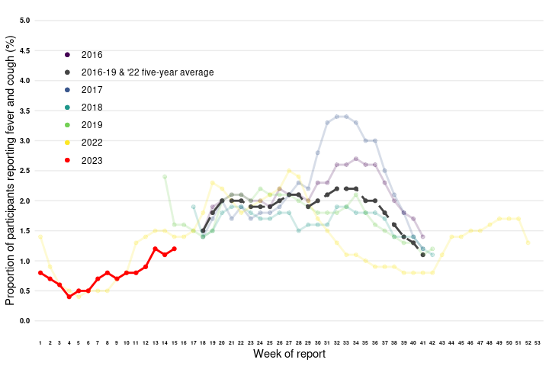

**Source:** FluTracking

*All data are preliminary and subject to change as updates are received, with most recent weeks considered particularly subject to revisions.

^FluTracking have expanded their reporting period from 2020 onwards due to COVID-19. As such, five-year historical comparisons are not available for data reported before May and after October for any year before 2020. The years 2020 and 2021 are excluded when comparing the current season to historical periods when influenza virus has circulated without public health restrictions. Please refer to Data considerations for interpretation of the five-year average.

**Figure 2:** Unweighted rate of ILI reported from ASPREN sentinel GP surveillance systems, Australia, 1 January 2016 to 16 April 2023, by year and week*^

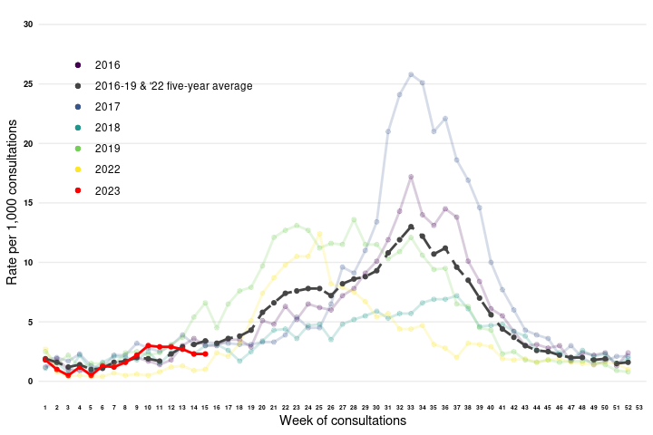

**Source:** ASPREN

*All data are preliminary and subject to change as updates are received, with most recent weeks considered particularly subject to revisions. The years 2020 and 2021 are excluded when comparing the current season to historical periods when influenza virus has circulated without public health restrictions. Please refer to Data considerations for interpretation of the five-year average.

^Please refer to surveillance system description for notes on impact of COVID-19 on ASPREN data.

#### 2.1.2. Laboratory-confirmed influenza

**National notification data (NNDSS):**

* There were 6,786 laboratory-confirmed influenza notifications with a diagnosis date this fortnight (Monday 3 April 2023 to Sunday 16 April 2023), compared to 5,710 notifications in the previous fortnight.
* From March 2023 the number of notifications of laboratory-confirmed influenza has gradually increased. The number of notifications year-to-date is higher than the 5-year average, but lower than observed in the same period in 2019 (Figure 3).
* In the year-to-date, there have been 25,870 notifications of laboratory-confirmed influenza to the NNDSS (Figure 4). This is a national notification rate of 100 cases per 100,000 population.

**ASPREN**

* In the year-to-date, there have been 25 (23.6%) influenza detections among the 106 ILI cases presenting to sentinel GPs who were tested for respiratory viruses.

**Sentinel laboratories**

* This fortnight (Monday 3 April 2023 to Sunday 16 April 2023), of the 16,020 samples tested across sentinel laboratories, 4.3% (n=686) have been positive for influenza, compared to 3.1% in the previous fortnight (Figure 4).
* Of the 107,143 samples tested across sentinel laboratories in the year-to-date, 2.3% (n=2,411) have been positive for influenza.

**Figure 3:** Notifications of laboratory-confirmed influenza, Australia, 1 January 2016 to 16 April 2023, by year and week of diagnosis*

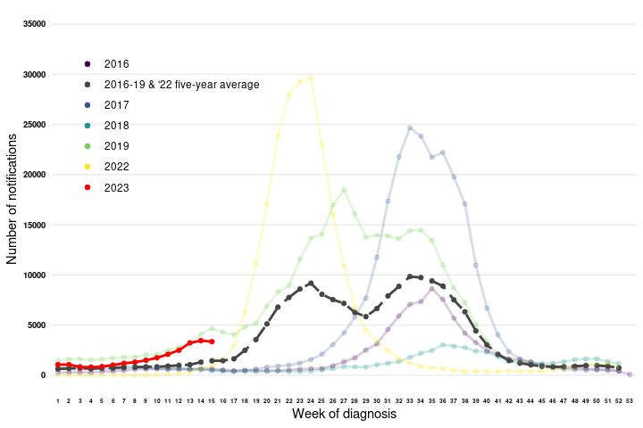

**Source:** NNDSS

*NNDSS notification data provided for the current and most recent weeks may be incomplete. All data are preliminary and subject to change as updates are received, with most recent weeks considered particularly subject to revisions. The years 2020 and 2021 are excluded when comparing the current season to historical periods when influenza virus has circulated without public health restrictions. Please refer to Data considerations for interpretation of the five-year average.

**Figure 4:** Proportion of sentinel laboratory tests positive for influenza and total number of specimens tested, 1 January to 16 April 2023, by subtype, year and week*

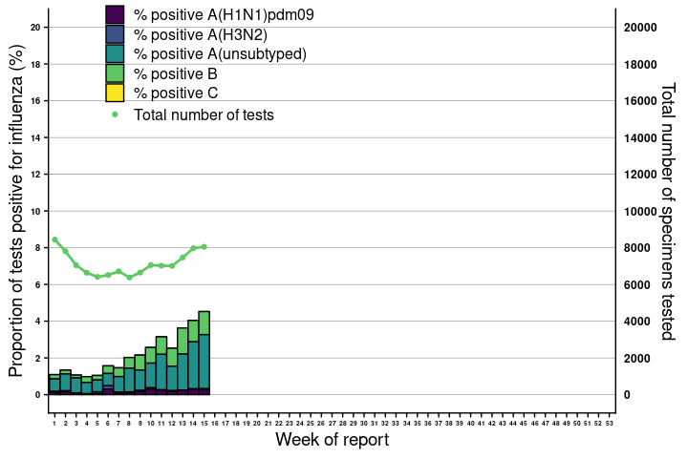

**Source:** Sentinel laboratories

*Total number of tests include all specimens that were tested for influenza, including multiplex panels used to test for SARS-CoV-2. Testing methodologies vary across jurisdictions and laboratories. All data are preliminary and subject to change as updates are received, with most recent weeks considered particularly subject to revisions.

#### 2.1.3. Geographical distribution of influenza activity

**National notification data (NNDSS):**

* This fortnight (Monday 3 April 2023 to Sunday 16 April 2023) influenza activity has increased in most jurisdictions.
* Of the 25,870 notifications of laboratory-confirmed influenza reported to the NNDSS in the year to date, there have been:
  + 156 in the Australian Capital Territory (ACT);
  + 8,549 in New South Wales (NSW);
  + 1,048 in the Northern Territory (NT);
  + 7,271 in Queensland (QLD);
  + 1,587 in South Australia (SA);
  + 187 in Tasmania (TAS);
  + 5,139 in Victoria (VIC); and
  + 1,933 in Western Australia (WA).
* The influenza notification rate has been highest in NT (418 per 100,000 population); and QLD (137 per 100,000 population).

**Figure 6:** Notifications of laboratory-confirmed influenza*, 1 January to 16 April 2023, by state or territory and week of diagnosis

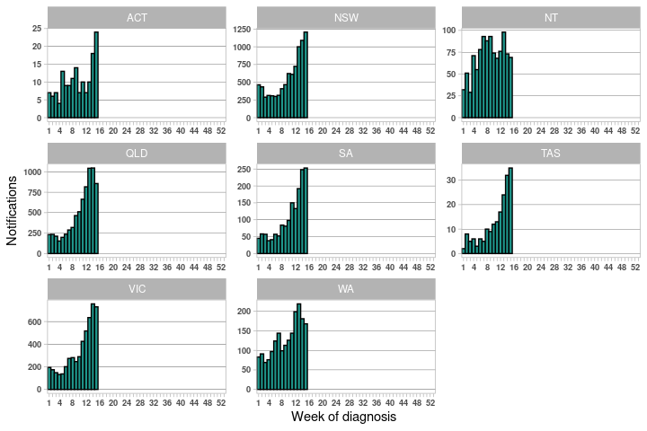

**Source:** NNDSS

*NNDSS notification data provided for the current and most recent weeks may be incomplete. All data are preliminary and subject to change as updates are received, with most recent weeks considered particularly subject to revisions, with most recent weeks considered particularly subject to revisions.

For further information regarding influenza activity at the jurisdictional level, please refer to the following State and Territory health surveillance reports:

* ACT: ACT Influenza Report
* NSW: [Respiratory surveillance reports](https://www.health.nsw.gov.au/Infectious/covid-19/Pages/weekly-reports.aspx)
* QLD: [Statewide Weekly Influenza Surveillance Report](https://www.health.qld.gov.au/clinical-practice/guidelines-procedures/diseases-infection/surveillance/reports/flu)
* SA: [Weekly Epidemiological Summary](http://www.sahealth.sa.gov.au/wps/wcm/connect/public+content/sa+health+internet/about+us/health+statistics/surveillance+of+notifiable+conditions) (Influenza section)
* TAS: [fluTAS Reports](https://www.health.tas.gov.au/health-topics/flu-influenza/flutas-reports)
* VIC: [Influenza Surveillance Reports](https://www2.health.vic.gov.au/public-health/infectious-diseases/infectious-diseases-surveillance/seasonal-influenza-reports)
* WA: [Virus WAtch](http://ww2.health.wa.gov.au/Articles/F_I/Infectious-disease-data/Virus-WAtch)

### 2.2. Severity

Severity is a measure of adverse outcomes or complications as a result of ILI such as hospital referrals, admissions, need for intensive care, and deaths. Measuring and understanding the severity of circulating influenza is difficult to establish at the beginning, or during a low, influenza season. The proportion of confirmed influenza cases with serious outcomes might be skewed initially because there are only a small number of people notified. This means that the measure of severity will vary substantially fortnight to fortnight until numbers are sufficiently high and there is enough data for measurements to stabilise. An assessment of severity can be provided once the signals become clearer.

**National notification data (NNDSS):**

* In the year-to-date, of the 25,870 notifications of laboratory-confirmed influenza, there have been 23 influenza-associated deaths notified to the NNDSS, with a case fatality rate of 0.09%. This case fatality rate is notably lower than the 5-year average case fatality rate for the same period (0.36%).
* 61% of deaths were attributed to A/Unsubtyped, 22% were B, 9% were A/H1N1, and 9% were A/H3N2.
* The median age of deaths notified was 76 years (range: 10–99 years).

Note: the number of influenza-associated deaths reported to the NNDSS does not represent the true mortality associated with this disease. The number of deaths is reliant on the follow up of cases to determine the outcome of their infection. The follow up of cases is not a requirement of notification and are only inclusive of laboratory-confirmed cases of influenza. Due to retrospective revision, the variation across jurisdictions in methodology, representativeness, and timeliness of death data, and reporting of an outcome of infection not being a requirement of notification, year on year comparisons of deaths in notified cases of influenza may not be reliable.

### 2.3. Impact

Impact measures how influenza affects society, including stress on health-care resources and societal and economic consequences.

**FluTracking**

* This fortnight (Monday 3 April 2023 to Sunday 16 April 2023), the proportion of of FluTracker participants reporting ILI and taking time off regular work duties while unwell was 0.7%, the same as observed in the previous fortnight.
* In the year-to-date, the proportion of FluTracking survey respondents reporting having ILI and taking time off regular duties while unwell has gradually increased since early February, with the highest peak observed thus far in week 13 at 0.89%.

### 2.4. At-risk population

At-risk populations are people who may be more susceptible to infection with the influenza virus and/or who may be more likely to experience severe outcomes from their infection.

**National notification data (NNDSS):**

* In the year-to-date, notification rates have been highest in people aged 05–09 years (291 notifications per 100,000 population), followed by the 0–04 year age group (202 notifications per 100,000 population), and the 10–14 year age group (145 notifications per 100,000 population).
* In the year to date, influenza A accounted for the highest number of notifications across all age groups.

### 2.5. Virology

**National notification data (NNDSS):**

* Of the 6,786 notifications of laboratory-confirmed influenza reported to the NNDSS this fortnight (Monday 3 April 2023 to Sunday 16 April 2023), 76% (n=5,146) were A/Unsubtyped; 21% (n=1,421) were B; 2% (n=165) were A/H1N1; 0% (n= 28) were untyped; 0.0% (n=22) were influenza A(H3N2) and 0.0% (n=4) were influenza A&B.
* In the year-to-date, 77% of notifications of laboratory-confirmed influenza reported to the NNDSS were influenza A (19,944/25,870), of which 94% were influenza A (unsubtyped); 1% were influenza A(H3N2); and 5% were influenza A(H1N1).. Influenza B accounted for 22.4% of notifications (5,804/25,870); influenza A&B accounted for 0.0% of notifications (8/25,870); and 0% of influenza notifications were untyped (114/25,870).
* In the year to date, most jurisdictions have reported that the majority of influenza notifications are attributed to influenza A. In the Northern Territory however, influenza B accounts for the highest proportion of notifications (Figure 8).

**ASPREN**

* In the year-to-date, there have been 25 influenza-positive sampled detected through ASPREN GPs. Of these, 68% (17/25) were influenza A: 59% (10/17) were H1N1; 18% (3/17) were H3N2; and 24% (4/17) were A untyped. Thirty two percent of samples (8/25) were influenza B: 75% (6/8) were B untyped; and 25% (2/8) were B/Victoria.

**Sentinel laboratories**

* Of the influenza positive samples in the year-to-date (n=2,411), 69.7% (n=1,681) were influenza A, of which 59.1% (n=1,425) were influenza A(unsubtyped); 2.8% (n=67) were A(H3N2); and 7.8% (n=189) were A(H1N1). 30.3% (n=730) were influenza B; and 0.0% (n=0) were influenza C.

**WHOCC**

* From 1 January to 16 April 2023, the WHOCC characterised 486 influenza viruses, of which 23.0% (n= 112) were influenza A(H3N2), and 32.1% (n=156) were influenza A(H1N1). 44.9% (n=218) were influenza B/Victoria, whereas 0.0% (n=0) were influenza B/Yamagata (Table 1).
* In the year to date, none of the influenza A(H1N1), A(H3N2), or influenza B/Victoria samples tested for neuraminidase inhibitor resistance have demonstrated reduced inhibition to Oseltamivir or Zanamivir.
* **Figure 6:** Rate of notifications of laboratory-confirmed influenza, Australia, 1 January to 16 April 2023, by age group and subtype*

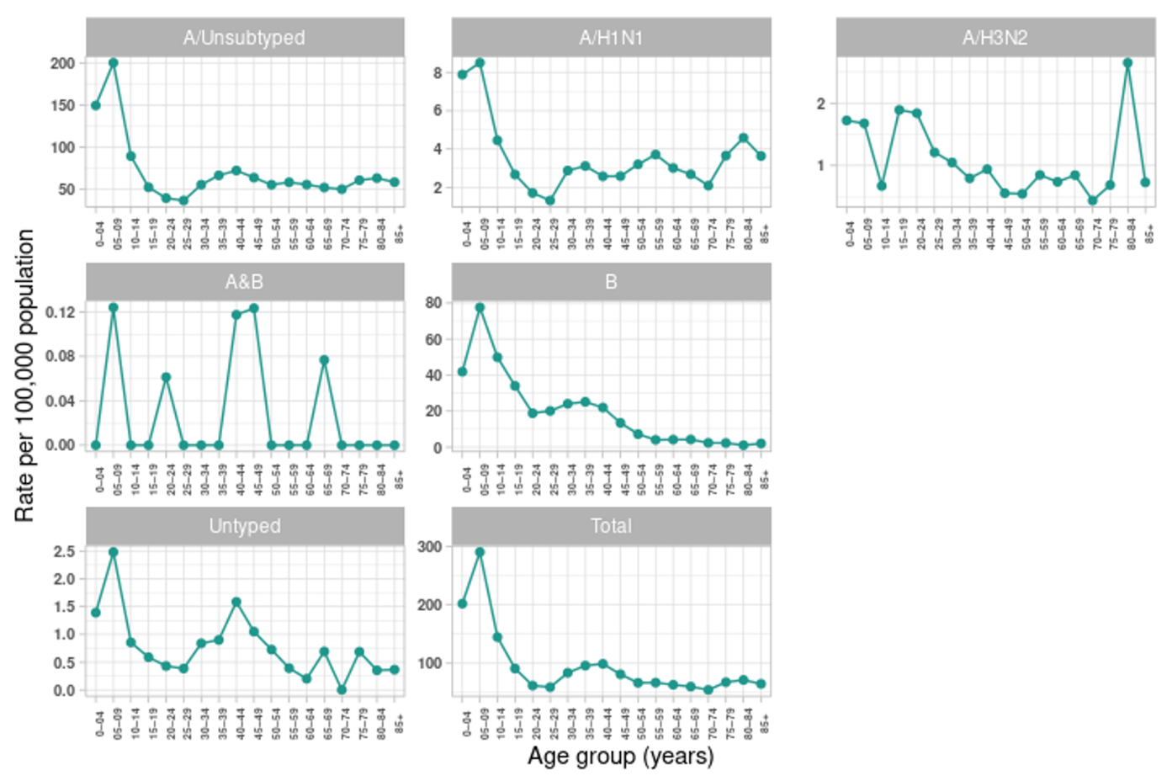

**Source:** NNDSS

*All data are preliminary and subject to change as updates are received.

**Figure 7:** Percent of notifications of laboratory-confirmed influenza, Australia, 1 January to 16 April 2023, by subtype and week of diagnosis*

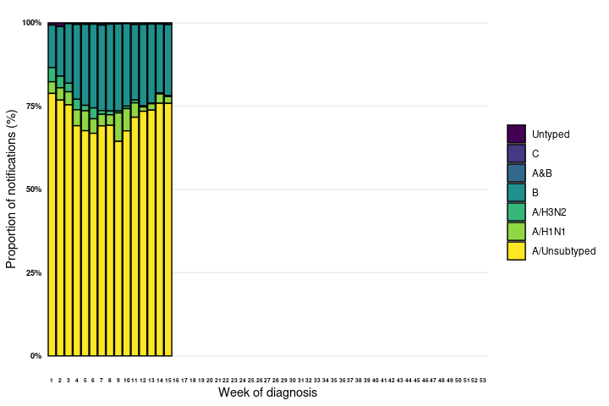

**Source:** NNDSS

*NNDSS notification data provided for the current and most recent weeks may be incomplete. All data are preliminary and subject to change as updates are received.

**Figure 8:** Percent of notifications of laboratory-confirmed influenza, Australia, 1 January to 16 April 2023, by subtype and state or territory*

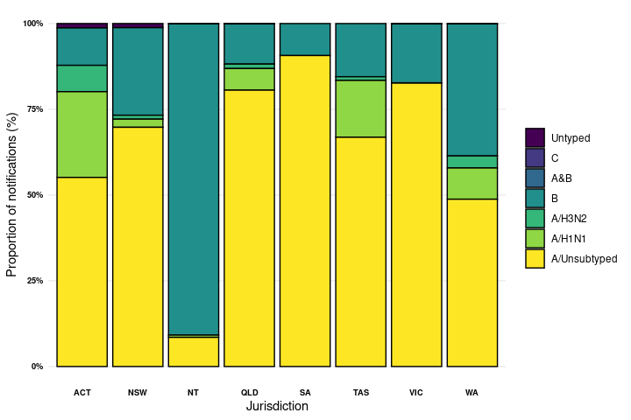

**Source:** NNDSS

*NNDSS notification data provided for the current and most recent weeks may be incomplete. All data are preliminary and subject to change as updates are received.

**Table 1:** Australian influenza viruses typed by haemagglutination inhibition (HI) assay from the WHOCC, 1 January to 16 April 2023*

| **Strain** | **ACT** | **NSW** | **NT** | **QLD** | **SA** | **TAS** | **VIC** | **WA** | **Total** |
| --- | --- | --- | --- | --- | --- | --- | --- | --- | --- |
| A(H1N1) pdm09 | 19 | 31 | 17 | 2 | 13 | 4 | 70 | 0 | **156** |
| A(H3N2) | 9 | 30 | 4 | 2 | 23 | 3 | 40 | 1 | **112** |
| B/Victoria lineage | 1 | 10 | 163 | 0 | 7 | 0 | 31 | 6 | **218** |
| B/Yamagata lineage | 0 | 0 | 0 | 0 | 0 | 0 | 0 | 0 | **0** |
| **Total** | **29** | **71** | **184** | **4** | **43** | **7** | **141** | **7** | **486** |

**Source:** WHOCC

Viruses tested by the WHOCC are not necessarily a random sample of all those in the community. State indicates the residential location for the individual tested, not the submitting laboratory. There may be up to a month delay on reporting of samples.

### 2.6. Vaccine match and effectiveness

**WHOCC**

* Of the 486 isolates characterised for antigenic similarity to their corresponding vaccine components by HI assay (Table 1):
  + 96.2% (150/156) of influenza A(H1N1) isolates characterised in the year to date have been antigenically similar to the corresponding vaccine components;
  + 78.6% (88/112) of influenza A(H3N2) isolates were antigenically similar to the corresponding vaccine components; and
  + 99.1% (216/218) of influenza B/Victoria isolates characterised in the year to date were antigenically similar to the corresponding vaccine components.

**Australian Influenza Vaccines Composition 2023**

* All 2023 southern hemisphere [seasonal influenza vaccinations](https://www.health.gov.au/sites/default/files/2023-03/atagi-advice-on-seasonal-influenza-vaccines-in-2023.pdf) registered for use in Australia are quadrivalent influenza vaccines (QIVs).
* The influenza virus strains included in egg-based QIVs in Australia in 2023 are:
  + A/Sydney/5/2021 (H1N1) pdm09-like virus;
  + A/Darwin/9/2021 (H3N2)-like virus;
  + B/Austria/1359417/2021 (B/Victoria lineage)-like virus; and
  + B/Phuket/3073/2013 (B/Yamagata lineage)-like virus.
* The influenza virus strains included in cell-based QIVs in Australia in 2023 are:
  + A/Sydney/5/2021 (H1N1) pdm09-like virus;
  + A/Darwin/6/2021 (H3N2)-like virus;
  + B/Austria/1359417/2021 (B/Victoria lineage)-like virus; and
  + B/Phuket/3073/2013 (B/Yamagata lineage)-like virus.

The best way to determine how well the vaccine protects against circulating viruses during the season is by determining the vaccine effectiveness. Vaccine effectiveness is usually estimated from observational studies and is calculated after the end of the influenza season, though interim analyses are sometimes available where there is sufficient data.

**Vaccine effectiveness**

It is too early to assess vaccine match and effectiveness for this season.