A new model for  
regulating Aged Care

Summary  
Consultation Paper No. 2  
Details of the proposed new model



# Contents

Contents 3

About this consultation 4

Introduction 5

Structure of the full Consultation Paper No 2. 6

Foundations 6

Key changes 7

Raising the quality of aged care 8

Safeguarding older people in Australia 8

Supporting quality care 10

Becoming a provider 11

Responsibilities of a Provider 13

Holding providers accountable 16

Transitioning to the new model 17

Transitioning existing providers 17

New providers entering aged care 18

Glossary 18

# About this consultation

The purpose of this consultation is to seek feedback on the proposed new model for regulating aged care (the new model). Your feedback will inform refinement of the model for consideration by government and inform the drafting of the new aged care Act (the new Act).

This summary document has been developed as an overview of the full paper [A new model for regulating aged care - Consultation Paper No.2 - Details of the proposed model.](https://www.health.gov.au/resources/publications/a-new-model-for-regulating-aged-care-consultation-paper-2-details-of-the-proposed-new-model) Throughout this summary, we will refer you to specific chapters in the full paper where you can read the proposed policy in more detail.

The new model is being developed through a staged consultation process to ensure it appropriately reflects insights and feedback from the sector, including older people in Australia, their families and carers, aged care providers and workers, peak bodies and experts, and those from diverse groups.

This paper follows:

* the [Concept Paper](https://www.health.gov.au/resources/publications/concepts-for-a-new-framework-for-regulating-aged-care?language=en) including its [plain English version](https://www.health.gov.au/sites/default/files/documents/2022/02/concepts-for-a-new-framework-for-regulating-aged-care-plain-english_0.pdf) published in February 2022
* [Consultation Paper No.1: A New Approach to Regulating Aged Care](https://consultations.health.gov.au/best-practice-regulation/aged-care-regulatory-framework/user_uploads/final-new-model-for-regulating-aged-care-sep-2022.pdf) including its [plain English version](https://consultations.health.gov.au/best-practice-regulation/aged-care-regulatory-framework/user_uploads/dt0003052-plain-english-model-for-regulating-aged-care-consultation-paper-v2-final.pdf) and [short summary sheet](https://consultations.health.gov.au/best-practice-regulation/aged-care-regulatory-framework/user_uploads/dt0003052-re-new-model-for-regulating-aged-care-summary-v6-final-20220902-2.pdf) published in September 2022
* in-depth consultation activities including workshops and webinars throughout 2022.

This consultation paper seeks views on:

* how the new model supports providers to deliver high quality care and   
  manage risks to older people receiving care
* the proposed new provider registration categories and associated obligations
* the transition arrangements to the new model.

Sharing your feedback

There are several ways to provide feedback. Visit the [Aged Care Engagement Hub](http://www.agedcareengagement.health.gov.au/regulatorymodel) for details.

Options include:

a quick 15-minute survey

a detailed survey to answer any or all of the questions included in the paper

a written submission emailed to [agedcareregmodel@health.gov.au](mailto:agedcareregmodel@health.gov.au)

a written submission mailed to:

Attention: Regulatory Strategy Section | Harmonisation and Regulatory Strategy Branch

Department of Health and Aged Care

GPO Box 9848

Sirius Building, Level 9 South

Canberra ACT 2601 Australia

To assist you to prepare your submission, there are questions at the end of each chapter in this paper to consider. We are seeking your feedback by 23 June 2023.

We also encourage you to participate in upcoming webinars and workshops. Find the details and how to register [here](https://agedcareengagement.health.gov.au/regulatorymodel).

Thank you for taking the time to contribute to this process. Thank you to those who have already contributed your feedback to inform the new model. Your insights, thoughts and expert advice are valued and will help to improve the quality and safety of aged care services for older people in Australia.

# Introduction

In response to the [Royal Commission into Aged Care Quality and Safety](https://agedcare.royalcommission.gov.au/) (Royal Commission) the Australian Government is developing and consulting on a range of reforms. This includes designing the new model that will be outlined in the new Act and its subordinate legislation.

The Royal Commission noted in its findings that the current regulatory framework is   
no longer fit for purpose:

“Ineffective regulation has been one of the contributing factors to the high levels of substandard care in Australia’s aged care system. Regulation should seek to prevent harm to people receiving aged care services and ensure that instances of substandard care are detected and addressed.”[1]

The new model will support the new Act, in-home aged care reforms and other recommendations from the Royal Commission.[2] The new model is expected to commence with the new Act.

## Structure of the full Consultation Paper No 2.

The full paper describes:

* how the new model will drive cultural change across the sector, improve outcomes for older people, and restore trust in the system
* how it will facilitate the delivery of high quality care and prevent, detect, and correct poor performance
* the proposed arrangements to transition to a new model.

It outlines limitations of the current regulatory framework and the proposed approach to address them, including:

* how providers will be supported to provide high quality and safe care
* how provider suitability to provide Commonwealth subsidised aged care services will be assessed at the time of entry and at regular intervals through registration and re-registration
* how registration categories, provider obligations and regulatory oversight will work to manage risk
* how older people will be empowered to provide feedback and raise complaints.

The full paper has appendices for A. Glossary of terms, B. Opportunities for harmonisation, C. Overview of limitations, and D. Service types available under current home care programs. An excerpt from the glossary is provided at the end of this document.

# Foundations

The new model will place older people in Australia at the centre of regulation, increasing protections and empowering them to exercise their rights in the context of a reformed and improved aged care system.

These rights are expected to be outlined in a Statement of Rights to be included in the new Act.

Under the new model, regulation will be proportionate to the risks being addressed and support continuous improvement in the sector. The new model’s four foundations build an approach that is:

* rights-based
* person-centred
* risk-proportionate
* focused on continuous improvement.

# Key changes

The proposed new model will introduce changes to the way aged care is regulated under the current regulatory framework.[3] Under the new model, changes are proposed to provider eligibility and entry to the sector, provider obligations (currently referred to as provider responsibilities), regulatory oversight, complaints and feedback mechanisms, and information available   
to older people.

These changes seek to:

* increase protections for older people and empower them to exercise their rights
* drive cultural change in the sector that promotes a new set of values and behaviours across the sector
* improve provider capability, sector sustainability, and public confidence in the system and providers, and
* support continuous improvement.

Read more about key changes being proposed in the ‘Overview’ section   
of the full paper.

# Raising the quality of aged care

Approach

Consistent high quality care requires cultural change across the sector. The new model is key to achieving this by placing more emphasis on relational regulation to build relationships, trust, and transparency in the sector.

The new model sets out to improve the way aged care is delivered, lift standards of care and detect and address harms. The proposed changes include:

* a stronger emphasis on building provider capability and working with providers to lift the standard of care
* encouraging providers to deliver more than the minimum standards, with ‘high quality care’ defined in the legislation[4]
* respecting the autonomy and independence of older people to make decisions that are right for them
* focusing on building and strengthening relationships between providers and older people, the Regulator and providers, and older people and the Regulator
* enhancing complaints and feedback mechanisms to improve outcomes for older people using regulatory intelligence at the point of care and at a system-wide level
* more requirements for providers to value complaints and feedback, and respond in a way that demonstrates a willingness to listen, apologise and implement change so that it does not happen again
* applying obligations on providers that are proportionate to the risks and characteristics of the subsidised services they deliver.

## Safeguarding older people in Australia

A range of regulatory tools and functions will be used to help achieve these aims. The tools are arranged across the following four groupings called ‘safeguards’:

* Supporting quality care – focuses on working with providers and helping the sector to lift the quality and safety of aged care service delivery
* Becoming a provider – the way entities will become an aged care provider and demonstrate they remain suitable to continue delivering services to older people
* Responsibilities of a provider – the obligations providers must meet to facilitate the delivery of high quality care and enhance the protections, rights and delivery of services provided to older people
* Holding providers accountable – the ways in which outcomes for older people will be achieved by facilitating high quality care and deterring poor performance through monitoring, compliance, and enforcement activities.

Figure 1 below outlines the safeguards that are discussed in the following parts of this Summary paper.

Figure 1 The safeguards and regulatory tools that support the new model

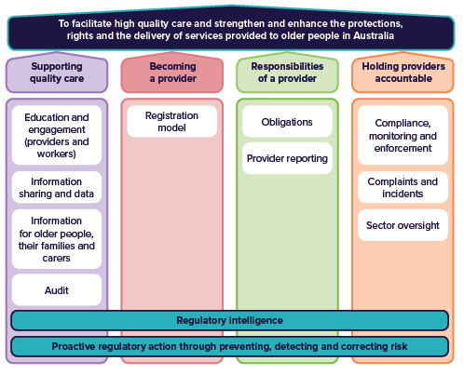

Read more and find questions for your consideration in the ‘Raising the quality of aged care’ section of the full paper.

# Supporting quality care

Approach

The new model will support and incentivise the sector to improve the quality and   
safety of aged care services. It recognises that different stakeholders will each have different roles to play.

The new model recognises that all stakeholders have an important role to play.   
For example, the Regulator will be positioned and empowered to identify systemic trends and respond to risk and issues proactively. The Regulator and the Department of Health and Aged Care (the Department) will work with providers to help lift the standard of care or exit those providers that cannot improve.

The proposed approach includes:

#### Information for older people, their families and carers

* access to detailed and easy to understand information so they feel confident in decisions about their care, know what to expect before they receive services, and how to exercise their rights.

#### Education and engagement with providers

* improved information, materials and programs for providers to understand older people’s rights, their obligations, how their performance compares to their peers,   
  and how to learn from each other.

#### Building capability and continuous improvement

* targeted development and education campaigns for providers
* sharing good practice and innovations
* building a safe and skilled workforce
* broad campaigns for the community to increase early identification of substandard care, abuse or neglect and how to escalate issues or seek support.

#### Incentivising high quality and safe care

* publishing provider performance information for increased transparency and accountability
* promoting good performance
* applying graded assessment against the Aged Care Quality Standards.

Read more and find questions for your consideration in the ‘Supporting quality care’ section of the full paper.

# Becoming a provider

Approach

The new model will introduce universal registration and re-registration for providers delivering Commonwealth subsidised aged care services to test their suitability, capability, viability, and propriety[5] at the point of entry and at regular intervals.

Provider registration will help safeguard older people by managing risks that are known at the time of registration and re-registration. Other regulatory tools will be used in an integrated manner to address other risks that are not known at this time.

The proposed approach includes:

#### Universal provider registration and re-registration

* registration as the single-entry point for all providers delivering Commonwealth subsidised aged care services
* providers will be able to register into one or more registration categories
* non-corporations, for example sole traders and partnerships, will be allowed to register to deliver in-home aged care services
* risk-proportionate registration requirements and conditions will apply to the categories
* key information about registered providers will be published on a register.

#### Registration categories

* six (6) registration categories are proposed, which group aged care services based on common characteristics, the associated service risks, and the provider obligations to address the risks
* Table 1 below shows the categories.

#### Assessment of provider suitability

* assessments will occur at the time of registration and re-registration, on the suitability of the applicant to provide the services, and the suitability of key personnel (to be known as responsible persons) in the applicant’s organisation.

#### Audit against the Quality Standards

* audits against the Quality Standards will be graded instead of the current pass or fail approach, to incentivise excellence, innovation, and continuous improvement.

Table 1 - Proposed Provider Registration Categories

|  |  |
| --- | --- |
| Provider Registration Category | Service types |
| Category 1:  Home and  community services | Domestic assistance  Home maintenance and repairs  Meals  Transport |
| Category 2:  Assistive technology and home modifications | Digital technologies  Digital monitoring, education and support  Goods, equipment and assistive technologies  (non-digital)  Home modifications |
| Category 3:  Social support | Social support |
| Category 4:  Clinical and  specialised supports | Personal care  Care management  Transition care services in the home  Specialised supports  Assistance with care and housing (hoarding and squalor support)  Nursing  Allied health |
| Category 5:  Home or  community-based respite | Respite (home and community based) |
| Category 6:  Residential care | Accommodation services  Residential respite  Care and services  Transition care services (residential)  Transition care support services (residential) |

Read more and find questions for your consideration in the ‘Becoming a provider’ section of the full paper.

# Responsibilities of a Provider

Approach

The new model will impose clear and targeted ongoing obligations on aged care providers to manage different risks to achieve safe, quality, and person-centred care.

Under the new model, provider responsibilities will be known as obligations. Providers are responsible for meeting their obligations, which aim to safeguard older people by putting in place the necessary controls to manage risk of harm and facilitate the delivery of high-quality care.

Over 300 provider responsibilities currently specified across multiple pieces of legislation will be replaced by a set of streamlined provider obligations that focus on safety and quality outcomes for older people and/or financial and prudential risks. Provider obligations and regulatory oversight will be designed around registration categories and will be risk-proportionate. There will be overarching obligations that all providers must meet. The obligations that are attached to a provider’s registration will be known as ‘conditions of registration’.

Provider obligations will include:

#### A Statement of Rights

* registered providers will be expected to provide aged care services in a manner consistent with these rights.

#### Overarching obligations

* the new Act will include a set of central provisions requiring, for example, that all registered providers must comply with all conditions of registration and cooperate with persons exercising powers under the new Act.

#### Conditions of registration

* Core conditions applied to all registered providers include:
  + the Code of Conduct for Aged Care (the Code) that came into effect in   
    December 2022[6]
  + workforce and worker registration requirements
  + rights and principles in the new Act
  + compliance with applicable laws
  + protecting personal information (as is currently required under the Act).
* Category-specific conditions of registration include:
  + conditions applicable to a relevant category, such as provider governance and the Quality Standards
  + categories 4 to 6 will be audited against the draft strengthened Quality Standards
  + the risks associated with registration categories 1 to 3, which will not be subject to audits at the point of registration, will be managed through targeted risk tools, including the Code and obligations appropriate to the nature of the subsidised services delivered by providers in these categories.
* Provider-specific conditions of registrationwhich are determined by the Regulator to manage risks associated with specific providers.

See Figure 2 below for an overview of how obligations will be applied to registration.   
Figure 3 provides further details of the risk-based approach for the proposed obligations.

The new obligations architecture will give providers a clear understanding of the standard of care expected to be delivered, and the penalties they face if this is not delivered. Registration conditions will be detailed on their certificate of registration. The public are expected to have access to this information via a register of aged care providers.

Read more and find questions for your consideration in the ‘Responsibilities of a provider’ section of the full paper.

Figure 2 The obligations architecture for the provider registration categories

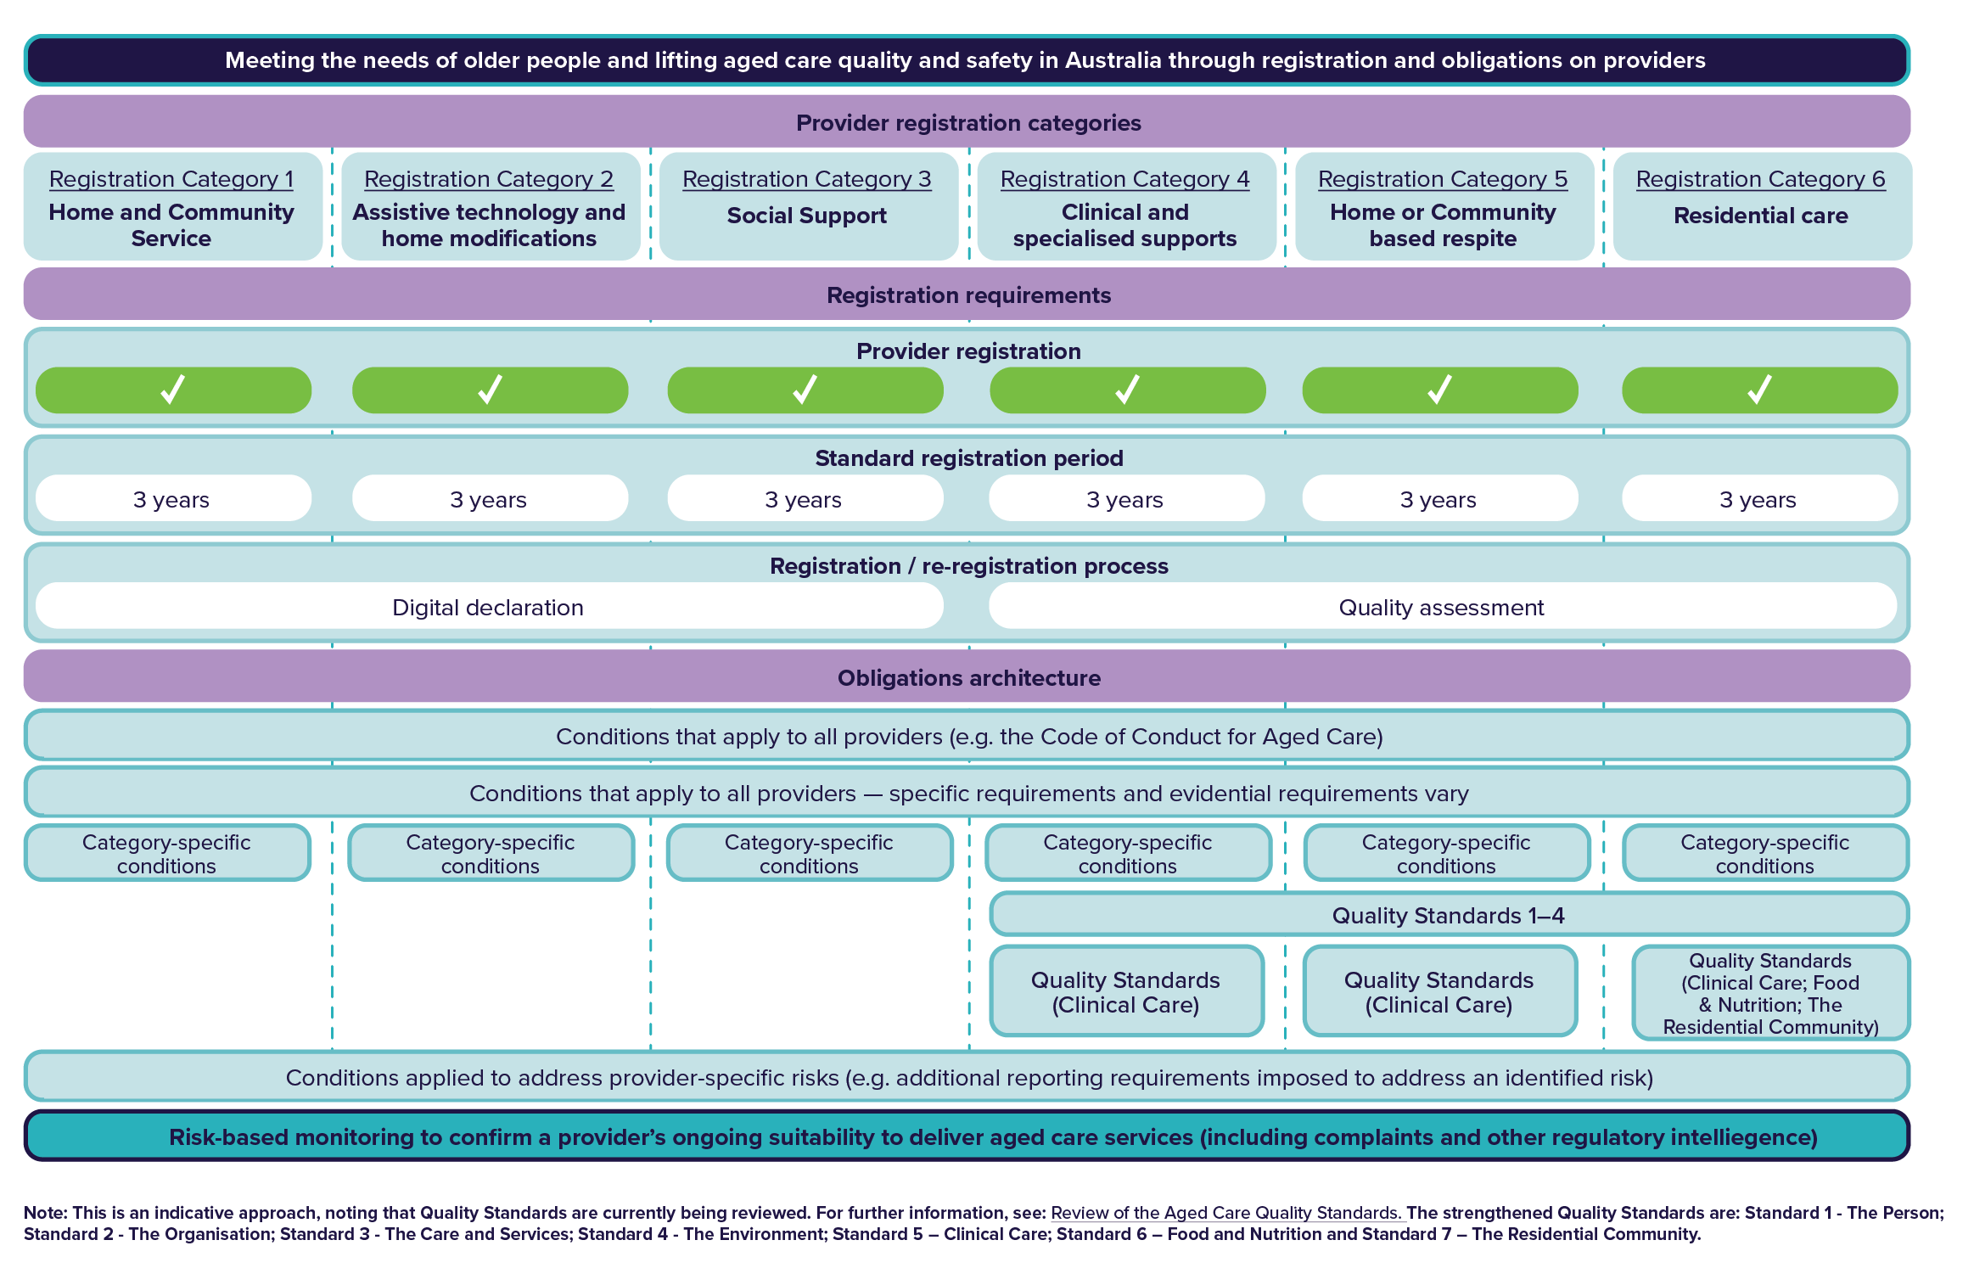

Figure 3 A risk-based approach to provider obligations in the new model for regulating aged care

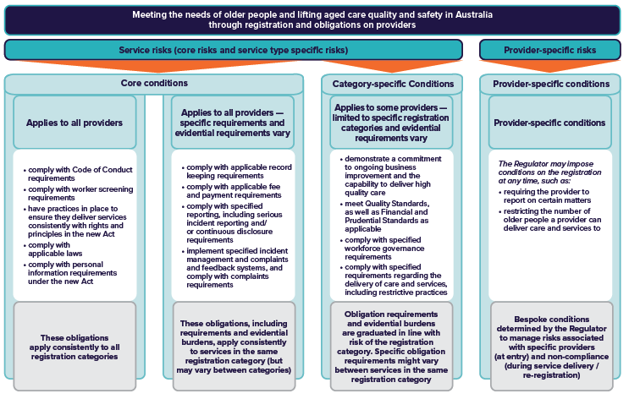

# Holding providers accountable

Approach

The new model will have a stronger focus on connecting information and intelligence to prevent, detect and correct risk and poor provider performance. It seeks to create a culture that values complaints and listens to feedback from older people.

The protection and promotion of the rights of older people will be central to the new aged care system. Older people will be encouraged and empowered to exercise their rights. Restorative justice processes may be introduced to create additional accountability on providers to respond, apologise and address feedback by making sustainable and meaningful changes to how services are delivered in the future. The Regulator’s monitoring, investigation and enforcement powers will be strengthened, broadened, streamlined and more flexible.

The proposed approach includes:

#### Risk-based monitoring

* the monitoring of all providers will be informed by data and regulatory intelligence so that the Regulator and the Department can form a holistic view of risk and respond to risk before it results in poor care or harm to older people.

#### Complaints management and feedback

* a revised complaints model will have the following principles:
  + a culture that values complaints
  + is person-centred
  + is procedurally fair
  + demonstrates empathy
  + practice reflects policy
  + complaints drive service improvement
  + and meets industry requirements.

#### Information sharing

* information sharing will be clear and transparent on when, why, and how the information will be used as well as how the privacy of individuals will be protected. It will build on recent legislative changes for improved information sharing between care and support sector regulators.

#### Compliance

* it will be the provider’s responsibility to demonstrate compliance with their obligations the Regulator will manage the risk of, or actual non-compliance, with a ‘Requirement for Action Notice’ and a ‘Compliance Notice’, to encourage or enforce compliance.

#### Enforcement

* a wide range of enforcement powers will allow the Regulator to use the most appropriate enforcement tool for a risk-based and proportionate response, based on the provider’s capability and willingness to comply, along with the risk presented by the non-compliance.

#### Compensation

* compensation may be available to older people who are negatively affected by registered providers that fail to meet their obligations, where the provider agrees to pay compensation.

Read more and find questions for your consideration in the ‘Holding providers accountable’ section of the full paper.

# Transitioning to the new model

Approach

It is proposed there will be a single ‘go-live’ date for the new model when the   
new Act commences. The current regulatory framework will cease when the new   
model commences.

Transition includes the planning and processes required to support the aged care sector to move from the current regulatory framework to the new model, while ensuring continuity of care. To simplify and streamline the process for the sector, preparation for transition will occur ahead of implementation. To support the sector during the transition, the Regulator and Department will continue to engage with providers and offer timely advice and assistance.

Subject to further consultation and consideration, the proposed transition approach is outlined below.

## Transitioning existing providers

Deeming – Existing providers of Commonwealth funded aged care programs (including grant funded providers under the current scheme) will be deemed into registration categories before go-live.

Requirements – All providers will receive advice on their proposed registration category(ies) and provide feedback before go-live. Providers will then be issued a certificate of registration that details the conditions of registration for their relevant registration category(ies).

Re-registration – While standard registration periods are expected to be 3 years, to avoid all providers having to re-register at the same time, re-registration timeframes for deemed providers will be staggered.

Compliance activity underway at the time of commencement – Providers who are subject to compliance and enforcement activity (e.g., review of a complaint) at the time of deeming, will see this process through under the current framework.

## New providers entering aged care

* It is expected that applications for approval as a new provider will be able to be submitted under the current scheme up until the commencement of the new Act.
* However, applications made in the 6 months prior to go-live may not be able to be decided by the Regulator before the new model commences. As a result, in the period leading up to transition, new providers will be encouraged to submit an application to be registered after go-live.

Read more and find questions for your consideration in the ‘Transitioning to the new model’ section of the full paper.

# Glossary

| Term | Definition |
| --- | --- |
| Condition of Registration | Conditions are a subset of provider obligations that are applied to registration.  A registered provider will be required to comply with any conditions placed on their registration. These conditions will outline specific obligations that the provider must meet. Some conditions will apply to all providers, some to providers in certain categories only and some to specific providers only. What a provider needs to do to meet a condition may also vary across registration categories. |
| Enforcement | Enforcement refers to actions taken by the Regulator to address aged care providers or workers who are not meeting applicable laws or responsibilities. |
| Obligations | Obligations refer to ‘what’ a registered provider must do to comply with the aged care legislative framework – and hence, the actions or behaviour that will be required of them. A failure to comply with one or more obligations that apply to them under the legislative framework could result in enforcement action being taken against the provider – for example, penalties, fines or other legal action.  Obligations include conditions of registration. |
| Provider Specific Conditions | These are individual conditions that the Regulator may decide to place on the registration of a specific provider due to concerns about their compliance with provider obligations and/or delivery of services to older people. Their aim will be to ensure that any risks to older people are managed while the Regulator works with the provider to improve their performance where necessary. |
| Regulatory intelligence | Regulatory intelligence includes monitoring, collecting, and analysing information related to regulations. It helps governments to make decisions. |
| Relational regulation | Refers to an approach by the Regulator that emphasises meaningful engagement on the ground, between the regulator, providers, workers, and older people (and their advocates). The term ‘relationship-based regulation’ may be used in place of ‘relational regulation’. |
| Risk-Based Monitoring | Risk-based monitoring uses a range of monitoring methodologies. Monitoring could be site-based, desk-based, announced, or unannounced. It may be as simple as a phone call following up an issue with a provider or it may be a full investigation of a particular issue (drawing on investigation powers and powers to compel provision of information). |
| The Regulator | In the current regulatory model, the aged care Regulator is the Aged Care Quality and Safety Commission. When referring to the new model, ‘Regulator’ is used to mean the body that will administer parts of legislation for aged care providers that relate to registration and re-registration of providers, enforcing provider obligations, and engaging directly with providers in relation to their compliance with those obligations. The Department of Health and Aged Care will administer other parts of the legislation as the System Governor. |

1. Royal Commission into Aged Care Quality and Safety, Final Report – Volume 1: Summary and Recommendations, 1 March 2021 p 136
2. The new model also responds to Royal Commission’s Recommendations 92 and 93 (provider approval and accreditation),   
   Recommendations 13, 14, 50, 131, 123, 133 and 135 (provider registration and obligations), Recommendations 97, 101, 102, 103, 134 and 136 (monitoring and enforcement), and Recommendations 10, 98 and 99 (complaints and whistle-blower protections).
3. The current regulatory framework, referenced in this paper, is outlined in the *Aged Care Quality and Safety Commission Act 2018* (the Commission Act), the *Aged Care Act 1997* (the Aged Care Act) and associated subordinate legislation.
4. A definition of ‘high quality care’ will be included in the new Aged Care Act in response to Recommendation 13   
   (Embedding high quality aged care) of the Royal Commission.
5. This responds to Royal Commission Recommendation 92
6. Available at [Code of Conduct for Aged Care - A fact sheet for aged care providers (agedcarequality.gov.au)](https://www.agedcarequality.gov.au/sites/default/files/media/code_of_conduct_for_aged_care_provider_fact_sheet_0.pdf) and   
   [Code of Conduct for Aged Care – consumer fact sheet | Aged Care Quality and Safety Commission](https://www.agedcarequality.gov.au/sites/default/files/media/code_of_conduct_for_aged_care_provider_fact_sheet_0.pdf)