**The Way Back Support Services Evaluation | Final Evaluation Report Appendices**

Beyond blue

21 December 2022

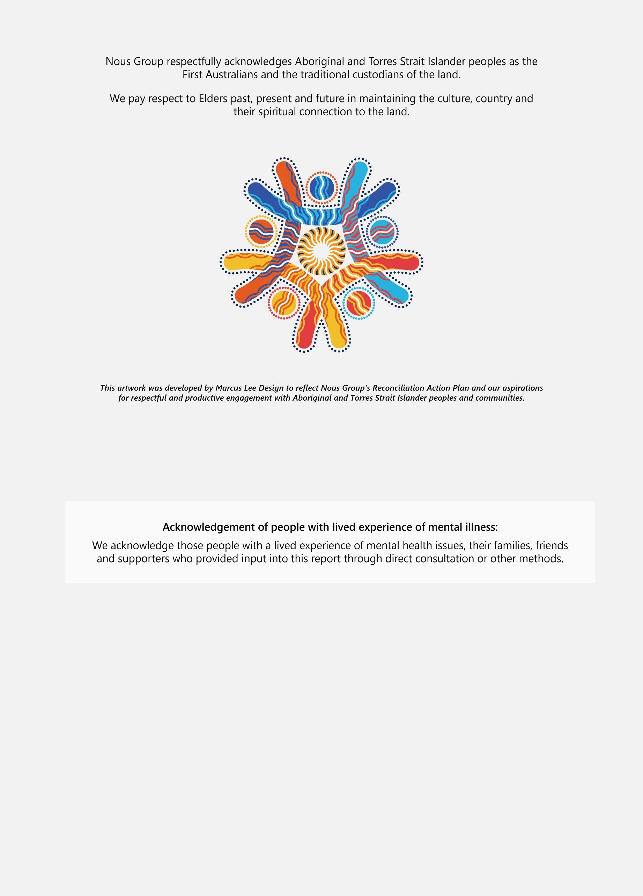Disclaimer:

Nous Group (**Nous**) has prepared this report for the benefit of the Beyond Blue (the **Client**).

The report should not be used or relied upon for any purpose other than as an expression of the conclusions and recommendations of Nous to the Client as to the matters within the scope of the report. Nous and its officers and employees expressly disclaim any liability to any person other than the Client who relies or purports to rely on the report for any other purpose. Nous has prepared the report with care and diligence. The conclusions and recommendations given by Nous in the report are given in good faith and in the reasonable belief that they are correct and not misleading. The report has been prepared by Nous based on information provided by the Client and by other persons. Nous has relied on that information and has not independently verified or audited that information.

© Nous Group

Contents

Appendix A List of The Way Back sites 2

Appendix B Methodology and data limitations 4

B.1 Evaluation approach 4

B.2 Key Evaluation Questions and detailed data collection plan 6

B.3 Data sources 9

B.4 Data analysis 10

B.5 Detailed evaluation methodology 12

B.6 Detailed data limitations 13

Appendix C Additional detail about The Way Back 16

C.1 Rationale for The Way Back 16

C.2 Enablers 17

Appendix D Interim report recommendations 23

1. List of The Way Back sites

This appendix provides a list of the 38 operational sites as at September 2022. A total of 27 of these sites are considered to be ‘in-scope’ for the purpose of the evaluation.[1]

| Site | Date operational | Funding Source | In-scope for final evaluation report |
| --- | --- | --- | --- |
| 1. Adelaide | 14/12/2020 | Bilateral agreement | In-scope |
| 1. Albury / Wodonga | 7/01/2022 | HOPE/Commonwealth | Not in scope of evaluation |
| 1. Ballarat/Grampians (HOPE) | 1/07/2020 | HOPE | Not in scope of evaluation |
| 1. Western Victoria: Ballarat | 1/07/2020 | HOPE | Not in scope of evaluation |
| 1. Bendigo/Echuca (HOPE) | 1/11/2020 | HOPE | Not in scope of evaluation |
| 1. Brisbane North: Redcliffe/Caboolture | 23/02/2018 | Bilateral agreement | In-scope |
| 1. Brisbane North: Inner City Brisbane | 6/09/2021 | Bilateral agreement | In-scope |
| 1. Brisbane South | 20/03/2021 | Bilateral agreement | In-scope |
| 1. Broken Hill | 06/09/2021 | Bilateral agreement | In-scope |
| 1. Cairns | 24/05/2021 | Bilateral agreement | In scope |
| 1. Canberra | 5/01/2019 | Bilateral agreement | In-scope |
| 1. Casey (HOPE) | 1/07/2020 | HOPE | Not in scope of evaluation |
| 1. CESPHN: Sutherland/St George | 10/01/2020 | Bilateral agreement | In-scope |
| 1. CESPHN: Concord/Canterbury | 04/01/2021 | PHN self-funded | In-scope |
| 1. Dandenong | 1/07/2020 | HOPE | Not in scope of evaluation |
| 1. Darwin | 1/07/2020 | Bilateral agreement | In-scope |
| 1. Geelong (HOPE) | 1/12/2017 | HOPE/Commonwealth | Not in scope of evaluation and ceased operation in 31/3/22 |
| 1. Gold Coast | 1/07/2020 | Bilateral agreement | In-scope |
| 1. Goulburn Valley | 6/01/2022 | HOPE | Not in scope of evaluation |
| 1. Central Coast: Gosford/Wyong | 01/02/2021 | Bilateral agreement | In-scope |
| 1. Hobart | 23/12/2021 | Bilateral agreement | In-scope |
| 1. Launceston | 9/12/2021 | Bilateral agreement | In-scope |
| 1. Mildura | 8/07/2020 | Bilateral agreement | In-scope |
| 1. Monash (Clayton) | 4/04/2022 | HOPE | Not in scope of evaluation |
| 1. Mt Isa | 14/06/2021 | Bilateral agreement | In scope |
| 1. Murrumbidgee | 1/02/2018 | Bilateral agreement | In-scope |
| 1. Newcastle | 1/04/2016 | Bilateral agreement | In-scope |
| 1. North Coast | 1/07/2020 | Bilateral agreement | In-scope |
| 1. Northern Sydney | 1/01/2021 | Bilateral agreement | In-scope |
| 1. Central Queensland: Rockhampton, Gladstone & Emerald | 31/03/2021 | PHN self-funded | In-scope |
| 1. Central Queensland: Bundaberg/Hervey Bay/Maryborough/Geynder | 31/03/2021 | Bilateral agreement | In-scope |
| 1. Central Queensland: Sunshine Coast/Nambour/Caloundra | 31/03/2021 | PHN self-funded | In-scope |
| 1. South West Sydney | 13/04/2021 | Bilateral agreement | In-scope |
| 1. Darling Downs and West Moreton (Toowoomba & Ipswich) | 23/10/2019 | Bilateral agreement | In-scope |
| 1. Traralgon and Warragul (Gippsland Central) (HOPE) | 29/02/2020 | HOPE | Not in scope of evaluation |
| 1. South East Gippsland (HOPE) | 29/02/2020 | HOPE/Commonwealth | Not in scope of evaluations |
| 1. Warrnambool (Great South Coast) | 30/08/2020 | Bilateral agreement | In-scope |
| 1. Westmead/Mt Druitt (Went West Sydney) | 11/01/2021 | Bilateral agreement | In-scope |

1. Methodology and data limitations
   1. Evaluation approach

This appendix outlines the program theory for The Way Back. The evaluation is underpinned by a theory of change and theory of action (program logic). The theory of change for The Way Back is summarised in Figure 1 The program logic presented overleaf on Figure 2 sets out the way in which The Way Back providers are expected to implement the service and expected outcomes.

Figure 1 | The Way Back theory of change

Figure 1 is an infographic showing The Way Back theory of change. 
If an individual presents to a hospital then then they are more likely to access help and service providers will have increased capacity  to provide follow up support. 

Figure 2 | The Way Back program logic

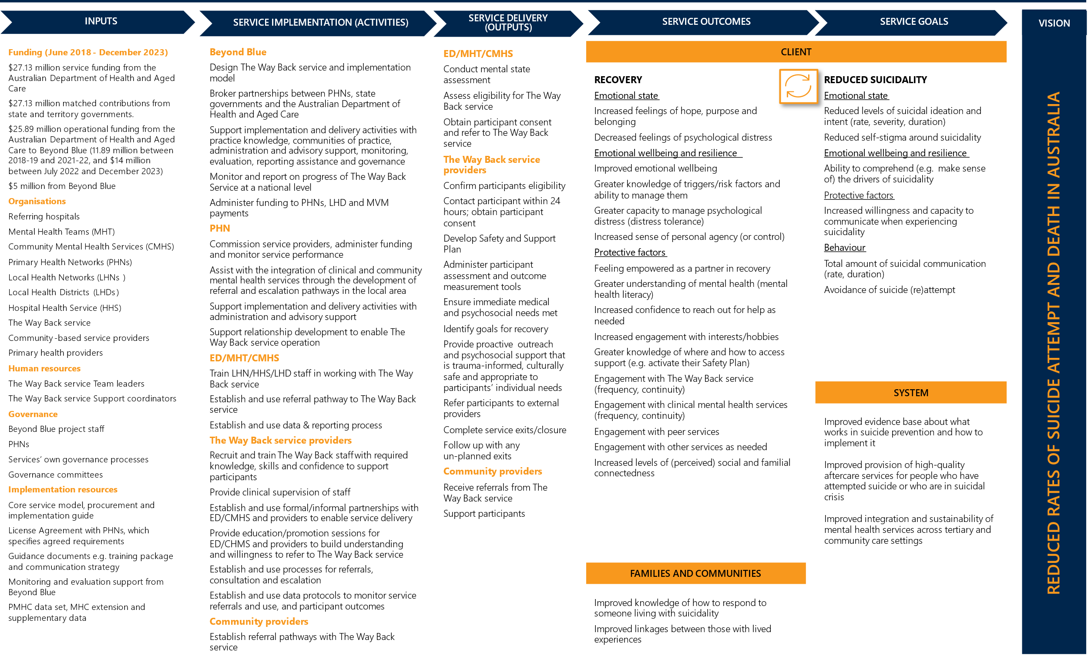

* 1. Key Evaluation Questions and detailed data collection plan

Table 1 provides the detailed data collection plan, outlines Key Evaluation Questions (KEQs) and research questions and data sources (as outlined in the Evaluation Framework).

Table 1 | Data sources for Key Evaluation Questions and research questions for the evaluation

|  |  |  |  |  |  |  |  |  |  |
| --- | --- | --- | --- | --- | --- | --- | --- | --- | --- |
| Research question | | Secondary data  documents | | Secondary data  Data sets (for example, PMHC MDS) | | Primary data  Interviews or focus groups | | Primary data  Surveys | |
| KEQ1. What is being delivered under The Way Back, where how and why? | | | | | | | | | |
| 1. What need does The Way Back aim to meet? | ✓ | | ✓ | | ✓ | |  | |
| 1. What is important, for whom, about the policy, operating and community context(s) in which The Way Back is delivered? | ✓ | |  | | ✓ | | ✓ | |
| 1. What is the service and implementation model, including the core model and design variations? (i.e. how does The Way Back work to support its participants?) | ✓ | |  | | ✓ | |  | |
| 1. What are the enablers of service delivery and implementation (in each site and across the network)? | ✓ | |  | | ✓ | | ✓ | |
| 1. What activities and outputs has The Way Back delivered, in each site? |  | | ✓ | | ✓ | | ✓ | |
| KEQ2. How well is The Way Back being delivered? | | | | | | | | |
| 1. To what extent is The Way Back providing the expected service reach and coverage for target populations in each site and why? | ✓ | | ✓ | | ✓ | | ✓ | |
| 1. To what extent do participants take up, participate and continue in the service as expected and in line with their assessed need and why, for which participants? |  | | ✓ | | ✓ | | ✓ | |
| 1. To what extent are participants satisfied with The Way Back and why, for which participants? | ✓ | | ✓ | | ✓ | | ✓ | |
| 1. In each site, how effectively is The Way Back delivered to participants relative to its intended design and why? (for example, considering evidence-based service standards and the local context) | ✓ | | ✓ | | ✓ | | ✓ | |
| 1. To what extent are expected (and unexpected) service enablers and barriers supporting The Way Back implementation and delivery in each site, how and why? How have they been made use of or overcome by providers? | ✓ | | ✓ | | ✓ | | ✓ | |
| KEQ3. What is changing, for whom, in The Way Back? | | | | | | | | |
| 1. To what extent do participants attain expected outcomes and goals (and any unexpected outcomes) during The Way Back service period and for which participants and why? |  | | ✓ | | ✓ | | ✓ | |
| 1. In which ways do participant outcomes vary, including for participant cohorts, by service criteria (i.e. after a suicide attempt or suicidal crisis) and by service site/variation? |  | | ✓ | | ✓ | | ✓ | |
| 1. What insights do these variations offer for what recovery looks like for different participants? |  | | ✓ | | ✓ | | ✓ | |
| 1. What role is The Way Back playing, if any, in improving the integration and sustainability of clinical and psychosocial mental health services? |  | |  | | ✓ | | ✓ | |
| KEQ4. Why and how does change occur in The Way Back, in which circumstances? | | | | | | | | |
| 1. What are the significant mechanisms of change for participants and for which participants, in which sites and how and why? | ✓ | |  | | ✓ | | ✓ | |
| 1. Overall, what contribution has The Way Back made to which participant outcomes and goals and for whom, in which sites and how and why? |  | | ✓ | | ✓ | | ✓ | |
| 1. To what extent did the peer support enhancement in Murrumbidgee LHD contribute to participant outcomes and goals, for which participants, how and why? What aspects of its contribution was unique, how does it compare to non-peer-based support and what was a reinforcement of benefits from the core model? |  | | ✓ | | ✓ | | ✓ | |
| 1. To what extent did other variations or enhancements on The Way Back service model contribute to participant outcomes and goals, for which participants, how and why? What aspects of their contribution were unique and what was a reinforcement of benefits from the core model? |  | | ✓ | | ✓ | | ✓ | |
| KEQ5. What can be done to improve the contribution of The Way Back and similar services to service outcomes and goals? | | | | | | | | |
| 1. How could The Way Back service model and its variations be further developed to improve the reach, quality and outcomes of the service for participants? | ✓ | | ✓ | | ✓ | | ✓ | |
| 1. What insights and lessons does The Way Back offer for the sector’s wider understanding of participant recovery and for designing and delivering effective follow-up services, in complex operating environments? | ✓ | | ✓ | | ✓ | | ✓ | |
| 1. What data should be collected to support a future summative evaluation and value-for-money assessment of The Way Back? | ✓ | | ✓ | |  | |  | |

* 1. Data sources

Figure 3 provides a detailed list of the key data sources that inform the final evaluation report. Further detail on three surveys conducted are provided in Table 2.

Figure 3 | Data sources that inform the final evaluation Report

Figure 3 is an infographic showing the data sources that informed the evaluation.
57 interviews with participants
15 interviews with referring health service staff
2 PHN focus groups
2 interviews with project steering committee members 
35 interviews with provider staff
4 collective analysis workshops with providers and PHNs
2 interviews with Beyond Blue staff
2 interviews with Beyond Blue CEO, Chief Strategy officer and Chief Services officer

Table 2 | Detailed methodology for evaluation surveys

|  |  |
| --- | --- |
| Survey | Detailed methodology |
| Participant survey | Respondents were asked 28 optional response questions to understand:  The types of services and supports received through The Way Back  The aspects of The Way Back that were most important to them and why, and  Their overall satisfaction with the quality of support received in The Way Back and opportunities for improvement.  Demographic information was also collected including location, age, gender, the language spoken at home, whether they identified as Aboriginal and/or Torres Strait Islander, and whether they identified as LGBTIQA+  Questions included open-text responses, and multiple-choice |
| Provider survey | Respondents were asked 34 optional response questions to understand:   * Implementation progress and challenges with The Way Back site * Experiences, strengths and professional development of staff delivering The Way Back, and * Opportunities to improve implementation, the core model and its variations.   Respondents were also asked basic demographic questions including location they work in, age, gender, language spoken at home, whether they identified as Aboriginal and/or Torres Strait Islander, and whether they identified as LGTBIQA+.  Questions included open-text responses, and multiple-choice responses. |
| Blue Voices and Roses in the Ocean (BVRITO) survey | Respondents were asked 21 optional response questions to understand:   * Types of services and supports received after a suicide crisis, attempt or bereavement * What was most helpful or would have been helpful in supporting their recovery journey or the recovery journey of the person you supported. * Ideas for improving supports and services offered to people in the future, particularly follow up services like The Way Back.   Questions included open-text responses, and multiple-choice responses. |

* 1. Data analysis
     1. Data analysis of outcomes data

Analysis was conducted to understand how participant outcomes change from the start of the service to the end of the service. The Way Back used outcome measures of suicidality (Suicidal Ideation Attributes Scale (SIDAS), psychological distress (Kessler Psychological Distress Scale (K10+)) and wellbeing (World Health Organisation- Five Well-Being Index (WHO-5)). Participants who were identified as Aboriginal and Torres Strait Islander were also provided with the option of the K5 as a culturally appropriate alternative to the K10+. The effects of different factors on changes in measures of suicidality, psychological distress and wellbeing, completion of the service and length of time spent in the service were estimated through a regression model and compared how members of certain cohorts compared to members of a baseline cohort.

* + 1. Sources for Cohen’s D Analysis

Table 3 provides the sources used for the Cohen’s d analysis of the K10+ scores used in section 7.4 of the final report.

Table 3 Sources used in Cohen’s d analysis of K10+ scores

|  |  |  |  |  |
| --- | --- | --- | --- | --- |
| Program or study | Description | Relevance to The Way Back | Findings | Effect size |
| The National Institute for Mental Health Research, 2015, Evaluation of Transition to Recovery (TRec) Program.  Available at: www.wcs.org.au. | The TRec program provides support for people with mental illness to support recovery following discharge from hospital. | High | K10 scores decreased from pre-TRec to post-TRec . Participants at the start of the program were approximately 11 times more likely to be categorized in the ‘high to very high’ distress category compared to participants who completed TRec. | Large effect size  (η2 = .31) |
| UNSW Social Policy Research Centre, Is headspace making a difference to young people’s lives? Final report of the independent evaluation of the headspace program. 2015. Available at: www.headspace.org.au. | headspace is focused on mental health and social and emotional wellbeing more broadly. This evaluation focuses in part on suicidal ideation and self-harm. | Medium | Overall, almost half (47 per cent, n=12,233) of young people who attended headspace’s K10+ scores decreased: 13.3 per cent experienced a clinically significant improvement, 9.4 per cent a reliable[2] improvement and 24.3 per cent an insignificant improvement. | Cohen’s d =-0.11 for the difference-in-differences between ‘headspace’ and ‘no treatment’ group |
| [CSAPHN, National Suicide Prevention Trial Evaluation: Final Report, 2021](https://www.countrysaphn.com.au/wp-content/uploads/2021/08/NSPT-Evaluation-Report-Final.pdf). Available at: countrysaphn.com.au | An evaluation of a range of psychosocial suicide prevention events in regional areas of South Australia including aftercare services. | Medium-Low | Total (N=322) mean scores on the Kessler K10+ depressive symptoms scale was 33.91 (SD=9.18). However, mean symptom scores reduced over time from episode start, review and end showing the success of aftercare service treatment. | No effect size provided. |
| Black Dog Institute, [Ibobbly mobile health intervention for suicide prevention in Australian Indigenous youth: a pilot randomised controlled trial](https://bmjopen.bmj.com/content/7/1/e013518). 2016, BMJ Open. | Ibobbly is an app that targets suicidal ideation, depression, psychological distress among Indigenous youth in remote Australia. | Low | Participants in the iBobbly group showed substantial and statistically significant reductions in K10+ scores compared with the waitlist control group (t=2.44; df=57.5; p=0.0177). reflecting a substantial effect. | Large effect size  Cohen’s d = 0.65 (95% CI 0.12 to 1.17). |

* 1. Detailed evaluation methodology

The evaluation methodology included four key components which aligned to the evaluation lenses. These are summarised in Figure 4.

Figure 4 | Evaluation methodology and its alignment with the evaluation lenses

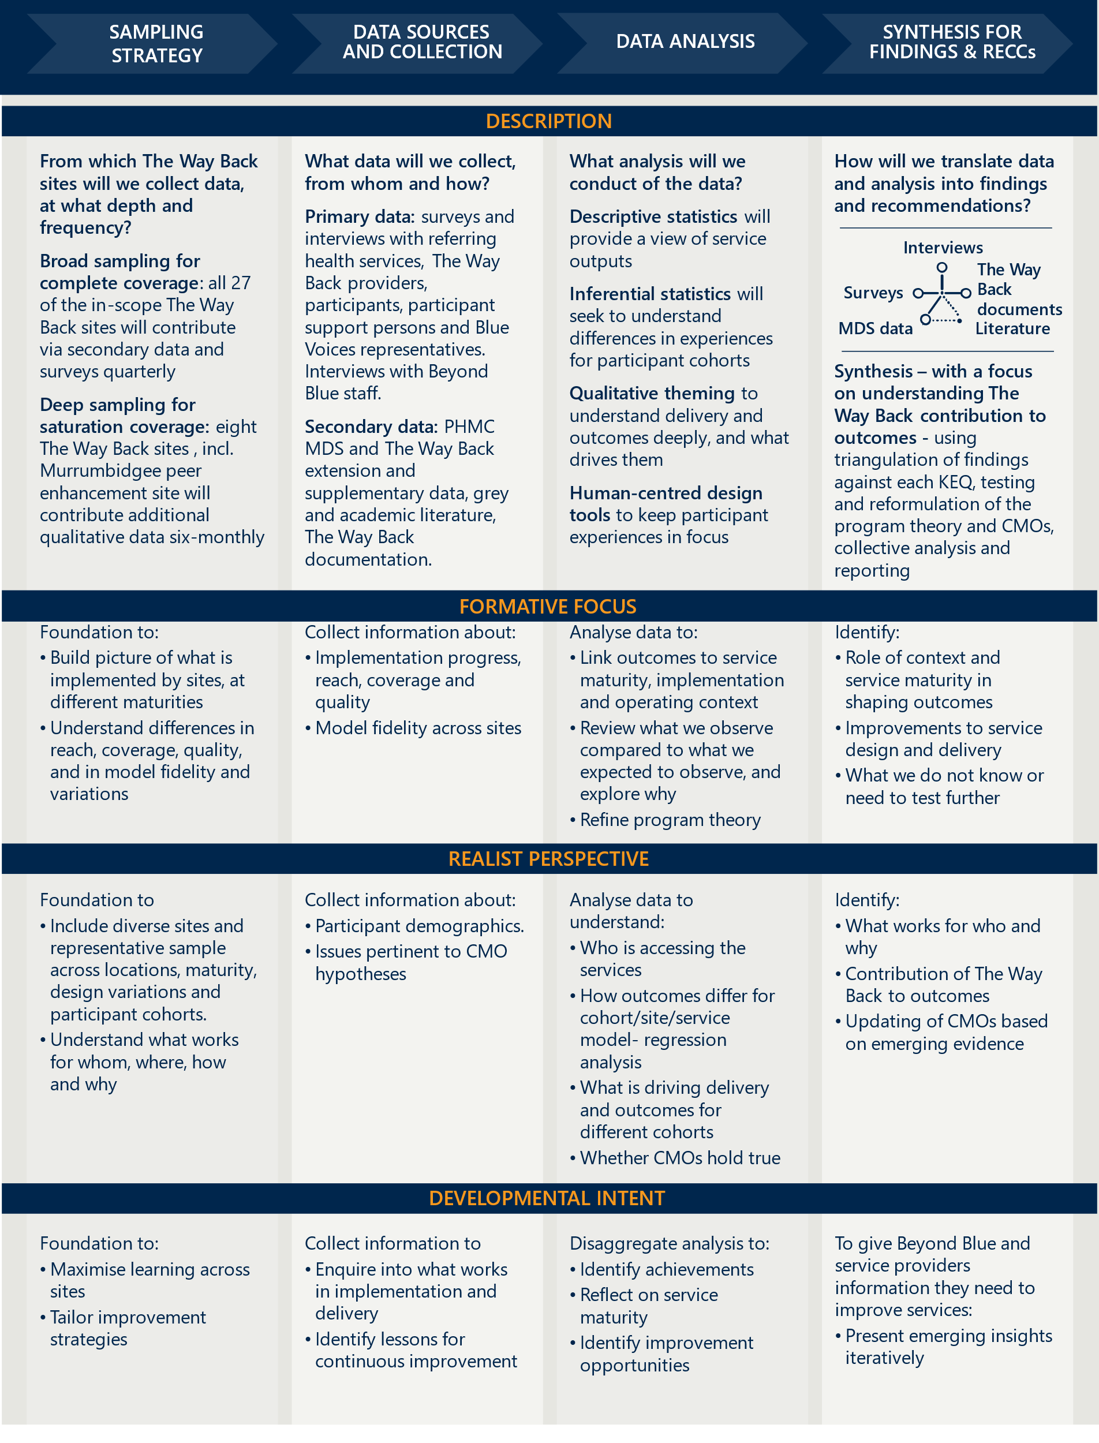

* 1. Detailed data limitations

There were limitations to the data presented in this report that are important to consider. Primary Mental Health Care-Minimum Data Set and The Way Back Extension Data (PMHC MDS) is under representative of true service use. All 27 in-scope sites had data recorded in the PMHC MDS. Three of the 27 sites commenced operations from June 2021 and have limited episodes recorded (≤ 100 episodes). A total of six sites had ≤ 150 episodes between July 2018 and September 2022.

An example of inconsistencies between data sources is illustrated in Figure 5, which shows a comparison of service episodes per site between PMHC MDS data and data from quarterly reports for the same period (between Q4 2020-21 and Q4 2021-22). Interviews with providers, PHNs and Beyond Blue highlighted that discrepancies in the data sources were likely due to:

* some sites commencing use of the PMHC MDS at different time points
* some sites manually inputting data into the quarterly reports while others used a drawdown directly from their PMHC MDS data portal.
* Use of different Client Management Systems (CMS) across sites to input data.

Figure 5 | Comparison of data for between Q4 2020-21 and Q4 2021-22 across PMHC MDS and quarterly reporting data

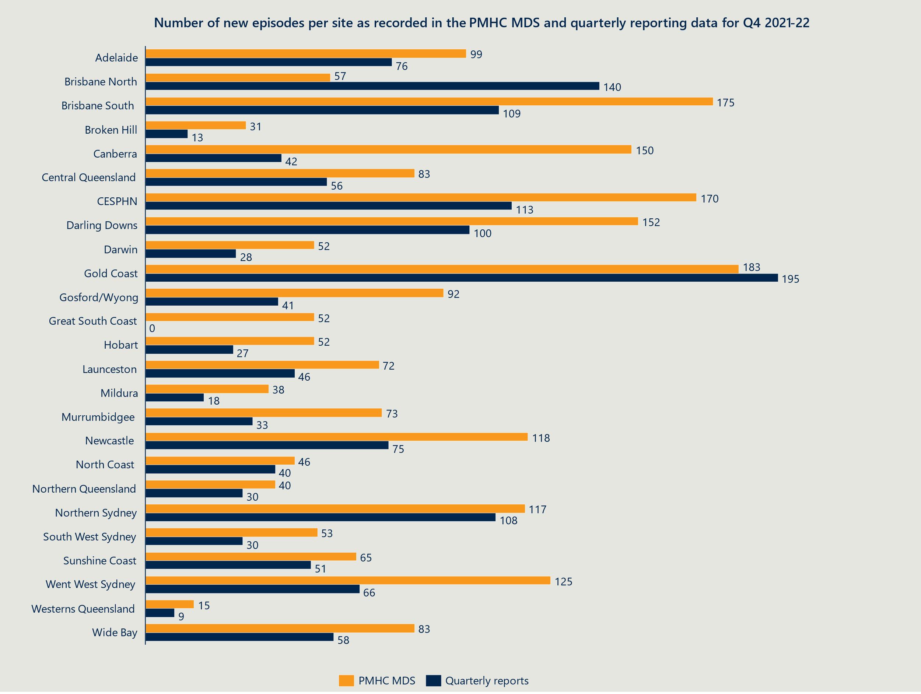

Other data quality challenges included:

* Quantitative outcomes data was available for a small proportion of participants in the PMHC MDS. Only a small proportion of episodes recorded in the PMHC MDS had completed outcome measures (i.e., suicidality, psychological distress, and wellbeing) recorded at beginning and end to measure change in outcomes over time. Twenty-two per cent of episodes had a matched pair recorded for the K10+ (n=1,933), 17 per cent for the WHO-5 (n=1,514) and 19 per cent for the SIDAS (n=1,675). However, descriptive analysis of the cohort of participants with matched pairs indicated that the sample was representative of the broader PMHC MDS sample, ensuring that from a participant demographic perspective (see section 5.3 of the final report), the sample was a valid representation of The Way Back participants.
* There were discrepancies between the PMHC MDS data and quarterly report data on the percentage of safety and support plans. The PMHC MDS indicated that just over half of participants nationally had a safety plan (57 per cent) however quarterly report data indicated this may be closer to 84 per cent on average.[3] Qualitatively, some sites indicated nearly 100 per cent of their participants have a safety plan in place while others indicated that the KPI was an inappropriate measure of their service performance as it did not recognise challenges with low uptake among participants. One site indicated that only recently has it become available in their Client Management System (CMS) to check the box for safety or support plans. The PMHC MDS was the primary dataset for this evaluation as it was the most consistent data source across all sites in most instances.[4]
* The quality and completeness of supplementary data on referral outcomes varied across sites. The supplementary dataset (see Figure 3 for further detail on this dataset) was limited as it could not report on specific characteristics of participants who declined to accept a referral into The Way Back. It provided reasons as to why a participant declined the service, however there were differences across sites in how they interpreted the definitions of reasons for declining. The evaluation reviewed and compiled each site’s supplementary data into a common format. The comparability of each site’s data was limited by variability in interpretation (as described above) and use of varying formats across sites.

Variability in the completeness and quality of quantitative data sources were likely due to:

* Different commencement times of providers, and therefore staggered data collection and reporting of data by providers into the PMHC MDS over time. This variability in the volume of data from different sites limited the evaluations’ ability to draw comparisons across sites.
* Different CMS used across sites to report into the PMHC MDS. This meant that sites had varied issues with how and what data was uploaded into the PMHC MDS. For example, one site indicated that their system had a mandatory requirement to complete fields on outcomes measures which meant they were unable to continue inputting any data until the field was filled. This resulted in a period of incorrect data for this site. This data was identified and has been excluded from analysis. Another site reported issues with the upload process itself between the CMS and the PMHC MDS (i.e., the PMHC MDS did not accurately reflect what was captured in to the CMS).
* Different approaches in how sites collected data for quarterly reports and supplementary data. Some sites inputted data manually into the quarterly reports, others uploaded data from the PMHC MDS data portal directly into the quarterly reports. This impacted the consistency of data across sources and also introduced the potential for human error. The evaluation drew on the most appropriate data source for the evaluation question being answered. The data source used was based on the quality and consistency of data reported across sites. The data source with the least amount of variation across sites (i.e., the quality and completeness of the data was consistent across sites) was chosen for analysis. The final report identified where different datasets were used and the rationale for this.
* Participants declining to complete safety and support plans and outcome measures during their time with The Way Back. This resulted in gaps in participant data and impacted the overall size of the cohort which could be reported on and the ability to report on outcomes at the start and end of the service episodes (i.e., matched outcome pairs).

1. Additional detail about The Way Back
   1. Rationale for The Way Back

This section summarises the background to, and the rationale for, The Way Back

* + 1. There are personal, social and economic effects when someone attempts or dies by suicide.

Over 3,000 deaths by suicide occur in Australia each year. In 2020, there were 3,139 deaths by suicide – an average of about nine per day.[5] For every death, there are around 26 suicide attempts.[6] Suicide can affect anyone, but risk differs across locations, gender, age, cultural identity, and sexual orientation.[7]

Each suicide attempt and death has a ‘ripple effect’ on the family and friends of the deceased/person who attempted suicide, as well as on colleagues, neighbours, first responders and communities. [8] Up to 135 people may be affected by the suicide death or attempt of one person.[9] Personal and social costs may be compounded by economic loss if someone is consequently unable to participate fully in work or home life, or if they lose a person on whom they were dependent. Economy-wide costs of suicide deaths are difficult to determine due to inadequate data and debates about the statistical value of life. Estimates of the impact of suicide deaths on the Australian economy range from $2.2 - $4.9 billion per year.[10]

COVID-19 has exacerbated demand for mental health services.[11] This came when the system was already under substantial stress and failing to meet needs,[12] including for the ‘missing middle’.[13]

* + 1. Evidence demonstrates the need for, and success of, aftercare in reducing suicide reattempts.

The *Fifth National Mental Health and Suicide Prevention Plan 2017-2022* (the Fifth National Plan) made suicide prevention a national priority and included a priority for Aboriginal and Torres Strait Islander people. It recognised that preventing re-attempts is essential to reduce suicide rates, given a previous attempt is the strongest predictor of a subsequent death by suicide.[14] It emphasised that consistent, timely and culturally safe follow-up support is critical.

Since then, major inquiries have recognised the importance of proactive aftercare in suicide prevention. The Productivity Commission Inquiry into Mental Health (the Productivity Commission Inquiry) and the Royal Commission into Victoria’s Mental Health System (the Royal Commission) called for universal aftercare. In its 2021 Budget, the Australian Government committed to ‘*provide aftercare services for all Australians discharged from hospital following a suicide attempt and trials for aftercare services for anyone experiencing suicidal crisis, but who do not attend a hospital*.[15]

* + 1. The Way Back aims to meet Australia’s need for immediate and proactive follow up support.

The Way Back seeks to address key gaps in the system by:

* *making proactive follow-up support available to people immediately* after a suicide attempt or suicidal crisis (for those who have presented to a hospital emergency department (ED) or community mental health service).[16] The service model emphasises the importance of meeting the need for *timely support* after an attempt or crisis, given the evidence on how critical *immediate* follow-up within 24-hours of discharge.[17] [18]
* *providing practical support and connecting people to clinical treatment and psychosocial services* in the three months after discharge from hospital following a suicide attempt or crisis.[19] There is currently no guaranteed, systematic follow up support offered to keep these people safe and motivated to recover. The Way Back can facilitate connections to a range psychosocial supports like housing, finance, employment, education, family support, community controlled Aboriginal and Torres Strait Islander services, CALD specific services, LGBTIQ services and/or spiritual support.
  1. Enablers
     1. Governance and funding
     2. The Way Back must comply with Beyond Blue’s Clinical Governance Framework.

The Way Back was required to comply with Beyond Blue’s Clinical Governance Framework which was developed to align with national standards and quality requirements including the *Australian Commission on Safety and Quality in Health Care’s National Clinical Governance Framework* and the *National Safety and Quality Health Service[20].*

Primary Health Networks (PHNs) were also required to comply with clinical governance clauses outlined in The Way Back’s license and service agreement. Providers must have in place systems, mechanisms and processes that ensure compliance is recorded measured and monitored.[21] The Way Back’s team leader played a core role in ensuring that staff acted in line with clinical governance standards.[22]

* + 1. Each site’s local context and funding category determine staffing profiles.

The funding category determined for each site also determines each site’s expected staffing profile and annual case load, as outlined in Table 4. Sites could sit in one of three categories. These categories were determined by two indicators: the locations population catchments, and five-year average death by intentional self-harm data. Higher population levels and higher average death by intentional self-harm represented a higher case load, and subsequently, higher staff FTE, compared to lower levels of these two indicators.

Table 4 | Staffing profile by annual case target[23]

| Site category | Annual case target | Position | FTE |
| --- | --- | --- | --- |
| 1 | 220 | Team leader  Admin/data entry  Support coordinators | 1  0.5  2.6 |
| 2 | 280 | Team leader  Admin/data entry  Support coordinators | 1  0.5  3.4 |
| 3 | 350 | Team leader  Admin/data entry  Support coordinators | 1  0.6  4.3 |

* + 1. Workforce

#### The Way Back’s core staff consisted of a team leader, support coordinators, and administrative support.

The key responsibilities, qualifications and reporting lines of team leaders and support coordinators at each of The Way Back sites are summarised in Table 5.

Table 5 | The Way Back workforce involved in delivery[24]

| Element | Team leader | | Support coordinator | | Administrative support |
| --- | --- | --- | --- | --- | --- |
| Responsibilities | * Screening referrals for eligibility and appropriateness for the service (for example, acuity/risks) * Managing and supervising support coordinators * Advice and consultancy to support coordinators in supporting participants * Clinical and incident risk management * Compliance with clinical governance requirements * Directly provide practice advice and supervision to Support Coordinators (if a credentialed mental health clinician) or ensure Support Coordinators have comparable access to clinical/practice advice | * Actioning all referrals * Confirming eligibility * Implementing service delivery tools for each participant * Providing the proactive outreach support for all consenting participants * Making and/or advocating for referrals to psychosocial services on behalf of a participant | | | * Support data entry activities * Support intake of referrals and allocation of new participants to support coordinators |
| Reporting to | * Provider Management | | | * Team Leader | * Team Leader |
| Minimum qualifications/  experience | * A credentialed mental health clinician (preferable) | | | * A non-clinical worker with relevant qualifications and/or expertise in supporting vulnerable people or at-risk cohorts | * Data entry and admin support experience |

#### The Way Back staff had access to a comprehensive training package.

The training package, developed by Beyond Blue, aimed to upskill team leaders and support coordinators in the key competencies required to deliver The Way Back efficiently, and in line with the core service model. Beyond Blue recommended that providers deliver an induction program to new staff to introduce them to the local mental health service system. All staff were required to complete courses on:

* PHMC and The Way Back extension data,
* suicide intervention and prevention,
* interpersonal skills,
* The Way Back service delivery techniques
* clinical and contextual Knowledge, including trauma informed principles,
* self-care, and
* population considerations.[25]

Nationally 2,515 support coordinators and team leaders completed The Way Back training and a further 502 have commenced training.[26] The implementation status of training is considered by The Way Back Data Management and Evaluation Sub Committee (DMESC) to be on-track and well progressed.[27]

Staff were also required to meet regularly with their Team Leader to receive practice-focused supervision, and with their team for the purposes of peer feedback, support and development, and service quality monitoring.[28]

* + 1. Monitoring and reporting

#### Providers were required to capture demographic, activity and outcomes data.

The Way Back data and analysis requirements are outlined in The Way Back Service Delivery Model and The Way Back Minimum Data Set and Dictionary.[29] Providers primarily reported data through the quarterly reports, which collect activity data, participant profile data, service contact data and workforce capacity data, and through reporting into PMHC MDS.

The Way Back had an objective of a minimum of 20 sites with data uploaded into the PMHC MDS starting from at least 1 July 2021.[30] All 27 in-scope sites have uploaded data into the PMHC MDS as at September 2022, with three of these commencing uploads since June 2021. [31] In summary, the key types of data collected included:

* Participant demographic information, including age, gender, sexuality, Aboriginal and Torres Strait Islander status, labour force status and more – noting that while all sites had the same data collection requirements, some sites had more comprehensive data collection than others (for example, due to upload issues between providers’ participant management systems and the PMHC MDS).
* Completion status for each episode (noting some exceptions), including whether treatment was concluded or if the episode was administratively closed.[32]
* Outcome’s data, noting this was limited.
* Eligibility criteria at referral. A few sites had a high proportion of episodes with no eligibility criteria recorded or inadequately described, rather than the primary or secondary eligibility criteria.
* Safety and support plans. Many sites reported higher proportions of completed safety and support plans in the quarterly reports than in the PMHC MDS data extract for the same period.
* Outbound referrals. All 27 in scope sites had some data recorded on which services The Way Back participants were referred to in the PMHC MDS between July 2018 and September 2022.

#### Six KPIs are used to measure the services performance.

Table 6 provides a description of KPIs that were used to measure service performance. In response to the recommendations developed from the interim evaluation report, Beyond Blue has since updated these to better reflect the service intent of The Way Back and were implemented from July 2022 (also outlined in Table 6).

Table 6 | Key Performance Indicators providers[33]

| KPI | Description | Target Metric | Updated description (from July 2022) | Updated Target Metric (from July 2022) |
| --- | --- | --- | --- | --- |
| Initial contact with Referred Person | For Referred Persons who are confirmed as eligible for The Way Back Support Service, contact[34] must be attempted with the Referred Person within one Business Day of receipt of the referral by the provider. | 100% of eligible Referred Persons attempted to be contacted within one Business Day of receipt of referral. | For Referred Persons who are confirmed as eligible for The Way Back Support Service, contact must be attempted with the Referred Person within one Business Day of receipt of the referral by the provider. | 100% of eligible Referred Persons attempted to be contacted within one Business Day of receipt of referral. |
| Correspondence with Primary Nominated Professional on entry to the service | For all Participants who have provided consent for their Primary Nominated Professional to be notified, correspondence must be sent advising them of their Participant’s participation in The Way Back Support Service withinthree Business Days of consent being obtained. | Where consent has been obtained, 90% of Primary Nominated Professional are to be notified of the Participants’ participation within three Business Days. | Removed | Not applicable |
| Correspondence with Primary Nominated Professional on exit from the service | For all Participants exited from the service (unplanned or planned) and who have nominated a Primary Nominated Professional, correspondence must be sent by the provider to their identified Primary Nominated Professional within three Business Days of the exit date. | Where consent has been obtained, 90% of Primary Nominated Professional are to be notified of the Participant’s exit within three Business Days of the exit date. | Removed | Not applicable |
| Safety Plan Update/development | Safety Plans must be updated or developed preferably at the initial Contact with the Participant and no later than the second Contact. | 90% of safety plans must be updated/developed by the second Participant Contact. | Safety Plans must be reviewed, updated and/or developed within the first service contact with the Participant. | 90% of safety plans must be updated/developed by the first service Contact with the Participant. |
| Support Plan Development | Support Plan is to be developed within two weeks of consent to participate in the service. | 90% of Support Plans must be completed within two weeks of consent to participate in the service. | Support Plan is to be developed within two weeks of consent to participate in the service. | 90% of Support Plans must be completed within two weeks of consent to participate in the service. |
| Quarterly New Participant Episode Target | Achieve 100% of the relevant Quarter New Participant Episode Target per Quarter.[35] | The provider must achieve 90% of the target. | Achieve 100% of the relevant Quarter New Participant Episode Target per Quarter. | The provider must achieve 90% of the relevant Quarter New Participant Episode Target. |

1. Interim report recommendations

Table 7 provides an overview of the recommendations developed for the interim evaluation report for The Way Back and how these have been actioned or incorporated recommendations for the final report, as per the development intent of the evaluation (see section 2.2 of the final report for additional detail). The interim report recommendations included nearer term actions or longer-term considerations. Recommendations from the interim report were either actioned by Beyond Blue or other stakeholders, superseded by updated recommendations developed for the final evaluation report, or included as part of the final evaluation report.

Table 7 | Summary of changes or updates on the interim evaluation report recommendations

| RECOMMENDATION | CHANGE/ UPDATE |
| --- | --- |
| NEARER TERM ACTIONS | |
| 1. Fund a The Way Back liaison officer role with sufficient FTE outposted in all referring hospitals to make initial contact with participants while they are in the ED or in-patient unit. | Included in final report recommendations (recommendation 3) |
| 2. Increase the proportion of participants that agree to have a completed safety plan and support plan, and who complete mental health assessment tools. | Included in final report recommendations (recommendation 4) |
| 3. Require PHNs to monitor and act on KPIs, where targets are not met in accordance with current service agreements. | Actioned |
| 4. Beyond Blu and PHNs should support The Way Back providers and referring health services to reduce the average length of time between the initial contact with the service and service delivery. | Included in final report recommendations (recommendation 2) |
| 5. Allow for extended service duration for the small number of participants who may require more than 12 weeks of support. | Removed. This recommendation is no longer supported given that the evaluation found that participants that stayed longer than 12 weeks in the service did not experience a significantly greater improvement in outcomes than the average participant. |
| 6. Strengthen The Way Back governance arrangements in the near term to ensure roles, responsibilities and accountabilities are clear and understood by all parties. | Included in final report recommendations (recommendation 10) |
| 7. Improve data collection, analysis and sharing practices to reduce the burden and better share insights to support learning. | Superseded by final report recommendation 16 |
| 8. Improve existing Community of Practice to better share good practice, problem solve and identify ways to upskill providers, including involvement of broader The Way Back network (for example, PHNs, referring health services). | Included in final report recommendation (recommendation 12) |
| 9. Improve The Way Back workforce capability to provide more consistent culturally safe care and provide care by a workforce with lived experience. | Superseded by final report recommendation 11. |
| 10. Improve support for The Way Back staff to better manage vicarious trauma and burnout. | Included in final report recommendations (recommendation 13) |
| 11. Encourage The Way Back providers to develop a community engagement strategy to explore whether The Way Back should be adapted to better meet the needs of Aboriginal and Torres Strait Islander participants and CALD participants. | Superseded by final report recommendation 5. |
| LONGER TERM CONSIDERATIONS | |
| 12. Consider expanding the role of The Way Back to help meet the needs of people before the point of a suicidal crisis and suicide attempt. | Removed as the evaluation concluded that expansion of The Way Back’s role would be outside the original service intent. A broader consideration is required by the mental health system to improve the availability of services to people before the point of crisis. |
| 13. Examine the expansion of inbound referral pathways to allow referrals from GPs, Ambulance and drug and alcohol services. | Superseded by final report recommendation 1 |
| 14. Improve implementation at future sites by lengthening the lead times for expected service delivery post funding confirmation and more widely and clearly communicating The Way Back purpose, benefits and inbound referral processes to referring services. | Superseded by final report recommendation 12 |
| 15. Simplify funding arrangements to PHNs informed by consultation with the Australian Department of Health and Aged Care. | Included in final report recommendations (recommendation 9). |
| 16. Collect participant experience and outcome measures at six- and 12-month points post service departure. | Not included in the final report. |

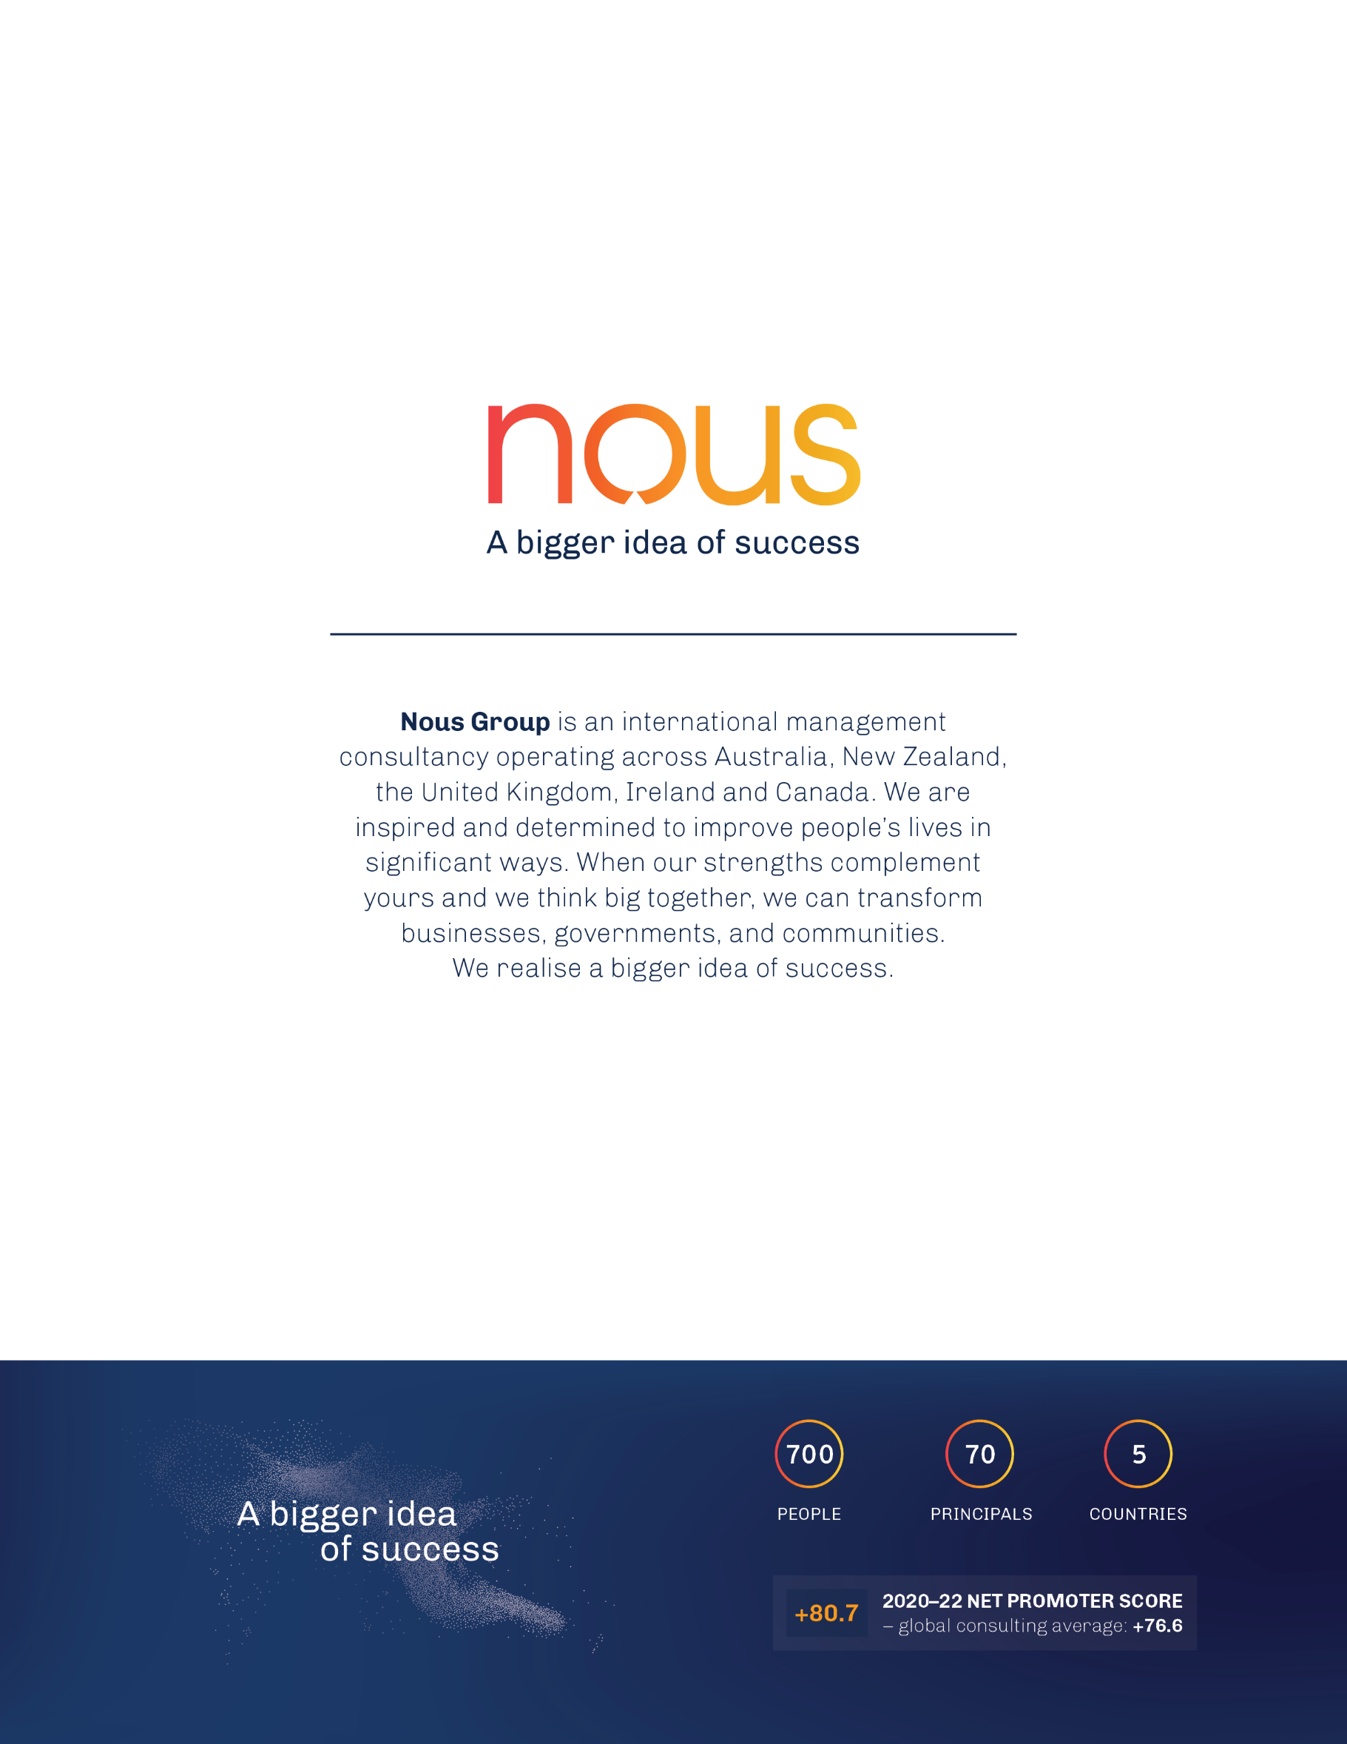

1. All HOPE sites were excluded as they were covered by a different evaluation. Other sites were excluded because they were not included in the ethics application because they either declined to participate in the evaluation or they became operational after the ethics application was submitted and approved.
2. A reliable improvement represents one that is a statistically significant improvement.
3. PMHC MDS data for in scope sites between July 2018 and September 2022 and Quarterly Reports for in scope sites for Q4 2020-21, Q1 2021-22, Q2 2021-22, Q3 2021-22 and Q4 2021-22.
4. The evaluation drew on quarterly report data to analyse referral numbers and KPIs for The Way Back.
5. Australian Institute of Health and Welfare. (2021). *Deaths by suicide over time 1907-2020.* Based on 2020 data.
6. Productivity Commission. (2019). *Productivity Commission Draft Report - Mental Health,* vol.2, p.848.
7. COAG Health Council. (2017). *The Fifth National Mental health and Suicide Prevention Plan*. Canberra: The Australian Government. pp.23
8. Community Affairs Reference Committee. (2010). *The Hidden Toll: Suicide in Australia*.
9. Cerel, J. (2016). *Connecting to the Continuum of Survivorship*. Paper presented at National Suicide Prevention: Connecting culture, context and capabilities, Canberra.
10. Productivity Commission. (2019). *Productivity Commission Draft Report - Mental Health,* vol.2, p.849.
11. Australian Institute of Health and Welfare. 2022. *Suicide & self-harm monitoring.* Retrieved from: https://www.aihw.gov.au/suicide-self-harm-monitoring/data/covid-19
12. Productivity Commission. (2019). *Productivity Commission Draft Report - Mental Health,* vol.2. p.525
13. As defined by the Inquiry those “several hundred thousand people who have symptoms that are too complex to be adequately treated by a GP and the limited MBS-rebated individual sessions with psychologists. But their condition also does not reach the threshold for access to State or Territory funded specialised mental health services. Alternative services, such as private psychiatrists or private hospitals, may be inaccessible due to long waiting lists or very high out-of-pocket costs”.
14. COAG Health Council. (2017); Department of Health and Aged Care. (2007). Living is for everyone: A framework for the prevention of suicide in Australia, Canberra: The Australian Government; Department of Health and Human Services. (2016). Victorian suicide prevention framework 2016–25, Victoria: Victorian State Government; Christiansen, E., & Jensen, B. (2007). Risk of repetition of suicide attempt, suicide or all deaths after an episode of attempted suicide: a register-based survival analysis. Australian and New Zealand Journal of Psychiatry, 41(3), pp. 257-265.
15. Department of Health and Aged Care (2021). Budget 2021-22: Generational change and record investment in the health of Australians.
16. This report uses ‘follow-up support’ as the term to describe what The Way Back does, given that participants could enter the service under one of the two criteria described. Most participants access The Way Back after a suicide attempt and so the service will have lessons for ‘aftercare’.
17. The SAX Institute for the Minister of Health NSW, ‘Evidence Check - Suicide aftercare services’, October 2019.
18. Suicide Prevention Australia. (2020). Aftercare policy position statement, October 2020). Accessed from https://www.suicidepreventionaust.org/wp-content/uploads/2021/03/Aftercare-Position-Statement.pdf
19. Beyond Blue, ‘The Way Back Support Service - Service delivery Model’, March 2020.
20. Beyond Blue. ‘Beyond Blue Clinical Governance Framework’,
21. Beyond Blue. ‘The Way Back Support Service - Service Delivery Model.’ March 2020. pp. 19.
22. Beyond Blue. ‘The Way Back Support Service: aftercare follow attempted suicide – 2018-19 Budget Proposal’. January 2018. pp. 17.
23. Beyond Blue, ‘The Way Back Support Service Implementation and Procurement Guide.’ March 2020. pp 8.
24. Beyond Blue, ‘The Way Back Support Service – Service Delivery Model’, March 2020.
25. Beyond Blue. ‘The Way Back Training Guide’. pp. 3.
26. Data provided by Beyond Blue from Training Dashboard, 2022
27. September 2021 Data Management and Evaluation Sub Committee agenda and meeting minutes.
28. Beyond Blue. ‘The Way Back Support Service Implementation and Procurement Guide.’ March 2020. pp. 9.
29. Beyond Blue, ‘The Way Back Support Service – Service Delivery Model’, March 2020. And Australian Department of Health and Aged Care, ‘The Way Back Support Service Minimum Data Set and Dictionary’, May 2020.
30. September 2021 DMESC Meeting Minutes.
31. PMHC MDS contains data from 24 sites between July 2018 and June 2021. There are three sites which commenced data collection since June 2021: Broken Hill, Hobart and Launceston.
32. It should be noted that neither the PMHC MDS and The Way Back extension provides an opportunity to determine the nature of a participants’ exit from the service. That is, ‘treatment concluded’ does not necessarily mean a positive experience and participants who elect to leave the service before concluding their treatment does not necessarily mean a negative experience.
33. Beyond Blue. ‘The Way Back Support Service – Service Delivery Model.’ March 2020. pp. 18.
34. In some cases, more than one attempt at contact may be required before The Way Back Support Service is able to reach the Participant. The requirement of contact to be made within one business day relates to the first attempt at contact and not necessarily when contact is made.
35. A grace period of 120 days shall be provided on achievement of the Total Annual Cases KPI. This is recognising that there will be a period of time before the provider builds to full capacity and the referral pathways are efficiently established.