# Star Ratings Brand Guidelines – Provider Guidelines

**Copyright**

© 2022 Commonwealth of Australia as represented by the Department of Health and Aged Care.

**Permitted usage**

You may copy, print, download, display and reproduce the whole or part of this work in unaltered form for your own personal use or, if you are part of an organisation, for internal use within your organisation, but only if you or your organisation:

* 1. do not use the copy or reproduction for any commercial purpose; and
  2. retain this copyright notice and all disclaimer notices as part of that copy or reproduction.

**Limited commercial rights**

The Department of Health and Aged Care also grants limited commercial rights to use the overall Star Ratings graphics in this work pursuant to the terms and conditions contained in page 3 of this document.

**Other usage**

Apart from rights as permitted by the Copyright Act 1968 (Cth) or allowed by this copyright notice, all other rights are reserved.

Requests and inquiries concerning reproduction and other rights to use are to be sent to the Communication Branch, Department of Health and Aged Care, GPO Box 9848, Canberra ACT 2601, or via e-mail to copyright@health.gov.au.

## Terms and conditions for using the overall Star Ratings graphics

1. Subject to these terms and conditions, approved providers (as defined in the Aged Care Quality and Safety Commission Act 2018) of residential care services (Approved Providers) are given limited permissions to use the overall Star Ratings graphics.
2. The overall Star Ratings graphics may only be used by Approved Providers for the purposes of promoting their aged care Star Rating.
3. Approved Providers must only use the official artwork files of the overall Star Ratings graphics that you download from the Department of Health and Aged Care website at <http://www.health.gov.au/resources/collections/star-ratings-resources>.
4. The overall Star Ratings graphics may only be used and reproduced according to these terms and conditions and this document and must not be modified, adapted, re-created, distorted or manipulated in any way.
5. The overall Star Ratings graphics may only be used in the following ways:
   * Digitally: on an Approved Provider’s website, intranet, email, newsletter or other online communications.
   * Print: on an Approved Provider’s physical materials, such as on newsletters, staff or corporate magazines, brochures, letterheads, banners for buildings, media advertisements.
6. The Department of Health and Aged Care grants a limited right of sub-license to allow Approved Providers to provide the overall Star Ratings graphics to commercial printers and designers for services permitted under condition 5 of these terms and conditions. Any other usage by third parties must be first consented to, in writing, by the Department of Health and Aged Care.
7. Approved Providers must ensure that the use of the overall Star Ratings graphics is consistent with their current aged care Star Rating which is displayed on the My Aged
8. Care website at [www.myagedcare.gov.au/find-a-provider.](https://www.myagedcare.gov.au/find-a-provider)
9. Approved Providers must not use the overall Star Ratings graphics in misleading ways, including but not limited to any of the following:
   * suggesting a partnership with or endorsement by the Commonwealth of Australia, the Department of Health and Aged Care or My Aged Care that does not exist; and
   * displaying or promoting an incorrect aged care Star Rating from the Department of Health and Aged Care – this includes continuing to display or promote an aged care Star Rating that has been superseded by an updated or diferent aged care Star Rating.
10. The Department of Health and Aged Care may revoke the permissions granted under these terms and conditions at any time, for any or no reason, by (including but not limited to):
    * giving individual Approved Provider’s written notice; or
    * by making a public notice on the Department of Health and Aged Care website.

## Introduction

In response to recommendations of the Royal Commission into Aged Care Quality and Safety, the Australian Government has developed Star Ratings for residential aged care.

Star Ratings will support older Australians and their representatives to compare aged care services and make choices about care that is right for them, based on an overall Star Rating and 4 sub-categories.

Subject to the terms and conditions on page 3 of this document, residential aged care providers (providers) can use Star Ratings to communicate to older Australians and their representatives about the quality of services.

To help providers do this, a set of graphic elements have been developed that can be used in a range of communications – both digitally, on websites and emails, and also in print, for example on brochures. Using these graphics will enable providers to display the aged care Star Ratings graphic in an official and recognised way. If used digitally, the graphics will also enable visitors to a provider’s website to link to the My Aged Care website where they can find more information about a service and information about aged care Star Ratings.

## Using the graphics efectively

### On websites

The overall Star Rating graphic may be used on providers own websites. Where a provider operates more than one accredited service, it must be clearly referenced as to which service the overall Star Rating applies to. It must also be clearly referenced as to what date (month/year) the overall Star Rating applies to.

### On emails

You can also display the overall Star Ratings graphic in the footer of your email templates.

### On websites

Use the JPG file (.jpg) for websites.

The artwork files must be used as a complete ‘block’ and must not be amended or distorted in any way. The overall Star Ratings graphics must be no smaller than 135 x 65 pixels.

If you use other web-based platforms to publicise your work, such as Facebook or other networking sites, you may also use the graphics here.

### On printed material

You can use the overall Star Rating graphic on your printed communications – such as brochures, posters, flyers or advertisements in local media. Please note: your rating can change daily, and it is misleading to display an incorrect rating.

The artwork files must be used as a complete ‘block’. Do not recreate, manipulate or alter any element of the graphic. The graphics should be no smaller than 25mm wide.

### Reproduction, format and size

To ensure high-quality print and colour reproduction, it’s essential that you use the official artwork that you can download on request from the Department of Health and Aged Care’s website. For high-quality printing, use the vector (.eps) file.

## Overall Star Rating graphic

The overall Star Rating graphic has been developed for providers to display the aged care Star Rating they have been given. The graphic must include the 3 required elements that need to be displayed whenever using the overall Star Rating graphic.

1. The aged care Star Ratings brandmark
2. The published aged care Star Rating
3. Timestamp of the month/year applicable to the overall Star Rating. A reference to the My Aged Care website to view up-to-date information.

This infographic is a guide to how providers are to use the layout 
1. The aged care Star Ratings brandmark
2. The published aged care Star Rating
3. Timestamp of the month/year applicable to the overall Star Rating. A reference to the My Aged Care website to view up-to-date information.


## Graphics to download

### Overall Star Rating

All these graphics are supplied as EPS, JPG and PNG files to ensure a high quality when printing in a large size and come with a transparent background.

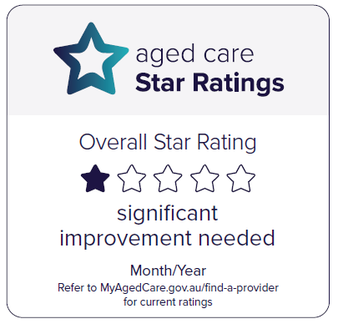

Filename: Overall Star Rating_one-star

Available formats: EPS, JPG, PNG

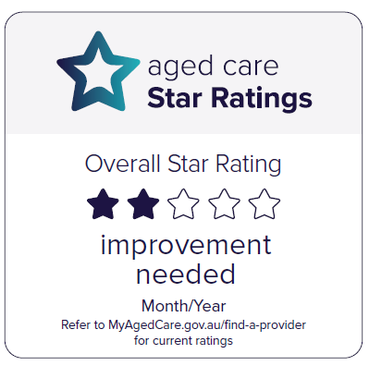

Filename: Overall Star Rating_two-star

Available formats: EPS, JPG, PNG

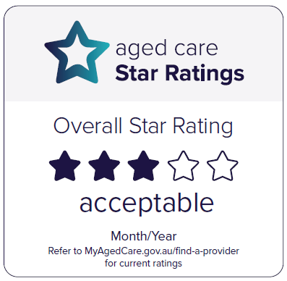

Filename: Overall Star Rating_three-star

Available formats: EPS, JPG, PNG

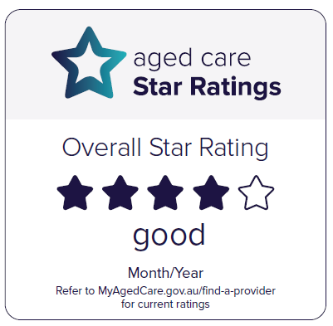

Filename: Overall Star Rating_four-star

Available formats: EPS, JPG, PNG

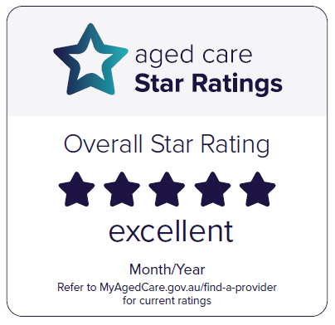

Filename: Overall Star Rating_fve-star

Available formats: EPS, JPG, PNG

# Need assistance?

Please contact the department’s design team at [designteam@health.gov.au](mailto:designteam@health.gov.au)

Visit [agedcareengagement.health.gov.au](https://agedcareengagement.health.gov.au/)

Phone1800 200 422 (My Aged Care’s freecall phone line)

For translating and interpreting services, call 131 450 and ask for My Aged Care on 1800 200 422. To use the National Relay Service, visit [nrschat.nrscall.gov.au/nrs](https://nrschat.nrscall.gov.au/nrs/internetrelay) or call 1800 555 660.