Medical Research  
Future Fund

Performance indicators towards the impact of the Medical Research Future Fund

March 2023

Contents

Introduction 1

Why is measuring the impact of the MRFF important? 2

Performance indicators: linking research outputs and outcomes to impact 3

Current monitoring and evaluation approaches of the MRFF 3

Program logic model for assessing the impact of the MRFF 4

What are the MRFF performance indicators? 6

Limitations 8

How will the performance indicators be measured? 10

How will the information and data be used? 12

What will these changes mean for me? 12

Further information 12

# Introduction

The Medical Research Future Fund (MRFF) is a priority-led fund focused on ‘improving the health and wellbeing of Australians’.[1] Measuring the impact of the MRFF is therefore critical to understanding whether it is meeting its stated objective.

In setting out the [*Australian medical research and innovation strategy 2016–21*](https://www.health.gov.au/resources/publications/australian-medical-research-and-innovation-strategy-2016-2021), the Australian Medical and Research Advisory Board articulated the MRFF’s vision, aim and objectives, and impact measures. Combining these objectives with the commitments laid out in the [*National health and medical industry growth plan*](https://www.health.gov.au/resources/publications/national-health-and-medical-industry-growth-plan) resulted in the five *MRFF Impact Measures*:

* better health outcomes
* beneficial change to health practice
* increased health efficiency
* increased job and export potential
* economic growth

To support this assessment of MRFF impact, the [*MRFF Monitoring, evaluation and learning strategy 2020-21 to 2023-24*](https://www.health.gov.au/resources/publications/mrff-monitoring-evaluation-and-learning-strategy-2020-21-to-2023-24) (MEL Strategy) was developed to provide an overarching framework for assessing the MRFF’s performance againsteight *Measures of Success* and ultimately the five *Impact Measures* (see Figure 1, from the MEL Strategy).

**Figure 1 Conceptual framework for monitoring and evaluating the MRFF**

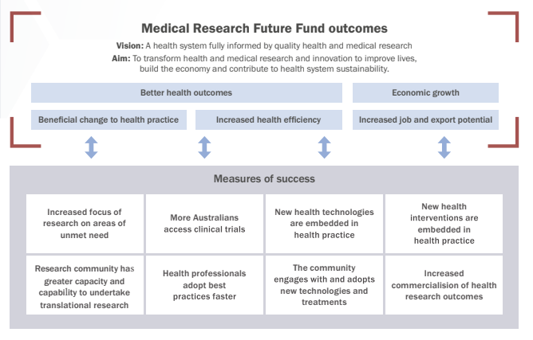

To aid implementation of the MEL Strategy, the Department of Health and Aged Care (the Department) has considered options for introducing approaches for assessing the impact of the MRFF, particularly using existing data to provide new insights and potentially inform future strategic priorities.

As part of this, the Department expanded on the existing conceptual framework for the MEL Strategy by developing a program logic to articulate the links between inputs, outcomes and measurement of impact.

# Why is measuring the impact of the MRFF important?

Impact can be defined as ‘real change in the real world’[2] Research impact as defined by the National Health and Medical Research Council encompasses knowledge, health, economic, and societal impacts[3]. The United Kingdom’s Research Excellence Framework was one of the first to assess impact outside of academia to inform policy and enable communication of the benefits of UK research to the world. The Research Excellence Framework defined impact as ‘an effect on, change or benefit to the economy, society, culture, public policy or services, health the environment or quality of life, beyond academia’[4].

Assessment provides the community, researchers, consumers, Government and other stakeholders with:

* **Accountability** – the MRFF’s object is to ‘improve the health and wellbeing of Australians’ and Government has also indicated its intent for the MRFF to produce economic outcomes.
* **Policy and research benefit** – information about research outputs, outcomes and implementation (including gaps) to enable development of policies that support the translation of research outcomes into practice
* **Public engagement** – data and information to enable the community to become involved in research and maximise use of its outcomes.
* **Visibility** – information about researchers, research organisations and industry, therefore enabling connections that facilitate collaboration and partnerships nationally and internationally among researchers, consumers and stakeholders.

In addition to benefiting consumers and stakeholders, the measurement of impact also directly benefits individual researchers by providing evidence to support future funding applications and career progress including academic promotion, as well as opportunities to assess research achievement and strategically prioritise their research activities.

# Performance indicators: linking research outputs and outcomes to impact

Whilst it is important, measuring impact is difficult[5] and comes with multiple challenges, including in gathering evidence that links research with impact[6]. For example, impact is a longer-term measure;it has been estimated that it can take about 17 years for research to feed into clinical practice[7]. Other challenges include attribution[8] as the link between the research and its impact is not always linear[9].

The Department has compiled a set of *MRFF performance indicators*, as a first step to understanding the MRFF’s impact. The formulation of performance indicators builds on other well-established models measuring performance and ultimately impact. This includes the Australian Government’s *Report on Government Services*[10]*,* which measures the performance of multiple government services.

The MRFF performance indicators are a set of quantifiable metrics that primarily capture the outputs and outcomes from MRFF-funded projects, to provide evidence on how well the MRFF is tracking in relation to its outcomes (the Measures of Success) and subsequently its five impact measures. These indicators will provide a basis for reporting on performance across the whole of the MRFF as well as over time, to provide a longer time frame for measuring and tracking progress. They are also a necessary step towards capture of the multiple and/or nonlinear pathways in which research impact is realised over time.

# Current monitoring and evaluation approaches of the MRFF

The MEL Strategy is being implemented by the Department, with three independent evaluations already [completed and published](https://www.health.gov.au/initiatives-and-programs/medical-research-future-fund/about-the-mrff/mrff-monitoring-evaluation-and-learning) and two more close to completion. These evaluations are using a variety of methods to assess the impact of MRFF Initiatives, including case studies, quantitative analysis using data collected from grant recipients and stakeholders, and interviews with national and international experts.

In its evaluation approach the Department also monitors program information (e.g. number of grants funded, the types of research funded) and data collected from grant recipients through progress, financial statements and end of project reports (e.g. outcomes achieved through the projects, challenges and barriers impacting research progress).

# Program logic model for assessing the impact of the MRFF

A program logic for monitoring and evaluating the impact of the MRFF is provided in Figure 2. The program logic builds upon the MEL Strategy, by linking the inputs and activities (projects and reporting mechanisms) of the MRFF with outputs and outcomes captured via the MRFF performance indicators, and ultimately impacts.

The inputs are set out in the [*2nd MRFF 10 Year Investment Plan*](https://www.health.gov.au/resources/collections/medical-research-future-fund-mrff-2nd-10-year-investment-plan-2022-23-to-2031-32), announced in March 2022.

The activities include: the establishment and implementation of research projects; and reporting and evaluation mechanisms that provide insights on the progress of and outputs and outcomes from funded projects.

MRFF outputs will now also be measured through nine new performance indicators – these are the main subject of this paper and are set out in more detail in the following sections.

MRFF program level outcomes and impacts are set out in the MEL Strategy, as the MRFF Measures of Success and MRFF Impact Measures, respectively.

**Figure 2 Program logic model for monitoring and evaluation of the MRFF, highlighting the MRFF performance indicators**

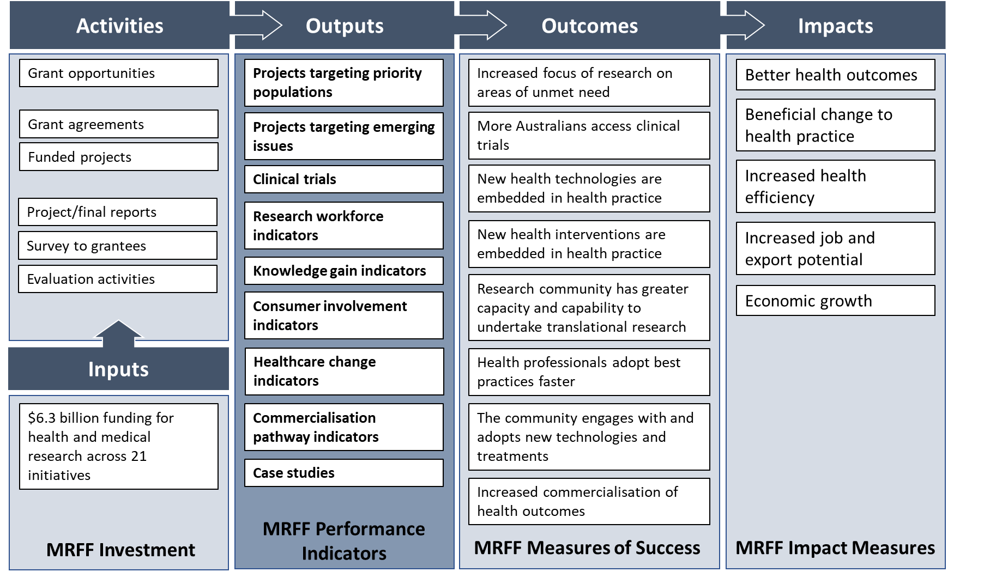

# What are the MRFF performance indicators?

The nine MRFF performance indicators are:

* 1. Projects targeting priority populations
  2. Projects targeting emerging issues
  3. Clinical trials
  4. Research workforce indicators
  5. Knowledge gain indicators
  6. Consumer involvement indicators
  7. Healthcare change indicators
  8. Commercialisation pathway indicators
  9. Case studies

Table 1 provides a rationale for each performance indicator and describes the measurable outputs that it will encompass.

**Table 1 MRFF performance indicators and their measurable outputs.**

|  |  |  |
| --- | --- | --- |
| **PERFORMANCE INDICATOR** | **RATIONALE** | **MEASURABLE OUTPUTS** |
| **Projects targeting priority populations** | To capture how much of MRFF-funded research is prioritising populations where current interventions or technologies may not be suitable or accessible, or where those populations may be under-represented for other reasons | Number, value and proportion of projects on:   * Aboriginal and Torres Strait Islander health * older people experiencing diseases of ageing * people with rare or currently untreatable diseases/conditions * people in remote/rural communities * people with a disability (including people with intellectual disability) * individuals from culturally and linguistically diverse communities * LGBTIQ+ people * youth |
| **Projects targeting emerging issues** | To capture how much of MRFF-funded research is addressing unmet need[11], in terms of new and emerging issues | Number, value and proportion of projects on:   * COVID19 or other emerging health challenges * Priorities arising from Senate Inquiries, emergencies, and other consumer-led mechanisms |
| **Projects involving clinical trials** | To capture multiple facets relating to clinical trials supported by MRFF funding | * number, value and proportion of projects by conditions, location * patients recruited (projected vs actual) * number of trials completed * number of trials with published outcomes |
| **Research workforce indicators** | To describe the research workforce supported by MRFF funding, in terms of capacity (e.g. is the MRFF supporting more early-to-mid career, diverse, rural/regional/remote researchers), and capability (e.g. increased training, mentorship, collaboration and access to further funding) | Number and type of research staff employed/supported:   * clinicians, allied health professionals, early-to-mid career, students, women, First Nations, rural/remote   Number of projects that:   * involve staff in research translation/knowledge mobilisation training * involve staff in industry exchange programs * involve international collaborators * involve interdisciplinary collaborators * result in new research collaborations/partnerships * have generated new funding (source and amount) |
| **Knowledge gain indicators** | To capture increased knowledge as a result of MRFF-funded research | * number of publications arising out of MRFF supported research * citation impact metrics |
| **Consumer involvement indicators** | To capture the level of involvement of relevant consumers throughout the research pipeline, from priority setting, co-design through to dissemination and translation | Number, value and proportion of projects that:   * include consumer organisations as project partners or advisory groups * involve consumers in priority and co-design of study * involve active consumer input in data gathering/analysis * involve active dissemination of results to consumers * deploy strategies to include traditionally underrepresented groups * involve consumers in project governance |
| **Healthcare change indicators** | To capture the outcomes of research, the methods for dissemination, translation and the impacts of research on clinical practice and healthcare systems | Number, value and proportion of projects that:   * engage with partners who can change practice (medical colleges, health system managers) * result in TGA/FDA/EMA or PBAC/MSAC application/ approval * are cited in or change protocol/clinical guidelines * result in new treatments * result in withdrawal of ineffective treatments * result in repurposing of current treatments/technologies * result in better access to health interventions or technologies among priority populations |
| **Commercialisation pathway indicators** | To capture the level of progress towards the creation of healthcare products, treatments or interventions | Number, value and proportion of projects that:   * include co-funding (financial or in-kind) from industry partners (source and amount) * result in a patent application/approval * result in a product entering Phase 3/4 clinical trials * have led to creation of new start-ups/ companies * result in a product entering the market in Australia or overseas |
| **Case studies** | To capture the richness and complexity in which funded research contribute to impact, that cannot be captured via quantitative means | Stories demonstrating key impacts or highlights how individual projects or groups of projects contribute to one or more Measures of Success or Impact Measures |

# Limitations

In recognising the complexities of linking projects outputs and outcomes to research impact, it is noted that:

* + some indicators are applicable to more than one Measure of Success (see Table 2)
  + no single indicator can adequately capture the heterogeneity and complexity of MRFF Initiatives and grant opportunities, and some are more applicable to specific Initiatives than others
  + a mixture of quantitative and qualitative approaches for measurement is necessary
  + some indicators will not be apparent or relevant in the short term, and may need to be captured over the longer term and at regular intervals after the lifetime of the grant, which will also allow demonstration of change over time
  + the most useful measures are likely the most difficult to measure, longer term ones
  + these indicators do not form a complete picture in demonstrating broader impact, and focussed evaluations on specific aspects of impact may be necessary (see **How will the performance indicators be measured?**)
  + these indicators represent a starting point and opportunity for learning and should be continually reviewed.

**Table 2 MRFF performance indicators and their contributions to the MRFF Measures of Success**

Note: Major contributors are indicated in dark blue, minor contributors in light blue

|  |  |  |  |  |  |  |  |  |
| --- | --- | --- | --- | --- | --- | --- | --- | --- |
|  | **MEASURE OF SUCCESS** | | | | | | | |
| **PERFORMANCE INDICATOR** | **Increased focus on areas of unmet need** | **More Australians have access to clinical trials** | **New health technologies are embedded in health practice** | **New health interventions are embedded in health practice** | **Research community has greater capacity and capability to undertake translational research** | **Health professionals adopt best practices faster** | **The community engages with and adopts new technologies and treatments** | **Increased commercialisation of health research outcomes** |
| **Projects targeting priority populations** |  |  |  |  |  |  |  |  |
| **Projects targeting emerging issues** |  |  |  |  |  |  |  |  |
| **Projects involving clinical trials** |  |  |  |  |  |  |  |  |
| **Research workforce indicators** |  |  |  |  |  |  |  |  |
| **Knowledge gain indicators** |  |  |  |  |  |  |  |  |
| **Consumer involvement indicators** |  |  |  |  |  |  |  |  |
| **Healthcare change indicators** |  |  |  |  |  |  |  |  |
| **Commercialisation pathway indicators** |  |  |  |  |  |  |  |  |
| **Case studies** |  |  |  |  |  |  |  |  |

.

# How will the performance indicators be measured?

The Department will collect the information and data required to assess and report on performance against the indicators from a range of sources:

* + **Program information (available now)**, which captures essential grant data such as investigators, institutions, budget, research areas.
  + **Progress/final reports (available annually and at end of project)**, which capture data on clinical trials, publications, workforce capacity and capability, as well as help identify impact case studies.
  + **Survey to grantees (planned for every 3 years)**, which will capture data not available through existing collections (e.g., those above), including research workforce, health care change and commercialisation.
  + **Other sources (as needed)**, including drawing upon external data sources such as bibliometrics, clinical trial registries, submissions for regulatory approval and reimbursement, and patent registries.

Some of the data can be collected in the short term and other data would be collected in the medium to long term. This reflects both that some data are already available or about to be collected and that some performance indicators are to be assessed over the longer term (e.g., commercialisation related measures).

Table 3 outlines the information and data collection methods for each performance indicator, including whether the information and data will be available in the short or medium to long term.

The performance indicators, along with the Measures of Success and Impact Measures, will also provide a framework to guide data collection and reporting as part of other MEL Strategy activities.

Finally, noting that longer-term performance indicators may be challenging to assess via routine approaches, other elements of the MEL Strategy are anticipated to be used to support assessment of impact (e.g. assessment of the impact of the MRFF themes such as researchers, translation and commercialisation).

**Table 3 Information and data to support assessment against the MRFF performance indicators**

|  |  |  |  |  |
| --- | --- | --- | --- | --- |
|  | **Short-Term** | | **Medium- to Long-Term** | |
| **PERFORMANCE INDICATOR** | **Program Information**  **(available now)** | **Progress/Final Reports**  **(ongoing/end of project)** | **Survey**  **(anticipated every 3 years)** | **Other sources**  **(regular/as needed)** |
| **Projects targeting priority populations** |  |  |  |  |
| **Projects targeting emerging issues** |  |  |  |  |
| **Projects involving clinical trials\*** |  |  |  | ANZCTR, Clinicaltrials.gov, or relevant trial registries |
| **Research workforce indicators*†** |  |  |  |  |
| **Knowledge gain indicators\*** |  |  |  | Literature Search, Bibliometrics |
| **Consumer involvement indicators** |  |  |  |  |
| **Healthcare change indicators*†** |  |  |  | TAAD, MTP Connect |
| **Commercialisation pathway indicators*†** |  |  |  | Patent registries |
| **Case studies\*** |  |  |  | Literature search  Chief Investigator interviews  MRFF Newsletter calls |

**\***For some indicators, collection across multiple sources reflect different measurable outputs, rather than duplicated collection of the same outputs. We will monitor data gathered and the mechanisms used to collect that data and review and refine processes as appropriate.

†These indicators will additionally be the focus on specific theme-based evaluations.

# How will the information and data be used?

Data collected from the survey as well as other sources above will be aggregated and analysed. The aim is to produce and publish a report representing a snapshot in time of the performance of the MRFF against the MRFF Measures of Success and MRFF Impact Measures. The analysis is planned to be repeated on a regular basis, e.g. every 3 years.

The outcomes of the analysis and report will be used to support broader MRFF policy and program review and development. Data on individual MRFF funded projects will be kept confidential, unless otherwise agreed with the research team (e.g. for case studies).

# What will these changes mean for me?

The Department will continue using information grantees provide through progress and end-of-project reports to support assessment of MRFF impact.

A survey of grantees will be instituted from 2023 to capture data not available through other mechanisms. The Department will take care to minimise burden on grantees, by considering the content, length, response format and timing of survey.

Grantees could use the new program logic and performance indicators as part of identifying each project’s contribution to the MRFF Measures of Success and MRFF Impact Measures. This information could be incorporated into applications and progress and end-of-project reports.

To facilitate accurate and broader data capture, grantees are also reminded to attribute the Department of Health and Aged Care and/or the MRFF in research publications and other media.

Participation in MRFF evaluation activities contributes to improvements in the administration and management of the MRFF and ensures researcher views and experiences help shape the operation of the MRFF.

Finally, it is hoped that pursuing good practice in the measurement and tracking of research impact will encourage more meaningful considerations of impact along all stages of the research pipeline and among the medical research community more broadly.

# Further information

More information on the Department’s MEL Strategy and ongoing evaluation activities can be found at <https://www.health.gov.au/initiatives-and-programs/medical-research-future-fund/about-the-mrff/mrff-monitoring-evaluation-and-learning>.

Should you have any questions regarding the performance indicators or evaluation of the MRFF, please contact [MRFF.Evaluations@health.gov.au](mailto:MRFF.Evaluations@health.gov.au)

Health.gov.au

All information in this publication is correct as at March 2023.

1. *Medical Research Future Fund Act 2015*, section 3
2. Smith, R, 2018. *Richard Smith: Measuring research impact – all the rage but hard to get right.* https://blogs.bmj.com/bmj/2018/07/30/richard-smith-measuring-research-impact-rage-hard -get-right/
3. National Health and Medical Research Council Research Impact Position Statement 2022. <https://www.nhmrc.gov.au/research-policy/research-translation-and-impact/research-impact>. Last accessed December 2022.
4. UK Research and Innovation, 2023, *How Research England supports research excellence.* www.ukri.org/about-us/research-england/research-excellence/ref-impact/
5. Ozanne, J.l., etal. 2016. *Assessing the Societal Impact of Research: The Relational Engagement Approach.* Journal of Public Policy and Marketing 36(1), p1-14. <https://core.ac.uk./download/pdf/74404568.pdf>
6. Penfield, T., Baker, M.J., Scoble, R., Wykes, M.C., 2013. *Assessment, evaluations, and definitions or research impact: A review,* Research Evaluation 23(1), p1-12.
7. Grant, J., Cottrell, R., Cluzeau, F., Fawcett, G., 2000. *Evaluating “payback” on biomedical research from papers cited in clinical guidelines: applied bibliometric study*, BMJ 320, pg1107-1111.
8. Penfield, T., Baker, M.J., Scoble, R., Wykes, M.C., 2013. *Assessment, evaluations, and definitions or research impact: A review,* Research Evaluation 23(1), p1-12.
9. Smith, R, 2018. *Richard Smith: Measuring research impact – all the rage but hard to get right.* https://blogs.bmj.com/bmj/2018/07/30/richard-smith-measuring-research-impact-rage-hard -get-right/
10. See Productivity Commission, Report on Government Services ([www.pc.gov.au/ongoing/report-on-government-services](http://www.pc.gov.au/ongoing/report-on-government-services))
11. From the 2022 MRFF 2022 National Critical Research Infrastructure Grant Opportunity:

    “Unmet medical need arises where individuals are living with a serious health condition where there are limited satisfactory options for prevention, diagnosis or treatment to support improved health outcomes.”