Title slide: MRFF Webinar - Assessing MRFF grants: Insights from assessors
15 March 2023
Co-hosts:
* Dr Masha Somi, Chief Executive Officer, Health and Medical Research Office
* Prof Caroline Homer AO, Deputy Chair, Australian Medical Research Advisory Board

# Contents

1. **MRFF Grant Assessment Process** – Dr Masha Somi and Professor Caroline Homer AO
2. **Grant Assessment Criteria**
3. Project Impact – Professor Walter Abhayaratna OAM
4. Project Methodology - Associate Professor Sarah Norris
5. Capacity, Capability and Resources to deliver the project - Dr BJ Newton
6. Overall Value and Risk - Prof Michael Kimlin
7. Consumer Involvement – Mr John Stubbs AM
8. **Questions and Answers**

# MRFF Grant Assessment Committees

* Members are **expert reviewers** who come from **different backgrounds** and bring **different perspectives**.
* Members are selected on their experiences and expertise in a range of areas including:

transdisciplinary

academia

clinical

health services delivery

translation of research

consumers and patients

Aboriginal and/or Torres Strait Islander health

industry and commercialisation expertise.

**To express interest to be on a GAC**: <https://www.nhmrc.gov.au/2022-23-medical-research-future-fund-mrff-grant-opportunities>.

# MRFF Grant Assessment Process

1. Grant opportunity closes.

2. Grants Assessment Committee and outcome report managed by the grants hub:
* Grant Assessment Committee established
*Conflicts of Interest are managed
*Grants hub and HMRO brief the committee on the MRFF grant opportunity and the assessment criteria
*Two spokespersons (plus, sometimes, another members) are assigned to each application for initial scoring
*Scores collated and outcome report is prepared.

3. Outcome report to HMRO:
* Grant Assessment Committee meets 
Chair does not participate in assessment or scoring
* Two spokespersons speak to the application
* There may be additional experts (e.g. consumer advisor) 
* All members discussion for each application
* All members score the application..

# Criterion 1: Project Impact

**Project Impact** is the extent to which a project’s **research outputs will contribute to meaningful advances in health outcomes, practice and/or policy**.

Aligned with the objectives and outcomes specified in the Grant Opportunity Guidelines.

Takes account of the project’s **contribution** to:

the objective of the **MRFF Initiative**

(for Missions) Goals, Missions and Aims set out in the **Mission’s Roadmap and Implementation Plan**.

Considers the project’s statement against the **MRFF Measures of Success**.

# Criterion 2: Project Methodology

**Project Methodology** is a description of the **design and conduct** of the proposed research in the form of a project plan. It includes:

the **scientific quality** and **feasibility** of the project plan

it’s **ability to deliver** on the project’s intended outcomes.

Projects are expected to be **original** and **build on research** that has already been undertaken, and not duplicate past research.

Articulate the **Research question** and proposed approach for addressing it.

Specify **Milestones and Performance Indicators**.

# Criterion 3: Capacity, Capability and Resources to deliver the project

**Capacity, Capability and Resources** are the relevant **skills, knowledge, experience** and **resources** the research team and any partners will contribute to the project:

**composition** of the research team

**contribution of individual researchers** to the project

**involvement of partners** in the successful delivery of the project.

# Criteria 4: Overall Value and Risk

Overall Value and Risk response will consist of your:

**Measures of Success statement**

**Proposed budget**

**Risk management plan**.

Overall Value and Risk is the extent to which the project’s research outputs will **meaningfully contribute** to the:

**Objectives and intended outcomes** of the grant opportunity

**Initiative** (or Mission)

**MRFF** more broadly.

Applicants should demonstrate that they have thoroughly considered the:

**risks associated with the delivery** of the project

**impact** of these risks.

# Consumer involvement in research projects

Examples of descriptors to strengthen consumer involvement in research and engagement with priority populations:

1. Project Impact:

**demonstrate** how the views and values of consumers, the community, health providers and/or other end users have informed the proposed research

1. Project Methodology:

**describe** how consumers have been involved in the trial design

1. Capacity, Capability and Resources to deliver the project:

projects that specifically focus on the health of priority populations should **demonstrate** that the research team includes **leadership by the priority population**.

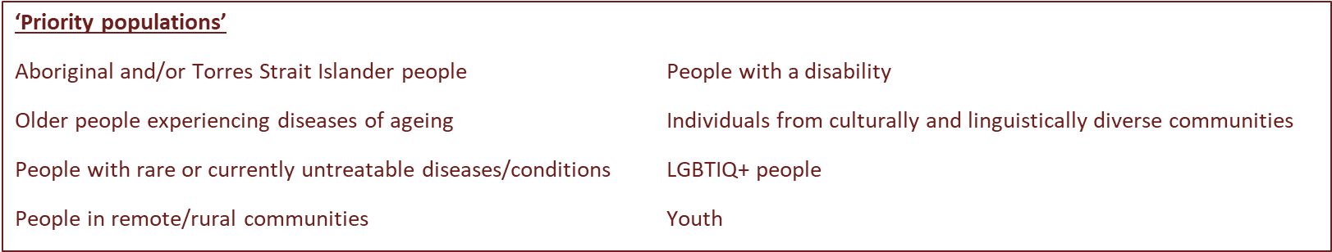

# Thank you for your time

People who would like to participate in a GAC are able to register their interest, at: <https://www.nhmrc.gov.au/2022-23-medical-research-future-fund-mrff-grant-opportunities>

Potential members of GACs may be contacted directly by the Department or one of the Grants Hubs.

**Upcoming webinar:**

MRFF Research Administration Officer (RAO) Webinar

Thursday 30th of March 2023 2:00pm-3:00pm (AEDT)

