# Lessons from the fourth Omicron COVID-19 wave

## Advice from the Chief Medical Officer, Professor Paul Kelly

The fourth Omicron wave of the COVID-19 pandemic ended in late February 2023. Each wave of infections presents an opportunity to reflect on the public health response measures implemented to mitigate the worst impacts of the pandemic on individuals, the health system and societal functioning at large. It is important to note that the advice I provide below is based on the best available information and data. Noting that the fourth Omicron wave ended very recently, there are some limitations in the completeness of data (particularly definitive, validated mortality data as compiled and reported by the Australian Bureau of Statistics (ABS)). In the absence of validated ABS mortality data, I have relied upon available surveillance and case management data as reported to the Department by states and territories (through the National Notifiable Diseases Surveillance System (NNDSS) and residential aged care providers respectively.

While vaccinations, antiviral treatments and the continuing public health response have provided strong protection against severe disease and death, the threat of COVID-19 remains very real – especially for those in our community who are most at risk of severe illness.

In partnership with my state and territory counterparts, we continue to closely monitor the pandemic with a view to ensuring we are as well prepared as we can be to meet the challenges presented by the next wave – which may already be underway. Our efforts must continue to be focused on those who are most at risk, so that no one is left behind as we continue to live in a world where new waves will likely emerge on a regular basis for at least the next two years.

### The fourth Omicron wave

#### Overview

Although it is acknowledged that case ascertainment has reduced, coinciding with changed testing arrangements and advice, data from settings with higher testing rates (including hospitals and aged care) indicates that, when compared with previous waves, this most recent wave resulted in less severe illness at a population level (see Figures 2 and 3).

The fourth Omicron wave was different to previous waves in some very important ways. It was longer, lasting around 19 weeks, and reached its peak after seven weeks, compared with previous waves which typically lasted around 12 weeks and peaked in three to five weeks (see Figure 1). This wave was less severe when compared to the third wave observed in winter 2022, with lower hospital and intensive care admissions and substantially fewer overall deaths than in any of the previous Omicron waves. This occurred at a time when, for the first time since the start of the pandemic in early 2020, virtually no public health and social measures were in force in the general community. This is testament to the very high levels of vaccination coverage, hybrid immunity and ready access to oral antiviral treatments for those who need them.

#### Populations at Greater Risk of Severe Illness

The current aim of Australia’s COVID-19 response is to protect people at higher risk of severe illness. As the levels of hybrid immunity continue to rise and persist in the general population, it is unsurprising that the relative burden of severe disease and death is now very much related to high-risk populations such as the elderly residents of aged care homes, noting that the full picture of what happened in the most recent Omicron wave, especially in relation to deaths, is still incomplete because of the lag between this period and when the ABS reports.

We know that COVID-19 is much more dangerous to people with complex underlying medical conditions, and that residents of aged care homes often have one or more such conditions. The effect of the vaccine in protecting this group is very clear. At the beginning of the pandemic around one in three residents who were infected died, whereas in the last wave the number was closer to one in forty. Residential aged care home (RACH) residents are highly vaccinated, with more than 80 per cent of residents having received four doses. Additionally, there has been very strong uptake of antiviral medications in this population. The aged care sector has also put in place robust infection prevention and control procedures.

These protections are proving to be effective with the average size and duration of RACH outbreaks reduced over time. This improvement is also demonstrated by the difference between the deaths reported by aged care providers in the first and fourth Omicron waves, which occurred at similar times of year. In the first Omicron wave, 1,708 people, or 5.6% of those infected in RACH lost their lives to COVID-19 whilst in the most recent wave (based on data up to 24 February 2023), 830 people died or around 2.6% of those infected, a decline of 51% (noting that this figure will change as data is updated). Despite this improvement, it remains clear that the rollout of the 2023 vaccine booster, continued access to oral antiviral medication, infection prevention and control training and personal protective equipment provision remain important in this setting.

The mortality rate among Australians with disability has also decreased significantly over the course of each successive Omicron wave. Among DSP recipients, the age-adjusted mortality rate during the fourth wave was nearly 80% lower than that observed during the first Omicron wave (down from 63 to 14 deaths per 100,000 population in those aged 16-65 years), and among NDIS participants, the rate was almost 75% less (down from 74 to 19 deaths per 100,000 population among those aged 7-65 years). The decreasing mortality rate within this cohort is likely due in large part to high vaccination coverage (over 75% third dose coverage for eligible NDIS participants and over 90% coverage for eligible NDIS participants living in residential settings). Despite this strong progress, the mortality rate among Australians with disability remains higher when compared to the general population. This is likely due in significant part to the increased prevalence of complex underlying health conditions amongst this cohort, as is the case for older Australians, and reinforces the importance of efforts to maintain high rates of vaccine coverage in this group.

Among First Nations peoples, while the rate of death during the fourth wave continued to be higher (1.4 times) than the general population, the difference in the mortality rate has also reduced when compared to previous Omicron waves. Further, the number of cases hospitalised or admitted to intensive care among First Nations people was much lower during the fourth wave when compared to previous waves. Antiviral uptake among First Nations peoples also increased, with uptake peaking in early January 2023. Tailored community specific approaches to antiviral supply, as well as vaccination administration, has likely enhanced uptake of these protective measures among First Nations communities and should continue.

The mortality rate among Australians from culturally and linguistically diverse (CALD) backgrounds was also lower during the fourth Omicron wave when compared to earlier waves, with rates of severe disease and death within the CALD community now essentially equivalent to the general population. This is likely in large part due to high levels of ‘hybrid immunity’, given ongoing widespread community transmission and ongoing efforts to increase vaccine coverage in the CALD community.

### Lessons Learned

The current transmission patterns within Australia differs from the initial phases of the pandemic when waves were driven by one or two dominant SARS-CoV-2 sub-lineages. Currently, and during the fourth Omicron wave, there is significant diversity in the range of lineages circulating within Australia, sometimes referred to as a 'variant soup'. Many of these circulating lineages will likely die out without causing a significant disease burden, but others have been shown to have stronger growth potential, with some exhibiting considerable capacity for immune escape. This phenomenon makes accurate prediction of the timing and nature of future waves very difficult. However, none of the recent variants have been associated with increased severity.

With high levels of transmission expected to continue to occur in the future, it is important that response measures are appropriate and proportionate to the assessed level of risk, with a focus on improving health outcomes among those at greater risk of severe illness. The response should consider the level of impact measures will have on protecting priority populations and the general community, make the best use of available resources and minimise social disruption.

The very high rates of vaccination, with nearly all Australians having received two doses and seven out of ten having received a third dose, has provided significant protection against severe disease and death. Indeed, the available data definitively shows that vaccination continues to provide strong protection against severe illness and death.

A study led by the National Centre for Immunisation Research and Surveillance (NCIRS) on COVID-19 vaccine effectiveness against mortality showed that while protection from COVID-19 wanes over time following vaccination there is still a level of residual protection present even after six months. It showed that every additional dose provided increased protection against death from COVID-19, with the largest benefits for Australians in residential aged care homes. This, in combination with widespread exposure in the general Australian community has led to high levels of ‘hybrid’ immunity, providing increased protection.

Access to antiviral oral medication has also become more widespread, offering further protection to vulnerable Australians, with over 70,000 prescriptions dispensed including over 56,000 in residential aged care homes during the fourth wave.

### Preparation for future waves

The Australian community will continue to experience waves of COVID-19 infection, which may put pressure on health systems and result in deaths. The next wave may coincide with the winter season, and while COVID-19 is not a seasonable disease there is a risk that co-circulation with other seasonal respiratory viruses such as influenza and respiratory syncytial virus (RSV) might occur, as has been seen in the recent Northern Hemisphere winter. This makes winter a much more dangerous time, especially for older Australians and people with complex health conditions. Preparations are underway ahead of the Australian winter to ensure our system is well prepared to manage such an eventuality, building on the substantial work from 2022.

It is crucial that we remain vigilant through various surveillance methods, to enable effective monitoring and responses in the context of reduced testing in the general population. In the current Australian context, the focus should continue to be on improving health outcomes for those at greatest risk of severe illness from COVID-19, including older Australians, those with disability, those with complex pre-existing medical conditions and the immune-compromised.

The National COVID-19 Community Protection Framework for a COVIDSafe Australia (the Framework) provides responses that can be employed to ‘slow the spread’ of the virus during waves of infection. This framework allows different parts of the country to make choices that are tailored to their circumstances to protect their communities.

Additionally, the National COVID-19 Health Management Plan (the Plan) has been developed to ensure health and aged care systems have the capacity to respond as the pandemic continues to evolve. Both the Framework and the plan remain fit for purpose.

In the weeks ahead, a new phase of the COVID-19 communication campaign will be rolled out, focusing on the take up of boosters, reinforcing the importance of planning and making sure that Australians at highest risk of severe illness have ready access to oral antiviral medications, and reinforcing protective precautions such as wearing masks and social distancing and ensuring adequate ventilation.

The vaccination program will continue to prioritise reducing severe illness and pressure on the broader health system. This includes encouraging the uptake of boosters and ensuring access to new vaccines. A plentiful supply of vaccines will continue to be available at no cost to every Australian, based on the advice of the Australian Technical Advisory Group on Immunisation (ATAGI). This will be supported by the capacity to scale up vaccination efforts and by sharing fact-based accurate information on COVID-19 vaccination. The ongoing focus of the program remains the implementation of the 2023 Booster advice, ensuring that most at-risk receive a booster if they have not had an infection or a dose in the prior six months. Additionally, from 1 April 2023 eligibility for Paxlovid will be expanded among people aged 60 to 69 years to encompass those with one risk factor (instead of two). Ahead of this winter season, similar to last year, measures are being undertaken to protect people in RACHs, including providing support to train nurses in infection control and prevention, ensuring access to workforce surge resources and making sure aged care providers are kept up to date with the latest information. In line with the Australian Government’s commitment to curb the spread of COVID-19, support frontline health workers and protect vulnerable Australians, the department, through the National Medical Stockpile (NMS), is continuing to deploy personal protective equipment (PPE) and rapid antigen tests (RATs).

On 10 March 2023, the NMS began its winter preparedness operations for 2023 to RACHs, with calls underway to confirm orders and plan deliveries. Deliveries are expected to commence 27 March and conclude in May 2023. Weekly deployments of RATs will continue for RACHs throughout 2023.

It is not possible to entirely eliminate the risk posed by COVID-19 in any part of the Australian community without taking steps that will significantly affect lives, such as very strict lockdowns. Free and accessible vaccination, improved access to antiviral oral medications, protective precautions and understanding how we can each play a part in protecting each other remain the key elements of the Australian COVID-19 pandemic response.

This is a point in time analysis, based on the best available evidence and considers the current broad health context to ensure that measures are proportionate and effective. If substantive new evidence comes to light, including a new variant of concern, the availability of new vaccinations or treatments or on the effectiveness of other interventions to protect the Australian community, then further advice will be provided at that time.

## Appendix 1

**Figure 1: Cases**



Source: National Notifiable Diseases Surveillance System (NNDSS), extracted 21 March 2023 for cases with an illness onset from 29 November 2021 to 19 March 2023. Note, the number of cases with an illness onset in the latest reporting week is likely an undercount due to the delay between illness onset and notification to health authorities.

**Figure 2: Deaths**

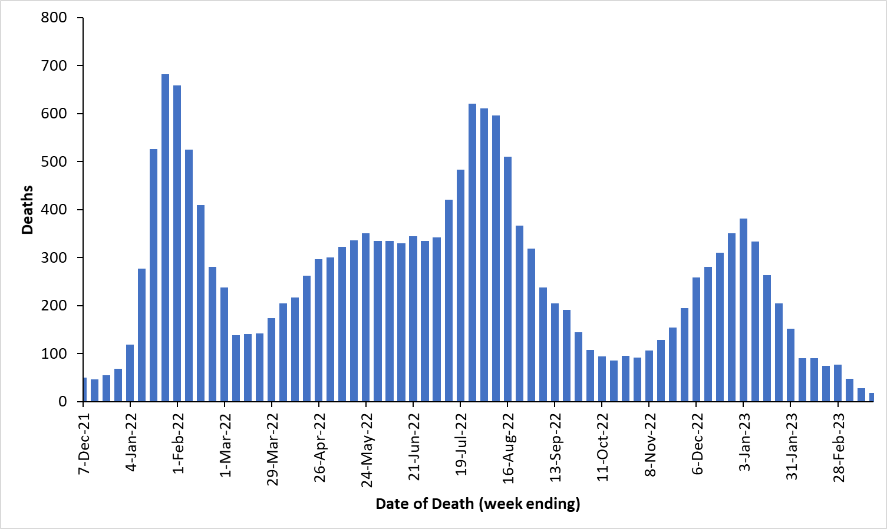

Source: NNDSS, extracted 22 March 2023 for cases with a date of death from 1 December 2021 to 21 March 2023

**Figure 3: Hospitalisation and ICU admission**

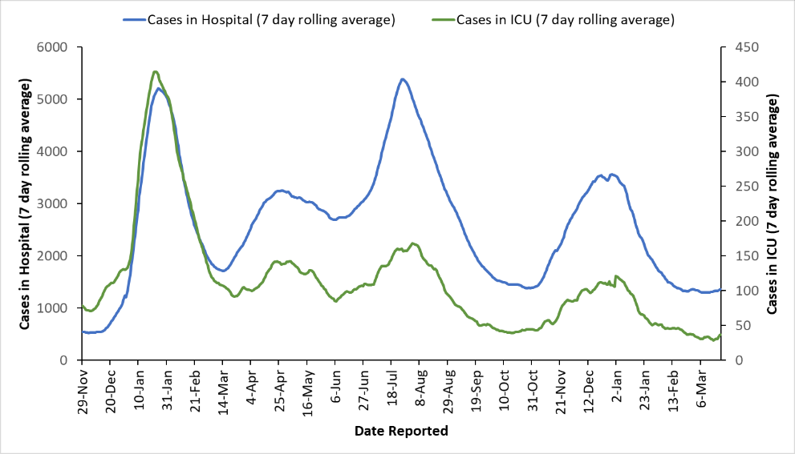

Source: State and Territory reporting to Department of Health and Aged Care, extracted 22 March 2023 for hospitalisations and ICU admissions reported from 29 November 2021 to 21 March 2023