Information kit

How to use this kit
Sporting clubs can use this kit to remind players, officials and spectators about ways they can protect themselves against mosquito-borne diseases, such as Japanese encephalitis virus (JEV).
As we transition from summer to autumn the risk of catching mosquito-borne diseases, including Japanese encephalitis virus (JEV), is still high because weather remains favourable for mosquito breeding.
You can share information about mosquito protection by:
- Including an article on your website or in newsletters/updates (see example content below)
- Publishing social media posts (see example content below)
- Distributing resources such as posters or information cards (see link below).

Key information
- Human cases of JEV have been detected in five states and territories - New South Wales, Queensland, Victoria, the Northern Territory, and South Australia.
- JEV has been detected in piggeries in Queensland, New South Wales, Victoria, and South Australia, and in feral pigs in parts of Queensland, the Northern Territory and Victoria.
- A small number of people have died of JEV in Australia during the current outbreak.
- JEV is a mosquito-borne flavivirus, and belongs to the same genus as dengue, yellow fever, Murray Valley encephalitis and West Nile/Kunjin viruses.
- JEV is spread to humans through bites from infected mosquitoes.
- The virus does not spread between humans.
- Animals such as pigs and horses cannot directly pass the virus to humans.
- Information on JEV can be found on the Department of Health and Aged Care website

Resources
A suite of materials that encourages Australians to protect themselves against JEV is available on the Department of Health and Aged Care website.
These materials are available for you to download, print and distribute.
If you would like to order free hard copies of the JEV bookmark, postcard or posters, please email publichealthcomms@health.gov.au with the quantity required and delivery address.

Website/newsletter article

Protect yourself from mosquitoes during sporting activity
If you’re participating in or watching sport outdoors, it’s important to take simple steps to avoid mosquito bites.
As we transition from summer to autumn the risk of catching mosquito-borne diseases, including Japanese encephalitis virus (JEV), is still high because weather remains favourable for mosquito breeding.
JEV is spread to humans only through bites from infected mosquitoes.
Most cases of Japanese encephalitis in people are asymptomatic, however some people may experience severe infection with high fever, neck stiffness, severe headache, coma and more rarely, permanent neurological complications or death.
Anyone experiencing these symptoms should urgently seek medical advice.
Players, coaches, officials and spectators are encouraged to use effective mosquito repellent containing DEET, picaridin, or oil of lemon eucalyptus on all exposed skin, wear long, loose fitting clothing when outside where practical, especially at dusk and dawn and empty any water-holding containers near sporting venues and accommodation.
If travelling to attend sporting events, look for accommodation that has properly fitted insect screens.
Insecticide sprays, vapour dispensing units (indoors) and mosquito coils (outdoors) can also be used to clear rooms and repel mosquitoes from an area (always follow label directions to use pesticides safely).
For more information about the spread of JEV in people and human health information, please visit the Department of Health and Aged Care website.

Social media posts
Graphic | Text
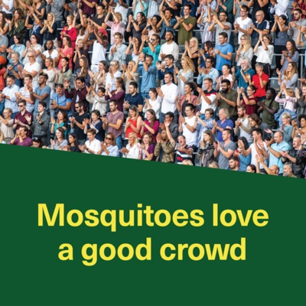 | If you’re watching sport outdoors, it’s important to take simple steps to make sure you're covered against mosquito-borne diseases, including Japanese encephalitis virus (JEV).  Protect yourself by:  🧴 applying repellent containing DEET, picaridin or oil of lemon eucalyptus on exposed skin  👖 wearing long, light-coloured, loose-fitting clothes outside where practical, especially at dusk and dawn  🚰 emptying any water-holding containers near sporting venues such as ovals.  For more information visit 💻health.gov.au/jev
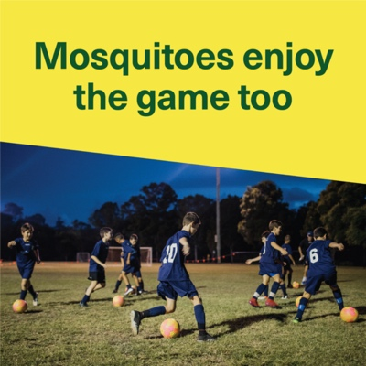 | If you’re training, coaching or playing sport outdoors, make sure you're covered against mosquito-borne diseases including Japanese encephalitis virus (JEV).  Protect yourself by:  🧴 applying repellent containing DEET, picaridin or oil of lemon eucalyptus on exposed skin  👖 wearing long, light-coloured, loose-fitting clothes outside where practical, especially at dusk and dawn  🚰 emptying any water-holding containers near sporting venues such as ovals.  For more information visit💻 health.gov.au/jev

