Information kit

How to use this kit
The Easter holiday period is a peak time for travel in Australia and is an opportunity to remind holiday makers, and people enjoying outdoor activity and celebrations, about ways they can protect themselves against mosquito-borne diseases, such as Japanese encephalitis virus (JEV).
You can share information about mosquito protection by:
- Including an article on your website or in newsletters/updates (see example content below)
- Publishing social media posts (see example content below)
- Distributing resources such as posters or information cards (see link below).

Key information
- Human cases of JEV have been detected in five states and territories - New South Wales, Queensland, Victoria, the Northern Territory, and South Australia.
- JEV has been detected in piggeries in Queensland, New South Wales, Victoria, and South Australia, and in feral pigs in parts of Queensland, the Northern Territory and Victoria.
- A small number of people have died of JEV in Australia during the current outbreak.
- JEV is a mosquito-borne flavivirus, and belongs to the same genus as dengue, yellow fever, Murray Valley encephalitis and West Nile/Kunjin viruses.
- JEV is spread to humans through bites from infected mosquitoes.
- The virus does not spread between humans.
- Animals such as pigs and horses cannot directly pass the virus to humans.
- Information on JEV can be found on the Department of Health and Aged Care website.

Resources
A suite of materials that encourages Australians to protect themselves against mosquito-borne diseases like JEV are available on the Department of Health and Aged Care website.
These materials are available for you to download, print and distribute.
If you would like to order free hard copies of the JEV bookmark, postcard or posters, please email publichealthcomms@health.gov.au with the quantity required and delivery address.

Website/newsletter article

Protect yourself from mosquitoes over the Easter Break
If you’re travelling or celebrating outdoors this Easter, it's important to be aware of areas with increased mosquito activity and follow simple steps to avoid mosquito bites.
As we transition from summer to autumn the risk of catching mosquito-borne diseases, including Japanese encephalitis virus (JEV), is still high because weather remains favourable for mosquito breeding.
JEV is spread to humans through bites from infected mosquitoes.
People are encouraged to use effective mosquito repellent containing DEET, picaridin, or oil of lemon eucalyptus on all exposed skin and wear long, loose fitting clothing when outside, especially at dusk and dawn. Mosquito nets or screens should be properly fitted to accommodation and tents. Where possible, empty water-holding containers around your accommodation where mosquitoes may breed.
Most cases of Japanese encephalitis in people are asymptomatic, however some people may experience severe infection with high fever, neck stiffness, severe headache, coma and more rarely, permanent neurological complications or death.
Anyone experiencing these symptoms should urgently seek medical advice.
Vaccines are available to those most at risk of infection, based on locality and profession.
For more information about vaccination, please visit the Department of Health and Aged Care website. The website also contains the contact information for state and territory public health authorities, who are responsible for JEV vaccination in their jurisdiction.
For more information about the spread of mosquito-borne diseases in people and human health information, please visit the Department of Health and Aged Care website.
You can reduce your risk of being bitten by a mosquito by following these simple steps:
- apply and regularly reapply an effective insect repellent on exposed skin, such as those containing DEET, picaridin or oil of lemon eucalyptus (always follow label directions to use repellents safely)
- use insecticide sprays, vapour dispensing units (indoors) and mosquito coils (outdoors) to clear rooms and repel mosquitoes from an area (always follow label directions to use pesticides safely)
- wear loose-fitting, light-coloured clothing when outdoors, especially at dusk and dawn
- cover all windows, doors, vents and other entrances with insect screens in homes and when camping, and
- remove or empty water-holding containers where mosquitoes may breed around homes and at campsites.

Social media posts
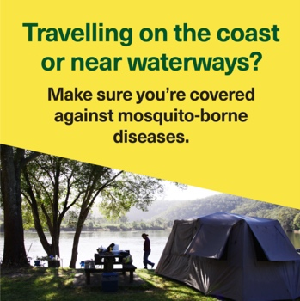 | If you’re near water over the Easter break, remember to make sure you're covered against mosquito-borne diseases like Japanese encephalitis virus (JEV).  Protect yourself by:  🧴 applying repellent containing DEET, picaridin or oil of lemon eucalyptus on exposed skin  using insecticide sprays, vapour dispensing units (indoors) and mosquito coils (outdoors) to clear rooms and repel mosquitoes from an area (always follow label directions to use pesticides safely)  👖 wearing long, light-coloured, loose-fitting clothes outside, especially at dusk and dawn  ⛺ ensuring accommodation, including tents, is properly fitted with mosquito nets or screens on windows, doors, vents and other entrances  🚰 emptying any water-holding containers where mosquitoes may breed.  For more information visit 💻health.gov.au/jev
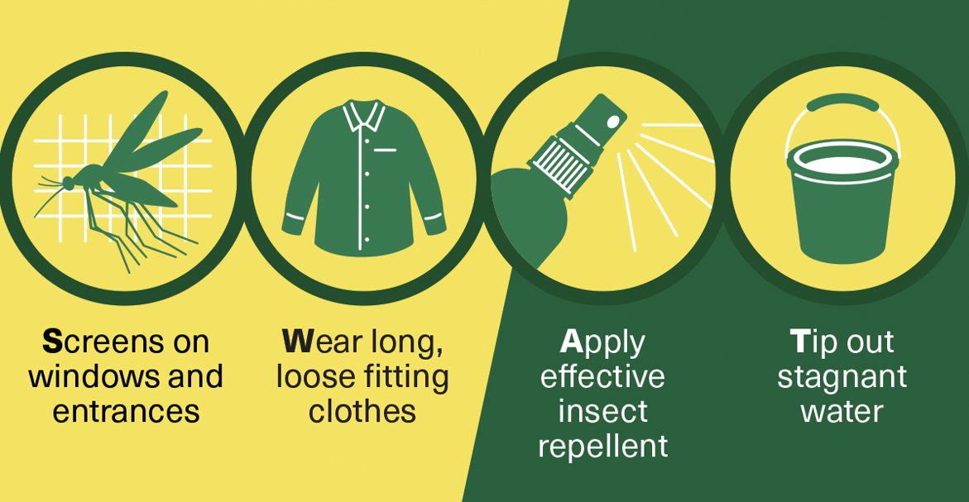 | Make sure you're covered against mosquito-borne diseases including JEV by:  🧴 applying repellent containing DEET, picaridin or oil of lemon eucalyptus  👖 wearing long, loose-fitting clothes, especially at dusk and dawn  ⛺ ensuring accommodation, including tents, is properly fitted with mosquito nets or screens  🚰 emptying any water-holding containers where mosquitoes may breed.  Visit 💻health.gov.au/jev
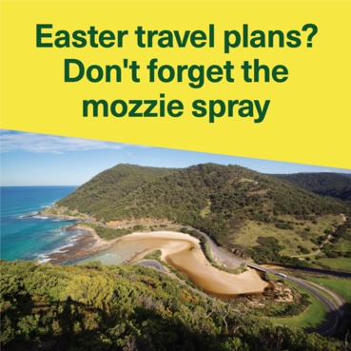 | If you’re planning a trip over the Easter break or visiting somewhere near a river or waterway, don't give mosquitoes a chance to bite.  Mosquitoes can spread a range of serious diseases, including Japanese encephalitis virus (JEV).  Apply repellent containing DEET, picaridin or oil of lemon eucalyptus to exposed skin.  For more information visit💻 health.gov.au/jev

