# Troubleshooting tips

If you are experiencing difficulties logging into the Government Provider Management System (GPMS), there are some things you can do to help determine the root cause and actions to resolve. This quick guide steps you through some of the commonly noted issues in accessing GPMS.

If problems persist after attempting to clear your cache, contact your organisation’s IT support.

## Deleting your cache

You may need to delete the cache in your browser in order for GPMS to load correctly.

### Deleting your Google Chrome cache

To delete the cache in Google Chrome, complete the following actions:

1. In Google Chrome, select the **Customise and control** Google Chrome **button**.

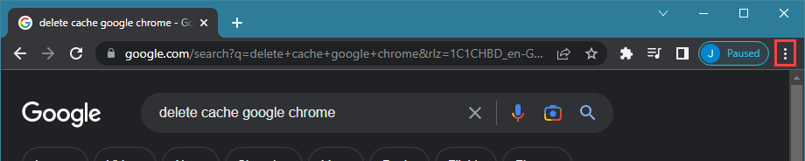

1. In the drop-down list that displays, select **More tools.**

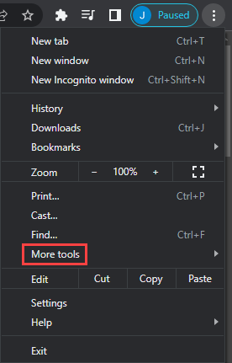

1. Select **Clear browsing data**.

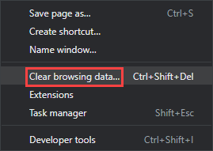

1. In the **Clear browsing data** window, select the **Clear data** button.

### Deleting your Microsoft Edge cache

To delete the cache in Microsoft Edge, complete the following actions:

1. In Microsoft Edge, select the **Settings** and more button.

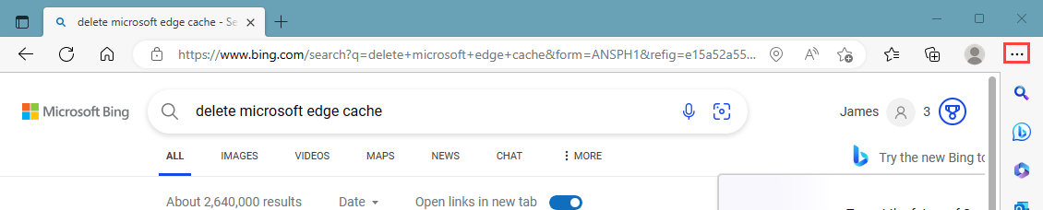

1. In the drop-down list that displays, select **Settings**.

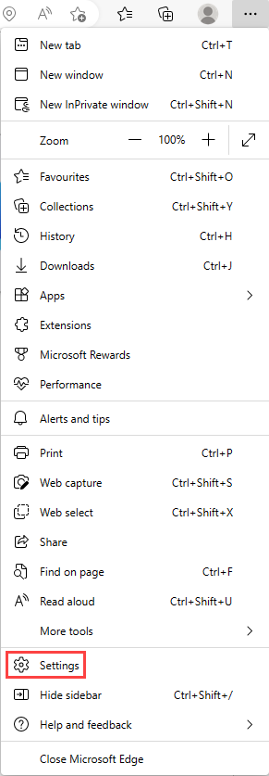

1. In the **Settings** screen that displays, select **Privacy, search, and services**.

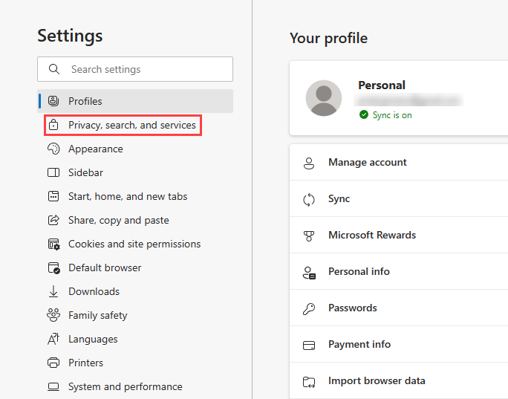

1. In the **Clear browsing data section**, select the Choose **what to clear** button.

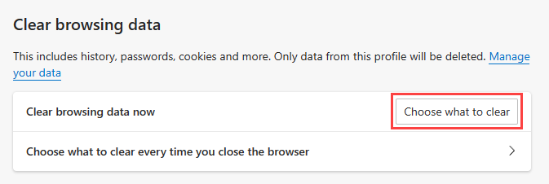

1. In the **Clear browsing data window,** select the **Clear now** button.

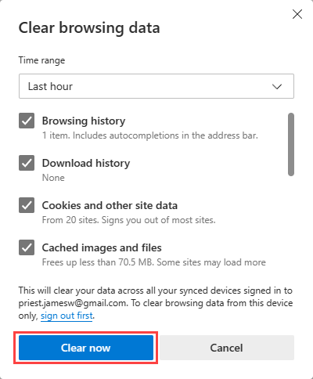

## If you still can’t access GPMS

Accessing GPMS requires you to authenticate with either myGovID/RAMS or VANguard FAS. If you are not sure which authentication service your organisation uses, or if you have not been set up with one speak to your organisation’s IT support.

**If you still cannot access GPMS, complete the following actions:**

### Are you an Organisation administrator?

Are you currently set up as an Organisation administrator in My Aged Care Service Support Portal?

Organisation administrators have been migrated over to GPMS. If you are not an Organisation administrator, you will need to be added to GPMS by an existing Organisation administrator.

### Can you log into My Aged Care Service Support Portal?

If you are an Organisation administrator, can you currently log into My Aged Care Service Support Portal with:

* VANguard (single sign-on), or
* myGovID

If you can log into My Aged Care Service Support Portal with either of the above, you should also be configured to access GPMS with the same authentication method.

### Neither VANguard or myGovID are working for me

If you are unable to log into GPMS with either VANguard or myGovID, contact your IT administrator to ensure your authentication is setup correctly. Support material can be found at the following links:

* myGovID <https://www.mygovid.gov.au/set-up>
* VANguard <https://vanguard.business.gov.au>

### The My Aged Care service provider and assessor helpline

If following the above steps has not resolved your access issues, you can contact the My Aged Care service provider and assessor helpline on the following number:

**1800 836 799**