# **The National Rural and Remote Nursing Generalist Framework 2023–2027**

This Framework is for Registered Nurses (RNs) who want to work in rural and remote places, where every day is not the same, and where nurses are encouraged and needed to work to their full scope of practice. It identifies the capabilities needed to deal with any type of presentation and supports the development of nurses in rural and remote settings. If you are a rural or remote nurse, use it to strengthen your own practice; if you are an educator, use it to inform curriculum;   
if you are an employer, use it to support your employees to practice with confidence.

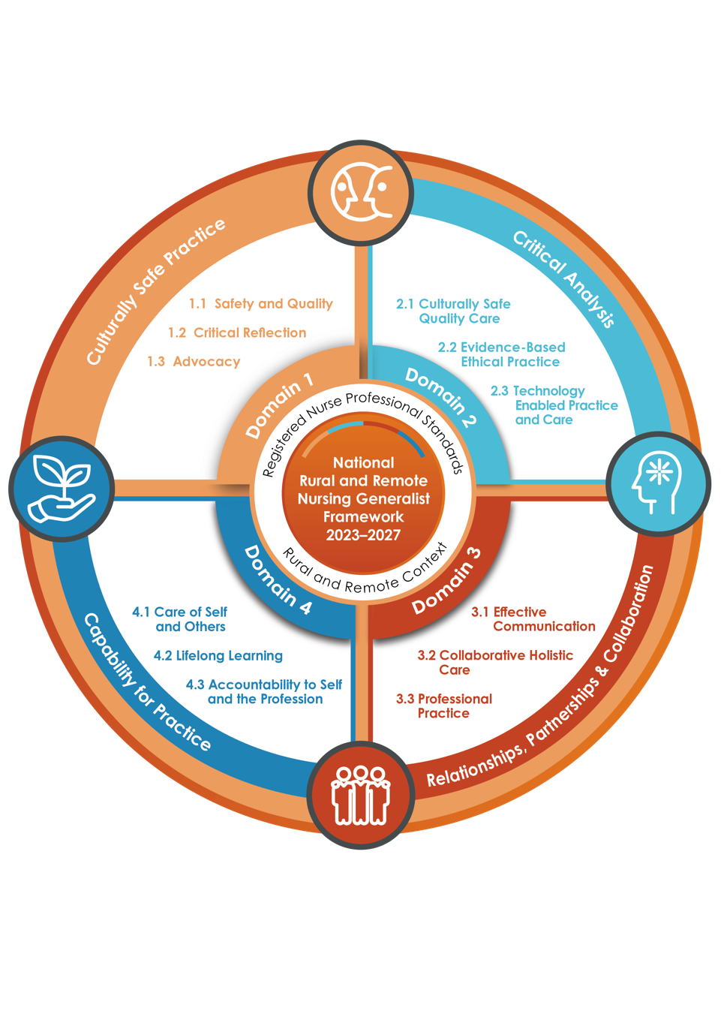

The Framework recognises rural and remote RNs often provide primary health, acute and aged care in very small teams, or in isolation. It acknowledges the legacies of prior rural and remote health service delivery with limited resources, and the effect of this on current rural and remote health outcomes.

The Framework is a tool and guide for:

* RNs who wish to transition to rural and remote nursing generalist practice
* states and territories, employers, educators, mentors, and health administrators employing and/or working with RNs in rural and remote healthcare settings
* nursing, midwifery, and other professional colleagues to support the capabilities of the   
  RN workforce.