**The National Rural   
and Remote Nursing Generalist Framework** 2023**–**2027

## Overview

This Framework is for Registered Nurses (RNs) who want to work in rural and remote places, where every day is not the same, and where nurses are encouraged and needed to work to their full scope of practice. It identifies the capabilities needed to deal with any type of presentation and supports the development of nurses in rural and remote settings. If you are a rural or remote nurse, use it to strengthen your own practice; if you are an educator, use it to inform curriculum; if you are an employer, use it to support your employees to practice with confidence.

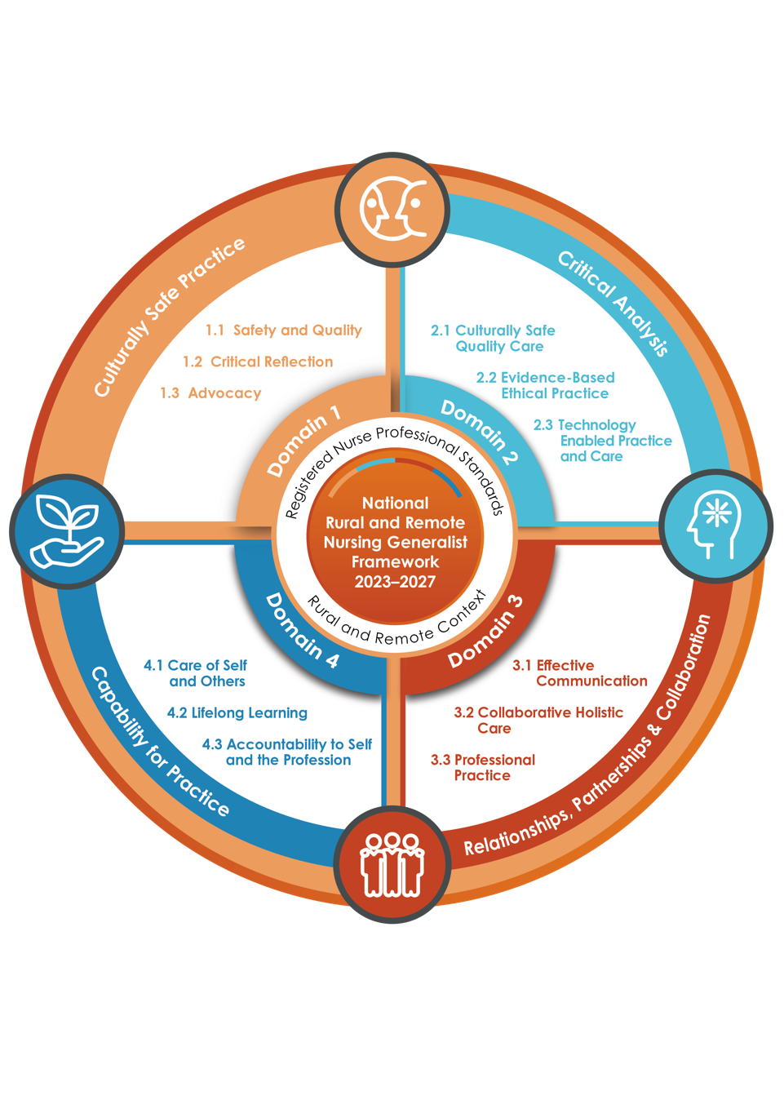

## Examples of How the Framework Can Be Applied

Diagram

Registered Nurses. Mapping their development of the capabilities with a mentor, to develop from formative to proficient skill levels. Educators and Education Providers. Supporting individual skill development or curriculum based on the capabilities. Government, Organisations and Employers. Using this Framework as a guide to grow and support the development of a skilled rural and remote RN workforce.

## 

## Domain 1. Culturally Safe Practice

**Knowledge and understanding of how one’s own culture, values, attitudes, assumptions and beliefs, influence perceptions of and interactions with people, families, community, and colleagues.**

**1.1 Safety and Quality   
1.2 Critical Reflection   
1.3 Advocacy**

| **Capabilities** | **Description** |
| --- | --- |
| 1. **Safety and Quality**   Applies evidence  and strength-based, holistic, clinically,  and Culturally Safe nursing care within the rural or remote context to deliver optimal and equitable individual and population health outcomes. Actively supports and respects the person’s right to determine their own Cultural Safety. Acts and leads inclusively to provide a Culturally Safe work and healthcare environment by supporting the rights, dignity, and safety  of all. | * + 1. Supports Aboriginal and Torres Strait Islander self-determination and ways of knowing, being and doing, in the context of history, culture and diversity, and affirms and protects these factors in nursing practice through continuing professional development.     2. Ensures that all healthcare measures protect Cultural Safety and understands the inextricable link between Cultural Safety, workforce and health outcomes, recognising that this can only be defined by Aboriginal and Torres Strait Islander or Culturally and Linguistically Diverse (CALD) peoples for themselves.     3. Utilises lifelong learning skills to develop Culturally Safe nursing practice including an understanding of Aboriginal and Torres Strait Islander health and Aboriginal Community Controlled Health Organisations (ACCHO’s).     4. Integrates the important role of Aboriginal and Torres Strait Islander health professionals, CALD advisors and knowledge from relevant organisations and communities into care, building effective partnerships.     5. Applies principles of trauma-informed care when working with Aboriginal and Torres Strait Islander people, and people from CALD and marginalised backgrounds. This includes using appropriate human and other resources and demonstrating personal humility about cross-cultural understanding and knowledge.     6. Actively promotes inclusivity in healthcare. |
| 1. **Critical Reflection**   Undertakes ongoing learning and personal reflection, seeking cultural mentorship and guidance on how dominant cultural paradigms influence perceptions and interactions with all people and communities, applying learnings to the provision of rural or remote healthcare. | 1. Recognises the impact of history and colonisation on contemporary Aboriginal and Torres Strait Islander health outcomes.      1. Acts to eliminate all forms of racism in practice and in the workplace. 2. Continuously reflects how one’s own culture, values, attitudes, assumptions, and beliefs influence interactions with people, families, community and colleagues. 3. Understands that safe, accessible healthcare requires recognition of power differentials in behaviour, knowledge and skill that do not privilege any group above another and actively works to counter racism to prevent and address health inequities. |
| 1. **Advocacy**   Regardless of sexuality, sex, gender, disability, ethnicity, race, religion, culture, political beliefs, or other personal characteristics:   * advocates for fairness and equity for all people in rural and remote communities * actively contributes to social change, challenging beliefs based on assumption. | * + 1. Promotes and supports equitable health services and affirms the principles of the United Nations Declaration on the Rights of Indigenous Peoples, and other human rights instruments, to support Aboriginal and Torres Strait Islander peoples to attain equitable health outcomes.     2. Demonstrates leadership and resilience in advocating for equitable health outcomes for Culturally Safe services whilst managing change resistance in all health care settings, including disability, aged care, youth residential care and correctional facilities. This includes using people’s nominated names and pronouns.     3. Advocates for and acts to facilitate access to quality and Culturally Safe health services for Aboriginal and Torres Strait Islander peoples and all minority and marginalised groups. |

## Domain 2. Critical Analysis

**Uses Critical Analysis in the assessment, planning, delivery, and evaluation of safe, quality, person-centred, evidence-based, individual care, and population and public health programs.**

**2.1 Culturally Safe Quality Care   
2.2 Evidence-Based Ethical Practice   
2.3 Technology Enabled Practice and Care**

| **Capabilities** | **Description** |
| --- | --- |
| 1. **Culturally Safe Quality Care**   Recognises the impact of colonisation on the social determinants of health and within past and current healthcare service models for rural and remote residents. Adopts reflexive, evidence-based practices to address context-specific inequities and deliver optimal health outcomes. | 1. Actively and openly incorporates professional and cultural knowledge in the assessment, planning, delivery, and evaluation of safe, quality, person and family-centred care. 2. Operates with cultural humility and respect, undertaking clinical assessments and plans that consider population and public health actions developed in collaboration with individuals, families, relevant care partners, and the multidisciplinary health care team. 3. Undertakes critical reflexivity that leads to improved holistic, Culturally Safe care whilst undertaking quality improvement activities to monitor and evaluate outcomes of care. |
| 1. **Evidence-Based Ethical Practice**   Utilises relevant data to identify best practice, place- and strengths-based person-centred interventions, co-designed with people, families, communities and the multidisciplinary team in the rural and remote context, recognising legacy challenges, and existing inequities. | 1. Critically evaluates and implements practice standards, policy, guidelines and legislation into practice. 2. Uses data monitoring and analysis to inform and prioritise inclusive action, optimise health outcomes, minimise risk, and maintain personal and Cultural Safety. Ensures appropriate and ethical use of health data, respecting confidentiality and data sovereignty. 3. Provides place-based multidisciplinary population health activities across the lifespan in partnership with the local community, identifying and overcoming risks through evidence- and strength-based co-design. 4. Implements and coordinates evidence-based and co-designed health interventions and programs to meet community priorities and needs, by embedding health promoting aims and values into practice. |
| 1. **Technology Enabled Practice and Care**   Utilises and connects available technology in the rural and remote context to enhance assessment and planning for holistic care and collaboration, to provide comprehensive primary health care. | 1. Maintains currency with digital health platforms and technologies to assist access to health care, inform care planning, delivery and evaluation of health outcomes, connecting care across the continuum. 2. Demonstrates recognised professional standards in utilising digital tools for professional development. 3. Ensures procedural knowledge in the use of digital tools in healthcare to align with policy, legal, ethical, security and privacy requirements. 4. Uses digital tools to build and maintain a professional online identity and reputation, in compliance with Australian Health Practitioner Regulation Agency’s (AHPRA) social media policy. |

## Domain 3. Relationships, Partnerships and Collaboration

**Engages in professional, Culturally Safe, and open engagement with the person and their full range of care partners to ensure effective delivery of holistic, comprehensive primary health care. This includes collegial generosity to build mutual trust and respect in professional multicultural and multidisciplinary relationships to optimise health outcomes.**

**3.1 Effective Communication   
3.2 Collaborative Holistic Care  
3.3 Professional Practice**

| **Capabilities** | **Description** |
| --- | --- |
| 1. **Effective Communication**   Communicates effectively with individuals, their care partners, and the comprehensive primary health care team, cognisant of their dignity, culture, values, beliefs, and rights, and how one’s own culture, values, attitudes, assumptions, and beliefs influence interactions. | 1. Actively and respectfully engages the person, their family, care partners, and community support networks including Aboriginal and Torres Strait Islander Health Professionals and other CALD advice as appropriate, in the therapeutic relationship to plan, deliver and evaluate evidence-based care. 2. Communicates effectively with the multidisciplinary team to provide wrap around care that is person focused, co-designed and place-based. 3. Always promotes and enables health literacy to address identified need, in partnership with the person, care partners, local community, and the multidisciplinary team. 4. Builds sustainable relationships with people from diverse groups including Aboriginal and Torres Strait Islander, CALD, and marginalised groups, to support collaborative decision making for optimal healthcare. 5. Facilitates Culturally Safe, evidence-based health education that strengthens confidence and supports self-care. 6. Develops Culturally Safe partnerships that recognise the importance to many rural and remote families and communities of defining health care needs as collective, rather than as individual. |
| 1. **Collaborative Holistic Care**   Initiates and demonstrates Culturally Safe collegial relationships that promote inclusive workplaces, supports community control, and uses appropriate digital and other technologies to overcome rural and remote barriers to healthcare. | * + 1. Utilises collaborative partnerships to deliver evidence-based comprehensive and holistic care, drawing on the collective experience, knowledge, and expertise of others.     2. Delivers Culturally Safe care in collaboration with the person, family, care partners and community support systems, recognising historical and contemporary impacts on professional approaches, perspectives, and practice.     3. Collaborates to strengthen the multidisciplinary team, to develop, implement and evaluate care that supports the person’s independence and self-management.     4. Applies trauma-informed care using all available resources, demonstrating humility and cross-cultural understanding within the relationship, as required.     5. Embeds patient monitoring systems, data collection, relevant documentation, and communication tools, linking population health activities to holistic care and connectivity across the care continuum. |
| 1. **Professional Practice**   Creates a supportive learning environment by generously sharing knowledge and skills and demonstrates humility in learning from others.  Understands the critical importance of relationships and partnerships within small communities and teams and establishes appropriate personal and professional boundaries.  Advocates for recognition and advancement of the role of nursing in promoting health and wellbeing of individuals and communities. | * + 1. Builds resilient relationships by providing and receiving professional mentorship, including across disciplines within the rural and remote multidisciplinary practice setting.     2. Develops professional and community partnerships in low resource isolated settings as appropriate to assist with innovation and to support staff safety.     3. Advocates for recognition and advancement of the role of the rural and remote nurse generalist in improving health outcomes, and to highlight health inequities and social injustice.     4. Delivers comprehensive clinical care in a variety of contexts, including complete episodes of care, prevention, and health promotion appropriate for age and demographic.     5. Embraces multidisciplinary collaborative team care, inclusive of all rural and remote generalists and care partners, to provide wrap around care and support.     6. Utilises clinical leadership and professional judgement to guide delegation, supervision, coordination, consultation, and referral, within Culturally Safe and respectful professional relationships, to optimise health outcomes. |



## Domain 4. Capability for Practice

**Is accountable for own level of rural and remote generalist capability, responding constructively to support colleagues’ capability for practice.**

**4.1 Care of Self and Others   
4.2 Lifelong Learning   
4.3 Accountability to Self and the Profession**

| **Capabilities** | **Description** |
| --- | --- |
| 1. **Care of Self and Others**   Develops and maintains the capability to deliver evidence-based care that enables people to make informed decisions for their health in the rural or remote setting, strengthening own and other’s wellbeing, and supporting colleagues to deliver Culturally Safe quality healthcare. | * + 1. Maintains own health, wellbeing and resilience through self-care strategies such as peer support and mentorship, clinical reflective supervision and employee assistance.     2. Recognising the demands of rural and isolated remote practice on self and others, demonstrates proficiency in comprehensive assessments in a range of settings, often in isolation with reduced access to immediate clinical supports, using resources innovatively to plan, treat and evaluate care, to full scope of practice.     3. Promotes a safe work environment through adherence to relevant legislation, standards of practice and safety protocols that reflect cultural and local requirements in isolated settings.     4. Engages in inter-professional collegial support and learning aligned to the rural or remote context. |
| 1. **Lifelong Learning**   Demonstrates commitment to ongoing personal and professional learning and development. | * + 1. Maintains currency and capability in professional standards of practice, to influence and strengthen rural and remote peoples’ autonomy for their health across the lifespan.     2. Engages in personal reflection and continuing professional development with nursing, remote and rural health professional organisations to enhance quality and Culturally Safe care for individuals, community and population groups.     3. Utilises a skills-based approach to educational pathways and standards that enable practice to accommodate the needs of the community.     4. Ability to critically think, analyse data and demonstrate clinical reasoning in challenging environments with limited resources and caring for known individuals within a small community. |
| 1. **Accountability to Self and the Profession**   Reflects on the process and quality outcomes of own practice and always acts to promote and improve the status of rural and remote nursing. | 1. Prepares for context of practice by identifying and acquiring extended knowledge and skills, undertaking professional development and education to safely deliver multidisciplinary team-based care. 2. Understands and takes accountability for personal and professional actions and decisions, and for the actions of others to whom they have delegated responsibilities. 3. Seeks and responds to feedback to improve and develop professional capability for both self and colleagues. 4. Understands and responds constructively to concerns around other health professionals’ practice by providing support to enhance their capability to improve rural and remote health across the care continuum. 5. Actively works to enhance and promote multidisciplinary, rural generalist teams to support better rural and remote health outcomes for current and future generations. 6. Maintains currency and capability to embed patient monitoring systems, data collection, relevant documentation and communication tools, that link population health activities to holistic care and connectivity across the care continuum. |