COVID-19 outbreaks in Australian residential aged care facilities

# National snapshot

As at 8:00 am 30 March 2023 there are 1,297 active COVID-19 cases in 190 active outbreaks in residential aged care facilities across Australia. There have been 78 new outbreaks, 18 new resident deaths and 1,150 combined new resident and staff cases reported since 23 March 2023.

Table 1: Aged Care COVID-19 data as at 8.00am 30 March 2023[1]

| Category | Active*[2]* | Previous  7 days | Cumulative  Total | Previous 7 days |
| --- | --- | --- | --- | --- |
| Outbreaks[3] | 190 | -2 | 13,481 | 78 |
| Residential Aged Care Facilities affected | 190 | -2 | 2,813 | 1 |
| Resident Cases[4] | 942 | 8 | 132,845 | 800 |
| Resident Deaths | N/A | N/A | 5,185 | 18 |
| Staff Cases | 355 | 21 | 81,547 | 350 |

Residential aged care homes with active outbreaks are included in Appendix 1.

**Table 2: Overview of Active Outbreaks in Australia**

|  |  |  |  |  |  |  |  |  |  |
| --- | --- | --- | --- | --- | --- | --- | --- | --- | --- |
|  | ACT | NSW | NT | QLD | SA | TAS | VIC | WA | Total |
| Total Facilities with outbreaks | 1 | 57 | 2 | 43 | 32 | 2 | 38 | 15 | **190** |
| *Total number of active resident cases* | 1 | 364 | 5 | 231 | 127 | 9 | 139 | 66 | **942** |
| *Total number of active staff cases* | 3 | 118 | 1 | 113 | 42 | 9 | 46 | 23 | **355** |
| Total Outbreaks Opened in Previous 7 Days | 0 | 24 | 1 | 15 | 12 | 0 | 18 | 8 | **78** |
| Total Outbreaks Closed in Previous 7 Days | 1 | 21 | 0 | 27 | 4 | 1 | 14 | 12 | **80** |

**Figure 1: National Outbreak Trends in Aged Care**

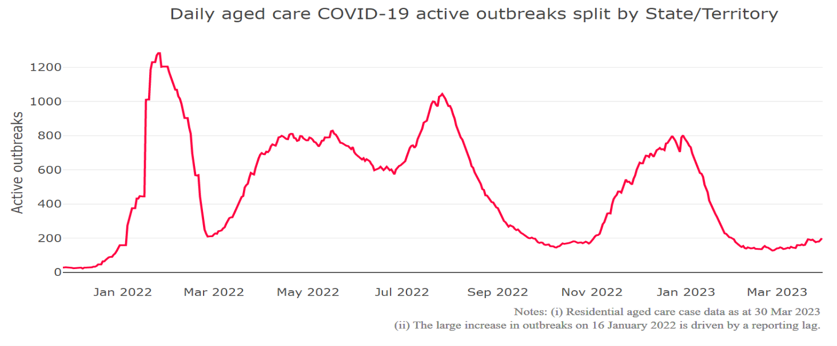

**Figure 2: Trends in Aged Care Cases – December 2021 to Present**

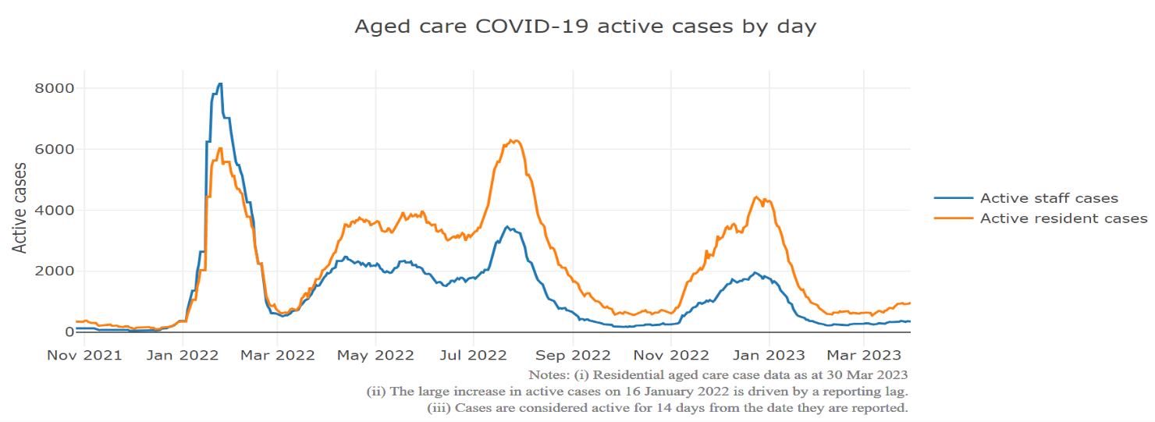

## Mortality

For the period of 1 January 2022 to 27 March 2023, COVID-19 is recorded as the cause of death in 5.6 per cent of all deaths in permanent residents in aged care facilities.

Since the beginning of the Omicron outbreak in mid December[5] 2021, there have been 79,206 deaths in residential aged care from all causes (report period from 15 December 2021 to 27 March 2023)[6]. COVID-19 deaths account for 5.4 per cent of this figure.

Over the course of the pandemic, all-cause excess mortality in Residential Aged Care was below expected numbers in 2020, and within expected range in 2021.

Figure 3: COVID-19 Deaths in Residential Aged Care Facilities overlaid with Community deaths

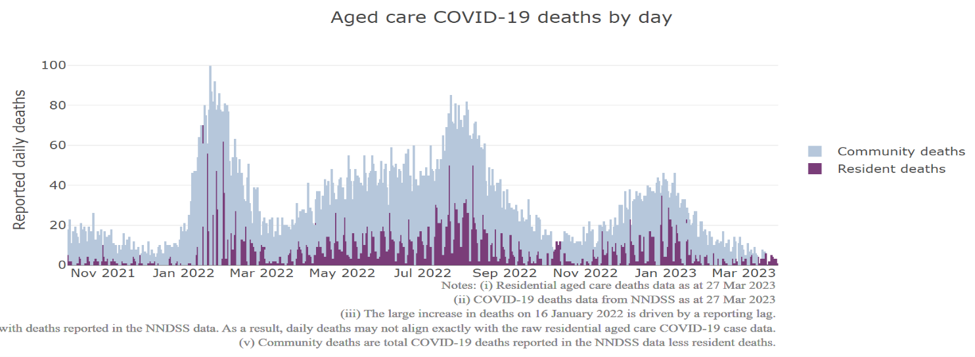

## Workforce in active residential aged care outbreaks

As at 31 March 2023, workforce surge staff have filled a total of 165,522 shifts in aged care services impacted by COVID-19, including 667 in the past 7 days. In the past 7 days (to 31 March) surge workforce providers have assisted 30 residential aged care homes. These shifts include roles for GPs, nurses, care workers, allied health workers, executive and ancillary staff. This includes:

Table 3: Workforce resources supplied to residential aged care facilities

| Workforce provider | Total Shifts | | Previous 7 days | |
| --- | --- | --- | --- | --- |
| Recruitment, Consulting and Staffing Association | 101,917 | 118 | |
| Healthcare Australia (Workforce Surge) | 13,691 | 7 | |
| Healthcare Australia (NACER) | 2,295 | N/A | |
| Mable | 2,711 | N/A | |
| Aspen Medical | 22,026 | 183 | |
| HealthX | 18,826 | 359 | |
| Torrens | 4,056 | N/A | |

The Australian Defence Force provided support to a total of 542 residential aged care homes between February and September 2022. The ADF deployment ceased on 30 September 2022.

## Oral antiviral treatments

Distribution of the oral anti-viral Lagevrio (Molnupiravir) commenced on 6 February 2022 to all RACFs with outbreak sites prioritised for delivery. The National Medical Stockpile has deployed 48,269 treatment courses of Lagevrio (Molnupiravir) to aged care facilities.

56,092 prescriptions for Lagevrio (Molnupiravir) have been issued to residents in residential aged care facilities, with a further 3,326 prescriptions for Paxlovid (nirmatrelvir + ritonavir) also issued since 28 February 2022 and up to 26 March 2023.

## Vaccination in Residential Aged Care Facilities

People living in residential aged care homes remain a high priority for the Government’s COVID-19 vaccination program, with continued ongoing targeted support and communications to maintain the high level of vaccination within this group.

During 2023, COVID-19 vaccines continue to be administered in residential aged care homes by primary care providers (general practitioners, registered nurses in general practices and community pharmacies).

The Department of Health and Aged Care is proactively working with Primary Health Networks to support residential aged care homes that may need assistance with facilitating COVID-19 vaccinations. In the initial phase of the 2023 booster rollout, the Government is targeting residential aged care homes that were early adopters of the fourth dose. In parallel, support is provided to individual aged care homes seeking assistance, linking them to their local Primary Health Network.

The 2023 COVID-19 vaccine booster program has moved away from dose numbers and focusses on ensuring protection for aged care residents is topped up if it has been more than 6 months since the last immunising event (an infection or a vaccine dose), regardless of the number of doses.

Based on this, at the beginning of the program in February 2023, nearly one third of aged care residents were not immediately eligible for a 2023 booster, as they had a vaccine dose or infection in the last 6 months.

As at 29 March 2023, there are:

* 54,676 (30.6%) aged care residents estimated with a vaccine dose or infection in the last 6 months (with recent immunity and not currently eligible for a 2023 booster dose).
* 11,311 (9.1%) estimated eligible aged care residents with a COVID-19 2023 booster dose.

The estimated eligible population is made up of residents who have completed their COVID-19 primary course, and had their last COVID-19 vaccine dose or infection more than 6 months ago. As residential aged care populations are fluid, and case overlay is not exact, eligible populations for vaccination are an estimate only.

**Table 4: Aged Care COVID-19 2023 Booster Doses (data as at 29 March 2023)**

| Jurisdiction | % of eligible residents vaccinated | Residents vaccinated |
| --- | --- | --- |
| National | 9.1% | 11,311 |
| ACT | 20.1% | 364 |
| NSW | 8.9% | 3,654 |
| NT | 4.4% | <200 |
| QLD | 7.9% | 2,010 |
| SA | 8.4% | 820 |
| TAS | 12.5% | 378 |
| VIC | 10.6% | 3,451 |
| WA | 5.6% | 623 |

Source: Matched AIR data of residents in permanent residential aged care facilities.

## Infection control and audits

The Aged Care Quality and Safety Commission (Commission) conducts a range of site and non-site activities to monitor and assess residential aged care services, including site audits and assessment contacts (site and non-site) (see Table 5 below). In August 2020, the Commission commenced an infection control monitoring (ICM) spot check program in all Australian jurisdictions.

The ICM spot check program involves on-site visits to residential aged care services, without an outbreak, to check compliance with personal protective equipment (PPE) and infection control arrangements. The purpose of the ICM spot check is to observe infection control practices, to ensure that staff, management and visitors were adhering to safe personal protective equipment protocols and to safe infection control arrangements as required under the quality standards.

As at 30 March 2023, the Commission had conducted 4,569 ICM spot checks to observe infection control practices and PPE protocols in residential aged care facilities.

Table 5: Total Quality Assessment and Monitoring Activities with residential services (including IPC), by type and month 1 March 2020 to 30 March 2023

|  |  |  |  |  |  |
| --- | --- | --- | --- | --- | --- |
| Regulatory Activities | 2019-20 (1 Mar - 30 Jun 2020) | 2020-21 | 2021-22 | 2022-23 (to 30 March 2023) | Total |
| ****Site visits**** | 318 | 3,452 | 1,732 | 2,432 | 7,934 |
| ****Non-site activities**** | 3,709 | 8,382 | 6,630 | 1,239 | 19,960 |
| Total activities | **4,027** | **11,834** | **8,362** | **3,671** | **27,894** |

# Appendix 1: National residential aged care services with Active outbreaks COVID-19

Please note, information reported in this table has been directly reported to the Department of Health and Aged Care by residential aged care facilities. Total cases refers to all staff and resident cases associated with the active outbreak and may not reflect the count of currently active cases. Where numbers have been incorrectly reported, facilities are able to correct these in the COVID-19 Support Portal through My Aged Care. Where a facility is reporting less than six resident or staff cases or less than six deaths, data has been suppressed to protect the privacy of affected individuals (note that “n/p” indicates data is not provided to protect privacy).

| Service Name | State | Resident Deaths | Resident Cases | Staff Cases | Total Incidents |
| --- | --- | --- | --- | --- | --- |
| BaptistCare Griffith | Australian Capital Territory | 0 | <6 | <6 | <6 |
| A H Orr Lodge | New South Wales | 0 | <6 | <6 | <6 |
| Advantaged Care at Barden Lodge | New South Wales | 0 | <6 | <6 | <6 |
| Alton Lodge | New South Wales | 0 | <6 | 0 | <6 |
| Anglicare Barry Marsh House | New South Wales | 0 | <6 | 0 | <6 |
| Banksia Village | New South Wales | 0 | 9 | <6 | n/p |
| Berrigan Multi-Purpose Service | New South Wales | 0 | <6 | 0 | <6 |
| Bilyara Hostel | New South Wales | 0 | <6 | <6 | <6 |
| Calvary Albury & District | New South Wales | <6 | 17 | 7 | 24 |
| Calvary Cooinda Retirement Community | New South Wales | 0 | 6 | <6 | n/p |
| Calvary Corymbia | New South Wales | 0 | 8 | <6 | n/p |
| Chamberlain Gardens Aged Care | New South Wales | <6 | 24 | 7 | 31 |
| Dudley Foord House | New South Wales | 0 | <6 | <6 | <6 |
| Elizabeth Lodge Hostel | New South Wales | 0 | 12 | <6 | n/p |
| Estia Health Blakehurst | New South Wales | 0 | <6 | 0 | <6 |
| Garrawarra Centre | New South Wales | 0 | 20 | 9 | 29 |
| Gill Waminda Aged Care Plus Centre | New South Wales | 0 | 25 | <6 | n/p |
| Greenhill Manor | New South Wales | 0 | <6 | <6 | <6 |
| HammondCare Waratah | New South Wales | 0 | 12 | <6 | n/p |
| Hawkesbury Living Pty Limited | New South Wales | 0 | 10 | <6 | n/p |
| Heritage Illawong | New South Wales | <6 | 36 | 8 | 44 |
| Hill View House Aged Care Facility | New South Wales | <6 | <6 | <6 | <6 |
| Hunters Hill Montefiore Home | New South Wales | 0 | 11 | <6 | n/p |
| Indochinese Aged Care Services | New South Wales | 0 | 0 | <6 | <6 |
| Lemongrove Gardens Hostel | New South Wales | 0 | <6 | 0 | <6 |
| Markmoran at Vaucluse | New South Wales | 0 | <6 | 0 | <6 |
| Mary Potter Nursing Home | New South Wales | <6 | 7 | <6 | n/p |
| Mayfield Aged Care | New South Wales | 0 | 31 | 7 | 38 |
| Mildred Symons House | New South Wales | 0 | 8 | <6 | n/p |
| Miranda Aged Care Facility | New South Wales | <6 | 19 | <6 | n/p |
| Moyne Aged Care Plus Centre (0033) | New South Wales | 0 | <6 | <6 | <6 |
| Narrabeen Glades Care Community | New South Wales | 0 | 9 | 0 | 9 |
| Paling Court Residential Aged Care | New South Wales | 0 | <6 | 0 | <6 |
| Patrick Bugden VC Gardens | New South Wales | 0 | 8 | <6 | n/p |
| Pemulwuy Aged Care | New South Wales | 0 | <6 | <6 | <6 |
| Peninsula Villages Ltd | New South Wales | 0 | 0 | <6 | <6 |
| Randwick Montefiore Home | New South Wales | 0 | <6 | <6 | <6 |
| Regis Elermore Vale | New South Wales | 0 | 21 | 0 | 21 |
| RFBI Bellingen Masonic Village | New South Wales | 0 | <6 | <6 | 8 |
| Rocky Point Residence | New South Wales | 0 | <6 | <6 | <6 |
| Russian Relief Association of St Sergius of Radonezh | New South Wales | 0 | <6 | 0 | <6 |
| Scalabrini Village Allambie Heights | New South Wales | 0 | 13 | <6 | n/p |
| Scalabrini Village Nursing Home (Bexley) | New South Wales | 0 | <6 | <6 | <6 |
| St Basil's Lakemba | New South Wales | <6 | 27 | 17 | 44 |
| St Marys Villa Residential Aged Care | New South Wales | 0 | 6 | <6 | n/p |
| St Vincent's Care Services Edgecliff | New South Wales | 0 | 7 | 6 | 13 |
| Stella Maris Aged Care Facility | New South Wales | 0 | <6 | <6 | <6 |
| Tarragal House | New South Wales | 0 | <6 | 0 | <6 |
| The Royce Manor | New South Wales | 0 | <6 | <6 | <6 |
| Uniting Banks Lodge Peakhurst | New South Wales | 0 | <6 | <6 | 7 |
| Wahroonga House | New South Wales | 0 | <6 | 7 | n/p |
| Wallsend Manor Aged Care | New South Wales | 0 | 6 | <6 | n/p |
| Warrigal Care Albion Park Rail | New South Wales | 0 | 14 | 10 | 24 |
| Warrigal Care Queanbeyan | New South Wales | 0 | 38 | 6 | 44 |
| Warrigal Care Shell Cove | New South Wales | <6 | 66 | 27 | 93 |
| Warrigal Wollongong | New South Wales | 0 | <6 | 0 | <6 |
| Windermere Aged Care Facility | New South Wales | 0 | 22 | <6 | n/p |
| Woollahra Montefiore Home | New South Wales | 0 | <6 | 0 | <6 |
| Mulakunya Flexible Aged Care Service (Nguiu) | Northern Territory | 0 | <6 | 0 | <6 |
| Pearl Supported Care | Northern Territory | 0 | <6 | <6 | <6 |
| Anam Cara | Queensland | 0 | 0 | <6 | <6 |
| Anglicare SQ Edwin Marsden Tooth Memorial Home for Aged | Queensland | 0 | <6 | <6 | 7 |
| Arcare Helensvale St James | Queensland | 0 | 26 | 11 | 37 |
| Arcare Seven Hills | Queensland | 0 | <6 | 0 | <6 |
| Arcare Slacks Creek | Queensland | 0 | 17 | 9 | 26 |
| Ashmore Retreat | Queensland | 0 | <6 | 0 | <6 |
| Bellevue Care Centre | Queensland | 0 | 16 | 9 | 25 |
| Blue Care Bundaberg Pioneer Aged Care Facility | Queensland | 0 | <6 | <6 | <6 |
| Blue Care Mackay Homefield Aged Care Facility | Queensland | 0 | 9 | 7 | 16 |
| Blue Care Rothwell Nazarene Aged Care Facility | Queensland | 0 | 12 | <6 | n/p |
| Buderim Views Assisted Aged Care | Queensland | 0 | <6 | <6 | <6 |
| Burpengary Manor Aged Care | Queensland | 0 | <6 | <6 | <6 |
| Churches of Christ Fair Haven Aged Care Service Maryborough | Queensland | 0 | 11 | <6 | n/p |
| Churches of Christ Gracehaven Aged Care Service | Queensland | 0 | <6 | 0 | <6 |
| Churches of Christ Little Mountain Aged Care Service | Queensland | 0 | <6 | 0 | <6 |
| Churches of Christ Stanthorpe Aged Care Service | Queensland | 0 | <6 | 6 | n/p |
| Estia Health Gold Coast | Queensland | 0 | 17 | 6 | 23 |
| Glenella Care | Queensland | 0 | 35 | 12 | 47 |
| Holland Park Aged Care | Queensland | 0 | 12 | 12 | 24 |
| Infinite Care Edmonton Gardens | Queensland | <6 | 26 | 10 | 36 |
| Jeta Gardens Aged Care Facility | Queensland | 0 | 13 | 14 | 27 |
| Kerrisdale Gardens | Queensland | 0 | <6 | <6 | <6 |
| Lutheran Services - Salem | Queensland | <6 | 14 | <6 | n/p |
| Lutheran Services - St Andrews | Queensland | 0 | <6 | 0 | <6 |
| Maryborough Community Aged Care | Queensland | 0 | 16 | 8 | 24 |
| Mercy Community Services - Emmaus | Queensland | 0 | <6 | <6 | <6 |
| Morayfield Grove Care Community | Queensland | 0 | <6 | 0 | <6 |
| North Lakes Terrace Care Community | Queensland | 0 | 42 | 14 | 56 |
| Ozcare Bakhita Villa Aged Care Facility | Queensland | 0 | <6 | <6 | 6 |
| Ozcare Villa Vincent | Queensland | 0 | 0 | <6 | <6 |
| Palm Lake Care Toowoomba | Queensland | 0 | 13 | 9 | 22 |
| Proserpine Nursing Home | Queensland | 0 | 12 | <6 | n/p |
| Redcliffe Aged Care Service | Queensland | 0 | 7 | <6 | n/p |
| Regis Birkdale | Queensland | 0 | <6 | <6 | <6 |
| Southern Cross Care Facility Caloundra | Queensland | 0 | <6 | <6 | <6 |
| Southern Cross Care Miles - Carinya | Queensland | 0 | 6 | <6 | n/p |
| St Vincent's Care Services Mitchelton | Queensland | 0 | 24 | 7 | 31 |
| St Vincent's Care Services Toowoomba - Nursing Home | Queensland | 0 | <6 | <6 | <6 |
| The Good Shepherd Nursing Home | Queensland | 0 | <6 | <6 | 7 |
| The Plains | Queensland | 0 | 34 | 11 | 45 |
| TriCare Annerley Aged Care Residence | Queensland | 0 | <6 | 0 | <6 |
| Villa Serena | Queensland | 0 | <6 | 0 | <6 |
| Warrina Innisfail | Queensland | 0 | <6 | 10 | n/p |
| ACH Group Residential Care - Colton Court | South Australia | 0 | <6 | 0 | <6 |
| ACH Group Residential Care - Highercombe | South Australia | <6 | 9 | 0 | 9 |
| ACH Group Residential Care - Kapara | South Australia | 0 | <6 | 0 | <6 |
| ACH Group Residential Care - Perry Park (high care) | South Australia | 0 | <6 | 0 | <6 |
| Alwyndor Aged Care | South Australia | 0 | <6 | <6 | 7 |
| Aminya Village Hostel | South Australia | 0 | 27 | 13 | 40 |
| AnglicareSA Brompton | South Australia | 0 | 6 | 0 | 6 |
| Bene Aged Care - The Italian Village | South Australia | 0 | 8 | <6 | n/p |
| Bucklands Residential Care | South Australia | 0 | 17 | <6 | n/p |
| Bupa Woodville | South Australia | 0 | <6 | 0 | <6 |
| Charla Lodge | South Australia | 0 | <6 | 0 | <6 |
| Clayton Church Homes - Magill | South Australia | 0 | <6 | 0 | <6 |
| Eldercare Hope Valley | South Australia | 0 | <6 | <6 | 8 |
| Eldercare Oxford | South Australia | 0 | 10 | <6 | n/p |
| Estia Health Aberfoyle Park | South Australia | 0 | <6 | 0 | <6 |
| Estia Health Burton | South Australia | 0 | <6 | <6 | <6 |
| Estia Health Hope Valley | South Australia | <6 | 53 | 15 | 68 |
| Estia Health Salisbury | South Australia | 0 | <6 | 0 | <6 |
| Estia Health Valley View | South Australia | <6 | 9 | <6 | n/p |
| Gaynes Park Manor | South Australia | 0 | <6 | 0 | <6 |
| Helping Hand Aged Care - Mawson Lakes Facility | South Australia | 0 | 6 | <6 | n/p |
| Kalyra Belair Aged Care | South Australia | 0 | 0 | <6 | <6 |
| Mallee - Lameroo MPS | South Australia | <6 | <6 | 7 | n/p |
| Mary Cecelia Hart Court Hostel | South Australia | 0 | 0 | <6 | <6 |
| Mount Carmel Residential Care | South Australia | 0 | <6 | 0 | <6 |
| Murray Mudge | South Australia | 0 | 11 | <6 | n/p |
| Olive Grove Aged Care | South Australia | 0 | 6 | 6 | 12 |
| Resthaven Westbourne Park | South Australia | 0 | 7 | <6 | n/p |
| St Basil's Aegean Village | South Australia | 0 | 7 | 0 | 7 |
| The Pines Lodge Residential Care | South Australia | 0 | 12 | <6 | n/p |
| Walara Hamley Bridge | South Australia | 0 | <6 | 0 | <6 |
| Westminster Village Nursing Home | South Australia | 0 | 16 | 6 | 22 |
| Huon Eldercare | Tasmania | 0 | <6 | 9 | n/p |
| Huon Eldercare | Tasmania | 0 | 7 | 0 | 7 |
| Anzac Lodge Private Nursing Home | Victoria | 0 | <6 | 0 | <6 |
| Ashleigh House Hostel | Victoria | 0 | 15 | <6 | n/p |
| Benetas Dalkeith Gardens | Victoria | 0 | 10 | 6 | 16 |
| Benetas St Paul's Terrace | Victoria | 0 | 8 | <6 | n/p |
| Bentons Lodge - Residential Aged Service | Victoria | 0 | 20 | <6 | n/p |
| BlueCross Scotchmans Creek | Victoria | 0 | <6 | 0 | <6 |
| Boronia Residential Aged Care | Victoria | 0 | <6 | 0 | <6 |
| Calvary Elanora | Victoria | 0 | <6 | 0 | <6 |
| Calvary Kelaston | Victoria | 0 | 10 | 0 | 10 |
| Calvary Kirralee | Victoria | 0 | <6 | <6 | <6 |
| Chaffey Aged Care | Victoria | <6 | 46 | 42 | 88 |
| Cobden District Health Services | Victoria | 0 | 9 | <6 | n/p |
| Craigcare Moonee Ponds | Victoria | 0 | 7 | <6 | n/p |
| Cumberland View Aged Care - Whalley Drive | Victoria | 0 | 6 | 0 | 6 |
| Diana Street Lodge | Victoria | 0 | 11 | 8 | 19 |
| Doutta Galla Avondale Heights Aged Care Facility | Victoria | 0 | <6 | <6 | <6 |
| Edgarley Home | Victoria | 0 | <6 | 0 | <6 |
| Elderly Chinese Home | Victoria | <6 | <6 | <6 | 8 |
| Estia Health Altona Meadows | Victoria | 0 | <6 | <6 | <6 |
| HammondCare - The Glens | Victoria | 0 | 11 | <6 | n/p |
| Kew Gardens Aged Care | Victoria | 0 | <6 | 0 | <6 |
| Maculata Place | Victoria | 0 | <6 | 0 | <6 |
| Margery Cole Residential Care Service | Victoria | <6 | 6 | 0 | 6 |
| Mayflower Reservoir | Victoria | 0 | 7 | <6 | n/p |
| mecwacare Park Hill | Victoria | 0 | <6 | 0 | <6 |
| Mercy Place Ballarat | Victoria | 0 | <6 | <6 | 6 |
| Mercy Place Wyndham | Victoria | 0 | <6 | 0 | <6 |
| MiCare Avondrust Lodge | Victoria | 0 | 0 | <6 | <6 |
| Moran Roxburgh Park | Victoria | 0 | <6 | <6 | <6 |
| Rainbow Bush Nursing Home Annexe | Victoria | 0 | <6 | <6 | 8 |
| Rainbow Bush Nursing Hospital Hostel | Victoria | 0 | <6 | <6 | n/p |
| Regis Macleod | Victoria | 0 | 10 | <6 | n/p |
| St Vincent's Care Services Kew | Victoria | 0 | <6 | 0 | <6 |
| St Vincent's Care Services Werribee | Victoria | 0 | <6 | 0 | <6 |
| Uniting AgeWell Box Hill | Victoria | 0 | <6 | <6 | 8 |
| Village Baxter - Manor | Victoria | 0 | <6 | 0 | <6 |
| Village Glen Aged Care Residences - Capel Sound | Victoria | 0 | <6 | 0 | <6 |
| Warrandyte Gardens Care Community | Victoria | 0 | 12 | <6 | n/p |
| Acacia Living Group Menora Gardens Aged Care Facility | Western Australia | 0 | 8 | <6 | n/p |
| Aegis Anchorage | Western Australia | 0 | <6 | <6 | <6 |
| Aegis Balmoral | Western Australia | 0 | <6 | <6 | 8 |
| Aegis Hilton Park | Western Australia | 0 | 18 | 8 | 26 |
| Aegis Karalee | Western Australia | 0 | <6 | 0 | <6 |
| Aegis Montgomery | Western Australia | 0 | <6 | 0 | <6 |
| Aegis The Pines | Western Australia | 0 | <6 | 0 | <6 |
| Bethanie Peel | Western Australia | 0 | <6 | 0 | <6 |
| Clarence Estate Residential Health and Aged Care | Western Australia | 0 | 14 | 11 | 25 |
| Guildford Village | Western Australia | 0 | <6 | 0 | <6 |
| McNamara Lodge | Western Australia | 0 | <6 | <6 | 6 |
| Melville Parkside Care Community | Western Australia | 0 | <6 | <6 | 6 |
| Murdoch Gardens Care Community | Western Australia | 0 | <6 | 0 | <6 |
| Regis Port Coogee | Western Australia | 0 | <6 | 0 | <6 |
| Riversea Mosman Park | Western Australia | 0 | 10 | <6 | n/p |

1. Outbreak opening and closure includes changes in the status of exposure sites to outbreaks (and vice versa), which are applied retrospectively to facility records. New case information can also change the status of a recovered site back to an active outbreak site. As a result, changes in active outbreak status may not align with day on day variations to active totals. These adjustments will also affect the number of cases in staff and residents reported each week.
2. Active residents and staff cases are the total currently positive cases in active outbreaks
3. An outbreak is considered to be active pending advice from the relevant Public Health Unit. An outbreak is defined as at least 1 positive case in a resident or 2+ cases in staff.
4. Case numbers and numbers of deaths are dependent upon reporting from facilities and validation of deaths from state and territory governments. This is subject to change as further information is provided.
5. The Omicron outbreak start date has been redefined from late November 2021 to mid December 2021. Changes have been made to align reporting with the start date of Omicron published in the Department’s external facing Epidemiology report.
6. The Department is now accessing aged care deaths data from the SIEBEL dataset. Figures are live and subject to change. Source: Department of Health and Aged Care unpublished data / SIEBEL dataset.