COVID-19 outbreaks in Australian residential aged care facilities

# National snapshot

As at 8:00 am 23 March 2023 there are 1,306 active COVID-19 cases in 205 active outbreaks in residential aged care facilities across Australia. There have been 92 new outbreaks, 18 new resident deaths and 1,017 combined new resident and staff cases reported since 16 March 2023.

Table : Aged Care COVID-19 data as at 8.00am 23 March 2023[1]

| Category | Active*[2]* | Previous  7 days | Cumulative  Total | Previous 7 days |
| --- | --- | --- | --- | --- |
| Outbreaks[3] | 205 | 44 | 13,395 | 92 |
| Residential Aged Care Facilities affected | 205 | 44 | 2,812 | 3 |
| Resident Cases[4] | 953 | 236 | 132,056 | 729 |
| Resident Deaths | N/A | N/A | 5,167 | 18 |
| Staff Cases | 353 | 45 | 81,198 | 288 |

Residential aged care homes with active outbreaks are included in Appendix 1.

**Table 2: Overview of Active Outbreaks in Australia**

|  |  |  |  |  |  |  |  |  |  |
| --- | --- | --- | --- | --- | --- | --- | --- | --- | --- |
|  | ACT | NSW | NT | QLD | SA | TAS | VIC | WA | Total |
| Total Facilities with outbreaks | 2 | 56 | 1 | 60 | 25 | 3 | 39 | 19 | **205** |
| *Total number of active resident cases* | 5 | 296 | 1 | 284 | 135 | 12 | 168 | 52 | **953** |
| *Total number of active staff cases* | 3 | 96 | 0 | 139 | 33 | 3 | 55 | 24 | **353** |
| Total Outbreaks Opened in Previous 7 Days | 0 | 27 | 1 | 22 | 13 | 2 | 17 | 10 | **92** |
| Total Outbreaks Closed in Previous 7 Days | 2 | 17 | 0 | 11 | 3 | 0 | 10 | 5 | **48** |

**Figure 1: National Outbreak Trends in Aged Care**

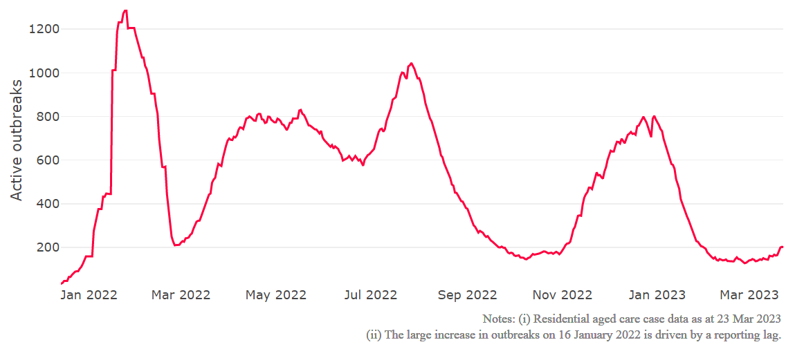

**Figure 2: Trends in Aged Care Cases – December 2021 to Present**

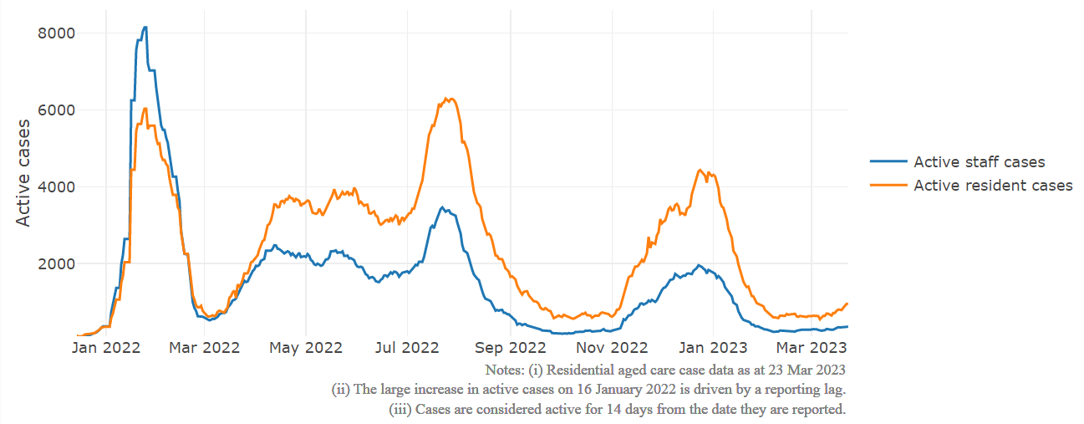

## Mortality

For the period of 1 January 2022 to 21 March 2023, COVID-19 is recorded as the cause of death in 5.6 per cent of all deaths in permanent residents in aged care facilities.

Since the beginning of the Omicron outbreak in mid December[5] 2021, there have been 78,117 deaths in residential aged care from all causes (report period from 15 December 2021 to 21 March 2023)[6]. COVID-19 deaths account for 5.5 per cent of this figure.

Over the course of the pandemic, all-cause excess mortality in Residential Aged Care was below expected numbers in 2020, and within expected range in 2021.

Figure 3: COVID-19 Deaths in Residential Aged Care Facilities overlaid with Community deaths

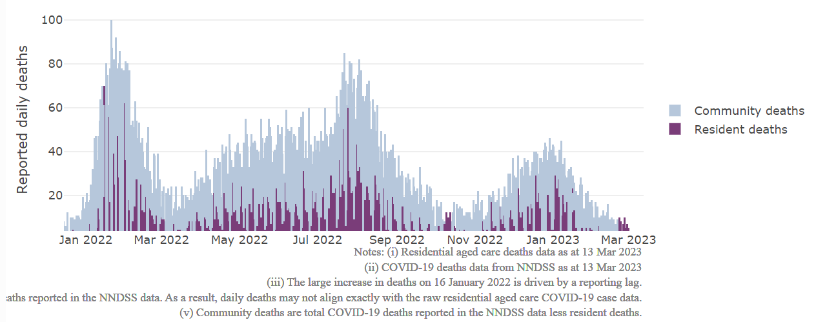

## Workforce in active residential aged care outbreaks

As at 24 March 2023, workforce surge staff have filled a total of 164,855 shifts in aged care services impacted by COVID-19, including 777 in the past 7 days. In the past 7 days (to 24 March) surge workforce providers have assisted 41 residential aged care homes. These shifts include roles for GPs, nurses, care workers, allied health workers, executive and ancillary staff. This includes:

Table 3: Workforce resources supplied to residential aged care facilities

| Workforce provider | Total Shifts | | Previous 7 days | |
| --- | --- | --- | --- | --- |
| Recruitment, Consulting and Staffing Association | 101,799 | 210 | |
| Healthcare Australia (Workforce Surge) | 13,684 | 47 | |
| Healthcare Australia (NACER) | 2,295 | N/A | |
| Mable | 2,711 | N/A | |
| Aspen Medical | 21,843 | 150 | |
| HealthX | 18,467 | 370 | |
| Torrens | 4,056 | N/A | |

The Australian Defence Force provided support to a total of 542 residential aged care homes between February and September 2022. The ADF deployment ceased on 30 September 2022.

## Oral antiviral treatments

Distribution of the oral anti-viral Lagevrio (Molnupiravir) commenced on 6 February 2022 to all RACFs with outbreak sites prioritised for delivery. The National Medical Stockpile has deployed 48,269 treatment courses of Lagevrio (Molnupiravir) to aged care facilities.

55,452 prescriptions for Lagevrio (Molnupiravir) have been issued to residents in residential aged care facilities, with a further 3,224 prescriptions for Paxlovid (nirmatrelvir + ritonavir) also issued since 28 February 2022 and up to 19 March 2023.

## Vaccination in Residential Aged Care Facilities

People living in residential aged care homes remain a high priority for the Government’s COVID-19 vaccination program, with continued ongoing targeted support and increasing communications to maintain the high level of vaccination within this group.

The Government continues to provide all residential aged care facilities with access to COVID vaccination clinics to ensure residents have every opportunity to get vaccinated. As at 2 March 2023, with the ‘Winter dose’ program from 2022 finalised 85.2% of aged care residents estimated to be eligible for fourth doses have received a fourth dose.

The Department of Health and Aged Care is proactively working with Primary Health Networks to support residential aged care homes that may need assistance with facilitating COVID-19 vaccinations.

The 2023 COVID-19 vaccine booster program started on 20 February 2023. The new program has moved away from dose numbers and focusses on ensuring protection for aged care residents is topped up if it has been more than six months since the last immunising event (an infection or a vaccine dose), regardless of the number of doses.

In the initial phase of the 2023 booster rollout, the Government is targeting residential aged care homes that were early adopters of the fourth dose. In parallel, support is provided to individual aged care homes seeking assistance, linking them to their local Primary Health Network. The Department continues to monitor low dose sites and communicate to facilities there is no minimum number of residents required for COVID-19 vaccination clinics.

The Department is finalising reporting arrangements for the new booster program, moving away from dose numbers and focussing on recency of coverage. Specific information on national and state/territory vaccination uptake for the 2023 COVID-19 booster dose will be available soon.

As at 2 March 2023, a total of 638,705 doses of COVID-19 vaccines have been administered to residents in residential aged care homes. Information is now received from the Australian Immunisation Register, meaning reported numbers may differ from previous reports. Information from the Australian Immunisation Register provides a more accurate representation of residents currently in residential aged care.

## Infection control and audits

The Aged Care Quality and Safety Commission (Commission) conducts a range of site and non-site activities to monitor and assess residential aged care services, including site audits and assessment contacts (site and non-site) (see Table 5 below). In August 2020, the Commission commenced an infection control monitoring (ICM) spot check program in all Australian jurisdictions.

The ICM spot check program involves on-site visits to residential aged care services, without an outbreak, to check compliance with personal protective equipment (PPE) and infection control arrangements. The purpose of the ICM spot check is to observe infection control practices, to ensure that staff, management and visitors were adhering to safe personal protective equipment protocols and to safe infection control arrangements as required under the quality standards.

As at 23 March 2023, the Commission had conducted 4,536 ICM spot checks to observe infection control practices and PPE protocols in residential aged care facilities.

Table 5: Total Quality Assessment and Monitoring Activities with residential services (including IPC), by type and month 1 March 2020 to 23 March 2023

|  |  |  |  |  |  |
| --- | --- | --- | --- | --- | --- |
| Regulatory Activities | 2019-20 (1 Mar - 30 Jun 2020) | 2020-21 | 2021-22 | 2022-23 (to 23 March 2023) | Total |
| ****Site visits**** | 318 | 3,452 | 1,733 | 2,351 | 7,854 |
| ****Non-site activities**** | 3,709 | 8,382 | 6,645 | 1,222 | 19,958 |
| Total activities | **4,027** | **11,834** | **8,378** | **3,573** | **27,812** |

# Appendix 1: National residential aged care services with Active outbreaks COVID-19

Please note, information reported in this table has been directly reported to the Department of Health and Aged Care by residential aged care facilities. Total cases refers to all staff and resident cases associated with the active outbreak and may not reflect the count of currently active cases. Where numbers have been incorrectly reported, facilities are able to correct these in the COVID-19 Support Portal through My Aged Care. Where a facility is reporting less than six resident or staff cases or less than six deaths, data has been suppressed to protect the privacy of affected individuals (note that “n/p” indicates data is not provided to protect privacy).

| Service Name | State | Resident Deaths | Resident Cases | Staff Cases | Total Incidents |
| --- | --- | --- | --- | --- | --- |
| BaptistCare Griffith | Australian Capital Territory | 0 | <6 | <6 | <6 |
| Fred Ward Gardens | Australian Capital Territory | 0 | 6 | 0 | 6 |
| A H Orr Lodge | New South Wales | 0 | <6 | <6 | <6 |
| ACDMA Aged Care Services | New South Wales | 0 | 28 | 6 | 34 |
| Advantaged Care at Barden Lodge | New South Wales | 0 | <6 | 0 | <6 |
| Advantaged Care at Edensor Gardens | New South Wales | 0 | 12 | <6 | n/p |
| Banksia Village | New South Wales | 0 | 7 | 0 | 7 |
| BaptistCare Bethshan Gardens Centre | New South Wales | 0 | <6 | 0 | <6 |
| Beresford Hall | New South Wales | <6 | <6 | <6 | <6 |
| Calvary Albury & District | New South Wales | <6 | 12 | <6 | n/p |
| Calvary Ryde Retirement Community - Mary Potter Residential Care | New South Wales | 0 | 14 | 0 | 14 |
| Chamberlain Gardens Aged Care | New South Wales | <6 | 21 | <6 | n/p |
| Clelland Lodge | New South Wales | 0 | <6 | 0 | <6 |
| Dellacourt | New South Wales | 0 | 0 | <6 | <6 |
| Dudley Foord House | New South Wales | 0 | <6 | 0 | <6 |
| Dural House Aged Care | New South Wales | 0 | 10 | <6 | n/p |
| Elizabeth Lodge (Rushcutters Bay) | New South Wales | <6 | <6 | <6 | 6 |
| Elizabeth Lodge Hostel | New South Wales | 0 | 12 | <6 | n/p |
| Estia Health Blakehurst | New South Wales | 0 | <6 | 0 | <6 |
| Garrawarra Centre | New South Wales | 0 | 8 | <6 | n/p |
| Greenhill Manor | New South Wales | 0 | <6 | <6 | <6 |
| Hawkesbury Living Pty Limited | New South Wales | 0 | <6 | <6 | <6 |
| Heritage Illawong | New South Wales | <6 | 35 | 8 | 43 |
| Hill View House Aged Care Facility | New South Wales | 0 | <6 | <6 | <6 |
| Holbrook District Hospital | New South Wales | 0 | 17 | 9 | 26 |
| IBIS Care Miranda | New South Wales | 0 | <6 | 0 | <6 |
| Indochinese Aged Care Services | New South Wales | 0 | 0 | <6 | <6 |
| James Milson Village North Sydney | New South Wales | 0 | <6 | 0 | <6 |
| Lucy Chieng Aged Care Centre | New South Wales | 0 | <6 | 0 | <6 |
| Markmoran at Vaucluse | New South Wales | 0 | <6 | 0 | <6 |
| Mayfield Aged Care | New South Wales | 0 | 31 | 7 | 38 |
| Meadowbank Grove Care Community | New South Wales | 0 | <6 | 0 | <6 |
| Mildred Symons House | New South Wales | 0 | <6 | <6 | 7 |
| Miranda Aged Care Facility | New South Wales | 0 | <6 | 0 | <6 |
| Moyne Aged Care Plus Centre (0033) | New South Wales | 0 | <6 | <6 | <6 |
| Narrabeen Glades Care Community | New South Wales | 0 | 9 | 0 | 9 |
| Paling Court Residential Aged Care | New South Wales | 0 | <6 | 0 | <6 |
| Patrick Bugden VC Gardens | New South Wales | 0 | <6 | <6 | <6 |
| Pemulwuy Aged Care | New South Wales | 0 | <6 | <6 | <6 |
| Regis Elermore Vale | New South Wales | 0 | 21 | 0 | 21 |
| RFBI Bellingen Masonic Village | New South Wales | 0 | <6 | <6 | 6 |
| S Antonio Da Padova Nursing Home | New South Wales | 0 | 0 | <6 | <6 |
| Scalabrini Village Allambie Heights | New South Wales | 0 | <6 | 0 | <6 |
| St Basil's Lakemba | New South Wales | <6 | 26 | 12 | 38 |
| St Marys Villa Residential Aged Care | New South Wales | 0 | <6 | <6 | 6 |
| St Vincent's Care Services Edgecliff | New South Wales | 0 | 6 | <6 | n/p |
| Stella Maris Aged Care Facility | New South Wales | 0 | 0 | <6 | <6 |
| Uniting Arrunga Ermington | New South Wales | 0 | <6 | 0 | <6 |
| Uniting Banks Lodge Peakhurst | New South Wales | 0 | <6 | <6 | <6 |
| Uniting Caroona Yamba | New South Wales | 0 | 10 | <6 | n/p |
| Uniting Mullauna Blacktown | New South Wales | 0 | 12 | <6 | n/p |
| Wahroonga House | New South Wales | 0 | <6 | 7 | n/p |
| Wallsend Manor Aged Care | New South Wales | 0 | 6 | <6 | n/p |
| Warrigal Care Albion Park Rail | New South Wales | 0 | <6 | 0 | <6 |
| Warrigal Care Shell Cove | New South Wales | 0 | 34 | 17 | 51 |
| Weeroona Aged Care Residence | New South Wales | 0 | 12 | <6 | n/p |
| Wesley Vickery | New South Wales | 0 | 12 | 7 | 19 |
| Windermere Aged Care Facility | New South Wales | 0 | 10 | 0 | 10 |
| Mulakunya Flexible Aged Care Service (Nguiu) | Northern Territory | 0 | <6 | 0 | <6 |
| Anglicare SQ Edwin Marsden Tooth Memorial Home for Aged | Queensland | 0 | 7 | <6 | n/p |
| Anglicare SQ Symes Grove Home for the Aged | Queensland | 0 | <6 | <6 | <6 |
| Arcare Helensvale St James | Queensland | 0 | 23 | 9 | 32 |
| Arcare Parkinson | Queensland | 0 | <6 | 0 | <6 |
| Arcare Parkwood | Queensland | 0 | 9 | 0 | 9 |
| Arcare Seven Hills | Queensland | 0 | <6 | 0 | <6 |
| Arcare Slacks Creek | Queensland | 0 | 17 | 9 | 26 |
| Ashmore Retreat | Queensland | 0 | <6 | 0 | <6 |
| Benevolent Living | Queensland | 0 | 18 | 16 | 34 |
| Berlasco Court Caring Centre | Queensland | 0 | <6 | 0 | <6 |
| Blue Care Bundaberg Pioneer Aged Care Facility | Queensland | 0 | <6 | <6 | <6 |
| Blue Care Carbrook Wirunya Aged Care Facility | Queensland | 0 | 26 | 17 | 43 |
| Blue Care Kenmore Aged Care Facility | Queensland | 0 | 7 | <6 | n/p |
| Blue Care Mackay Homefield Aged Care Facility | Queensland | 0 | 7 | 6 | 13 |
| Blue Care Wynnum Aged Care Facility | Queensland | 0 | 6 | <6 | n/p |
| Bolton Clarke Centaur | Queensland | 0 | <6 | <6 | 8 |
| Bolton Clarke Galleon Gardens | Queensland | 0 | 0 | <6 | <6 |
| Bolton Clarke Pioneers Nursing Home | Queensland | <6 | <6 | 0 | <6 |
| Buderim Views Assisted Aged Care | Queensland | 0 | <6 | 0 | <6 |
| Burpengary Gardens Care Community | Queensland | 0 | 16 | 0 | 16 |
| Burpengary Manor Aged Care | Queensland | 0 | <6 | <6 | <6 |
| Carinya (Atherton) Hostel | Queensland | 0 | <6 | 0 | <6 |
| Central & Upper Burnett District Home for the Aged Nursing Home | Queensland | 0 | <6 | <6 | <6 |
| Churches of Christ Clive Burdeu Aged Care Service | Queensland | 0 | 31 | 6 | 37 |
| Churches of Christ Fair Haven Aged Care Service Maryborough | Queensland | 0 | 11 | <6 | n/p |
| Churches of Christ Homesteads Aged Care Service | Queensland | 0 | <6 | 0 | <6 |
| Churches of Christ Little Mountain Aged Care Service | Queensland | 0 | 8 | <6 | n/p |
| Churches of Christ Moonah Park Aged Care Service | Queensland | 0 | 0 | <6 | <6 |
| Churches of Christ Stanthorpe Aged Care Service | Queensland | 0 | <6 | <6 | 9 |
| Estia Health Gold Coast | Queensland | 0 | 17 | 6 | 23 |
| Glenella Care | Queensland | 0 | 18 | <6 | n/p |
| Holland Park Aged Care | Queensland | 0 | 12 | 7 | 19 |
| Infinite Care Edmonton Gardens | Queensland | 0 | <6 | <6 | <6 |
| Jeta Gardens Aged Care Facility | Queensland | 0 | <6 | <6 | 7 |
| Kerrisdale Gardens | Queensland | 0 | <6 | <6 | <6 |
| Lutheran Services - Cooinda Aged Care Centre | Queensland | 0 | <6 | <6 | <6 |
| Lutheran Services - Salem | Queensland | <6 | 13 | <6 | n/p |
| Marebello | Queensland | 0 | 42 | 15 | 57 |
| Maryborough Community Aged Care | Queensland | 0 | 16 | 8 | 24 |
| MiCare Prins Willem Alexander Lodge | Queensland | 0 | <6 | 0 | <6 |
| Milton House | Queensland | <6 | <6 | <6 | <6 |
| New Auckland Place | Queensland | 0 | 0 | <6 | <6 |
| NewDirection Care at Bellmere | Queensland | 0 | 0 | <6 | <6 |
| North Lakes Terrace Care Community | Queensland | 0 | 40 | 14 | 54 |
| Ozcare Villa Vincent | Queensland | 0 | 0 | <6 | <6 |
| Palm Lake Care Toowoomba | Queensland | 0 | 9 | <6 | n/p |
| Proserpine Nursing Home | Queensland | 0 | <6 | 0 | <6 |
| Redcliffe Aged Care Service | Queensland | 0 | 6 | <6 | n/p |
| Regis Birkdale | Queensland | 0 | <6 | <6 | <6 |
| Residency by Dillons Tin Can Bay | Queensland | 0 | 8 | 10 | 18 |
| Seabrae Manor | Queensland | 0 | <6 | 0 | <6 |
| Southern Cross Care Miles - Carinya | Queensland | 0 | <6 | <6 | 6 |
| St Vincent's Care Services Kangaroo Point - Marycrest | Queensland | 0 | <6 | <6 | <6 |
| St Vincent's Care Services Maroochydore | Queensland | 0 | <6 | 0 | <6 |
| St Vincent's Care Services Mitchelton | Queensland | 0 | 24 | 7 | 31 |
| The Good Shepherd Nursing Home | Queensland | 0 | <6 | <6 | <6 |
| The Plains | Queensland | 0 | 17 | <6 | n/p |
| TriCare Annerley Aged Care Residence | Queensland | 0 | <6 | 0 | <6 |
| Warrina Innisfail | Queensland | 0 | <6 | 10 | n/p |
| ACH Group Residential Care - Colton Court | South Australia | 0 | <6 | 0 | <6 |
| ACH Group Residential Care - Highercombe | South Australia | 0 | 6 | 0 | 6 |
| ACH Group Residential Care - Perry Park (high care) | South Australia | 0 | <6 | 0 | <6 |
| Alwyndor Aged Care | South Australia | 0 | <6 | <6 | 6 |
| Aminya Village Hostel | South Australia | 0 | 27 | 10 | 37 |
| AnglicareSA Brompton | South Australia | 0 | <6 | 0 | <6 |
| Belalie Lodge | South Australia | 0 | <6 | 0 | <6 |
| Bene Aged Care - The Italian Village | South Australia | 0 | 7 | <6 | n/p |
| Boandik St Mary's | South Australia | 0 | <6 | <6 | 7 |
| Bucklands Residential Care | South Australia | 0 | 9 | <6 | n/p |
| Charla Lodge | South Australia | 0 | <6 | 0 | <6 |
| Clayton Church Homes - Magill | South Australia | 0 | <6 | 0 | <6 |
| Eldercare Oxford | South Australia | 0 | 9 | <6 | n/p |
| Estia Health Burton | South Australia | 0 | <6 | <6 | <6 |
| Estia Health Hope Valley | South Australia | 0 | 45 | 10 | 55 |
| Estia Health Salisbury | South Australia | 0 | <6 | 0 | <6 |
| Estia Health Valley View | South Australia | <6 | 8 | <6 | n/p |
| Lerwin Nursing Home | South Australia | 0 | <6 | 0 | <6 |
| Mallee - Lameroo MPS | South Australia | 0 | 6 | <6 | n/p |
| McCracken Views Residential Care | South Australia | 0 | <6 | 0 | <6 |
| Murray Mudge | South Australia | 0 | 9 | <6 | n/p |
| Olive Grove Aged Care | South Australia | 0 | <6 | <6 | 9 |
| The Pines Lodge Residential Care | South Australia | 0 | 9 | <6 | n/p |
| Westminster Village Nursing Home | South Australia | 0 | 7 | <6 | n/p |
| Huon Eldercare | Tasmania | 0 | <6 | 7 | n/p |
| Huon Eldercare | Tasmania | 0 | 7 | 0 | 7 |
| Uniting AgeWell Aldersgate Village | Tasmania | 0 | 19 | <6 | n/p |
| Arcare Balnarring | Victoria | 0 | <6 | <6 | 6 |
| Arcare Caulfield | Victoria | 0 | 7 | <6 | n/p |
| Ashleigh House Hostel | Victoria | 0 | 14 | <6 | n/p |
| Benetas Dalkeith Gardens | Victoria | 0 | <6 | <6 | 6 |
| Benetas St Laurence Court - Kangaroo Flat | Victoria | 0 | 7 | <6 | n/p |
| Benetas St Paul's Terrace | Victoria | 0 | <6 | <6 | <6 |
| Bentons Lodge - Residential Aged Service | Victoria | 0 | 20 | <6 | n/p |
| Calvary Elanora | Victoria | 0 | <6 | 0 | <6 |
| Calvary Kelaston | Victoria | 0 | 9 | 0 | 9 |
| Chaffey Aged Care | Victoria | <6 | 45 | 42 | 87 |
| Cobden District Health Services | Victoria | 0 | 8 | 0 | 8 |
| Craigcare Moonee Ponds | Victoria | 0 | 6 | <6 | n/p |
| Diana Street Lodge | Victoria | 0 | 8 | <6 | n/p |
| Doutta Galla Yarraville Village Aged Care Facility | Victoria | 0 | 15 | <6 | n/p |
| Edgarley Home | Victoria | 0 | <6 | 0 | <6 |
| Elderly Chinese Home | Victoria | 0 | <6 | <6 | 6 |
| Estia Health Melton South | Victoria | <6 | 64 | 11 | 75 |
| Estia Health Ringwood | Victoria | 0 | <6 | <6 | <6 |
| Glenview Community Care Nursing Home | Victoria | 0 | <6 | 0 | <6 |
| GraniteHill Aged Care | Victoria | 0 | <6 | <6 | 6 |
| Homewood Residential Aged Care | Victoria | 0 | 60 | 0 | 60 |
| Luson Bloom | Victoria | <6 | 19 | <6 | n/p |
| Margery Cole Residential Care Service | Victoria | <6 | 6 | 0 | 6 |
| Mayflower Reservoir | Victoria | 0 | 7 | <6 | n/p |
| mecwacare Park Hill | Victoria | 0 | <6 | 0 | <6 |
| Mercy Place Ballarat | Victoria | 0 | <6 | <6 | 6 |
| Mercy Place Montrose | Victoria | 0 | 9 | 14 | 23 |
| Monash Gardens | Victoria | 0 | 33 | <6 | n/p |
| Murrenda Aged Care Home | Victoria | 0 | <6 | 8 | n/p |
| Regis Macleod | Victoria | 0 | 10 | <6 | n/p |
| St Vincent's Care Services Werribee | Victoria | 0 | <6 | 0 | <6 |
| Villa Maria Catholic Homes Justin Villa Aged Care Residence | Victoria | <6 | <6 | 0 | <6 |
| Villa Maria Catholic Homes Wantirna Aged Care Residence | Victoria | 0 | <6 | <6 | <6 |
| Village Baxter - Manor | Victoria | 0 | <6 | 0 | <6 |
| Warrandyte Gardens Care Community | Victoria | 0 | 11 | <6 | n/p |
| Wimmera Nursing Home | Victoria | 0 | 9 | 10 | 19 |
| Acacia Living Group Menora Gardens Aged Care Facility | Western Australia | 0 | <6 | <6 | 7 |
| Aegis Balmoral | Western Australia | 0 | <6 | <6 | <6 |
| Aegis Hilton Park | Western Australia | 0 | <6 | <6 | 6 |
| Aegis Montgomery | Western Australia | 0 | <6 | 0 | <6 |
| Aegis Shoreline | Western Australia | 0 | <6 | 0 | <6 |
| Aegis The Pines | Western Australia | 0 | <6 | 0 | <6 |
| Baptistcare Bethel | Western Australia | 0 | <6 | 0 | <6 |
| Baptistcare Gracehaven | Western Australia | 0 | <6 | 0 | <6 |
| Baptistcare William Carey Court | Western Australia | 0 | <6 | 0 | <6 |
| Brightwater The Cove | Western Australia | 0 | 0 | <6 | <6 |
| Clarence Estate Residential Health and Aged Care | Western Australia | 0 | 10 | 9 | 19 |
| Geraldton Shore Care Community | Western Australia | <6 | 7 | 0 | 7 |
| Jeremiah Donovan House | Western Australia | 0 | 7 | <6 | n/p |
| Juniper Sarah Hardey | Western Australia | 0 | 8 | <6 | n/p |
| McNamara Lodge | Western Australia | 0 | <6 | <6 | <6 |
| Melville Parkside Care Community | Western Australia | 0 | <6 | <6 | 6 |
| MercyCare Wembley Catherine McAuley | Western Australia | 0 | <6 | <6 | 9 |
| Regents Garden Scarborough Condocare | Western Australia | 0 | <6 | <6 | <6 |
| Regis Port Coogee | Western Australia | 0 | <6 | 0 | <6 |
| Riversea Mosman Park | Western Australia | 0 | 10 | <6 | n/p |

1. Outbreak opening and closure includes changes in the status of exposure sites to outbreaks (and vice versa), which are applied retrospectively to facility records. New case information can also change the status of a recovered site back to an active outbreak site. As a result, changes in active outbreak status may not align with day on day variations to active totals. These adjustments will also affect the number of cases in staff and residents reported each week.
2. Active residents and staff cases are the total currently positive cases in active outbreaks
3. An outbreak is considered to be active pending advice from the relevant Public Health Unit. An outbreak is defined as at least 1 positive case in a resident or 2+ cases in staff.
4. Case numbers and numbers of deaths are dependent upon reporting from facilities and validation of deaths from state and territory governments. This is subject to change as further information is provided.
5. The Omicron outbreak start date has been redefined from late November 2021 to mid December 2021. Changes have been made to align reporting with the start date of Omicron published in the Department’s external facing Epidemiology report.
6. The Department is now accessing aged care deaths data from the SIEBEL dataset. Figures are live and subject to change. Source: Department of Health and Aged Care unpublished data / SIEBEL dataset.