COVID-19 outbreaks in Australian residential aged care facilities

# National snapshot

As at 8:00 am 9 March 2023 there are 931 active COVID-19 cases in 156 active outbreaks in residential aged care facilities across Australia. There have been 75 new outbreaks, 17 new resident deaths and 753 combined new resident and staff cases reported since 2 March 2023.

Table : Aged Care COVID-19 data as at 8.00am 9 March 2023[1]

| Category | Active*[2]* | Previous  7 days | Cumulative  Total | Previous 7 days |
| --- | --- | --- | --- | --- |
| Outbreaks[3] | 156 | 12 | 13,202 | 75 |
| Residential Aged Care Facilities affected | 156 | 12 | 2,807 | 0 |
| Resident Cases[4] | 651 | 16 | 130,648 | 548 |
| Resident Deaths | N/A | N/A | 5,131 | 17 |
| Staff Cases | 280 | -7 | 80,640 | 205 |

Residential aged care homes with active outbreaks are included in Appendix 1.

**Table 2: Overview of Active Outbreaks in Australia**

|  |  |  |  |  |  |  |  |  |  |
| --- | --- | --- | --- | --- | --- | --- | --- | --- | --- |
|  | ACT | NSW | NT | QLD | SA | TAS | VIC | WA | Total |
| Total Facilities with outbreaks | 3 | 48 | 1 | 47 | 14 | 2 | 29 | 12 | **156** |
| *Total number of active resident cases* | 7 | 166 | 1 | 224 | 35 | 16 | 165 | 37 | **651** |
| *Total number of active staff cases* | 0 | 98 | 0 | 86 | 21 | 2 | 48 | 25 | **280** |
| Total Outbreaks Opened in Previous 7 Days | 3 | 27 | 1 | 22 | 7 | 2 | 9 | 4 | **75** |
| Total Outbreaks Closed in Previous 7 Days | 0 | 20 | 1 | 17 | 9 | 0 | 11 | 5 | **63** |

**Figure 1: National Outbreak Trends in Aged Care**

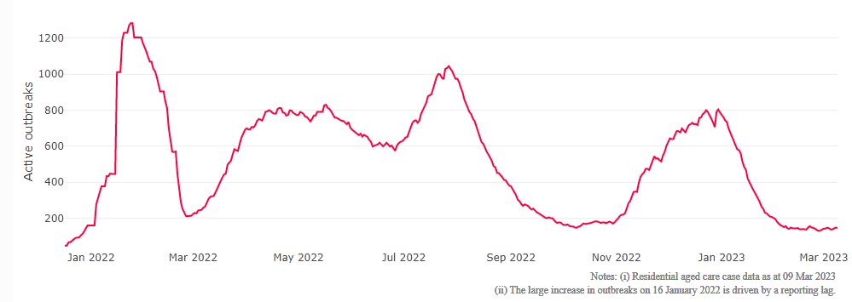

**Figure 2: Trends in Aged Care Cases – December 2021 to Present**

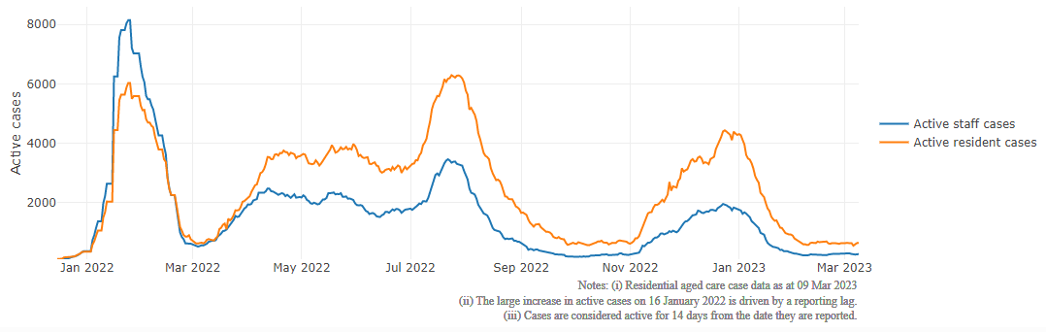

## Mortality

For the period of 1 January 2022 to 6 March 2023, COVID-19 is recorded as the cause of death in 5.8 per cent of all deaths in permanent residents in aged care facilities.

Since the beginning of the Omicron outbreak in mid December[5] 2021, there have been 75,848 deaths in residential aged care from all causes (report period from 15 December 2021 to 6 March 2023)[6]. COVID-19 deaths account for 5.6 per cent of this figure.

Over the course of the pandemic, all-cause excess mortality in Residential Aged Care was below expected numbers in 2020, and within expected range in 2021.

**Figure 3: COVID-19 Deaths in Residential Aged Care Facilities overlaid with Community deaths  
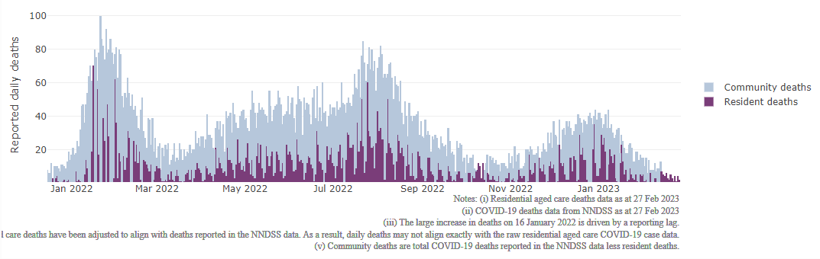**

## Workforce in active residential aged care outbreaks

As at 10 March 2023, workforce surge staff have filled a total of 163,327 shifts in aged care services impacted by COVID-19, including 544 in the past 7 days. In the past 7 days (to 10 March) surge workforce providers have assisted 10 residential aged care homes. These shifts include roles for GPs, nurses, care workers, allied health workers, executive and ancillary staff. This includes:

**Table 3: Workforce resources supplied to residential aged care facilities**

| Workforce provider | Total Shifts | | Previous 7 days | |
| --- | --- | --- | --- | --- |
| Recruitment, Consulting and Staffing Association | 101,407 | 133 | |
| Healthcare Australia (Workforce Surge) | 13,575 | 21 | |
| Healthcare Australia (NACER) | 2,295 | N/A | |
| Mable | 2,711 | N/A | |
| Aspen Medical | 21,527 | 66 | |
| HealthX | 17,756 | 324 | |
| Torrens | 4,056 | N/A | |

The Australian Defence Force provided support to a total of 542 residential aged care homes between February and September 2022. The ADF deployment ceased on 30 September 2022.

## Oral antiviral treatments

Distribution of the oral anti-viral Lagevrio (Molnupiravir) commenced on 6 February 2022 to all RACFs with outbreak sites prioritised for delivery. The National Medical Stockpile has deployed 48,269 treatment courses of Lagevrio (Molnupiravir) to aged care facilities.

54,310 prescriptions for Lagevrio (Molnupiravir) have been issued to residents in residential aged care facilities, with a further 3,076 prescriptions for Paxlovid (nirmatrelvir + ritonavir) also issued since 28 February 2022 and up to 5 March 2023.

## Vaccination in Residential Aged Care Facilities

People living in residential aged care homes remain a high priority for the Government’s COVID-19 vaccination program, with continued ongoing targeted support and increasing communications to maintain the high level of vaccination within this group.

The Government continues to provide all residential aged care facilities with access to COVID vaccination clinics to ensure residents have every opportunity to get vaccinated. As at 2 March 2023, with the ‘Winter dose’ program from 2022 finalised 85.2% of aged care residents estimated to be eligible for fourth doses have received a fourth dose.

The Department of Health and Aged Care is proactively working with Primary Health Networks to support residential aged care homes that may need assistance with facilitating COVID-19 vaccinations.

The 2023 COVID-19 vaccine booster program started on 20 February 2023. The new program has moved away from dose numbers and focusses on ensuring protection for aged care residents is topped up if it has been more than six months since the last immunising event (an infection or a vaccine dose), regardless of the number of doses.

In the initial phase of the 2023 booster rollout, the Government is targeting residential aged care homes that were early adopters of the fourth dose. In parallel, support is provided to individual aged care homes seeking assistance, linking them to their local Primary Health Network. The Department continues to monitor low dose sites and communicate to facilities there is no minimum number of residents required for COVID-19 vaccination clinics.

The Department is finalising reporting arrangements for the new booster program, moving away from dose numbers and focussing on recency of coverage. Specific information on national and state/territory vaccination uptake for the 2023 COVID-19 booster dose will be available soon.

As at 2 March 2023, a total of 638,705 doses of COVID-19 vaccines have been administered to residents in residential aged care homes. Information is now received from the Australian Immunisation Register, meaning reported numbers may differ from previous reports. Information from the Australian Immunisation Register provides a more accurate representation of residents currently in residential aged care.

## Infection control and audits

The Aged Care Quality and Safety Commission (Commission) conducts a range of site and non-site activities to monitor and assess residential aged care services, including site audits and assessment contacts (site and non-site) (see Table 5 below). In August 2020, the Commission commenced an infection control monitoring (ICM) spot check program in all Australian jurisdictions.

The ICM spot check program involves on-site visits to residential aged care services, without an outbreak, to check compliance with personal protective equipment (PPE) and infection control arrangements. The purpose of the ICM spot check is to observe infection control practices, to ensure that staff, management and visitors were adhering to safe personal protective equipment protocols and to safe infection control arrangements as required under the quality standards.

As at 9 March 2023, the Commission had conducted 4,469 ICM spot checks to observe infection control practices and PPE protocols in residential aged care facilities.

Table 5: Total Quality Assessment and Monitoring Activities with residential services (including IPC), by type and month 1 March 2020 to 9 March 2023

|  |  |  |  |  |  |
| --- | --- | --- | --- | --- | --- |
| Regulatory Activities | 2019-20 (1 Mar - 30 Jun 2020) | 2020-21 | 2021-22 | 2022-23 (to 9 March 2023) | Total |
| Site visits | 318 | 3,452 | 1,733 | 2,106 | **7,609** |
| Non-site activities | 3,709 | 8,382 | 6,643 | 1,184 | **19,918** |
| Total activities | **4,027** | **11,834** | **8,376** | **3,290** | **27,527** |

# Appendix 1: National residential aged care services with Active outbreaks COVID-19

Please note, information reported in this table has been directly reported to the Department of Health and Aged Care by residential aged care facilities. Total cases refers to all staff and resident cases associated with the active outbreak and may not reflect the count of currently active cases. Where numbers have been incorrectly reported, facilities are able to correct these in the COVID-19 Support Portal through My Aged Care. Where a facility is reporting less than six resident or staff cases or less than six deaths, data has been suppressed to protect the privacy of affected individuals (note that “n/p” indicates data is not provided to protect privacy).

| Service Name | State | Resident Deaths | Resident Cases | Staff Cases | Total Incidents |
| --- | --- | --- | --- | --- | --- |
| Goodwin Ainslie (Goodwin House) | Australian Capital Territory | 0 | <6 | 0 | <6 |
| Goodwin Monash | Australian Capital Territory | 0 | <6 | 0 | <6 |
| RFBI Holt Masonic Village | Australian Capital Territory | 0 | <6 | 0 | <6 |
| ACDMA Aged Care Services | New South Wales | 0 | 16 | 0 | 16 |
| Advantaged Care at Edensor Gardens | New South Wales | 0 | 10 | <6 | n/p |
| Auburn Glen Care Community | New South Wales | 0 | 0 | <6 | <6 |
| BaptistCare Maranoa Centre - Alstonville | New South Wales | 0 | <6 | 0 | <6 |
| Calvary Ryde Retirement Community - Mary Potter Residential Care | New South Wales | 0 | 22 | 8 | 30 |
| Canberra Nursing Home | New South Wales | 0 | <6 | 0 | <6 |
| Carino Care at Rockdale | New South Wales | 0 | <6 | <6 | <6 |
| Carinya House | New South Wales | 0 | 9 | <6 | n/p |
| Catholic Healthcare Bethlehem House | New South Wales | 0 | <6 | 0 | <6 |
| Catholic Healthcare Holy Spirit Dubbo | New South Wales | 0 | <6 | 0 | <6 |
| Catholic Healthcare Lewisham Nursing Home | New South Wales | 0 | <6 | 0 | <6 |
| Catholic Healthcare St John's Villa | New South Wales | 0 | 19 | <6 | n/p |
| Charingfield | New South Wales | 0 | <6 | 0 | <6 |
| Chiswick Manor Care Community | New South Wales | 0 | <6 | <6 | 6 |
| Clelland Lodge | New South Wales | 0 | <6 | 0 | <6 |
| Dural House Aged Care | New South Wales | 0 | <6 | <6 | 8 |
| Emmaus | New South Wales | <6 | 33 | 17 | 50 |
| Estia Health Forster | New South Wales | 0 | 0 | <6 | <6 |
| Goodhew Gardens | New South Wales | 0 | <6 | 0 | <6 |
| Heritage Illawong | New South Wales | 0 | 0 | <6 | <6 |
| Illawarra Diggers | New South Wales | 0 | <6 | <6 | <6 |
| Killarney Court Aged Care Facility | New South Wales | 0 | 12 | <6 | n/p |
| Maroba Nursing Home | New South Wales | 0 | <6 | <6 | 8 |
| Mary Mackillop Hostel Carrington Retirement Village | New South Wales | 0 | 0 | 12 | 12 |
| Mayfield Aged Care | New South Wales | 0 | 6 | 0 | 6 |
| Mountain View Lodge Hostel | New South Wales | 0 | <6 | <6 | <6 |
| Pathways Sailors Bay | New South Wales | 0 | <6 | 0 | <6 |
| Porter Lodge | New South Wales | 0 | <6 | 0 | <6 |
| Rathgar Lodge | New South Wales | 0 | <6 | 0 | <6 |
| RFBI Dubbo Masonic Village | New South Wales | 0 | 7 | <6 | n/p |
| RFBI Glen Innes Masonic Village | New South Wales | 0 | <6 | 0 | <6 |
| Rutherford Park Care Community | New South Wales | 0 | 6 | <6 | n/p |
| Scalabrini Village Allambie Heights | New South Wales | 0 | 6 | 0 | 6 |
| Southern Cross Care Daceyville Residential Aged Care | New South Wales | 0 | 12 | <6 | n/p |
| Southern Cross Care Thornton Park | New South Wales | 0 | <6 | 0 | <6 |
| St Agnes Site | New South Wales | 0 | <6 | <6 | <6 |
| St Basil's Lakemba | New South Wales | 0 | 10 | 0 | 10 |
| Stanmore Place Care Community | New South Wales | 0 | <6 | 0 | <6 |
| Stella Maris Aged Care Facility | New South Wales | 0 | <6 | <6 | <6 |
| The Whiddon Group - Kelso | New South Wales | 0 | <6 | <6 | <6 |
| Uniting Caroona Jarman Goonellabah | New South Wales | 0 | 16 | <6 | n/p |
| Uniting Ronald Coleman Lodge Woollahra | New South Wales | 0 | <6 | 0 | <6 |
| Uniting Thomas Roseby Lodge Marrickville | New South Wales | 0 | <6 | 0 | <6 |
| Wahroonga House | New South Wales | <6 | 7 | 16 | 23 |
| Warrigal Care Shell Cove | New South Wales | 0 | 21 | 14 | 35 |
| Mulakunya Flexible Aged Care Service (Nguiu) | Northern Territory | 0 | <6 | 0 | <6 |
| Arcare Parkinson | Queensland | 0 | <6 | <6 | <6 |
| Arcare Sanctuary Manors | Queensland | 0 | 0 | <6 | <6 |
| Arcare Thornlands | Queensland | 0 | <6 | 0 | <6 |
| Benevolent Living | Queensland | 0 | 9 | <6 | n/p |
| Blue Care Bundaberg Pioneer Aged Care Facility | Queensland | 0 | <6 | 0 | <6 |
| Blue Care Carbrook Wirunya Aged Care Facility | Queensland | 0 | 26 | 15 | 41 |
| Blue Care Kenmore Aged Care Facility | Queensland | 0 | <6 | <6 | 9 |
| Blue Care Redland Bay Yarrabee Aged Care Facility | Queensland | 0 | <6 | 6 | n/p |
| Blue Care Wynnum Aged Care Facility | Queensland | 0 | <6 | 0 | <6 |
| Bolton Clarke Carrington | Queensland | 0 | <6 | <6 | <6 |
| Bupa Glenvale | Queensland | <6 | 18 | 8 | 26 |
| Calvary Gympie Views | Queensland | <6 | 39 | 16 | 55 |
| Carinity Shalom | Queensland | 0 | <6 | 0 | <6 |
| Carramar Aged Care | Queensland | 0 | 6 | <6 | n/p |
| Churches of Christ Brig-o-doon Aged Care Service | Queensland | 0 | <6 | <6 | <6 |
| Churches of Christ Clive Burdeu Aged Care Service | Queensland | 0 | 28 | <6 | n/p |
| Churches of Christ Fair Haven Aged Care Service Maryborough | Queensland | 0 | <6 | <6 | <6 |
| Churches of Christ Little Mountain Aged Care Service | Queensland | 0 | 7 | <6 | n/p |
| Dovetree | Queensland | 0 | <6 | 0 | <6 |
| Estia Health Gold Coast | Queensland | 0 | 6 | 0 | 6 |
| Infinite Care Edmonton Gardens | Queensland | 0 | <6 | 0 | <6 |
| Infinite Care Mount Lofty | Queensland | 0 | <6 | <6 | <6 |
| Lodges on George | Queensland | 0 | <6 | 0 | <6 |
| Maranatha Aged Care | Queensland | 0 | <6 | <6 | 7 |
| Marebello | Queensland | 0 | 13 | <6 | n/p |
| Narangba Community Aged Care | Queensland | 0 | 13 | 21 | 34 |
| Newstead Grand Care Community | Queensland | <6 | 9 | <6 | n/p |
| North Lakes Terrace Care Community | Queensland | 0 | 14 | <6 | n/p |
| North Rockhampton Nursing Centre | Queensland | 0 | 7 | <6 | n/p |
| PresCare - Alexandra Gardens | Queensland | 0 | <6 | 0 | <6 |
| Regis Home Hill | Queensland | <6 | 20 | 20 | 40 |
| Regis Kirwan | Queensland | 0 | 7 | <6 | n/p |
| Regis Salisbury | Queensland | 0 | 22 | <6 | n/p |
| Residency by Dillons Tin Can Bay | Queensland | 0 | 7 | 8 | 15 |
| Salem | Queensland | 0 | <6 | 0 | <6 |
| St Vincent's Care Services Bardon | Queensland | 0 | <6 | <6 | 6 |
| St Vincent's Care Services Kangaroo Point - Marycrest | Queensland | 0 | <6 | <6 | <6 |
| St Vincent's Care Services Mitchelton | Queensland | 0 | <6 | <6 | <6 |
| Sylvan Woods Nursing Home | Queensland | 0 | <6 | 0 | <6 |
| TriCare Stafford Lakes Aged Care Residence | Queensland | 0 | 22 | 7 | 29 |
| Wheller Gardens - John Wesley Gardens | Queensland | <6 | 18 | <6 | n/p |
| Whiddon Beaudesert Star | Queensland | 0 | 17 | 14 | 31 |
| Woodford Manor Aged Care | Queensland | 0 | <6 | <6 | <6 |
| Zion | Queensland | <6 | <6 | <6 | <6 |
| Aminya Village Hostel | South Australia | 0 | <6 | 0 | <6 |
| Boandik St Mary's | South Australia | 0 | <6 | <6 | 6 |
| Estia Health Lockleys | South Australia | 0 | <6 | 0 | <6 |
| Jamestown Hospital and Health Service | South Australia | 0 | 9 | <6 | n/p |
| Japara Oaklands | South Australia | 0 | <6 | 0 | <6 |
| Kalyra McLaren Vale Aged Care | South Australia | 0 | 8 | <6 | n/p |
| Keith & District Hospital Inc | South Australia | 0 | 0 | <6 | <6 |
| Mary Cecelia Hart Court Hostel | South Australia | 0 | 0 | <6 | <6 |
| Morlancourt | South Australia | 0 | <6 | 0 | <6 |
| Regis Playford | South Australia | <6 | 23 | <6 | n/p |
| Resthaven Mount Gambier | South Australia | <6 | <6 | <6 | <6 |
| Reynella Lodge | South Australia | 0 | <6 | 0 | <6 |
| Sandpiper Lodge Residential Care | South Australia | <6 | 7 | <6 | n/p |
| Rivulet | Tasmania | 0 | <6 | <6 | <6 |
| Uniting AgeWell Aldersgate Village | Tasmania | 0 | 14 | <6 | n/p |
| Allawah Special Care Hostel | Victoria | 0 | <6 | 0 | <6 |
| Baptcare - Westhaven Community | Victoria | 0 | <6 | 0 | <6 |
| Cooinda Lodge Nursing Home | Victoria | 0 | <6 | <6 | <6 |
| Doutta Galla Yarraville Village Aged Care Facility | Victoria | 0 | 7 | <6 | n/p |
| Epping Meadows Care Community | Victoria | 0 | <6 | 0 | <6 |
| Estia Health Glen Waverley | Victoria | 0 | 22 | 11 | 33 |
| Estia Health Melton South | Victoria | <6 | 52 | 6 | 58 |
| Estia Health South Morang | Victoria | <6 | 42 | 12 | 54 |
| Havilah Hostel | Victoria | 0 | <6 | <6 | 6 |
| Hope Aged Care Brunswick | Victoria | 0 | <6 | 0 | <6 |
| Kew Gardens Aged Care | Victoria | <6 | 8 | 8 | 16 |
| Luson Bloom | Victoria | <6 | 6 | <6 | n/p |
| Manor Court Werribee Aged Care Ltd | Victoria | 0 | 0 | <6 | <6 |
| Martin Luther Homes | Victoria | 0 | <6 | <6 | <6 |
| mecwacare Calwell Manor | Victoria | <6 | 15 | 7 | 22 |
| Mount Clear Aged Care | Victoria | 0 | 23 | <6 | n/p |
| Oasis Aged Care | Victoria | 0 | 6 | <6 | n/p |
| Penshurst Nursing Home | Victoria | 0 | 0 | <6 | <6 |
| Regis Blackburn | Victoria | 0 | <6 | 0 | <6 |
| Regis Cranbourne | Victoria | 0 | 20 | <6 | n/p |
| Villa Maria Catholic Homes Shanagolden Aged Care Residence | Victoria | 0 | <6 | 0 | <6 |
| Walmsley Aged Care | Victoria | 0 | <6 | 0 | <6 |
| Water Gardens | Victoria | 0 | 20 | 8 | 28 |
| Wintringham Gilgunya Village | Victoria | 0 | <6 | 0 | <6 |
| Wintringham Williamstown Hostel | Victoria | 0 | <6 | 0 | <6 |
| Aegis Stirling | Western Australia | 0 | 12 | 12 | 24 |
| Baptistcare Gracehaven | Western Australia | 0 | <6 | 0 | <6 |
| Baptistcare Gracewood | Western Australia | 0 | <6 | 0 | <6 |
| Canning Lodge | Western Australia | 0 | 0 | <6 | <6 |
| Geegeelup Aged Care Facility | Western Australia | 0 | 0 | <6 | <6 |
| Juniper Sarah Hardey | Western Australia | 0 | 6 | <6 | n/p |
| Regents Garden Aubin Grove | Western Australia | 0 | <6 | 0 | <6 |
| Regents Garden Residential Aged Care Resort - Lake Joondalup | Western Australia | 0 | <6 | <6 | <6 |
| The Richardson West Perth | Western Australia | 0 | <6 | 0 | <6 |
| Treeby Parklands Care Community | Western Australia | 0 | <6 | <6 | 7 |
| Waratah Lodge | Western Australia | 0 | 8 | <6 | n/p |

1. Outbreak opening and closure includes changes in the status of exposure sites to outbreaks (and vice versa), which are applied retrospectively to facility records. New case information can also change the status of a recovered site back to an active outbreak site. As a result, changes in active outbreak status may not align with day on day variations to active totals. These adjustments will also affect the number of cases in staff and residents reported each week.
2. Active residents and staff cases are the total currently positive cases in active outbreaks
3. An outbreak is considered to be active pending advice from the relevant Public Health Unit. An outbreak is defined as at least 1 positive case in a resident or 2+ cases in staff.
4. Case numbers and numbers of deaths are dependent upon reporting from facilities and validation of deaths from state and territory governments. This is subject to change as further information is provided.
5. The Omicron outbreak start date has been redefined from late November 2021 to mid December 2021. Changes have been made to align reporting with the start date of Omicron published in the Department’s external facing Epidemiology report.
6. The Department is now accessing aged care deaths data from the SIEBEL dataset. Figures are live and subject to change. Source: Department of Health and Aged Care unpublished data / SIEBEL dataset.