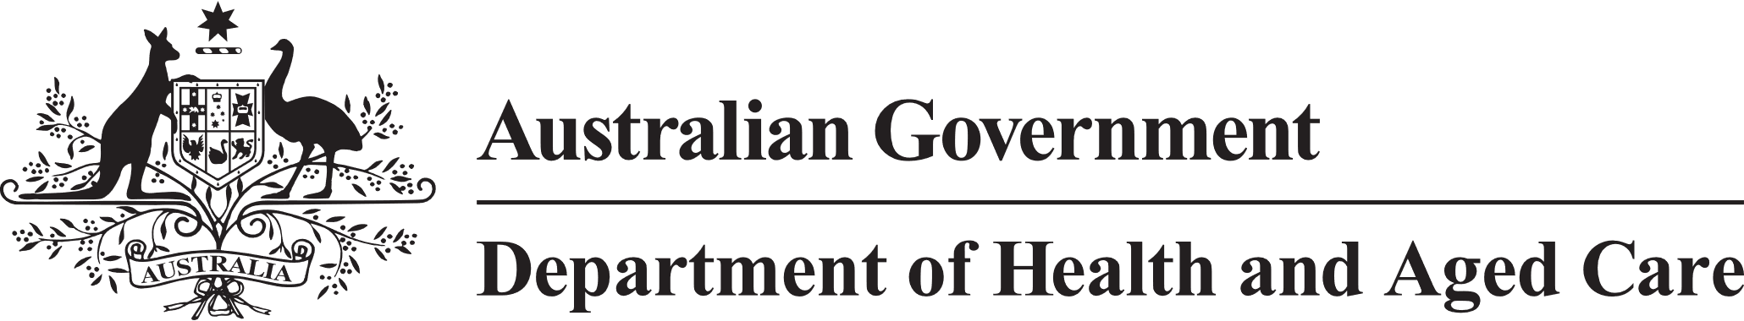

**Council of Elders**

# Communique – 25 January 2023

Mr Ian Yates AM chaired his last meeting of the Council of Elders (the Council) on   
25 January 2023. Mr Yates has since commenced a new role as the Interim Inspector-General of Aged Care.

The Council recorded its appreciation for Mr Yates’ work as Chair and thanked him for steering it wisely during his tenure.

The Council noted that the government is progressing the appointment of a new Chair.

The Council was provided information on a range of items and provided the following advice.

**Phasing of Future Reforms** – The Council discussed the future reforms and suggested an overarching reform summary be published.

**The new Aged Care Act** – The Council considered the proposed Aged Care system governance section under the new Act, including the proposed role of ‘System Governor’, and noted that the changes are intended to provide a clear outline of the Department’s responsibilities. The System Governor would be the steward of the Aged Care system, responsible for all areas that the Secretary of the Department of Health and Aged Care is currently responsible for, and any new requirements and responsibilities not included in the current legislation.

Members advised that the language was not easy to understand and suggested that more accessible terms be used. Members suggested that people’s human rights as they age be given greater prominence in the Act.

**Ageing Well** – The Council discussed the proposed development of an Ageing Well Strategy. Members agreed that ageing well means more than maintaining physical activity and includes social connection. Members suggested ways that people could be encouraged to take responsibility for maintaining their health from an earlier age. While discussing risk factors and prevention, the Council noted the importance of mental health and the power of the mind.

**Star Ratings** – The Council heard reports from its portfolio working group on Star Ratings. Members discussed community feedback they were aware of, which indicated a perception that a rating of 3 was below par rather than acceptable. Members encouraged the Department to continue to help educate the community about how to understand the ratings.

**Regulatory Framework** – Members considered the draft Regulatory Framework (the Framework), proposed to underpin the new Aged Care Act and the next steps in the consultation process. Member discussion centred on how the regulations will aim to address risks to quality and safety. The Council recommended that the Framework should not duplicate existing regulatory processes and burden providers. This will allow for a greater range of providers into the market, giving older people greater choice.

The next meeting of the Council of Elders will be held on 22 and 23 February 2023.