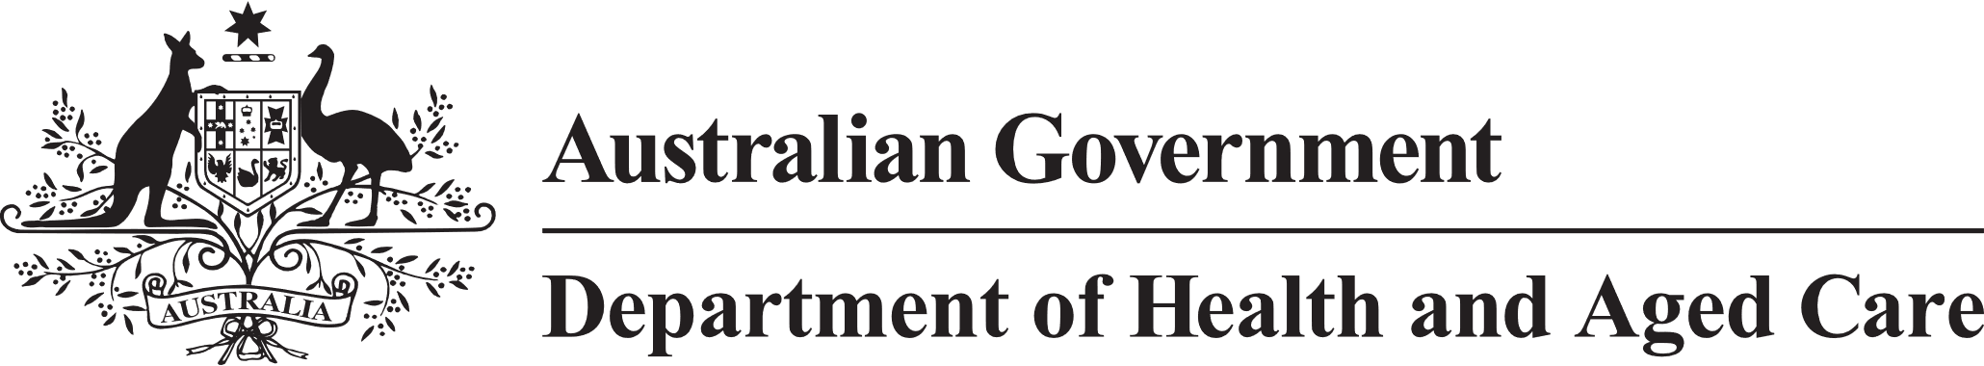

**Council of Elders**

# Communique – 22 and 23 February 2023

At its February meeting, the Council of Elders met with the Department of Health and Aged Care, and the Department of Social Services, to discuss aged care reforms and emerging issues, and develop advice on critical issues for the Minister for Aged Care. As the voice of older people, Members shared stories they heard from their local communities and experiences at forums, such as the NSW Seniors Festival Expo in Sydney, and the Care and Ageing Well Expo in Melbourne.

**Community Engagement** – Council stressed to government the critical importance of expanding and amplifying its communications to older people and their families about the progress of implementing the recommendations from the Royal Commission into Aged Care Quality and Safety. Council recommended that more information is shared with the community about reform work underway, including what has already been delivered, such as the Star Ratings, and aged care reform challenges that are still being worked through.

**Home Care Packages program updates** – Council Members shared community feedback they had received about the impact on some older people of updates to the Home Care Packages program provider and consumer manuals. Council has brought this issue to the attention of the Minister for Aged Care and received a briefing from the Department of Health and Aged Care on Council’s concerns about older people’s access to disability related supports. Council noted concerns about the way the update was communicated in advance to service users. Council will continue to advise the Minister on these important issues.

**Star Ratings** – Members shared feedback from the community that indicated that Star Ratings had been well received generally. Council recommended the government continue working on making it easier to find and navigate Star Ratings on-line.

**Carer Gateway** – Council received an update about Carer Gateway and discussed the need for more support to be provided to older people who are carers, particularly those who are long-term carers, and greater access for First Nations older carers, and those from CALD backgrounds, to culturally appropriate respite. In general, the Council considered the program to be well developed and Council encouraged continued collaboration across State and Territory governments, Carers Australia, and Carer Gateway. However, Council thinks there are opportunities for government to improve support to older, long-term carers. Council will raise these opportunities in the context of the development of a Carer Strategy, being led by the Department of Social Services for the Minister for Social Services.

**Clarifying Commonwealth and State Roles and Responsibilities to Deliver Health Care for Older People** – Council considered work being led by the Commonwealth, in cooperation with the States and Territories, to improve the coordination of services for older people moving between home, acute hospital care, and/or residential aged care. Council’s advice focussed on the significance of roles like case coordinators working alongside medical professionals, and allied health workers to support older people and their families to make informed decisions. Council encouraged government to look at best practice programs that improve transitions and offer more graduated support options.

**Implementation of Royal Commission Recommendation 44.b – Volunteers** – Volunteers provide an essential service to many older people. Council welcomed the work being done to implement the recommendation and provided practical suggestions about training and support to volunteers to help government implement Royal Commission recommendation 44.b which requires aged care service providers to offer volunteer programs that are coordinated, and training based. Council suggested that training be targeted to ensure volunteers are providing older people with the appropriate level of care; and the role and responsibility of volunteers within the Aged Care Sector be clearly articulated to ensure that volunteers understand their requirements.

**Inspector-General of Aged Care** – With the commencement of the Interim Inspector ‑General on 30 January 2023, the Office of the Inspector-General has been formally created. Council discussed a report on the progress of the Office to date. The Council looks forward to working with the Interim Inspector-General.

The next meeting of the Council of Elders will be held on 19 and 20 April 2023.