 

Primary Health Network Program Annual Performance Report 2019-20

# Acknowledgement

This document was developed by the Australian Government Department of Health and Aged Care as part of the Primary Health Networks Program Performance and Quality Framework.

**© Commonwealth of Australia 2022**

This work is copyright. You may download, display, print and reproduce the whole or part of this work in unaltered form for your own personal use or, if you are part of an organisation, for internal use within your organisation, but only if you or your organisation do not use the reproduction for any commercial purpose and retain this copyright notice and all disclaimer notices as part of that reproduction. Apart from rights to use as permitted by the Copyright Act 1968 or allowed by this copyright notice, all other rights are reserved and you are not allowed to reproduce the whole or any part of this work in any way (electronic or otherwise) without first being given the specific written permission from the Commonwealth to do so. Requests and inquiries concerning reproduction and rights are to be sent to the Communication Branch, Department of Health and Aged Care, GPO Box 9848, Canberra ACT 2601, or via e-mail to [copyright@health.gov.au](mailto:copyright@health.gov.au).

Preferred citation: Australian Government Department of Health and Aged Care. (2022). PHN Program Performance Report 2019-20.

# Disclaimer

Opinions expressed in PHN Program Performance Report 2019-20 are those of the authors and not necessarily those of the Australian Government Department of Health and Aged Care. Data may be subject to revision.

Contents

Acknowledgement 2

Disclaimer 2

Introduction 4

Emergency Department and Hospitalisations 4

PPH among senior Australians compared to non- seniors - 2015-16 to 2019-20 5

Lower urgency emergency department presentations 6

Program 7

Workforce 7

Alcohol and Other Drugs 7

General Practices 7

Digital Health 8

My Health Record 8

Aboriginal and Torres Strait Islander Health 9

Services for Specific Populations 10

Mental Health 11

Population Health 12

Organisational 13

Reference List 14

Appendix 1 15

Appendix 2 16

Addressing needs 16

Quality Care 16

Improving Access 17

Coordinated Care 19

Capable Organisations 19

# Introduction

This is the second Primary Health Networks (PHN) Program-wide performance report conducted under the PHN Program Performance and Quality Framework (the Framework).

The Framework consists of a set of performance indicators which are used to measure individual PHNs’ progress towards outcomes. These indicators are considered program indicators and were selected as they reflected areas where PHNs could be expected to influence changes. In addition, several Program-wide performance indicators have been collected to assist in measuring how the PHN Program contributes to achieving a range of health outcomes. These are referred to as Contextual Indicators. All contextual indicator data has been compiled on a PHN level and relates to performance within and across PHNs, it does not represent national performance.

The Department notes that these indicators represent a snapshot of PHN performance. The Department continues to work collaboratively with all PHNs to improve the way service delivery is monitored and measured (including through the Framework).

PHNs reported against the performance indicators in their 12 Month Performance Reports. These reports include reporting on financial expenditure, delivery of activities and the performance indicators. The Department assessed the performance of each individual PHN and these individual assessments have been drawn on to create this PHN Program Performance Report. This report provides a summary of the key findings, by priority area, for the PHN Program for the 2019-20 reporting period.

PHNs faced unprecedented challenges during the reporting period. These included the impact of the Covid-19 pandemic, notably in its early days when the health system, and the Australian public, faced considerable uncertainty about how events would transpire. For many PHNs, the arrival of the pandemic immediately followed the severe impact of calamitous bushfires. The workforce demands, system pressures, and other impacts of these events were extensive. The Department wishes to place on record its appreciation for the flexibility and adaptability of PHNs in those dynamic and difficult circumstances.

# Emergency Department and Hospitalisations

Potentially preventable hospitalisations (PPH) are currently a health system performance indicator of accessibility and effectiveness in the National Health Reform Agreement and an area of focus for PHNs. The indicator can be calculated using routinely collected hospital admission data and allows insight into the interface between primary and secondary health care. It can be disaggregated at various levels, by geographic regions, population subgroups and conditions to highlight priority areas for further investigation[1].

PPH are an admission to hospital for a condition which could have been prevented through an individualised health or disease management intervention in a primary care or community care setting (e.g. by a general practitioner, dentist, or allied health professional). Age-standardised rates are used in PPH data as a method of controlling for varying age ranges across diverse populations.

Since July 2015 and up to the end of the 2017-18 financial year (FY) national rates of PPH have remained largely consistent, experiencing minimal changes across all categories.

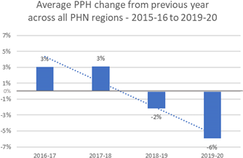

Figure  *– Average PPH change from previous year across all PHN regions*

However, between the 2018-19 and 2019-20 FY, reductions in PPH were reported by more than 90% of PHN regions, declining on average around 6% (see Figure 1). This decrease was identified not only in overall PPH, but also for PPH categorised by acute conditions and PPH categorised by chronic conditions (see Table 1 in Appendix for a full list of conditions). Furthermore, this reduction remained when assessing the total PPH associated with people both under and over the age of 65 years (i.e., non-age-standardised).

Chronic and acute conditions accounted for similar proportions of total PPH. On average, 47% of PPH were attributed to chronic conditions while 45% were from acute conditions. Vaccine-preventable conditions accounted for the remaining proportion. The underlying contributors to PPH in each PHN region were stable, with the leading causes (e.g., chronic or acute) remaining unchanged year on year in more than 80% of PHNs between the 2015-16 to 2019-20 FY.

PPH occurs more frequently among senior Australians (65 years or older) compared to non-seniors (under 65 years). This higher rate of PPH among senior Australians has remained consistent across each PHN regions over time, with an average of over 4 PPH of senior Australians for every 1 PPH among non-seniors (see Figure 2).

## PPH among senior Australians compared to non- seniors - 2015-16 to 2019-20

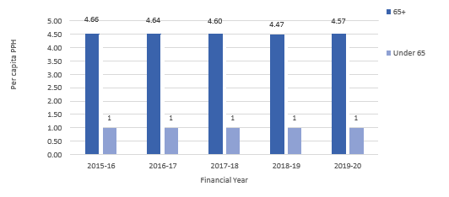

Figure – Ratio of PPH among senior Australians compared to non-seniors

# Lower urgency emergency department presentations

Lower urgency emergency department (ED) presentations are visits to an ED for a health condition that may be managed more appropriately or effectively in a different health care setting.

Presentations that are lower urgency are sometimes used as a proxy measure of access to primary health care. Higher presentation rates may suggest a lack of access to GPs or other primary care services, which may have been better placed to manage a person’s health condition[2]. Presentation time is taken into consideration when looking at lower urgency presentations, as there are periods of time when alternative health services are usually closed. After-hours refers to weekday nights (8pm- 8am), Saturday afternoons, Sundays and public holidays[3].

There have not been large changes in the rate of lower-urgency presentations across PHN regions from 2015-16 to 2019-20.

In 2019-20, the rate per 1,000 population of lower-urgency emergency department presentations across PHN regions increased slightly in-hours, with a median rate 3% higher than 2018-19. After- hours presentations decreased however, with a median rate 12% lower than in 2018-19.

There are differences in the rates of lower-urgency presentations between PHNs classified as regional and metropolitan by AIHW[4]. The majority of PHNs with low rates of lower-urgency presentations were metropolitan, whereas regional PHNs had high rates of lower-urgency presentations. Changes over time in lower-urgency presentation rates are different between metropolitan and regional PHNs. While regional PHNs have a higher rate of lower-urgency presentations to begin with, they are performing comparably with metropolitan PHNs when it comes to improvements in this area.

After hours lower-urgency emergency department presentation rates have decreased from 2015-16 to 2019-20, with the 2019-20 median rate decreasing by 16% compared to the 2015-16 median. The largest median change was between 2018-19 and 2019-20 which saw an 8% decrease. This trend is more evident in PHN regions with lower presentation rates and in the non-senior population; however, it is present in all areas. In roughly 75% of PHNs, the rate of lower-urgency after-hours presentations improved in the 4 years between the founding of the PHN program and this report.

In-hours presentation rates have changed less between years, and the change has been a slight growth in the number of lower-urgency presentations (±1% on the previous year). The median rate of presentations in 2019-20 is a 5% increase on the rate from 2015-16. Between 2018-19 and 2019-20, the increase in median presentation rate was more pronounced (10% higher) in the metropolitan PHNs, while there was little change in the regional PHNs. Overall, 65% of PHNs saw improvements in the first 2 years of the PHN Program, however when averaged over the 4 years of the Program, only 35% of PHNs saw improvements in the rate of lower-urgency presentations.

The rates of lower-urgency emergency department presentations were much more aligned between seniors and non-seniors than in the case of PPH. Non-seniors were more likely to have a lower urgency presentation during the in hours period than seniors; and after hours the ratio was 2 presentations in the non-senior population for every presentation by a senior.

# Program

All PHNs met the program indicators (see appendix 2) they were asked to report on in the 2019-20 reporting period. This includes:

* delivering activities to address prioritised needs,
* demonstrating health system improvement,
* innovation or commissioning best practice; and
* delivering support activities to general practices and other health care providers.

# Workforce

In the workforce priority area, PHNs are assessed against 2 indicators:

* All PHNs have a commissioning framework which assists them to fulfil their commissioning role in a strategic way.
* 84% of PHNs support drug and alcohol commissioned health professionals in their region and supported, or are supporting, specialist drug and alcohol treatment service providers to have or work towards accreditation.

# Alcohol and Other Drugs

All PHNs remained consistent or improved the rate of drug and alcohol commissioned providers actively delivering services in the region and established partnerships with local key stakeholders for drug and alcohol treatment services.

# General Practices

There has been an overall increase from 2018-19 to 2019-20 in the rate of general practices that are accredited, and those that are receiving Practice Incentive Program (PIP) after hours payments.

Accreditation is a voluntary process for general practices to demonstrate they are meeting RACGP safety and quality standards[5]. The PIP payments measured were the participation payment, sociable after hours cooperative and practice coverage payments, and complete after hours cooperative and practice coverage payments.

The median rate of accreditation was 84% (up from 78% in 2018-19), and the accreditation rate increased in 52% of PHNs. Accreditation rates have become more varied between PHNs, but the bulk of the change has been positive, as shown in Figure 3.

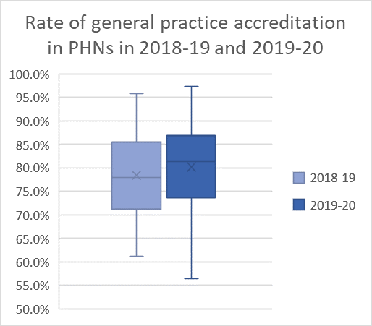

Figure : The percentage of general practices that are accredited has increased in most PHNs

The median rate of general practices receiving PIP after hours payments was 72% (up from 62% in 2018-19), with this rate having increased in 97% of PHNs. There was some increase in variation between PHNs here too, but, overall, performance improved on the previous year.

# Digital Health

There are 3 indicators of PHN performance in the digital health priority area:

* All PHNs have raised awareness of, and provided access to, My Health Record (MyHR) education, to all general practices in their regions.
* 87% of PHNs increased the rate of health care providers using smart forms, e-referrals and/or telehealth.
* 81% of PHNs increased the rate of accredited general practices sharing data with the PHN.

# My Health Record

PHNs were funded by the Australian Digital Health Agency to support and encourage the use of MyHR in general practices, pharmacies and among other health care providers, to enable better- coordinated care and better-informed treatment decisions for patients.

Uploading and cross-viewing documents in MyHR has increased in the majority of PHNs.

The median rate of general practices uploading documents to MyHR at least once a week was 23% (up from 15% in 2017-18, the latest year available at the publication of the previous report). For pharmacies, the median rate of regular uploaders was 27% (up from 1% in 2017-18). The number of general practices regularly uploading documents to MyHR increased in 97% of PHNs, while the number of pharmacies regularly uploading to MyHR increased in all PHNs. No allied health organisations regularly uploaded documents to MyHR in any PHN in 2019-20, and data on allied health services uploading to MyHR was not available for 2017-18.

Cross-views of MyHR (the viewing of a MyHR document authored in a different practice) increased by more than 5% from 2018-19 in all PHNs in general practices that were registered MyHR providers,

and in pharmacy providers in 90% of PHNs. 94% of PHNs saw an increase in cross-views in pharmacies. The median rate of documents cross-viewed over the year was 50 per general practice in 2019-20 (up from 9 per general practice in 2018-19) and 6 per pharmacy (up from 3 per pharmacy in 2018-19).

While there were some small decreases in the number of documents cross-viewed by pharmacies in 6% of PHNs, as the below graphs show, change was overall positive in both settings.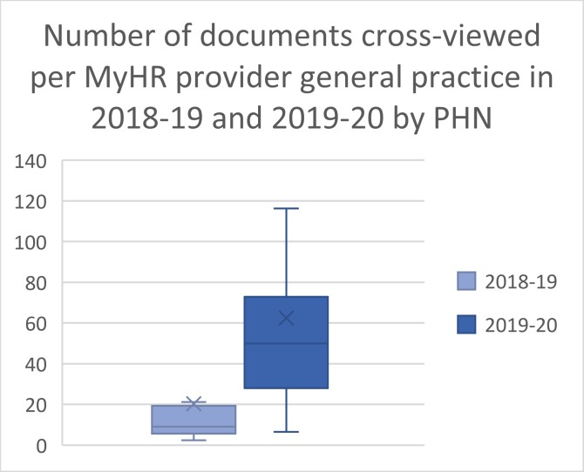 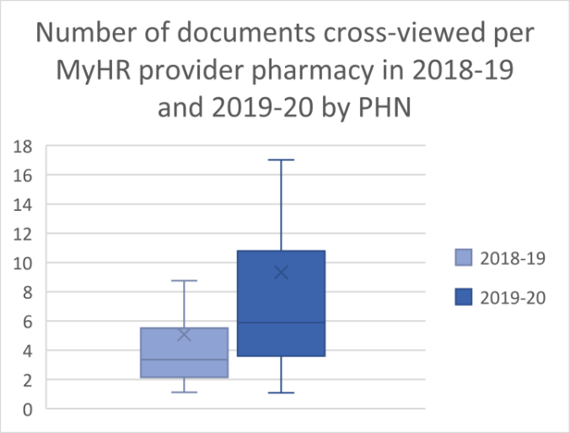

Figure : The number of documents cross-viewed in general practices and pharmacies that are registered MyHR providers increased between 2018-19 and 2019-20. Outliers not shown.

# Aboriginal and Torres Strait Islander Health

The PHN Program is assessed against 8 indicators under the Framework. The PHNs are assessed for performance against 7 indicators in the Aboriginal and Torres Strait Islander health priority area and the program performance is informed by a further one contextual indicator.

All PHNs satisfied requirements for 4 of the indicators, including:

* Delivering Integrated Team Care (ITC) services
* Informing the department of the number and type of organisations they are engaging in the delivery of ITC services
* Improving the cultural competency of mainstream primary health care services
* Providing evidence of their ITC processes in supporting Aboriginal and Torres Strait Islander people to access coordinated care

97% of PHNs satisfied requirements for 2 of the indicators:

* Provided evidence that all drug and alcohol commissioned services are culturally appropriate for Aboriginal and Torres Strait Islander people.
* Provided support for Aboriginal and Torres Strait Islander identified health workforce.

58% of PHNs reported growth in the following indicator:

* the proportion of PHN commissioned mental health services delivered to the Aboriginal and Torres Strait Islander people that were culturally appropriate[6].

Finally, the number of Aboriginal and Torres Strait Islander Peoples Health Assessments indicates the degree to which the Indigenous population is accessing primary health services designed to identify and prevent health care problems. Data in the previous report was from 2016-17.

* In 2019-20, median performance was 24 health assessments performed per 100 Indigenous PHN residents (down from 30 per 100 in 2016-17).
* In 39% of PHNs, the proportion of the population accessing health assessments had increased however the median change across all PHNs from 2017-18 to 2019-20 was a decline of 13%. Further analysis into this decrease in health assessments is needed; however, there does not appear to be an immediately apparent correlation with COVID-19.

# Services for Specific Populations

These indicators measure Medicare Benefit Schedule services provided people with chronic health conditions, and older Australians. 2018-19 data was not available for these indicators in the previous report; years have been noted as relevant below.

The number of MBS services related to team care arrangements and case conferences for people with chronic health conditions by PHN was monitored over the reporting period. Data in the previous report was from 2014-15. The number of services increased between 2014-15 and 2019-20 in all PHNs, with a median increase of 51%. The onset of COVID-19 coincided with a general drop in the number of services provided across PHNs between quarters one and two of 2020. Notably, 94% of PHNs provided less chronic care services in quarter two, with the reported median decreasing by 8%.

In aged care, analysis looked at the provision of MBS services related to consultations, medication management, telehealth, and after-hours care to people in residential aged care facilities (RACFs), and GP health assessments for the population aged 75 years and over. There has been improvement in all areas across most PHNs.

The median rate of services per RACF place was 21 (up from 20 in 2016-17), with a median increase between years of 5%. The rate of services increased in 74% of PHNs.

The median rate of the PHN population at least 75 years old with a GP health assessment is increasing across all PHNs. In 2019-20 the rate was 30% (up from 23% in 2016-17), with the median increase being 29%.

Telehealth Services in Response to COVID-19

The COVID-19 pandemic began to affect life in Australia in March 2020. Accordingly, telehealth equivalents for Indigenous health assessments and team care arrangements were introduced, starting on 13 March. These items have been included in the analyses, and telehealth uptake in the April-June quarter of 2020 has been noted.

Telehealth uptake on Aboriginal and Torres Strait Islander Peoples Health Assessments was relatively similar across PHNs, with 71% showing the proportion of telehealth services in quarter two 2020 to be between 5% and 20%. Most other PHNs were below 40% telehealth services, and the highest was

an Aboriginal and Torres Strait Islander person, or

employed by an Aboriginal Community Controlled Health Service, or

has indicated that they have completed a recognised training program in the delivery of culturally safe services to Aboriginal and Torres Strait Islander peoples.

44%. The number of telehealth services was greater than the change between quarters one and two—or change was positive—in 71% of PHNs. Change in the number of services between quarters was varied, ranging from 45% to negative 32%, but the majority of PHNs (55%) fell between ±10%.

The uptake of delivery of services related to team care arrangements and case conferences for people with chronic health conditions via telehealth was not uniform across PHNs. 61% had between 20% and 40% of services provided via telehealth; the lowest proportion was 15%, and the highest was 52%, outstripping the number of services provided in person. In all PHNs, the number of telehealth services provided in response to COVID-19 in quarter 2 made back at least 50% of the drop in non-telehealth services between quarters; in most PHNs the figure was between 70% and 90%.

# Mental Health

In response to the 2019-20 bushfires, funding was provided to 9 PHNs which were severely impacted by bushfires. This included Community Wellbeing and Participation grants and funding for Bushfire Emergency Coordinators to coordinate critical, localised, non-clinical mental health supports in partnership with local governments. PHNs were also funded to commission immediate counselling and other mental health services to support the needs of people experiencing distress or trauma, offering up to 10 free mental health services to individuals, families and emergency services personnel affected by bushfires. PHNs continued to deliver local programs and services based on community consultation.

The bushfire response had implications for delivery of services in the affected regions, including the need to coordinate and divert services to respond to people who were impacted by bushfires, deliver bushfire response initiatives, and workforce availability.

PHN performance is assessed against 6 indicators in the mental health priority area (set out below). Multiple issues may have impacted PHNs reporting achievement of mental health targets including some service providers providing incomplete data, data governance arrangements (rates of clients consenting to their data being provided to the Commonwealth), and the increasing complexity and delivery of new services throughout bushfires and COVID-19 responses. The department continues to work with PHNs to improve data quality and recognises the impact of workforce demands across the health sector.

While no PHN met the criteria for all 6 indicators during the 2019-20 reporting period, all PHNs reported improvements in at least 1 indicator when compared to baseline metrics obtained during the 2018-19 reporting period. Most notably there was a median improvement of 6% across all PHNs for 3 of the commissioned service indicators, while there was a median improvement of approximately 17% across all PHNs for clinical outcome measures. Six PHNs met only 1 mental health indicator; 7 met 2, 5 met 3, and the remaining 13 PHNs met 4/6 indicators.

* 97% of PHNs jointly developed comprehensive regional mental health and suicide prevention plans with their Local Hospital Networks.
* 65% of PHNs increased the number of people accessing PHN-commissioned low intensity psychological interventions. PHNs noted several barriers in meeting the criteria, including early termination of service agreements and the COVID-19 pandemic which affected service delivery.
* 55% of PHNs increased the number of people in their regional population receiving PHN- commissioned psychological therapies delivered by mental health professionals**.**
* 45% of PHNs demonstrated growth in the rate of regional population receiving PHN- commissioned clinical care coordination services for people with severe and complex mental
* illness. PHNs noted that mental health nurse workforce levels impacted some PHNs’ ability to deliver the service in some areas.
* 16% of PHNs met the target rate of completed episodes of care that recorded valid clinical outcome measures at episode start and episode end. The Department will continue to collaborate with PHNs who are working with organisations and practitioners to promote the value of collecting and using outcomes data, with many PHNs applying it to continuous quality improvement.
* Data reported through the PMHC MDS indicates that 3% of PHN (or one PHN) met the target (100%) for following up people at risk of suicide[7].

# Population Health

For PHNs this encompasses the rate of children fully immunised at 5 years old, and cancer screening rates for cervical, bowel, and breast cancer by PHN. 2019-20 data was available for childhood immunisations, but not for cancer screening rates, so the latter is an observation of trends from 2014-15 (note PHNs commenced 1 July 2015) to 2018-19.

Overall, vaccination rates did not increase or meet targets in just over half of PHNs, but cancer screening rates were consistently increasing in most.

In this context, ‘fully immunised’ means having a record on the Australia Immunisation Register of 4 doses of a DTP-containing vaccine; 4 doses of polio vaccine; and 2 doses of an MMR-containing vaccine. 35% of PHNs met the national immunisation target of having 95% of children 5 years of age fully immunised, while 10% of PHNs had improved the fully immunised rate for children 5 years of age but did not meet the target. This is a decline from 2018-19 when 97% of PHNs met the target and may be due to disruptions in immunisation programs from the summer bushfires of 2019-20 and the COVID-19 pandemic.

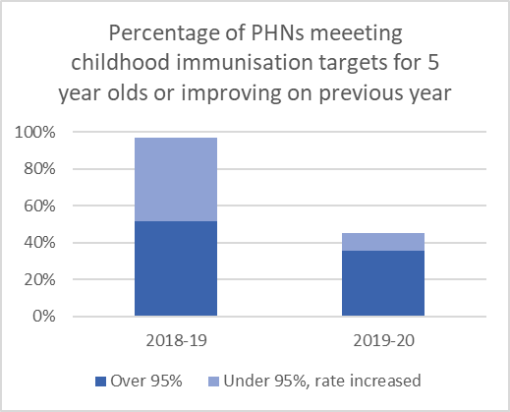

Figure : The percentage of PHNs meeting childhood immunisation targets or improving on the previous year’s performance has decreased between 2018-19 and 2019-20

Between 2014 and 2019, the majority of PHNs showed consistent growth in the percentage of people participating in cancer screening. 90% of PHNs increased cancer screening rates in 2 or more reporting years. It is unknown as yet what, if any, impact 2020 had on cancer screenings.

# Organisational

All PHNs met 87% of the organisational indicators. Performance against indicators that were not met by all PHNs were as follows:

* Only 6% of PHNs failed to provide an explanation against all activity variations in their variance report of scheduled activities. A variance report provides the department with information about a PHNs variance between projected achievement and spend and actual achievement and spend. It keeps track of spend and helps to identify where there might be barriers to delivery of an activity.
* 68% of PHNs increased, or maintained at 100%, the proportion of their contracts for commissioned health services which contained both output and outcome performance indicators.
* 16% of PHNs had minor decreases in the rate of performance indicators in their contracts between 2018-19 and 2019-20. This impacted only between 1-10% of each of these PHNs’ overall contracts.
* 13% of PHNs had more moderate decreases in contract performance indicators from 2018-19 to 2019-20, with a decline between 15-50% from their overall contracts
* 3% of PHNs which had 100% of contracts with performance indicators in 2018-19 did not maintain this through to 2019-20

Overall, around 29% of PHNs had all (100%) of their contracts containing performance indicators in both the 2018-19 and 2019-20 reporting periods. As of 2019-20, an additional 6% of PHNs have achieved 100%.

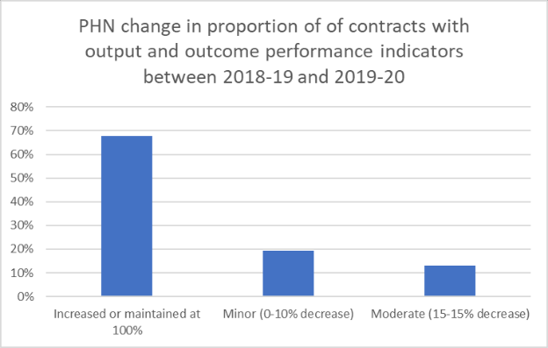 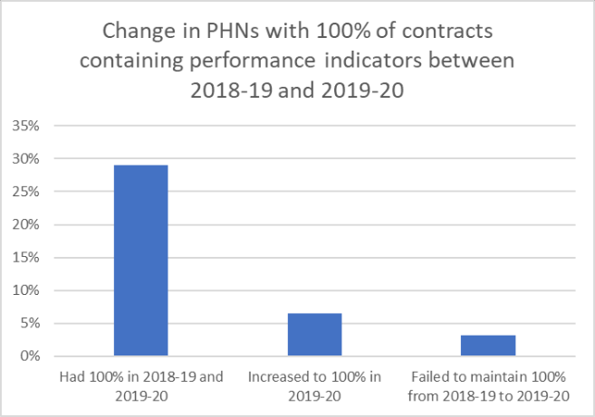

Figure : Changes in the number of contracts PHNs had with output and outcome performance indicators between 2018-19 and 2019-20

# Reference List

AIHW [Cancer screening programs quarterly data,](https://www.aihw.gov.au/reports/cancer-screening/national-cancer-screening-programs-participation/data) last updated 5 May 2022.

AIHW Lower urgency ED presentation data, received 27 April 2022.

AIHW Potentially Preventable Hospitalisations data, received 4 May 2022.

AIHW, RACF places sourced from [AIHW GEN Aged Care Data](https://www.gen-agedcaredata.gov.au/), page updated 16 August 2021.

Australian Digital Health Agency, My Health Record information, received 29 October 2021. Department of Health [Childhood immunisation coverage data](https://www.health.gov.au/resources/collections/childhood-immunisation-coverage-data-phn-and-sa3)**,** page last updated 2 May 2022.

Department of Health Enterprise Data Catalogue, Indigenous estimated resident population and 75+ year old information.

Department of Health MBS Division, MBS service data, received 24 September 2022. Department of Health, PIP after-hours payment information, received 19 August 2021.

Healthdirect Australia National Health Services Directory Count of general practices, pharmacies and allied health organisations, received 6 October 2021.

# Appendix 1

Table : Breakdown of potentially preventable hospitalisation conditions

| Acute PPH |
| --- |
| Cellulitis |
| Convulsions and epilepsy |
| Dental conditions |
| Ear, nose and throat infections |
| Eclampsia |
| Gangrene |
| Pelvic inflammatory disease |
| Perforated/bleeding ulcer |
| Pneumonia (not vaccine-preventable) |
| Total acute |
| Urinary tract infections, including pyelonephritis |
| **Chronic PPH** |
| Angina |
| Asthma |
| Bronchiectasis |
| Congestive cardiac failure |
| COPD |
| Diabetes complications |
| Hypertension |
| Iron deficiency anaemia |
| Nutritional deficiencies |
| Rheumatic heart disease |
| Total chronic |
| **Vaccine preventable PPH** |
| Other vaccine-preventable conditions |
| Pneumonia and influenza (vaccine-preventable) |
| Total vaccine preventable |

# Appendix 2

Assessment of each of the 42 performance indicators under the PHN Performance and Quality Framework for the 2019-20 reporting year.

## Addressing needs

**P1 (Program):** PHN activities address prioritised needs.

* All 31 PHNs have demonstrated their activities address prioritised needs as set out in PHN Needs Assessment and/or national priorities.

**P2 (Program):** Health system improvement and innovation.

* All 31 PHNs have provided descriptions of a health system improvement, innovation, or commissioning best practice that has taken place in 2019-20.

**IH1 (Indigenous Health):** Numbers of ITC services delivered by PHN.

* All 31 PHNs have provided evidence of delivering services across the range allowed by Integrated Team Care guidelines, including care coordination, supplementary services, and clinical services.

**IH2 (Indigenous Health):** Types of organisations delivering ITC services.

* All 31 PHNs have shown engagement with an appropriate range of Integrated Team Care services including Aboriginal Medical Services, mainstream organisations, and services delivered by the PHN itself.

## Quality Care

**P4 (Program):** Support provided to general practices and other health care providers.

* All 31 PHNs have demonstrated they provide a range of support activities to general practices and other health care providers within their region.

**MH6 (Mental Health):** Outcome readiness – completion rates for clinical outcome measures.

* This indicator was measured as a baseline in 2018-19. In 2019-20 6 PHNs reported the required 70% of episodes of mental health care as having valid outcome measures taken at the start and end of the episode.

**IH3 (Indigenous Health):** Evidence that all drug and alcohol commissioned services are culturally appropriate for Aboriginal and Torres Strait Islander people.

* 30 PHNs provided adequate evidence of the cultural appropriateness of these services, which is 3 more than in the 2018-19 reporting period.

**IH4 (Indigenous Health):** Proportion of PHN commissioned mental health services delivered to the regional Aboriginal and Torres Strait Islander population that were culturally appropriate.

* This indicator was measured as a baseline in 2018-19. 18 PHNs reported at least a 5% increase in the proportion of these services that were culturally appropriate between the 2018-19 and 2019-20 reporting periods.

**IH5 (Indigenous Health):** ITC improves the cultural competency of mainstream primary health care services.

* All 31 PHNs have described sufficient activities undertaken to improve the cultural competency of mainstream primary health care services, which is one more than in the 2018- 19 reporting period.

**IH6 (Indigenous Health):** PHN provides support for Aboriginal and Torres Strait Islander identified health workforce.

* 30 PHNs have supplied either or both descriptions of formal and informal support activities, and a workforce strategy addressing the capability, capacity, and proportion of the Aboriginal and Torres Strait Islander identified health workforce. This is 4 more than in the 2018-19 reporting period.

**W1 (Workforce):** Rate of drug and alcohol treatment service providers with suitable accreditation. This indicator was measured as a baseline in 2018-19.

* 26 PHNs report all specialist drug and alcohol treatment service providers have or are working toward accreditation.

**W2 (Workforce):** PHN support for drug and alcohol commissioned health professionals.

* 26 PHNs supplied adequate evidence of support provided to drug and alcohol commissioned health professionals, which is 5 more than in the 2018-19 reporting period.

**W3 (Workforce):** PHN Commissioning Framework.

* All 31 PHNs have Commissioning Frameworks including strategic planning, procuring services, and monitoring evaluation phases, with cultural appropriateness and stakeholder engagement considered throughout the process. This is 14 more than in the 2018-19 reporting period. This is the indicator where the greatest positive change has occurred.

**DH2 (Digital Health):** Rate of health care providers using specific digital health systems. This indicator was measured as a baseline in 2018-19.

* 27 PHNs reported an increase in the rate of general practices, pharmacies, and allied health service practices using smart forms, e-referrals, and telehealth.

**DH3 (Digital Health):** Rate of accredited general practices sharing data with PHN. This indicator was measured as a baseline in 2018-19.

* 25 PHNs reported at least a 5% increase in the rate of accredited general practices sharing data with them (or where the baseline rate was over 60%, maintenance of that rate).

## Improving Access

**MH1 (Mental Health):** Rate of regional population receiving PHN commissioned low intensity psychological interventions. This indicator was measured as a baseline in 2018-19.

* 20 PHNs reported at least 5% growth in the number of people accessing low intensity episodes from 2018-19 to 2019-20.

**MH2 (Mental Health):** Rate of regional population receiving PHN commissioned psychological therapies delivered by mental health professionals. This indicator was measured as a baseline in 2018-19.

* 17 PHNs reported at least 5% growth in the number of people accessing psychological therapy episodes from 2018-19 to 2019-20.

**AOD1 (Alcohol and Other Drugs):** Rate of drug and alcohol commissioned providers actively delivering services.

* All 31 PHNs report that the rate of drug and alcohol commissioned providers actively delivering services has remained the same or increased from 2018-19 to 2019-20.

## Coordinated Care

**MH3 (Mental Health):** Rate of regional population receiving PHN commissioned clinical care coordination services for people with severe and complex mental illness. This indicator was measured as a baseline in 2018-19.

* 14 PHNs reported at least 5% growth in the number of people accessing care coordination episodes from 2018-19 to 2019-20.

**MH4 (Mental Health):** Formalised partnerships with other regional service providers to support integrated regional planning and service delivery.

* 30 PHNs had comprehensive regional mental health and suicide prevention plans being jointly developed with LHNs. This is not a change in the number of PHNs that have met this indicator from the 2018-19 reporting period, although it was not met by a different PHN in each year.

**MH5 (Mental Health):** Proportion of people referred to PHN commissioned services due to a recent suicide attempt or because they were at risk of suicide followed up within 7 days of referral. This indicator was measured as a baseline in 2018-19.

* One PHN reported 100% of episodes where suicide risk was identified at referral received follow-ups within 7 days. There are limitations to this performance measure and the Department is working with PHNs to improve the data definitions and methodology used to calculate the KPI.

**IH7 (Indigenous Health):** ITC processes support Aboriginal and Torres Strait Islander people enrolled in the program to access coordinated care.

* All 31 PHNs provided satisfactory descriptions of the referral, intake, and discharge processes used in their ITC programs.

**DH1 (Digital Health):** Rate of health care providers informed about My Health Record.

* All 31 PHNs report 100% of general practices are aware of and provided access to My Health Record education, which is one more than in the 2018-19 reporting period.

**AOD2 (Alcohol and Other Drugs):** Partnerships established with local key stakeholders for drug and alcohol treatment services.

* All 31 PHNs have a satisfactory range of organisations involved in delivering drug and alcohol services, which is 2 more than in the 2018-19 reporting period.

## Capable Organisations

**P1 (Program):** PHN activities address prioritised needs.

* All 31 PHNs have demonstrated their activities address prioritised needs as set out in PHN Needs Assessment and/or national priorities.

**P4 (Program):** Support provided to general practices and other health care providers.

* All 31 PHNs have demonstrated they provide a range of support activities to general practices and other health care providers within their region.

**W3 (Workforce):** PHN Commissioning Framework.

* All 31 PHNs have Commissioning Frameworks including strategic planning, procuring services, and monitoring evaluation phases, with cultural appropriateness and stakeholder engagement considered throughout the process. This is 14 more than in the 2018-19 reporting period. This is the indicator where the greatest positive change has occurred.

**O1 (Organisational):** PHN has an independent and diverse skills-based Board.

* All 31 PHNs have appropriately independent and diverse skills-based Boards.

**O2 (Organisational):** PHN Clinical Council and Community Advisory Committee Membership.

* All 31 PHNs have at least one Clinical Council and Community Advisory Committee.

**O3 (Organisational):** PHN Board considers input for committees.

* All 31 PHNs provided satisfactory statements explaining how the Board considers input from committees.

**O4 (Organisational):** Record of PHN Board member attendance at meetings.

* All 31 PHNs’ Board members met or exceeded minimum attendance at meetings.

**O5 (Organisational):** PHN Board has a regular review of its performance.

* All 31 PHNs have Board performance reviews at least every 3 years.

**O6 (Organisational):** PHN Board approves strategic plan.

* All 31 PHNs’ Boards approved their PHN strategic plan.

**O7 (Organisational):** Variance report of scheduled activities.

* 29 PHNs accounted for all variations, which is 2 less than in the 2018-19 reporting period.

**O8 (Organisational):** Quality management system.

* All 31 PHNs have or are in the process of moving towards a fit for purpose quality management system.

**O9 (Organisational):** Staff satisfaction.

* All 31 PHNs have a fit for purpose process to measure staff satisfaction at least every 2 years.

**O10 (Organisational):** Performance management process.

* All 31 PHNs have a fit for purpose process to measure staff performance at least every 2 years.

**O11 (Organisational):** Cultural awareness training.

* All 31 PHNs conduct or offer cultural awareness training to staff at least every 2 years.

**O12 (Organisational):** Rate of contracts for commissioned health services that include both output and outcome performance indicators. This indicator was measured as a baseline in 2018-19.

* 24 PHNs have increased the number of contracts containing both output and outcome measures from 2018-19 to 2019-20.

**O13 (Organisational):** Annual Report and audited financial statements.

* All 31 PHNs’ annual reports meet requirements, and audited financial reports have

unqualified auditor statements.

**O14 (Organisational):** PHN stakeholder engagement.

* All 31 PHNs have described satisfactory stakeholder engagement activities undertaken.

**O15 (Organisational):** Engaging with complaints.

* All 31 PHNs have attempted to address all complaints referred by the Department.

1. AIHW (2019) [Potentially preventable hospitalisations in Australia,](https://www.aihw.gov.au/reports/primary-health-care/potentially-preventable-hospitalisations/contents/overview) AIHW website, accessed 2 June 2022.
2. AIHW (2020) [Use of emergency departments for lower urgency care,](https://www.aihw.gov.au/reports/primary-health-care/use-of-ed-for-lower-urgency-care-2018-19/contents/lower-urgency-care/summary) AIHW website, accessed 2 June 2022.
3. AIHW (2020) [Use of emergency departments for lower urgency care technical note,](https://www.aihw.gov.au/getmedia/9adbc139-40d0-461b-bee6-5eff903fa5ac/aihw_phc_3_technical_note.pdf.aspx) AIHW website, accessed 2 June 2022.
4. AIHW (2020) [Use of emergency departments for lower urgency care technical note,](https://www.aihw.gov.au/getmedia/9adbc139-40d0-461b-bee6-5eff903fa5ac/aihw_phc_3_technical_note.pdf.aspx) AIHW website, accessed 3 June 2022.
5. Available at [www.racgp.org.au/running-a-practice/practice-standards/standards-5th-edition](http://www.racgp.org.au/running-a-practice/practice-standards/standards-5th-edition)
6. A culturally appropriate service is defined as one that is delivered by a service provider who is:
7. There are limitations to this performance measure and the Department is working with PHNs to improve the data definitions and methodology used to calculate the KPI. This indicator relates to the proportion of people referred to PHN-commissioned services following a recent suicide attempt, or who were at risk of suicide, that were followed up within 7 days of referral. A range of factors contribute to PHNs not meeting this target including clients with unique personal preferences, availability or complexities related to their presentation, workforce capacity challenges, inaccurate information at referral or data capture, and a challenging business context. This indicator excludes specific aftercare services, such as The Way Back or other aftercare service model. 2019-20 was the first year of operation for the majority of PHN-funded aftercare services. Recent findings from the Interim Evaluation Report of The Way Back Support Service suggest 98% of clients referred to the Way Back Support Service were contacted within one business day. The Interim Evaluation Report found that 91% of clients were satisfied or very satisfied with the service received; clients’ emotional distress improved significantly during their service period; and clients, on average, experienced a significant reduction in suicidality up to 4 months post-service exit.