COVID-19 outbreaks in Australian residential aged care facilities

# National snapshot

As at 8:00 am 3 February 2023 there are 1,091 active COVID-19 cases in 198 active outbreaks in residential aged care facilities across Australia. There have been 78 new outbreaks, 23 new resident deaths and 890 combined new resident and staff cases reported since 27 January 2023.

Table 1: Aged Care COVID-19 data as at 8.00am 3 February 2023[1]

| Category | Active*[2]* | Previous  7 days | Cumulative  Total | Previous 7 days |
| --- | --- | --- | --- | --- |
| Outbreaks[3] | 198 | -53 | 12,834 | 78 |
| Residential Aged Care Facilities affected | 198 | -53 | 2,803 | 1 |
| Resident Cases[4] | 805 | -361 | 127,992 | 634 |
| Resident Deaths | N/A | N/A | 5,067 | 23 |
| Staff Cases | 286 | -127 | 79,473 | 256 |

The Department of Health and Aged Care has concluded a review and reconciliation of all data provided directly by aged care providers from early 2022, resulting in adjustments to the data and an increase in cumulative totals reported as at 25 January 2023.

**Table 2: Overview of Active Outbreaks in Australia**

|  |  |  |  |  |  |  |  |  |  |
| --- | --- | --- | --- | --- | --- | --- | --- | --- | --- |
|  | ACT | NSW | NT | QLD | SA | TAS | VIC | WA | Total |
| Total Facilities with outbreaks | 2 | 72 | 3 | 52 | 19 | 1 | 25 | 24 | **198** |
| *Total number of active resident cases* | 4 | 325 | 34 | 131 | 69 | 9 | 133 | 100 | **805** |
| *Total number of active staff cases* | 2 | 110 | 13 | 92 | 15 | 0 | 26 | 28 | **286** |
| Total Outbreaks Opened in Previous 7 Days | 0 | 25 | 0 | 25 | 11 | 0 | 8 | 9 | **78** |
| Total Outbreaks Closed in Previous 7 Days | 1 | 38 | 0 | 35 | 21 | 1 | 22 | 13 | **131** |

**Figure 1: National Outbreak Trends in Aged Care**

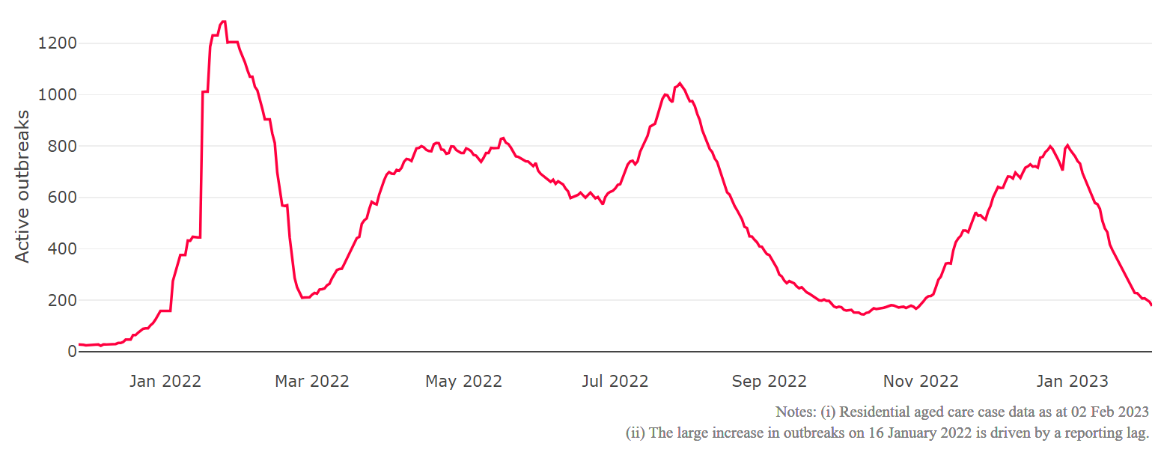

**Figure 2: Trends in Aged Care Cases – November 2021 to Present**

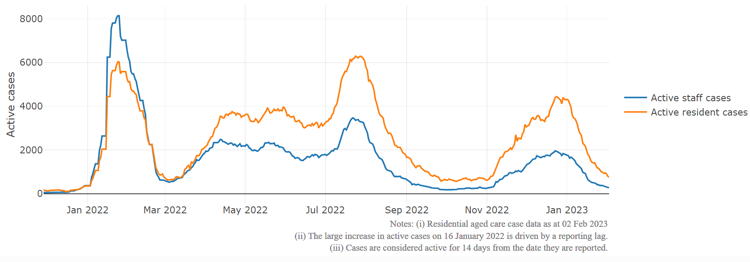

## Mortality

For the period of 1 January 2022 to 30 January 2023, COVID-19 is recorded as the cause of death in 6.1 per cent of all deaths in permanent residents in aged care facilities.

Since the beginning of the Omicron outbreak in late November 2021, there have been 72,820 deaths in residential aged care from all causes (report period from 29 November 2021 to 30 January 2023)[5]. COVID-19 deaths account for 5.8 per cent of this figure.

Over the course of the pandemic, all-cause excess mortality in Residential Aged Care was below expected numbers in 2020, and within expected range in 2021.

**Figure 3: COVID-19 Deaths in Residential Aged Care Facilities overlaid with Community deaths**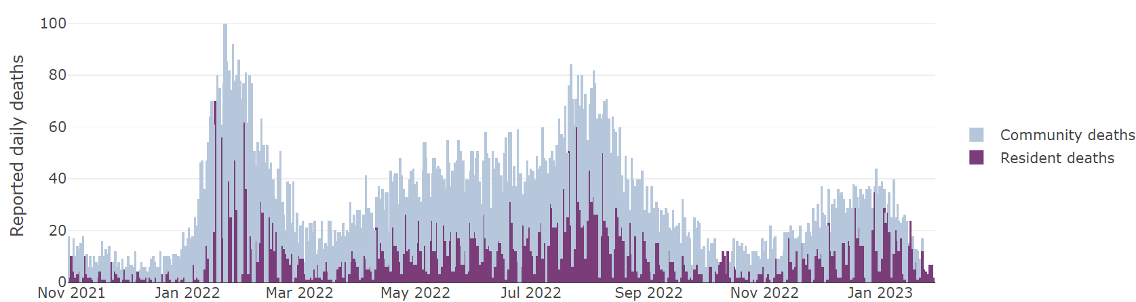



## Workforce in active residential aged care outbreaks

As at 3 February 2023, workforce surge staff have filled a total of 161,031 shifts in aged care services impacted by COVID-19, including 675 in the past 7 days. In the past 7 days (to 3 February) surge workforce providers have assisted 32 residential aged care homes. These shifts include roles for GPs, nurses, care workers, allied health workers, executive and ancillary staff. This includes:

**Table 3: Workforce resources supplied to residential aged care facilities**

| Workforce provider | Total Shifts | | Previous 7 days | |
| --- | --- | --- | --- | --- |
| Recruitment, Consulting and Staffing Association | 100,901 | 370 | |
| Healthcare Australia (Workforce Surge) | 13,518 | 33 | |
| Healthcare Australia (NACER) | 2,295 | N/A | |
| Mable | 2,711 | N/A | |
| Aspen Medical | 21,368 | 0 | |
| HealthX | 16,182 | 272 | |
| Torrens | 4,056 | N/A | |

The Australian Defence Force provided support to a total of 542 residential aged care homes between February and September 2022. The ADF deployment ceased on 30 September 2022.

## Oral antiviral treatments

Distribution of the oral anti-viral Lagevrio (Molnupiravir) commenced on 6 February 2022 to all RACFs with outbreak sites prioritised for delivery. The National Medical Stockpile has deployed 48,269 treatment courses of Lagevrio (Molnupiravir) to aged care facilities.

51,618 prescriptions for Lagevrio (Molnupiravir) have been issued to residents in residential aged care facilities, with a further 2,704 prescriptions for Paxlovid (nirmatrelvir + ritonavir) also issued since 28 February 2022 and up to 29 January 2023.

## Vaccination in Residential Aged Care Facilities

The Australian Government’s COVID-19 vaccination program is delivering in-reach vaccine services for aged care residents and workers across Australia, through Commonwealth vaccine providers, primary care and self-vaccination services by aged care providers.

The Government continues to provide all residential aged care facilities with access to COVID vaccination clinics to ensure residents have every opportunity to get their fourth dose. As at 3 February 2023, there are currently 157,626 residents eligible for fourth doses. In total 135,060residents (85.7% of eligible residents) have received a fourth dose.

As at 3 February 2023, a total of 638,231 doses of COVID-19 vaccines have been administered to residents in residential aged care facilities. Information is now received from the Australian Immunisation Register, meaning reported numbers may differ from previous reports. Information from the Australian Immunisation Register provides a more accurate representation of residents currently in residential aged care.

|  |  |  |  |  |  |  |  |  |  |
| --- | --- | --- | --- | --- | --- | --- | --- | --- | --- |
| Residential aged care fourth dose vaccination summary | | | | | | | | | |
|  | **National** | **NSW** | **VIC** | **QLD** | **SA** | **WA** | **TAS** | **NT** | **ACT** |
| Total residents who have received a fourth dose | 135,060 | 42,778 | 36,832 | 26,206 | 11,520 | 12,172 | 3,373 | 330 | 1,849 |
| Percentage against total residents* | 75.6% | 74.6% | 79.7% | 72.7% | 74.8% | 73.6% | 76.7% | 70.7% | 81.9% |
| Percentage against eligible residents (interval only)** | 83.1% | 81.5% | 86.5% | 81.6% | 82.9% | 81.2% | 84.5% | 81.5% | 87.5% |
| Percentage against eligible residents (interval and case overlay)*** | 85.7% | 84.5% | 88.7% | 83.8% | 86.5% | 83.7% | 86.8% | 85.9% | 89.2% |

Sources: Aged care AIR data as at 02 February 2023, AIR mapping file for residents in permanent residential RACFs as at 2 September 2022, AUS-CAIRS aged care resident case data as at 01 February 2023.

* Residents who have had a fourth dose of a COVID-19 vaccine *(this may include the booster dose for severely immunocompromised residents)* total residents in Commonwealth funded positions in residential aged care facilities

** Residents who have had a fourth dose of a COVID-19 vaccine *(this may include the booster dose for severely immunocompromised residents)* overtotal residents who have had a third dose of a COVID-19 vaccine over 3 months ago *(this may include the third primary course dose for severely immunocompromised residents)*

***Residents who have had a fourth dose of a COVID-19 vaccine *(this may include the booster dose for severely immunocompromised residents)* overtotal residents who have had a third dose of a COVID-19 vaccine over 3 months ago with case overlay applied *(this may include the third primary course dose for severely immunocompromised residents)*. Eligible residents have been reduced by an estimate of the number of COVID cases in the facility. The number of cases is calculated by the number of cases self-reported through AUS-CAIRS over the last 90 days adjusted by the fourth dose vaccination rate in a facility (percentage by eligible residents).

## Infection control and audits

The Aged Care Quality and Safety Commission (Commission) conducts a range of site and non-site activities to monitor and assess residential aged care services, including site audits and assessment contacts (site and non-site) (see Table 5 below). In August 2020, the Commission commenced an infection control monitoring (ICM) spot check program in all Australian jurisdictions.

The ICM spot check program involves on-site visits to residential aged care services, without an outbreak, to check compliance with personal protective equipment (PPE) and infection control arrangements. The purpose of the ICM spot check is to observe infection control practices, to ensure that staff, management and visitors were adhering to safe personal protective equipment protocols and to safe infection control arrangements as required under the quality standards.

As at 2 Febraury 2023, the Commission had conducted 4,337 ICM spot checks to observe infection control practices and PPE protocols in residential aged care facilities.

Table 5: Total Quality Assessment and Monitoring Activities with residential services (including IPC), by type and month 1 March 2020 to 2 February 2022

|  |  |  |  |  |  |
| --- | --- | --- | --- | --- | --- |
| Regulatory Activities | 2019-20 (1 Mar - 30 Jun 2020) | 2020-21 | 2021-22 | 2022-23 (to 2 Feb 2023) | Total |
| Site visits | 318 | 3,452 | 1,733 | 1,707 | **7,210** |
| Non-site activities | 3,709 | 8,382 | 6,589 | 1,139 | **19,819** |
| Total activities | **4,027** | **11,834** | **8,322** | **2,846** | **27,029** |

# Appendix 1: National residential aged care services with Active outbreaks COVID-19

Please note, information reported in this table has been directly reported to the Department of Health and Aged Care by residential aged care facilities. Total cases refers to all staff and resident cases associated with the active outbreak and may not reflect the count of currently active cases. Where numbers have been incorrectly reported, facilities are able to correct these in the COVID-19 Support Portal through My Aged Care. Where a facility is reporting less than six resident or staff cases or less than six deaths, data has been suppressed to protect the privacy of affected individuals (note that “n/p” indicates data is not provided to protect privacy).

| Service Name | State | Resident Deaths | Resident Cases | Staff Cases | Total Incidents |
| --- | --- | --- | --- | --- | --- |
| Adelene Court Hostel | New South Wales | 0 | <6 | <6 | <6 |
| Adelene Nursing Home | New South Wales | 0 | 19 | 12 | 31 |
| Anglican Care Bishop Tyrrell Place | New South Wales | <6 | 33 | 22 | 55 |
| BaptistCare Kularoo Centre | New South Wales | 0 | 24 | 0 | 24 |
| Berkeley Vale Care Community | New South Wales | <6 | 18 | 13 | 31 |
| BlueWave Living | New South Wales | 0 | 13 | <6 | n/p |
| Booroongen Djugun Limited | New South Wales | 0 | <6 | 0 | <6 |
| Bowral House Nursing Home | New South Wales | 0 | 7 | <6 | n/p |
| Brian King Gardens | New South Wales | 0 | <6 | 0 | <6 |
| Brother Alberts Home | New South Wales | 0 | 10 | <6 | n/p |
| Bupa Bankstown | New South Wales | 0 | <6 | 0 | <6 |
| Bupa St Ives | New South Wales | <6 | <6 | 0 | <6 |
| Byron Aged Care | New South Wales | 0 | <6 | 0 | <6 |
| CASS Residential Aged Care Facility | New South Wales | 0 | 13 | <6 | n/p |
| Concord Community Hostel | New South Wales | 0 | 6 | 0 | 6 |
| Constitution Hill Aged Care | New South Wales | 0 | <6 | <6 | 6 |
| Dougherty Villa | New South Wales | 0 | <6 | <6 | 7 |
| Estia Health Camden | New South Wales | 0 | 14 | <6 | n/p |
| Fairlea Aged Care @ Penshurst | New South Wales | 0 | 0 | <6 | <6 |
| Gillawarna Village | New South Wales | 0 | <6 | 0 | <6 |
| Greenhill Manor | New South Wales | 0 | 12 | <6 | n/p |
| HammondCare - Horsley | New South Wales | 0 | <6 | <6 | <6 |
| HammondCare - Leighton Lodge | New South Wales | <6 | 14 | <6 | n/p |
| HammondCare Waratah | New South Wales | 0 | 6 | <6 | n/p |
| Hunters Hill Montefiore Home | New South Wales | 0 | 0 | 12 | 12 |
| Indochinese Aged Care Services | New South Wales | <6 | 12 | <6 | n/p |
| Jacaranda Grove Hostel | New South Wales | 0 | 25 | 6 | 31 |
| Japara Henley Manor | New South Wales | 0 | 6 | 0 | 6 |
| Lachlan Lodge | New South Wales | 0 | <6 | 0 | <6 |
| Leigh Place | New South Wales | 0 | <6 | <6 | <6 |
| MacKillop House | New South Wales | 0 | <6 | 0 | <6 |
| Manilla Multi-Purpose Service | New South Wales | 0 | <6 | <6 | <6 |
| Mareeba Aged Care | New South Wales | 0 | 9 | <6 | n/p |
| Mary Potter Nursing Home | New South Wales | 0 | 6 | 0 | 6 |
| McLean Care Mackellar Alkira Campus | New South Wales | 0 | <6 | 0 | <6 |
| Moran Kellyville | New South Wales | <6 | 59 | 17 | 76 |
| Newmarch House | New South Wales | 0 | <6 | <6 | 7 |
| Oran Park House Aged Care Facility | New South Wales | 0 | <6 | 0 | <6 |
| Patrick Bugden VC Gardens | New South Wales | 0 | <6 | <6 | <6 |
| Pemulwuy Aged Care | New South Wales | 0 | <6 | 0 | <6 |
| Randwick Montefiore Home | New South Wales | 0 | <6 | <6 | 7 |
| Regis Hurstville | New South Wales | 0 | 29 | 7 | 36 |
| RFBI Basin View Masonic Village | New South Wales | <6 | <6 | 0 | <6 |
| RFBI West Wyalong Masonic Village | New South Wales | 0 | <6 | <6 | <6 |
| Seven Hills Nursing Home | New South Wales | 0 | 15 | 0 | 15 |
| Southern Cross Care John Woodward Residential Aged Care | New South Wales | 0 | <6 | 0 | <6 |
| Southern Cross Care Marian Nursing Home | New South Wales | 0 | 7 | 6 | 13 |
| St Basil's Randwick | New South Wales | 0 | <6 | 0 | <6 |
| St Vincent's Care Services Haberfield | New South Wales | 0 | <6 | <6 | <6 |
| Stanmore Place Care Community | New South Wales | <6 | 34 | 7 | 41 |
| The Whiddon Group - Grafton | New South Wales | 0 | <6 | <6 | <6 |
| The Whiddon Group - Narrabri - Robert Young | New South Wales | 0 | 0 | <6 | <6 |
| Tingira Hills Care Community | New South Wales | <6 | 21 | <6 | n/p |
| Uniting Edinglassie Emu Plains | New South Wales | <6 | 13 | <6 | n/p |
| Uniting Mingaletta Port Macquarie | New South Wales | 0 | 6 | <6 | n/p |
| Uniting Narla Belmont North | New South Wales | 0 | 6 | <6 | n/p |
| Uniting Narla Belmont North | New South Wales | 0 | <6 | <6 | <6 |
| Uniting Pacifica Nambucca Heads | New South Wales | 0 | 14 | <6 | n/p |
| Vaucluse Nursing Home | New South Wales | <6 | 8 | 0 | 8 |
| Wahroonga House | New South Wales | <6 | <6 | 9 | n/p |
| Warrigal Care Bundanoon | New South Wales | 0 | <6 | 0 | <6 |
| Woodlands Lodge | New South Wales | 0 | <6 | 0 | <6 |
| Yallambee Lodge | New South Wales | 0 | 16 | 11 | 27 |
| Hetti Perkins | Northern Territory | 0 | 48 | 17 | 65 |
| Hetti Perkins | Northern Territory | 0 | 48 | 16 | 64 |
| Anam Cara | Queensland | 0 | <6 | <6 | 6 |
| Anglicare SQ Edwin Marsden Tooth Memorial Home for Aged | Queensland | 0 | <6 | <6 | <6 |
| Arcare Caboolture | Queensland | 0 | <6 | <6 | 6 |
| Arcare Eight Mile Plains | Queensland | 0 | 13 | <6 | n/p |
| Arcare Helensvale St James | Queensland | 0 | <6 | 0 | <6 |
| Arcare Parkwood | Queensland | 0 | 17 | <6 | n/p |
| Arcare Peregian Springs | Queensland | 0 | 0 | <6 | <6 |
| Arcare Sanctuary Manors | Queensland | 0 | 0 | <6 | <6 |
| Bellevue Care Centre | Queensland | 0 | 0 | <6 | <6 |
| Bethesda Caring Centre | Queensland | 0 | 0 | <6 | <6 |
| Bolton Clarke Cazna Gardens | Queensland | 0 | <6 | 0 | <6 |
| Bribie Cove | Queensland | <6 | 58 | 23 | 81 |
| Bundaleer Lodge Nursing Home | Queensland | 0 | 8 | <6 | n/p |
| Carinity Kepnock Grove | Queensland | 0 | <6 | <6 | 7 |
| Carinity Shalom | Queensland | 0 | <6 | <6 | <6 |
| Churches of Christ Fassifern Aged Care Service | Queensland | <6 | 27 | 14 | 41 |
| Churches of Christ Gracehaven Aged Care Service | Queensland | 0 | 14 | 20 | 34 |
| Churches of Christ Lady Small Haven Aged Care Service | Queensland | 0 | <6 | <6 | <6 |
| Churches of Christ Little Mountain Aged Care Service | Queensland | 0 | <6 | <6 | 7 |
| Cooinda House | Queensland | 0 | <6 | 0 | <6 |
| Immanuel Gardens | Queensland | 0 | <6 | 0 | <6 |
| Infinite Care Cornubia | Queensland | 0 | 0 | <6 | <6 |
| Lions Haven For The Aged | Queensland | 0 | <6 | <6 | <6 |
| MiCare Prins Willem Alexander Lodge | Queensland | 0 | 8 | 0 | 8 |
| NewDirection Care at Bellmere | Queensland | 0 | 0 | <6 | <6 |
| Newstead Grand Care Community | Queensland | 0 | <6 | 0 | <6 |
| North Lakes Terrace Care Community | Queensland | 0 | <6 | 0 | <6 |
| Ozcare Malanda | Queensland | 0 | <6 | <6 | 7 |
| Ozcare Villa Vincent | Queensland | <6 | 47 | 32 | 79 |
| Palm Lake Care Toowoomba | Queensland | 0 | 13 | 17 | 30 |
| Pyramid Residential Care Centre | Queensland | 0 | <6 | <6 | <6 |
| Regis Kuluin | Queensland | 0 | <6 | 0 | <6 |
| Regis Yeronga | Queensland | 0 | <6 | 0 | <6 |
| Riverview Gardens Aged Care Plus Centre | Queensland | 0 | 9 | <6 | n/p |
| Southern Cross Care Allora - Homestead | Queensland | 0 | <6 | <6 | 8 |
| Southern Cross Care Facility Caloundra | Queensland | 0 | 0 | <6 | <6 |
| Southern Cross Care Taroom - Leichhardt Villa | Queensland | 0 | <6 | <6 | 6 |
| St Andrews | Queensland | 0 | 7 | 0 | 7 |
| St Pauls | Queensland | 0 | 13 | <6 | n/p |
| St Vincent's Care Carina | Queensland | <6 | 25 | 10 | 35 |
| St Vincent's Care Services Arundel | Queensland | 0 | 0 | <6 | <6 |
| St Vincent's Care Services Bardon | Queensland | <6 | <6 | 0 | <6 |
| The Good Shepherd Nursing Home | Queensland | 0 | <6 | 8 | n/p |
| The Terraces Assisted Aged Care | Queensland | 0 | <6 | 0 | <6 |
| TriCare Bundaberg Aged Care Residence | Queensland | 0 | 11 | <6 | n/p |
| TriCare Stafford Lakes Aged Care Residence | Queensland | 0 | <6 | 0 | <6 |
| Trinder Park | Queensland | 0 | 35 | 8 | 43 |
| Wheller Gardens - Emmaus Village | Queensland | 0 | <6 | 0 | <6 |
| Wheller Gardens - St Marks House | Queensland | 0 | 0 | <6 | <6 |
| Wongaburra Garden Settlement Hostel | Queensland | 0 | 10 | 10 | 20 |
| ACH Group Residential Care - Milpara | South Australia | 0 | <6 | 0 | <6 |
| AnglicareSA Elizabeth - Dutton Court | South Australia | 0 | <6 | 0 | <6 |
| AnglicareSA Elizabeth East | South Australia | 0 | 13 | <6 | n/p |
| Clayton Church Homes - Magill | South Australia | 0 | <6 | 0 | <6 |
| Eldercare Evanston Park | South Australia | 0 | <6 | 0 | <6 |
| Estia Health Burton | South Australia | 0 | <6 | <6 | <6 |
| Estia Health Encounter Bay | South Australia | <6 | 31 | <6 | n/p |
| Helping Hand Aged Care - Golden Grove | South Australia | 0 | 19 | 6 | 25 |
| Helping Hand Aged Care - Parafield Gardens | South Australia | 0 | 6 | 0 | 6 |
| Helping Hand Aged Care - Rotary House | South Australia | 0 | <6 | 0 | <6 |
| Mary Cecelia Hart Court Hostel | South Australia | 0 | 30 | 20 | 50 |
| Regis Marleston | South Australia | <6 | 13 | <6 | n/p |
| Rembrandt Court | South Australia | 0 | 45 | 28 | 73 |
| Resthaven Marion | South Australia | 0 | <6 | <6 | <6 |
| Reynella Lodge | South Australia | 0 | 0 | <6 | <6 |
| St Pauls Lutheran Hostel | South Australia | 0 | 6 | <6 | n/p |
| Wesley House | South Australia | 0 | 18 | 0 | 18 |
| Westminster Village Nursing Home | South Australia | <6 | 9 | 0 | 9 |
| Regis Tasmania - Legana | Tasmania | <6 | 55 | 12 | 67 |
| Avonlea | Victoria | 0 | <6 | <6 | 7 |
| Banfields Aged Care | Victoria | 0 | <6 | 0 | <6 |
| Chelsea Lodge Hostel | Victoria | 0 | <6 | 0 | <6 |
| Embracia Moonee Valley | Victoria | 0 | <6 | 0 | <6 |
| Estia Health Altona Meadows | Victoria | 0 | 60 | 17 | 77 |
| Harmony Village Inc | Victoria | 0 | <6 | 0 | <6 |
| Hesse Rural Health Service Nursing Home | Victoria | 0 | <6 | 0 | <6 |
| Irvin House | Victoria | 0 | 21 | 7 | 28 |
| Isomer Aged Care Facility | Victoria | 0 | 12 | <6 | n/p |
| Japara The Regent | Victoria | 0 | 27 | 10 | 37 |
| Luson Bloom | Victoria | 0 | 23 | <6 | n/p |
| Melbourne Hebrew Memorial Nursing Home | Victoria | 0 | <6 | 0 | <6 |
| Nyah District Aged Care Service (Jacaranda Lodge) | Victoria | <6 | 9 | 7 | 16 |
| R. M. Begg Kyneton Aged Care | Victoria | <6 | 25 | <6 | n/p |
| Rathdowne Place | Victoria | 0 | 17 | <6 | n/p |
| Regis Armadale | Victoria | 0 | <6 | <6 | 7 |
| Rose Lodge | Victoria | 0 | 6 | <6 | n/p |
| The Heights Donvale | Victoria | 0 | 22 | 0 | 22 |
| Wantirna Views Care Community | Victoria | 0 | <6 | 0 | <6 |
| Wattle Rise | Victoria | 0 | 10 | <6 | n/p |
| Whittlesea Lodge | Victoria | 0 | 27 | 7 | 34 |
| Wintringham McLean Lodge Hostel | Victoria | 0 | <6 | 0 | <6 |
| Aegis Ellenvale | Western Australia | 0 | <6 | 0 | <6 |
| Baptistcare Balladong Gardens | Western Australia | 0 | 7 | <6 | n/p |
| Baptistcare David Buttfield Centre | Western Australia | 0 | 6 | <6 | n/p |
| Baptistcare Graceford | Western Australia | 0 | <6 | <6 | 9 |
| Baptistcare Gracehaven | Western Australia | 0 | 7 | 24 | 31 |
| Bethanie Geneff | Western Australia | 0 | <6 | 0 | <6 |
| Bunbury Gardens Care Community | Western Australia | <6 | 32 | 7 | 39 |
| Esperance Aged Care Facility | Western Australia | 0 | 8 | 13 | 21 |
| Juniper Chrystal Halliday | Western Australia | 0 | 10 | 10 | 20 |
| Juniper Cygnet | Western Australia | 0 | 35 | <6 | n/p |
| Karinya Residential Care | Western Australia | 0 | 0 | <6 | <6 |
| Kungkarrangkalpa Aged Care Service | Western Australia | 0 | 0 | <6 | <6 |
| Lady McCusker Home | Western Australia | 0 | 7 | 0 | 7 |
| Murdoch Gardens Care Community | Western Australia | 0 | 9 | <6 | n/p |
| Nazareth House Geraldton | Western Australia | 0 | 8 | <6 | n/p |
| Regis Bunbury | Western Australia | 0 | 6 | <6 | n/p |
| Regis Nedlands | Western Australia | 0 | 37 | <6 | n/p |
| Regis Woodlands | Western Australia | 0 | <6 | <6 | <6 |
| Second Avenue Hostel | Western Australia | 0 | 11 | 9 | 20 |
| SwanCare Waminda | Western Australia | 0 | 55 | 17 | 72 |
| The 2nd Avenue Nursing Home | Western Australia | 0 | 13 | 9 | 22 |
| Wattle Hill Lodge | Western Australia | 0 | <6 | 0 | <6 |

1. Outbreak opening and closure includes changes in the status of exposure sites to outbreaks (and vice versa), which are applied retrospectively to facility records. New case information can also change the status of a recovered site back to an active outbreak site. As a result, changes in active outbreak status may not align with day on day variations to active totals. These adjustments will also affect the number of cases in staff and residents reported each week.
2. Active residents and staff cases are the total currently positive cases in active outbreaks
3. An outbreak is considered to be active pending advice from the relevant Public Health Unit. An outbreak is defined as at least 1 positive case in a resident or 2+ cases in staff.
4. Case numbers and numbers of deaths are dependent upon reporting from facilities and validation of deaths from state and territory governments. This is subject to change as further information is provided.
5. 5 The Department is now accessing aged care deaths data from the SIEBEL dataset. Figures are live and subject to change. Source: Department of Health and Aged Care unpublished data / SIEBEL dataset.