# Care Recipient Guidance Understanding your Home Care Package statement

Version 3 – February 2023



## Introduction

Home Care Packages have been designed to support a care recipient (you) to make informed choices on how to best use your Home Care Package funds to receive the services and items needed to remain independent and live well at home.

Your Home Care Provider (Provider) is required to give you a regular statement that shows how your Package funds are used. This statement needs to list the details and cost of each service and item so you can review if your Package funds are being used in the best way possible and in accordance with the program rules. Care recipients should be issued a monthly statement each month for the prior month’s services.

In December 2021, the Government developed a Home Care Package statement template that supports providers to develop statements that are easier to understand and gives you the information needed to make better decisions about your care .

An overview of the monthly statement template is shown below, with more detailed information in this document to help you understand each section. While we are encouraging providers to use the template, not all providers will be able to replicate all aspects of the template due to limitations in their computer systems. If you are not happy with your monthly statements, we encourage you to speak with your provider about how they could make them better using the guidance in this document. We also strongly recommend you talk to your provider if you do not understand a charge or have not agreed to one in your statement.

Figure 1. Overview of the Better Practice Home Care Package Statement

|  |  |  |  |
| --- | --- | --- | --- |
| 1. Overview | 2. Summary income and expenses | 3. Detailed expenses and adjustments | 4. Other package information |



## 1. Overview

Your monthly statement is intended to help you understand:

* The funds coming into your Package every month from Government subsidy and your contributions.
* How funds are being spent on services and items every month.
* The remaining balance which may be used for more services and items to support you to live well at home.

The first page of your statement gives you a summary of the above, so you can easily see the funds coming in and out of your Package.

Figure 2. Overview page for your Home Care Package statement

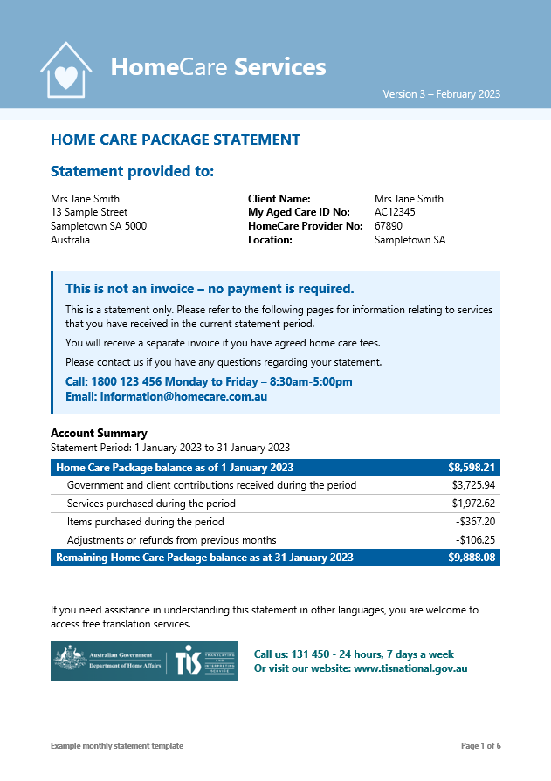

The remaining pages provide the details behind the income received, what was spent, and how much is remaining.

If you need assistance understanding your Statement or accessing it in a different language, you can contact your Provider or access free Translation & Interpretation Services by calling 131 450.



## 2. Summary income and expenses

This provides a breakdown of your income and expenses. At a glance, you can see what makes up your Package income, and how it is being spent on services and items during the month.

Your package income consists of government subsidy (less any reductions that apply) and client contributions.

### (a) Income received during the period – Government subsidy

Government subsidies are based on your assessed needs and include:

(i) *Home Care Package basic subsidy*: The basic subsidy rate depends on the package level – it increases for higher levels.

(ii) **Plus** *Supplements*: Primary and other supplements provide extra funding for specific care needs. For some supplements, we automatically check eligibility for you. For others, you need to apply.

(iii) **Less** *Reductions that apply*: The Government reduces the subsidy if reductions apply. There are two types that apply to home care – the care subsidy reduction and the compensation payment reduction.

a. *Care subsidy reduction*: This is your assessed income tested care fee, which is payable if you have entered home care from 1 July 2014 and have an income over a certain amount. This amount is automatically deducted from your Government subsidy.

b. *Compensation payment reduction*: A person can get an entitlement to compensation through a settlement, judgement, or reimbursement arrangement. This may be for things like an injury in the workplace or from a car accident. If the compensation covers some or all of the cost of their home care, a reduction applies. We will deduct the compensation amount from the subsidy we pay you on their behalf.

Figure 3. Government subsidy received during the period

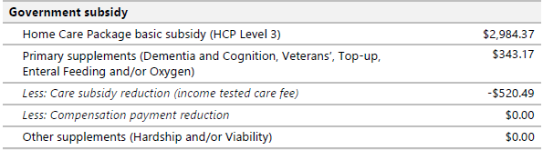

You can view the daily basic subsidy rates in the [Schedule of Subsidies and Supplements](https://www.health.gov.au/resources/publications/schedule-of-subsidies-and-supplements-for-aged-care). The rates are adjusted every year on 1 July.

### (b) Income received during the period – Client contributions

Client contributions represent the other part of your Package income and may be referred to as fees. Any contribution you make is added to your Package balance to be spent on services and items for your care. You must pay the assessed income tested care fee. All other fees may be discussed with your Provider.

Figure 4. Client contributions received during the period

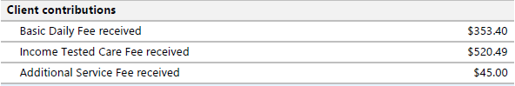

The fees that may apply to people who start Home Care Packages from 1 July 2014 are:

1. *Basic daily fee:* Everyone can be asked to pay this fee, but some Providers do not collect it. The amount you pay varies depending on your package level. The basic daily fee increases twice a year in line with the age pension. To see the maximum fee that Providers can charge for each package level, go to Home Care Package costs and fees at [www.myagedcare.gov.au](http://www.myagedcare.gov.au).
2. *Income tested care fee:* If your income is above a certain amount, you will need to pay an income tested care fee to contribute to the cost of your care. This fee is different for everyone. Full pensioners do not pay an income tested care fee. Annual and lifetime caps apply to this fee. To see the caps, go to Home Care Package costs and fees at [www.myagedcare.gov.au](http://www.myagedcare.gov.au).

*(iii) Additional service fees:* You can choose to pay additional service fees if you need or want care and services over the value your package budget. Care and services must be outlined in your care plan. You and your Provider must agree on the fees for these services.

### 

### (c) Expenses incurred during the period – Equipment, items and services purchased during the period

This section provides an overview of how your Package funds have been spent on equipment, items and services during the period. This may be for the purchase or rental of items and equipment such as continence or mobility aids, or for services such as nursing and allied health, transport, personal care, respite, home cleaning, light gardening and more. It also shows how much funds are spent on other package services such as care management and package management.

Your care needs may change over time, so it’s important to continually review what you are purchasing to ensure that you are making the best choices to live well at home.

Figure 5. Equipment, items and services purchased during the period

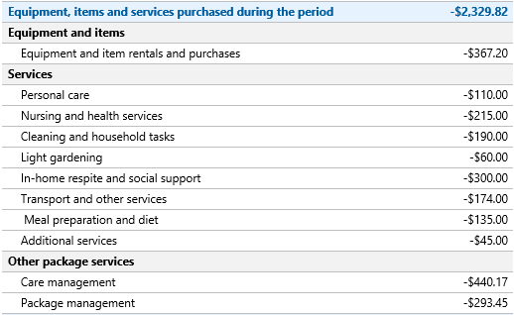

### (d) Refunds and adjustments

There may sometimes be adjustments or refunds for incorrect or missing charges relating to previous months. This will also be shown in the summary table for your reference. If you require more information on adjustments or refunds shown, speak to your Provider.

Figure 6. Adjustments or refunds from previous months

Image snapshot of the adjustments or refunds section of the Better Practice Home Care Package statement template.



## 3. Detailed services and items

This section provides an itemised account of any items and services purchased during the month, so you can check it for accuracy, while also reviewing if they are still the right mix of services and items for your care. This is presented in categories and shown in chronological order to make it easier for you to review the information.

### (a) Equipment and item rentals and purchases

This section lists out the equipment and items charged to the Package that month. The right equipment and items can go a long way to helping you remain independent and have peace of mind. If you have a clinical need for such items, your Provider will work with you to update your care plan and check the item can be funded under program rules. Your Provider will discuss rental options and/or option to purchase. So that you have the item as soon as possible, renting the equipment is encouraged (rather than waiting until you accumulate enough funds under the Package).

Figure 7. Equipment and item rentals and purchases

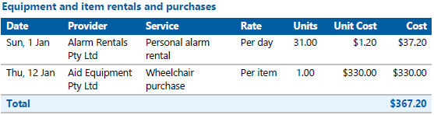

### (b) Services

This section lists out the services you have received during the period. The information is itemised to show when you received it, who delivered it, what service it was and how the cost is calculated.

You will likely be receiving a range of services every month. These may have different prices and costs based on the time and day you received it (e.g., weekday, night or weekend), or if the Provider is charging any related costs such as travel or service charges.

Please note that all prices shown in Figure 8 are example figures only and not intended to be indicative of what you should be charged. Your Provider is required to publish their Pricing Schedule online and include it as part of your Home Care Agreement. Please refer to that information if you have concerns on how the costs have been calculated.

Figure 8. Purchased services

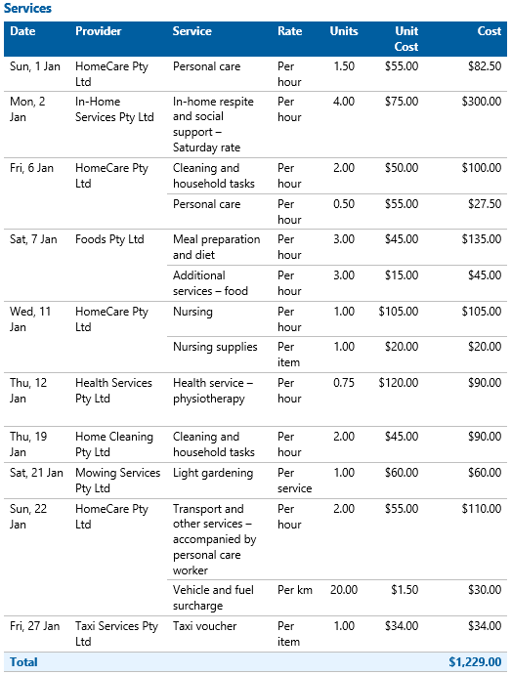

### (c) Other package services

This section lists out other package services you have received during the period, which generally include:

(i) *Care management*, which may include reviewing the Home Care Agreement and care plan, coordinating and scheduling services, ensuring the care aligns with other supports, providing a point of contact for the home care recipient or their support network, ensuring care is culturally appropriate, and identifying and addressing risks to the home care recipient’s safety.

(ii) *Package management*, which may include preparing monthly statements, managing package funds, meeting compliance and quality assurance standards.

Note: On 1 January 2023, care management prices were capped at 20% of the package level and package management prices were capped at 15% of the package level. Providers were also required to publish all-inclusive prices for third party services so that care recipients no longer receive unexpected additional charges. Please refer to [HCP pricing updates](https://www.health.gov.au/resources/publications/home-care-packages-pricing-update?language=en)

You would have agreed to fixed charges for these services. Please refer to the Provider’s Pricing Schedule for more information on how providers should charge for these services.

Figure 9. Other package services

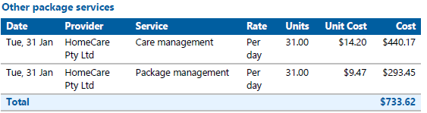

### (d) Adjustments or refunds from previous periods

From time to time, you may find errors in your Home Care Package statement. Perhaps your Provider charged you for two hours of a service, when it was only one hour; or perhaps they have charged you an incorrect amount. Sometimes they may have accidentally not charged your Package for a service you received.

These adjustments or refunds could either increase or decrease your Package balance. Because it relates to a previous period, it is shown separately in the statement so it is easier for you to understand what the charge or refund is for.

Figure 10. Adjustments or refunds from previous periods

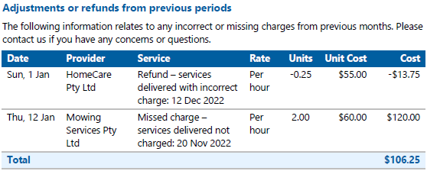



## 4. Other information related to your Package

The information shown on this last page is for your reference only. It shows you additional information about your remaining Package funds and status of your agreed fees and contributions to your Package.

### (a) Remaining Package funds

Your remaining Package funds are available to you to fund your care needs in line with program rules. Changes made to funding arrangements in September 2021 means that the majority of these funds are held by Services Australia in your Home Care Account. Your Provider may also hold some funds from prior to September 2021.

Most of your fees and contributions are spent regularly towards your care, however there may be some amounts that have accumulated and may be refunded to you or your estate if you stop your services. An estimated balance is shown in the statement for your reference.

Should you choose to change Providers, your previous Provider will transfer any remaining balances and client contributions that they hold to the new Provider. **Note:** From 1 January 2023, you cannot be asked to pay an exit amount, even if you have previously agreed to it.

Your Home Care Account (unspent subsidy held by Services Australia) remains available to you and your new Provider after you move Providers.

Figure 11. Remaining package funds (previous and current period)

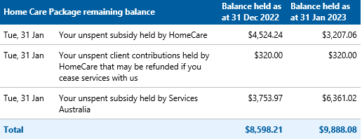

### (b) Payment status of your fees and contributions

The second page of your statement (Summary income and expenses) showed the client contributions that your Provider received from you during the statement period.

In this section, the Provider will show the total amount that may be outstanding from previous and current periods based on your assessed and agreed client contributions.

Figure 12. Payment status of your fees and contributions

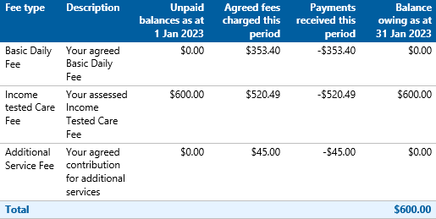

The balance owed amount is based on information held by your Provider at the end of the period. If you have made any payments since this date, they will be reflected in your next statement.

If your financial situation has changed or if you are concerned about how you can pay the outstanding fees, you should contact your Provider to discuss financial and hardship options.

If you would prefer instead to discuss your fees and services with an independent third party, you are welcome to contact the Older Persons Advocacy Network (OPAN) who can connect you to a representative to discuss your needs on a confidential basis. Please refer to their website ([www.opan.org.au](http://www.opan.org.au)) or call them on 1800 700 600 for more information.



## Frequently Asked Questions

#### I have a question about my statement, who can I ask?

Please contact your Provider if you have any questions about your statement.

#### Why are there costs on my statement for services I didn’t receive?

The information reflects services delivered during the month and/or information received by brokered services. There may be differences to what was actually delivered (in terms of hours delivered or dates). Please contact your Provider to let them know about this charge. If any adjustments are needed that would result in additional costs or refunds, your Provider will adjust this in the next statement.

#### Why are there services listed in the Summary income and expenses section that do not relate to me?

The Summary income and expenses section shows the general categories of services and items that may be accessed under a Home Care Package. If the balance is zero, that means you did not receive a service under this category in the period. Having all categories shown may be helpful when reviewing if your current care and services are still right for you, or if its timely to contact your Provider to make some changes to your care plan.

Some Providers may tailor the statement to remove services and items that do not relate to your care plan.

#### What are the Other Package fees that I am paying for?

Care management is a vital service, which includes reviewing Home Care Agreements and care plans, ensuring care and services are culturally appropriate and aligned with other supports, liaising with care recipients and their representatives and risk management. Package management is where most administrative costs are captured in the program, including invoicing, claiming, and providing individualised budgets and monthly statements to care recipients, and ensuring the quality of the care and services included in the package, such as quality assurance, infection control plans and procedures. Your care management and package management costs have been agreed under your Home Care Agreement. Please refer to your agreement to confirm amounts and contact your Provider if you have any questions about these charges.

#### Why is there a balance outstanding in my fees and client contributions? How do I pay it?

As part of the changes effective 1 September 2021, Providers are required to share with you any fees and contributions that you have agreed to that were still unpaid at the end of the statement period. You must pay your assessed income tested care fee, but all other fees may be negotiated with your Provider, noting that this may require you to reduce the services and items that you are receiving under your Package.

This information is for your reference only, and your Provider will likely send you a separate invoice with details on how to pay the outstanding balance.

#### Where are my payments shown?

This is a statement only. For detailed information on your previous payments, please refer to your latest invoice or request this from your Provider.

#### I still have unresolved questions, who can help me?

If you have been unable to resolve your question with your Provider and would like to discuss your fees and services with an independent third party, you are welcome to contact the Older Persons Advocacy Network (OPAN) who can connect you to a representative to discuss your needs on a confidential basis. Please refer to their website (www.opan.org.au) or call them on 1800 700 600 for their contact information.