December 2020

Report to Commonwealth Department of Health

Mental Health Workforce – Educational Institutes Review

Final Report



Contents

Executive summary i

Project context i

National Mental Health Workforce Strategy – Recommendation framework i

Workforce definition ii

Educational Institute Review iii

Roles in scope iv

Training the mental health workforce iv

Commencements, enrolments and completions iv

Course content vi

Course delivery vi

Placements vi

Encouraging Continuing Professional Development vii

Requirements for CPD vii

Availability of CPD viii

Incentives to encourage employers to provide training viii

Capacity of educational institutes to respond to increased demand for mental health workers ix

Opportunities x

Attracting students x

Transitioning graduates to employees xi

Supporting upskilling xi

1. Report Methodology 1

Commencements 1

Enrolments 1

Completions 1

2. Current State Assessment 2

2.1.1Counsellor / Psychotherapist 2

2.1.2Dietitian 3

2.1.3General Practitioner 4

2.1.4Nurse 5

2.1.5Occupational Therapist 8

2.1.6Psychiatrist 9

2.1.7Psychologist 10

2.1.8Social Worker 11

2.1.9Speech Pathologist 12

2.2.1Aboriginal and Torres Strait Islander Health Worker 13

2.2.2Allied Health Assistant 16

2.2.3Lived Experience (Peer) Worker 18

2.2.4Mental Health Worker 19

2.3 Demand for courses 24

2.3.1Commencements / Enrolments 24

2.3.2Completions 26

2.3.3Upskilling, continuing professional development and employer support for training 27

2.4 Appropriateness of course content 27

2.5 Diversity of modes of delivery 29

3. Opportunities 31

3.1 Addressing workforce shortages 31

3.2 Enhancing course attractiveness 31

Positive career pathways 31

Diversified delivery 32

Improved employer support 32

3.3 Increasing volume of training 32

Lead time to increase supply 32

Access to teaching staff 33

Access to placements 33

3.4 Transitioning graduates to employees 34

Supporting upskilling 34

APPENDICES 1

A.1 Course mapping – Overview 1

A.2 Higher Education Provider – Data availability 3

# Executive summary

## Project context

In December 2018, the Australian Government committed to developing a ten-year National Mental Health Workforce Strategy (the Strategy) to attract, train and retain the workforce needed to meet the rising demands of the mental health system in Australia. The development of the Strategy is overseen by the independent National Mental Health Workforce Strategy Taskforce (the Taskforce).

The Taskforce endorses service systems and service delivery practices, at organisational and practitioner levels, that provide care to people experiencing mental distress and/or ill-health (consumers), their families and carers that are:

* person-centred, recognising consumers and their carers as partners in planning and decision making
* recovery oriented
* trauma informed
* culturally safe
* place-based
* integrated.

The Taskforce also acknowledges that, over time, consumers require services:

* of varying levels of intensity
* from a wide range of professionals
* in a wide range of service settings.

Consumers should be able to access these services when they need them and in the way that best meets their needs, which may involve accessing services of different levels of intensity at the same time. Consumers should be afforded continuity of care, with a designated lead professional or team responsible for follow-up, monitoring outcomes and keeping people experiencing mental ill-health and their carers connected.

The Strategy aims to provide the workforce required to deliver such care. This is independent from the model of care as the model may vary over time and from place to place, depending on the needs of consumers, carers and local communities. The Strategy aims to identify approaches that could be implemented by all Australian governments to address current workforce challenges impacting on the effective provision of mental health services.

### National Mental Health Workforce Strategy – Recommendation framework

The Taskforce commenced in early 2020 and has developed the following framework for recommendations, informed by the work of targeted Working Groups focused on specialist areas.[1]

**FIGURE ES 1** NATIONAL MENTAL HEALTH WORKFORCE STRATEGY – RECOMMENDATION FRAMEWORK

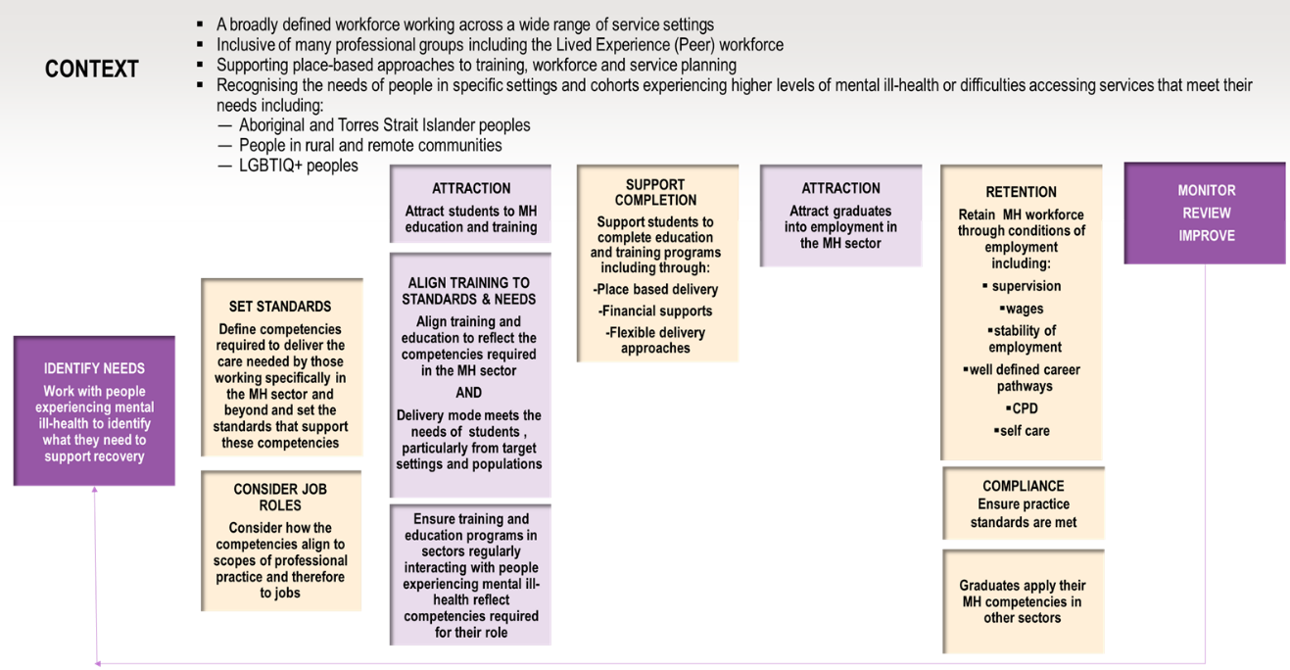

SOURCE: ACIL ALLEN, 2020.

### Workforce definition

The Taskforce has adopted an organising framework premised on social and emotional wellbeing that recognises the indivisible connection between people’s physical, social, emotional and cultural wellbeing. This is adapted from the National Strategic Framework for Aboriginal and Torres Strait Islander Peoples’ Mental Health and Social and Emotional Wellbeing 2017-2023.

The organising framework involves a broad definition of the mental health workforce that includes people who interact with and provide support and clinical care to people experiencing mental distress and/or ill-health. The workforce is drawn from a wide range of professions and occupations performing an even broader array of roles across different service settings including public, private and community-based organisations. The mental health workforce also includes an informal workforce of family, friends and community members who support people experiencing mental distress and/or ill-health.

**FIGURE ES 2** NATIONAL MENTAL HEALTH WORKFORCE STRATEGY – ORGANISING FRAMEWORK

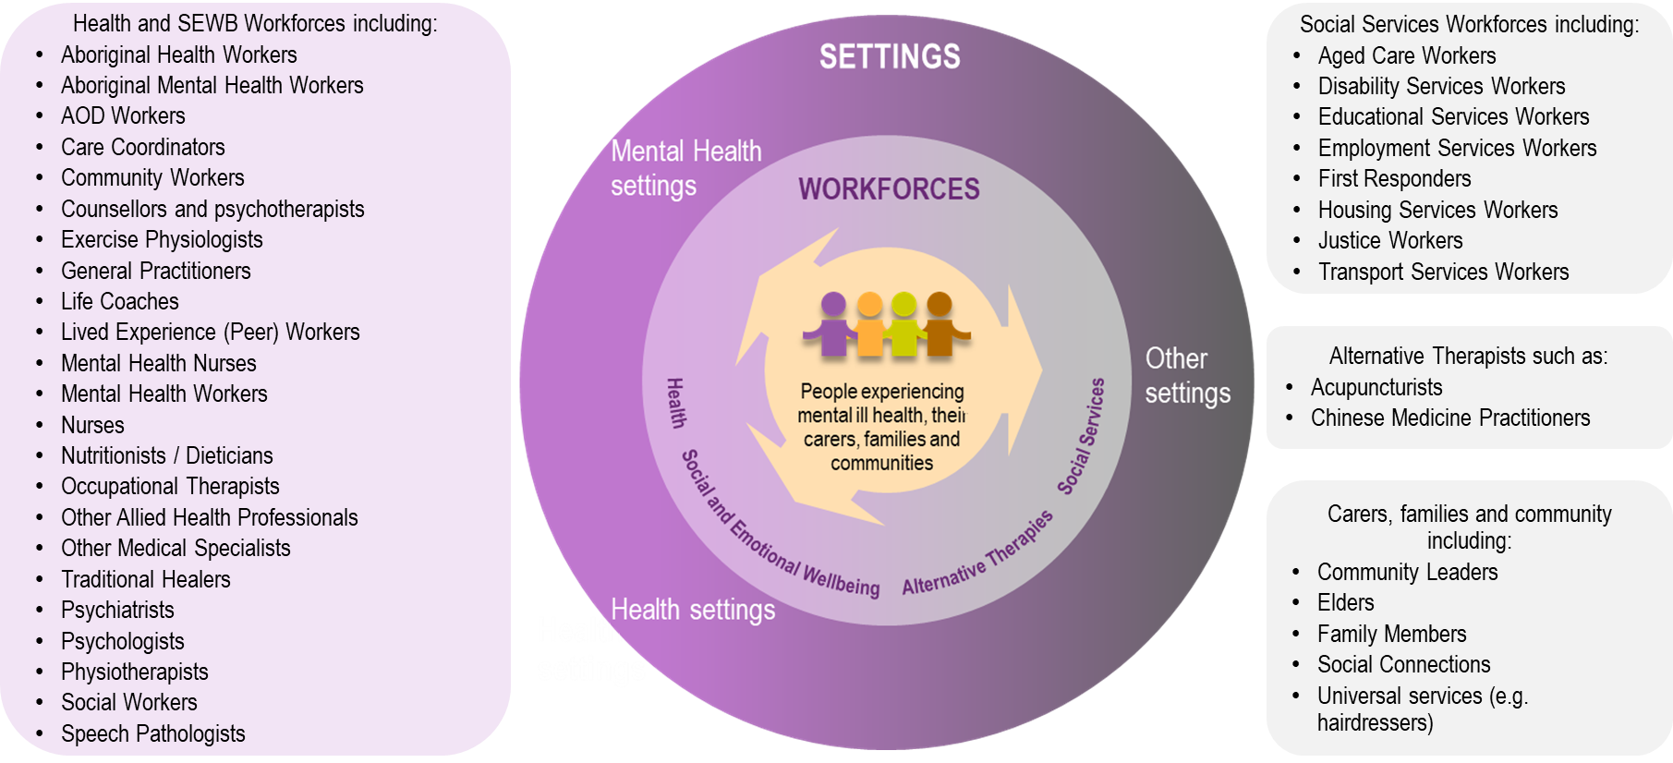

SOURCE: NATIONAL MENTAL HEALTH WORKFORCE STRATEGY TASKFORCE, 2020.

### Educational Institute Review

The Department commissioned ACIL Allen to undertake research to support the development of the Strategy, focusing on the capacity of educational institutes to meet the training needs of the mental health workforce.

The objective of this report, the Educational Institute Review (EIR), is to examine the learning needs of the workforce, the challenges to accessing training and education, and the capacity to meet increased demand. It addresses the following questions:

* What training requirements will be needed for the mental health workforce?  
  This question addresses the training that qualifies the mental health workforce to work in the field. Continuing Professional Development (CPD) is addressed in the following question.
* What incentives would encourage employers to provide training?  
  The role of CPD is examined, as are the factors that influence employer provision of it.
* What is the capacity of educational institutes in the tertiary and vocational education sectors to respond to increased demand for mental health workers?  
  This question explores the self-reported readiness of tertiary and vocational education institutes to increase the supply of courses that train the mental health workforce.

The EIR should be read in conjunction with the Labour Market Analysis (LMA) which provides evidence on current employment trends and issues for the mental health workforce.

The EIR draws on a mixed-methods approach, which included:

* data analysis – analysing publicly available data on enrolments and completions for higher education and vocational education and training
* targeted consultations – with education providers, professional associations, employer representatives and employee representatives to explore training needs and opportunities.

### Roles in scope

This report focuses on the professional and occupational groups whose roles involve working regularly with people experiencing mental distress or ill-health.

**TABLE ES.1** EIR – ROLES IN SCOPE

| Professional / occupational group | Regulation | Training | Length of training | |
| --- | --- | --- | --- | --- |
| **Aboriginal and Torres Strait Islander Health Worker** | Australian Health Practitioner Regulation Agency (AHPRA) | Vocationally trained | | 12 months |
| **Allied Health Assistant** | Unregulated | Vocationally trained | | 12 months |
| **Counsellor[2] / Psychotherapist** | Self-regulated | Tertiary qualified | | 3 years |
| **Dietitian** | Self-regulated | Tertiary qualified | | 4 years |
| **General Practitioner** | AHPRA | Post-graduate | | 8 years |
| **Lived Experience (Peer) Worker** | Unregulated | Vocationally trained | | 8 months |
| **Mental Health Worker** | Unregulated | Vocationally trained | | 12 months |
| **Nurse:** | AHPRA |  | |  |
| Enrolled Nurse |  | Vocationally trained | | 18 months |
| Registered Nurse |  | Tertiary qualified | | 3 years |
| Credentialled Mental Health Nurse | Australian College of Mental Health Nurses | Post-graduate | | 3 years |
| **Occupational Therapist** | Self-regulated | Tertiary qualified | | 4 years |
| **Psychiatrist** | AHPRA | Post-graduate | | 11 years |
| **Psychologist** | AHPRA |  | |  |
| Psychologist |  | Post-graduate | | 6 years |
| Clinical Psychologist |  | Post-graduate | | 8 years |
| **Social Worker** | Self-regulated | Tertiary qualified | | 4 years |
| **Speech Pathologist** | Self-regulated | Tertiary qualified | | 4 years |

## Training the mental health workforce

### Commencements, enrolments and completions

The EIR examined education and training commencements (number of students beginning a course in a given year), enrolments (number of students enrolled in a course in a given year) and completions (number of students who complete a course in a given year) for both higher education and vocational training courses over the period 2015-19, where data were available.

Commencements and enrolments provide insight into the level of demand for courses from students. The level of interest in courses associated with the professional and occupational groups listed above has generally increased over time. This indicates that there are few issues with attracting students to training courses associated with the mental health sector. The exceptions to this trend include Allied Health Assistants, General Practitioners (GPs), Mental Health Workers, Enrolled Nurses and Psychiatrists.

Completions identify the potential workforce available to work in the mental health sector. Completion rates have remained consistently high, in line with general trends for health-related courses. Low completion rates impacted on the Aboriginal and Torres Strait Islander Health Workers, Lived Experience (Peer) Workers, and Mental Health Workers. Barriers to completion for these groups include financial pressures (for example, income foregone due to participation in training), personal circumstances (such as caring responsibilities) and difficulty in attending face-to-face training (due to travel time and costs).

A summary of the trends by professional / occupational group is provided in the figure below.

**FIGURE ES 3** SUMMARY OF ENROLMENTS AND COMPLETIONS TRENDS – 2015-19

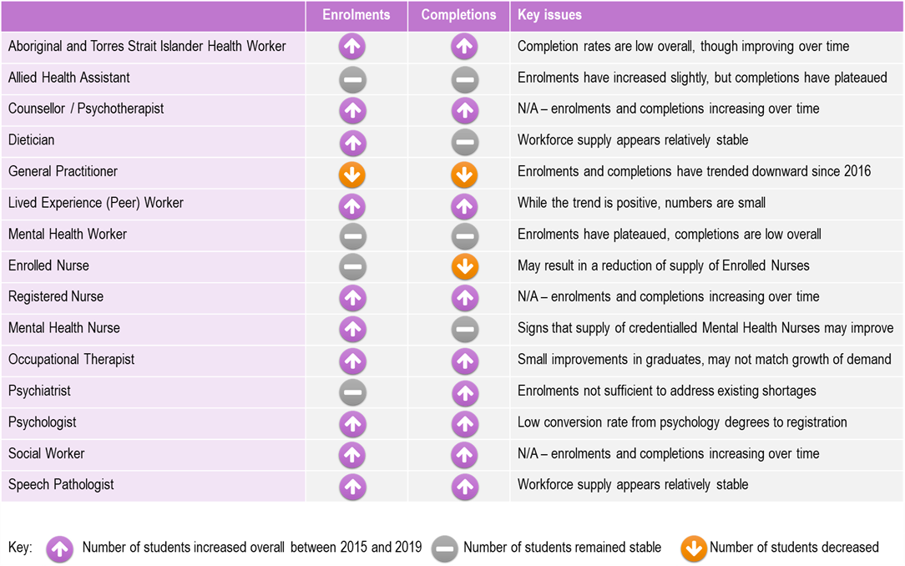

SOURCE: ACIL ALLEN CONSULTING ANALYSIS OF HEIMS AND VOCSTATS DATA, 2015-19.

The University of Queensland’s (UQ) *Analysis of national mental health workforce demand and supply: Stage 1 report* identified that there are current shortages across most professional and occupational groups within the mental health workforce. These shortages are likely to be exacerbated over time as demand for mental health services increases.

This highlights the need to address current and emerging workforce shortages by increasing the pool of appropriately trained graduates. While recognising the wide-ranging needs identified by UQ, there are specific roles which require more significant support to attract sufficient numbers of students. These include Aboriginal and Torres Strait Islander Health Workers, Lived Experience (Peer) Workers, Mental Health Workers, Nurses, Occupational Therapists and Psychiatrists.

### Course content

Consultations with professional associations, employer and employee representatives indicated that current educational offerings generally provide graduates with the knowledge and skills required to work in the roles for which they have been trained.

However, given the broad definition of the mental health workforce and recognising that many graduates will not work in the mental health sector, programs outside those that deal specifically with mental health are often designed with little mental health content. This is relevant both to graduates working in mental health settings (for example Occupational Therapists) and in a wide range of other settings, such as first responders, educational institutions and social services, where contact with people experiencing mental distress and/or ill-health can be expected.

### Course delivery

Consultation feedback indicated that in most instances course delivery modes are appropriate, though there is a recognised need to increase the training options for students in rural and remote areas including online, blended and local delivery options. Lived Experience (Peer) workers also require greater flexibility in program delivery to address the barriers they face to participating in training.

Aboriginal and Torres Strait Islander students would benefit if more courses could be delivered in a manner that reduces their need to travel away from home, and greater support provided to those that are required to do so.

### Placements

The quality of placements has a significant impact on the likelihood of students pursuing employment in the mental health sector once they graduate.

Training placements for some professional groups (such as Psychiatrists, GPs and Psychologists) are often in the most stressful settings, such as public acute care inpatient units.[3] While the negative experiences of students are unlikely to impact on course completions, they do impact on the choice to undertake further study (for example, for medical graduates to become Psychiatrists), to work within the mental health sector or to work in the public mental health system. This is evident in the trends in specialties taken up by medical graduates, which indicates more medical graduates are preferring adult medicine, emergency medicine, paediatrics and surgery to psychiatry.[4] There are also difficulties accessing placements in rural and remote contexts across the breadth of settings relevant to the mental health sector.

Consultations identified that the difficulty in accessing placements is due to the reliance on State and Territory-funded placements which are predominantly in the public system and the limited availability of placements in the private or community sector. Some Primary Health Networks (PHNs) are encouraging service providers to work with universities to offer clinical internships, with plans to extend these arrangements across a range of workplace settings.

**CONCLUSION ES 1** TRAINING REQUIREMENTS FOR THE MENTAL HEALTH WORKFORCE

Overall, there are few issues attracting students to courses that train the mental health sector for the professional and occupational groups in scope for this review. However, there are some exceptions to this trend, and this is of specific concern where there is a corresponding workforce shortage (noting that reliable data on workforce shortages is not available across all professional and occupational groups). The difficulties attracting sufficient numbers of students to these courses are likely to persist in the absence of a coordinated approach to improving flexibility of training options and employment conditions, including career pathways for graduates.

Completion rates for courses that prepare graduates for work in the mental health sector remain consistently high, with the exception of courses for Aboriginal and Torres Strait Islander Health Workers, Lived Experience (Peer) Workers, and Mental Health Workers. Educational institutes will need to provide greater flexibility in course delivery to better meet the needs of students, and more supports to help students complete courses to enable the anticipated increased utilisation of these workforces. While the modes of course delivery are appropriate in most instances, further work is needed to meet the needs of students from rural and remote areas, Aboriginal and Torres Strait Islander students, and people with Lived Experience.

Current educational offerings in the professions and occupations in scope for this review generally provide graduates with the knowledge and skills required to work in the professions and occupations for which they are trained. Where these professions and occupations are not specifically focused on mental health, educational offerings often do not include sufficient training in mental health. These shortcomings will need to be addressed either through changes to pre-service training or by providing mental health specific post-employment training, if the broadly defined mental health workforce is to be appropriately trained.

Providing students with well-supported training placements across a range of settings plays a critical role in attracting them to employment in the mental health sector. Education providers, service commissioners, service providers and professional associations need to work collaboratively to ensure students’ placements in mental health are of high quality with adequate supervision, and to expose them to the range of service settings that reflect the opportunities of the whole mental health sector.

## Encouraging Continuing Professional Development

## Requirements for CPD

There is limited data available on CPD practices across professional and occupational groups in scope for this review. Most professional groups have CPD requirements associated with the maintenance of registration or practice, which means individuals are responsible for ensuring they meet these requirements.

For those roles that are not specific to the mental health sector (for example, Social Workers), it is challenging to determine the extent to which CPD activities are undertaken on mental health-related content. This may impact on the currency of knowledge and skills of the associated workforce. Similarly, for roles with no mandatory CPD requirements (for example, Lived Experience (Peer) Workers), it is difficult to identify the level of CPD activity.

## Availability of CPD

Except where registration requirements dictate otherwise, CPD in the mental health sector is often undertaken through unaccredited training activities (for example, participation in conferences, publishing in journals, or completion of short courses). Feedback from employee representatives and professional associations indicated that there is a wide range of CPD offerings available, both face-to-face, online and in the workplace. However, employees often experience difficulties in accessing time off work to complete CPD and may need to undertake CPD in their own time rather than as part of their employment.

There are few accredited training opportunities available for upskilling or CPD regarding mental health practice outside the professions and occupations that work predominantly or exclusively in mental health such as Psychiatrists, Psychologists, Mental Health Nurses, Counsellors and Psychotherapists.[5] One exception is NSW Health’s Higher Education Training Institute, which provides postgraduate courses in Applied Mental Health Studies and Psychiatric Medicine. The close connection to contemporary practice and applied learning were highlighted through consultations as key strengths of these offerings.

## Incentives to encourage employers to provide training

The extent to which employers support employee professional development plays an important role in attracting and retaining workers to the mental health sector. In many regulated professions, employers provide access to CPD as one way of differentiating themselves as an employer of choice (for example, law firms, who regularly provide CPD sessions to staff during business hours) or take an active role in ensuring all staff continually develop their practice (for example, schools, who incorporate significant amounts of CPD into their school timetables).

While the National Standards for Mental Health Services (2010) require that ‘Staff are appropriately trained, developed and supported to safely perform the duties required of them’, there are no specific requirements in these standards for employers to provide access to CPD. Enterprise Bargaining Agreements often include entitlements that relate to training, and service commissioners (including PHNs) may encourage CPD through their contracts and relationships with providers.

PHNs play an important role in developing the mental health workforce as commissioners of mental health services. While approaches to capacity building vary widely across PHNs, it is achieved in part by requiring commissioned service providers to have appropriate clinical governance and risk management arrangements that include CPD and professionally relevant supervision. Commissioning processes can include audit activities, with some PHNs requiring evidence of supervision and CPD activities in preference to reliance on providers’ internal processes. Expectations can also be set regarding participation in clinical internship programs. Some PHNs take a more active role in workforce development through use of capacity building coordinators, who work with service providers to address capability gaps.

**CONCLUSION ES 2** ENCOURAGING EMPLOYER SUPPORT FOR CPD

Workers in the mental health sector have varied experiences accessing CPD across roles and settings. For professional groups with mandatory CPD requirements, there are difficulties in accessing time off to complete the required training. For some occupational groups, this is a greater challenge in public settings than it is in private ones. For occupational groups without formal training or CPD requirements (namely Lived Experience (Peer) and Mental Health Workers), there is limited incentive for employers to support development as it does not impact funding received. Relatively low wages and high casualisation of these groups make it difficult for workers to support their own development, in the absence of employer assistance.

Employers need to be encouraged and supported to continually develop their staff. There is a need to encourage employers to provide access to CPD to support the attractiveness of the mental health sector – regardless of whether roles have mandatory CPD requirements to maintain registration or not. There are benefits to the employer in the form of a more highly skilled workforce, confidence that their workforces are aware of emerging practice, being an employer of choice, increased work satisfaction among employees and reduced staff turnover.

Service funding arrangements are a key driver of limited employer-supported training. Current funding structures are generally activity-based and do not include sufficient loadings for training or development, although some PHNs are actively working with service providers to encourage workforce development through commissioning arrangements. It is difficult for employers to facilitate employee training, either financially (due to limited resourcing) or by providing time off (due to workforce shortages), if insufficient funding is provided or KPIs preclude staff having time to complete it. Reform to funding arrangements may be required to help incentivise employers to provide training.

## Capacity of educational institutes to respond to increased demand for mental health workers

Education providers are hesitant to scale-up training delivery without clear evidence of student demand and have varied readiness to meet increased demand for courses. This variation depends on whether the increased capacity involves scaling up existing programs or diversifying to offer new programs. For providers to scale up existing programs, the self-reported timeframes for doing so vary between twelve months for a 50 per cent increase (on average) and three to five years for a 100 per cent increase (on average). For providers to develop new programs outside existing areas of study, the estimated timeframes are between three to five years in recognition of the considerable effort required to develop expertise and resources, and secure funding.

Factors that influence the capacity to increase supply of education programs include:

* access to teaching staff, with difficulties in recruiting and retaining the academic and clinical staff needed to support quality delivery. These challenges are exacerbated for roles where there are workforce shortages.
* access to placements, which present a challenge to current levels of delivery for such roles as Mental Health Workers, Lived Experience (Peer) Workers, and Occupational Therapists. Expanding capacity would require establishing various arrangements that support high quality placements, including discipline-specific supervision across a range of mental health settings.

Student demand for some courses is likely to be influenced by changes in government policy that will see increases and decreases in student contributions for some areas of study, effective from 2021. The Job-ready Graduates Package may mean the annual cost of study for social work, psychotherapy and counselling, and psychology (excluding post-graduate clinical psychology) will increase significantly depending on the units of study selected.

**CONCLUSION ES 3** EDUCATION INSTITUTIONS’ CAPACITY TO INCREASE SUPPLY

Education institutes will respond to increased demand for the mental health workforce by providing more places in existing courses and offering new courses if demand for workers translates to increased demand for places by potential students. Implementation details on changes to government policy that will increase or decrease student contribution levels for some courses is yet to be finalised, but is likely to impact student demand for some courses in the mental health area, and therefore the supply of these courses.

The time taken to provide additional places depends on whether new programs are required, the scale of the uplift required in existing programs, the availability of staff to teach programs, the availability of placements if required, and the availability of funds to support expansion prior to students commencing.

Funding arrangements for study in mental health-related disciplines are likely to influence both student demand and the willingness of education institutes to expand programs in financially constrained times.

## Opportunities

There is generally strong demand for mental health-related courses, as evident through the current level and trends for enrolments. To meet the increasing demands on the mental health system, there is a need to increase the supply of potential workers. Current and emerging shortages can be addressed, in part, by attracting new student cohorts to study and by increasing the number of appropriately trained graduates.

### Attracting students

Increased training capacity is dependent on generating sufficient interest to achieve the required student numbers for a course to be viable.

Campaigns to promote the attractiveness of careers in the mental health sector, and thus raise the demand from students, are one strategy to build demand. The Productivity Commission recommends that ‘governments and specialist medical colleges should take further steps to reduce the negative perception of, and to promote, mental health as a career option’.[6]

Another strategy is to develop clearer pathways through education and training to employment. This applies to all professional and occupational groups within the mental health workforce. Particular challenges are evident for the Aboriginal and Torres Strait Islander Health Workers, Lived Experience (Peer) Workers and Mental Health Workers – roles where current variation in practice impacts on the clarity of opportunities available. Lessons could be drawn from the current articulation pathways for nursing that link vocational and higher education pathways to clear employment and practice outcomes.

Improving the accessibility of training could also increase student numbers. Access to locally-based training is a recognised barrier for rural and remote students and Aboriginal and Torres Strait Islander Health Workers, in particular. The value of online delivery in improving accessibility is being increasingly recognised by professional associations. In part, this is due to the COVID-19 pandemic, which necessitated a transition to online delivery. While there is broad support for increased blended delivery through online platforms, consultations identified the need for appropriate compliance mechanisms to ensure that quality is maintained.

### Transitioning graduates to employees

Some professional and occupational groups have direct pathways into the mental health sector which means there are few issues with attraction to employment. This includes Counsellors and Psychotherapists, Lived Experience (Peer) Workers, Psychiatrists, and Clinical Psychologists.

For other professional and occupational groups, there are broad career opportunities available and graduates do not always pursue employment in the mental health sector. This relates to Dietitians, General Practitioners, Nurses, Occupational Therapists, Social Workers and Speech Pathologists. For Aboriginal and Torres Strait Islander Health Workers, the social and emotional wellbeing approach produces a softer distinction between physical and mental health settings, which means graduates may move between sectors. The ability to grow these groups is dependent, in part, on encouraging more graduates to see mental health as a sector of choice.

Opportunities to improve the attractiveness of the sector are covered in the separate LMA report, and include:

* improving the awareness of career pathways in the mental health sector
* improving the quality of placements during training
* improving the alignment of training with workplace roles
* developing robust supervision structures to support ongoing practice development
* addressing issues of workplace culture and perceptions of high workloads, heavy stress and occupational violence.

### Supporting upskilling

The need for shorter, modularised programs emerged consistently through the research to address current issues around length and cost of training which inhibits both entry-level training and upskilling for some professional and occupational groups.

This approach, often referred to as micro-credentialling, is a model that allows students to undertake study in buildable blocks which can be easier to complete than a full-length qualification. Micro-credentialling also provides more flexibility for employers, reducing the length of commitment to balancing employee study with work availability.

The current funding arrangements for education and training do not support the delivery of micro-credentials, which makes them less viable for education providers to deliver. The development of micro-credentials would also need to be supported by a quality assurance mechanism to ensure the skills developed aligned with the requirements of professional associations, employers, and consumers.

# 1. Report Methodology

1.1 Methodology

The EIR draws on a mixed-methods approach, which includes:

* higher education data – enrolment and completion data from 2015 to 2019, provided by the Department of Education, Skills and Employment
* vocational and educational data – enrolment and completion data from 2015 to 2019, drawn from VOCSTATS data set
* targeted consultations – with higher education and vocational providers delivering mental-health related training, professional associations and employer and employee representatives.

Data from higher education and vocational training courses were analysed to determine the level of interest in mental-health related courses, and the potential workforce produced as new graduates.

## Commencements

Commencement provide insight into the level of attraction to courses related to mental health. Commencements are defined as the number of students beginning a course in a given year.[7] This includes students transferring from another course.

Commencements data are available for higher education courses but are no longer recorded for vocational education and training. This report uses commencements to assess demand for higher education courses, and enrolments to assess demand for vocational courses.

## Enrolments

Enrolments provide insight into the level of overall demand for courses relating to mental health. Enrolments are defined as the number of students enrolled in a course in a given year, including both new and continuing students.

## Completions

Completions provide an estimate of the number of new graduates from a course that could potentially move into employment in the mental health sector. Increases in enrolments takes several years to show a corresponding increase in completions, in line with the length of training.

Completions data record the number of students who have finished all the academic requirements of a course in a year. [8] Raw numbers are provided as data are not available on the proportion of students who enrol and complete a given course.

# 2. Current State Assessment

**This chapter examines the current trends in education and training by role, including enrolments and completions, delivery modes, and course content. The chapter is separated into tertiary qualified roles and vocationally trained roles.**

2.1 Tertiary qualified roles

2.1.1 Counsellor / Psychotherapist

Counsellors and Psychotherapists are a self-regulated profession with membership and registration requirements outlined in the Psychotherapy and Counselling Federation of Australia Training Standards (2020). To be eligible for registration as a Counsellor or Psychotherapist on the Australian Register of Counsellors & Psychotherapists (ARCAP) which is associated with PACFA, an individual must have completed education and training in counselling, psychotherapy or Aboriginal and Torres Strait Islander Healing Practices at an Australian Qualification Framework level 7 (bachelor’s degree) to 9 (master’s degree). On average, the length of training is three years and costs $55,368.

In addition, the Australian Counselling Association outlines minimum qualifications for registration as a Counsellor which include the completion of an ACA accredited course at a Diploma or above. [9]

**TABLE 2.1** COUNSELLOR / PSYCHOTHERAPIST – MAPPED QUALIFICATIONS

|  |  |
| --- | --- |
| Role | Qualifications |
| **Counsellor / Psychotherapist** | Graduate Diploma in Counselling  Bachelor of Counselling  Bachelor of Counselling and Psychotherapy  Master of Counselling |

SOURCE: ACIL ALLEN CONSULTING, 2020.

#### Commencements and completions

Commencements show an increase in new students joining courses related to counselling and psychotherapy which indicates there are limited issues with the current attraction to training. Consultations identified that the Federal Government’s higher education funding reforms may impact on the relative attractiveness of these courses due to the associated increase in cost, but data are not yet available on the impact.

Figure 2.1 shows that commencements increased by approximately 37 per cent. Completions trend up in line with the increase in commencements, albeit at a time delay due to length of training.

**FIGURE 2.1** COUNSELLOR / PSYCHOTHERAPIST – COMMENCEMENTS AND COMPLETIONS

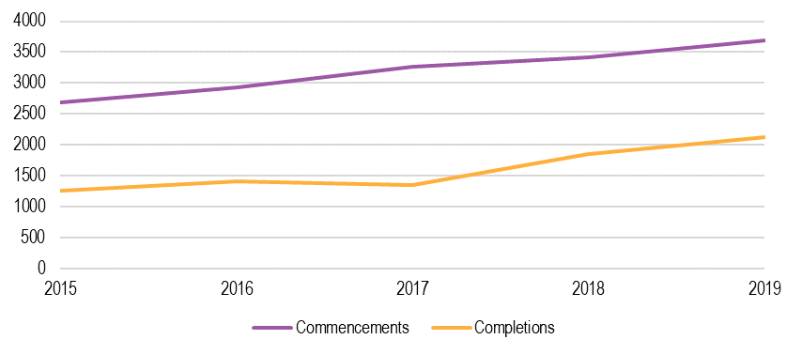SOURCE: ACIL ALLEN ANALYSIS OF HEIMS DATA, 2015-2019.

2.1.2 Dietitian

Dietitians are self-regulated by the Dietetic Credentialing Council. Educational pathways include qualifications at a bachelor’s, graduate diploma, and master’s level. The average length of training is 4 years.

**TABLE 2.2** DIETITIAN – MAPPED QUALIFICATIONS

|  |  |
| --- | --- |
| Role | Qualifications |
| **Dietitian** | Bachelor of Health Science (Nutrition)  Bachelor of Dietetics  Graduate Diploma in Human Nutrition  Master of Nutrition  Master of Dietetics |

SOURCE: ACIL ALLEN CONSULTING, 2020.

#### Commencements and completions

Commencements and completions for dietetics courses have remained relatively stable from 2015 to 2019, with a small upward trend (Figure 2.3). There is no current evidence of a workforce shortage for Dietitians. This may indicate that current training levels are sufficient to fill the positions available, though there are existing shortages in rural and remote contexts which indicate maldistribution.[10]

**FIGURE 2.2** DIETITIAN – COMMENCEMENTS AND COMPLETIONS

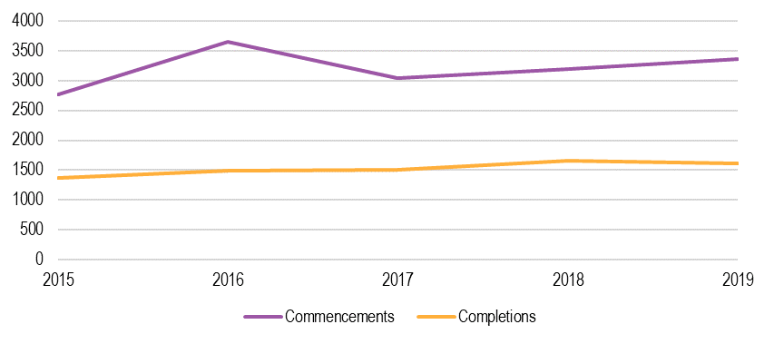

SOURCE: ACIL ALLEN ANALYSIS OF HEIMS DATA, 2015-19.

2.1.3 General Practitioner

General Practitioners (GPs) are regulated through the Australian Health Practitioner Regulation Agency (AHRPA) and must complete a Bachelor of Medicine and a postgraduate degree in medicine, followed by an internship in a hospital and specialist general practice vocational training. The length of training is, on average, 8 years. This pathway includes the requirements of the Fellowship of the Royal Australian College of General Practitioners (FRACGP) which provides a specialist general practice qualification accredited by the Australian Medical Council.

In addition to the education pathway, GPs must also undertake Mental Health Skills Training in order to access higher MBS rates under the Better Access program.

**TABLE 2.3** GENERAL PRACTITIONER – MAPPED QUALIFICATIONS

|  |  |
| --- | --- |
| Role | Qualifications |
| **General Practitioner** | Bachelor of Medicine  Doctorate of Medicine |

SOURCE: ACIL ALLEN CONSULTING, 2020.

#### Commencements and completions

Figure 2.3 shows the number of students commencing and completing courses related to general practice from 2015 to 2019. There has been a decline in commencing students over the time period, with almost 13 per cent fewer commencements in 2019 than there were in 2015. Over the time period, there was a 9.4 per cent decline in supply of new graduates.

The Productivity Commission found no evidence of a current Australia-wide shortage in GPs, with growth in the GP headcount (at an average 3% per year) significantly exceeding population growth from 2013 to 2018. While the figures from the Productivity Commission differ slightly from the data provided below [11], there is no suggestion of an issue in current attraction to training or completion for GPs.

**FIGURE 2.3** GENERAL PRACTITIONER – COMMENCEMENTS AND COMPLETIONS

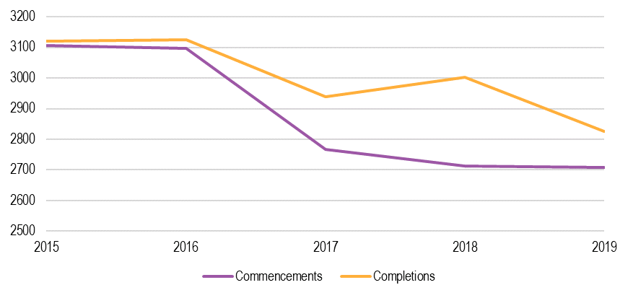SOURCE: ACIL ALLEN ANALYSIS OF HEIMS DATA, 2015-19.

2.1.4 Nurse

Nurses are regulated under AHPRA through the Nursing and Midwifery Board. There are two distinct education and training pathways into nursing – Enrolled Nurses who must hold a Diploma of Nursing, and Registered Nurses who must hold a bachelor’s degree.

The Australian College of Mental Health Nurses also credentials Mental Health Nurses who must hold a recognised specialist mental health nursing qualification, as specified in the C4N Qualification Framework and ACMHN Addendum.

The average training for Enrolled Nurses takes 1.5 years (with cost estimated at $21,000), for Registered Nurses takes 3 years (with cost estimated at $30,000), and for Credentialed Mental Health Nurses takes 4 years (cost data not available).

**TABLE 2.4** NURSE – MAPPED QUALIFICATIONS

|  |  |
| --- | --- |
| Role | Qualifications |
| **Enrolled Nurse** | Diploma of Nursing |
| **Registered Nurse** | Bachelor of Nursing  Bachelor of Science (majoring in Nursing)  Bachelor of Nursing (Advanced Studies)  For students with previous tertiary qualifications, complete a two-year Master of Nursing (Graduate Entry) program. |
| **Mental Health Nurse** | Specialist mental health nursing qualification (e.g., Master’s). |

SOURCE: ACIL ALLEN CONSULTING, 2020.

#### Registered Nurses – Commencements and completions

There has been a steady increase in commencements for Registered Nurses from 2015 to 2019 (Figure 2.4) with 93,292 total commencements recorded over the time period. The data do not indicate any issue with attracting students into training, nor with completions of courses.

**FIGURE 2.4** REGISTERED NURSE ONLY – COMMENCEMENTS AND COMPLETIONS

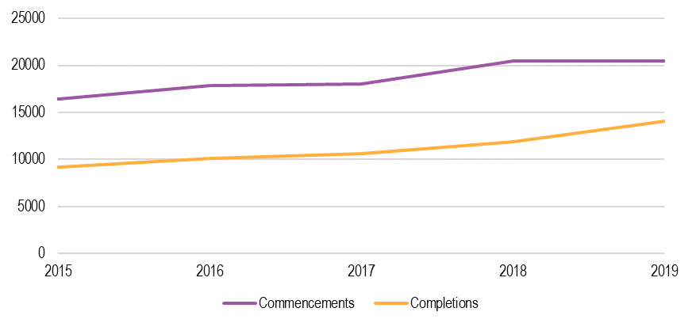  
SOURCE: ACIL ALLEN ANALYSIS OF HEIMS DATA, 2015-19.

#### Enrolled and Registered Nurses – Completions trends only

Completions for Enrolled and Registered Nurses are shown in Figure 2.5. 55,857 students completed nursing courses at universities, while 28,933 completed the Diploma of Nursing at vocational providers. The completions figures show an increase in supply of new Registered Nurses and a decrease in supply of Enrolled Nurses. This aligns with the UQ research which identified a small deficit in supply of Nurses that is expected to increase over time and may necessitate investment to increase nursing supply.

**FIGURE 2.5** ENROLLED AND REGISTERED NURSE – COMPLETIONS

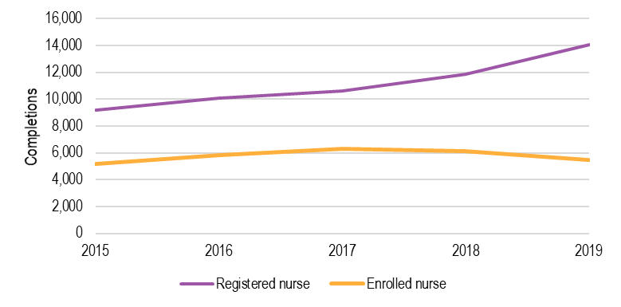SOURCE: ACIL ALLEN ANALYSIS OF VOCSTATS AND HEIMS DATA, 2015-19.

#### Mental Health Nurse – Commencements and completions

There is an increase in the number of nurses commencing specialist mental health studies, which is a positive sign given the recognised shortages in this role. However, the volume of students completing post-graduate studies is low when compared to the number that are identified as working in a mental health role – approximately 23,083 in 2018. [12] Completions for these courses have remained stable over time, but this may reflect the lag time produced through the additional length of study.

**FIGURE 2.6** MENTAL HEALTH NURSE – COMMENCEMENTS AND COMPLETIONS

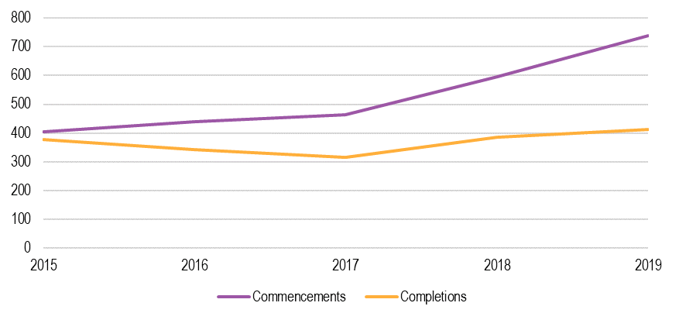SOURCE: ACIL ALLEN ANALYSIS OF HEIMS DATA, 2015-19.

2.1.5 Occupational Therapist

Occupational Therapists are regulated by the Occupational Therapy Board of Australia. Education and training pathways include both Bachelor of Occupational Therapy and Master of Occupational Therapy qualifications. The average length and cost of training for occupation therapy-related courses is 4 years and $29,000.

**TABLE 2.5** OCCUPATIONAL THERAPIST – MAPPED QUALIFICATIONS

|  |  |
| --- | --- |
| Role | Qualifications |
| **Occupational Therapist** | Bachelor of Occupational Therapy  Master of Occupational Therapy |

SOURCE: ACIL ALLEN CONSULTING, 2020.

#### Commencements and completions

Demand for Occupational Therapists is increasing, driven by an increasing recognition of the role in the health sector more broadly and specifically as a product of the maturation of the NDIS. There is a recognised shortage of Occupational Therapists, with the challenges exacerbated in rural areas. [13] While commencements have increased by 21.9 per cent over the last five years, the trend has stabilised in the last two years. This may indicate some issues with attraction to training, though consultations identified that courses remained highly competitive.

Completions for Occupational Therapists have plateaued over time, which aligns with the trends in commencements. Over 2015-19, 8,608 students completed courses in occupational therapy. In 2019, there were 1,615 completions recorded, an increase of 24.6 per cent compared to 2015. This indicates that growth in supply may not be sufficient to meet demands for service and could necessitate increased support to attract students to courses.

**FIGURE 2.7** OCCUPATIONAL THERAPIST – COMMENCEMENTS AND COMPLETIONS

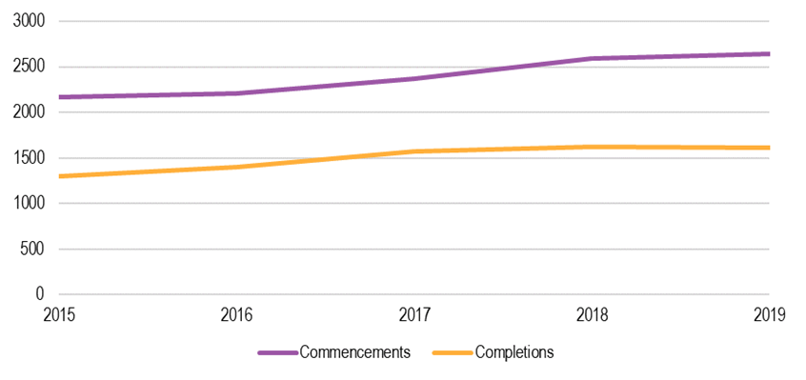SOURCE: ACIL ALLEN ANALYSIS OF HEIMS DATA, 2015-19.

2.1.6 Psychiatrist

Psychiatrists are regulated through AHRPA. To become a Fellow at the Royal Australian and New Zealand College of Psychiatrists (RANZCP), students must complete an undergraduate medical degree, at least one year of general medical training and hold current general registration as a medical practitioner in Australia or New Zealand. This is followed by a three stage process involving:

* 12 months in an adult psychiatry rotation, including a minimum of 6 months in an acute setting.
* 24 months, with four rotations designed to expose the trainee to a variety of different specialties.
* 24 months, with a further four rotations each of six months in duration.

Training takes, on average, 11 years which has been identified as the Productivity Commission as a key risk to addressing the growing shortage of qualified Psychiatrists.[14]

**TABLE 2.6** PSYCHIATRIST – MAPPED QUALIFICATIONS

|  |  |
| --- | --- |
| Role | Qualifications |
| **Psychiatrist** | Master of Psychiatry |

SOURCE: ACIL ALLEN CONSULTING, 2020.

#### Commencements and completions

Figure 2.8 shows the commencements over the five-year period. Between 2015 and 2018 there was a 56.5 per cent increase in commencements, but by the following year this number had fallen 21.3 per cent from its 2018 peak.

Over the period, 386 students completed a course in psychiatry. From 2017 onwards there was a marked increase in the number of students completing psychiatry courses. From 2017 to 2019, there was a 358.9 per cent increase, with 156 completions in 2019. This reflects a strong increase in the supply of new psychiatrists from 2017 onwards.

The Productivity Commission has highlighted both current and emerging shortages for Psychiatrists [15] and the need to increase supply. This aligns with UQ’s findings on the current and projected demand of the psychiatry workforce. [16]

**FIGURE 2.8** PSYCHIATRIST – COMMENCEMENTS AND COMPLETIONS

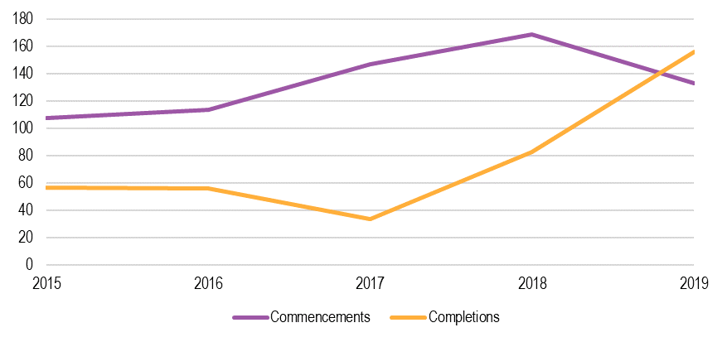SOURCE: ACIL ALLEN ANALYSIS OF HEIMS DATA, 2015-19.

2.1.7 Psychologist

The requirements for registration as a psychologist are determined by the Psychology Board of Australia (PsyBA) under AHPRA. This includes completion of a Bachelor of Psychology or bachelor’s degree with a major in psychology, an honours year or post-graduate diploma followed by:

* two-year postgraduate qualification (higher degree pathway)
* two-year internship (4+2 pathway)
* an additional year of study and one-year internship (5+1 pathway)
* at least two years of additional study and an area of practice endorsements (for example, for Clinical Psychologists).

**TABLE 2.7** PSYCHOLOGIST – MAPPED QUALIFICATIONS

|  |  |
| --- | --- |
| Role | Qualifications |
| **Psychologist** | Bachelor of Psychology / Psychological Science |

SOURCE: ACIL ALLEN CONSULTING, 2020.

#### Commencements and completions

Commencements in psychology courses have increased over time (Figure 2.9), which indicates continued attraction to studying in this field.[17] It is important to note that this should not be taken as representative of an increase in students interested in becoming Psychologists as the courses are generalist programs with broad employment opportunities upon completion.

Between 2015 and 2019, 42,022 students completed courses in psychology. This represents an 18.5 per cent increase over the time period. The Productivity Commission found no evidence of a shortage of psychologists, but did recognise a disconnect between the number of students choosing psychology degrees and the number of registered psychologists – with only 10% of students in 2017 going on to post-graduate training to become a registered Psychologist. Employment opportunities for graduates from psychology degrees are diverse and can include business operations, community development and relations, public health, management consultancy, human resources, and training roles, among others.

**FIGURE 2.9** PSYCHOLOGIST – COMMENCEMENTS AND COMPLETIONS

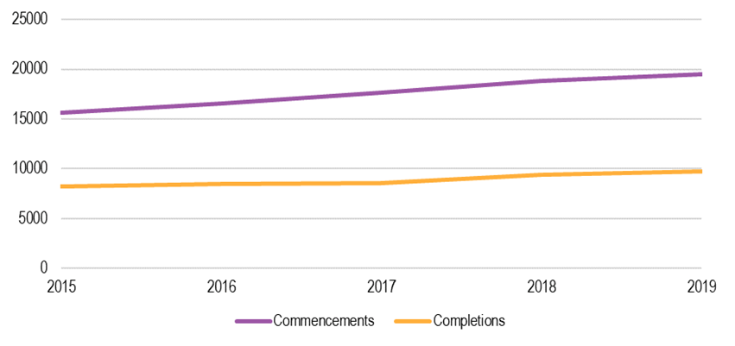SOURCE: ACIL ALLEN ANALYSIS OF HEIMS DATA. 2015-19.

2.1.8 Social Worker

Social Workers are self-regulated through the Australian Association of Social Workers. Education and training pathways include both Bachelor of Social Work and Master of Social Work qualifications. The average length of training is 4 years, and data were not available on the average course costs.

**TABLE 2.8** SOCIAL WORKER – MAPPED QUALIFICATIONS

| Role | Qualifications |
| --- | --- |
| **Social Worker** | Bachelor of Social Work  Master of Social Work |

SOURCE: ACIL ALLEN CONSULTING, 2020.

#### Commencements and completions

Interest in social work-related courses remains high and has increased over time. Figure 2.10 shows the number of commencements in courses related to social work over the 2015 to 2019 period, where there was a 23.2 per cent increase in commencements.

Completions for social work courses have increased by a 37.9 per cent, with over half of this increase occurring between 2018 and 2019. This aligns with the findings of the UQ research, which identified that the supply of Social Workers aligns closely with current demand. [18]

**FIGURE 2.10** SOCIAL WORKER – COMMENCEMENTS AND COMPLETIONS

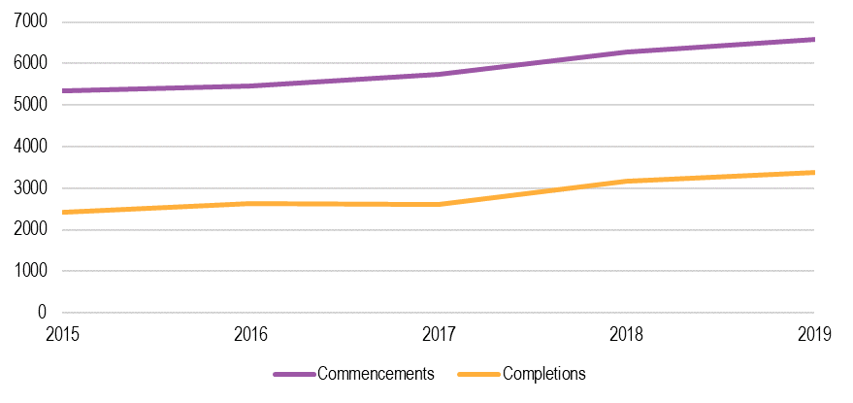SOURCE: ACIL ALLEN ANALYSIS OF HEIMS DATA, 2015-19.

2.1.9 Speech Pathologist

Speech Pathologists are self-regulated through Speech Pathology Australia. Education and training pathways include a Bachelor of Speech Pathology or Master of Speech Pathology. The length of training is generally 4 years.

**TABLE 2.9** SPEECH PATHOLOGIST – MAPPED QUALIFICATIONS

|  |  |
| --- | --- |
| Role | Qualifications |
| **Speech Pathologist** | Bachelor of Speech Pathology  Master of Speech Pathology |

SOURCE: ACIL ALLEN CONSULTING, 2020.

#### Commencements and completions

Commencements and completions for speech pathology courses have remained relatively stable from 2015 to 2019, with a general upward trend (Figure 2.11). There is no current evidence of a workforce shortage for Speech Pathologists, though the labour market is tightening as demand increases through the NDIS and other health sector programs.[19] This may indicate that current training levels are sufficient and in line with workforce needs, but will require monitoring.

**FIGURE 2.11** SPEECH PATHOLOGIST – COMMENCEMENTS AND COMPLETIONS

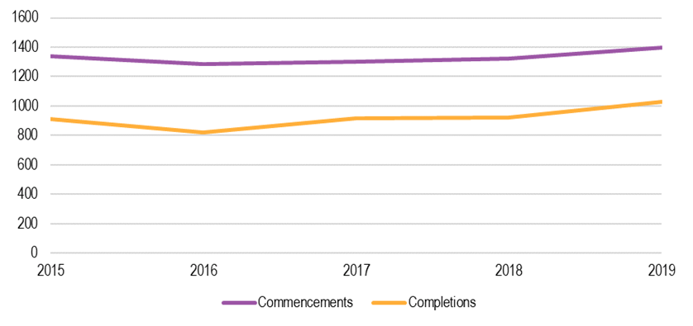SOURCE: ACIL ALLEN ANALYSIS OF HEIMS DATA, 2015-19.

2.2 Vocationally trained roles

2.2.1 Aboriginal and Torres Strait Islander Health Worker

Aboriginal and Torres Strait Islander Health Workers are regulated by the Aboriginal and Torres Strait Islander Health Practice Board of Australia (ATSIHPBA), under AHPRA. Aboriginal Health Practitioners, a protected title, must be registered and hold a Certificate IV in Aboriginal and/or Torres Strait Islander Primary Health Care (Practice).

In areas where the protected title does not apply, the roles of Aboriginal and Torres Strait Islander Health Workers are defined differently by jurisdictions and have diverse education and training pathways. This could include a range of qualifications from Certificate III to Advanced Diploma, as summarised in the table below.

The length of training for Aboriginal and Torres Strait Islander Health Workers takes, on average, 12 months full time and costs $5,925. The majority of training (approximately 80%) in these qualifications is delivered through public providers, though the proportion of private RTOs delivering the Certificate IV is higher than other qualifications.

**TABLE 2.10** ABORIGINAL AND TORRES STRAIT ISLANDER HEALTH WORKER – MAPPED QUALIFICATIONS

| **Role** | **Qualification** |
| --- | --- |
| **Aboriginal and Torres Strait Islander Health Worker** (protected title) | Certificate IV in Aboriginal and/or Torres Strait Islander Primary Health Care (Practice). |
| **Non-protected titles**  (Aboriginal Mental Health Worker)  (Aboriginal Health Practitioner) | Certificate II in Aboriginal and/or Torres Strait Islander Primary Health Care  Certificate III in Aboriginal and/or Torres Strait Islander Primary Health Care  Diploma in Aboriginal and/or Torres Strait Islander Primary Health Care  Advanced Diploma in Aboriginal and/or Torres Strait Islander Primary Health Care[20] |

SOURCE: ACIL ALLEN CONSULTING, 2020.

#### Enrolments

Enrolments are increasing for the Certificate IV in Aboriginal and/or Torres Strait Islander Primary Health Care (Practice) but remain low for other qualifications linked to this role. Given shortages of Aboriginal and Torres Strait Islander Health Workers[21], further initiatives may be required to incentivise potential students to enter training in the Certificate IV.

Figure 2.12 shows the trends for enrolments in the courses associated with Aboriginal and Torres Strait Islander Health Workers in the vocational education sector from 2015 to 2019. Over this period, enrolments in the Certificate IV in Aboriginal and/or Torres Strait Islander Primary Health Care Practice have doubled, from 524 in 2015 to 1084 in 2019. This course alone represents over half of the enrolments of the courses in this grouping, which is likely associated with the connection to protected title.

The Certificate III in Aboriginal and/or Torres Strait Islander Primary Health Care also saw an increase of 40 per cent over the time period, from 320 enrolments in 2015 to 448 enrolments in 2019. The Certificate II in Aboriginal and/or Torres Strait Islander Primary Health Care and the Certificate IV in Aboriginal and/or Torres Strait Islander Primary Health (Community Care) saw enrolments decline. At the Diploma level, the number of enrolments was consistently low.

**FIGURE 2.12** ABORIGINAL AND TORRES STRAIT ISLANDER HEALTH WORKER – QUALIFICATION ENROLMENTS

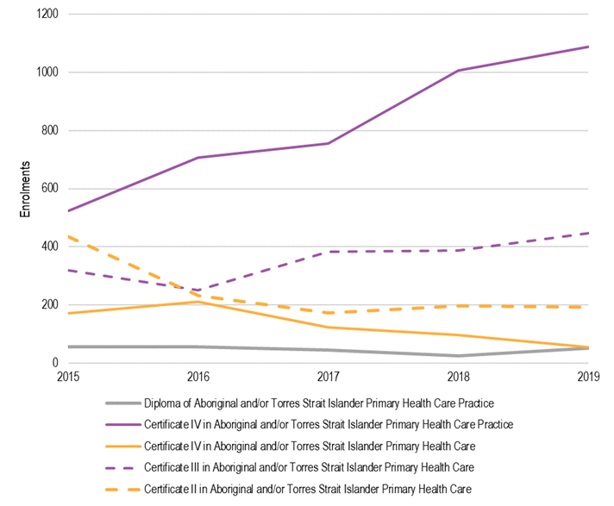

SOURCE: ACIL ALLEN CONSULTING ANALYSIS OF VOCSTATS DATA, 2015-19.

#### Completions

Completions for the Aboriginal and Torres Strait Islander Health Worker qualifications vary by qualification, though there appears to be an increasing supply of potential workers (Figure 2.13). Though there is an increasing supply, consultations identified that completions are generally quite low and can vary between 30 and 70 per cent. Factors that drive low completions for Aboriginal and Torres Strait Islander Health Workers include personal circumstances, difficulty in financing course costs, and time required away from community to attend face-to-face training.

**FIGURE 2.13** ABORIGINAL AND TORRES STRAIT ISLANDER HEALTH WORKER – COMPLETIONS

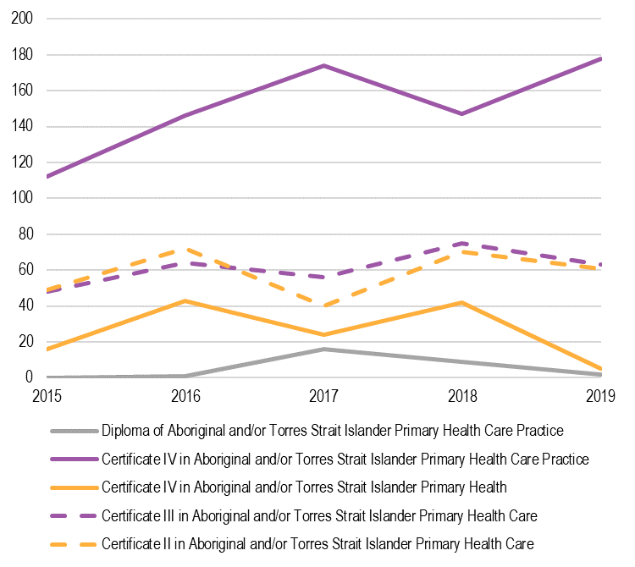

SOURCE: ACIL ALLEN ANALYSIS OF VOCSTATS DATA, 2015-19.

2.2.2 Allied Health Assistant

Allied Health Assistants work under the direction or supervision of Allied Health professionals to provide support to clients across a range of area and are not nationally regulated. Education and training pathways for Allied Health are summarised below.

**TABLE 2.11** ALLIED HEALTH ASSISTANT – MAPPED QUALIFICATIONS

|  |  |
| --- | --- |
| Role | Qualifications |
| **Allied Health Assistant** | Certificate III in Allied Health Assistance  Certificate IV in Allied Health Assistance |

SOURCE: ACIL ALLEN CONSULTING, 2020.

The length of training for Allied Health Assistants varies between 6 months for the Certificate III and 1 year (full time) for the Certificate IV. The average cost of training is $3567 and $8295 respectively, although these courses are subsidised in some jurisdictions including VIC, NSW, SA and WA. Most training is provided through the public system.

#### Enrolments

There has been a recent increase in the number of enrolments in qualifications for Allied Health Assistants. This trend has likely been driven by the increasing focus on this role through the NDIS, where Allied Health Assistants are increasingly being employed to address shortages of other allied health professionals.

Figure 2.14 shows the trends for enrolments in Allied Health Assistant courses from 2015 to 2019. Over this period, enrolments in the Certificate III and IV in Allied Health Assistance initially decreased but have returned close to their original level. The Certificate IV saw a significant increase in enrolments between 2018 and 2019 of approximately 20 per cent.

**FIGURE 2.14** ALLIED HEALTH ASSISTANT – ENROLMENTS

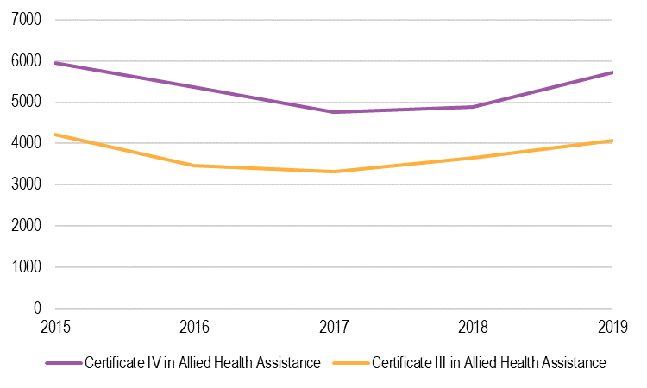  
SOURCE: ACIL ALLEN ANALYSIS OF VOCSTATS DATA, 2015-19.

#### Completions

Completions for Allied Health Assistant qualifications have varied significantly over 2015 to 2019, with a general downward trend in supply of potential workers. Figure 2.15 shows the completions over the period. In 2019, there were 1069 completions of the Certificate IV and 835 completions of the Certificate III.

**FIGURE 2.15** ALLIED HEALTH ASSISTANT – COMPLETIONS

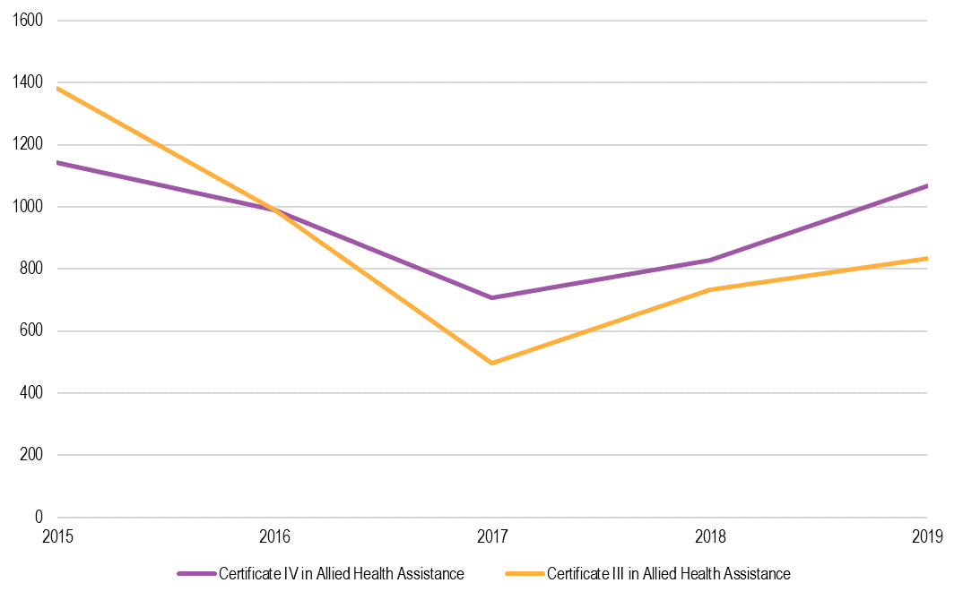

SOURCE: ACIL ALLEN ANALYSIS OF VOCSTATS DATA, 2015-19.

2.2.3 Lived Experience (Peer) Worker

Lived Experience (Peer) Workers are not regulated at national or state levels. Education and training pathways into Lived Experience (Peer) roles are diverse. There are no minimum educational requirements and Lived Experience (Peer) workers can also operate in the sector with no formal qualifications. While generally valued for their experiential skills, consultations identified the benefit of increased consistency around training and education to provide confidence in the level of skills held by Lived Experience (Peer) Workers.

The table below outlines the qualifications that have clear occupational linkages with Lived Experience (Peer) roles.

**TABLE 2.12** LIVED EXPERIENCE (PEER) WORKER – MAPPED QUALIFICATIONS

|  |  |
| --- | --- |
| Role | Qualifications |
| **Lived Experience (Peer) Worker** | Certificate IV in Mental Health Peer Work  Mental Health Peer Work Skill Set[22] |

SOURCE: ACIL ALLEN CONSULTING, 2020.

The length of training is, on average, 8 months and costs $4,000. Subsidised places are available in VIC, NSW, SA and WA. Most training is provided by public providers, with few private RTOs offering the qualification.

#### Enrolments

Enrolments are increasing for the Certificate IV in Mental Health Peer Work but have stabilised somewhat over 2018 to 2019 (Figure 2.16). Given the scale of current and projected future shortages for Lived Experience (Peer) workers[23], further initiatives may be required to incentivise potential students to enter training in the Certificate IV.

Consultations identified that barriers to enrolment may include the cost of training (both in terms of fees and lost income), difficulties in completing the academic requirements of the qualification and personal circumstances (such as caring responsibilities or mental ill-health).

**FIGURE 2.16** LIVED EXPERIENCE (PEER) WORKERS – ENROLMENTS

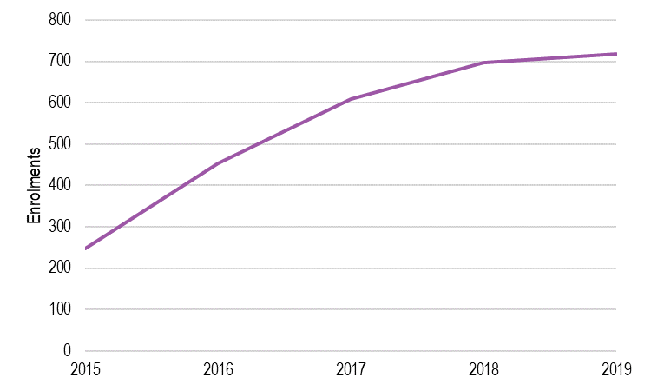

SOURCE: ACIL ALLEN ANALYSIS OF VOCSTATS DATA, 2015-19.

#### Completions

Completion rates for the Certificate IV in Mental Health Peer Work have increased over time, in line with the improvements in enrolments. Over the period, 707 students completed the Certificate IV in Mental Health Peer Work. This indicates there is an increasing availability of Lived Experience (Peer) Workers, although it could be anticipated that numbers will plateau in line with enrolments and will fall short of demand.

**FIGURE 2.17** CERTIFICATE IV IN MENTAL HEALTH PEER WORK - COMPLETIONS

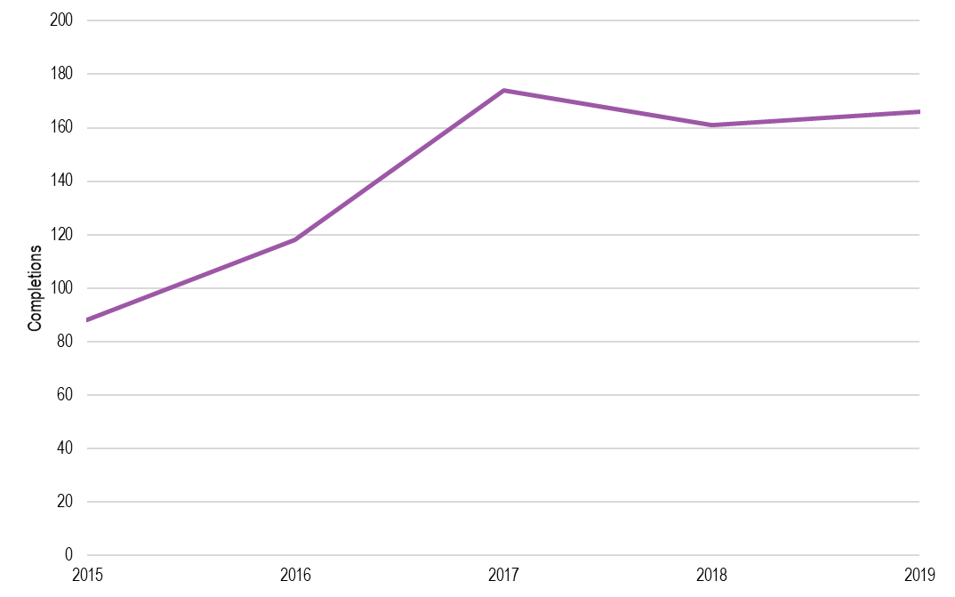

SOURCE: ACIL ALLEN ANALYSIS OF VOCSTATS DATA, 2015-19.

2.2.4 Mental Health Worker

Mental Health Workers are not nationally regulated. Education and training pathways into Mental Health Worker roles are diverse. There are no minimum educational requirements for Mental Health Workers. Mental Health Workers can also operate in the sector with no formal qualifications.

The table below outlines the qualifications that have clear occupational linkages with Mental Health Worker roles.

**TABLE 2.13** MENTAL HEALTH WORKER – MAPPED QUALIFICATIONS

|  |  |
| --- | --- |
| Role | Qualifications |
| **Mental Health Worker** | Certificate III in Individual Support  Certificate IV in Ageing Support  Certificate IV in Disability  Certificate IV in Alcohol and Other Drugs  Certificate IV in Mental Health  Diploma of Alcohol and Other Drugs  Diploma of Mental Health |

SOURCE: ACIL ALLEN CONSULTING, 2020.

Though these qualifications have related occupational outcomes, there is limited overlap in content. The table below outlines the core units within each of the qualifications, with common units highlighted in bold. It shows that there are common skills in working with diverse people, working legally and ethically, and providing services. Other skills may be common, but units of competency are tailored to specific sectors.

TABLE 2.14 MAPPING OF MENTAL HEALTH WORKER RELATED CONTENT

| Certificate IV (Mental Health) | Certificate IV in AOD | Certificate IV in Disability | Certificate IV in Ageing Support | Certificate III in Ind. Support | Diploma of Mental Health | Diploma of AOD |
| --- | --- | --- | --- | --- | --- | --- |
| **Work with diverse people**  **Work legally and ethically**  Promote Aboriginal and/or Torres Strait Islander cultural safety  Establish self-directed recovery relationships  Provide recovery oriented mental health services  Work collaboratively with the care network and other services  Provide services to people with co-existing mental health and alcohol and other drugs issues  Work effectively in trauma informed care  Promote and facilitate self-advocacy  Assess and promote social, emotional and physical wellbeing  Participate in workplace health and safety | **Work with diverse people**  **Work legally and ethically**  Work in an alcohol and other drugs context  Assess needs of clients with alcohol and other drugs issues  Provide interventions for people with alcohol and other drugs issues  Develop and review individual alcohol and other drugs treatment plans  Assess co-existing needs  Provide brief interventions  Use communication to build relationships  Work with people with mental health issues  Develop and maintain networks and collaborative partnerships  Provide first aid | **Work with diverse people**  Provide individualised support  Follow established person-centred behaviour supports  Develop and provide person-centred service responses  Facilitate the empowerment of people with disability  Facilitate community participation and social inclusion  Facilitate ongoing skills development using a person-centred approach  Provide person-centred services to people with disability with complex needs  Manage legal and ethical compliance  Recognise healthy body systems  Follow safe work practices for direct client care | **Work with diverse people**  Facilitate the interests and rights of clients  Facilitate the empowerment of older people  Coordinate services for older people  Implement interventions with older people at risk  Provide support to people living with dementia  Facilitate individual service planning and delivery  Meet personal support needs  Support independence and wellbeing  Support relationships with carers and families  Manage legal and ethical compliance  Deliver care services using a palliative approach  Develop and maintain networks and collaborative partnerships  Recognise healthy body systems  Follow safe work practices for direct client care | **Work with diverse people**  **Work legally and ethically**  Provide individualised support  Support independence and well being  Communicate and work in health or community services  Recognise healthy body systems  Follow safe work practices for direct client care | **Work with diverse people**  **Provide systems advocacy services**  **Provide services to people with co-existing mental health and alcohol and other drugs issues**  **Research and apply evidence to practice**  **Reflect on and improve own professional practice**  Promote Aboriginal and/or Torres Strait Islander cultural safety  Establish self-directed recovery relationships  Provide recovery oriented mental health services  Work collaboratively with the care network and other services  Provide early intervention, health prevention and promotion programs  Implement recovery oriented approaches to complexity  Assess and promote social, emotional and physical wellbeing  Provide support to develop wellness plans and advanced directives  Implement trauma informed care  Manage work health and safety | **Work with diverse people**  **Provide systems advocacy services**  **Provide services to people with co-existing mental health and alcohol and other drugs issues**  **Research and apply evidence to practice**  **Reflect on and improve own professional practice**  Work in an alcohol and other drugs context  Assess needs of clients with alcohol and other drugs issues  Provide interventions for people with alcohol and other drugs issues  Develop strategies for alcohol and other drugs relapse prevention and management  Provide advanced interventions to meet the needs of clients with alcohol and other drug issues  Develop and review individual alcohol and other drugs treatment plans  Assess co-existing needs  Establish and manage client relationships  Work effectively in trauma informed care  Collaborate in professional practice  Provide first aid |

The length of training is 12 months full time, and costs vary significantly across the different qualifications from $4,000 for mental health qualifications and up to $10,000 for alcohol and other drugs. Subsidised places are available in VIC, NSW, SA and WA. When compared with other vocationally trained roles, a higher proportion of training is delivered through private providers (50% for the Certificate IV in Mental Health and up to 80% for the Certificate IV in Ageing Support).

#### Enrolments

Enrolments in qualifications related to Mental Health Worker roles have remained relatively consistent over 2015 to 2019 (Figure 2.18). Enrolments in the Certificate IV in Mental Health and Diploma of Mental Health have remained relatively consistent over the period and are notably lower than other qualifications in the community sector.

Consultations indicated that there is limited awareness of pathways into mental health work through these qualifications, and limited incentive to enrol given the low relationship to employment outcomes. Given the scale of current and projected future shortages for Mental Health Workers[24] and increasing preferences from employers for qualified employees, further initiatives may be required to incentivise potential students to enter training.

**FIGURE 2.18** MENTAL HEALTH WORKER – ENROLMENTS

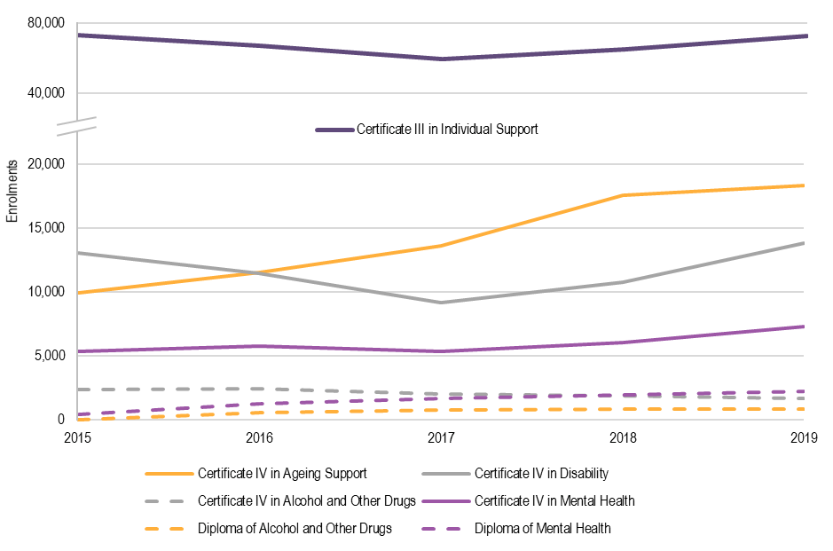

SOURCE: ACIL ALLEN CONSULTING ANALYSIS OF VOCSTATS DATA, 2015-19.

#### Completions

Completions for Mental Health Worker related qualifications have decreased as a whole, with 18.5 per cent fewer completions recorded in 2019 than in 2015 (Figure 2.19). This presents a risk to the availability of vocationally qualified Mental Health Workers, particularly given the recognised deficits identified by UQ.

**FIGURE 2.19** MENTAL HEALTH WORKERS – COMPLETIONS

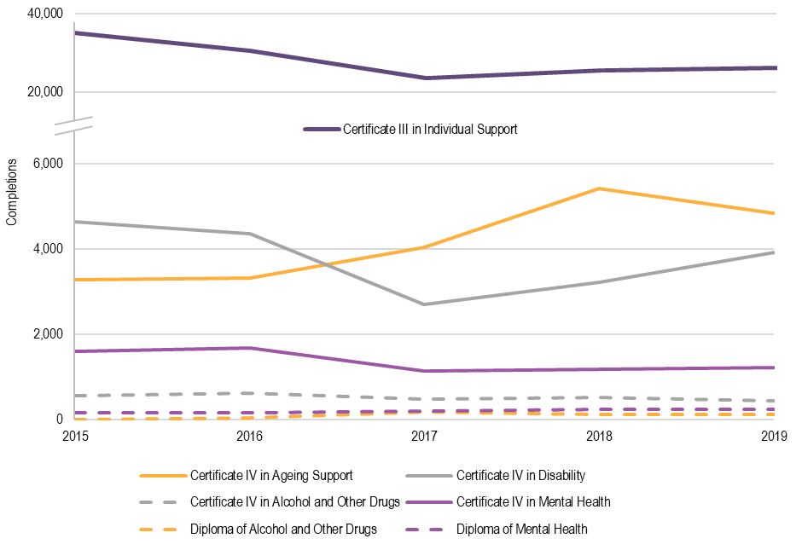

SOURCE: ACIL ALLEN ANALYSIS OF VOCSTATS DATA, 2015-19.

## 2.3 Demand for courses

2.3.1 Commencements / Enrolments

The level of interest in courses associated with the professional and occupational groups listed above has generally increased over time. This indicates that there are few issues with attracting students to training in courses associated with the mental health sector. The exceptions to this trend included Allied Health Assistants, General Practitioners, Mental Health Workers, Enrolled Nurses and Psychiatrists.

The majority of the mental health workforce currently obtains entry-level qualifications through self-funded or government subsidised study, often undertaken prior to employment in the sector or while working in a non-professional role. This includes Counsellors/Psychotherapists, Dietitians, General Practitioners, Nurses, Occupational Therapists, Psychiatrists, Psychologists, Speech Pathologists and Social Workers. There was little evidence of employers supporting the funding of training.

Self-funded study can be challenging to support for those where there is no requirement to hold a qualification to practice, and where wages are generally low. This includes Aboriginal and Torres Strait Islander Health Workers, Lived Experience (Peer) Workers, and Mental Health Workers. Consultations identified financial pressures (for example, lost income and course fees) as key barriers to entering training.

Availability of local training offerings also impacts on enrolments. This was relevant for rural and remote students across all professional and occupational groups, and for Aboriginal and Torres Strait Islander Health Workers who may have difficulty in attending training off-country.

While the trends over the last five years indicate increasing interest in courses, there are factors which could influence future enrolment trends including changes to minimum qualification requirements. Any change to the minimum qualification requirements for unregulated roles (for example, Lived Experience (Peer) and Mental Health Worker roles) could drive increased demand for training. Similar patterns have been observed in the disability sector where the establishment of qualification requirements through the Victorian Disability Worker Registration Scheme are driving an increase in training delivery.

Changes to higher education funding may also have an impact. On 19 October 2020, the Job-ready Graduates Package passed in parliament. Under the Job-ready Graduates Package, the annual cost of study will increase or decrease for different roles in the mental health workforce. The table below provides a summary of those changes.

**TABLE 2.15** IMPACT ON MAXIMUM STUDENT FEE CONTRIBUTIONS

| Professional / occupational group | Current model | New model | Impact | | |
| --- | --- | --- | --- | --- | --- |
|  |  |  | **Cost ($)** | **%** | |
| **Counsellor / Psychotherapist***\** | Band 1: $6,804 | Band 2: $7,950 | + 1,146 | + 17 | ▲ |
| **Dietitian** | Band 2: $9,698 | Band 2: $7,950 | - 1,748 | - 18 | ▼ |
| **General Practitioner** | Band 3: $11,355 | Band 3: $11,300 | - 55 | - 0.5 | ⚫ |
| **Nurse (Registered)** | Band 1: $6,804 | Band 1: $3,950 | - 2,854 | - 42 | ▼ |
| **Nurse (Mental Health)** | Band 1: $6,804 | Band 1: $3,950 | - 2,854 | - 42 | ▼ |
| **Occupational Therapist** | Band 2: $9,698 | Band 2: $7,950 | - 1,748 | - 18 | ▼ |
| **Psychiatrist** | Band 3: $11,355 | Band 3: $11,300 | - 55 | - 0.5 | ⚫ |
| **Psychologist\*** | Band 1: $6,804 | Band 2: $7,950 | + 1,146 | + 17 | ▲ |
| **Psychologist (Clinical)** | Band 1: $6,804 | Band 1: $3,950 | - 2,854 | - 42 | ▼ |
| **Social Worker\*** | Band 1: $6,804 | Band 2: $7,950 | + 1,146 | + 17 | ▲ |
| **Speech Pathologist** | Band 2: $9,698 | Band 2: $7,950 | - 1,748 | - 18 | ▼ |

Note: * Disciplines of Professional Pathway Social Work and Professional Pathway Psychology. † Post graduate clinical psychology.

SOURCE: ACIL ALLEN, 2020.

It is important to note that the impact of the proposed changes for Counsellors/ Psychotherapists, Psychologists and Social Workers differs based on whether units of study are recognised under two newly developed ‘Professional Pathways’ for Social Work and Psychology. Should students undertake study in units that are not aligned to these pathways, the associated cost could increase to Band 4 ($13,500). The allocation of units to the Professional Pathways has not yet been finalised and is being overseen by a working group overseen by the Commonwealth Government. The financial implications of these reforms could reduce demand for courses in future, though no data is available on the scale of impact.

2.3.2 Completions

Completions are trending upwards in line with enrolments over the 2015-2019 period. As data were not available on completions as a proportion of enrolments, it is difficult to comment on specific issues around completions.

Notwithstanding this, health-related courses have the lowest risk of non-completions in the higher education sector, with medical students recognised as having one of the highest completion rates. Other mental health-related fields including nursing, physiotherapy and public health have higher completions than non-health related courses.[25] This high completion rate is generally driven by the close correlation with occupational outcomes in the health sector, though it is unclear what proportion of health graduates choose to enter the mental health sector specifically.

Low completion rates were observed for the Aboriginal and Torres Strait Islander Health Workers, Lived Experience (Peer) Workers, and Mental Health Workers. Barriers to completion largely aligned with barriers to entry and covered financial impacts, travel difficulties and personal circumstances.

Changes in interest over time can also influence completion. Preferred roles shift as students get older which reflects changing understanding of work environments, job prospects and fields of interest.[26] Research on higher education qualifications has shown that completion rates are influenced by student characteristics such as capability, socio-economic status, and full or part time study. Two other factors have a strong impact on completions:

* Aboriginal or Torres Strait Islander status [27] – Aboriginal and Torres Strait Islander students have a higher risk of non-completion, compared with non-Indigenous students. While this statistic is not specific to health-related education, the trends are consistent across disciplines.[28] Consultations indicated that completions can be supported through improved connections between Aboriginal and Torres Strait Islander Liaison Officers and students, when travelling off country to study.
* Rural and remote locations – Regional and remote students increasingly move to metropolitan locations to study and are more likely to cite financial and fee difficulties as their reason for not completing due to the stress of supporting life away from home.[29]

There is limited data available to track student journeys through training to employment. Improving data collection around student pathways would improve understanding of whether they return to study later, shift to a different qualification (for example, in the VET sector) or move into employment. Consultations identified that many of those who don’t complete mental health-related training may move into a different field or return at a later date.

2.3.3 Upskilling, continuing professional development and employer support for training

Service funding arrangements are a key driver of limited employer-supported training. Current funding structures are generally activity-based and do not include sufficient loadings for training or development. This makes it challenging for employers to facilitate employee training, either financially (due to limited resourcing) or by providing time off (due to workforce shortages).

There are few accredited training opportunities available for upskilling or continuing professional development (CPD) regarding mental health practice.[30] As such, there is limited data available on the uptake or CPD practices across all professional and occupational groups. One exception is NSW Health’s Higher Education Training Institute, which provides postgraduate courses in Applied Mental Health Studies and Psychiatric Medicine. The close connection to contemporary practice and applied learning were highlighted through consultations as key strengths of these offerings.

The level of employer support for upskilling or CPD is critical for all professional and occupational groups but affects roles in different ways. For professional groups with mandatory CPD requirements, there are difficulties in accessing time off to complete the required training. This is a greater challenge in public settings than it is in private. Consultations indicated that employers in the private setting were more likely to provide time and funding to support CPD activities.

For occupational groups without formal training or CPD requirements (namely Lived Experience (Peer) and Mental Health Workers), there is limited incentive for employers to support development due to the funding arrangements. Relatively low wages and high casualisation[31] of these groups make it difficult for workers to support their own development, in the absence of employer assistance.

## 2.4 Appropriateness of course content

Important to workforce quality is the extent to which course content aligns with the requirement of professional associations, industry and contemporary practice requirements.

Existing processes for universities to be accredited to deliver courses by professional associations are summarised in the table below by role. Professional associations reported that the content of current education and training programs aligned well with the needs of the mental health sector, which is likely a product of these accreditation processes.

**TABLE 2.16** ACCREDITATION PROCESS BY ROLE

| Role | Course accreditation |
| --- | --- |
| **Aboriginal and Torres Strait Islander Health Worker** | Recognition of nationally recognised qualification (Certificate IV) as regulated by the Australian Skills Quality Authority. |
| **Allied Health Assistant** | No accreditation process through professional associations due to the lack of minimum qualification requirements.  Qualification content accredited through the National Skills Standards Council. |
| **Counsellor / Psychotherapist** | Training providers and educational institutions apply to have counselling and psychotherapy education programs assessed and accredited by PACFA and ACA. The accreditation process involves rigorous, independent assessment of counselling and psychotherapy training programs and leads to the designation of ‘PACFA Accredited Course’ or ‘ACA Accredited Course’. |
| **Dietitian** | Educational providers can apply to have minimum bachelor-level qualifications accredited against National Competency Standards for Dietitians, which involves review of program’s governance, staffing, resources, curriculum, professional placement program, and processes for international students. |
| **General Practitioner** | The Australian Medical Council (AMC) is responsible for accrediting education providers and programs of study, which includes medical schools (successful completion of an approved program of study qualifies a person for general registration) and specialist medical colleges (successful completion of an approved program of study in a recognised medical specialty from these accredited education providers qualifies a person for specialist registration). |
| **Lived Experience (Peer) Worker** | No accreditation process through professional associations due to the lack of minimum qualification requirements.  Qualification content accredited through the National Skills Standards Council. |
| **Mental Health Worker** | No accreditation process through professional associations due to the lack of minimum qualification requirements.  Qualification content accredited through the National Skills Standards Council. |
| **Nurse** | The Australian Nursing and Midwifery Accreditation Council (ANMAC) accredits education providers and programs of study for the nursing and midwifery profession, including Registered Nurse Accreditation Standards (2012), Enrolled Nurse Accreditation Standards (2017) and Nurse Practitioner Accreditation Standards (2015). |
| **Occupational Therapist** | Occupational Therapy of Australia Ltd (OTC) to accredits education providers and programs of study for the occupational therapy profession, through the *Accreditation standards for entry-level occupational therapy education programs* (December 2018). |
| **Psychiatrist** | The RANZCP accredits training programs and posts in psychiatry through accreditation standards covering main educational, clinical, and governance areas. |
| **Psychologist** | Programs must first be accredited by APAC before they can be approved by the Psychology Board of Australia (PsyBA) as suitable programs of study for the purpose of registration as a psychologist. |
| **Speech Pathologist** | Speech Pathology Australia (the Association) grants accreditation to speech pathology programs that meet the prescribed accreditation standards (for both undergraduate and post-graduate. |
| **Social Worker** | The AASW accredits both Bachelor of Social Work and Master of Social Work qualifications for entry into the social work profession. Graduates of accredited social work courses are eligible for membership of the AASW. |
| Source: ACIL Allen Consulting, 2020. | |
|  | |

Where there were strong linkages between accreditation standards and courses, industry and employers reported that course content generally provided graduates with the knowledge and skills required to operate in contemporary practice environments. There were key capability gaps regarding trauma informed practice and cultural safety, and it was reported that these gaps apply to both new graduates and the existing workforce.

Feedback on course content for unregulated roles was more mixed. For both Lived Experience (Peer) and Mental Health Workers, course content was seen to provide strong foundational skills in working with people with mental ill health and their families, recovery approaches and diversity. There were reported gaps in building skills required to work in interdisciplinary teams and organisational environments (the more generic aspects of mental health work).

A key challenge for course content was the alignment between the capabilities being developed by students and their roles post-graduation. For Aboriginal and Torres Strait Islander Health Workers, employers were reportedly not utilising the full suite of trained capabilities, instead employing Aboriginal and Torres Strait Islander Health Workers in a narrower role. For Psychologists and Occupational Therapists, entry-level positions were often generic mental health roles that did not allow for the application of discipline-specific skills. This points to a potential disconnect between the discipline-specific focus of education and training programs and the current design of some roles within the mental health sector. This is explored further in the Labour Market Analysis due to the impact on workforce retention.

## 2.5 Diversity of modes of delivery

Modes of delivery for education and training programs impact on the access for different student cohorts. The figures below provide aggregate data on the proportion of content by delivery mode within higher education courses. This provides an insight into the relative need for face-to-face training for each of the tertiary qualified roles.

The majority of delivery occurs through face-to-face training, which is likely a product of the current accreditation standards for respective disciplines. These standards generally include specific requirements for face to face training, given the need to develop and assess practical skills in applied environments. The specific requirements vary, with some stipulating percentage of course content by delivery mode and others stipulating specific content that must be delivered through face to face training. The data indicate that the roles with the current highest needs for face to face training include GPs, Occupational Therapists, and Speech Pathologists.

**FIGURE 2.20** PROPORTION OF COURSE CONTENT BY MODE OF DELIVERY – HIGHER EDUCATION

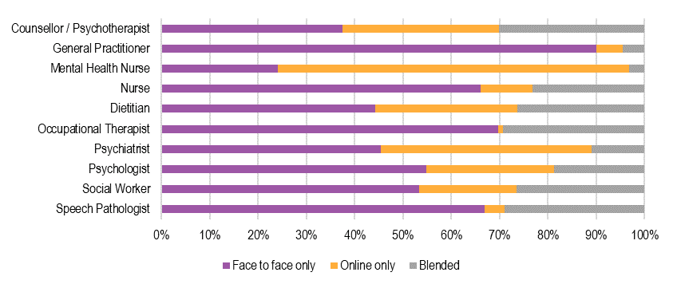  
  
SOURCE: ACIL ALLEN CONSULTING ANALYSIS OF HEIMS DATA, 2019.

Delivery trends are much more varied for vocational qualifications. National Training Package Standards include requirements for delivery mode specific to the qualification, rather than through professional associations and accreditation standards. The proportion of online qualifications is low when compared with overall delivery in the vocational education and training sector.

**FIGURE 2.21** PROPORTION OF COURSE CONTENT BY MODE OF DELIVERY – VOCATIONAL EDUCATION

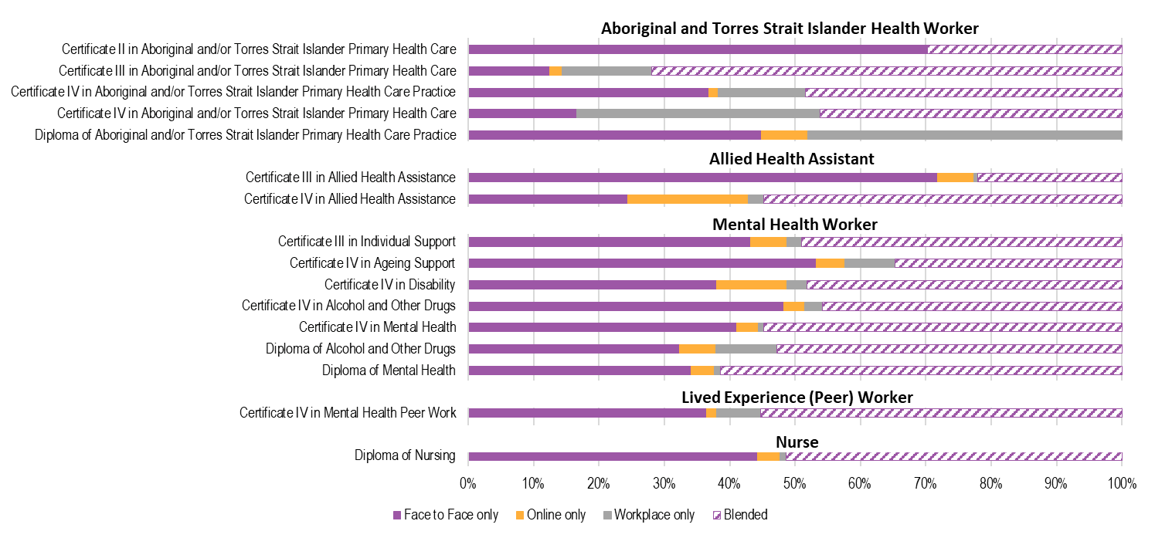

SOURCE: ACIL ALLEN ANALYSIS OF VOCSTATS DATA, 2019.

# 3. Opportunities

**This chapter explores opportunities to improve training and education and explores the factors that influence the capacity of educational institutions to respond to increased demand for mental health-related training.**

## 3.1 Addressing workforce shortages

There is generally strong demand for mental health-related courses, as evident through the current level of and trends for enrolments. However, to meet the increasing demands on the mental health system, there remains a need to increase the supply of potential workers. Current and emerging shortages can be addressed, in part, by attracting new student cohorts to study, increasing the number of appropriately trained graduates and encouraging graduates to enter employment in the mental health sector.

## 3.2 Enhancing course attractiveness

### Positive career pathways

Education providers are hesitant to scale-up training delivery without clear evidence of student demand. Increased delivery is dependent on generating sufficient interest to achieve required student numbers for a course to be viable. Student demand is generally associated with the perceptions of employment outcomes. For the mental health sector, where some roles are perceived to have poor remuneration or career pathways[32], student demand could limit the viability of increased delivery.

This may require the development of campaigns or activities to improve the attractiveness of careers in the mental health sector, and thus raise the demand from students. The Productivity Commission recommends that ‘governments and specialist medical colleges should take further steps to reduce the negative perception of, and to promote, mental health as a career option’. [33]

A key driver for student demand is the clarity of training and education pathways. In the vocational sector, there is an absence of clear education and training pathways for school leavers or adult learners into the community services industry (and consequently to mental health-related roles), and an absence of clear transition points for existing workers wanting to progress or diversify their careers.[34] There are also limited incentives for students to undertake self-funded study to obtain a vocational qualification as these qualifications often have a low impact on earning capacity or access to higher roles. In addition, the employment conditions associated with entry-level roles (i.e. low pay, insecure work, casual and part-time employment) reduce the attractiveness of work.

The development of clearer pathways through education and training to employment could help to improve the attraction of new students to training. This would apply to all professional and occupational groups in the mental health workforce but would be particularly important for Aboriginal and Torres Strait Islander Health Workers, Lived Experience (Peer) Workers and Mental Health Workers – roles where current variation in practice impacts on the clarity of opportunities. Lessons could be drawn from the current articulation pathways for Nursing, that link vocational and higher education pathways to clear employment and practice outcomes.

### Diversified delivery

Improving the accessibility of training is a further opportunity. Access to locally-based training is a recognised barrier for rural and remote students and Aboriginal and Torres Strait Islander Health Workers, in particular. The value of online delivery improving accessibility is being increasingly recognised by professional associations. In part, this is due to the COVID-19 pandemic which necessitated a transition to online delivery. While there is broad support for enhanced delivery through online mechanisms, consultations identified the need for appropriate compliance mechanisms to ensure that quality is maintained.

Current accreditation standards for programs (both from professional associations and through national Training Package Standards) generally require that certain aspects of training are delivered through face-to-face engagement to ensure that practical skills can be developed and assessed. This presents a barrier to the use of online delivery modes to improve access for rural and remote students in particular. Fully online training is unlikely to be feasible for the mental health sector but blended delivery could be increased through adaptation of current accreditation standards.

### Improved employer support

Increasing the level of support provided by employers for employees to undertake nationally recognised training would benefit the access to qualifications for the Lived Experience (Peer) and Mental Health Workforces. Possible options identified to improve employer support for training identified through the consultations included:

* amended State and Territory funding arrangements to include allowances for staff training and development
* (for example, traineeships or apprenticeships)
* shorter courses or qualifications to minimise the impact on service delivery and operations.

## 3.3 Increasing volume of training

### Lead time to increase supply

The readiness to increase delivery for both vocational and higher education providers is impacted by a range of factors, including internal factors (alignment with strategic direction of the education provider, existing expertise in academic and teaching staff, timing of course development and review processes) and external factors (student demand, funding for places).

For providers to scale up existing programs, self-reported readiness varied between twelve months for a 50% increase (on average) and three to five years for a 100% increase (on average). These timeframes were similar for the development of new programs leveraging existing expertise, which were estimated at six to twelve months for the VET sector and twelve months to two years for HE.

For providers to develop new programs outside existing areas of study, the estimated timeframes were longer in recognition of the considerable effort required to develop expertise and resources, and funding required to do so.

### Access to teaching staff

Increased delivery requires access to more academic and practical staff to both deliver education and supervise practice. Some disciplines identified this as a key challenge for scaling up delivery, with anticipated difficulties in accessing sufficient teaching staff with the required expertise in mental health.

This was particularly relevant for Aboriginal and Torres Strait Islander Health Workers and Mental Health Workers in the vocational sector. Within those disciplines trained in the higher education sector, there are pre-existing difficulties in recruiting and retaining adequate numbers of mental health academics.[35]

Further complicating factors are the ageing demographics of the academic health workforce and the competitiveness of private practice, both of which are recognised factors in limiting access to health expertise in educational institutes. Regional and remote locations also limit access to academic and clinical teaching staff.

### Access to placements

Any future increase in the number of students in mental health related courses will lead to an increase in the number of placements required. Access to placements will impact on both higher education and vocational courses. Consultations identified that there are already significant difficulties in accessing sufficient placements for current levels of delivery.

Funding is a key factor as coordinating the logistics and covering placements costs can be expensive. Funding arrangements for student placements vary by jurisdiction and discipline, with most service providers now operating under some form of cost recovery for health student placements which requires education providers to pay for access to placements.[36] Federal and State funding for education does not always cover the costs associated with facilitating placements, which can present an issue in scaling up delivery.[37] This is a particular challenge for medical specialties (like Psychiatry) were the complex funding arrangements between the Commonwealth, State and Territory Governments and the specialty colleges can result in a limited number of training places.

Quality is a potential issue, should the number of placements required increase significantly.[38] Education institutes are increasingly partnering with private and community based providers due to challenges in accessing quality placements in the public system. Negative placement experiences can impact the likelihood of retention in the mental health sector. Similarly, some disciplines have difficulty getting placements in mental health settings at all – including nursing and occupational therapy.

## 3.4 Transitioning graduates to employees

Some professional / occupational groups have direct pathways into the mental health sector, which means there are few issues with attraction to employment. This includes Counsellors and Psychotherapists, Lived Experience (Peer) Workers, Psychiatrists, and Clinical Psychologists.

For other professional / occupation groups, there are broad career opportunities available and graduates do not always pursue employment in the mental health sector. This relates to Aboriginal and Torres Strait Islander Health Workers (who may move more freely between health and mental health due to the social and emotional wellbeing approach), Dietitians, General Practitioners, Nurses, Occupational Therapists, Social Workers and Speech Pathologists. The ability to grow these workforces is dependent, in part, on encouraging more graduates to see mental health as a sector of choice.

Opportunities to improve this aspect are covered in the separate Labour Market Analysis (LMA) report, and include:

* improving the awareness of career pathways in the mental health sector
* improving the quality of placements during training
* improving the alignment between training and roles within the mental health sector
* developing robust supervision structures to support ongoing practice developing
* addressing issues of workplace culture and perceptions of high workloads, heavy stress and occupational violence.

In the education and training sector, the quality of placements has a significant impact on the likelihood of students pursuing employment in the mental health sector once they graduate. Training placements for some professional groups (such as General Practitioners, Nurses, Occupational Therapists, and Psychologists) are often in the most stressful settings, such as public acute care inpatient units.[39]

While the negative experiences of students are unlikely to impact on completions, they can impact on the choice to undertake further study (for example, for a GP to become a Psychiatrist or a psychology graduate to become a Clinical Psychologist) or to work within the mental health sector (for General Practitioners, Nurses and Occupational Therapists).

Consultations identified that the difficulty in accessing quality placements is due to the reliance on State and Territory-funded placements in the public system and the limited availability of placements in the private or community sector.

### Supporting upskilling

The need for shorter, modularised programs emerged consistently through the research to address current issues around length and cost of training. This approach, often referred to as micro-credentialling, is a model that allows students to undertake study in buildable blocks which can be easier to complete than a full-length qualification. Micro-credentialling also provides more flexibility for employers, reducing the length of commitment to balancing employee study with work availability.

The current funding arrangements for education and training do not support the delivery of micro-credentials, which makes them less viable for education providers to deliver. The development of micro-credentials would also need to be supported by a quality assurance mechanism to ensure the skills developed aligned with the requirements of professional associations, employers, and consumers.



# APPENDICES

A. Course mapping

## A.1 Course mapping – Overview

To support the analysis of data, courses delivered from 2015-19 were mapped against the roles in scope for the EIR. An overview of these mappings is provided in the table below.

| Professional / Occupational group | Associated courses |
| --- | --- |
| **Aboriginal and Torres Strait Islander Health Worker** | * Certificate IV in Aboriginal and/or Torres Strait Islander Primary Health Care (Practice). * Certificate II in Aboriginal and/or Torres Strait Islander Primary Health Care * Certificate III in Aboriginal and/or Torres Strait Islander Primary Health Care * Diploma in Aboriginal and/or Torres Strait Islander Primary Health Care * Advanced Diploma in Aboriginal and/or Torres Strait Islander Primary Health Care |
| **Allied Health Assistant** | * Certificate III in Allied Health Assistance * Certificate IV in Allied Health Assistance |
| **Counsellor / Psychotherapist** | * Graduate Diploma in Counselling * Graduate Diploma in Clinical Counselling * Master of Counselling and Psychotherapy * Bachelor of Counselling * Bachelor of Counselling and Psychotherapy * Master of Counselling |
| **General Practitioner** | * Bachelor of Medicine * Graduate Diploma of Medicine * Master of Medicine * Doctorate of Medicine |
| **Lived Experience (Peer) worker** | * Certificate IV in Mental Health Peer Work * Mental Health Peer Work Skill Set |
| **Mental Health Worker** | * Certificate III in Individual Support * Certificate IV in Ageing Support * Certificate IV in Disability * Certificate IV in Alcohol and Other Drugs * Certificate IV in Mental Health * Diploma of Alcohol and Other Drugs * Diploma of Mental Health |
| **Nurse** | * Diploma of Nursing * Bachelor of Nursing * Graduate Certificate in Acute Care Nursing * Bachelor of Science (majoring in Nursing) * Bachelor of Nursing (Advanced Studies) * Master of Nursing (Graduate Entry) program. |
| **Occupational Therapist** | * Bachelor of Occupational Therapy * Bachelor of Occupational Therapy Practice * Bachelor of Occupational Therapy Paediatrics * Master of Occupational Therapy * PhD Occupational Therapy |
| **Psychiatrist** | * Graduate Diploma in Psychiatry * Master of Psychiatry * Doctor of Psychiatry |
| **Psychologist** | * Bachelor of Psychology * Bachelor of Social Science (Psychology) * Bachelor of Psychological Science * Graduate Diploma in Psychology * Master of Psychology * Doctor of Psychology |
| **Social Worker** | * Bachelor of Social Work * Bachelor of Arts (Social Work) * Master of Social Work * Master of Social Work (Professional Qualifying) |

## A.2 Higher Education Provider – Data availability

The higher education included in the data provided by HEIMS are listed in the table below. This list may not be exhaustive, and additional relevant courses could fall out of the scope of this report.

|  |  |
| --- | --- |
| Australian Catholic University | Southern Cross University |
| Australian College of Applied Psychology | Swinburne University of Technology |
| Australian College of Nursing Ltd | Tabor Adelaide |
| Australian Institute of Professional Counsellors | Tabor College NSW |
| Avondale College of Higher Education | Tabor College Perth |
| Bond University | The Australian National University |
| Cairnmillar Institute School | The Cairnmillar Institute |
| Charles Darwin University | The University of Adelaide |
| Charles Sturt University | The University of Melbourne |
| Chisholm Institute | The University of New England |
| Christian Heritage College | The University of Newcastle |
| CQUniversity | The University of Notre Dame Australia |
| Curtin University | The University of Queensland |
| Deakin University | The University of Sydney |
| Eastern College Australia | The University of Western Australia |
| Edith Cowan University | Think: Colleges Pty Ltd |
| Endeavour College of Natural Health | Torrens University Australia |
| Excelsia College | University of Canberra |
| Federation University Australia | University of New South Wales |
| Flinders University | University of South Australia |
| Griffith University | University of Southern Queensland |
| Health Education & Training Institute | University of Tasmania |
| Holmesglen Institute of TAFE | University of Technology Sydney |
| ISN Psychology Pty Ltd | University of the Sunshine Coast |
| James Cook University | University of Wollongong |
| La Trobe Melbourne | Victoria University |
| La Trobe University | Western Sydney University |
| Macquarie University |  |
| Monash University |  |
| Morling College |  |
| Murdoch University |  |
| Phoenix Institute of Australia Pty Ltd |  |
| Queensland University of Technology |  |
| RMIT University |  |
| Source: HEIMS data set, 2015-19. |  |

B Stakeholder consultation

The list below outlines the organisations consulted through the development of the Educational Institutes Review report. ACIL Allen would like to thank them for their contribution to this research.

* AMA Council of Rural Doctors
* Australian College of Mental Health Nurses
* Australian College of Nursing
* Australian Council of Deans of Health Sciences
* Australian Psychological Society
* Australian Register of Counsellors and Psychotherapists
* Curtin University
* Deakin University
* Deputy Chief Medical Officer for Mental Health
* Flourish Australia (Community based employer)
* Health Education Training Institute
* LGBTI Health Alliance
* Lifeline
* Melbourne Disability Institute
* Melbourne Polytechnic
* Melbourne University
* National Aboriginal and Torres Strait Islander Health Worker Association
* National Aboriginal Community Controlled Health Organisation
* National Rural Health Alliance
* Occupational Therapy Australia
* Royal Australian College of General Practitioners
* Royal Australian and New Zealand College of Psychiatrists
* The Gordon Institute



1. Including Aboriginal and Torres Strait Islander Communities, Education and Training, Intergovernmental and Interjurisdictional, Lived Experience (Peer) and Rural and Remote.
2. Some Counsellors are vocationally trained, rather than tertiary qualified.
3. Australian Government. 2020. Productivity Commission into Mental Health – Inquiry Report Volume 1. Pg. 746.
4. There is limited contemporary data on specialisation trends. This information is drawn from Health Workforce Australia’s (2014) report, Australia’s Future Health Workforce – Doctors, pg 17. Specialties with lower growth than psychiatry included dermatology, intensive care, and obstetrics. The number of places in medical specialisation programs is influenced by factors beyond demand from medical graduates including funding and availability of supervisors.
5. There are accredited activities related to the ability to practice – for example, FPS training for General Practitioners.
6. Productivity Commission, 2020. Pg 748.
7. A more expansive definition of commencements can be found here  
   <https://heimshelp.dese.gov.au/resources/glossary/glossaryterm?title=Commencing%20Student>
8. A definition of completions can be found here <https://heimshelp.dese.gov.au/resources/glossary/glossaryterm?title=Course%20Completion>
9. Data on Diploma-level qualifications as recognised by the ACA are not included in this analysis due to data quality issues.
10. Siopis, G., Jones, A., & Allman-Farinelli, M. (2020). The dietetic workforce distribution geographic atlas provides insight into the inequitable access for dietetic services for people with type 2 diabetes in Australia. Nutrition & dietetics: the journal of the Dietitians Association of Australia, 77(1), 121–130. https://doi.org/10.1111/1747-0080.12603.
11. This may be due to the qualifications for which data were available, which may not represent an exhaustive sample of all courses that are related to General Practice. Other contributing factors may be the use of overseas trained General Practitioners, who would not be represented in Australian training data.
12. Australian Institute of Health and Welfare. 2020. Mental Health Services in Australia. Accessed at <https://www.aihw.gov.au/reports/mental-health-services/mental-health-services-in-australia/report-contents/mental-health-workforce> on 15 December 2020.
13. Q, 2020. Pg 40
14. Productivity Commission, 2020. Pg 710
15. Productivity Commission, 2020. Pg 709.
16. UQ, 2020. Pg 6.
17. The trends presented here differ to those referenced in the Productivity Commission, which noted that from 2008 to 2017, the FTE student load for 3-year bachelor degrees in psychology grew by 78%, honours degrees by 250% and professional postgraduate programs by 61%. The difference here could be both the time period referenced and the courses included. It is likely that the data available for this report were not as exhaustive as those provided to the Productivity Commission.
18. UQ, 2020. Pg 33.
19. Department of Jobs and Small Business, 2019. Job Outlook – Speech Pathologist.
20. Of note is that the Advanced Diploma in Aboriginal and/or Torres Strait Islander Primary Health Care is not currently offered by any Registered Training Organisations (RTOs).
21. University of Queensland, 2020. Pg 6
22. Of note is that the *Mental Health Peer Work Skill Set* is on the scope of a number of RTOs however had no completions or enrolments in the time period.
23. University of Queensland, 2020. Pg 6.
24. UQ, 2020. Pg 6.
25. Grattan Institute. Background Paper No. 2018-08. University attrition: what helps and what hinders university completion? November 2018; Marks, G. (2007). Completing university: characteristics and outcomes of completing and non-completing students.
26. Gore, J., Holmes, K., Smith, M., Fray, L., McElduff, P., Weaver, N. and Wallington, C. “Unpacking the career aspirations of Australian school students: towards an evidence base for university equity initiatives in schools”. Higher Education Research and Development 36.7, pp. 1383–1400.
27. For higher education courses in 2019, Aboriginal and Torres Strait Islander students represented les than one per cent of all commencements for Dietitians, Psychiatrists and Speech Pathologists. The highest representation was in social work, at 4.3 per cent of commencements. For vocational qualifications in 2019, Aboriginal and Torres Strait Islander students represented 4 per cent of Lived Experience (Peer) enrolments and 6 per cent of Mental Health Worker enrolments.
28. Grattan Institute. 2018. Mapping Australian higher education.
29. Grattan Institute, 2018
30. There are accredited activities related to the ability to practice – for example, FPS training for General Practitioners.
31. The workforce arrangements for these groups are discussed in more detail in the Labour Market Analysis report.
32. This is explored in detail in the Labour Market Analysis report.
33. Productivity Commission, 2020. Pg 748.
34. Cortis, N., Macdonald, F., Davidson, B., and Bentham, E. 2017. Reasonable, necessary and valued: Pricing disability services for quality support and decent jobs.
35. See, for example, Happell, B and McAllister, M. 2015. The challenges of undergraduate mental health nursing education from theperspectives of heads of schools of nursing in Queensland, Australia. Australian College of Nursing 22(3) pp267-274.
36. For example, NSW LHDs and Victorian public providers. See Sax Institute, 2014. The costs and benefits of providing undergraduatestudent clinical placements. <https://www.saxinstitute.org.au/wp-content/uploads/The-costs-and-benefits-of-providing-undergraduate-student-clinical-place.pdf>
37. Health Workforce Australia. 2011. Mapping clinical placements: capturing opportunities for growth—demand (University) study. Adelaide: HWA.
38. See, for example, Council of Deans of Nursing and Midwifery. 2019. Submission to the Productivity Commission. <https://www.pc.gov.au/__data/assets/pdf_file/0007/249937/sub663-mental-health.pdf>
39. Productivity Commission, 2020. Pg. 746.