Health Technology Assessment Consumer Consultative Committee ‘Making Connections’ Symposium 2021

Report and Evaluation

# Foreword

Strengthening and improving processes for consumer engagement is a continuing, dynamic conversation across all aspects of the health system. When we talk about patient involvement in Health Technology Assessments (HTA) it is essential we develop processes that are meaningful for patients, and which support the most relevant and compelling patient evidence frameworks to use for evaluations and health care decisions.

The inaugural ‘Making Connections’ Symposium in 2021 was a first for the Department of Health and Aged Care Office of Health Technology Assessment, in this format. It signalled an ongoing commitment to provide opportunities for consumer and patient representatives, the Department, and various members of the HTA committees, to build and strengthen connections with those in the community interested in engaging in HTA processes, in an interactive and educative environment.

The Symposium was an opportunity to reach out and hold discussions and share views in a transparent way for all participants. It was an event where each speaker contributed their time and efforts to work with attendees for maximising the opportunities for connection at a grassroots level, across topics which had been prioritised or suggested by patient networks beforehand.

In the time of COVID, it was no small feat to be able to harness the technology and make this event a reality but given the challenges of the pandemic year for so many of the attendees, it was heartening even being able to connect with people virtually. I think the evaluation of this event also showed that people valued the opportunity to come together for their own networking and peer engagement purposes as well.

I want to thank the members of the Consumer Consultative Committee, the staff of the Consumer Evidence and Engagement Unit and other members of the Department for making this event a success. I especially want to thank all our speakers and presenters who gave their time, expertise and experiences for those contributions.

Finally, I want to thank everyone who attended and participated in our sessions and social forums and who gave their time for sharing views, and feedback on the content and themes, and other ideas. I undertook that we were listening, we would note the inputs, and we would use all of that to take into the future. I look forward to further events where these conversations can be continued, but also where we can hopefully show how we have sought to translate ideas and suggestions into implementation.

Let the energy and spirit of all these endeavours take us to the optimal place that supports best health outcomes for individuals, and a transparent and equitable system for every patient involved.

Jo Watson

Chair, HTA CCC

August 2022

Contents

Foreword iii

Summary 5

Introduction 6

Planning 6

Evaluation 7

Symposium Program Development 7

Speakers 8

Pre-Symposium engagement and activity 8

The Program 9

Interaction with the virtual event platform 11

Post-Symposium Evaluation 13

The Survey 13

Survey and interview responses 13

Please tell us what worked well at the symposium? 14

Post-symposium reflections 16

Conclusion 18

Appendix 1: Operationalisation of the Symposium 19

Selection of vendor 19

Developing and operationalising the Symposium 19

Event Statistics 19

Resourcing Impacts 20

Appendix 2: Symposium Program 21

# Summary

The inaugural ‘Making Connections’ Symposium, hosted by the HTA Consumer Consultative Committee (CCC), was held on 23 September 2021.

The aim of the Symposium was to bring together consumers and consumer organisations to make connections, share experiences, and hear updates and information about HTA in Australia. It also aimed to raise the profile of the Office of HTA (OHTA) with individual consumers and consumer organisations.

The Symposium was a virtual one-day event supported by the Australian Government Department of Health and Aged Care (the Department), and the website/platform was hosted by Delegate Connect.

There were 99 registrations for the Symposium. This included 55 consumers and staff from 46 national consumer organisations, 16 CCC members and Department staff and 28 speakers.

At the conclusion of the Symposium, a member of the HTA CCC and two other consumer attendees were invited to share their reflections of the day. Attendees also had the opportunity to provide feedback via email, an online survey or short interview.

Feedback was largely positive about the Symposium, with all attendees who completed an evaluation saying they would attend future events. Some attendees commented that a broader range of consumers and consumer groups could have been invited.

From a Departmental perspective, there are learnings regarding the time and resources required to operationalise an event like this, and how to best schedule this amongst activities of the Consumer Evidence and Engagement Unit (CEEU).

This report provides a summary of the event’s organisation, engagement, evaluation and learnings.

Taking the feedback and learnings forward, as the CEEU work toward a 2022 Symposium the CEEU will look to:

* begin Symposium planning and preparations earlier
* inform more consumer organisations and networks of the Symposium
* provide more transparent eligibility criteria for attendance at the Symposium
* make pre-Symposium resources available earlier
* spread the Symposium over two half-days instead of one long day (and outside of school holidays)
* ensure time in breaks where nothing is going on
* offer more opportunities for interaction and networking amongst attendees.

# Introduction

The CCC was established in 2017, as a non-statutory committee external to the Department to provide strategic advice and support to the principal HTA Committees.

The activities of the CCC are guided by a Terms of Reference and were last updated in 2019. The HTA CEEU was established in 2019 to assist and further the work of the CCC and allow the development of structured projects of engagement with consumer and patient groups.

Since its inception, the CCC has hosted a range of workshops and meetings with consumer organisations. Following is an example of these activities:

Dec 2017 Workshop with consumer organisations to:

* Better support patient representatives to understand and engage effectively with HTA processes and decision-making outcomes by the Pharmaceutical Benefits Advisory Committee (PBAC), the Medical Services Advisory Committee (MSAC) and the Prostheses List Advisory Committee (PLAC)

May 2018 Workshop with representatives of consumer organisations to:

* Explain the current process of providing input to HTA committees
* Hear from consumer/patient groups to gather suggestions on how to improve the process and engage effectively with HTA assessments by PBAC, MSAC and PLAC

Oct 2019 Workshop which provided information on:

* Pre-launch demonstration of the Medicine Status Website
* HTA CCC and CEEU work plans
* Public Summary Documents
* Future workshops and masterclasses

A workshop planned for March 2020, covering health economics, ethics and genomics, and examples of MSAC assessment, did not go ahead due to COVID-19 travel restrictions.

The CCC work plan has included activities relating to consumer engagement and participation in HTA processes. Hosting a symposium was a planned activity for 2020-2021, which addressed a goal of improving engagement and communication with patient/consumer groups in HTA-related matters. It also addressed a key role for the CCC as outlined in the Terms of Reference, i.e. to foster collaboration with appropriate stakeholders.

It was anticipated a symposium would be a hybrid model with both face-to-face and virtual presentations and activities. Ongoing COVID-19 restrictions meant face-to-face activities were not possible and the final decision to hold a fully virtual event was made in June 2021. This decision also considered feedback received from consumer groups that webinars and virtual meetings were preferred, as this limited the need for interstate travel.

The inaugural ‘Making Connections’ Symposium was operationalised by the CEEU and hosted by the CCC, with funding support from the Department.

## Planning

Originally, discussions about the Symposium were held with staff from the CEEU and followed up as Agenda items at CCC meetings. Suggestions were made by CCC members for speakers, content, networking opportunities and topics for pre-recorded videos. It was important to provide clear information about the processes for consumers/consumer organisations to undertake when engaging with HTA.

It was considered a Symposium was an ideal opportunity for greater networking between consumers, consumer organisations and staff from the OHTA.

The aim of the Symposium was to bring together consumers and consumer organisations to make connections, share experiences, and hear information about HTA and the OHTA. It was considered this would be an effective way to increase knowledge about HTA processes, as well as provide opportunities for people to make connections, and raise queries and issues.

A small Symposium Working Group with eight members (four members of the CCC, including the Chair), three CEEU team members and one external consumer consultant) was established in June 2021. The Group met four times before the Symposium to provide input into development of the program and identification of speakers. The following decisions were made as a result of these meetings:

* The Symposium would be a virtual event
* There would be no registration fee
* An evaluation of the event would be undertaken.

## Evaluation

A Post-Symposium evaluation survey, which opened on 23 September 2021 and closed on   
15 October 2021, was published on the Department’s Consultation Hub.

The survey available to all Symposium attendees via a link on the Symposium website.

This evaluation survey aimed to:

1. Determine if the Symposium’s aims had been met (i.e. bring people together to share experiences and make connections, provide opportunities to hear about HTA and raise awareness and increase the profile of OHTA)
2. Provide feedback about what worked well and what did not work well to enable reflection and planning for future events.

A range of methods was to be used to evaluate the Symposium:

* Comments in the chat box during the event
* A post-symposium survey to all attendees
* Where required, sampling of attendees for phone feedback
* Debriefing meetings with the CEEU team and HTA CCC

For a full discussion of the process of evaluation and its outcomes, see “Post-Symposium Evaluation”.

## Symposium Program Development

It was considered important for the Symposium to provide information about ‘who and where’ people could go to within the OHTA and CEEU for support and resources. It was decided that by identifying gaps in people’s knowledge, it would provide a valuable opportunity to provide relevant and useful information. This included making short videos on a range of topics, with an emphasis on increasing awareness of HTA and where it fits within the wider health system. These would be made available prior to the Symposium and as resources after the event. Other ideas on content were proposed, which included inviting a speaker from an international HTA agency, facilitated room discussions, information on the Medicare Benefits Schedule Review, genomics, and reforms to the OHTA processes.

The Working Group also discussed ways to provide attendees with the opportunity to raise issues or ask questions. Suggested solutions included having a panel discussion or ‘soapbox’ session, where attendees were given a set time to speak. As the Symposium was a virtual event, it was felt a ‘soapbox’ session was more appropriate for a face-to-face event.

It was decided to include a facilitated session with Chairs of the PBAC and MSAC, to allow attendees to ask questions via the ‘chat’ function or the ‘Ask a Question’ function on the platform.

The Working Group suggested various speakers for the Symposium, that included Department staff and consumer organisations, researchers and industry representatives.

Eighty-two consumer organisations, which were known to the CEEU from previous engagement activities, were sent a ‘save-the-date’ email and an invitation to suggest topics of interest for the Symposium in July 2021. Fourteen responses were received on potential topics and speaker suggestions. The consumer feedback, combined with feedback from Departmental stakeholders and the Working Group, informed the final content for Pre-Symposium videos, resources and the program (Appendix 2).

## Speakers

Twenty-eight people accepted invitations to present at the Symposium, in either pre-recorded presentations or in the live-streamed event. For the livestream event, four speakers were from the Department, seven were affiliated with the PBAC, MSAC or CCC, three were external content experts, and 14 were consumers or staff from consumer organisations.

The content for the pre-Symposium pre-recorded videos was provided by two Department speakers and four speakers affiliated with PBAC and MSAC.

## Pre-Symposium engagement and activity

Invitations to register for the event were sent to 134 consumer representatives including those from consumer organisations, individual consumers and consumer committee members. All invitees were encouraged to share information about the Symposium with their networks to encourage greater participation.

Three people were declined registration on the basis that they did not appear to meet the criteria of being a consumer or from a consumer organisation.

A week prior to the Symposium, a range of pre-recorded videos and resources (Appendix 2) were made available to registered attendees and speakers on the Symposium website and provided information on the Department, the CEEU and HTA processes. These videos and resources aimed to improve attendee information and knowledge prior to the start of the Symposium.

The pre-Symposium videos were viewed several times (Table 1). Viewing of resources was not able to be tracked.

Table : Views of Pre-Release Videos to 24 September 2021

|  |  |
| --- | --- |
| Videos | Number of views |
| An overview of the Department of Health | 11 |
| What is Health Technology Assessment? | 9 |
| About the Pharmaceutical Benefits Scheme | Not tracked - web link |
| Pharmaceutical Benefits Advisory Committee Processes | 6 |
| About the Medical Services Committee | 7 |
| Medical Services Advisory Committee Processes Explained | 5 |
| Introducing the Consumer Evidence and Engagement Unit | 6 |
| What Consumers can Input | 7 |

Comments about what was most helpful about having short videos available included:

* “Good cover of information”
* “I intend to watch them all”
* “The videos put things together for me and can see me watching them again in the future!”

## The Program

The Symposium program (Appendix 2, Table A2) covered a range of topics and areas of interest to consumers and consumer organisations, who were new and/or experienced at engaging with HTA processes.

The opening session included:

* Welcome The Hon Greg Hunt MP Minister for Health (pre-recorded)
* Acknowledgement of Country Ms Jo Watson CCC Chair

Introduction of proceedings

* Opening Address Ms Adriana Platona

First Assistant Secretary

Technology Assessment and Access Division (Department)

The second session included an update on the National Medicines Policy Review and a breakout session which had two streams covering different topics.

During the lunch break there were four facilitated networking rooms available for people to join to ask questions and make connections. Two breakout rooms were hosted by CCC members to start conversations and answer any questions. The other two rooms were hosted by speakers from Stream A and B.

The third plenary session was on ‘What is, and the use of, Real World Evidence’. Three speakers provided presentations on various aspects of this topic and then a Q&A Panel closed the session.

The final session included a facilitated conversation with the PBAC and MSAC Chairs, followed by personal reflections from two consumer attendees and a CCC member on the Symposium (Figure 1).

Figure : Graphic illustration of consumer reflections on the Symposium

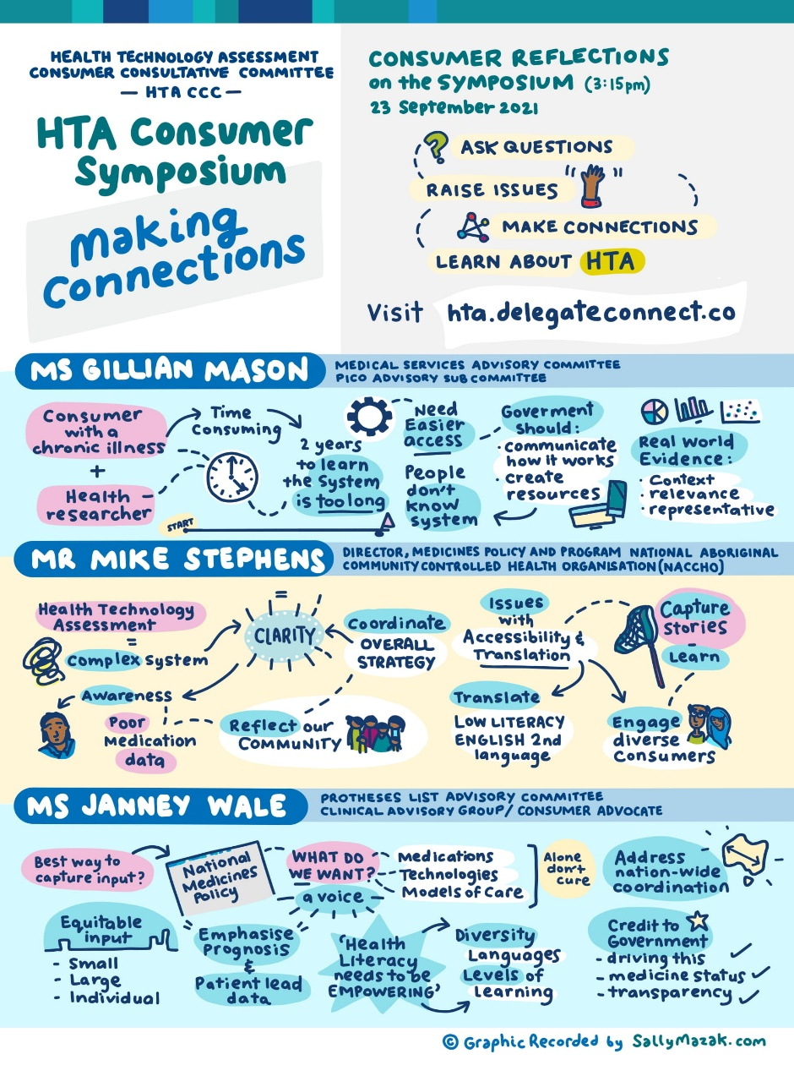

## Interaction with the virtual event platform

The number of registered users logged in for each session was consistently between 55-60 users throughout the whole day, suggesting registered users remained engaged for most of the day (Figure 2 and Table 2). This is supported by the regular engagement during the day in the chat box and questions submitted in real time during each session. In total, there were 169 chat messages posted, and 43 questions submitted via ‘Ask A Question’.

Figure : Livestreaming minutes consumed per room

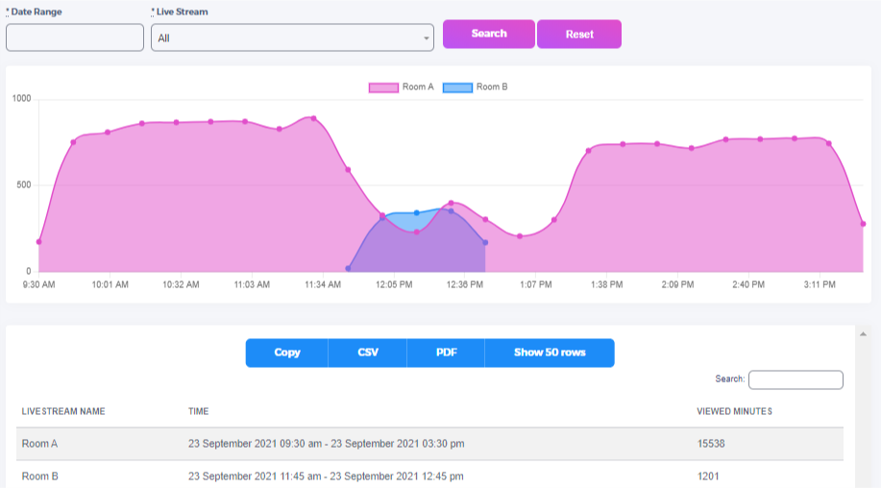

Table : Users per session

|  |  |
| --- | --- |
| Session | Users logged in |
| Welcome and Opening Address | 61 |
| Plenary 1 – Genomics, Gene Therapies | 61 |
| Morning | 60 |
| Plenary 2 – National Medicines Policy | 60 |
| Breakout Stream A | 35 |
| Breakout Stream B | 25 |
| Lunch | 37 |
| Plenary 3 – Real World Evidence | 56 |
| Afternoon Break | 52 |
| Conversations and Reflections | 56 |

Figure : Website User Logins from 11 July - 13 October 2021

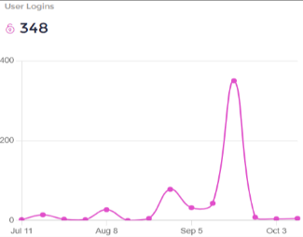

To 24 September 2021, there had been a total of 336 user logins (including admin users) to the Symposium website and an additional 12 logins post Symposium through to 13 October 2021 (Figure 3).

The three peaks in user activity appear at the times when people were notified the Symposium website was launched (early August), registrations opened (30 August 2021) and the day of the Symposium (23 September 2021).

# Post-Symposium Evaluation

The evaluation process includes feedback from the chat function on the website, emails received during (and at the conclusion of) the Symposium, an online survey and short telephone interviews.

At the conclusion of the Symposium, several comments were received from attendees:

* “Fabulous day, thank you to all presenters. Love more of these and opportunities to work on some solutions collaboratively”
* “Great day, wish we could have all got together in person - this time next year hopefully! Thanks again to organisers :)”
* “Thank you for an outstanding forum HTA CCC Symposium ‘Making Connections’ recently. The diversity of presentations and the level of information was great, and it was also so important to hear the commitment of the department and the advisory committees to inclusive engagement”
* “I found the presentations both interesting and thought provoking and have been involved in subsequent discussions and presentations that have further challenged my thinking around consumer representation as part of community engagement.”

## The Survey

As aforementioned, the Post-Symposium evaluation survey on the Department’s Consultation Hub was made available to all attendees via the Symposium website. Registered attendees were contacted by email twice, regarding availability of livestream videos, and a reminder to complete the evaluation survey. The survey closed on 15 October 2021, and 17 responses were received.

Due to the low survey response rate to the survey, a sample of attendees who joined for most of the Symposium, were invited to take part in a short phone interview. The interviews followed the same questions as the online survey. Seven people accepted the invitation to be interviewed.

The evaluation survey included general demographic questions and then specific questions to address aims of the evaluation:

1. To determine if the Symposium’s aims had been met
2. To understand what worked well and what did not work well, to enable reflection and planning for future events.

Overall, the people who responded to the survey or phone interviews were representatives of consumer organisations who had previously interacted with the OHTA or CCC members. One third of the respondents were from New South Wales, followed by Victoria and then the Australian Capital Territory.

### Survey and interview responses

Following is an overview of responses to questions which sought feedback on the aims of the Symposium i.e. bring people together to share experiences and make connections, provide opportunities to hear about HTA and raise awareness and increase the profile of the OHTA. There were also specific questions about the function of the Symposium that asked attendees what worked well and where the event could have been improved.

#### Did you make any new ‘connections’ at the symposium?

Ten survey respondents said they made new connections at the Symposium and three people said they already knew people. Two interviewees said they found it too daunting to go into virtual rooms. It was much easier during face-to-face events when you can talk to a stranger during the breaks but it’s not so easy with virtual events.

#### Do you feel more confident knowing who to contact in the Office of Health Technology Assessment following the symposium? Why?

Most responses received to this question were positive.

* “Yes! It was great to see the HTA team being able to be transparent, accessible to organisations, and to know they are happy to 'talk' to us”
* “Very because of the messages coming from the Department, especially Adriana, were very genuine”
* “Yes, it was great to put faces to names. She had spoken to Sally Wortley on the phone but was great to see and hear her present about the CEEU”.

Fourteen respondents commented they had increased their understanding of HTA processes:

* “It was great to hear that the HTA team are looking into how to better educate organisations on the processes, and engagement more at the start of the application process. There are so many out there that have no idea what to do through these processes and how to even start”
* “Being reassured by both the Minister and the Department that consumer involvement in the HTA process was genuinely welcomed”
* “Improved my knowledge of barriers faced by consumer groups in submitting their views to MSAC on applications of interest-may not have been informed, given too short a period to gather good data, and not invited to participate in stakeholder workshops-which is something members of MSAC should be able to participate in, in order to seek answers to questions they have on consumer needs/perspectives”
* “I particularly found the information about the questions that arise when assessing genetic testing useful”.

### Please tell us what worked well at the symposium?

All respondents to the survey and interviews provided information about ‘what worked well’ at the Symposium and included positive comments about:

1. The structure and organisation of the symposium
2. The technology
3. Interesting topics and excellent range of speakers
4. The structure

The feedback suggested that the style of the Symposium was suitable for a national audience. Respondents said they appreciated the opportunity to find out who was who, and who does what, in the HTA space.

The feedback also suggested that the event was well planned, and the tone of the day was friendly, open and provided plenty of breaks, whilst still allowing time and opportunity for people to ask questions. One survey respondent described the event as being “brilliantly organised, professional and worked fantastically. It was clear a lot of careful thinking and hard work went into it, and it showed”.

The lunchtime networking rooms were seen by many as a positive way of connecting with others in the sector. Respondents said being able to have a conversation with like-minded people who shared a common purpose was of value for future connections.

Conversely, some people said they felt going into a room without knowing people was daunting and was even harder when it was a virtual room. Face-to-face events provide easier opportunities to meet new people at breaks and during sessions.

1. Technology

The Symposium platform worked well, and comments were made that it was easy to access. The virtual approach allowed more people to participate who may not have been able to attend a face-to-face event. One respondent said virtual events overcame issues such as travel restrictions, cost, health conditions, work or family commitments.

The chat room function was mentioned by many as being a good way to see who was attending, have a say about what was being presented and to stay involved in the day.

It was noted that questions asked during the day were well moderated and one respondent said “it felt like a good discussion even though we could not ask the questions in person”.

1. Topics and speakers

Most people considered the range of speakers to be very good.

The diverse range of topics covered would help to raise awareness and increase knowledge of HTA processes. This was supported by having a range of speakers from government, research, industry and consumer organisations.

Having speakers from the Department was seen as positive and reaffirming of a commitment to consumer engagement in HTA.

#### Do you have any suggestions to improve future events?

All respondents who completed the survey or were interviewed, provided suggestions for improvements that could be used in planning for future events.

Many commented it would be useful to have smaller group sessions to provide opportunity for discussions and interactions and support greater leaning and skill development. Several suggested that a Q&A session would be a useful addition.

Other comments included:

* The timing of the symposium was not optimal i.e., school holidays and multiple forums on the National Medicines Policy were held in the same week.
* There was no time to have a break to eat or to reflect on and synthesise the information in the presentations.
* Queries about the selection of attendees, and who made the decision about who could attend. One person referred to this as being a ‘mystery’ and thought that future events should be open and transparent about how attendees were selected.
* Asking at registration about sharing contact details, to facilitate lasting connections.
* Providing Pre-Symposium resources and videos earlier.
* The facilitator in the networking room was not welcoming of all comments or points raised.

Two respondents commented on the eligibility criteria for attendance, with one saying that negative comments were made on social medial following the Symposium (it would be worthwhile to be more open and transparent about the criteria before the event).

One respondent reported not being on the ‘big user’ list for HTA and that they sometimes found things out by chance. Communication could be improved for future events.

There were several comments raised about the length of the symposium and the difficulty in remaining engaged over the whole day. One respondent suggested separating out the technical aspects from the consumer / patient stories information might make it easier for people to be able to attend sessions that were suited to their needs.

If events like this are to be held in the future, it might be good to have a consumer networking session the following day. This would work well if it was a hybrid event with a mix of face-to-face and virtual presentations.

#### Will you attend a future symposium or events on health technology assessment?

All 24 respondents (those who responded to survey and were interviewed) were very positive about attending future events and comments included:

* “It's really important for improving patient input, public confidence, and legitimate HTA for the HTACCC/CEEU to provide opportunities like this for shared learning and making connections
* “Absolutely -- with pleasure & anticipation! :)”
* “Yes, with bells on”

### Post-symposium reflections

The Chair of the CCC, CEEU staff and two consultants attended a virtual retreat on   
18 October 2021. Each person was asked to provide their reflections on the Symposium at the start of the meeting. Themes raised are summarised in Figure 5.

Figure : Graphic illustration of Post Symposium Reflections and Discussions

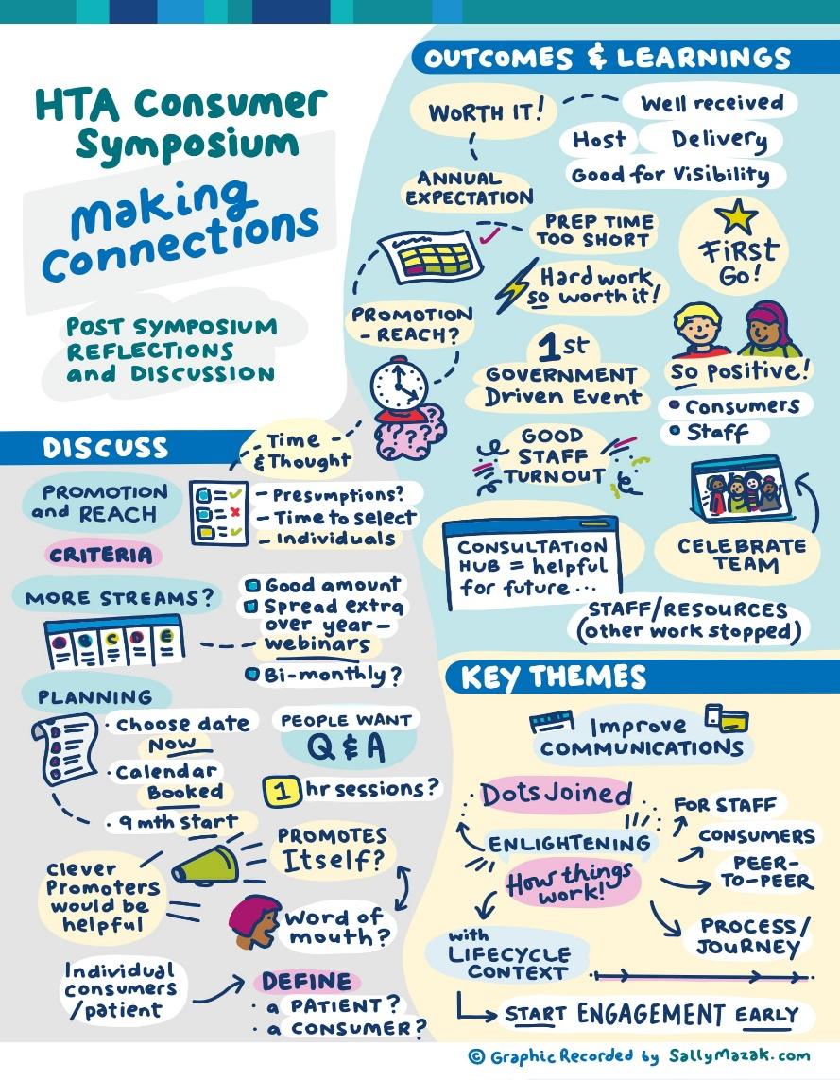

Everyone agreed the event was successful in achieving its aim of bringing people together and providing information about HTA. Other feedback included:

* The impact of short lead-up period in preparing for the Symposium and future events would be better served with longer preparation times.
* The need to develop a calendar of events.
* Define consistent terminology to be used for HTA e.g. patient, consumer, community.
* Holding regular webinars and/or Q&A sessions.

The CCC were invited to submit their reflections on the Symposium at the conclusion of the event, and then during the CCC meeting held on 18 November 2021. Their feedback is summarised below:

* Smaller consumer organisations or those from diverse backgrounds may not have an equal ‘voice’ in the HTA processes. It was important to have a clearer pathway for them to be able to better engage, particularly with the MSAC process.
* Whilst there had been ‘big and positive changes in consumer engagement in the past five years’ there was still work to be done to ensure equity for all groups. It was also important to consider how to reach out to consumers who may feel marginalised. Often those responding to surveys are those who are mainstream, while those who are unwell may not respond.
* Future events could build on opportunities to better utilise the break-out and networking sessions by providing an opportunity for consumer organisations and their representatives to have small-group Q&A with CCC members.
* Patient or personal stories shared throughout the event were powerful if utilised effectively in supporting HTA processes, but there is a need for consistency in the use of stories in the assessment process. It was suggested that there is a potential opportunity for the CEEU to develop training to support consumers to build advocacy skills and use their story for maximum benefit.
* There seems to be a gap between expectations and understanding of how consumer submissions could be (or are being) used in the PBAC process. A lack of knowledge leads to misunderstandings about why items are funded.
* The Symposium was useful in providing CCC members a learning and development opportunity to hear about activities outside their respective HTA committees.
* Personal stories or individual narratives that were shared throughout the event were valuable in advocating for the importance of consumer engagement.
* There is a need to acknowledge that some smaller consumer organisations may only access information about HTA on an ad-hoc basis. The level of information and support required would change accordingly.
* There was concern about the eligibility criteria for consumer groups applying to attend the Symposium. It was recommended there is greater clarity around attendance criteria and its application for any future events. This will prevent the perception of a ‘closed shop’ event.

Overall, the Symposium was considered by CCC members as being successful and a similar event should be held in the future.

# Conclusion

Feedback received during and after the Symposium via the ‘chat’ function, the evaluation survey and interviews, and from the CCC was overall very positive. This strongly suggests the Symposium achieved its aims of bringing people together to share experiences and make connections, providing opportunities to hear about HTA and raise awareness and increase the profile of the OHTA.

The learnings on operationalising the event from a Departmental perspective (including total cost of the event, including staff hours (see Appendix 1) and externally from comments received through the ‘chat’ function and the evaluation processes will be applied to planning future events.

# Appendix 1: Operationalisation of the Symposium

The information below provides an overview of activities associated with operationalisation of the Symposium. While the event was hosted by the CCC, the planning and coordination of the event was done by the CEEU, during a period of COVID-related lockdown.

## Selection of vendor

In May and June 2021, three vendor quotes were sourced for hosting the virtual Symposium. Delegate Connect was selected, based on being the only vendor able to build a specific virtual platform and offer a complete end-to-end service. The quote from Delegate Connect fell within the capacity of the budget approved to support the operation of the CCC and CEEU. Members of the Working Group who had attended an event hosted by Delegate Connect (the CHF Changing Gears Symposium in March 2021), were able to provide positive feedback on their ability to deliver a professional event.

In July 2021 approval for expenditure was provided and a contract was executed with Delegate Connect.

## Developing and operationalising the Symposium

* In July 2021, a small working group was established to provide input into development of the Program. This group met via virtual format four times and were provided agenda papers prior to each event.
* On 27 July 2021, 82 consumer organisations that were known to the CEEU (due to previous engagement in HTA processes) were sent a ‘save-the-date’ email notice that included an invitation to provide feedback on topics-of-interest for the Symposium.
* A draft program was semi finalised mid-August 2021, allowing invitations to speakers to be sent out between 18 August to 10 September 2021.
* Session and speaker changes were made up to the week before the Symposium. The Program was finalised on 20 September 2021.
* Pre-released video content was made available on 17 September 2021. Development of this content had been led by CEEU staff, with input from Departmental staff during August and September 2021.
* By the time the Symposium was held, most registrants had created user profiles and logged into the Symposium website. Those who had not were the invited speakers who accessed their sessions via the speakers Zoom link. This suggests half the speakers logged in to view Symposium content, either to view questions for their session or content outside the session they were speaking in.

Alongside development of the Symposium’s content, the CEEU team engaged with Delegate Connect to develop the Symposium website and livestream event platform. This operational activity involved a significant investment of time.

## Event Statistics

Over the period of the livestreamed event on 23 September 2021, users consumed 16,739 minutes of viewing (Figure 2).

In addition to user engagement described in the main report section ‘Interaction with the Virtual event platform’, during the one-lunch break, there were four networking rooms made available for attendees to connect in. A number of participants took the opportunity to connect via these rooms (Table 3).

Table : Networking Room Visitors

| Networking Room | Users logged in |
| --- | --- |
| Stream A | 2 |
| Stream B | 9 |
| CCC A | 6 |
| CCC B | 11 |

Also, symposium attendees were invited on the day of the livestream to tag any social media posts about the Symposium, with the hashtag #HTACCC.

As at 24 September 2021, 23 users had shared 79 tweets/retweets about the Symposium. Two attendees also congratulated the HTA CCC and CEEU team on the Symposium via LinkedIn posts, with numerous interactions occurring with those posts.

## Resourcing Impacts

With the commencement in June 2021 of an additional part-time project co-ordinator (contracted 15hr/week) in the CEEU, resourcing was available to start planning for the Symposium.

From mid-July 2021, the part-time resource was fully utilised in developing and project managing the Symposium. This work included:

* Supporting development of the agenda (including external stakeholder survey mailout and collation, meetings within the Department, speaker invitations and tracking).
* Meetings, training and communications with Delegate Connect regarding Symposium website and event-day logistics (including various spreadsheets for uploads, and event day running sheet).
* Managing creation and/or review of content for the Symposium website and event day (website visuals, announcements, registration process, program, speaker biographies, resources, on-demand videos, speaker video recordings, event day title slides and break videos), in accordance with Delegate Connect requirements and deadlines.
* Speaker invitations (including to the Minister) and speaker tracking, biography collation, communications and training with Delegate Connect.
* Supporting Departmental processes for creation/approval of Symposium agenda, pre-recorded content, pre-recording of the Minister’s Opening Remarks.
* Facilitating review and approval of registrations.
* Event-day chat/question/speaker support.
* Attendee communications pre/post event and problem-solving.

In the final two weeks before the Symposium, the part-time resource hours were increased to approximately 35 hours/week to help finalise preparations.

In addition, the HTA CCC Chair, CEEU Lead and CEEU support staff contributed significant time to meetings, development of program and their own presentations, speaker invitations and general decision making regarding the Symposium. This time commitment increased as the Symposium neared, with 20-30% of CEEU staff time allocated to the Symposium activities in the final month prior to the event.

Following the Symposium, the part-time resource and contracted resource, as well as the CEEU Lead, spent time (each up to 8 hours per week, for 6 weeks) in seeking/collating post-Symposium feedback and developing the Evaluation Report and Summary.

# Appendix 2: Symposium Program

Table A1: Pre-release content

|  |  |
| --- | --- |
| Videos | Downloadable Resources |
| About MSAC (4min) | Useful Websites and Info |
| About the Pharmaceutical Benefits Scheme (PBS) | HTA CCC Membership |
| About the Department | Glossary – Consumer Evidence and Engagement Unit |
| Introducing the Consumer Evidence and Engagement Unit (CEEU) | Review of the National Medicines Policy |
| Medical Services Advisory Committee (MSAC) Explainer | National Medicines Policy Review – Terms of Reference |
| Pharmaceutical Benefits Advisory Committee (PBAC) Explainer | National Medicines Policy Review – Discussion Paper |
| What Consumers can Input |  |
| What is Health Technology Assessment (HTA) |  |

Table A2: Live-stream content

|  |
| --- |
| Welcome and Opening Address |
| **9:45** Welcome to Symposium  The Hon. Greg Hunt, MP  Minister for Health |
| **9:50** Welcome to Country  Introduction to Proceedings  Jo Watson |
| **10:00** Opening Address  Adriana Platona |
| **10:15** Genomic Testing, Cell & Gene Therapies – Connecting the Dots   1. SWAN’s Perspective on the HTA Process (10 minutes) 2. The Challenges Assessing Genomic Testing and Cell and Gene Therapies (15 minutes) 3. Cell and Gene Therapies: From Recommendation to Access - Consumer Experience (10 minutes) 4. Heather Renton 5. Dr Janice Fletcher 6. Sharon Winton   Panel Discussion: How Can Consumers Build Connections and Contribute in this Area?  (20 minutes)  Add: Gabrielle Lockett - Moderator: Sally Wortley |
| **11:10** Morning Break |
| Plenary 2: The National Medicines Policy Review |
| **11:20** National Medicines Policy Review (15 minutes)  Dr Sarah Dineen-Griffin  Ms Jan Donovan  Q&A on the National Medicines Policy Review (20 minutes)  Moderator: Jo Watson |
| Breakout Streams |
| **11:55** (for **12:00** start)  Stream A   * Consumer HTA Experience - Spinal Muscular Atrophy Association of Australian Inc - Julie Cini * Consumer HTA Experience - Leukaemia Foundation - Emily Forrest; Catriona Rafael * Consumer Evidence and Engagement Unit Update - Sally Wortley   Stream A Q&A  Stream B   * Consumer HTA Experience - XLH Australia - Naomi Ford * Consumer HTA Experience - Breast Cancer Network Australia - Kirsten Pilatti * Reflections on the Summaries Pilot - Jo Watson   Stream B Q&A  0 minutes per speaker/Q&A.  Stream A Moderator: Anne McKenzie  Stream B Moderator: Ann Single |
| **12:40** Lunch  Networking rooms (**12:50-13:25**)   * CCC A * CCC B   Stream A, Stream B |
| Plenary 3: What is, and the use of, Real World Evidence |
| **13:25**   1. What is Real World Evidence and what are the challenges? (15 minutes) 2. The Role and Use of Registries (10 minutes) 3. Collecting and Using Real World Evidence - the Consumer Experience (10 minutes) 4. Michelle Burke 5. Professor Susannah Ahern 6. Simone Leyden   Real World Evidence Q&A Panel – Professor Kirsten Howard, Professor Susannah Ahern, Simone Leyden (20 minutes)  Moderator: Michelle Burke |
| **14:20** Afternoon Break |
| Conversations and Reflections |
| **14:30** In conversation with the MSAC & PBAC Chairs  Professor Robyn Ward  Professor Andrew Wilson  Moderator: Anne McKenzie |
| **15:10** Consumer reflections on the Symposium (5 minutes each)  Gillian Mason  Janney Wale  Mike Stephens |
| **15:25** Meeting Wrap  Jo Watson |
| **15:30** Meeting close |

Health.gov.au