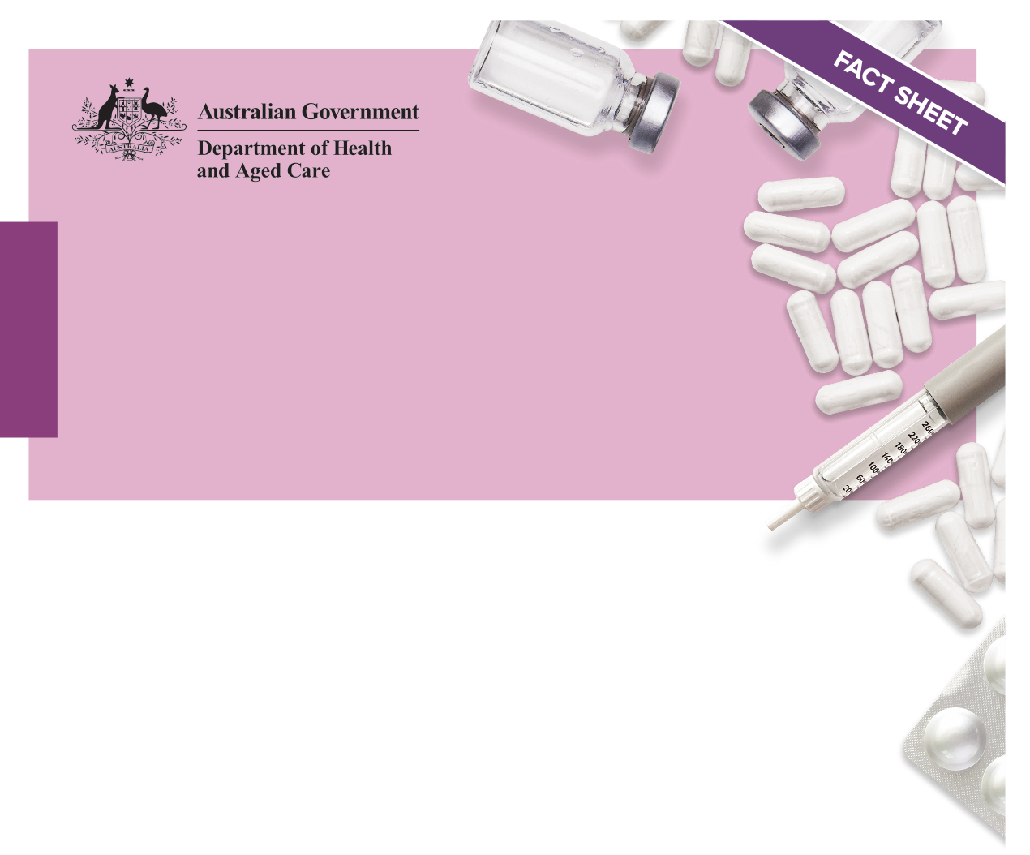National quality use of medicines

Achieving continuity in medication management

Guiding principles

# Purpose and scope

The [Guiding Principles to Achieve Continuity in Medication Management](http://www.health.gov.au) (the Guiding Principles) promote practice that keeps the individual receiving care at the centre of an integrated health system. They set a framework for providing comprehensive continuity of medication management for all individuals receiving care, as they transition throughout the healthcare system, and include actions to support vulnerable groups that use the healthcare system.

These Guiding Principles build on the 2005 edition of the guiding principles and are underpinned by [Australia’s National Medicines Policy](https://www.health.gov.au/resources/publications/national-medicines-policy).

They are to be applied by all providers of healthcare services and healthcare professionals involved in medication management and the individual (and/or their carer) receiving care.

# The Guiding Principles – a summary

The following summary includes the heading and statement for each Guiding Principle. A selection of key tasks are also included for healthcare service providers, healthcare professionals, and/or the individual, their carer and/or family to action. Guiding Principles 1–4 set the overarching requirements for the effective implementation of the remaining Guiding Principles 5–10.

## Clinical governance and leadership

Leaders of healthcare services have responsibilities in ensuring the safe and quality use of medicines and in ensuring the ongoing continuity of medication management.

### Key tasks

* For providers of healthcare services to have clinical governance processes and structures in place to support the safe transitions of care
* For healthcare professionals to work within, and be supported by, well-designed clinical systems and processes to deliver safe, high-quality clinical care.

## Responsibility for medication management

Providers of healthcare services, managers and healthcare professionals have a responsibility to participate in all aspects of medication management in partnership with the individual receiving care, their carer and/or family.

### Key task

For roles and responsibilities for each of the steps of the medication management pathway to be clearly defined so that everyone involved are aware of their own role, and the roles of others in the pathway, and takes responsibility for it

## Accountability for medication management

Providers of healthcare services, managers and healthcare professionals are jointly and individually accountable for making sure that activities to support the continuity of medication management are implemented.

### Key task

For each healthcare professional to be accountable for their assigned responsibilities in ensuring the safe transition of individuals to the next episode of care.

## Safety and quality systems

Safety and quality systems (see **Figure 1**) are integrated within governance processes to enable providers of healthcare services and healthcare professionals to actively manage and improve the safety and quality of health care for and with individuals receiving care.

### Key task

For providers of healthcare services to establish and implement governance processes to support patient safety and quality systems.

Figure : Priority areas for action

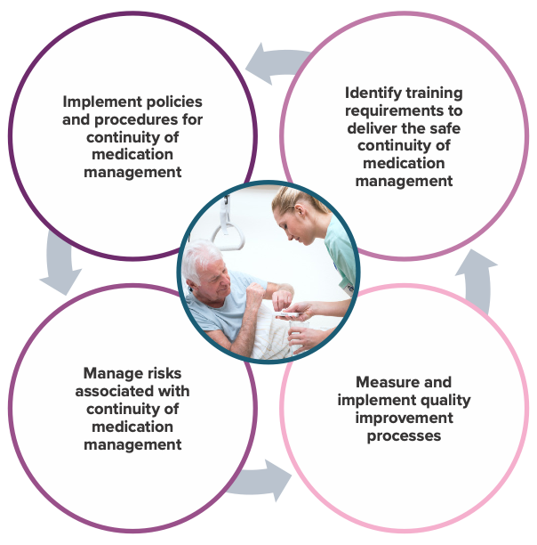

## Medication reconciliation

Accurate and complete medication reconciliation should be performed at the time of presentation or admission, or as early as possible in the episode of care. Medication reconciliation needs to be performed at all transitions of care.

### Key task

For healthcare professionals to perform and document medication reconciliation in collaboration with the individual, their carer and/or family, at the time of presentation or admission, or as early as possible in the episode of care and at the time of transition.

## Review of current medicines

Throughout each episode of care, the safe and quality use of current medicines needs to be assessed and reviewed in partnership with the individual receiving care.

### Key task

For healthcare professionals to ensure that medication review is an ongoing process of review and documentation, contributes to the medication management plan (MMP), and is in collaboration with the individual receiving care, their carer and/or family.

## Medication management plan

An MMP is a continuing plan developed and used by healthcare professionals, in collaboration with the individual, their carer and/or family, to develop strategies to manage the use of medicines.

### Key task

For an individual’s MMP to form an integral part of care planning for the individual and be reviewed during the episode of care and before transition of care.

## Sharing decision making and information about medicines with the individual receiving care

As early as possible in the episode of care, the individual receiving care, their carers and/or family should receive sufficient information, in a form they can use and understand, to enable them to safely and effectively use all medicines in accordance with the agreed MMP.

### Key tasks

* For the provider of healthcare services to ensure there are systems, policies and processes in place to support the sharing of timely information
* For healthcare professionals, prior to supplying and/or prescribing a new medicine, to provide sufficient medicines-related information to the individual receiving care, their carers and/or family.

## Collaborating and communicating medicines-related information with other healthcare professionals

When an individual is transitioned to another episode of care, the transferring healthcare professional needs to supply comprehensive, complete and accurate information to the healthcare professional responsible for continuing the individual’s medication management in accordance with their MMP.

### Key tasks

* For providers of healthcare services to implement digital communication resources, develop policies and procedures for collaboration and communication between healthcare professionals
* For healthcare professionals to ensure complete, accurate, verified and timely medicines-related information is shared with relevant healthcare services.

## Ongoing access to medicines

The individual receiving care, their carer and/or family needs to receive sufficient supplies of medicines and information about how to obtain further supply of medicines, to enable them to fulfil or comply with their MMP. This should consider person-specific circumstances and equity of access.

### Key tasks

* For providers of healthcare services to have policies, procedures and guidelines in place that address ongoing access to medicines
* For healthcare professionals to ensure that an individual receives a sufficient supply of medicines in a planned and timely way.