COVID-19 outbreaks in Australian residential aged care facilities

# National snapshot

Due to the 26 January 2023 public holiday, the data period for this report is from 18 January to 24 January 2023 (inclusive).

As at 8:00 am 25 January 2023 there are 1,660 active COVID-19 cases in 291 active outbreaks in residential aged care facilities across Australia. There have been 79 new outbreaks, 44 new resident deaths and 1,409 combined new resident and staff cases reported since 18 January 2023.

Table : Aged Care COVID-19 data as at 8.00am 25 January 2023[1]

| Category | Active*[2]* | Previous  7 days | Cumulative  Total | Previous 7 days |
| --- | --- | --- | --- | --- |
| Outbreaks[3] | 291 | -104 | 12,734 | 79 |
| Residential Aged Care Facilities affected | 291 | -104 | 2,802 | 1 |
| Resident Cases[4] | 1,228 | -526 | 127,283 | 1,006 |
| Resident Deaths | N/A | N/A | 5,045 | 44 |
| Staff Cases | 432 | -200 | 79,197 | 403 |

The Department of Health and Aged Care has concluded a review and reconciliation of all data provided directly by aged care providers from early 2022.

This has resulted in retrospective adjustments to outbreaks, cases and deaths figures and an overall increase in cumulative totals. This has not affected what has been reported as occurring in the previous seven day period.

**Table 2: Overview of Active Outbreaks in Australia**

|  |  |  |  |  |  |  |  |  |  |
| --- | --- | --- | --- | --- | --- | --- | --- | --- | --- |
|  | ACT | NSW | NT | QLD | SA | TAS | VIC | WA | Total |
| Total Facilities with outbreaks | 3 | 96 | 3 | 68 | 32 | 6 | 53 | 30 | **291** |
| *Total number of active resident cases* | 8 | 465 | 68 | 210 | 152 | 11 | 227 | 87 | **1,228** |
| *Total number of active staff cases* | 6 | 147 | 22 | 105 | 40 | 4 | 61 | 47 | **432** |
| Total Outbreaks Opened in Previous 7 Days | 2 | 33 | 0 | 20 | 5 | 0 | 12 | 7 | **79** |
| Total Outbreaks Closed in Previous 7 Days | 2 | 62 | 1 | 39 | 21 | 2 | 33 | 23 | **183** |

**Figure 1: National Outbreak Trends in Aged Care**

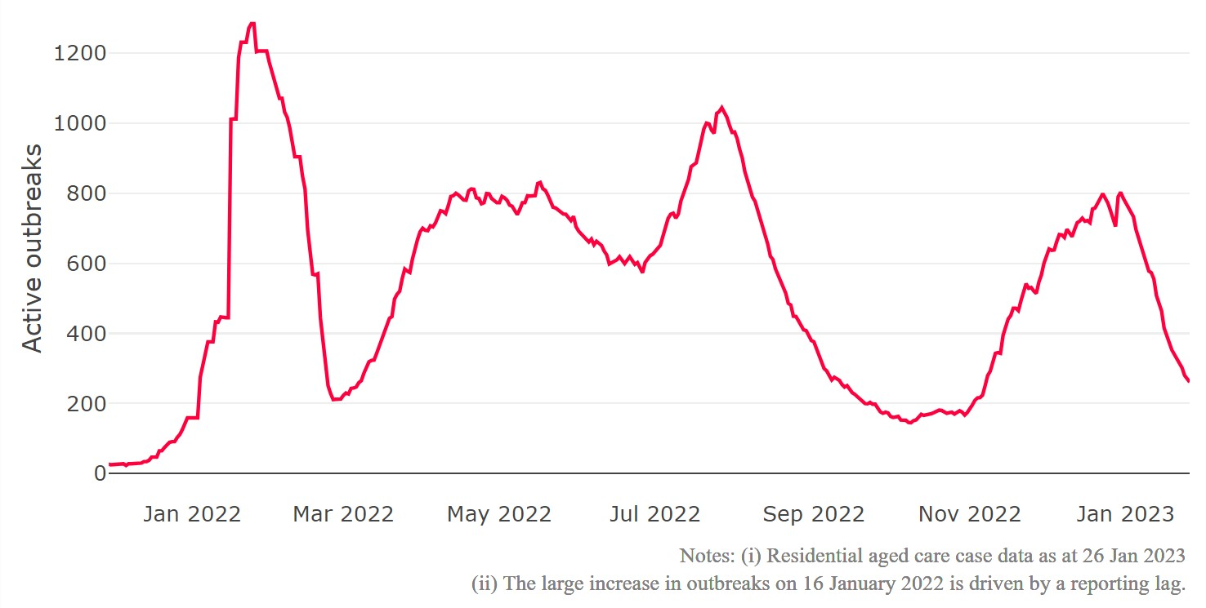

**Figure 2: Trends in Aged Care Cases – November 2021 to Present**

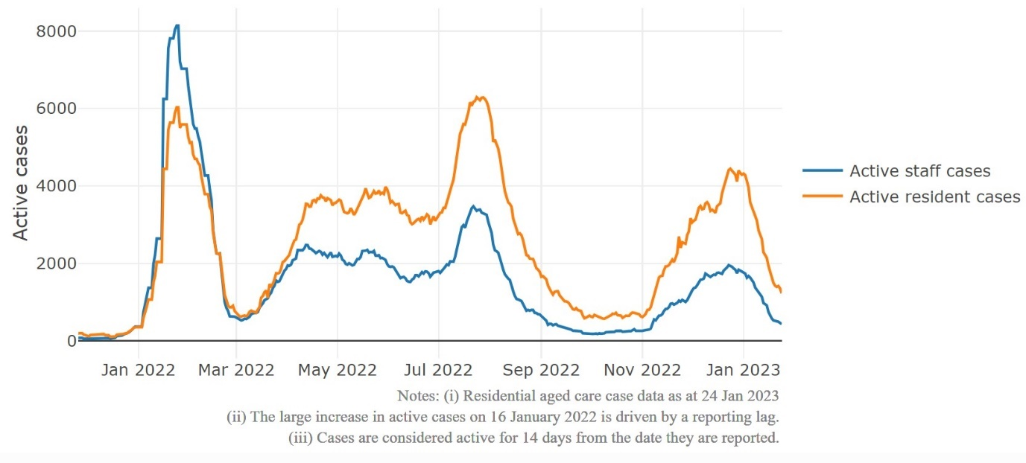

## Mortality

For the period of 1 January 2022 to 20 January 2023, COVID-19 is recorded as the cause of death in 6.2 per cent of all deaths in permanent residents in aged care facilities.

Since the beginning of the Omicron outbreak in late November 2021, there have been 71,437 deaths in residential aged care from all causes (report period from 29 November 2021 to 20 January 2023)[5]. COVID-19 deaths account for 5.8 per cent of this figure.

Over the course of the pandemic, all-cause excess mortality in Residential Aged Care was below expected numbers in 2020, and within expected range in 2021.

**Figure 3: COVID-19 Deaths in Residential Aged Care Facilities overlaid with Community deaths**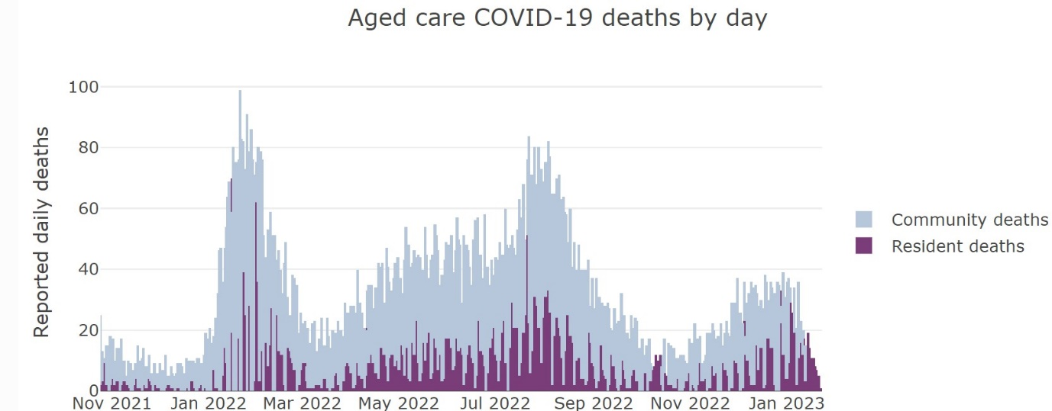



## Workforce in active residential aged care outbreaks

As at 25 January 2023, workforce surge staff have filled a total of 160,356 shifts in aged care services impacted by COVID-19, including 817 in the past 7 days. In the past 7 days (to 20 January) surge workforce providers have assisted 46 residential aged care homes. These shifts include roles for GPs, nurses, care workers, allied health workers, executive and ancillary staff. This includes:

**Table 3: Workforce resources supplied to residential aged care facilities**

| Workforce provider | Total Shifts | | Previous 7 days | |
| --- | --- | --- | --- | --- |
| Recruitment, Consulting and Staffing Association | 100,531 | 475 | |
| Healthcare Australia (Workforce Surge) | 13,485 | 52 | |
| Healthcare Australia (NACER) | 2,295 | N/A | |
| Mable | 2,711 | N/A | |
| Aspen Medical | 21,368 | 14 | |
| HealthX | 15,910 | 276 | |
| Torrens | 4,056 | N/A | |

The Australian Defence Force provided support to a total of 542 residential aged care homes between February and September 2022. The ADF deployment ceased on 30 September 2022.

## Oral antiviral treatments

Distribution of the oral anti-viral Lagevrio (Molnupiravir) commenced on 6 February 2022 to all RACFs with outbreak sites prioritised for delivery. The National Medical Stockpile has deployed 48,269 treatment courses of Lagevrio (Molnupiravir) to aged care facilities.

50,947 prescriptions for Lagevrio (Molnupiravir) have been issued to residents in residential aged care facilities, with a further 2,610 prescriptions for Paxlovid (nirmatrelvir + ritonavir) also issued since 28 February 2022 and up to 22 January 2023.

## Vaccination in Residential Aged Care Facilities

The Australian Government’s COVID-19 vaccination program is delivering in-reach vaccine services for aged care residents and workers across Australia, through Commonwealth vaccine providers, primary care and self-vaccination services by aged care providers.

The Government continues to provide all residential aged care facilities with access to COVID vaccination clinics to ensure residents have every opportunity to get their fourth dose. As at 27 January 2023, there are currently 157,833 residents eligible for fourth doses. In total 134,929residents (85.5% of eligible residents) have received a fourth dose.

As at 27 January 2023, a total of 638,067 doses of COVID-19 vaccines have been administered to residents in residential aged care facilities. Information is now received from the Australian Immunisation Register, meaning reported numbers may differ from previous reports. Information from the Australian Immunisation Register provides a more accurate representation of residents currently in residential aged care.

|  |  |  |  |  |  |  |  |  |  |
| --- | --- | --- | --- | --- | --- | --- | --- | --- | --- |
| Residential aged care fourth dose vaccination summary | | | | | | | | | |
|  | **National** | **NSW** | **VIC** | **QLD** | **SA** | **WA** | **TAS** | **NT** | **ACT** |
| Total residents who have received a fourth dose | 134,929 | 42,721 | 36,828 | 26,187 | 11,488 | 12,158 | 3,368 | 330 | 1,849 |
| Percentage against total residents* | 75.5% | 74.5% | 79.7% | 72.7% | 74.6% | 73.5% | 76.6% | 70.7% | 81.9% |
| Percentage against eligible residents (interval only)** | 83.0% | 81.4% | 86.5% | 81.6% | 82.7% | 81.2% | 84.4% | 81.5% | 87.5% |
| Percentage against eligible residents (interval and case overlay)*** | 85.5% | 84.3% | 88.6% | 83.5% | 86.1% | 83.8% | 86.9% | 83.9% | 89.1% |

Sources: Aged care AIR data as at 26 January 2023, AIR mapping file for residents in permanent residential RACFs as at 2 September 2022, AUS-CAIRS aged care resident case data as at 25 January 2023.

* Residents who have had a fourth dose of a COVID-19 vaccine *(this may include the booster dose for severely immunocompromised residents)* total residents in Commonwealth funded positions in residential aged care facilities

** Residents who have had a fourth dose of a COVID-19 vaccine *(this may include the booster dose for severely immunocompromised residents)* overtotal residents who have had a third dose of a COVID-19 vaccine over 3 months ago *(this may include the third primary course dose for severely immunocompromised residents)*

***Residents who have had a fourth dose of a COVID-19 vaccine *(this may include the booster dose for severely immunocompromised residents)* overtotal residents who have had a third dose of a COVID-19 vaccine over 3 months ago with case overlay applied *(this may include the third primary course dose for severely immunocompromised residents)*. Eligible residents have been reduced by an estimate of the number of COVID cases in the facility. The number of cases is calculated by the number of cases self-reported through AUS-CAIRS over the last 90 days adjusted by the fourth dose vaccination rate in a facility (percentage by eligible residents).

## Infection control and audits

The Aged Care Quality and Safety Commission (Commission) conducts a range of site and non-site activities to monitor and assess residential aged care services, including site audits and assessment contacts (site and non-site) (see Table 5 below). In August 2020, the Commission commenced an infection control monitoring (ICM) spot check program in all Australian jurisdictions.

The ICM spot check program involves on-site visits to residential aged care services, without an outbreak, to check compliance with personal protective equipment (PPE) and infection control arrangements. The purpose of the ICM spot check is to observe infection control practices, to ensure that staff, management and visitors were adhering to safe personal protective equipment protocols and to safe infection control arrangements as required under the quality standards.

As at 25 January 2023, the Commission had conducted 4,304 ICM spot checks to observe infection control practices and PPE protocols in residential aged care facilities.

Table 5: Total Quality Assessment and Monitoring Activities with residential services (including IPC), by type and month 1 March 2020 to 19 January 2022

|  |  |  |  |  |  |
| --- | --- | --- | --- | --- | --- |
| Regulatory Activities | 2019-20 (1 Mar - 30 Jun 2020) | 2020-21 | 2021-22 | 2022-23 (to 25 Jan 2023) | Total |
| Site visits | 318 | 3,452 | 1,733 | 1,651 | **7,154** |
| Non-site activities | 3,709 | 8,382 | 6,589 | 1,128 | **19,808** |
| Total activities | **4,027** | **11,834** | **8,322** | **2,779** | **26,962** |

# Appendix 1: National residential aged care services with Active outbreaks COVID-19

Please note, information reported in this table has been directly reported to the Department of Health and Aged Care by residential aged care facilities. Total cases refers to all staff and resident cases associated with the active outbreak and may not reflect the count of currently active cases. Where numbers have been incorrectly reported, facilities are able to correct these in the COVID-19 Support Portal through My Aged Care. Where a facility is reporting less than six resident or staff cases or less than six deaths, data has been suppressed to protect the privacy of affected individuals (note that “n/p” indicates data is not provided to protect privacy).

| Service Name | State | Resident Deaths | Resident Cases | Staff Cases | Total Incidents |
| --- | --- | --- | --- | --- | --- |
| BaptistCare Griffith | Australian Capital Territory | 0 | 12 | <6 | n/p |
| Fred Ward Gardens | Australian Capital Territory | <6 | <6 | <6 | <6 |
| Jindalee Aged Care Residence | Australian Capital Territory | 0 | <6 | <6 | <6 |
| Adelene Court Hostel | New South Wales | 0 | <6 | <6 | <6 |
| Adelene Nursing Home | New South Wales | 0 | 19 | 12 | 31 |
| Anglican Care Bishop Tyrrell Place | New South Wales | <6 | 33 | 19 | 52 |
| Ashwood Residential Care Service | New South Wales | 0 | 0 | <6 | <6 |
| Aurrum Kincumber | New South Wales | 0 | <6 | 0 | <6 |
| BaptistCare Kularoo Centre | New South Wales | 0 | 24 | 0 | 24 |
| Bathurst Riverview Care Community | New South Wales | 0 | <6 | <6 | <6 |
| Bayswater Gardens | New South Wales | 0 | <6 | <6 | 8 |
| Berkeley Vale Care Community | New South Wales | 0 | 16 | 13 | 29 |
| BlueWave Living | New South Wales | 0 | 11 | <6 | n/p |
| Boronia House | New South Wales | 0 | 42 | 18 | 60 |
| Bowral House Nursing Home | New South Wales | 0 | 7 | <6 | n/p |
| Brian King Gardens | New South Wales | <6 | 43 | 20 | 63 |
| Bundaleer Gardens Hostel | New South Wales | 0 | 12 | <6 | n/p |
| Bupa Bankstown | New South Wales | 0 | 13 | <6 | n/p |
| Bupa St Ives | New South Wales | <6 | <6 | 0 | <6 |
| Calvary Muswellbrook Retirement Community | New South Wales | 0 | <6 | <6 | <6 |
| Cameron Park Care Community | New South Wales | <6 | 20 | 9 | 29 |
| Catholic Healthcare Coolamon Villa | New South Wales | 0 | 7 | <6 | n/p |
| Catholic Healthcare Maranatha Lodge | New South Wales | <6 | 16 | <6 | n/p |
| Catholic Healthcare McQuoin Park | New South Wales | 0 | <6 | 0 | <6 |
| Cedar Place Aged Care Facility | New South Wales | 0 | <6 | <6 | <6 |
| Clelland Lodge | New South Wales | 0 | 0 | <6 | <6 |
| Dougherty Villa | New South Wales | 0 | <6 | <6 | 7 |
| Dural House Aged Care | New South Wales | 0 | <6 | 0 | <6 |
| Elizabeth Lodge (Rushcutters Bay) | New South Wales | <6 | 35 | 6 | 41 |
| Estia Health Camden | New South Wales | 0 | 14 | <6 | n/p |
| Estia Health Dalmeny | New South Wales | 0 | 6 | 0 | 6 |
| Eugowra Multi-Purpose Service | New South Wales | 0 | 7 | <6 | n/p |
| Ferndale Gardens Aged Care Facility | New South Wales | 0 | <6 | <6 | <6 |
| Feros Village Wommin Bay | New South Wales | <6 | 9 | <6 | n/p |
| Gillawarna Village | New South Wales | 0 | <6 | 0 | <6 |
| Greenwood Aged Care | New South Wales | 0 | <6 | 0 | <6 |
| HammondCare - Leighton Lodge | New South Wales | <6 | 9 | <6 | n/p |
| HammondCare Waratah | New South Wales | 0 | 6 | <6 | n/p |
| Haydays Retirement Hostel | New South Wales | 0 | 6 | <6 | n/p |
| Hunters Hill Montefiore Home | New South Wales | 0 | 0 | 11 | 11 |
| Indochinese Aged Care Services | New South Wales | 0 | 9 | <6 | n/p |
| Jacaranda Grove Hostel | New South Wales | 0 | 21 | <6 | n/p |
| Lachlan Lodge | New South Wales | 0 | <6 | 0 | <6 |
| Manilla Multi-Purpose Service | New South Wales | 0 | <6 | <6 | <6 |
| Mary Potter Nursing Home | New South Wales | 0 | <6 | 0 | <6 |
| Meadowbank Grove Care Community | New South Wales | 0 | 22 | 0 | 22 |
| Millrace Hostel | New South Wales | 0 | 8 | <6 | n/p |
| Mona Vale House | New South Wales | 0 | 0 | <6 | <6 |
| Montrose Aged Care Plus Centre | New South Wales | 0 | 18 | <6 | n/p |
| Moran Engadine | New South Wales | 0 | <6 | <6 | <6 |
| Moran Kellyville | New South Wales | 0 | 42 | 7 | 49 |
| Murray House | New South Wales | 0 | 12 | 13 | 25 |
| Newmarch House | New South Wales | 0 | <6 | <6 | 7 |
| Pacific Lodge Aged Care Plus Centre | New South Wales | 0 | 14 | <6 | n/p |
| Pathways Cronulla Pines | New South Wales | 0 | 12 | <6 | n/p |
| Patrick Bugden VC Gardens | New South Wales | 0 | <6 | <6 | <6 |
| Pemulwuy Aged Care | New South Wales | 0 | 38 | 9 | 47 |
| Randwick Montefiore Home | New South Wales | 0 | <6 | 0 | <6 |
| Regis Port Stephens | New South Wales | 0 | 19 | 13 | 32 |
| RFBI Armidale Masonic Village | New South Wales | 0 | 6 | <6 | n/p |
| RFBI Basin View Masonic Village | New South Wales | 0 | <6 | 0 | <6 |
| RFBI Dubbo Masonic Village | New South Wales | 0 | <6 | <6 | <6 |
| RFBI Moonbi Masonic Village - Moonby | New South Wales | 0 | 47 | 15 | 62 |
| Rylstone Multi-Purpose Service | New South Wales | 0 | 12 | 8 | 20 |
| Scalabrini Village Allambie Heights | New South Wales | 0 | 6 | <6 | n/p |
| Seven Hills Nursing Home | New South Wales | 0 | 13 | 0 | 13 |
| Southern Cross Care John Woodward Residential Aged Care | New South Wales | 0 | <6 | 0 | <6 |
| Southern Cross Care Marian Nursing Home | New South Wales | 0 | <6 | <6 | 8 |
| St Basil's Randwick | New South Wales | 0 | <6 | 0 | <6 |
| Stanmore Place Care Community | New South Wales | <6 | 31 | <6 | n/p |
| The Little Sisters of the Poor Mount St Joseph's Home | New South Wales | 0 | <6 | 0 | <6 |
| Three Tree Lodge | New South Wales | 0 | <6 | <6 | <6 |
| Tingira Hills Care Community | New South Wales | <6 | 10 | <6 | n/p |
| Tweed River Care Community | New South Wales | 0 | 13 | <6 | n/p |
| Uniting Aldersgate Lilyfield | New South Wales | 0 | <6 | 0 | <6 |
| Uniting Griffith | New South Wales | 0 | <6 | 11 | n/p |
| Uniting Irwin Hall Mayfield | New South Wales | <6 | 29 | <6 | n/p |
| Uniting Mingaletta Port Macquarie | New South Wales | 0 | 6 | <6 | n/p |
| Uniting Mullauna Blacktown | New South Wales | 0 | 8 | <6 | n/p |
| Uniting Narla Belmont North | New South Wales | 0 | <6 | 0 | <6 |
| Uniting Narla Belmont North | New South Wales | 0 | <6 | 0 | <6 |
| Uniting Pacifica Nambucca Heads | New South Wales | 0 | 14 | <6 | n/p |
| Uniting Wesley Gardens Belrose | New South Wales | 0 | 26 | <6 | n/p |
| Uniting Westmead | New South Wales | 0 | <6 | 0 | <6 |
| Vaucluse Nursing Home | New South Wales | <6 | 8 | 0 | 8 |
| Wahroonga House | New South Wales | 0 | <6 | <6 | 9 |
| Warrigal Care Bundanoon | New South Wales | 0 | <6 | 0 | <6 |
| Willandra Residential Aged Care Facility | New South Wales | 0 | 7 | 0 | 7 |
| Yallambee Lodge | New South Wales | 0 | 15 | 8 | 23 |
| Hetti Perkins | Northern Territory | 0 | 26 | 10 | 36 |
| Hetti Perkins | Northern Territory | 0 | 38 | 12 | 50 |
| Terrace Gardens | Northern Territory | 0 | <6 | 0 | <6 |
| Adventist Retirement Village - Victoria Pt | Queensland | 0 | <6 | 0 | <6 |
| Anglicare SQ Edwin Marsden Tooth Memorial Home for Aged | Queensland | 0 | 10 | <6 | n/p |
| Anglicare SQ St Martin's Nursing Home | Queensland | 0 | 22 | 8 | 30 |
| Arcare Caboolture | Queensland | 0 | <6 | <6 | <6 |
| Arcare Eight Mile Plains | Queensland | 0 | 6 | 0 | 6 |
| Arcare Helensvale St James | Queensland | 0 | <6 | 0 | <6 |
| Ashmore Retreat | Queensland | <6 | 43 | 14 | 57 |
| Beaumont Care Roslyn Lodge | Queensland | <6 | 14 | 11 | 25 |
| Bellevue Care Centre | Queensland | 0 | 0 | <6 | <6 |
| Berrinba Greens Care Community | Queensland | 0 | 7 | <6 | n/p |
| Bethesda Caring Centre | Queensland | 0 | 0 | <6 | <6 |
| Blue Care Elanora Pineshaven Aged Care Facility | Queensland | 0 | 6 | <6 | n/p |
| Bolton Clarke Baycrest | Queensland | 0 | 20 | 6 | 26 |
| Bribie Cove | Queensland | <6 | 58 | 23 | 81 |
| Bundaleer Lodge Nursing Home | Queensland | 0 | 7 | <6 | n/p |
| Bupa Merrimac | Queensland | 0 | 9 | 7 | 16 |
| Burpengary Manor Aged Care | Queensland | <6 | 7 | 6 | 13 |
| Calamvale Parklands Care Community | Queensland | <6 | 19 | 6 | 25 |
| Calvary Robina Rise | Queensland | 0 | <6 | 0 | <6 |
| Carinity Hilltop | Queensland | 0 | <6 | <6 | <6 |
| Carinity Kepnock Grove | Queensland | 0 | <6 | <6 | 6 |
| Churches of Christ Fassifern Aged Care Service | Queensland | <6 | 27 | 14 | 41 |
| Churches of Christ Little Mountain Aged Care Service | Queensland | 0 | <6 | <6 | 6 |
| Cooinda House | Queensland | 0 | <6 | 0 | <6 |
| Harbour Quays Residential Aged Care | Queensland | 0 | <6 | 0 | <6 |
| Immanuel Gardens | Queensland | 0 | <6 | 0 | <6 |
| Infinite Care Cornubia | Queensland | 0 | 0 | <6 | <6 |
| Jimboomba Community Aged Care | Queensland | 0 | 16 | 10 | 26 |
| Lions Haven For The Aged | Queensland | 0 | <6 | <6 | <6 |
| Marebello | Queensland | 0 | <6 | <6 | <6 |
| Mercy Community Services - Emmaus | Queensland | 0 | 12 | 9 | 21 |
| MiCare Prins Willem Alexander Lodge | Queensland | 0 | 8 | 0 | 8 |
| NewDirection Care at Bellmere | Queensland | 0 | 0 | 23 | 23 |
| Ozcare Magdalene Villa Aged Care Facility | Queensland | 0 | 19 | 11 | 30 |
| Ozcare Villa Vincent | Queensland | <6 | 44 | 26 | 70 |
| Palm Lake Care Toowoomba | Queensland | 0 | 10 | 17 | 27 |
| PresCare - Alexandra Gardens | Queensland | 0 | 14 | <6 | n/p |
| Proserpine Nursing Home | Queensland | 0 | 31 | 14 | 45 |
| Pyramid Residential Care Centre | Queensland | 0 | <6 | <6 | 8 |
| Regis Caboolture | Queensland | 0 | 7 | <6 | n/p |
| Regis Home Hill | Queensland | 0 | <6 | <6 | <6 |
| Regis Lutwyche | Queensland | <6 | 49 | 19 | 68 |
| Regis Maroochydore | Queensland | 0 | 27 | 7 | 34 |
| Regis Salisbury | Queensland | 0 | <6 | 0 | <6 |
| Regis Sandgate - Lucinda | Queensland | <6 | 25 | 10 | 35 |
| Regis Sandgate - Musgrave | Queensland | 0 | 19 | 8 | 27 |
| Regis Sippy Downs | Queensland | 0 | <6 | 0 | <6 |
| Regis Whitfield | Queensland | 0 | <6 | 0 | <6 |
| Seabrae Manor | Queensland | 0 | <6 | 0 | <6 |
| Sinnamon Village - Knowles Court | Queensland | 0 | <6 | 0 | <6 |
| Southern Cross Care Holland Park - Duhig Village | Queensland | 0 | <6 | 0 | <6 |
| St Andrews | Queensland | 0 | 6 | 0 | 6 |
| St Paul de Chartres Residential Aged Care | Queensland | 0 | 0 | <6 | <6 |
| St Pauls | Queensland | 0 | 10 | 0 | 10 |
| St Vincent's Care Carina | Queensland | 0 | 25 | 9 | 34 |
| St Vincent's Care Douglas | Queensland | 0 | <6 | <6 | 7 |
| Sunnycare Residential | Queensland | 0 | 7 | <6 | n/p |
| The Good Shepherd Nursing Home | Queensland | 0 | 0 | 21 | 21 |
| Trinder Park | Queensland | 0 | 32 | <6 | n/p |
| Villa Serena | Queensland | 0 | <6 | 0 | <6 |
| Wongaburra Garden Settlement Hostel | Queensland | 0 | 9 | 7 | 16 |
| ACH Group Residential Care - Colton Court | South Australia | 0 | <6 | 0 | <6 |
| ACH Group Residential Care - Highercombe | South Australia | 0 | 38 | 0 | 38 |
| ACH Group Residential Care - Kapara | South Australia | 0 | <6 | 0 | <6 |
| ACH Group Residential Care - Milpara | South Australia | 0 | <6 | 0 | <6 |
| ACH Group Residential Care - ViTA | South Australia | 0 | 15 | 0 | 15 |
| All Care Aged Care The Vales | South Australia | 0 | <6 | 0 | <6 |
| AnglicareSA Elizabeth East | South Australia | 0 | 13 | <6 | n/p |
| Ashman Grove Aged Care Hostel | South Australia | 0 | 32 | 10 | 42 |
| Calvary Flora McDonald Retirement Community | South Australia | 0 | <6 | 0 | <6 |
| Clayton Church Homes - Magill | South Australia | 0 | <6 | 0 | <6 |
| Clayton Church Homes - Prospect | South Australia | 0 | 14 | <6 | n/p |
| Dunbar Homes Salisbury | South Australia | 0 | 34 | 9 | 43 |
| Estia Health Encounter Bay | South Australia | <6 | 30 | <6 | n/p |
| Estia Health Kadina | South Australia | 0 | 14 | 9 | 23 |
| Helping Hand Aged Care - Golden Grove | South Australia | 0 | 18 | 6 | 24 |
| Helping Hand Aged Care - Parafield Gardens | South Australia | 0 | 0 | <6 | <6 |
| Kalyra Belair Aged Care | South Australia | <6 | 18 | <6 | n/p |
| Mary Cecelia Hart Court Hostel | South Australia | 0 | 28 | 20 | 48 |
| Regis Burnside | South Australia | 0 | 64 | 11 | 75 |
| Regis Marleston | South Australia | 0 | <6 | 0 | <6 |
| Regis Playford | South Australia | 0 | <6 | <6 | <6 |
| Rembrandt Court | South Australia | 0 | 45 | 28 | 73 |
| Resthaven Craigmore | South Australia | 0 | 12 | <6 | n/p |
| Resthaven Leabrook | South Australia | 0 | 21 | 9 | 30 |
| Reynella Lodge | South Australia | 0 | 9 | <6 | n/p |
| Ridleyton Greek Home for the Aged | South Australia | 0 | 12 | <6 | n/p |
| The Philip Kennedy Centre Residential Care | South Australia | 0 | <6 | <6 | <6 |
| Warrina Court Residential Aged Care Service | South Australia | <6 | <6 | <6 | 7 |
| Wesley House | South Australia | 0 | <6 | 0 | <6 |
| Westminster Village Nursing Home | South Australia | <6 | 9 | 0 | 9 |
| Ainslie Low Head | Tasmania | 0 | <6 | 11 | n/p |
| Ainslie Low Head | Tasmania | 0 | 17 | 11 | 28 |
| Coroneagh Park | Tasmania | <6 | 33 | 8 | 41 |
| Regis Tasmania - Legana | Tasmania | <6 | 45 | 11 | 56 |
| Aberlea Inc | Victoria | <6 | 18 | 8 | 26 |
| Allanvale Private Nursing Home | Victoria | 0 | 8 | 0 | 8 |
| Banfields Aged Care | Victoria | 0 | <6 | 0 | <6 |
| BlueCross Ashby | Victoria | 0 | 19 | <6 | n/p |
| BlueCross The Boulevard | Victoria | 0 | <6 | 0 | <6 |
| Bupa Berwick | Victoria | 0 | 19 | <6 | n/p |
| Bupa Eastwood | Victoria | 0 | <6 | <6 | 7 |
| Bupa Kyneton | Victoria | 0 | 13 | <6 | n/p |
| Camberwell Gardens | Victoria | 0 | <6 | <6 | <6 |
| Casey Aged Care | Victoria | 0 | <6 | <6 | <6 |
| Clarinda on the Park | Victoria | 0 | 20 | 8 | 28 |
| Corryong MPS | Victoria | 0 | <6 | <6 | 6 |
| Elderly Chinese Home | Victoria | 0 | <6 | 0 | <6 |
| Emerald Hill Residence | Victoria | 0 | <6 | 0 | <6 |
| Emmy Monash Aged Care | Victoria | 0 | <6 | 0 | <6 |
| Epping Gardens | Victoria | 0 | <6 | 0 | <6 |
| Estia Health Altona Meadows | Victoria | 0 | 60 | 17 | 77 |
| Glengollan Village | Victoria | 0 | <6 | 0 | <6 |
| Harmony Village Inc | Victoria | 0 | <6 | 0 | <6 |
| Highton Gardens Care Community | Victoria | 0 | 9 | 0 | 9 |
| Irvin House | Victoria | 0 | 21 | 7 | 28 |
| Isomer Aged Care Facility | Victoria | 0 | 11 | <6 | n/p |
| Japara Bayview | Victoria | 0 | <6 | 0 | <6 |
| Japara The Regent | Victoria | 0 | 26 | 9 | 35 |
| Lakes Entrance Care Community | Victoria | 0 | <6 | 0 | <6 |
| Lifeview Willow Wood | Victoria | 0 | <6 | 0 | <6 |
| Liscombe House | Victoria | 0 | 15 | <6 | n/p |
| Luson Bloom | Victoria | 0 | 16 | <6 | n/p |
| mecwacare Noel Miller Centre | Victoria | 0 | 16 | <6 | n/p |
| Mercy Place Colac | Victoria | <6 | <6 | 6 | n/p |
| Nyah District Aged Care Service (Jacaranda Lodge) | Victoria | <6 | 9 | 7 | 16 |
| Peninsula Grange Aged Care | Victoria | 0 | 11 | <6 | n/p |
| R. M. Begg Kyneton Aged Care | Victoria | <6 | 22 | <6 | n/p |
| Rathdowne Place | Victoria | 0 | <6 | 0 | <6 |
| Rose Lodge | Victoria | 0 | <6 | <6 | 6 |
| Rosebrook | Victoria | <6 | 27 | 11 | 38 |
| St Basil's Homes for the Aged in Victoria | Victoria | 0 | <6 | <6 | 7 |
| St Vincent's Care Services Werribee | Victoria | 0 | 13 | <6 | n/p |
| The Heights Donvale | Victoria | 0 | 13 | 0 | 13 |
| Vermont Aged Care | Victoria | 0 | 9 | 0 | 9 |
| Village Baxter - Manor | Victoria | 0 | 10 | <6 | n/p |
| Village Glen Aged Care Residences - Capel Sound | Victoria | 0 | 23 | 19 | 42 |
| Violet Town Bush Nursing Centre | Victoria | 0 | 22 | 17 | 39 |
| Wantirna Views Care Community | Victoria | 0 | <6 | 0 | <6 |
| Wattle Rise | Victoria | 0 | <6 | <6 | 6 |
| Acacia Living Group Menora Gardens Aged Care Facility | Western Australia | <6 | 10 | <6 | n/p |
| Aegis Sandstrom | Western Australia | 0 | 0 | 6 | 6 |
| Alfred Cove Care Community | Western Australia | 0 | 0 | <6 | <6 |
| Amaroo Village Buckley Caring Centre | Western Australia | 0 | 41 | 27 | 68 |
| Baptistcare Balladong Gardens | Western Australia | 0 | <6 | <6 | <6 |
| Baptistcare David Buttfield Centre | Western Australia | 0 | 0 | <6 | <6 |
| Baptistcare Gracehaven | Western Australia | 0 | 7 | 20 | 27 |
| Baptistcare Yallambee | Western Australia | 0 | 11 | 9 | 20 |
| Bethanie Waters | Western Australia | 0 | 51 | 25 | 76 |
| Brightwater Inglewood | Western Australia | 0 | <6 | <6 | <6 |
| Bunbury Gardens Care Community | Western Australia | <6 | 29 | 7 | 36 |
| Carine Parkside Care Community | Western Australia | 0 | 20 | 15 | 35 |
| Esperance Aged Care Facility | Western Australia | 0 | 7 | 9 | 16 |
| Juniper Bethavon | Western Australia | 0 | <6 | <6 | <6 |
| Juniper Chrystal Halliday | Western Australia | 0 | 9 | 8 | 17 |
| Juniper Cygnet | Western Australia | 0 | 35 | <6 | n/p |
| Juniper Gerdewoonem | Western Australia | <6 | 15 | 6 | 21 |
| Juniper Hillcrest | Western Australia | 0 | <6 | 8 | n/p |
| Juniper The Residency | Western Australia | <6 | 25 | 7 | 32 |
| Kalkarni Residency | Western Australia | 0 | 47 | <6 | n/p |
| Lady McCusker Home | Western Australia | 0 | <6 | 0 | <6 |
| Nazareth House Geraldton | Western Australia | 0 | <6 | <6 | <6 |
| Regents Garden Residential Aged Care Resort - Lake Joondalup | Western Australia | 0 | <6 | 0 | <6 |
| Regis Bunbury | Western Australia | 0 | <6 | <6 | 6 |
| Regis Greenmount | Western Australia | <6 | 25 | 11 | 36 |
| St Ritas Nursing Home | Western Australia | <6 | 21 | 9 | 30 |
| SwanCare Waminda | Western Australia | 0 | 39 | 15 | 54 |
| The 2nd Avenue Nursing Home | Western Australia | 0 | 8 | 6 | 14 |
| Wattle Hill Lodge | Western Australia | 0 | <6 | 0 | <6 |

1. Outbreak opening and closure includes changes in the status of exposure sites to outbreaks (and vice versa), which are applied retrospectively to facility records. New case information can also change the status of a recovered site back to an active outbreak site. As a result, changes in active outbreak status may not align with day on day variations to active totals. These adjustments will also affect the number of cases in staff and residents reported each week.
2. Active residents and staff cases are the total currently positive cases in active outbreaks
3. An outbreak is considered to be active pending advice from the relevant Public Health Unit. An outbreak is defined as at least 1 positive case in a resident or 2+ cases in staff.
4. Case numbers and numbers of deaths are dependent upon reporting from facilities and validation of deaths from state and territory governments. This is subject to change as further information is provided.
5. 5 The Department is now accessing aged care deaths data from the SIEBEL dataset. Figures are live and subject to change. Source: Department of Health and Aged Care unpublished data / SIEBEL dataset.