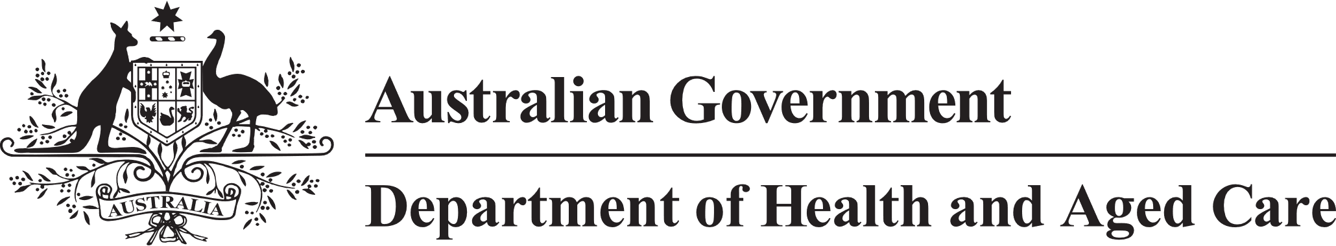

**Council of Elders**

# Communique – 8 and 9 December 2022

At the December meeting, the Council of Elders considered and provided advice on significant aged care reforms including the care finders program that commenced in January 2023, improving the design of residential aged care, reform of the Support at Home program, the development of new Aged Care Quality Standards and a new Aged Care Act. The Council also discussed Star Ratings, launched in December 2022, and key findings of a sector readiness survey.

Council received reports from its working groups and noted that most of the key reform areas were on the agenda for the meeting.

Council welcomed the introduction of [**care finders**](https://www.myagedcare.gov.au/help-care-finder) which will deliver more localised and face‑to-face support to access aged care. Members noted services provided through the care finder program will increase between January and April 2023 as care finder organisations recruit, on-board and train staff. Council provided advice on criteria to assess the effectiveness of the program, particularly about ensuring the program stays focused on working with the most vulnerable older people.

The Council considered the outcomes and principles being developed for the [**Residential Aged Care Accommodation Framework**](https://www.health.gov.au/our-work/residential-aged-care/managing-residential-aged-care-services/improving-accommodation-in-residential-aged-care). Council sees potential for the principles and guidelines to drive innovation in new builds, to support greater choice, dignity and independence, and improve support for older people. An example is the inclusion of non‑infrastructure elements like independent and direct access to outside spaces, fresh air, and space for people to maintain social connections. The Council suggested the guidelines be expanded to consider ways to help people maintain strong connections to their Cultures. They also recommended the use of technology be included.

The Council considered the results of the public consultation for the [**Aged Care Quality Standards**](https://www.agedcarequality.gov.au/providers/standards), held in October and November 2022. Members provided advice on providing person-centred care, and about balancing the rights of older people to the dignity of risk with other competing rights.

Members provided advice on the [**Support at Home**](https://www.health.gov.au/resources/publications/support-at-home-program-overview?language=en) program including assessment settings that can contribute to the prevention of elder abuse, particularly financial abuse. Members gave advice to improve the clarity of language used in the program to reduce potential confusion with other programs.

The Council welcomed the launch of [**Star Ratings**](https://www.health.gov.au/our-work/star-ratings-for-residential-aged-care) as a tool to increase transparency and support decision making. Star Ratings is a significant change that will help older people and their families think about and plan for residential care. The Council will monitor the roll out of Star Ratings, with a particular focus on watching for any unintended consequences or impacts on older people’s right to the dignity of risk.

The Council considered the public consultation planned for the [new **Aged Care Act**](https://www.health.gov.au/our-work/aged-care-reforms/aged-care-legislative-reform). Members suggested ways to strengthen consultation with communities that may be under‑represented including First Nations, and culturally and linguistically diverse communities. Members encouraged the government to find innovative ways to communicate the importance of this reform to older people, and to receive the input from older people. It is critical that older people have a wide range of ways to take part in the consultation. The consultation will be an important opportunity for older people to have their say about what matters as the aged care system is reformed. Council Members encourage all older people to take part in the consultations when they start.

In 2023, members are keen to have more opportunities to talk to older people, to hear about their thoughts and opinions. Council will hear from more older people by expanding its engagement with and communication to communities across Australia.

To get involved in the Aged Care Reforms, visit the [**Department of Health and Aged Care Engagement Hub**](https://agedcareengagement.health.gov.au)at [agedcareengagement.health.gov.au](https://agedcareengagement.health.gov.au/)

The next meeting of the Council of Elders will be held on 25 January 2023.