Infection Prevention and Control Expert Group – The hierarchy of controls for minimising the risk of COVID-19 transmission
27 September 2022
The Infection Prevention and Control Expert Group (ICEG) provides advice and information to support best practice for infection prevention and control in community, hospital, and institutional settings.
This document outlines how to use the hierarchy of controls to manage the risk of COVID-19 transmission. This advice applies to settings where there may be a high risk of COVID-19 transmission such as health care and residential care.
To prevent COVID-19 transmission, a variety of strategies are required across the healthcare system. These strategies should be informed by infection prevention and control (IPC) systems, in addition to risk assessment and management using the hierarchy of controls.
For more guidance on IPC during the COVID-19 pandemic, see the Department of Health and Aged Care website.

Controlling exposures to occupational hazards in the workplace
Controlling exposures to occupational hazards protects personnel in a workplace. You can use the hierarchy of controls to achieve practical and effective control of workplace hazards.
This hierarchy lists different risk-avoidance or mitigation strategies in decreasing order of reliability. Use multiple control strategies until you eliminate the hazard, or it is effectively minimised. These can be implemented at the same time and/or following one another. The hierarchy consists of hazard control measures broadly grouped into 6 categories:
- elimination
- substitution
- isolation
- engineering controls
- administrative controls
- personal protective equipment (PPE).

The diagram below shows the most effective measures higher on the list.
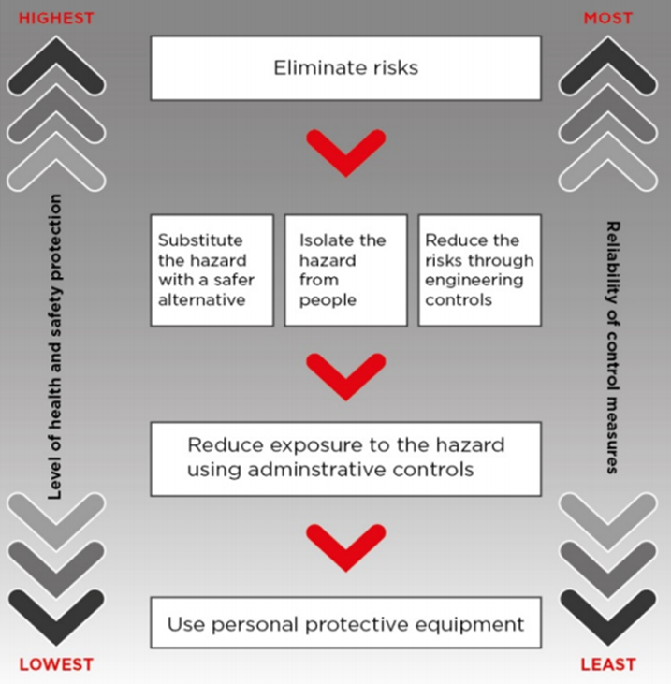
The model code of practice: How to manage work health and safety risks is on the Safe Work Australia website. This provides information on how to do risk assessments, including:
- how to identify hazards
- how to apply effective risk controls.

Applying the hierarchy of controls in health and residential care settings
Employers have a primary duty of care to do all that is reasonably practicable to eliminate risk. If this is not possible, minimise risks as far as is reasonably practicable. This can be done by using one or a combination of control measures.
Standard and transmission-based precautions consist of a range of risk-minimisation strategies to prevent infection. Each strategy used in standard and transmission-based precautions sits in one or more of the 6 control categories.
Using PPE is an important component of a risk management program to prevent potential COVID-19 exposure. However, administrative controls need to support PPE use to enable timely identification and isolation of potentially infected patients, residents, or staff.
PPE must be accessible at the point of care for high-risk individuals or COVID-19 cases. Correct use of PPE in line with situational risk assessment is essential. See Guidance on the use of PPE for health care workers in the context of COVID-19.
The hierarchy of controls should be applied in patient/resident contact settings and other shared facilities such as:
- lunch/tea rooms
- offices
- foyers
- corridors
- changing areas
- meeting rooms
- toilets.
Several suggested strategies are provided in the table below (Table 1).
Table 1. Potential risk minimisation strategies for COVID-19
Category | Example control measures
Elimination | Physically remove the hazard
Reduce opportunities for the virus to enter the facility. | Do not admit COVID-19 positive patients to hospital unless clinically necessary. Manage care in home or another location if possible.
Limit the number of patients or residents going into hospitals or outpatient settings. For example:
- set up offsite and/or outdoor fever/testing clinics
- consider telehealth appointments.
 | Proactively detect and prevent entry to the facility of potentially infectious personnel. This includes pre-entry screening questions, and in some circumstances, testing using a rapid antigen test (RAT) or PCR test.
 | Reduce the number of visitors and non-essential staff in a facility to a minimum. Promote the use of tele links for patient/resident visitors, where appropriate.
 | Reduce the number of entry points into the facility/ and monitor visitor/staff movements. Simplify visitor registration.
 | Exclude unwell staff with symptoms from the workplace and provide alternative work options for at-risk staff, where possible.
Substitution | Replace the hazard
Find other ways to provide care to reduce the potential for transmission. | Administer aerosolised medicine with spacers instead of nebulisers.
 | Substitute in-person appointments with telehealth services, when appropriate.
Isolation | Isolate people from the hazard
Isolate infected persons to prevent potential transmission. | Use negative pressure rooms with anteroom for COVID-19 positive patients where available. If a negative pressure room is not available, use a standard isolation room or single room with a private bathroom.  Avoid rooms with positive pressure airflow, and do not use Class P Isolation Rooms.
Consider grouping COVID-19 positive patients in dedicated wards or zones separate to:
- uninfected patients/residents
- those with uncertain COVID-19 status.
If there are multiple COVID-19 positive patients/clients/residents, consider:
- increasing the distance between patients/residents/guest rooms
- a physical redesign or
- creating a dedicated COVID-19 positive isolation area.
 | Ensure appropriate waste management in line with state and territory legislation regarding clinical and related waste.
Engineering Controls | Reduce risk through engineering controls
Use physical barriers and other forms of hazard reduction. For example: ventilation controls and physical barriers to assist with isolation. | Review and optimise ventilation and air quality including:  - air exchange rates  - air flow and air filtration systems  - temperature  - ambient humidity  Outdoor visits for residential facilities should be encouraged, where possible.
In health and residential facilities:
- optimise air exchanges in patient/resident rooms
- ensure that air from infected patient/resident rooms does not leak significantly into adjacent corridors.
 | Consider using safe, temporary barriers to direct wandering residents into dedicated areas.
 | Redesign work areas to limit number of workers at workstations. Maintain airflow direction away from staff workstations towards patient care areas where possible.
 | Consider placing physical barriers such as glass or plastic screens in triage and reception areas where physical distancing is difficult to maintain.
 | Ensure optimal vaccination coverage by encouraging residents, and the general population to stay up to date with COVID-19 vaccinations
Administrative Controls | Change the way people work
Effective and consistent implementation of COVID-19 policies & protocols | Set up clear lines of governance. Assign an organisational lead with overall responsibility for overseeing:  - task analysis  - risk assessments  - ventilation assessments/monitoring indoor air where applicable  - IPC strategies implementation  - promoting and facilitating hand hygiene, respiratory hygiene, cough etiquette and COVID-19 vaccination.
 | Ensure evidence-based infection prevention and control policies and guidance are in line with national guidance. If needed, adapt the guidance to suit local worker health and safety requirements and other conditions.
 | Give clear guidance on when to change patient/resident placement.
 | In health care and residential care settings, consider making ‘lower’” and “higher risk” zones to help staff, patient/resident and visitor movement.
 | Ensure staff training in standard and transmission-based precautions is provided.
 | Give guidance on environmental cleaning and disinfection according to risk. Conduct regular checks with frequency determined by risk.
 | Provide continuing education on IPC to all staff, patients, residents, and visitors.
 | Regularly update residents, family members, staff, and other service providers on COVID-19 policies.
 | Develop a vaccination program for both staff and residents, to ensure staff and residents are up to date with their COVID-19 vaccinations.
 | Give policy support to reduce the risk of staff attending when unwell. This can include conducive pay and leave arrangements for casual staff.
 | Use signage (in appropriate languages) at the facility entrance to alert visitors not to attend while unwell.
 | Consider surveillance testing of asymptomatic staff in health and residential facilities during facility outbreaks and when local community transmission is high.
Minimise opportunities for infection transmission | Separate care of COVID-19 positive and unaffected patients or residents. Assign staff to care groups and reduce frequency and number of personnel on ward rounds.
 | Triage and manage visitors and promote hand hygiene and PPE compliance.
 | Reduce opportunities for transmission between staff by maintaining use of telehealth technology for staff meetings.
 | Allocate surgical masks for source control to patients or residents with respiratory symptoms to use when they are outside of their ward or room. Educate patients and residents on safe mask use and disposal.
 | During facility outbreaks, encourage patients and residents remain in their allocated room or zoned area.
 | Manage all workspaces to reduce respiratory transmission risk by adopting measures to improve physical distancing. For example, floor markings, spaced seating, maximum room occupancy notices.
 | Adopt general measures to reduce contact spread. Have enough hand hygiene products and facilities available and increase cleaning and disinfection of shared areas.
 | Set up a plan to manage a facility outbreak and ensure all stakeholders are aware of roles and responsibilities.
 | Use standardised relevant State/Territory infection control signage for standard and transmission-based precautions.
Maintain staff wellbeing | Where possible, roster on an appropriate number of staff to avoid excessive workloads and ensure staff can take regular breaks.
 | Know which staff may be more vulnerable to severe COVID-19 infection and redeploy if needed.
 | Develop a policy to manage staff and others who become unwell in the workplace.
 | Ensure all staff providing health care and residential care are up to date with COVID-19 vaccinations as soon as practicable.
 | Provide an employee assistance program that provides psychological support.
Personal Protective Equipment (PPE) | Protect the worker
Review PPE policies and guidelines | Risk-assess PPE recommendations for specific staff roles and activities. Make sure these are consistent with ICEG’s Guidance on the use of PPE for health care workers in the context of COVID-19.
 | Have enough supply of PPE items and related equipment at the point of use.
 | Give effective education and communicate on appropriate PPE use for standard, contact, droplet, and airborne precautions.
 | Conduct regular staff PPE training and donning (putting on) and doffing (removing) competency assessments.
 | Manage the PPE supply chain across all levels of the health service and ensure appropriate PPE ordering by staff.
 | Anticipate PPE supply needs, particularly for residential care facility outbreaks.
 | Ensure the appropriate disposal of PPE – general waste is suitable for PPE that is not visibly soiled by blood/body fluid.
Set up a respiratory protection program | Fit test staff who may need to wear a particulate filter respirator (P2/N95 or equivalent).
 | Train staff to perform a fit check (seal check) every time a particulate filter respirator (P2/N95 or equivalent) is used.
 | Have a trained ‘buddy’ observe staff donning and doffing PPE to reduce potential lapses.
 | Emphasise the importance of eye protection as an essential component of standard, droplet, and airborne precautions. Train staff in safe cleaning of reusable eyewear, if used.
 | Consider the use of reusable powered air purifying respirator (PAPR) or elastomeric respirator where there is high risk from aerosol exposure. For example, some procedures in critical care environments. Train staff in their safe use.
Where PAPR devices or equivalent are available to use, ensure staff:
- are trained and competency assessed for their use
- continue to use the devices to maintain currency of practice.

Resources
Safe Work Australia: How to manage work health and safety risks, Code of Practice, May 2018.safeworkaustralia.gov.au/system/files/documents/1901/code_of_practice_-_how_to_manage_work_health_and_safety_risks_1.pdf
The Australasian Faculty of Occupational and Environmental Medicine (AFOEM) in the Royal Australasian College of Physicians has produced a detailed document on COVID-19 workplace risk mitigation strategies, covid-19-workplace-on-workplace-risk-management.pdf (racp.edu.au)
Australian Guidelines for the Prevention and Control of Infection in Healthcare (2019): nhmrc.gov.au/about-us/publications/australian-guidelines-prevention-and-control-infection-healthcare-2019
Australasian Health Facility Guidelines: healthfacilityguidelines.com.au/aushfg-parts

Source: Safe Work Australia, How to manage work health and safety risks Code of Practice May 2018 , page 19, Hierarchy of Control Measures.
During review, the following example was removed as experiential evidence shows aerosol production is minimal: planning for alternatives to aerosol-generating procedures, including high-flow oxygen and continuous/bilevel positive airways pressure (CPAP/BiPAP).
For further information, refer to the Australasian Health Facility Guidelines.
Refer to the Australian Commission on Safety and Quality in Health Care for standard and transmission based precautions and signage.

