Terms of reference – Clinical Implementation Reference Group

# Purpose

The purpose of this document is to detail governance arrangements and scope of the Clinical Implementation Reference Group (CIRG).

# Role of the group

The role of the CIRG is to support the effective implementation of changes to the Prostheses List resulting from the Prostheses List Reforms by providing clinical advice to the Department. The CIRG will be a time limited committee that will be in place until 30 June 2022.

# Scope

The CIRG will support an integrated approach to the implementation of the Prostheses List reforms. The CIRG will provide clinical advice to the Department of Health on the design and implementation of proposed changes to the Prostheses List, including providing advice on:

* the regrouping of the Prostheses List;
* the removal of identified general use items from the Prostheses List (mainly listed in the General Miscellaneous Category) with reference to the revised definition and scope;
* a proposed framework for utilisation reviews;
* key features of a compliance framework; and
* essential elements for an evaluation framework, including activities and data analysis.

If clinical messaging is required, the CIRG can contribute advice and provide support in engaging relevant stakeholders. This includes advice on the need for and information on, communication documents such as factsheets and stakeholder education material. However, the Department will be responsible for managing all consultations with relevant stakeholders.

# Out of scope

Broader policy discussions regarding the reforms agreed through decisions of the Government, not relevant to this Group, will be the remit of the Prostheses List Reform Taskforce and the Stakeholder Engagement Forum.

# Membership

The CIRG will be made up of up to 15 independent clinical expert members without material conflicts of interest and will have a chair and deputy chair. Membership of the CIRG will comprise of selected Prostheses List Advisory Committee and Clinical Advisory Group members, clinicians that have previously participated on MBS review panels and/or nominees from the AMA and craft groups. Members will not be representing any Associations, Societies or Boards that they are affiliated with.

# Governance structure

The CIRG will provide advice and will not be a decision-making committee. The CIRG will report to the First Assistant Secretary, Technology Assessment and Access Division.

The CIRG does not have the authority to reconsider or overturn decisions and recommendations that have been made by the Government or the Prostheses List Reform Taskforce.

The Governance structure is outlined below:

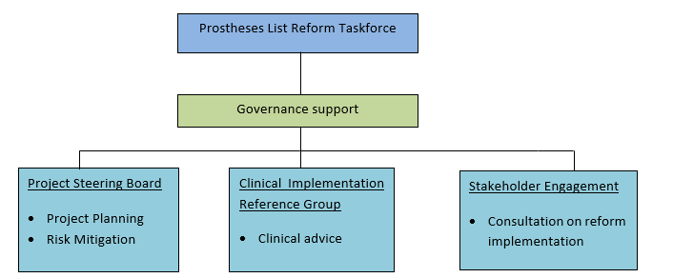

# Conflict of interest and confidentiality

CIRG members shall sign a confidentiality and non-disclosure agreement with the Department at the beginning of their work. Conflicts of interest will be managed in accordance with the Departmental ‘*Health technology assessment committees – conflicts of interest process guide’.*

All documents prepared by or presented to the CIRG are assumed to be confidential unless identified otherwise by the Department. Members of the CIRG have full authority to share the non-confidential substance of discussions and papers, they shall not report or attribute the comments of individuals nor their affiliations outside of meetings, whether conducted face to face or virtual. Unless so specified, the content of discussions and papers of the CIRG is confidential.

CIRG members and guests are expected to declare any conflicts of interest, where they arise, and if deemed appropriate, the person(s) are to be excused from the discussion and in the case of CIRG members, to abstain from participating in decision-making.

All discussions and advice in relation to the work undertaken by the CIRG should be done so without prejudice and is designed to ensure that stakeholders can genuinely inform improvements to services delivered through the Prostheses List. They should not be considered as agreement or commitment by Government.

# Meetings

It is expected that the CIRG will meet monthly as required with meetings approximately two hours in duration. Special meetings may be called by the Chair as required and urgent items may be conducted outside of meetings when required and agreed to by the Chair.

Working groups may be established by the CIRG to progress specific work. Working groups are time limited and sponsored and chaired by a CIRG member.

# Terms of reference review

Where required the Terms of reference for the CIRG may be reviewed and amended by the Department of Health and Aged Care.