# Paralysis from tick bites

|  |
| --- |
| Important! Watch this video about how to safely remove a tick[1] |
| [***https://www.allergy.org.au/patients/insect-allergy-bites-and-stings***](https://www.allergy.org.au/patients/insect-allergy-bites-and-stings) |

## What is tick paralysis?

Tick saliva contains toxins, which can be injected into a host when a tick bites. Paralysis is the most severe reaction to a tick toxin.

In Australia, tick paralysis is mostly seen in animals (dogs, cats, sheep, cattle, goats, pigs and horses), but humans can also be affected. Tick paralysis is rare in humans as a tick must be attached for 4-5 days to inject enough toxin. When it does occur it is usually seen in children between 1-5 years of age, rather than adults. In affected children, the tick attachment site is usually on the chest or on the head region. Tick paralysis can be fatal if left untreated, however, there has not been a death from tick paralysis in Australia since 1945 (due to advances in intensive care treatment and the addition of intensive care-units in regional hospitals).

This factsheet should be read alongside the factsheets *Prevention of tick bites in Australia* and *Management of tick bites in Australia.*

## What are the symptoms?

Early symptoms of tick paralysis may include rashes, headache, fever, influenza-like symptoms, tenderness of lymph nodes, unsteady gait, intolerance to bright light (photophobia), increasing weakness of the limbs and partial facial paralysis.

In older children and adults, initial symptoms can also include difficulty in reading, due to double vision as a result of eye muscle weakness or repetitive uncontrollable eye movements (nystagmus).

Children affected by tick paralysis usually become subdued, refuse food, and sleep for excessive periods. In children, the toxin from the Australian paralysis tick can also cause inflammation of the heart (myocarditis) in addition to muscle paralysis.

It is important for people to seek medical attention quickly if such symptoms occur.

An attached tick needs to be safely managed and safely removed (see video above, and the *Management of tick bites in Australia* factsheet) without delay. However, even after an Australian paralysis tick is removed, a patient’s condition can worsen. The toxin is potentially fatal, and paralysis can spread and continue spreading for up to 48 hours after the tick has been removed. **It is crucial to carefully observe an affected patient during this period. If the affected patient’s condition worsens during this period seek medical attention quickly.** See section on ‘How is it treated?’ in this factsheet for more information.

## How is it caused?

When the Australian paralysis tick bites, it injects a mixture of neurotoxins into its host. Muscle paralysis is induced by these neurotoxins that are transmitted in the saliva of a female Australian paralysis tick when it feeds. The toxins, known as holocyclotoxins, are similar to botulinum toxin (botox). Paralysis is not instantaneous. The tick needs to be attached for several days before signs of paralysis become obvious.

TheAustralian paralysis tick is responsible for over 95% of tick bites in people in eastern Australia and for most tick-borne illnesses in Australia (Figure 1).

Figure 1: Questing female Australian paralysistick (Public domain)

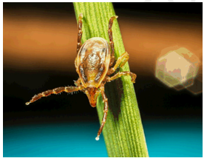

*Public domain: Doggett, S. L., Department of Medical Entomology, NSW Health Pathology*

[*https://www1.health.gov.au/internet/main/publishing.nsf/650f3eec0dfb990fca25692100069854/ea2fa455f96f36f1ca257c3700786bcb/WebPageBody/0.5510?OpenElement&FieldElemFormat=gif*](https://www1.health.gov.au/internet/main/publishing.nsf/650f3eec0dfb990fca25692100069854/ea2fa455f96f36f1ca257c3700786bcb/WebPageBody/0.5510?OpenElement&FieldElemFormat=gif)

Two other tick species in Australia can cause paralysis:

* The southern paralysis tick (*Ixodes cornuatus*) is found in Tasmania and Victoria. This tick is also called the Tasmanian paralysis tick. However, the habitat of the southern paralysis tick is more restricted than that of the Australian paralysis tick and very few cases of paralysis in humans have been associated with the southern paralysis tick.
* Hirst’s marsupial tick(*Ixodes hirsti*) is found in South Australia. It has also been documented in New South Wales and Tasmania. Hirst’s marsupial tick has kangaroos and their kin, domestic dogs and cats, and some birds as it’s hosts, not humans.

## How do people know if they have been bitten by a tick?

A tick bite usually looks like a small dark freckle with a scab, or mole, on the skin. A magnifying glass may be helpful to confirm a tick is present.

As ticks are very small and their bites do not usually hurt, ticks can easily be overlooked on the body, especially if the tick is in a sheltered spot. Ticks prefer soft skin and hairy areas. People may be unaware when they are bitten by a tick as the tick can inject small amounts of saliva with anaesthetic properties so that the person cannot feel that the tick has attached itself. In addition to the bite being painless, often the person will not sense a tick moving on their skin. However, once it starts to feed, it becomes noticeable, enlarging as it becomes filled with blood and eggs.

## Who is at risk?

The Australian paralysis tick is the most likely tick to cause paralysis in Australia. The Australian paralysis tick is commonly found on the east coast of Australia, which means that over 50% of the Australian population are potentially exposed to this tick.

People who live in, or travel to, areas where the Australian paralysis tick is regularly found (endemic) and who also engage in outdoor activities that increase the risk of being bitten by an Australian paralysis tick are at increased risk of paralysis.

### Tick paralysis, while rare in humans, is more common in children rather than adults, the majority of cases occurring in children between 1-5 years of age; In affected children, the tick attachment site is usually on the chest or on the head region.

### Risk areas for paralysis after tick bites

The main distribution of the Australian paralysis tick is within 20 km of the coast along virtually the entire eastern seaboard of Australia (see Figure 2 overleaf). However, it has been isolated in areas more than 100 km inland including the Bunya Mountains, Barcaldine, and Thargomindah in Queensland and the Lower Blue Mountains in New South Wales. It can also be found in the Australian Capital Territory, probably having travelled from the coast on people and their pets. It is not known to occur in South Australia, Western Australia or the Northern Territory.

In the locations where Australian paralysis ticks are regularly found, they prefer forested areas with high annual rainfall. They are found most commonly in wet grassy forests and temperate rain forests in moist, humid coastal areas with abundant native animals that serve as hosts for the tick. The Australian paralysis tick has an extensive host range including, but not limited to, domestic animals such as dogs, cats, chickens and other fowl; native animals such as wallabies, kangaroos, bandicoots, possums and dingoes; introduced pests such as rabbits and black rats; as well as humans. Long grasses and bushland provide ideal environments for ticks, and if people live close to these areas, it is common for people to have Australian paralysis ticks in their garden.

Figure 2: Distribution map of the Australian paralysis tick (*Ixodes holocyclus*) (Public domain)

*Public domain: Distribution map of the Paralysis Tick of Australia (Ixodes holocyclus)*

*Roberts FHS (1970) Australian Ticks. Yeerongpilly QLD.*

*Adapted from Roberts FHS (1970) Australian Ticks. Yeerongpilly QLD by TAGS Inc, Bill Conroy & Norbert Fischer*

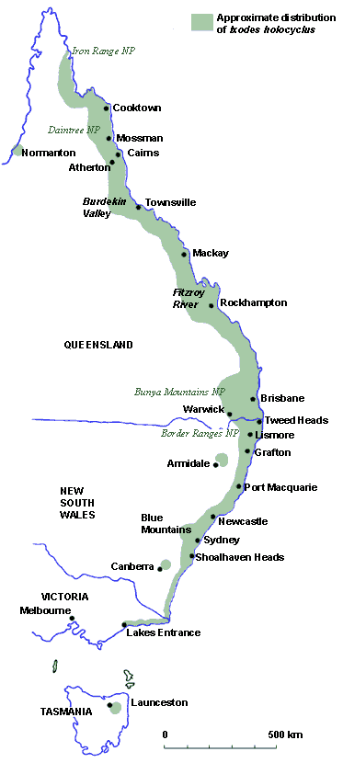

### Risk seasons for paralysis after tick bite

The tick season in Australia is often considered to range from July to December when adult ticks are more common, however, the risk of exposure to ticks exists throughout the year.

The larval stage of the Australian paralysis tick is most active during the autumn months, the nymph during winter, and the adult during the spring. This tick is most active during periods of high humidity, especially after rain, and this is when people should take particular care to avoid tick bites. Any life stage, however, may be found at any time of the year.

### How is it prevented?

Paralysis is caused by the bite of a tick that is capable of inducing paralysis. Follow the guidance and advice in the *Prevention of tick bites in Australia* factsheet for information on personal preventive strategies to prevent tick bites on people and pets, and preventing tick bites around the home.

See the *Management of tick bites in Australia* factsheet for information about safely managing tick bites.

## How is it treated?

Locating and removing all ticks from the patient’s body is an important part of therapy, despite the risk of a short-term worsening of symptoms. While tick antitoxin is available, there can be serious side effects for which medical treatment would be required. Antibiotics may be required, and patients may require mechanical respiratory ventilation in an intensive care unit as paralysis progresses. A full recovery is usually slow and may take several weeks.

1. An allergy project supported by the National Allergy Strategy, Australasian Society of Clinical Immunology and Allergy, Allergy & Anaphylaxis Australia, and Tick-induced Allergies Research and Awareness.