National Medicines Policy

2022

(plain language)



# 

# Table of contents

Introduction 1

Pillar 1: Fair, timely, safe and reliable access to medicines and medicines services, at affordable prices 7

Pillar 2: Medicines are high quality, safe and effective 9

Pillar 3: Medicines are used correctly and safely 11

Pillar 4: Medicines industry and researchers work together and are innovative and sustainable. They have the ability and skills to meet health needs now and in the future. 14

Partnerships – achieving the Policy’s vision and aim 16

Governance 23

Implementation 23

Evaluation 24

Conclusion 25

# Introduction

Australia’s National Medicines Policy (the Policy) is a high-level framework. It focuses on the availability of medicines and how they are used. It also focuses on medicines services. These services help make sure medicines are used correctly and safely. The Policy covers the research and development of medicines. It also looks at how medicines are:

* manufactured
* regulated or controlled
* evaluated or assessed
* supplied and dispensed
* stored and accessed.

The Policy promotes the correct and safe use of medicines. It concentrates on the health needs of Australians now and in the future and it understands that it is the responsibility of everyone involved in medicines and medicines services to help achieve the best health, social and economic results for Australians. The Policy brings all the different groups, individuals and organisations together to work as partners.

These partners are responsible to make sure the Policy works. The Policy understands the important role of consumers and customers. It puts these people at the centre of its planning, and it focuses on meeting the needs of Australia’s diverse population.

To help make the Policy a success it will use shared decision-making and strategic partnerships. It will also include people who use medicines in how related policies and programs are:

* designed
* developed
* implemented
* evaluated.

The Policy is connected to other policies, strategies, laws and programs. For the Policy to meet its vision and aim, it needs to be in line with health changes across Australian, state and territory governments.

This is the second edition of the Policy. We published the first edition in 2000.

## Vision

The Policy’s vision is:

To achieve the world’s best health, social and economic results for all Australians and to do this through a supportive medicines policy.

We can reach this vision with partnerships, structures and processes that support the Policy.

## Aim

The aim of the Policy is to make sure:

* All Australians have fair, timely, reliable and affordable access to high-quality medicines and medicines services.
* Medicines are used safely and correctly. People have the information they need to make informed choices, and health care is well organised and based on their needs.
* There is support to encourage world-class innovation and research. This includes research that results in new treatments, medicines and medicines services in Australia.

## Scope

In this Policy we use the word ‘medicines’ to mean therapies and products that are used to treat a disease or health condition. This includes:

* prescription medicines
* gene therapies
* vaccines
* non-prescription medicines
* complementary medicines
* traditional medicines, including Aboriginal and Torres Strait Islander traditional medicines.

The Policy also covers devices used to give and monitor medicines or used together with medicines.

We use the term ‘medicines services’ to mean services and programs that help make sure medicines are used correctly and safely. This includes:

* education, training and awareness programs
* digital information and software to help people to make decisions about medicines
* medication review services
* services that diagnose medical conditions including for personalised medicines. Personalised medicines look at differences in people’s genes, environments and lifestyles.

The Policy also uses terms and ideas from other policies. These may change over time. For example, the Policy’s central pillars and principles (explained below) use terms that are used Australia-wide when talking about using and managing medicines correctly and safely.

This scope means the Policy can change to meet:

* new treatments and technologies
* new or improved medicines services
* any new policies for devices or other technologies
* ongoing changes to Australia’s therapeutic goods regulatory framework
* ongoing improvements to national plans for safety and quality in health care.

## Achieving the vision and aim through partnerships

Partners in the Policy include:

* people who use medicines or medicines services and their families and carers
* Australian, state and territory governments and regulatory agencies
* non-government organisations
* health professionals
* consumer organisations – including not-for-profits
* private and public health services
* industry – including pharmaceutical, software and medical service industries
* researchers and academics
* health educators – including higher education and professional training organisations
* health professional organisations and other health related organisations
* the media
* the general community.

We need all partners to work together to achieve the best health, social and economic results for all Australians. Each partner has a role in the Policy by respecting what the other partners have to offer. Some partners also have extra responsibilities to achieve the aim and vision of the Policy. You can read more about these on pages 16-22.

**Figure 1 – The relationships between the Policy partners**

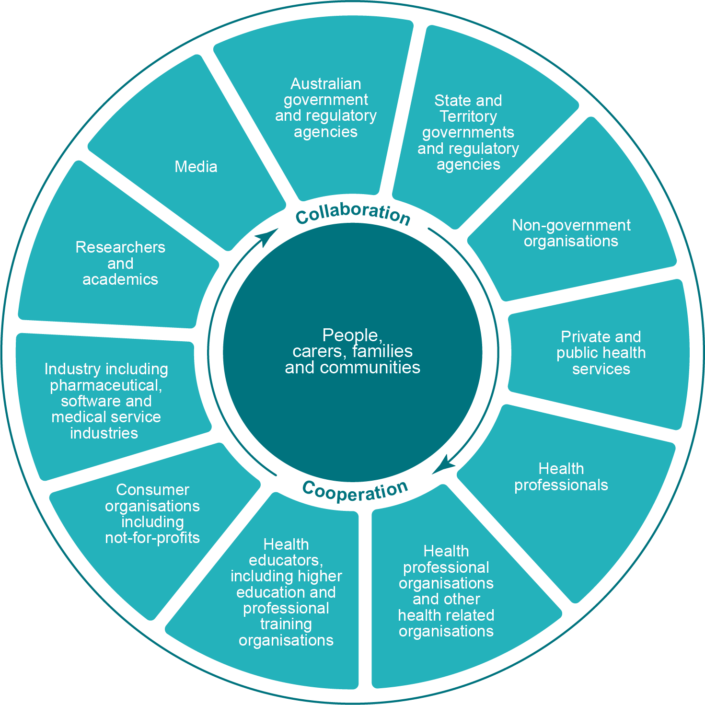

## Central pillars, principles and enablers

The Policy is based on 4 central pillars. These ideas support the Policy’s principles and enablers to achieve the vision and aim of the Policy (Figure 2). The Policy explains the responsibility of all partners to work together to achieve its aim and each of the central pillars.

**Figure 2 – Overview of the Policy**

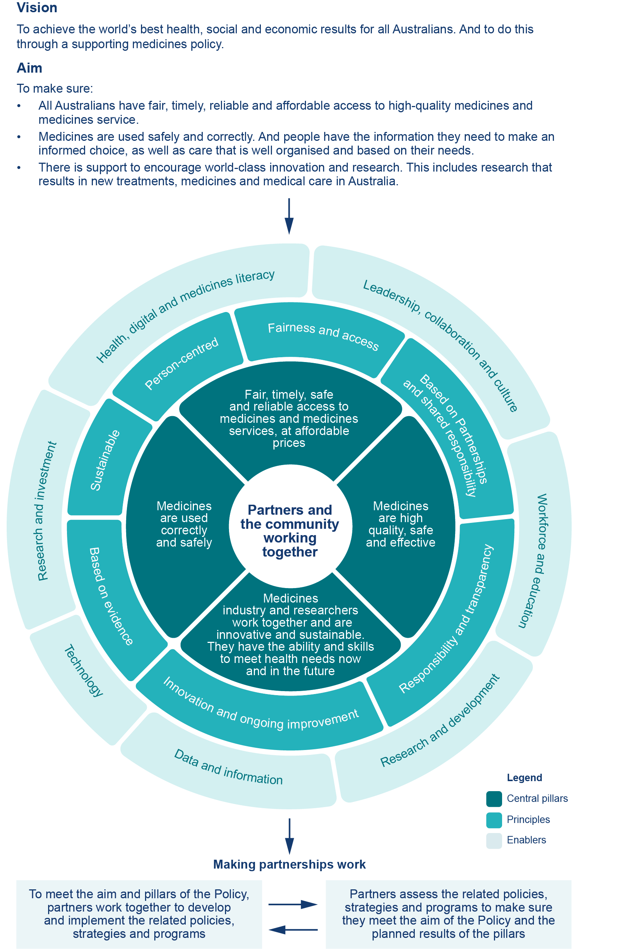

## Central pillars

The central pillars of the Policy are:

1. Fair, timely, safe and reliable access to medicines and medicines services, at affordable prices.
2. Medicines are high quality, effective and as safe as possible.
3. Medicines are used correctly and safely.
4. Medicines industry and researchers that work together are innovative and sustainable. They also have the ability and skills to meet health needs now and in the future.

The Policy identifies the planned results for each of the central pillars. We describe these results with the detail about each pillar.

## Principles

The Policy has 7 principles. These principles guide partners to work together to achieve the Policy’s aim. Partners will co-design, develop, implement and assess the Policy’s strategies and programs.

| **Principle** | **What we’ll do** |
| --- | --- |
| **Person-centred** | Make sure consumers have the information they need to take part in making decisions. Recognise the person’s goals, diversity and experience. This includes improving people’s health, digital and medicines knowledge so that they can understand the information they’re given. Support people and their families and carers to be involved at all levels of the Policy. |
| **Fairness and access** | Focus on achieving positive health results that matter to people and their communities. Make sure all Australians have timely, safe and reliable access to effective, high-quality medicines. This includes access to culturally safe medicines services and information. Make sure everyone has access no matter a person’s background, age, disability, location or personal circumstance. Focus on supporting vulnerable groups in the community including:   * Aboriginal and Torres Strait Islander people * people from culturally and linguistically diverse backgrounds * children and older people * people with disability * people living in rural and remote areas * people on low incomes * people living with rare and under-recognised diseases * people with mental illness * LGBTIQ+ people * pregnant and breastfeeding women.   Recognise that people may be in more than one of these groups. |
| **Based on partnerships and shared responsibility** | Set up active, respectful conversations and collaboration between partners. Listen to and recognise the wisdom and expertise of each partner. All partners act responsibly, as stewards of the Policy. |
| **Responsibility and transparency** | Hold all partners responsible for their actions and for working towards the Policy’s central pillars. Do all activities, and share information, in a respectful, ethical and transparent way. |
| **Innovation and ongoing improvement** | Make sure all partners support new and better ways to find and respond to health needs and provide better value. This will help achieve the best health, social and economic results for all Australians. This includes making access to medicines and medicines services fairer and continually improving the health system. |
| **Based on evidence** | Make sure all partners use relevant and current evidence and best practice to guide:   * research * decision-making * program design and communication.   This includes information on safety, fairness and effectiveness. It also includes real-world experience and experience and results patients have reported. |
| **Sustainable** | Encourage all partners to focus on improving how medicines are used. Partners will look at the health, social and economic effect and how sustainable their strategies and programs are. All partners will work to reduce the impact research, development, manufacture and supply of medicines have on the environment. This includes collecting and disposing of medicines, devices and packaging safely and with minimal impact on the environment. |

## Enablers

There are 7 enablers that support the Policy:

* **Health, digital and medicines literacy**  
  We want to build people’s skills, knowledge and understanding so that they can find and use information about their health and health care. This includes using medicines safely and correctly. Access to this information will help them to make informed decisions. The whole health system needs to provide person-centred health information, education, support and services. We need to have information to meet each person’s culture, accessibility and information needs. Digital tools and technologies should help people to manage their health and wellbeing and connect them to their healthcare teams. They should also give them choices for how, when and where they get their care.
* **Leadership, collaboration and culture**We want to encourage all partners to follow and share the aim, pillars and principles of the Policy in a collaborative, respectful and transparent way. All partners must develop and support a culture that is open to learning and quality improvement. This includes using co-design and other collaborative processes.
* **Workforce and education**  
  We want to make sure the workforce is knowledgeable and capable. And that they have the resources they need to provide coordinated and person-centred care. This includes that health professionals are trained to work to their full range of practice and use their skills consistently across Australia. They will work with other partners and use current best practice guidelines.
* **Research and development**  
  We want to increase knowledge and support innovation. We want to provide fair and safe access to new and better medicines as well as new and improved medicines services. This includes supporting international research partnerships. This will help support good health and keep improving the quality of medicines and medicines safety.
* **Data and information**We wantto make sure data and information is collected, stored and shared responsibly. Decisions based on data and information from a range of digital sources help to improve people’s health and their fair access to medicines. It also helps make sure that medicines are used correctly and safely and that the health system is more efficient. This includes the ability to use data to predict trends, such as trends in medicine use and new therapies.
* **Technology**  
  We want to use digital information and technologies that can help manage a person’s medicines across different services. We also want to use technologies to improve access to, and the quality and safety of, health and medicines.
* **Resources and investment**  
  We want to make sure we invest, share and use resources to achieve the aim of the Policy.

# Pillar 1: Fair, timely, safe and reliable access to medicines and medicines services, at affordable prices

**What we want to happen:**

* **Medicines and medicines services are affordable and people can access them in a fair, timely and safe way. This will achieve the best health, social and economic benefits for Australians.**

To make sure people have fair access to medicines and medicines services we need to look at how quickly they can safely access them and how affordable they are. We also need to look at the health, social and economic benefits. Australia-wide programs that provide affordable medicines include:

* Pharmaceutical Benefits Scheme
* Repatriation Pharmaceutical Benefits Scheme
* National Immunisation Program.

Medicines are also accessed through:

* public and private hospitals
* clinical trials
* compassionate access programs
* privately purchased (including non-prescription medicines).

Agreements between Australian, state and territory governments support people to access medicines and medicines services.

## Fairness

All Australians should have fair access to safe, effective and high-quality medicines. This access should be the same whatever a person’s background, age, disability, location or personal circumstance. Everyone should also have access to medicines services and medicines information that is culturally appropriate for them.

This pillar focuses on getting rid of health barriers that vulnerable groups might experience. We can address some issues vulnerable people experience in the following ways:

* including Aboriginal and Torres Strait Islander leadership in all partnerships. This will help to identify priorities and to find solutions
* including people from culturally and linguistically diverse backgrounds in partnerships to co-design solutions. This will help increase access to medicines and culturally appropriate medicines information and medicines services
* communicating with people with disability and health professionals and providing access to easy-to-read information about medicines. This will help people access the information about and reviews of medicines that they need
* looking at cost, supply and access to medicines and health services for people in rural and remote communities
* considering the lack of evidence and affordable treatments for people with some rare and under-recognised diseases.

Where a person lives shouldn’t affect their safe access to medicines. For example, if they live in:

* different states and territories
* hospital or community health care
* disability care or residential aged care
* detention centres or jails.

Ways of tackling these barriers include through regulation, by meeting each person’s needs, educating the workforce and increasing access to internet and telehealth services.

## Timeliness

All Australians must have timely, safe and reliable access to medicines and medicines services to support their health and wellbeing. We need processes that assess the value and price of medicines for best possible access for Australians. This includes the ability to quickly respond to new technologies, such as new specialised therapies and services. This is particularly important where people have needs that haven’t been met and for public health emergencies or natural disasters. Processes for deciding the price and supply of medicines must also be efficient.

People may also not be able to access medicines in a timely way because of shortages or other supply issues. This is particularly a problem for rural and remote communities. All partners need to work together to reduce the impact of medicines shortages and other supply issues.

## Affordability

All Australians should be able to afford the medicines and medicines services they need. This is particularly important for:

* people with multiple health conditions taking multiple medicines
* people with low incomes
* people or families with high out-of-pocket healthcare costs.

We need a strong and transparent way to work out the value of a medicine. This will help with the coordinated, fair and efficient supply and use of medicines. The value of a medicine includes:

* its benefits to the health and wellbeing of the person
* the social and economic benefits to the person, their families, carers and community.

Decisions about whether to invest in medicines should be based on thorough evaluation. This includes looking at:

* real-world evidence
* patient reports
* the possible impact of a medicine across Australia’s health systems.

# Pillar 2: Medicines are high quality, safe and effective

**What we want to happen:**

* **Australia’s processes to make sure medicines meet the proper standards are effective, protect health and safety and are trusted by the community.**
* **Medicines are safe and effective. Their labelling and information is easy to find and supports their safe and correct use.**

The Therapeutic Goods Administration (TGA) regulates all medicines supplied in Australia. This includes prescription, non-prescription and complementary medicines.

No medicine is 100 per cent risk-free. The risk is greater for some medicines. The TGA has stricter controls for medicines that are a higher risk when used or misused. The TGA assesses the quality and safety of all medicines. It also looks at how effective higher risk medicines are. The TGA controls the manufacturing and advertising of medicines. It also decides whether you need a prescription or consultation from a health professional for a medicine.

## Protecting the health and safety of the community

Making sure medicines are safely and correctly used is vital. For medicines that have a higher risk, ongoing quality checks make sure we meet the highest standards of quality, safety and effectiveness.

These processes include assessments before and after a medicine is registered. They include feedback from people, their families and carers and health professionals. The outcomes of these assessments are generally available to the public. This shows how standards are achieved and maintained.

To protect the health and safety of the community, all partners must aim to:

* improve access to up-to-date, easily understood information. This helps people make informed decisions, including whether to take a medicine or choose another option
* build the Australian public’s knowledge about medicines regulation. This includes what they can expect from medicines regulation and what it doesn’t cover
* encourage people and their families or carers and health professionals to report unexpected or harmful reactions to medicines
* help identify and report possible issues with medicines
* make sure all suppliers, researchers and industry members understand and meet their legal and code of conduct responsibilities.

## Effective, timely and risk-appropriate regulation

Australia’s medicines regulation process protects the health and safety of the community. It needs to be up-to-date, flexible and support timely, safe access to medicines and medicines services.

We can achieve this through:

* standard and transparent processes to assess and monitor medicines
* looking for ways to work with international regulators and come up with a standard approach, reduce double up and get earlier access to medicines for Australians
* regulations that make sure appropriate and ethical practices are followed in research, development, evaluation, manufacture, supply, storage and advertising medicines
* regulations to reduce fake medicines coming into Australia
* regulations and communication to reduce the risks for unregulated herbal or supplement products
* clear processes for responding to issues quickly. This includes communicating the results to all partners and affected people
* making sure accurate and easily understood medicines information is available to all people, families, carers and health professionals
* developing flexible processes to respond to high unmet clinical need, medicines supply issues, public health emergencies and natural disasters.
* building relationships between regulators and the medicines industry, researchers, people, families and carers and health professionals. This includes Australian, state and territory agreements to protect the Australian public from false advertising of products and services.

# Pillar 3: Medicines are used correctly and safely

**What we want to happen:**

* **People, their families and carers take part in making decisions about the safe and correct use of medicines to prevent, manage and treat a health condition and maintain good health.**
* **Health professionals work in a person-centred way. They are trained and supported to use medicines safely and correctly.**

The Australian Commission on Safety and Quality in Health Care (the Commission) leads Australia-wide improvements in the safety and quality of health care. Its work improves value and sustainability of the health system. The Commission works alongside the TGA to achieve better health and experiences of the health system for all Australians. This includes programs to reduce medication errors and to improve the safe use of medicines.

The correct use of medicines and medicines safety is a national health priority. It is also a key part of the Policy and includes:

* **Choosing treatment options**  
  Medicines can be used to manage health conditions and treat illnesses. Medicines must only be chosen where they are the best treatment option.
* **Choosing suitable medicines**  
  When choosing, prescribing or stopping the use of a medicine, we must think about:
  + the clinical and non-clinical factors – non-clinical factors include a patient’s situation like their lifestyle
  + the person’s experience, needs, preferences and values
  + the possible benefits and harms
  + the costs.
* **Using medicines safely and effectively**  
  Getting the best results means:
  + checking results and reporting harmful effects
  + managing symptoms or side effects
  + reducing misuse, overuse and underuse
  + helping people to make decisions to use medicines safely and effectively.

Using medicines correctly and safely includes medicines management. Medicines management includes:

* information and decision support tools
* meeting regulations and safety when distributing and storing medicines
* targeting known risk areas
* work practices like monitoring and risk assessment
* using medication safety strategies and tools to share information about medicine.

## Person-centred care and shared decision-making

Person-centred care puts the person first. It’s vital for using medicines correctly and safely. It includes providing information to help people to take part in decisions and make choices.

Health literacy, digital literacy and medicines literacy help people to decide, with their doctor, whether to use a medicine. Medicines literacy means people know how to find and use information about medicines that is relevant and accurate. The Policy partners understand that they all need to work together to:

* encourage people, their families and carers, to be informed and take part in making decisions. This includes helping them to improve their medicines literacy and understanding
* appreciate the knowledge and experiences of people, their families and carers in a shared decision-making with health professionals
* encourage people to ask for, and use, reliable and good quality information and services as part of informed decision-making
* develop people’s skills and confidence to manage their own health and medicines, including when and where to get help
* give people, their families, carers and health professionals access to clear, accurate and up-to-date information on medicines use that suits their needs, including particular patient groups such as patients who are pregnant and breastfeeding
* provide culturally safe, person-centred services and support for both face-to-face and non-face-to-face conversations
* provide appropriate and targeted support for people to understand the risks and benefits of medicines as well as the other options available.

The Policy recognises that people with low medicines literacy find it harder to prevent and manage illness and maintain good health. The safe and correct use of medicines must be available to people with different language skills and cultural backgrounds. All Australians must be involved in the design, implementation and assessment of medicines use and related services.

All Policy partners understand that focusing on health, digital and medicines literacy is not just about the safe and correct use of medicines. It helps achieve positive results for using the health system over a lifetime.

All health professionals are responsible for supporting the safe and correct use of medicines. Any changes to a person’s list of medicines need to be to be communicated to the person, their families and carers and all health professionals involved in their care.

## Promoting the correct and safe use of medicines across the health system

Reducing harm and promoting the safe and best use of medicines is an ongoing process. Health professionals need to be up-to-date with new medicines and how to use existing medicines and health technologies. A medicine should only be used when it is the best medical option and following best practice. This is whether the medicine is prescribed, recommended or chosen by the patient. Health professionals must be trained in person-centred care and informed decision-making. This helps them to have discussions about treatment options, including medicines.

All partners need to work together to reduce the risk of harm from the use, overuse, underuse and misuse of medicines. For example:

* checking people for early signs and symptoms of harm or misuse of a medicine
* asking people who have started a new medicine if they have any symptoms or side effects
* correct use of antimicrobials, such as antibiotics and antivirals, to reduce antimicrobial resistance. Antimicrobial resistance happens when medicines like antibiotics no longer work against the bacteria they were made to treat
* checking for the incorrect use of multiple drugs
* stopping the use of medicines that aren’t needed anymore
* reducing harm from high-risk medicines
* improving the safe and correct use of medicines when someone is moving from one place of care to another.

Medicines are an important part of almost every type of care. They are the most common form of health care. The Policy partners understand that to support people, health professionals and the health system to use medicines safely and correctly, they need to have:

* leadership that coordinates programs and support
* policies, guidelines, standards and clinical information that guide the safe and correct use of medicines. This will need better digital systems and the use of smart technologies
* education, training and awareness campaigns to help health professionals to safely:
  + prescribe, dispense and administer medicines
  + monitor their effects
  + stop using them when necessary
  + involve people in making decisions about medicines.

They also need to have:

* access to up-to-date, reliable and good quality information for the Australian health system. This includes information about medicines through a person’s healthcare journey. It also includes information that covers misinformation and the unethical promotion of medicines
* research, evaluation and data collection, to assess and report on results.

# Pillar 4: Medicines industry and researchers work together and are innovative and sustainable. They have the ability and skills to meet health needs now and in the future.

**What we want to happen:**

* **Medicines industry and researchers that are supported to help meet health needs now and in the future in Australia and internationally. They work in a way that is sustainable and responds to health needs. They deliver and encourage world-class innovation, including developing and marketing medicines, new technologies and services.**
* **A medical research sector that creates high-quality evidence, strategies and processes. These then help keep improving the correct and safe use of medicines.**
* **Efficient and reliable supply chains that deliver medicines and services in a fair, timely and affordable way throughout Australia.**

The medicines industry and research sectors are an important part of improving the health of Australians. Industry and research sectors that work together, are dynamic and sustainable, make sure all Australians can benefit from their innovations. The supply chains and networks for medicines and devices the Policy covers include:

* product sponsors
* manufacturers
* wholesalers
* health software providers
* hospitals
* community and hospital pharmacies
* Aboriginal and Torres Strait Islander health services
* residential aged care facilities.

Under the Policy, all partners need to coordinate and meet service delivery and health research, education and industry policy.

## Medicines industry and researchers are supported

The medicines industry and research sectors need to be supported by:

* investment
* government, industry, education and research policies
* strong partnerships between academia, government science organisations, industry, health services and individuals.

The Australian medicines industry and the research sectors need to be competitive in the international market. Promoting international standards that protect intellectual property rights can help support trade and investment. It also encourages innovation and creativity.

All partners should keep improving and developing their research knowledge, processes and infrastructure. This will help to increase the clinical trials sector in Australia.

We need efficient and effective processes that encourage and support innovation and assessment. Regulation should be fit-for-purpose and meet international best practice. This will help keep patients safe and achieve strong, evidence-based results.

To build reliable supply chains and networks, we need to support and encourage advanced manufacturing for biopharma and medical technologies. Biopharma products are complex medicines made from living cells or organisms. We can build these supply chains by:

* increasing investment in infrastructure and marketing
* supporting partnerships and innovation hubs
* transforming innovative research into new treatments and medicines.

Governments, health professionals, industry, researchers and educators need to work together so that all Australians can access medicines that improve their health. This will also help us to benefit from the social and economic advantages that come from innovation.

# Partnerships – achieving the Policy’s vision and aim

All partners need to play their role in the Policy in a way that respects the other partners. Partners need to say if they have any conflicts of interest and manage these.

We encourage all partners to list the areas where they can deliver or help us to achieve the Policy’s vision and aim.

Australian, state and territory governments, and other partners, will support, coordinate and assess the Policy’s progress to reach its aim. Partners will need to share how they’re using the Policy’s principles as well as how what they’re doing is meeting the planned results of the pillars. They will need to report this information in an easy-to-understand and meaningful way. This information will need to be accessible and regularly updated.

Different partners are responsible for the planned results of each pillar of the Policy. We also need to keep in mind what other national health strategies are doing. This is so we implement the Policy in a consistent and unified way.

## Making the partnership work

To achieve the planned results of the central pillars, all partners need to work together and be respectful of each other’s expertise.

### Pillar 1 – Fair, timely, safe and reliable access to medicines and medicines services, at affordable prices.

**Partner’s responsibilities and roles to achieve Pillar 1**

| **What we want to happen** | **Partners** | **Responsibilities and roles** |
| --- | --- | --- |
| **Medicines and medicines services are affordable and people can access them in a fair, timely and safe way. This will achieve the best health, social and economic benefits for Australians.** | * Consumer organisations and representatives * Patient advocates * Not-for-profits | Support people to take part in the health sector at all levels.  Be involved in developing and sharing health and medicines information for individuals and groups. This will focus on people who find it hard to access medicines. |
|  | Health professionals | Discuss treatment options with patients. Use a person-centred way to recommend, prescribe and supply medicines and medicines services. Help people to decide whether to use a medicine. Encourage the safe and correct use of medicines. |
|  | Australian government and national agencies | Deliver national health programs. Regulate access to medicines and medicines services.  Be responsible for making sure systems and policies work together across states and territories.  Support national platforms, governance, processes and guidelines for safe and accessible clinical trials. |
|  | State and territory governments and agencies | Provide safe, reliable access to affordable medicines through publicly funded services.  Be responsible for making sure systems and policies work together across states and territories. |
|  | Medicines industry, including software providers | Research, develop and supply medicines with the best health and value to people and the community. Do this in a fair, timely and sustainable way.  Provide consistent information about medicines to health professionals and individuals. |
|  | Researchers | Lead research and clinical trials that meet national and international advice. These should also add to evidence that supports the safe, timely, fair and reliable access to medicines. |
|  | Health educators, including higher education and professional training organisations | Work with all partners to develop and deliver education and training programs that support fair, timely and safe access to medicines for all Australians. |
|  | Health professional organisations and other health related organisations | Develop systems, processes and guidelines, which promote safe, timely, fair and reliable access to medicines. |
|  | Media | Report responsibly on issues about safe, timely, fair, reliable and affordable access to medicines. |

### Pillar 2 – Medicines are high quality, safe and effective.

**Partner’s responsibilities and roles to achieve Pillar 2**

| **What we want to happen** | **Partners** | **Responsibilities and roles** |
| --- | --- | --- |
| **Australia’s processes to make sure medicines meet the proper standards are effective, protect health and safety and are trusted by the community.**  **Medicines are safe and effective. Their labelling and information is easy to find and supports their safe and correct use.** | * Consumer organisations and representatives * Patient advocates * Not-for-profits * People, their families and carers | Support people to be involved in approving medicines. Support people to check and report harmful effects and product quality.  Help people to understand how medicines are regulated. Support people to be involved in developing information about the risks and benefits of medicines. This will help people use medicines effectively and safely. |
|  | Health professionals | Prescribe, dispense and give medicines in line with relevant guidelines. Discuss options with the person taking the medicine, or their families and carers.  Monitor and report harmful effects and medicines safety issues. |
|  | * Australian government and national agencies * State and territory governments and agencies | Work together to make sure regulation for research, development, production, supply and advertising of medicines is best practice.  Make sure regulation is in line with, and relevant to, international standards, where appropriate.  Make sure information about medicines is best practice. This includes labelling, product information and consumer medicines information. |
|  | Researchers and medicines industry, including software providers | Meet research and development, manufacturing and regulatory standards. This includes safety monitoring and reporting.  Use appropriate language in easy-to-understand, accurate and consistent information about medicines. |
|  | Professional organisations | Promote best practice for reporting harmful effects and other medicines issues to the authorities. |
|  | Health educators, including higher education and professional training organisations | Develop and deliver training on collecting data about the safety, quality and effectiveness of medicines. The training should include the regulations, processes and the role of partners in collecting data. |
|  | Media | Report responsibly and accurately about product safety and quality issues. |

### Pillar 3 – Medicines are used correctly and safely.

**Partner’s responsibilities and roles to achieve Pillar 3**

| **What we want to happen** | **Partners** | **Responsibilities and roles** |
| --- | --- | --- |
| **People, their families and carers take part in making decisions about the safe and correct use of medicines to prevent, manage and treat a health condition and maintain good health.**  **Health professionals work in a person-centred way. They are trained and supported to use medicines safely and correctly.** | People, their families and carers | Take part in the safe and correct use of medicines as part of a range of treatment options.  With support from other partners, build their knowledge and understanding of medicines. This includes the benefits and risks of the effective, safe and correct use of medicines. This includes looking at using information from digital sources where appropriate. |
|  | * Consumer organisations and representatives * Patient advocates * Not-for-profits | Build health, digital and medicines literacy in the community. This will help people take part in making decisions about medicines. This includes helping people to find and understand information about medicines and the risks and benefits. Make sure this information is accessible and meets the needs of the person. |
|  | Health professionals | Use programs and initiatives to use medicines safely and correctly in clinical practice. This includes getting the up-to-date list of medicines the person is using at every stage of care.  Collect and dispose of expired or unwanted medicines safely.  Promote public awareness around issues with medicines. This includes disposing of medicines safely to reduce the impact on the environment.  Communicate the risks and benefits of medicines. This will help people to make informed decisions about their medicines. It also builds their health and medicines literacy.  Communicate information about the safe and correct use of medicines effectively and respectfully.  Make sure you have consent before sharing any health-related information.  Meet up-to-date best practice guidelines on prescribing, dispensing, giving and cancelling medicines.  Use digital technologies in clinical practice to support using medicines correctly and safely. |
|  | Health professional organisations | Support health professionals to use systems, programs and initiatives to use medicines safely and correctly. |
|  | * Australian government and national agencies * State and territory governments and agencies | Organise and fund programs, processes, structures and clinical settings to use medicines safely and correctly. This includes raising awareness among public and health professionals.  Provide leadership and direction on improvements in the safe and correct use of medicines. |
|  | Researchers and academics | Research, trial, evaluate and report on the safe and correct use of medicines. Do this together with other partners. |
|  | Medicines industry, including software providers | Promote the safe and correct use of medicines in research, evaluation, development, manufacture and supply.  Make sure up-to-date, accurate, consistent and easy-to-understand medicines-related information is available. This should be available for health professionals and people, and their families and carers. |
|  | Health educators, including higher education and professional training organisations | Make sure that education encourages using medicines safely and correctly in a person-centred way and with shared decision-making. This includes education in undergraduate, postgraduate and continuing professional development programs. |
|  | Media | Responsibly report on medicines and issues with their use.  Manage digital platforms to protect people from online disinformation and misinformation on medicines. |

### Pillar 4 – Medicines industry and researchers work together and are innovative and sustainable. They have the ability and skills to meet health needs now and in the future.

**Partner’s responsibilities and roles to achieve Pillar 4**

| **What we want to happen** | **Partners** | **Responsibilities and roles** |
| --- | --- | --- |
| **Medicines industry and researchers are supported to help meet health needs now and in the future in Australia and internationally. They work in a positive and sustainable way that responds to health needs. They deliver and encourage world-class innovation, including developing and marketing medicines, new technologies and services.**  **A medical research sector that creates high-quality evidence, strategies and processes. These then help keep improving the correct and safe use of medicines.**  **Efficient and reliable supply chains that deliver medicines and services in a fair, timely and affordable way throughout Australia.** | Medicines industry, including software providers and innovation hubs | Research, develop, market, manufacture and supply medicines following international best practice processes and procedures. This makes sure that medicines meet quality, safety and effectiveness standards.  Work with all partners to make sure that the processes for medicines development and evaluation are:   * safe * timely * efficient * transparent.   as well as making sure they meet the health needs of all Australians.  Make sure the supply and distribution network of medicines is reliable for all Australians, whatever their needs or location. |
|  | Researchers and academics | Research and develop medicines to meet international best practice processes and procedures. This makes sure that medicines are high-quality, safe and effective.  Work with people to research and collect evidence to make sure medicines are used safely and correctly. |
|  | * Australian government and national agencies * State and territory governments and agencies | Create policies and funding that encourage research in medicines and medicines services.  Make sure policies, funding and regulations encourage manufacturing, distribution and supply of high-quality medicines here and overseas.  Provide consistent frameworks for medicines and medicines services and their distribution.  Help increase the number of clinical trials. Use supportive policies to encourage people to take part in the trials. |
|  | * Health professionals and health professional organisations * Consumer organisations and representatives | Work with governments, industry, researchers and individuals to design, develop and assess medicines. |
|  | Health educators, including higher education and professional training organisations | Develop and deliver training to support the workforce to achieve the planned results of this pillar. |
|  | Media | Responsibly and accurately report on new medicines, technologies and related services.  Manage digital platforms to protect people from online disinformation and misinformation on medicines. |

# Governance

The Policy guides the work of all partners. It encourages better collaboration and cooperation between partners to reach the vision and aim of the Policy. We will review and update the Policy every 5 years, or when important changes are needed. The Australian Government may make changes to the Policy at any time. It will consult on any suggested changes.

The Australian Government’s role is to lead collaboration between partners. It will encourage partners to work towards shared goals and be transparent about responsibilities, reporting and communication. This includes helping partners to work together on problems that can’t be solved by any one partner.

Leadership is needed at national, state and territory, partner organisations and individual program levels. These leaders will report on:

* achievements made towards the central pillar results
* how the Policy’s principles have been used
* the overall impact of the Policy.

We may use existing governance set-ups, such as the Health Ministers’ Meeting and Health Chief Executives Forum. These manage national health priorities, including the correct and safe use of medicines.

We may use other governance set-ups, including committees and working groups, to support the strategies and programs of the Policy. These governance structures must meet the Policy’s principles and be focused on person-centred care. They will need to include a wide range of consumer organisations and individuals at all levels.

# Implementation

The Policy is a framework that sets out a vision and common aim and planned results for all partners to work towards. No one partner can be completely responsible for achieving the Policy’s aim. This means its implementation is a group responsibility.

The Australian Government is responsible for making sure policies are in line with national health, social and economic change.

Each partner should share what work they’ve done to meet the central pillars and the Policy’s principles. Any new policies, strategies, services and programs being developed involving medicines and medicines services need to show whether they meet the pillars and principles of the Policy.

The Australian Government’s actions include:

* looking at ways to make sure all partners take part
* making sure the way the Policy is used and communicated is clear and open. And being clear and open in the way the results are assessed
* working with the states and territories to make sure issues about medicines and medicines services are handled consistently. This includes making sure systems, policies, procedures and the management of clinical trials work together
* collaborating with the states and territories to invest in programs to make sure medicines are used safely and correctly. This includes investing in training for health professionals to deliver these programs
* having ways in place to identify and act on opportunities for scientific and technological innovation.

The actions for partners responsible for processes and systems that support the Policy include:

* reviewing their policies, strategies and programs to make sure they meet the Policy’s aim, principles and central pillars. This includes looking for any gaps or areas that don’t meet the aims of the Policy
* investing in training and education programs on creating culturally safe and person-centred care and shared decision-making
* developing programs with input from people, their families and carers. This includes improving health, digital and medicines literacy. This should focus on culturally safe information about medicines to help people take part in making decisions.

# Evaluation

The Policy lists the planned results that partners will work together to achieve. Monitoring and evaluating their progress can show what impact the Policy is having. It can also help identify any new priorities.

Each partner needs to publicly share the results of their programs that relate to the Policy. This information must be accessible and clear. Sharing this information will encourage partners to work together in a collaborative and respectful way.

All partners responsible for strategies and programs related to the Policy need to regularly check to make sure they’re working towards the aim of the Policy. The Australian Government will also check progress against the planned results of the Policy’s pillars.

**Figure 3 – Guide for partners to evaluate how they’re meeting the Policy**

|  |  |
| --- | --- |
| **Questions to ask** | Have you addressed the Policy’s principles in how you’ve developed and implemented the related  policies, strategies and programs?  Has this work helped achieve the planned results  of the Policy’s pillars? |
| **What to evaluate** | Policies, strategies, programs and initiatives |
| **How to measure progress** | Indicators – Australia-wide and at a program-level |
| **Who will be responsible for measuring and reporting?** | All partners working to achieve the Policy’s pillars |
| **How results will be shared** | Annual reports, summaries, conferences and statements from ministers and governments |

# Conclusion

We can achieve the vision of the Policy by working together towards improving the health, social and economic results for all Australians. Key to the success of this Policy is getting the public involved in achieving the vision and aim of the Policy. This plain language version helps to support the complete version of the National Medicines Policy 2022.