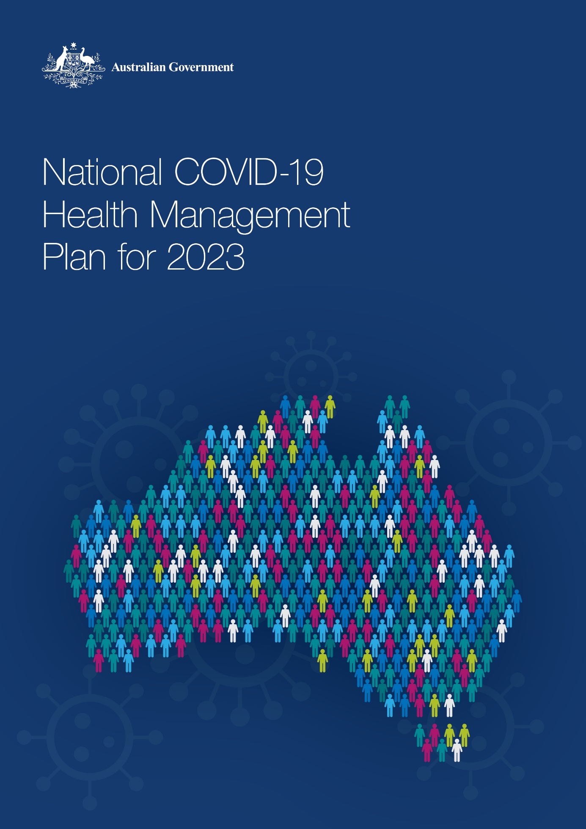

Executive Summary

A National COVID-19 Health Management Plan (the National Plan) has been developed to outline the Australian Government health supports to manage COVID-19 over the next 12 months. These health supports have been informed by the likely 2023 Australian epidemiological outlook and advice from the Chief Medical Officer, Professor Paul Kelly.

Over 2023, Australia will transition to managing COVID-19 in a similar way to other respiratory viruses, moving away from bespoke arrangements. While we are learning more about the virus and its impacts on the community and health systems all the time, we are not yet at a “steady state” where we can predict and manage it within normal systems. This means health response measures are still required.

The National Plan summarises the interconnecting whole-of-system measures to transition our management of COVID-19, while maintaining a state of readiness and capacity to respond as the pandemic continues to evolve.

The key objectives of the National Plan are:

* minimising the level of severe COVID-19 and death
* prioritising those at risk of severe illness, including through targeted supports
* ensuring the health system as a whole has the capacity and capability to respond to future waves and variants
* promoting uptake of COVID-19 vaccinations and treatments, and
* slowing the spread of transmission, including through each individual’s actions and engagement with protective measures.

The National Plan health supports are grouped under key themes in line with the objectives.

* **Vaccine certainty** – continuation of the vaccine program as a key means of defence
* **Informed community, informed choices** – increasing community education and engagement to maximise vaccination and treatment uptake, and community protection
* **Taking the pressure off hospitals** – investments to reduce stress on the health system to support timely, effective and affordable care
* **No one left behind** – additional supports for those who are most at risk of experiencing severe COVID-19 and for those who may have difficulty accessing the care they need
* **Effective and fast testing** – clear guidance on when and where to get tested
* **National Medical Stockpile (NMS) safety net and pandemic preparedness** – ensuring Australia’s strategic reserve is prepared with stock and effective distribution as needed
* **Recovery** – looking towards the future to address the longer impacts of the pandemic on the health of Australians, including long COVID and mental health

Australians will continue to receive early advice on any changes to public health risk, emerging issues and how to protect themselves – through the measures in the National Plan and the newly developed National COVID-19 Community Protection Framework.

## Monitoring and adapting the National Plan

We need to remain vigilant and monitor the epidemiological situation to ensure the pandemic control settings and health measures remain fit for purpose, are based on the best evidence available and are proportionate and equitable. This includes monitoring the impact of co‑circulating viruses and broader emergencies which may impact health system capacity. The Australian Government is committed to continuous improvement and review of COVID‑19 measures.

# Australian 2023 COVID-19 epidemiological outlook

## Advice from the Chief Medical Officer, Professor Paul Kelly

The COVID-19 pandemic continues to throw up new challenges. While vaccinations, antiviral treatments and the continuing public health response have provided strong protection to Australians against severe illness and death, the threat posed by COVID-19 continues to evolve.

The likely emergence of new variants, including those able to partially evade immune responses, mean the Australian community can expect to experience new waves on a regular basis for at least the next two years. The Australian Government will continue to respond to these waves as they occur – with a particular focus on protecting those most at risk in our community.

The severity of future waves may be milder, placing less pressure on the health system. This, combined with improved immunity and hybrid immunity from repeat infections and targeted vaccinations, would reduce the clinical impact and result in fewer Australians suffering severe illness and death.

The National COVID-19 Community Protection Framework for a COVIDSafe Australia also provides an array of responses that can be employed to “slow the spread” of the virus during these waves.

Further, the National COVID-19 Health Management Plan has been developed to ensure the health and aged care systems have the capacity to respond as the pandemic continues to evolve.

Those at risk of more severe COVID-19 include people who are at risk of greater exposure or more severe illness associated with COVID-19, including due to a lack of access to health care. These groups include older Australians, First Nations people, people with disability, people from culturally and linguistically diverse communities, people living in remote communities, people with complex underlying health conditions and the immunocompromised.

### Australia’s COVID-19 response and recovery has three key areas of focus

**Vaccines:** Australia’s COVID-19 vaccination program continues to prioritise reducing severe illness and pressure on the broader health system. This includes encouraging the uptake of boosters and ensuring access to new vaccines.

**Treatments:** The oral antiviral medications available on the Pharmaceutical Benefits Scheme are being prescribed in increasing volumes. These treatments are being prescribed to Australians who are most at risk of severe illness and death – including those in high-risk settings. As new medications are developed, the Australian Government will assess their effectiveness and make them available as needed. Further COVID-19 treatment purchases will continue over 2023, including to assist people whose immune system prevents them from responding to vaccines.

**Long COVID:** An important aspect of Australia’s COVID-19 recovery will be management of long COVID. Research is continuing into this condition in Australia. Australia’s experience of long COVID is potentially different to many other countries due to our high two-dose vaccination rates and the fact that our widespread levels of infection only occurred after the Omicron variant emerged. Infection with the Omicron variant is less likely to lead to long COVID than the Delta variant.

We need to investigate the Australia-specific, longer-term effects of the COVID‑19 pandemic. Understanding the effect on mental health, chronic disease management and cancer screening as well as delayed elective surgery will also be important. This will lead to an informed plan for addressing these longer lasting secondary effects of the pandemic in the coming years.

## Protection provided by COVID-19 vaccines

COVID-19 vaccines protect Australians against serious illness and death and have been instrumental in allowing society to reopen both socially and economically.

Since the COVID‑19 Vaccine Program commenced, vaccination has been critical in reducing hospitalisations, admissions to Intensive Care Units and deaths. Vaccines remain highly effective in preventing severe illness and death and are needed to maintain protection, particularly for priority and at risk populations.

As we can expect to experience COVID-19 waves for the next two years, to maintain protections in 2023 we need to continue to follow the expert advice on the need for additional vaccine doses, particularly as new variants of concern and new vaccines and treatments emerge.

Our priority continues to be ensuring Australians maintain their full recommended vaccination status, particularly those who are most at risk of severe illness from COVID-19.

As at 23 November 2022, over 95 per cent of eligible Australians have received two or more doses, but only 72.3 per cent for third doses. However, the data indicates there is more work to do to protect Australians from COVID-19 through vaccination, in particular for those most at risk of severe illness, such as First Nations people (56.5 per cent third dose) and individuals living in Residential Aged Care Homes (92.0 percent third dose, 74.7 per cent fourth dose).

### Vaccine response measures

The National COVID-19 Vaccine Program will transition over the next 12 months to be better aligned with the objectives of the National Immunisation Program. During this phase, the Australian Government will carefully consider the recommendations made by Professor Jane Halton AO in her review of vaccine and treatment procurement.

In 2023, the Australian Government will continue to promote vaccination uptake by:

* providing free COVID-19 vaccines to all eligible people in Australia based on recommendations from Australian Technical Advisory Group on Immunisation (ATAGI)
* ensuring adequate supply of, and access to, safe and effective vaccines
* focusing vaccination efforts on priority groups (people most at risk of severe illness)
* considering the role of new vaccines as they emerge, for example vaccines with potentially more universal variant coverage and impact on transmission
* supporting the ability to scale up vaccination efforts if there are significant new waves, and
* sharing accurate information on COVID-19 vaccination.

To support this, the Government will continue to secure new vaccines that provide greater protection against COVID-19 variants, and/or protect against additional viruses such as influenza.

The Government is also committed to increasing Australia’s vaccine development and manufacturing capability. This is an important strategic step to mitigate potential future supply challenges and ensure Australia has continued access to vaccines.

To ensure vaccines and necessary supports are available during any potential periods of peak demand, the Government will continue to work with the states and territories in relation to vaccine administration, supply, storage and distribution arrangements.

### Informed community, informed COVID‑19 choices

The Australian Government is committed to making sure that the community has up to date and accurate information about COVID-19. This information will support Australians to make informed choices to maximise their protection against COVID-19 – including how, together, we can take action to move beyond the pandemic.

The key ways to protect yourself, fellow Australians and the health system are to:

* stay up to date with recommended vaccines
* have a plan for what to do if you get COVID-19, including quick access to antiviral treatments (if eligible)
* stay home when you are sick and wear a mask, and avoid high-risk settings if you need to leave, and
* maintain awareness of the changing environment, including through the Community Protection Framework which will inform you of any updates to public health measures.

Future national communications campaigns will focus on:

* the National COVID-19 Vaccine Program – encouraging uptake in any additional doses recommended by ATAGI
* COVID-19 treatments – increasing awareness of eligibility, access (including how to get fast access and to make a plan) and the benefits
* preventive behaviours – campaigns advising what to do during COVID-19 waves and how to respond as new variants emerge, and
* 2023 winter preparedness – what to do ahead of winter, including how we manage COVID-19, influenza and other respiratory viruses.

We know that COVID-19 has had a disproportionate and ongoing impact on a number of population groups within Australia. With this in mind, the communications campaigns will have a focus on communities experiencing the most significant consequences of the pandemic and where data has identified a relatively low uptake of preventive measures.

These communications will continue to be informed by advisory groups such as the Culturally and Linguistically Diverse COVID-19 Health Advisory Group, the Advisory Committee on the Health Emergency Response to Coronavirus (COVID-19) for People with Disability, and the National Aboriginal and Torres Strait Islander Health Protection sub-committee of the Australian Health Protection Principal Committee (AHPPC).

Tailored communication strategies will be developed for these groups to ensure messages are delivered at a community level through:

* partnerships with trusted community leaders, community organisations and local health professionals to champion messages
* grassroots engagement activities in communities, and
* development of bespoke resources for specific communities, including translation of materials to be more accessible.

The Government will continue to monitor the effectiveness of communications activities and continuously update the campaigns so they reflect the evolving epidemiological situation.

## Taking the pressure off hospitals

We have seen, and will continue to see, differing health system impacts for the different COVID-19 variants of concern. Our health system and services, in both hospitals and primary care settings, need to be adaptable and responsive to the challenges from varying situations.

A new National Partnership Agreement to Protect Priority Groups from COVID-19 will be available to help states and territories target Polymerase Chain Reaction (PCR) testing and vaccine uptake to those most at risk of severe COVID-19 and death – safeguarding the health system.

### Caring for COVID-19 positive patients in the community

The Australian Government is committed to strengthening the primary care system to ensure that Australians are able to manage COVID-19 and seek treatment within the community regardless of their COVID-19 status, socioeconomic status or location.

Our investments need to support the primary care sector in providing timely care in the community which prevents hospitalisations and takes the pressure off hospitals.

This includes having access to primary care services both in-person and digitally, to ensure people requiring COVID-19 testing and additional supports such as antiviral treatments can access them as soon as possible when and where they need them.

To ensure Australians can access fast care in the community the following additional supports are available:

* the Healthdirect Living with COVID service – a national hotline which helps Australians manage their symptoms safely at home and connects them with the right health supports when needed
* Medicare Benefit Schedule items to assist with telehealth antiviral medications to ensure that COVID-19 positive people are able to use telehealth (including if they have not seen a doctor in the last 12 months), and to assist diagnosis of mRNA COVID-19 vaccine-associated myocarditis, and
* GP-led respiratory clinics from March 2023 which can be activated as required to treat all respiratory illnesses, removing infectious patients and pressure from other parts of the health system.

## No one left behind

We know there are some groups that are at greater risk of exposure or more severe illness associated with COVID-19, including due to their lack of access to health care. These groups include older Australians, First Nations people, people with disability, people from culturally and linguistically diverse communities, people living in remote communities, people with complex underlying health conditions and the immunocompromised.

To ensure that no Australian is left behind, population-wide as well as specific targeted supports will be implemented.

The Australian Government’s commitment to prioritising care and support to people at risk will be delivered through:

* supporting high levels of vaccination among people at risk of severe COVID-19 or death and workers in settings with increased risk of outbreaks occurring (for example residential aged care homes and disability care facilities)
* prioritised arrangements for COVID-19 testing, enabling rapid access to treatments when needed, including through the Point of Care Testing Program in remote communities and continued support to jurisdictions for PCR testing for at risk groups
* providing targeted access to treatments through the Pharmaceutical Benefits Scheme (and NMS where required), and continued support through Medicare for people who have tested positive to COVID-19 to have longer phone consults with GPs so they can be assessed for antiviral treatment eligibility.

**Further supports for older Australians living in residential aged care homes**

The Australian Government is committed to protecting and providing additional assistance to older Australians and the sector caring for them. In addition to continued provisions from the NMS, commitments to increase vaccination and access to antiviral treatments the Australian Government will:

* continue to reimburse residential aged care homes for COVID-19 outbreak management costs
* maintain surge workforce arrangements
* enhance sector preparedness and infection prevention capability and
* continue emergency in-reach PCR testing arrangements during outbreaks

These targeted support services will provide strong protection for senior Australians and ensure their rights are considered in the manner in which aged care providers manage outbreaks.

Attached to the National Plan is a Statement of Expectations on COVID-19 management in aged care settings to outline what is required to deliver safe and quality care with regards to COVID-19.

**Additional supports for First Nations People**

There is further work to be done to support First Nations and remote communities in our response to COVID-19. The Australian Government is providing additional supports to help achieve equitable vaccination rates, and provide capacity to quickly identify and respond to COVID-19 cases and outbreaks through testing and treatment (including through the NMS). The Australian Government will continue to work in partnership with communities, the National Aboriginal Community Controlled Health Organisation and the Royal Flying Doctor Service.

Further, the National Aboriginal and Torres Strait Islander Health Protection committee, a sub-committee of the AHPPC, will ensure a First Nations voice, leadership and expertise will be embedded within First Nations COVID-19 responses.

**Additional supports for people with disability**

The Australian Government will continue to leverage and engage sector stakeholders and disability channels to ensure people with disability and their workers continue to have timely access to information on how they can keep safe and prevent serious illness from COVID-19, and to inform ongoing refinement of policy responses. This includes ongoing sector engagement through the Advisory Committee for the COVID-19 Response for People with Disability and the Disability Health Sector Consultation Committee.

Additional supports include accessible access to COVID-19 vaccination and antiviral treatments through primary care channels, such as in-reach vaccinations delivered in people’s homes, supports from the NMS and targeted communications.

**Additional supports for people from culturally and linguistically diverse communities**

A range of multicultural organisations will work with different communities through culturally appropriate and effective communication materials which will be developed using the advice of the Culturally and Linguistically Diverse Communities (CALD) Advisory Group. These supports and engagement with CALD communities will ensure there is culturally safe access to vaccines and treatments as well as preventive, mental health and holistic support.

## Effective and fast COVID-19 testing

There will be an ongoing need to evaluate and optimise how we test, who we test and when we test people for COVID-19 over the course of 2023.

Over the next 12 months, COVID-19 testing requirements will be aligned with testing arrangements associated with other respiratory illnesses.

Testing for COVID-19 will no longer be a surveillance tool but will be more targeted and used to ensure quick access to antiviral treatments.

It is vital that easy access to testing and treatment for people who may benefit from antiviral therapies is maintained as this will both protect people at risk from severe illness and death and protect the health system.

Access to antiviral COVID-19 treatments can be provided to eligible people following either a positive PCR test or Rapid Antigen Test (RAT).

From 1 January 2023, to obtain a Medicare-funded PCR test you will continue to require a referral from a medical or nurse practitioner. There is no public health requirement or recommendation for low-risk individuals to seek PCR testing.

**2023 national approach to COVID-19 testing**

It is important that every Australian knows when and how they should test for COVID‑19 and what to do next – whether it’s staying home when unwell, taking a RAT and monitoring symptoms, or getting quick access to antiviral treatments.

|  |  |  |
| --- | --- | --- |
| Low-risk population | Low-risk, with close contact to high-risk population | High-risk population |
| Low-risk people are encouraged to stay home when feeling sick.They should take a RAT if they have respiratory and/or other COVID‑19 symptoms. If a positive COVID-19 result is received, stay home where possible and if you must leave, wear a mask and avoid high-risk settings.  Continue to monitor symptoms and engage early with your primary care provider if symptoms worsen. | Low-risk people who live or work with people who are high-risk, particularly for COVID-19, are encouraged to take a RAT if they have respiratory and/or other COVID-19 symptoms and stay home when feeling sick. If symptoms persist following a negative RAT, these people should get a PCR through a GP or normal referral pathway.  People entering high risk settings will be encouraged to continue to use RATs for screening and diagnosis to prevent further transmission. | People in high-risk populations who are at risk of severe COVID‑19 and would benefit from antiviral treatments will be prioritised for PCR testing and engagement with primary care services.  If you are at risk of severe COVID-19, you should consult with your primary care provider about your eligibility for antiviral treatments and create a plan to ensure fast access to treatment.  Those at higher risk of severe COVID-19 include: older Australians, First Nations people, people with disability, people from culturally and linguistically diverse communities, people living in remote communities, people with complex underlying health conditions and the immunocompromised. |

## Utilising the NMS safety net and pandemic preparedness

### The NMS safety net

The NMS was established as Australia’s strategic reserve of drugs, vaccines, antidotes and Personal Protective Equipment (PPE) for use in national health emergencies.

The Australian Government purchases and stockpiles these items so Australia is more self‑sufficient during an emergency and able to respond to high levels of demand – and the NMS will continue to provide a safety net for the provision of essential equipment and treatments when needed.

As the health and aged care systems rebuild their resilience and recover from the original shock of COVID-19, and commercial availability of health supplies and PPE increase, the NMS will transition back to a strategic reserve.

The NMS will remain an enduring aspect of Australia’s health emergency preparedness response measures. Supplies from the NMS will continue to play a key mitigation role in ensuring support for people most at risk of severe COVID-19, as well as the continuation of essential services including in aged care, disability, First Nations health care and remote community health care.

**Australia’s pandemic preparedness**

There are many lessons and opportunities that have been highlighted throughout the pandemic, including the importance of emergency planning and a coordinated response capability.

Establishing an Australian Centre for Disease Control (CDC) will help to leverage the lessons from COVID-19 and prepare Australia for future pandemics and other public health challenges. An Australian CDC will also boost emergency response capacity, strengthen prevention, communication and national coordination, and enhance collaboration across all levels of government.

It is vital that the design, consultation and collaboration processes are undertaken and appropriately supported to create a new flagship hub that is world leading in pandemic preparedness. This process is under way, with preparatory work funded in the October Budget.

## Looking towards recovery

Given the epidemiological outlook suggests that any new COVID-19 variants will continue to act in ways similar to Omicron, meaning care can largely occur in the community – Australia is in a position to look towards recovery.

This includes working together with COVIDSafe behaviours to move beyond the pandemic but also to provide supports to manage the impacts of COVID-19 on the health system and on individuals.

**Additional mental health supports**

Further, COVID-19 has a significant impact on the mental health of all Australians, whether it’s been the disconnection to loved ones and society, the loss of loved ones from COVID-19, the uncertainty and economic impact, or the effect on everyday living such as employment and education.

Additional digital mental health services will be provided to all Australians. This will ensure that critical free and low-cost services can continue to meet ongoing increased demand from the community. These services will reduce barriers to care (such as stigma, geography and cost) and will assist Australians to lessen the impacts of COVID-19 and look towards recovery.

**Long COVID research**

It is recognised that as we learn more about Australia-specific long COVID, different types of health care may be required for people with long COVID, depending on their symptoms and circumstances.

An important aspect of Australia’s COVID-19 recovery will be management of long COVID. Australia-specific research is required into the causes and impacts of this condition (on individuals and the health system), particularly in the context of high vaccination rates and lower severity variants.

Following this research, the Australian Government will release a long COVID strategy to ensure we continue to look towards the emerging evidence and how the Australian health system can support people who suffer for longer periods from COVID-19.

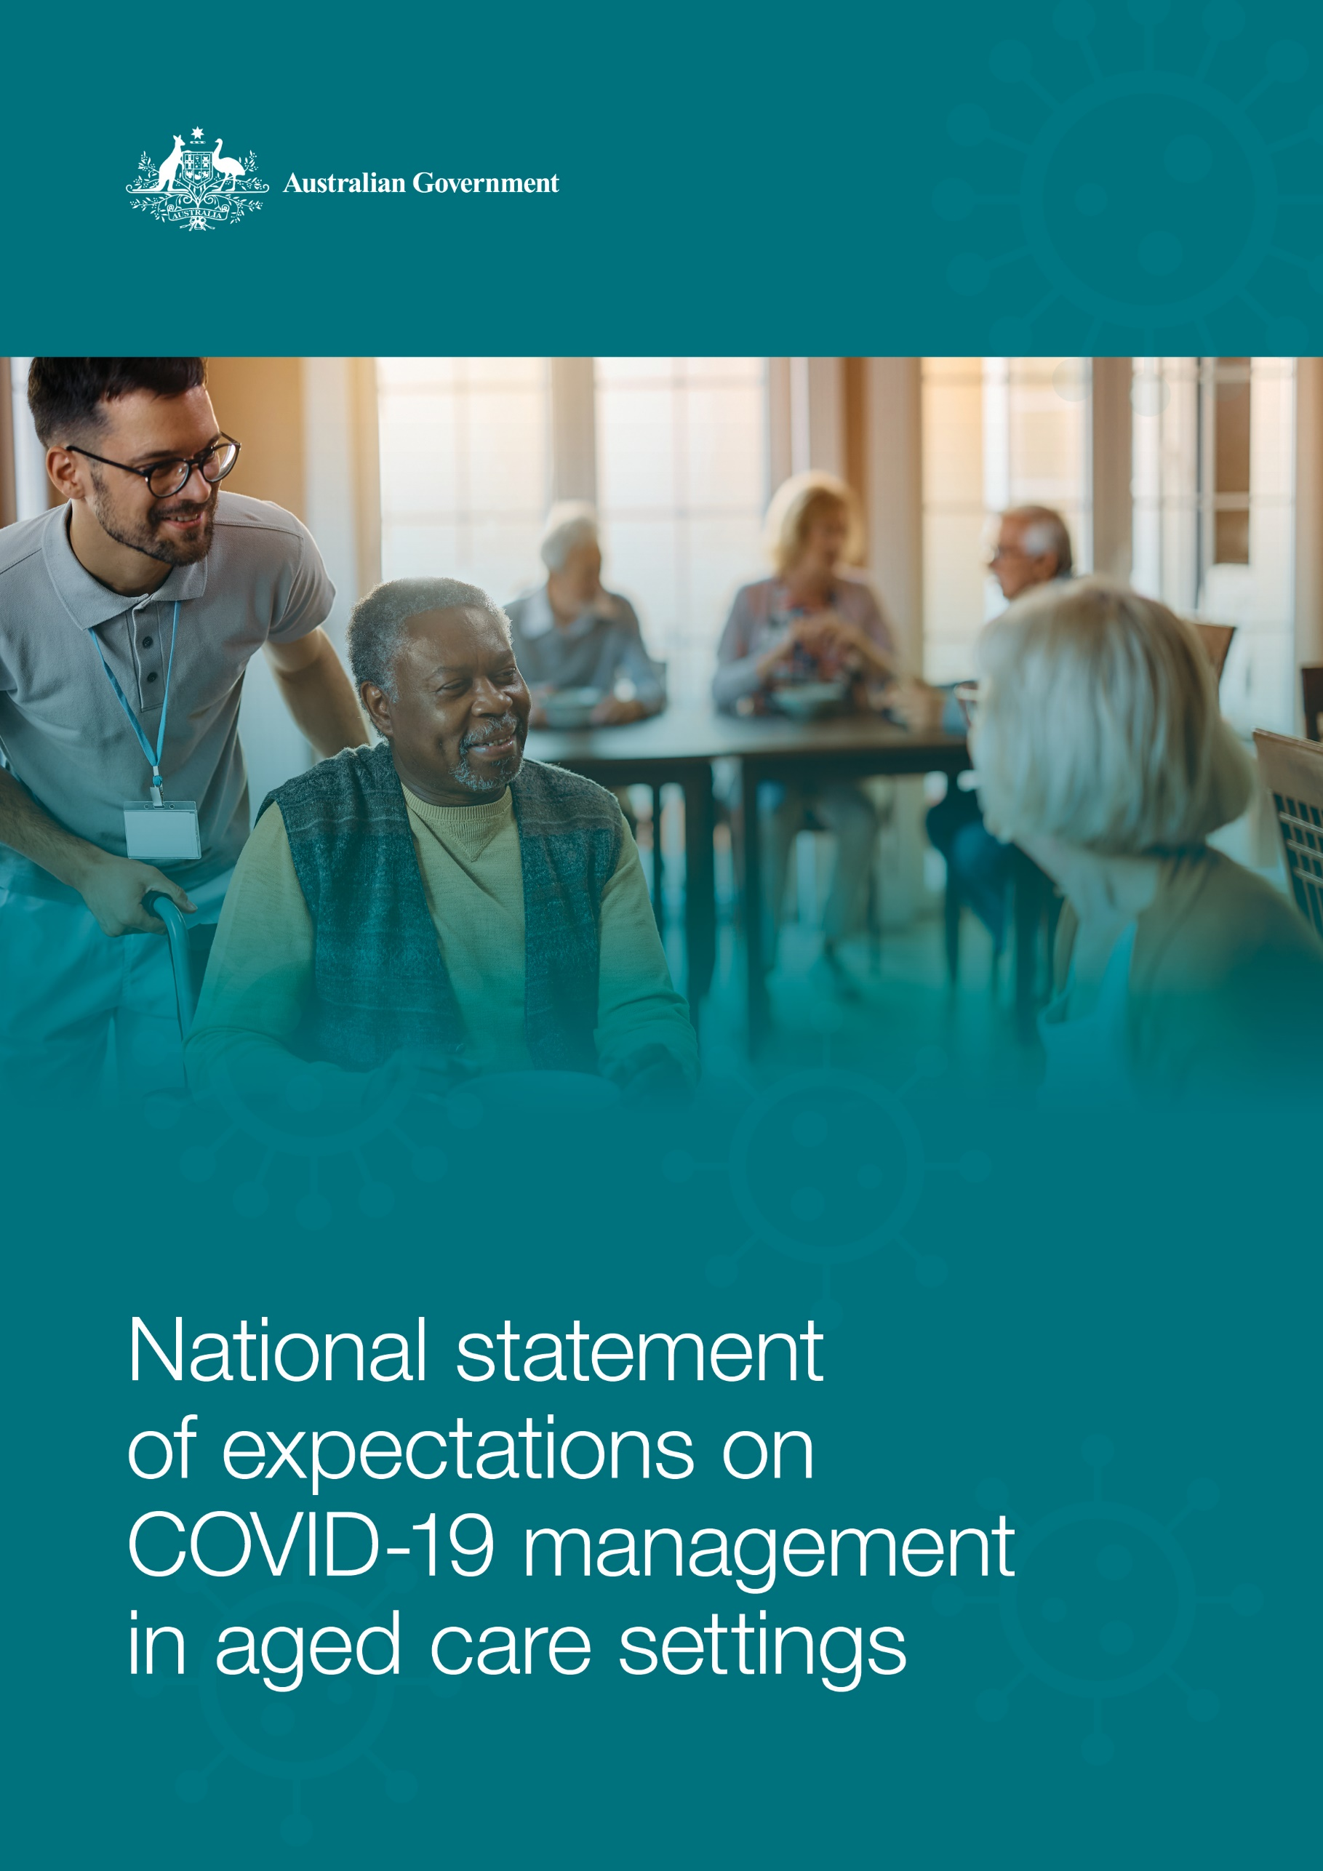

# Preamble

The National COVID-19 Health Management Plan and the National COVID-19 Community Protection Framework have been developed to provide guidance on the management strategies and Australian Government supports to manage COVID-19 during 2023.

The National Statement of Expectations on COVID-19 Management in Aged Care Settings (the National Statement) has been developed alongside the Health Management Plan and Community Protection Framework. It provides specific guidance to aged care providers and services (residential, group and care-at-home settings) on their responsibilities for preparing for, and responding to, the impact of COVID‑19.

Aged care providers and services need to be responsive to changes in COVID-19 prevalence in their communities so they can implement a hierarchy of infection prevention and control (IPC) measures and response activities.

This National Statement is also a best practice reference document that sets out the Australian Government’s expectation of the actions aged care providers and services need to take when preparing for, and responding to, the impact of COVID-19. It should be read in conjunction with other approved guidelines, including those issued by the Communicable Diseases Network Australia.

# Key principles

As COVID-19 continues to circulate through Australian communities, older people will remain at a significantly greater risk of severe outcomes from the virus. It remains crucial for aged care services to make sure elderly Australians, for whom they are responsible, in all service settings, receive appropriate protection from, and management of, any COVID‑19 infections in their surrounds.

## Risk based

* Aged care providers are required to deliver safe and quality services in line with the Aged Care Quality Standards (the Standards). In doing so, aged care providers should be regularly assessing the risk of COVID-19 infection within their services and adapting their planning and preparedness to respond based on monitoring of the local situation. Each provider and service should take all possible steps to address any risks identified through their assessments, such as establishing screening processes and knowing how to establish zones in their buildings in the event of an outbreak.

## Proportionate

* Aged care providers and services need to ensure that a hierarchy of IPC measures (including imposing restrictions on movement and access) are proportionate to managing the identified risks. This includes balancing the need for proportionate measures (for example, isolation of residents in their rooms) against maintaining the quality of life and wellbeing of residents and older people.

## Scalable Capability

* Aged care providers and services should ensure that appropriate IPC settings are in place and plan for how they will scale up their measures as quickly as possible when direct impacts are identified, for example the use of personal protective equipment (PPE). The level of protections and restrictions that need to be applied should be understood by all staff and elderly care recipients. Resources and supply chains for PPE, workforce, and other supplies should be well established and on standby.

## Human rights focused

* Firm and strong protections need to be maintained to ensure providers can manage the impact of COVID-19 in a way that is cognisant of the rights of senior Australians. The impact of social isolation on the mental, social, physical and emotional wellbeing of elderly Australians can be profound. People receiving aged care services should also have timely access to medically appropriate acute and primary care services, continuity of all care and lifestyle support, and ongoing access to visitors.

# Planning and preparedness

* Aged care providers and services are expected to maintain their preparedness to respond to COVID‑19 infections.
* This should be done by having, maintaining, practising and revising/updating outbreak management plans. For residential aged care providers, this should include an identified onsite IPC lead, embedded in the service and appropriately supported to drive good practice.
* To ensure aged care provider services are informed and prepared, they are expected to undertake regular infection risk assessments by monitoring local COVID-19 information and state and territory health advice. They are also expected to stay up to date with the latest guidelines released by the Communicable Diseases Network Australia and other public health bodies.
* Preparedness planning should include a dedicated plan in the following key areas – identified leadership and governance for managing an outbreak; workforce contingencies; resource supply (such as personal protective equipment); clinical governance; communications; and arrangements to support ongoing visitation and recovery activities (for both older people in their home and those in residential care).

# Testing and case identification

* Early and regular testing ensures COVID-19 infections are detected quickly within residential and in-home aged care settings and impacts are minimised and managed effectively.
* Residential aged care services are expected to have a process for screening visitors to each service, informed by current Commonwealth, state and territory health advice. Implementation or cessation of specific screening activities should be informed by regular risk assessments of COVID-19 in the local community.
* Aged care services are expected to provide access to testing to screen staff in both residential and home care services, and visitors to residential services. Encouraging testing with a rapid antigen test (RAT) prior to entry and maintenance of up-to-date vaccination is strongly recommended.
* It is recommended that surveillance screening of staff and visitors to residential care settings should occur at least twice a week and not more than 72 hours apart for staff or on entry for each visitor. If in-home care services require staff to test regularly, they should follow the same testing frequency. When a residential care service is managing COVID-19 infections, it is recommended this be increased to daily testing of staff and visitors.
* Residents or care recipients with respiratory symptoms, or who are delirious, should be tested. RAT kits can be used for initial case identification but PCR testing is recommended, where available, for residents once cases are identified or suspected onsite.
* More frequent testing during an outbreak in a residential setting is appropriate. If PCR testing is not available, this should increase to daily testing of staff and residents using RAT kits.
* All residential aged care services are required to report COVID-19 cases through [My Aged Care provider portal](https://www.health.gov.au/resources/apps-and-tools/my-aged-care-service-provider-portal).
* Aged care services are also expected to ensure any infections are reported to state or territory public health units in line with state and territory requirements.

# Managing COVID-19 infections

## A hierarchy of infection prevention and control

* All aged care services need to comply with relevant Aged Care Quality Standards including requirements specific to infection prevention and control (IPC) that require organisations to: demonstrate minimisation of infection-related risks; have a workforce which has the qualifications and knowledge to effectively perform their roles, including relevant training; and, where clinical care is provided, have a clinical governance framework in place.
* All aged care services need to make sure that all staff are trained in fundamental IPC skills and regularly refresh their skills, including hand hygiene, appropriate use of PPE, and cleaning practices.
* All residential aged care services should make sure they have an identified IPC lead nurse, who is supported by management and has adequate time and resources to oversee IPC capability across the service.

## Isolation of residents who test positive for COVID-19

* Residents who test positive should be isolated within the aged care service in line with IPC best practice and for no longer than is considered clinically necessary. Isolation arrangements should be implemented with consideration to the older person’s dignity, choice and continuity of care, as described in the Quality Standards. This includes minimising restriction where practical, such as allowing isolated residents to socialise with each other (with suitable precautionary measures in place) to reduce social isolation.
* Each state and territory, and each public health unit, will have different advice on how to manage the isolation of residents, and local advice should be followed when isolating an elderly person.

## Access by visitors to aged care residents

* All aged care residents, including those isolating, should have access to at least one essential visitor at all times, including during management of COVID‑19 infections. This includes specific visitors identified through partners-in-care and named visitors models, and volunteers.
* Essential visitors (including volunteers) who visit frequently (that is, three or more times a week) are expected to undertake basic IPC training, including use of PPE, facilitated by the aged care provider.
* Without diminishing the principle above, aged care services can set restrictions on visitors in order to reduce infection risk, such as placing limits on the number of visitors at any one time or limiting the movement of visitors indoors.

## Furlough of aged care staff who test positive for COVID-19

* Aged care staff who test positive for COVID-19 should not attend work for at least 7 days after testing positive and until they have no symptoms of COVID-19. This includes staff providing close personal care to an older person in their home or in a community setting.
* Staff should be supported to take leave, including after they test positive for COVID‑19, including through the payment of leave even when it might not necessarily be applicable.

## Use of personal protective equipment

* Aged care providers should make sure that all aged care homes and in-home care services have appropriate stocks of PPE available, and arrangements with commercial suppliers to replenish PPE stocks as required.
* All aged care homes should encourage staff and visitors to wear a face mask when indoors and in close contact with other people at a residential care home.
* All in-home care services should provide their staff with PPE to use in each consumer’s home, including any additional PPE required to support a consumer who has tested positive to COVID-19.
* During an outbreak, aged care homes should extend the provision of PPE to all visitors and increase the PPE worn by staff. This includes gloves, gowns, eye protection and face masks as well as dedicated stations to put on and take PPE off safely.
* All PPE used in residential aged care homes and provided by care staff at in-home services should be fit for its intended purpose as described in their Instruction for Use and should be approved and used in line with advice from the Therapeutic Goods Administration.
* Under [state and territory workplace safety legislation](https://covid19.swa.gov.au/covid-19-information-workplaces/industry-information/aged-care/general-information?tab=tab-toc-worker), all aged care services are responsible for providing a safe working environment for their staff and visitors. This includes providing appropriate PPE as well as providing training on how to use and dispose of it.

# Access to treatment and services

## Antiviral treatment

* All people aged 70 years and over are eligible to receive COVID-19 oral antiviral treatments where they are considered appropriate by a treating health practitioner. Aged care providers should facilitate a discussion about the use of antiviral treatment between the older person and their health practitioner in anticipation of testing positive for COVID-19.
* All aged care services should make sure their residents and care recipients can access antiviral treatment as soon as possible. Aged care services should have established links with primary care providers to rapidly assess residents and care recipients, and community pharmacies to get rapid supply of medications.

## Access to primary and acute medical services

* All aged care residents and care recipients should have access to medically appropriate primary care services. Aged care services should make sure all staff are aware of the pathway to obtain primary care assessment. This can include for the management of other identified respiratory illnesses such as influenza or the management of medical conditions not related to COVID-19.
* All aged care residents and care recipients should receive medically appropriate acute care, including rapid transfer to hospital if medically required.
* Aged care residents and care recipients should be monitored for any symptoms of [Long COVID](https://www.health.gov.au/resources/publications/getting-help-for-long-covid) and assisted to gain access to treatment or support as required.
* Aged care providers and services should consider vulnerable consumers in the community whose care may have been discontinued and consider welfare contacts for consumers who live alone.

## Vaccination

* Aged care homes are expected to monitor the COVID-19 vaccination status of residents and assist them or care recipients to access additional doses through primary care providers. Residents should be supported to access all appropriate vaccines, including COVID-19, influenza, pneumococcal and herpes zoster vaccines.
* Staff should also be supported to remain up to date with all relevant vaccinations.
* In-home care recipients should be supported to access primary care providers to ensure they remain up to date with their vaccinations.

## Sufficient staffing levels and access to health and community services

* Aged care services are expected to maintain staffing levels and have standing arrangements for backup surge capacity to manage an outbreak.
* Aged care services are expected to support residents and care recipients to receive any required health or community services. This should include providing access to appropriate PPE and settings in which visits can occur safely.

# Reporting and communications

* Residential aged care services managing the impacts of COVID-19 infections are expected to engage regularly with the Australian Government Department of Health and Aged Care and state and territory public health units. This includes reporting of cases through the [My Aged Care provider portal](https://www.health.gov.au/resources/apps-and-tools/my-aged-care-service-provider-portal).
* Aged care services should have an outbreak communication plan which provides processes for advising consumers and their families or representatives about COVID‑19 precautions or management and should be regularly communicating updates.