National Communicable Disease Surveillance Dashboard

14 December 2022

# User Guide

This user guide explains how the National Communicable Disease Surveillance Dashboard works using the new Microsoft Power BI user interface. The dashboard provides a way to dynamically query the data held in the National Notifiable Disease Surveillance System (NNDSS). The dashboard presents data in an aggregate and filterable format.

The items covered in this guide are:

* starting the dashboard tool
* navigating the dashboard and pages
* applying and removing filters to the dashboard
* exporting data out from the dashboard
* interpreting caveats.

# Starting the dashboard tool

Navigating to the webpage that hosts the dashboard will present you with a ‘Start Now’ button, as shown in Figure 1. Clicking on this button will open the dashboard in a new window.

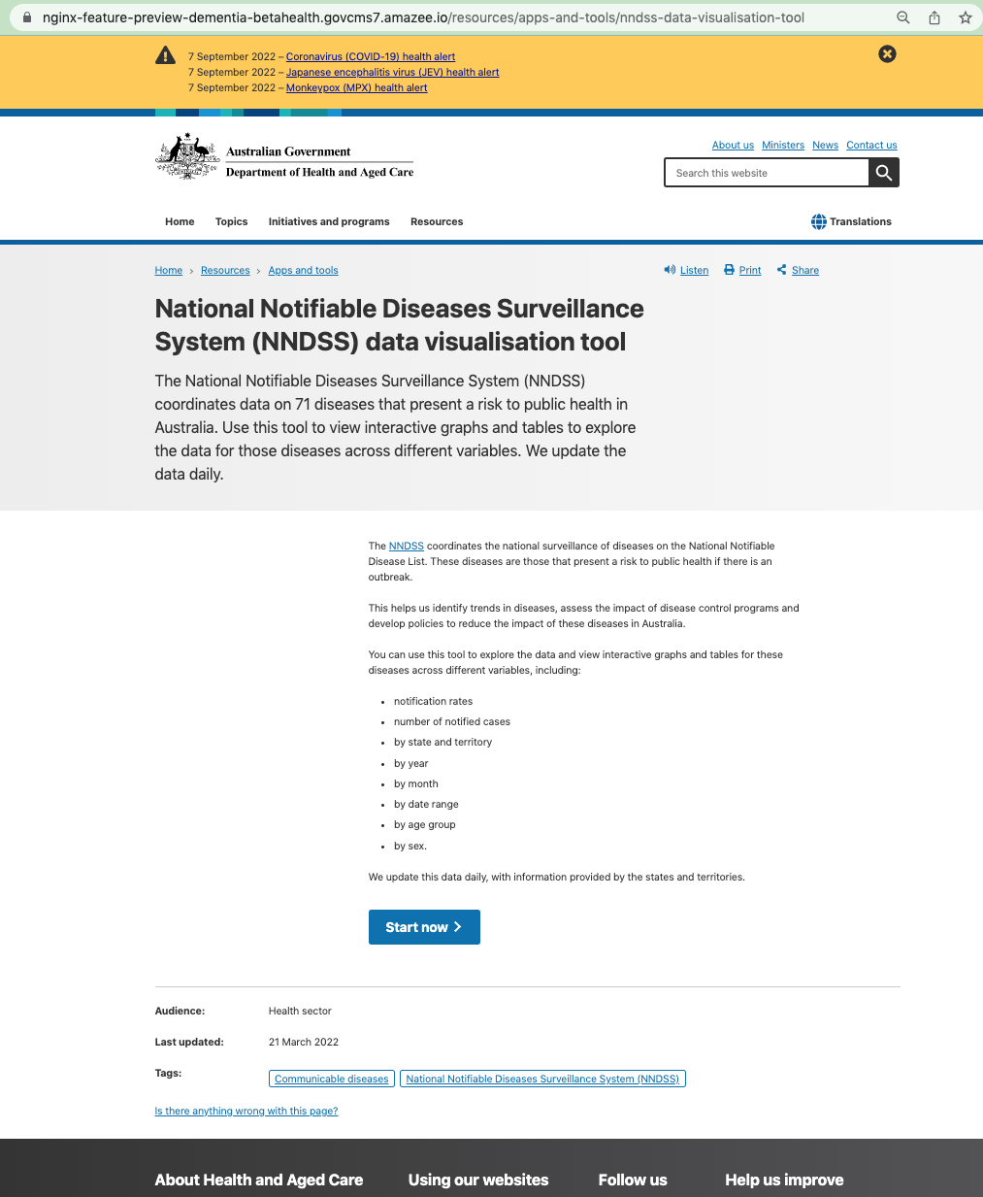

Figure 1 – Dashboard landing page

# Navigating the dashboard and pages

To help with navigating the dashboard, Figure 2 shows some important points with a brief description corresponding to each number:

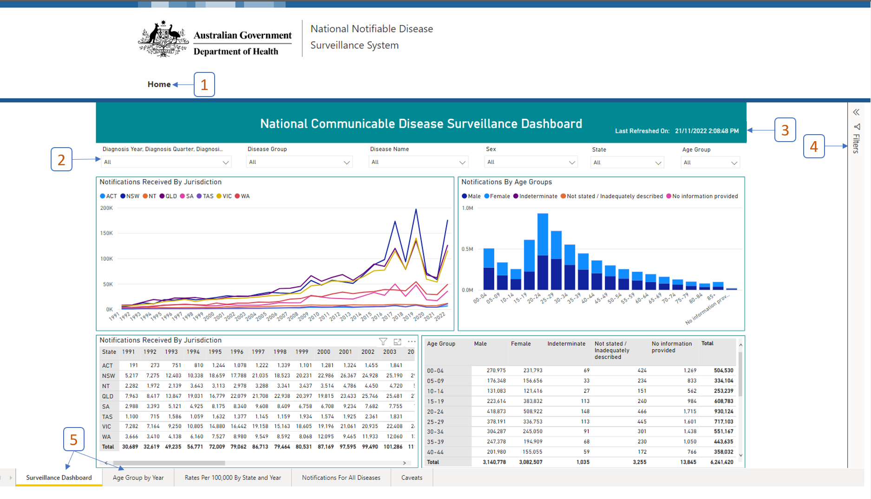

Figure 2 – Key navigation points

1. Home button

Clicking this button will return you to the Department of Health and Aged Care home page.

1. Filter selection

This row of drop-down options are filters that apply to the entire dashboard until cleared. You can apply any combination of filters. See the ‘Applying and removing filters to the dashboard’ section for details on how to use the filters.

1. ‘Last Refreshed On’ date

The ‘Last Refreshed On’ date shows the date and time when the data for the dashboard were loaded from the NNDSS database. The dashboard refreshes every morning to reflect any updates received in the previous 24 hours.

1. Filter Panel

After selecting a table or graph (objects), you can expand this panel by clicking the arrow at the top of the panel. This will show a summary of which filters have been applied to the selected object.

1. Worksheets

The worksheets divide the report into different sections to allow a more focussed presentation of data. Clicking on the worksheets will navigate to the report in that worksheet.

# Applying and removing filters to the dashboard

Filters allow you to quickly select aspects of the data which are of most interest to you. Filters are linked across all worksheets and will continue to apply until you clear them, or you reload the page.

**To choose multiple options from the same filter, as shown in Figure 3, hold down the:**

* **Ctrl key for Windows users**
* **command key for IOS users .**

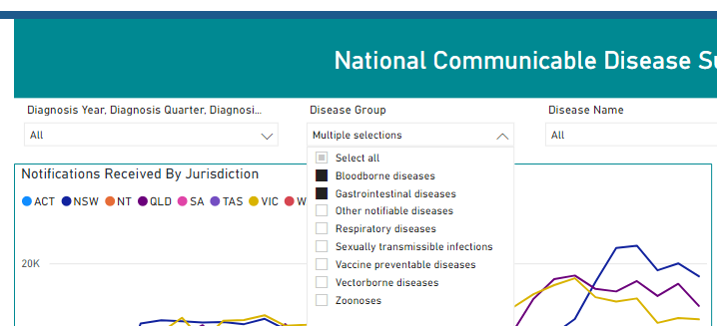

Figure 3 – Multiple selection in filter

To reset a filter, hover your mouse over the filter option and press the ‘eraser’ icon (Figure 4).

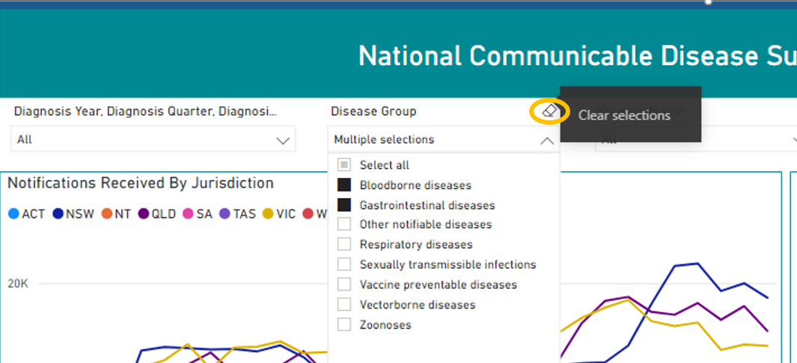

Figure 4 – clearing filters

# Exporting data out from the dashboard

You can export data from the dashboard after applying any filters as needed. You can choose to export data in either in a .csv file or .xlsx file. Microsoft Excel can open both file types, but most users prefer .csv files for use with other analytical tools such as R Studio, SAS or STATA.

To export the data from a graph or table you need to:

1. apply any filters required in the dashboard
2. select the object you want to exporting
3. in the selected object, click the 3 dots in the top right, shown in Figure 5 with a green ellipse. The ‘More options’ menu will appear. Now click the export data option shown in Figure 5 in a yellow ellipse.

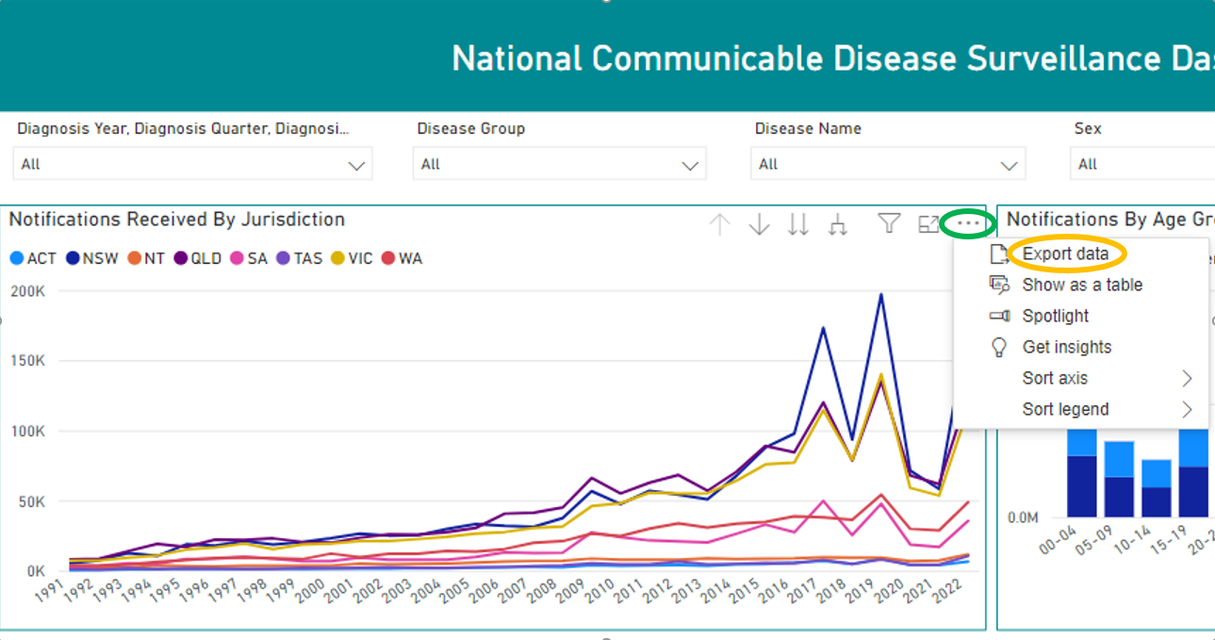

Figure 5 – More options and export data

1. Clicking on export data opens the Export data screen (Figure 6) which allows you to choose between a .csv file or .xlsx file. Exports of graphs will only export the summarised data used in the graph. Exporting tables allow the export of data with the current tabular layout.

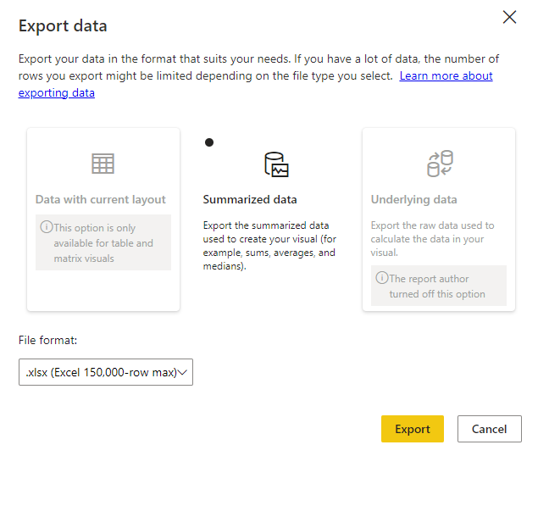

Figure 6 – Export data options

1. Once you select the Export button, Power BI will generate a file and download it through your browser. The file will summarise which filters were applied at the time of export with the included field names and counts as shown in the object.

# Interpretating caveats

The data stored within the NNDSS only includes nationally notifiable diseases. Diseases become nationally notifiable at different times and each state and territory has individual legislative requirements before transmitting data to the NNDSS. This means some data are not available for all jurisdictions for the entire period a disease has been nationally notifiable. These differences are outlined in the caveat worksheet.

The caveat worksheet also provides links to where data had come from the Australian Bureau of Statistics (ABS) to calculate notification rates per 100,000 population.

There are also caveats for communicable diseases that have ongoing alternative national reporting arrangements and are not present in the dashboard. You can find links to access reporting for these diseases in the caveat worksheet.