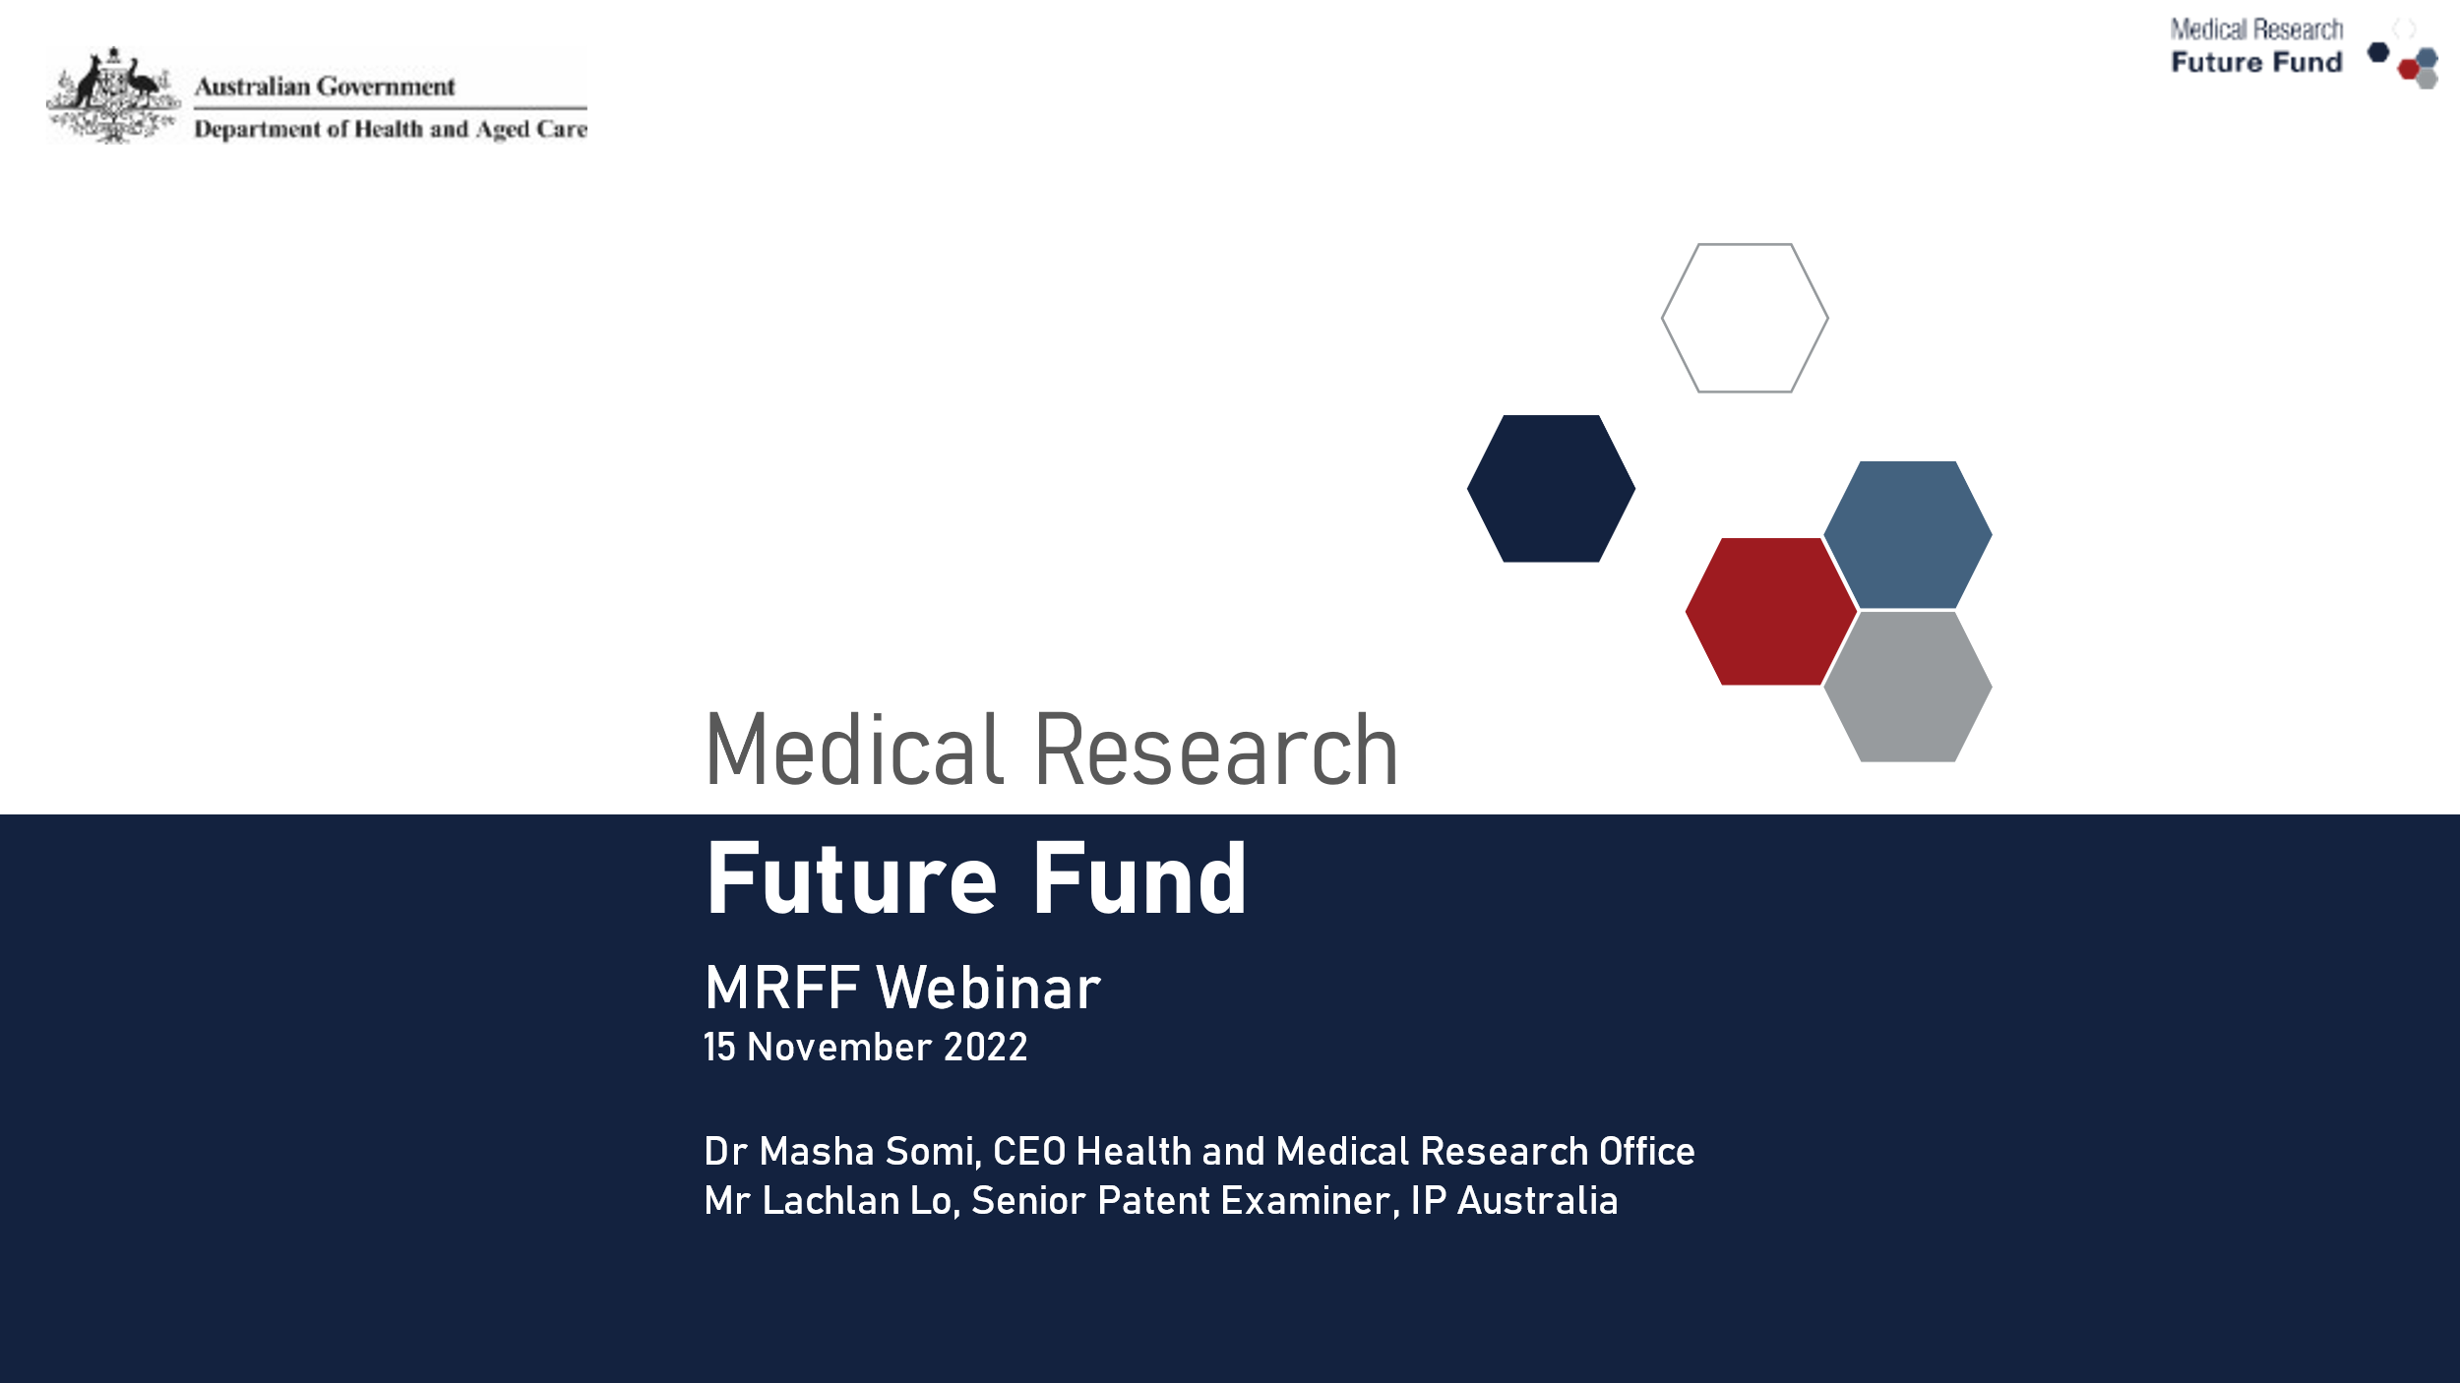

Contents
- The Medical Research Future Fund (MRFF) and Intellectual Property
- IP Australia: effectively managing intellectual property
- MRFF Program Updates and News
- Australian Medical Research and Innovation Priorities 2022–2024
- Program Focus: Refreshed Assessment Criteria and Consumer reference panel
- Initiative Focus: Million Minds Health Research Mission
- What is an Innovation Grant?
- Program and Communication Updates
- Q&A
- Keeping Connected

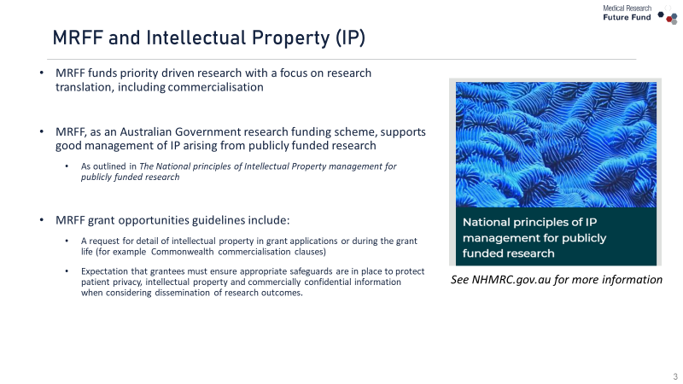
MRFF and Intellectual Property (IP)
- MRFF funds priority driven research with a focus on research translation, including commercialisation
- MRFF, as an Australian Government research funding scheme, supports good management of IP arising from publicly funded research
  - As outlined in The National principles of Intellectual Property management for publicly funded research
- MRFF grant opportunities guidelines include:
  - A request for detail of intellectual property in grant applications or during the grant life (for example Commonwealth commercialisation clauses)
  - Expectation that grantees must ensure appropriate safeguards are in place to protect patient privacy, intellectual property and commercially confidential information when considering dissemination of research outcomes.

Commonwealth Commercialisation Clauses
- Grant Agreements relating to projects funded under some Grant Opportunities may include commercialisation clauses
  - For example, 2021 BioMedTech Incubator Grant Opportunity, 2021 COVID-19 Treatment Access and Public Health Activities Grant Opportunity and 2021 mRNA Clinical Trial Enabling Infrastructure Grant Opportunity
- The intent of the clauses is to give an early opportunity for the Australian Government to purchase commercialised products (at market conditions) where research has had MRFF support
- As stated in the National principles:
  - good intellectual property management will foster the most beneficial use of Australian research and development to secure value for industries, government, researchers and the community.
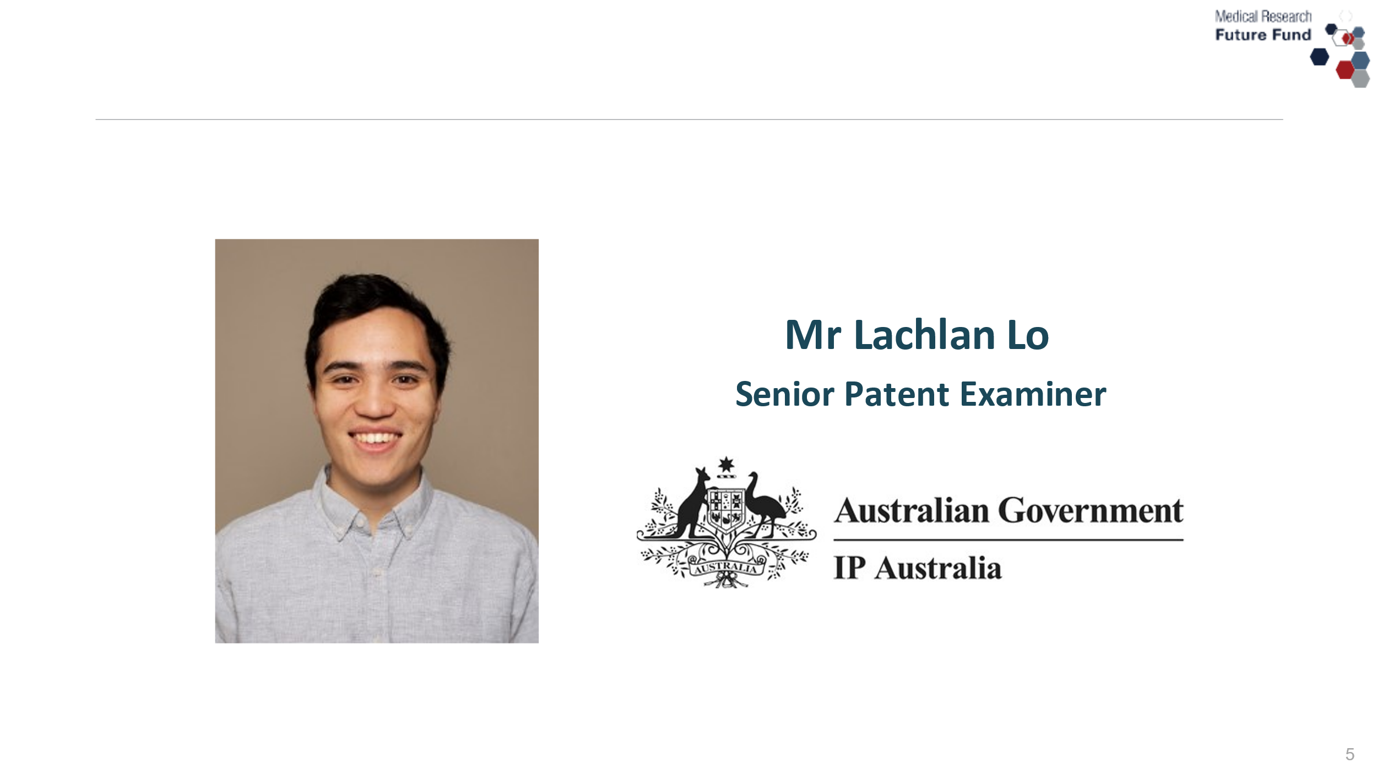



INTELLECTUAL PROPERTY
Intellectual property, or IP, refers to a range of different, legally enforceable rights that arise from the new ideas you create
The property of your mind or exclusive knowledge
Australia’s IP laws provide a legal framework to protect your creative ideas through IP rights.

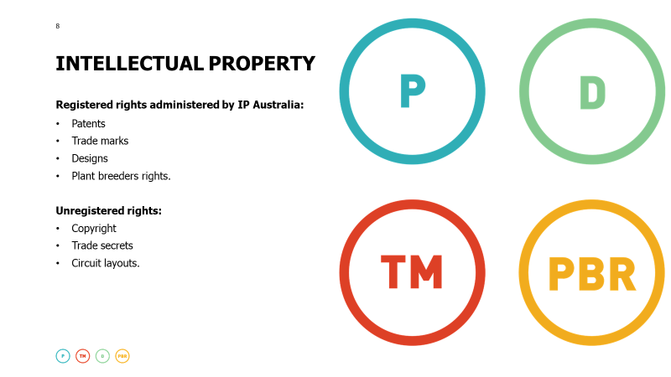
INTELLECTUAL PROPERTY
Registered rights administered by IP Australia:
Patents
Trade marks
Designs
Plant breeders rights.
Unregistered rights:
Copyright
Trade secrets
Circuit layouts.



PATENTS
A legally enforceable right for a device, substance, method or process
Must be new, inventive and useful.
Life span of patents:
Standard – up to 20 years
Pharmaceutical – up to 25 years.


PATENT STATISTICS
(2021)
37,397 Australian patent filings
9% were Australian applicants
11% increase in filings from 2020
94% filed by organisations, 6% filed by individuals.
https://www.ipaustralia.gov.au/sites/default/files/ip_report-2022-may.pdf


BENEFITS OF PATENTS
Rights holders:
Exclusive right to commercially exploit the invention
Prevent others from infringing
Block competition
License the patent as a revenue stream
Can sell the patent
Can attract investors and help secure research funding.
The public:
Detailed description of the invention is disclosed
Contributes to the scientific knowledge of the tech area
Encourages R&D of new and innovative products
Accelerates and advances technological development.

FOR AN IDEA TO BE PATENTABLE:
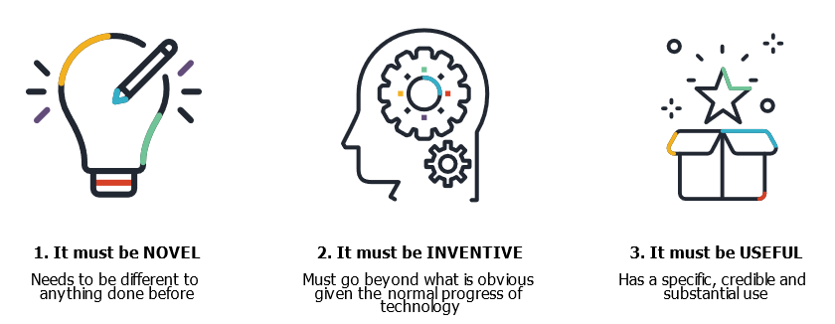


WHAT CAN BE PATENTED
A device is usually protected by a group of patents relating to different aspects.
For example, a heart monitor can be covered by patents relating to:
User interface
Software
Battery
Memory
Power management system
Integrated circuits
Wireless or internet connectivity


WHAT CAN’T BE PATENTED
Human beings or the biological process for their generation
Artistic creations
Mathematical models
Plans, schemes or other purely mental processes.
Each country has different requirements:
E.g. You can patent methods of surgery and medical treatments in the US and Australia, but not in Europe or Japan.


IP MANAGEMENT
IN COLLABORATION
Protecting your IP is just the first step in commercialising your idea.
Collaboration between researchers and business is a key element of successful innovation.
Collaborations can involve complexity in managing the interrelationships between confidentiality, use of existing IP, publication of information, commercialisation, decision making around IP rights.
Consideration and management of IP at the outset can help to prevent delays and avoid IP disputes as the project progresses.


COMMERCIALISE YOUR IP
The following tools can assist:
Australian IP Toolkit – designed to facilitate, simplify and improve collaboration between researchers and industry – template contracts, agreements, guides and checklists.
Source IP – a digital marketplace helping businesses and researchers connect and collaborate.
Small business portal – helping business navigate the IP system.
Patents Case Management for SMEs – connects you with a dedicated IP Australia subject matter expert who is your single point of contact to assist you at any stage of the process.
Patent Analytics Hub – translates patent literature to help government and publicly funded research organisations make informed research, development, collaboration and commercialisation decisions.
Engaging an attorney toolkit – equip small and early stage business with the tools they need to have more informed conversations with the attorney profession.

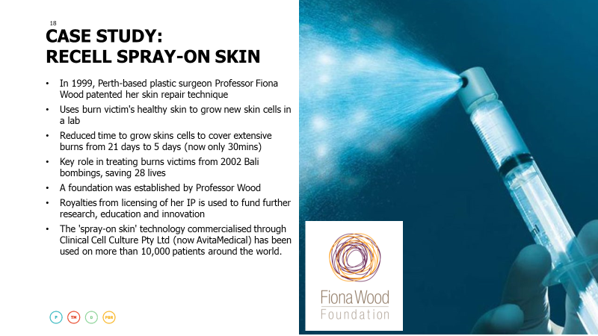
CASE STUDY:
RECELL SPRAY-ON SKIN
In 1999, Perth-based plastic surgeon Professor Fiona Wood patented her skin repair technique
Uses burn victim's healthy skin to grow new skin cells in a lab
Reduced time to grow skins cells to cover extensive burns from 21 days to 5 days (now only 30mins)
Key role in treating burns victims from 2002 Bali bombings, saving 28 lives
A foundation was established by Professor Wood
Royalties from licensing of her IP is used to fund further research, education and innovation
The 'spray-on skin' technology commercialised through Clinical Cell Culture Pty Ltd (now AvitaMedical) has been used on more than 10,000 patients around the world.


SEARCHING PATENTS
Before you apply for a patent, it's important to conduct a comprehensive search.
Why you should search
Before introducing a new product to the market, you need to ask yourself two things:
Can I protect my invention with a patent?
Does my invention infringe someone else's patent?
Searching can help answer these questions:
determine who owns what IP
check that your IP is not being infringed
obtain product information on your competitors for research purposes.


PATENT SEARCHING


GOOGLE PATENTS



PATENT ATTORNEYS
It's recommended that you seek professional assistance before applying for a patent
Patent attorneys:
Provide advice regarding patenting and IP
Help to prepare and file Patent Applications
Provide representation in Patent oppositions
Provide advice in relation to Patent infringement.


DISCLOSURE
BEWARE: Don't go public too soon
Don’t demonstrate, sell or discuss your invention in public before filing an application
Confidentiality or Non-Disclosure Agreements (NDAs)
Legal contract to ensure that a person who gains access to sensitive information doesn’t disclose it to a third party

THE APPLICATION PROCESS
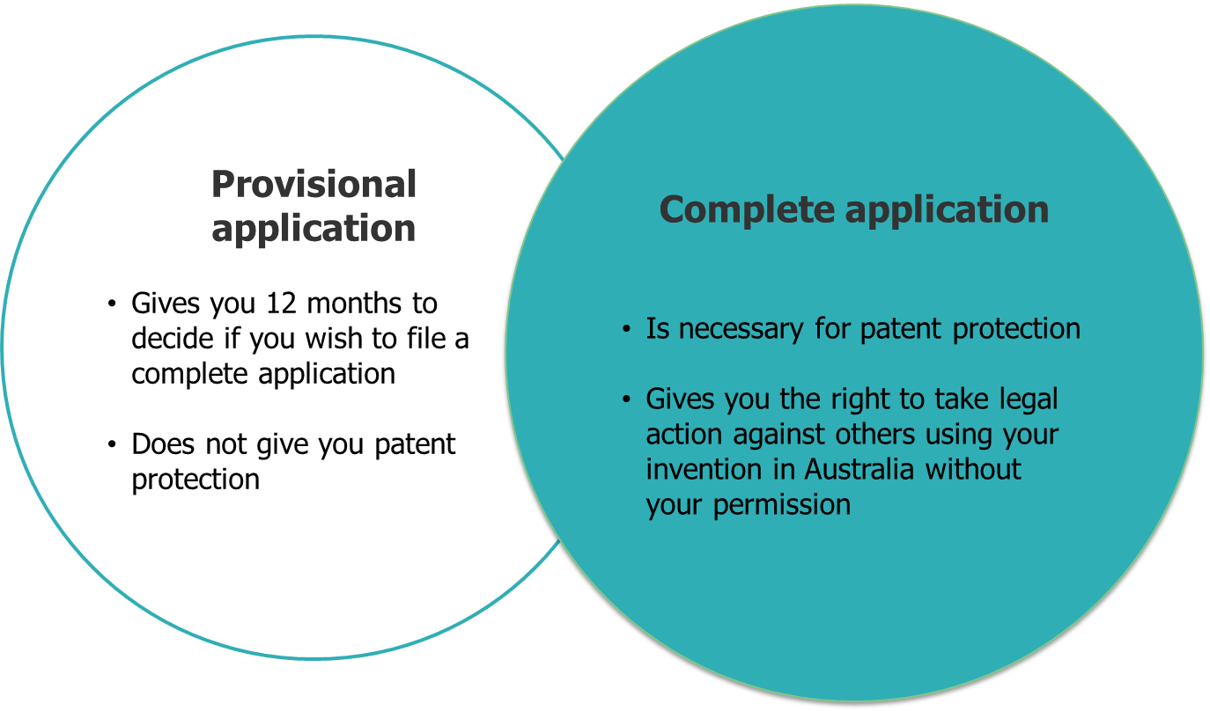


PROTECTION
An Australian patent does not give you protection outside of Australia.
For overseas patent protection, you have two choices:
- Apply separately to each country
- Apply through WIPO's international Patent Cooperation Treaty system.

COSTS
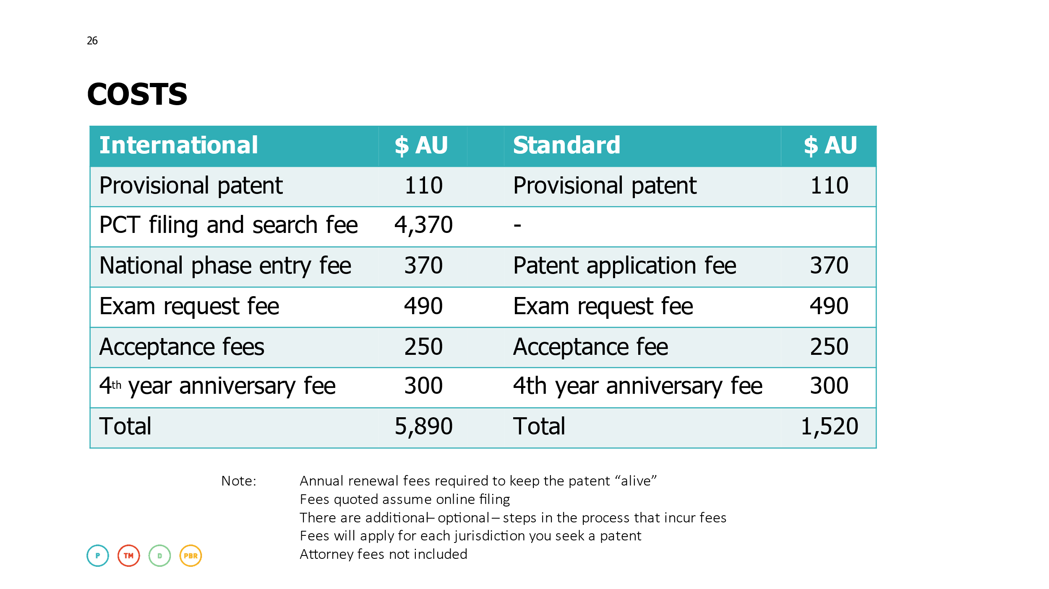
Note: Annual renewal fees required to keep the patent “alive”
Fees quoted assume online filing
There are additional – optional – steps in the process that incur fees
Fees will apply for each jurisdiction you seek a patent
Attorney fees not included


ENFORCEMENT
If you find your invention is being copied or used by someone else without your permission, it is up to you to take action against them.
IP Australia does not police IP rights or launch legal proceedings on your behalf.



EXAMPLES OF MEDICAL DEVICES
Neurostimulators
Tissue engineering bioreactors
Diagnostic instruments
Syringes, catheters, probes
Prostheses
Respiratory devices
Medical imaging devices
Patient monitoring
Implantable devices
Surgical equipment
Disposable medical supplies, etc.
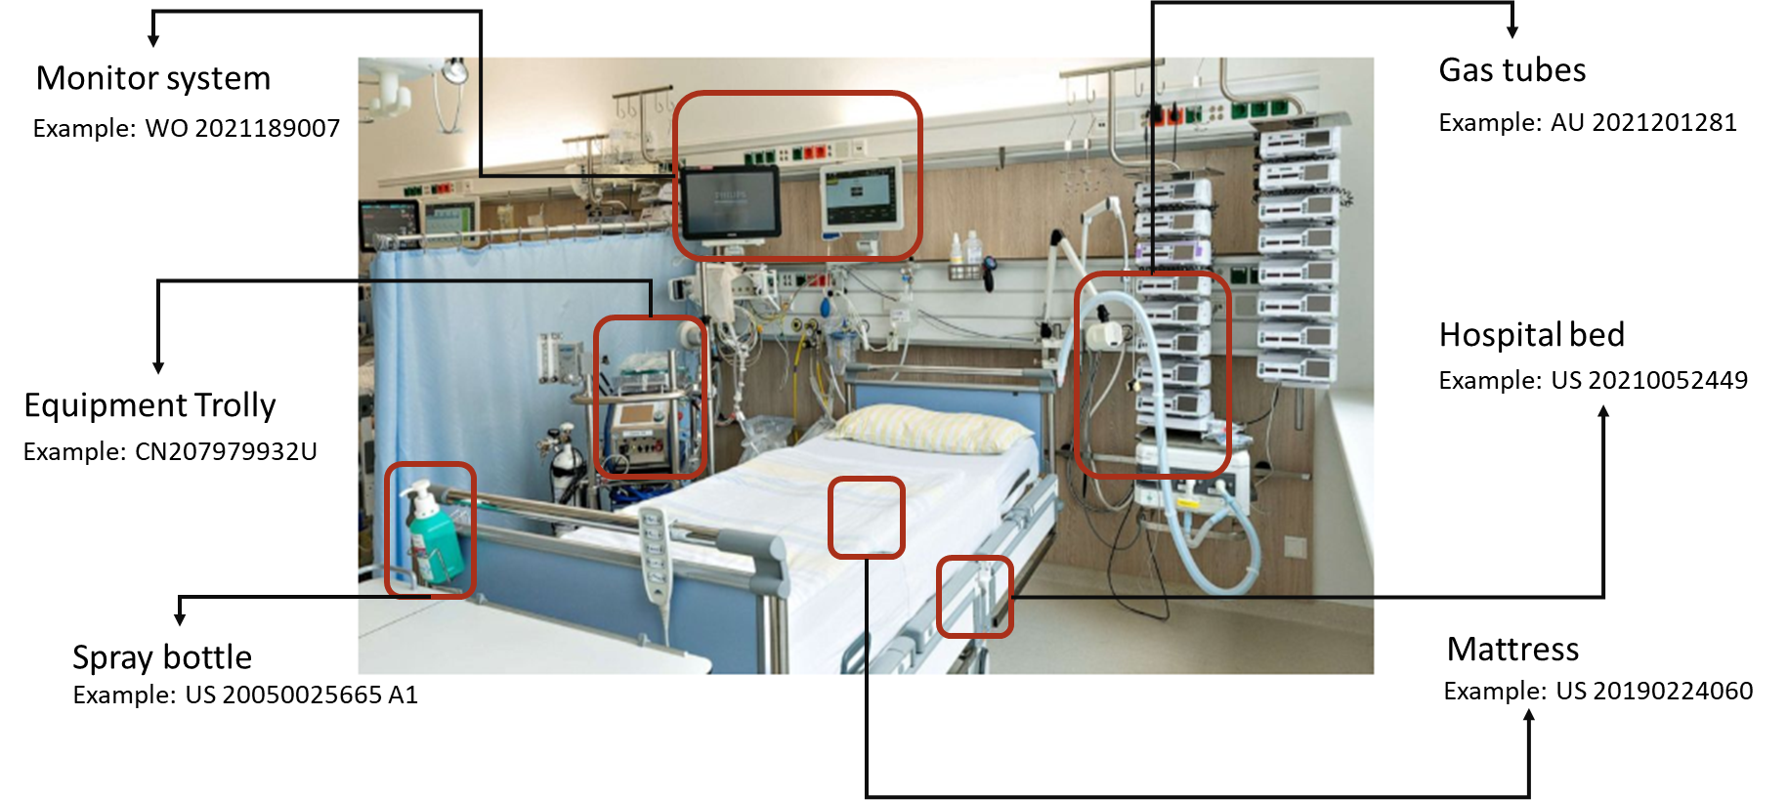

STANDARD PATENT APPLICATIONS IN AUSTRALIA (2021)
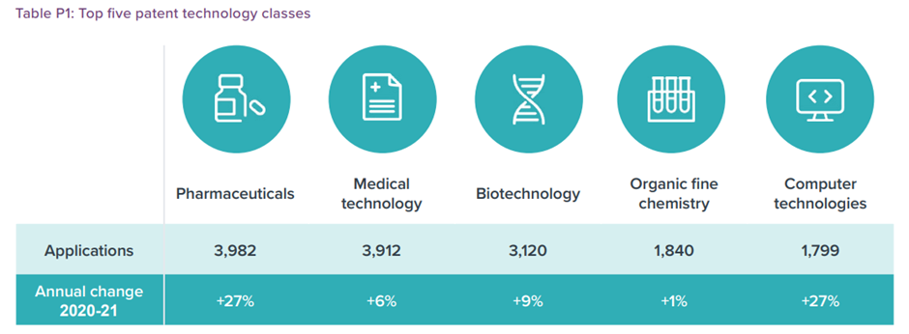
https://www.ipaustralia.gov.au/sites/default/files/ip_report-2022-may.pdf

TOP DOMESTIC PATENT APPLICANTS IN AUSTRALIA (2021)
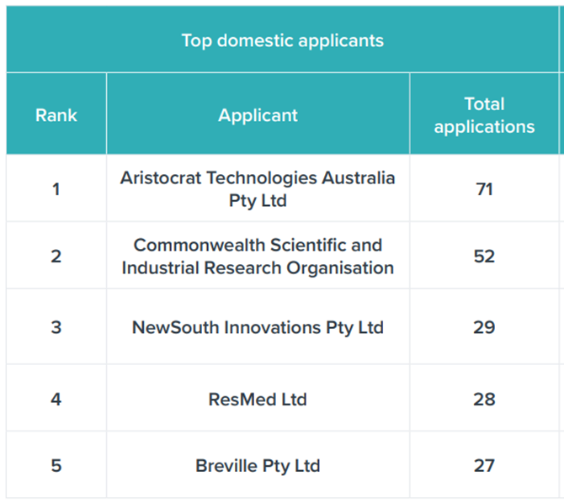
https://www.ipaustralia.gov.au/sites/default/files/ip_report-2022-may.pdf

KEY REGIONS FOR MEDICAL DEVICE PATENTS
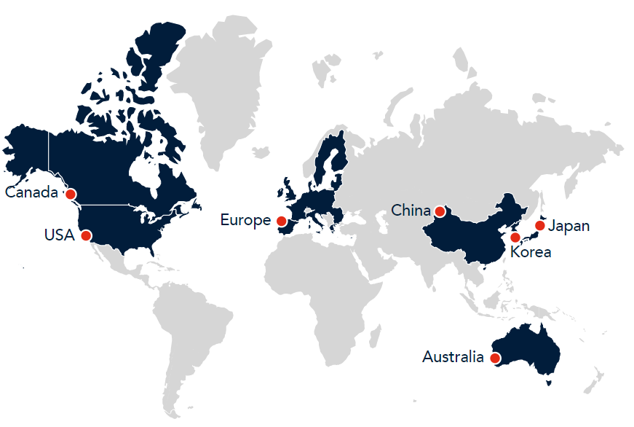
https://www.baxterip.com.au/specialisations/medical-patents


IMPORTANT TAKEAWAYS
Consider IP management early
When you register your IP, it will be published online
Your invention needs to be a secret until you apply
You will need to consider what countries you want to seek protection in
Visit ipaustralia.gov.au to search, read case studies, and find checklists, guides and toolkits
Seek professional advice.

EDUCATION AND RESOURCES
IP Australia website: ipaustralia.gov.au
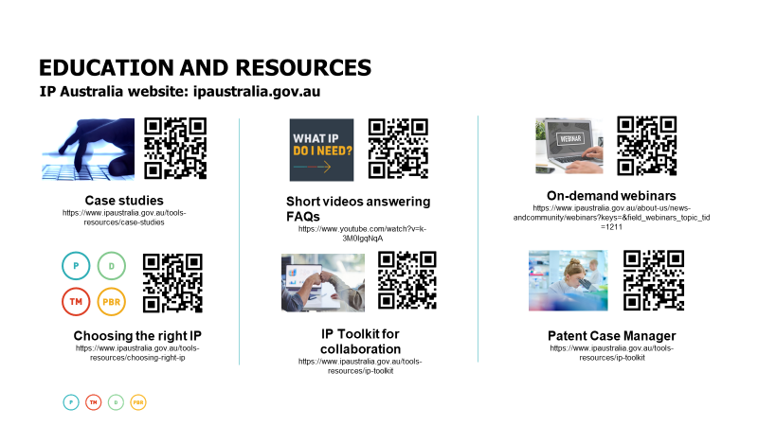

EXPORTING, ECONOMIC PAPERS & ANALYTIC REPORTS
IP Australia website: ipaustralia.gov.au
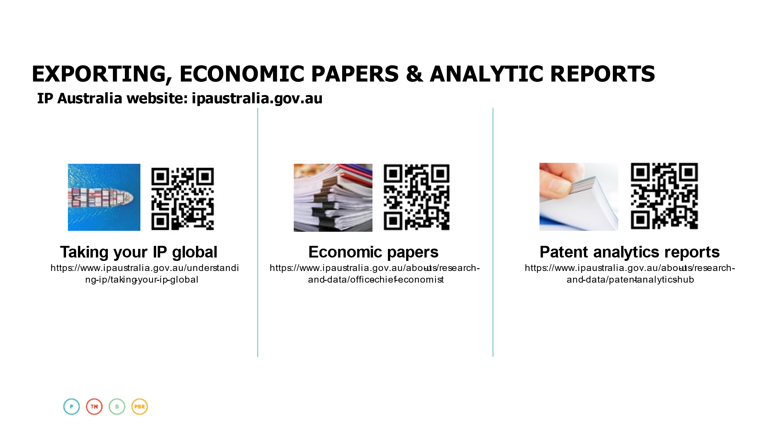

Australian Medical Research and Innovation Priorities 2022–2024
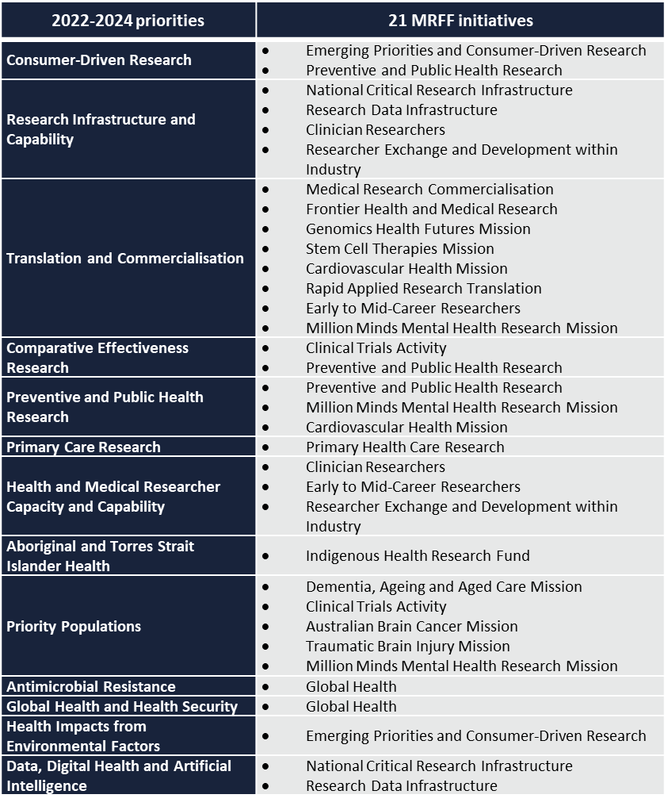
- 2022-2024 Priorities took effect on 6 November 2022.
- Australian Medical Research Advisory Board developed the Priorities concurrently with the Australian Medical Research and Innovation Strategy 2021-26
- The table is a high-level overview of how the MRFF initiatives align with the 2022-24 Priorities
- See: www.legislation.gov.au/Details/F2022L01407

Program Focus: MRFF Consumer Reference Panel (CRP)
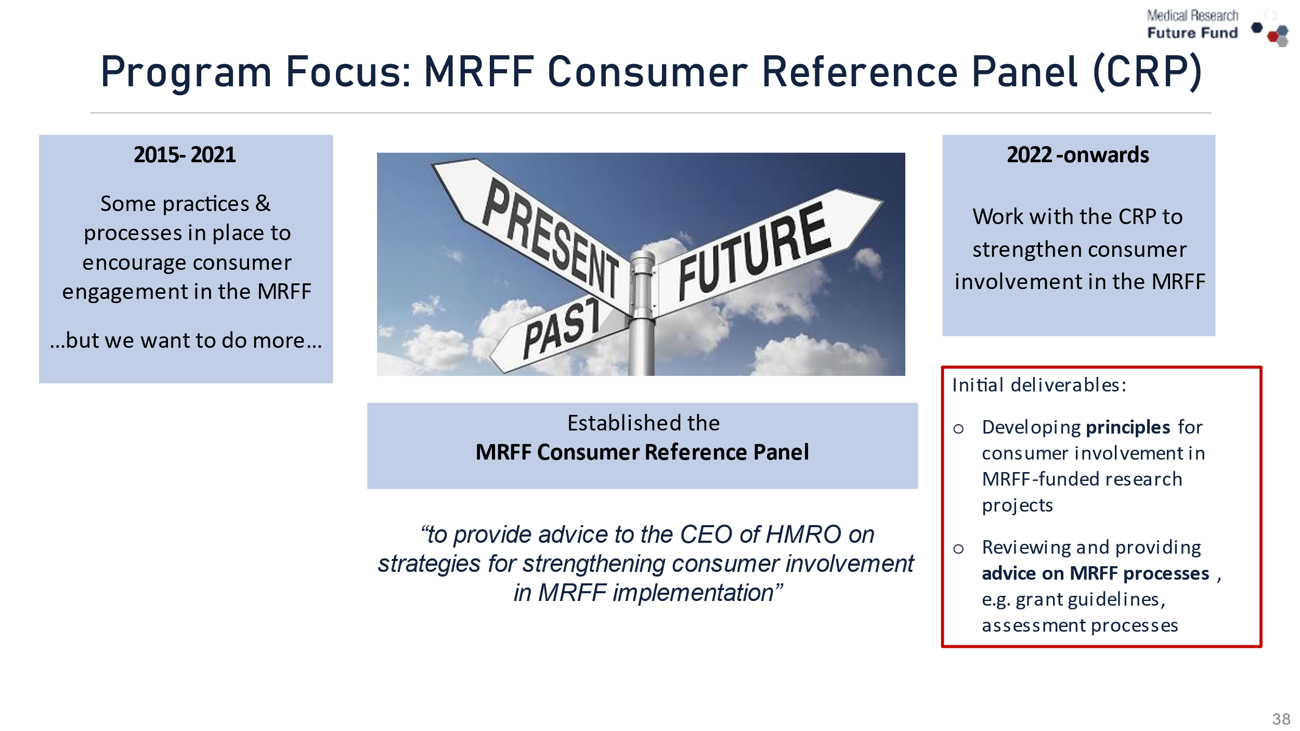

Program Focus: Refresh of Assessment Criteria
- Refinement of descriptors for the four criteria that are used to assess applications to MRFF grant opportunities
- The key changes to the assessment criteria descriptors include:
  - reducing the number of descriptive dot points to assist applicants and assessors
  - using simpler language to clearly draw out the elements to be assessed
  - incorporating specific expectations for research focusing on priority populations
  - including more explicit expectations for consumer involvement.
- Will be implemented across new MRFF grant opportunities
- Department will provide guidance and support to grant assessment committee members
- More information at: www.health.gov.au/resources/publications/refresh-of-the-medical-research-future-fund-assessment-criteria-october-2022

Next steps
- Strengthening the involvement and representation of priority populations in the MRFF
  - integrate diverse voices and experiences into the design and assessment of MRFF granting activities.
  - initially, further strengthen inclusion of the unique knowledge and experiences of First Nations people on grant assessment committees.
- Seeking expressions of interest to join MRFF grant assessment committees
  - researchers with expertise in priority populations.
  - individuals from priority population groups to join MRFF grant assessment committees.
  - www.nhmrc.gov.au and search ‘MRFF Grant Assessment Committee’.
- Thank you to all members of the grant assessment committees.
  - The MRFF Roll of Honour has been published acknowledging the people who participated in MRFF grant assessments between 1 July 2021 and 30 June 2022.

Initiative Focus: Million Minds Mental Health Research Mission
- Innovative mental health research to support a million Australians with mental health issues with access to new approaches to prevention, diagnosis, treatment and recovery
  - $125 million from 2018-19 to 2027-28
- To date, $64.8 million has been awarded for 18 mental health research grants
  - Eating disorders (2 projects)
  - Mental health of children and young people (2 projects)
  - Mental health of First Nations Peoples (3 projects)
  - Suicide prevention (3 projects)
  - COVID-19 Mental Health Research (6 projects)
  - Establishment of mental health Clinical Trials Networks (2 projects)

Review of the Million Minds Mental Health Research Mission
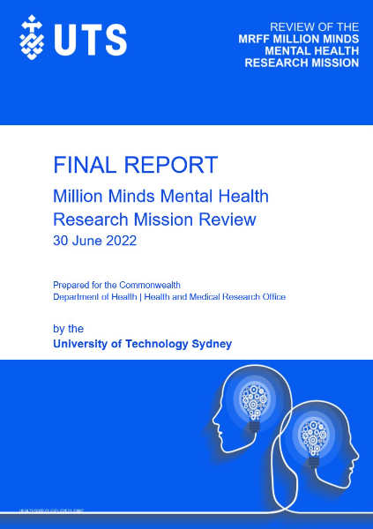
- The MRFF Monitoring, Evaluation and Learning Strategy 2020-21 to 2023-24, states that regular reviews are to be undertaken of the MRFF initiatives
- University of Technology Sydney was contracted to undertake a review of the Mission and the review report was published on
28 October
  - The independent review found investments align with the Mission’s existing Roadmap and progress towards the MRFF Measures of Success and Impact Measures
  - The report listed opportunities for the Mission including investing in research in high burden of disease topics and high risk groups, understanding the variety of factors influencing mental illness, and integrative approaches for improving mental health such as interdisciplinary approaches and community involvement
- The Mission’s Expert Advisory Panel considered the opportunities identified in the review report during the development of the Mission’s Roadmap and Implementation Plan

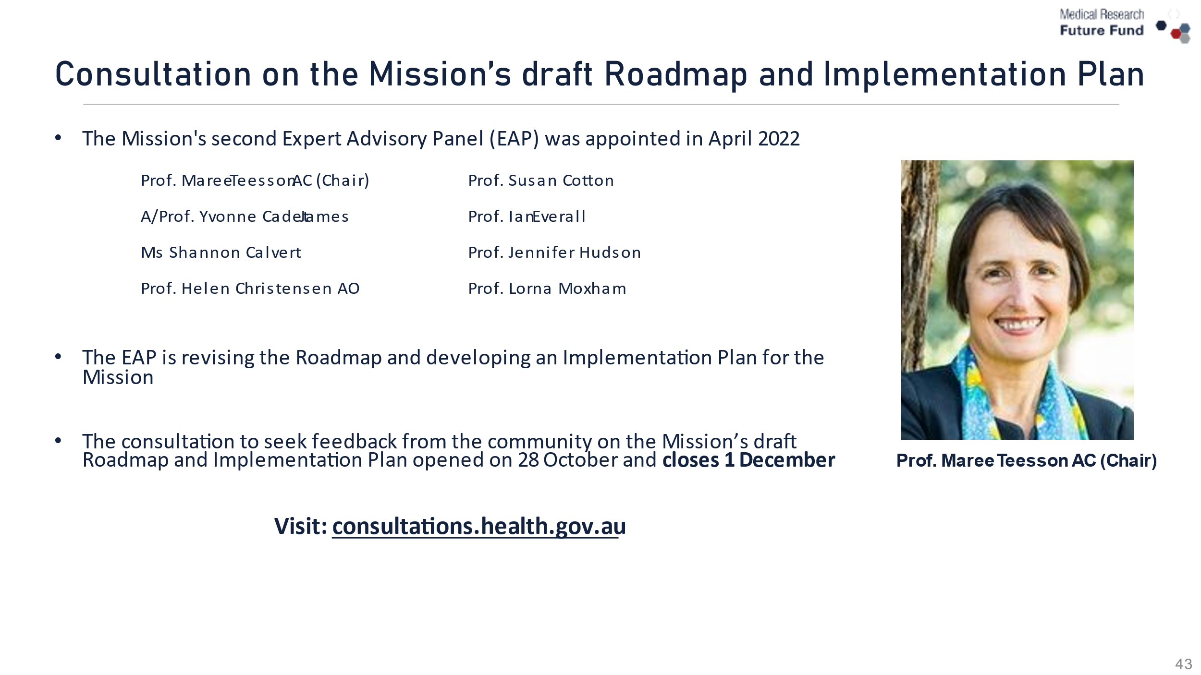
Consultation on the Mission’s draft Roadmap and Implementation Plan
- The Mission's second Expert Advisory Panel (EAP) was appointed in April 2022

Prof. Maree Teesson AC (Chair)
A/Prof. Yvonne Cadet-James
Ms Shannon Calvert
Prof. Helen Christensen AO
Prof. Susan Cotton
Prof. Ian Everall
Prof. Jennifer Hudson
Prof. Lorna Moxham

- The EAP is revising the Roadmap and developing an Implementation Plan for the Mission
- The consultation to seek feedback from the community on the Mission’s draft Roadmap and Implementation Plan opened on 28 October and closes 1 December
Visit: consultations.health.gov.au

MRFF Innovation Grants
- These grants
  - allow grantees to build evidence of the feasibility of their projects to be competitive in future
  - aimed to support capacity building for specific groups of researchers (eg First Nations researchers)
  - small scale ($200,000) and short-term (6-12 months) funding
- In making a recommendation for an Innovation grant, the Grant Assessment Committee will consider an Innovation Grant pitch in the application
- Innovation grants have been awarded in
  - 2021 Improving the Health and Wellbeing of Aboriginal and Torres Strait Islander Mothers and Babies Grant Opportunity
  - 2021 Dementia, Ageing and Aged Care Grant Opportunity

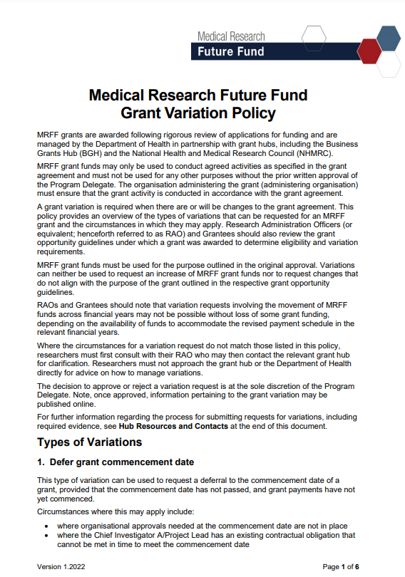
MRFF Program updates
- MRFF Grant Variation Policy (published May 2022)
- Policy Statement for Department of Health and Aged Care Staff Participating in Activities Funded by MRFF (published March 2022)
- Continue work with Business Grants Hub on the Business Grants Management system for MRFF grant applications
- MRFF Monitoring, Evaluation and Learning Strategy 2020-2021 to 2023-2024 sets out the principles and approach used to monitor and evaluate the MRFF
  - Current evaluation of initiatives: Australian Brain Cancer Mission and Clinical Trials Activity Initiative
  - A stakeholder consultation phase on the Australian Brain Cancer Mission is planned
- Currently Performance Indicators for the MRFF Measures of Success are being developed; more information will be available in 2023

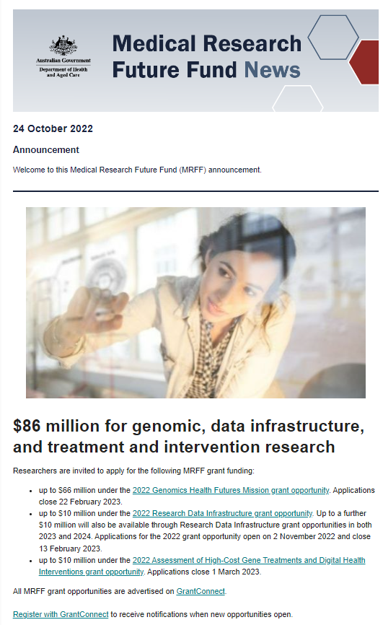
MRFF Communications updates
- Inaugural MRFF RAO Webinar is available on the MRFF website
- MRFF Projects
  - Stories for the general public to read about projects funded by MRFF
  - Recently published
    - Reducing the high rate of chronic kidney disease in First Nations communities (Kim Morey, Co-Theme Leader of Wardliparingga Aboriginal Health Equity, South Australian Health and Medical Research Institute)
    - Supporting bushfire responders after the fires (Dr David Lawrence, University of Western Australia)
- Newsletter will announce the opening of Grant Opportunities
  - Subscribe to the newsletter at the MRFF website
  - Register with GrantConnect to also receive notifications when new opportunities open.

What else?
- Let us know your concerns so we can act on them
- Give us your great ideas
  - What would a great grant opportunity, process etc look like?
- Strengthened focus on consumer involvement
  - What relationships can you build on?
- Contribute to consultations
  - Million Minds Mental Health Mission by 1 December

What else contd.?
- Encourage you to get informed
  - MRFF newsletter, webinars, webpages, Twitter, LinkedIn
- To feature in announcements/media/events
  - Encourage researchers to write easily understandable, engaging media summaries
  - Tell us about your projects for features on the MRFF Projects webpage
- Encourage you to nominate for a Grant Assessment Committee
  - https://www.nhmrc.gov.au/2021-22-medical-research-future-fund-mrff-grant-opportunities

Q&A


Continuous feedback loops…we are listening and learning

- Receive feedback via AMRAB and other consultation processes
- Seek and receive feedback from sector, including through structured processes
- Observing which grant opportunities generate most interest
- Identifying gaps in funding opportunities
- Scanning the environment for emerging issues/unmet needs

Keep Connected
