Long Form Collection Notice

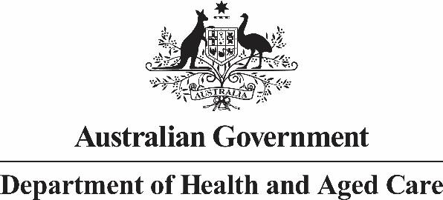

# Australian National Aged Care Classification (AN-ACC) Specialised ATSI residential care service status and Specialised Homeless residential care service status

## APP 5 Notice

| **List of questions** | Details |
| --- | --- |
| **Who is collecting your personal information?** | Your personal information is being collected by the Australian Government Department of Health and Aged Care (the department). |
| **What personal information is being collected?** | * For specialised homeless residential care service status, the names of permanent care recipients who were homeless on entry to residential aged care. * For specialised ATSI residential care service status, the names of permanent care recipients who are Aboriginal or Torres Strait Islander (ATSI) persons. * For the Approved Provider, the details of the person completing and submitting the form for assessment. |
| **Is the collection authorised or required by law?** | The collection of this information is required if the Approved Provider applies for a specialised residential care service status under either section 64P or 64T of the *Aged Care (Subsidy, Fees and Payments) Determination 2014* |
| **Why does the department collect your personal information?** | We collect personal information for the purpose of determining a residential service’s eligibility for specialised status. |
| **What would happen if the department did not collect your personal information?** | If you do not or are unable to provide your personal information the department may not be able to determine whether the residential care service has met the requirements necessary to be a specialised residential care service. |
| **Who will the department disclose your personal information to?** | We will not disclose your personal information. |
| **Access to and correction of your personal information** | The Department’s privacy policy contains information about how you may access and seek correction of personal information about you that is held by the Department. |
| **Privacy complaints** | The Department’s privacy policy contains information about how you may complain about a breach of the Australian Privacy Principles or the *Australian Government Agencies Privacy Code* and how the Department will deal with complaints. |
| **Overseas disclosure of your personal information** | We will not disclose your personal information to any overseas recipients. |
| **Further information** | You can read the Department’s privacy policy [here](http://www.health.gov.au/internet/main/publishing.nsf/Content/privacy-policy). You can obtain a copy of the APP privacy policy by contacting the department using the contact details set out at the end of this notice. |
| **Contact details** | If you wish to contact the Department about a privacy-related matter, including questions about this notice, please contact the Department’s Privacy Officer by one of the following methods:  **Post**  Privacy Officer  Department of Health and Aged Care  23 Furzer Street  WODEN ACT 2606  **Email**  [privacy@health.gov.au](mailto:privacy@health.gov.au)  **Telephone**  02 6289 1555 | |