Long Form Collection Notice

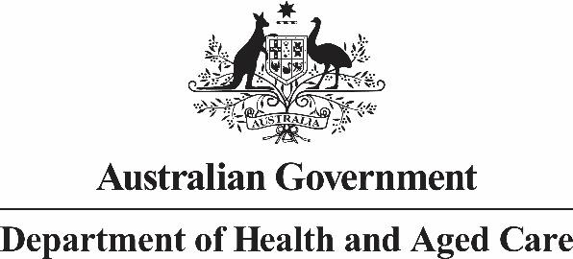

# Australian National Aged Care Classification (AN-ACC) Specialised Homeless residential care service status – Care recipient assessment APP 5 Notice

| List | Detail |
| --- | --- |
| **Who is collecting your personal information?** | Your personal information may be collected by the Australian Government Department of Health and Aged Care (the department). |
| **What personal information is being collected?** | * For specialised homeless residential care service status, the names of permanent care recipients who were homeless prior to entry into residential aged care. * In addition, for specialised homeless residential care service status, permanent care recipient’s date of birth, gender, unique ID, date of entry, homelessness status, income, mental and behavioural diagnoses, and information on challenging behaviours. * For the Approved Provider, the details of the person completing and submitting the form for assessment. |
| **Why does the department collect your personal information?** | We may collect personal information for the purpose of determining a residential service’s eligibility for specialised status. |
| **What would happen if the department did not collect your personal information?** | If you do not or are unable to provide your personal information the department may not be able to determine whether the residential care service has met the requirements necessary to be a specialised residential care service. |
| **Who will the department disclose your personal information to?** | We will not disclose your personal information. |
| **Access to and correction of your personal information** | The Department’s privacy policy contains information about how you may access and seek correction of personal information about you that is held by the Department. |
| **Privacy complaints** | The Department’s privacy policy contains information about how you may complain about a breach of the Australian Privacy Principles or the *Australian Government Agencies Privacy Code* and how the Department will deal with complaints. |
| **Overseas disclosure of your personal information** | We will not disclose your personal information to any overseas recipients. |
| **Further information** | You can read the [Department’s privacy policy](http://www.health.gov.au/internet/main/publishing.nsf/Content/privacy-policy). You can obtain a copy of the APP privacy policy by contacting the department using the contact details set out at the end of this notice. |
| **Contact details** | If you wish to contact the Department about a privacy-related matter, including questions about this notice, please contact the Department’s Privacy Officer by one of the following methods:  **Post**  Privacy Officer  Department of Health and Aged Care  23 Furzer Street  WODEN ACT 2606  **Email**  [privacy@health.gov.au](mailto:privacy@health.gov.au)  **Telephone**  02 6289 1555 | |
| **Consent** | The Approved Provider of the residential care service will seek your consent to use any details needed to support their application for specialised homeless residential care service status under the AN-ACC residential aged care funding model. | |