Japanese encephalitis virus

Stakeholder kit

How to use this kit
This kit includes information from the Department of Health and Aged Care and the Department of Agriculture, Fisheries and Forestry for stakeholders about Japanese encephalitis virus (JEV) that you can disseminate through your members, networks, and other channels.

Major announcements
1 March 2022 – Japanese encephalitis detected in Eastern Australia
1 March 2022 – Japanese encephalitis detected in Australia
4 March 2022 – Japanese encephalitis virus situation declared a Communicable Disease Incident of National Significance
11 March 2022 – $69 million for Japanese encephalitis virus (JEV) response
16 November– $9.7 million for flood hit Australian communities

Key information
- JEV has been detected in five states and territories – New South Wales, Queensland, Victoria, the Northern Territory, and South Australia – in humans and a number of piggeries. Feral pigs have been detected with JE in parts of the Northern Territory and Far North Queensland.
- A small number of people have died of JEV in Australia during the current outbreak.
- JEV is a mosquito-borne flavivirus, and belongs to the same genus as dengue, yellow fever, Murray Valley encephalitis and West Nile/Kunjin viruses.
- JE is a rare disease caused by the JEV; the first documented case was in 1871 in Japan.
- JE is a nationally notifiable disease in both humans and animals.
- JEV is spread to humans through mosquito bites.
  - The virus does not spread between humans.
  - Animals such as pigs and horses cannot directly pass the virus to humans.
- Few animals are thought to play a significant role in the natural transmission of JEV – with the most common being waterbirds and pigs.
  - Once infected, people do not play a role in transmitting the virus.
  - Once infected. pigs and some species of waterbirds can produce sufficient levels of virus in their blood to infect mosquitoes, which can then infect humans.
- JEV is not a food safety concern. Commercially produced pork meat and pork products are safe to consume.
- The current status for human cases can be found on the Department of Health and Aged Care website.
- The JEV outbreak has been declared a Communicable Disease Incident of National Significance for human health.
- The Australian Government’s health and agriculture departments are working closely with their state and territory government counterparts to ensure a coordinated response.
- The response includes mosquito surveillance and control measures and identification of those at direct risk, and the rollout of vaccines.

Symptoms in humans
- Most infections are asymptomatic – but on rare occasions infection can result in serious illness and even death.
- Symptomatic infection usually begins with sudden onset of fever, headache and vomiting.
- Those with a severe illness may also experience neck stiffness, depressed level of consciousness, focal neurological signs, convulsions (especially in children) and paralysis.
- Symptoms (if they occur) usually develop 5 to 15 days after a person has been bitten by an infected mosquito.

Protection against JEV this summer
- JEV cannot be transmitted from human to human, nor by consuming meat from an infected animal.
- Ways to prevent JEV infection include:
  - avoiding being bitten by mosquitoes, and
  - vaccination against JEV.
- Protection from mosquito bites is an important way to minimise potential exposure to JEV and other mosquito-borne diseases. This includes:
  - applying and regularly reapplying an effective mosquito repellent containing DEET, Picaridin, or Oil of Lemon Eucalyptus on all exposed skin (always follow label directions)
  - wearing long, loose-fitting, light coloured clothing when outside to cover exposed skin, especially around dusk and dawn
  - ensuring accommodation, including tents, is properly fitted with mosquito nettings or screens
  - using insecticide sprays, vapour-dispensing units (indoors) and mosquito coils (outdoors) to clear rooms and repel mosquitoes from an area (always follow label directions to use pesticides safely)
  - covering all windows, doors, vents and other entrances with insect screens in homes and when camping, and
  - removing or emptying containers or other items such as tyres which may hold stagnant water where mosquitoes may breed around homes and at campsites.

Vaccination
- State and territory public health units are coordinating and implementing JEV vaccination programs for those most at risk of infection.
- Eligibility varies across states and territories. At the beginning of the outbreak, JEV vaccination was initially prioritised for those with occupational and/or relevant animal exposure risk.
- Eligibility criteria has recently expanded in a number of states and territories to include those living or working in particular regions, and who spend a significant period of time each day outdoors.
- People seeking information on whether they should have a JEV vaccination are encouraged to contact their local public health authority.
- In Australia, two JE vaccines are registered for use:
  - Imojev (Sanofi Pasteur) – a single-dose, live attenuated virus vaccine (which cannot be given to some people, such as pregnant women and those who are immunocompromised), and
  - JEspect (Seqirus) – a two-dose (inactivated) vaccine which requires a 28-day interval between doses.
- Further information is included in the JE vaccine advice from the Australian Technical Advisory Group on Immunisation.
- For more information about vaccination visit the Department of Health and Aged Care website.

Animal health
- JE is a nationally notifiable disease, which means that anyone who suspects an animal is showing signs of the disease, must report it to a veterinarian or the national Emergency Animal Disease Watch Hotline on 1800 675 888.
- In pigs, the most common clinical signs are mummified and stillborn or weak piglets. Some may have neurological signs, limb deformities and misshapen heads.
- Piglets infected after birth can develop encephalitis which presents as paddling or other neurological signs in the first six months of life. In other cases, wasting, depression or hindlimb paralysis may be seen in suckling piglets and weaners. Adult sows do not typically show signs of disease.
- Pig producers are asked to be highly vigilant for signs of this disease and report unexplained pig abortions or stillbirths.
- People working with pigs, even if they’re only a backyard pet or a small herd, should take steps to control mosquitoes, as well as continuing to practise good biosecurity.
- JEV occurs most commonly in pigs, but horses can also become infected. Horse owners can put measures in place to help their horses avoid mosquito bites, including using hooded rugs, fly masks, and applying a safe insect repellent.
- In horses, many cases show no signs of the disease. Some animals may show signs of elevated temperature, jaundice, lethargy or anorexia. Other signs may include lack of coordination, difficulty swallowing, impaired vision and in rare instances, a horse may become over-excited. Horses are a “dead-end host”, meaning JEV will not be transmitted by mosquitoes biting a horse and then a human.
- The clinical presentation of JE is similar to other mosquito-borne diseases such as infection with West Nile/Kunjin virus, Murray Valley encephalitis virus, and Hendra virus. As Hendra virus can be transmitted directly from horses to people, it is important to be cautious and wear a face mask, gloves and coveralls if caring for a sick horse and/or while waiting for test results.
- There are useful guides about controlling mosquitoes in piggeries or on horse properties which are free to download from www.farmbiosecurity.com.au.
- Other animals can be infected but typically do not show signs of illness, such as cattle, sheep, alpacas, goats, dogs, cats, bats, rodents, reptiles, amphibians and birds. Cattle, dogs, sheep, alpacas, and goats are also dead-end hosts that do not infect mosquitoes or people. Waterbirds are the main reservoir for spreading the virus to mosquitoes.

Trusted sources of information
Department of Health and Aged Care
The Australian Immunisation Handbook
DAFF Biosecurity: Animal Pests and Diseases - JEV

ATAGI clinical guidance on JEV
Website/newsletter article
The risk of catching Japanese encephalitis virus (JEV) and other mosquito-borne diseases is higher this summer due to warm, wet weather providing ideal mosquito breeding conditions.
JEV is spread only through mosquito bites and is more common in areas of increased mosquito activity, such as lakes, creeks, rivers and dams. People should also be vigilant around areas where animals that can infect mosquitoes with JEV – such as waterbirds and pigs – are present.
If you’re travelling this summer, it is important to be aware of areas with mosquito activity and follow simple steps to avoid mosquito bites.
People are encouraged to use effective mosquito repellent containing DEET, Picaridin, or Oil of Lemon Eucalyptus on all exposed skin and wear long, loose fitting clothing when outside, especially at dusk and dawn. Mosquito nets or screens should be properly fitted to accommodation and tents.
Most people who catch JEV will have no symptoms and severe illness is rare. Symptomatic infection usually begins with sudden onset of fever, headache and vomiting.
A very small proportion of people infected, less than one per cent, may develop a serious illness such as encephalitis and experience symptoms including neck stiffness, severe headache and coma, and more rarely, permanent neurological complications or death.
Anyone experiencing these symptoms should urgently seek medical advice.
JEV cannot be transmitted from human to human nor by consuming meat from an infected animal.
Vaccines are available to those most at risk of infection, based on locality and profession. For more information about vaccination please visit the Department of Health and Aged Care website.
For more information about the spread of JEV in people and human health information please visit the Department of Health and Aged Care website.

Social media posts
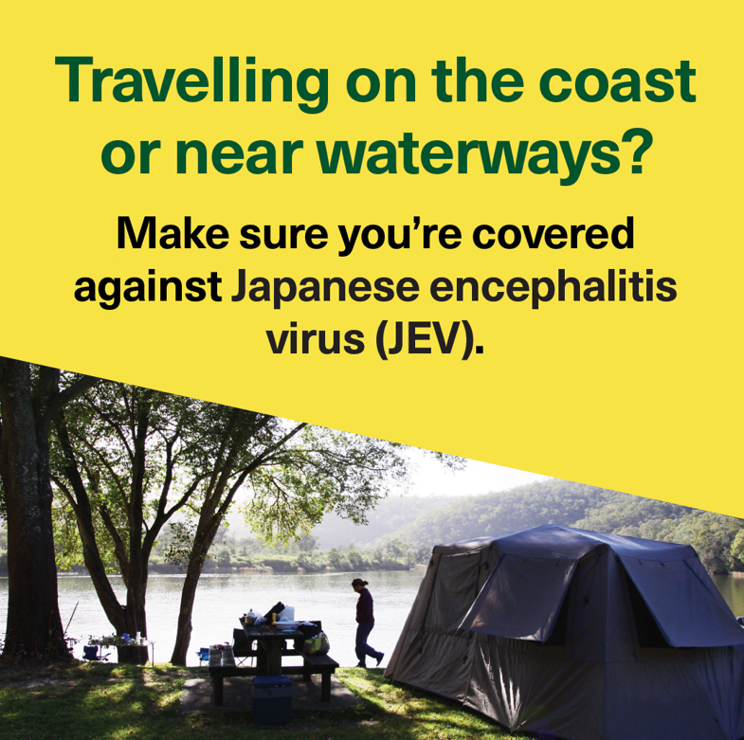 | If you’re near water this summer, remember to make sure you're covered against mosquito-borne diseases like Japanese encephalitis virus (JEV).  Protect yourself by:  🧴 applying repellent containing DEET, picaridin or Oil of Lemon Eucalyptus on exposed skin, and use insecticides and mosquito coils, especially at dusk and dawn  👖 wearing long, light-coloured, loose-fitting clothes outside, especially at dusk and dawn  ⛺ ensuring accommodation is properly fitted with mosquito nets or screens on windows, doors, vents and other entrances  🚰 emptying any water-holding containers where mosquitoes may breed.  For more information visit 💻health.gov.au/jev
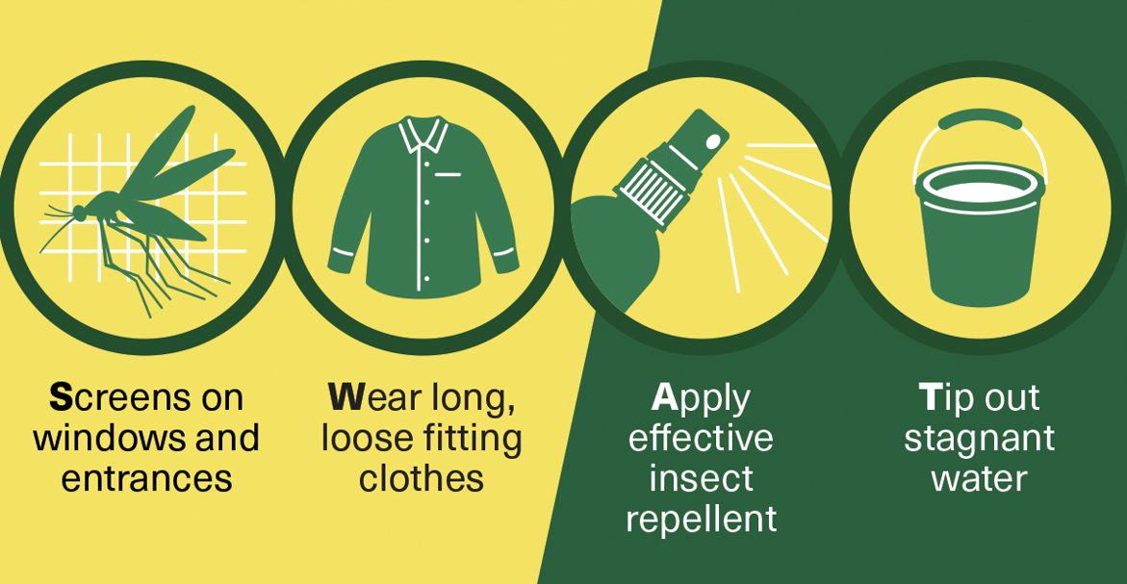 | Make sure you're covered against Japanese encephalitis virus (#JEV) by:  🧴 applying repellent  👖 wearing long, loose-fitting clothes  ⛺ ensuring accommodation is properly fitted with mosquito nets or screens  🚰 emptying any water-holding containers.  Visit 💻health.gov.au/jev

Additional materials
A suite of materials that encourages Australians to protect themselves against JEV is available on the Department of Health and Aged Care website. These materials are available for you to download, print and distribute.

