Guidance for Managing Departing and Returning Aid Workers

Office of Health Protection and Response

Endorsed by the Australian Health Protection Principal Committee, December 2018

Administrative updates November 2022

Contents

1 Purpose 3

2 Scope 3

3 Definitions 3

4 Context 4

5 Principles 5

5.1 Aid workers departing from Australia to a LHD outbreak overseas 5

5.2 Aid workers returning from a LHD outbreak overseas 5

5.3 Aid workers with possible LHD symptoms or high risk exposures 5

6 Notification of Departing or Returning Aid Workers 6

6.1 Role of the National Incident Centre 6

6.2 Role of aid worker providers/organisations 6

7 Managing Departing Aid Workers 6

7.1 Role of the National Incident Centre 6

7.2 Role of aid worker providers/organisations 6

7.3 Role of the Public Health Authority 7

8 Managing Returning Aid Workers 7

8.1 Role of the National Incident Centre 7

8.2 Role of the Public Health Authority 7

Appendices 8

Appendix 1 National Incident Centre and Public Health Authority Contact details 8

Appendix 2 Aid Worker Departures - Notification Template 10

Appendix 3 Checklist of actions for departing aid workers 11

Appendix 4 Aid Worker Arrivals- Notification Template 12

# Purpose

This guidance document works to assist those managing aid workers who are departing from or returning to Australia from an area affected by a Listed Human Disease (LHD).

# Scope

This policy applies to all aid workers:

* leaving Australia to provide healthcare or community assistance in response to an outbreak of a LHD overseas; and
* returning to Australia after providing healthcare or community assistance in response to a LHD outbreak.

Aid worker provider/organisations, relevant Australian Government agencies, state and territory Public Health Authorities (PHA) may use this policy to assist in the management of aid workers departing from and returning to Australia.

# Definitions

For the purposes of interpretation and implementation of this guidance document the following terms are defined accordingly:

| Term | Definition |
| --- | --- |
| Aid Worker | Workers providing healthcare or community assistance in response to a LHD outbreak. |
| Aid Worker provider/organisation | Organisations providing aid workers to assist in a LHD response. |
| Listed Human Disease (LHD) | A LHD is a human disease that the Director of Human Biosecurity considers may be communicable and cause significant harm to human health. LHDs currently include:   1. human influenza with pandemic potential; 2. Middle East respiratory syndrome; 3. plague; 4. severe acute respiratory syndrome (SARS); 5. smallpox; 6. viral haemorrhagic fevers; 7. yellow fever; 8. human coronavirus with pandemic potential (e.g. COVID-19).   LHDs are contained in the *Biosecurity (Listed Human Diseases) Determination 2016*. If deemed appropriate, additional diseases may be added to the list at short notice by the Director of Human Biosecurity. |
| National Incident Centre (NIC) | The NIC is the Australian Government Department of Health and Aged Care’s (DoHAC) emergency operations centre. The NIC is responsible for disseminating information and supporting coordination of resources between DoHAC, other Australian Government departments, state and territory governments, and the World Health Organization (WHO), as required, during a national health emergency.  The NIC is contactable 24 hours a day, 7 days a week. |
| Public Health Authority (PHA) | Generally located in the state or territory health department and is responsible for the notification, investigation of and response to communicable diseases. Each state and territory may have a different name for this function. |
| Specified period | The period of time for which restrictions and monitoring requirements will be imposed.  The specified period will be determined by the PHA based on the assessment of the incubation period of the disease, the date of last possible exposure, and other relevant disease factors. |

# Context

This guidance document operates concurrently with the *Assessing Ill and Deceased Travellers at Australia's International Borders Policy* and the *Human Biosecurity Control Orders Policy*.

The policy has been endorsed by the Australian Health Protection Principal Committee (AHPPC) and is consistent with the guidelines for returning aid workers in the Ebola virus disease (EVD) Series of National Guidelines (SoNG) for Public Health Units <https://www.health.gov.au/resources/collections/cdna-series-of-national-guidelines-songs>

# Principles

## Aid workers departing from Australia to a LHD outbreak overseas

* Aid workers and/or their organisations are encouraged to notify the NIC of their travel arrangements prior to departure. NIC contact details are at Appendix 1.
* Aid workers are encouraged to attend a briefing and/or to read relevant briefing material provided on the specific LHD.
* Aid workers are encouraged to subscribe on the Smartraveller website to receive travel advice and alerts about their destination: <https://subscription.smartraveller.gov.au/subscribe/>

## Aid workers returning from a LHD outbreak overseas

* Aid workers are encouraged to fly directly to their final destination in Australia (if possible) or a major city if a briefing has been arranged by the aid worker organisation.
* Aid workers may be subject to monitoring and may be asked to comply with a range of restrictions after returning to Australia for a specified period after leaving the LHD affected country or region.
* Aid workers are expected to contact the PHA in their home (or arrival) state or territory if contact by the relevant PHA has not been made within one business day after arrival. PHA contact details are at Appendix 1.
* Aid workers are encouraged to minimise movement and personal contact beyond their household until assessment by the PHA has been performed.
* Following return to Australia, aid workers are discouraged from taking a holiday to additional countries, and to avoid unnecessary travel within Australia, during the specified period due to risk of transmission and additional contact tracing requirements if infection has occurred.

## Aid workers with possible LHD symptoms or high risk exposures

* Aid workers and their providers/organisation should notify the NIC as soon as possible of any possible LHD symptoms or known high risk exposures before returning to Australia.
* Aid workers who display symptoms upon entry into Australia should present to border staff (Biosecurity Officers) and will be subject to existing traveller with illness screening and assessment processes.

# Notification of Departing or Returning Aid Workers

## Role of the National Incident Centre

In the event the NIC is notified through its existing mechanisms of a LHD outbreak in a country, the NIC will make contact with relevant aid worker providers/organisations, the Department of Foreign Affairs and Trade (DFAT) and the World Health Organization (WHO) to ascertain whether Australian aid workers are currently providing, have provided or are likely to provide assistance in the outbreak response.

Depending on the severity of the outbreak and the risk of transmission to Australia, the NIC will continue to work with aid worker providers/organisations, DFAT and the WHO to collate the required information on aid workers who will assist in the outbreak response.

Information collated is consistent with the objectives of the *National Health Security Act 2007.*

The NIC will provide notifications of arrivals and/or departures and the related information to the relevant PHA within 24 hours of receiving the notification from the organisation.

## Role of aid worker providers/organisations

Aid worker providers /organisations are encouraged to notify the NIC by completing the:

* Aid Worker Departures - Notification Template (Appendix 2) and the Checklist of actions for departing aid workers (Appendix 3) and/or;
* Aid Worker Arrivals- Notification Template (Appendix 4) for returning aid workers assisting in LHD outbreak affected areas.

This information should be provided to the NIC at least 7 days before departure from or return to Australia (where possible).

It is the responsibility of the aid worker provider/organisation to provide updates to the NIC regarding changes in flight or contact details.

# Managing Departing Aid Workers

## Role of the National Incident Centre

Following the receipt of a departure notification, the NIC will follow up with the aid worker providers/organisations if the checklist at Appendix 3 has not been completed.

## Role of aid worker providers/organisations

Aid worker providers/organisations prior to departure are encouraged to adequately brief and advise their workers on the relevant disease, prevention, and any restrictions that may apply on return to Australia (the NIC in consultation with the PHA may provide appropriate reading or reference material to assist, upon request).

## Role of the Public Health Authority

Aid workers who are working independently and are not part of an aid worker provider/organisation may be contacted by the relevant PHA if the NIC or PHA becomes aware of their travel. The PHA may provide a briefing on the LHD including; infection, symptoms, precautions, procedures, and other relevant information.

PHAs are available to answer questions that individuals may have regarding the LHD or restrictions likely to apply.

# Managing Returning Aid Workers

## Role of the National Incident Centre

The NIC will work with the aid worker provider/organisation to ensure the correct completion of the template at Appendix 4 and will provide the notification to the relevant PHA to action within 24 hours of receiving the notification from the organisation. If a returning aid worker is assessed as high risk, the NIC may also inform the relevant airline.

## Role of the Public Health Authority

The PHA will contact the aid worker within one business day of arrival into Australia to facilitate an exposure and clinical risk assessment, and an assessment of personal circumstances, such as the proximity of the person’s usual place of residence to a facility that can test for the relevant disease.

The outcome of the risk assessment will determine what type of self-monitoring (temperature checks etc) is required. The PHA will put in place an appropriate voluntary plan, including whether any restriction of activities (living, working, movement) is appropriate within the specified period.

If requested, the PHA will provide details to the NIC on the outcome of assessments made and the restrictions placed.

In the event of non-compliance, a Human Biosecurity Control Order (HBCO) can be applied to an individual who is suspected of having, or has been in contact with a person who has or is suspected of having, a LHD, or an individual who has failed to comply with directions. HBCOs can only be imposed by a Chief Human Biosecurity Officer, a Human Biosecurity Officer or a Biosecurity Officer (officers) under the *Biosecurity Act 2015*. If a HBCO is being considered, please contact the NIC immediately for advice. An officer must notify the Director of Human Biosecurity, as soon as reasonably practicable, if the officer imposes, varies or revokes a HBCO.

Appendices

Appendix 1 National Incident Centre and Public Health Authority Contact details

| Jurisdiction | Public Health Authority and Public Health Unit contact details |
| --- | --- |
| NIC | 02 6289 3030  [Health.Ops@Health.gov.au](mailto:Health.Ops@Health.gov.au) |
| ACT | 02 5124 9213 |
| NSW | 1300 066 055  <http://www.health.nsw.gov.au/Infectious/Pages/phus.aspx> |
| NT | 08 8922 8044 Monday – Friday daytime  08 8922 8888 ask for CDC doctor on call –for after hours |
| QLD | 13 432 584  <https://www.health.qld.gov.au/system-governance/contact-us/contact/public-health-units> |
| SA | 1300 232 272 |
| TAS | 1800 671 738 |
| VIC | 1300 651 160 |
| WA | 08 9222 2131 After hours 08 9328 0553  <https://www.healthywa.wa.gov.au/Articles/A_E/Contact-details-for-population-public-health-units> |

| State/territory | Name of quarantine hospital(s) Contact details |
| --- | --- |
| ACT | Canberra Hospital 02 5124 0000 |
| NSW | Westmead Hospital 02 9845 5555  Children’s Hospital Westmead 02 9845 0000 |
| NT | Royal Darwin Hospital 08 8922 8888  Ask for CDC doctor on call |
| QLD | Royal Brisbane and Women’s Hospital 07 3636 8111  Queensland Children’s Hospital 07 3068 1111 |
| SA | Royal Adelaide Hospital 08 8222 4000  Women’s and Children’s Hospital Adelaide 08 8161 7000 |
| TAS | Royal Hobart Hospital  03 6166 8308 and ask for the on-call Infectious Diseases Physician |
| VIC | Royal Melbourne Hospital Grattan Street, Parkville  03 9342 7000 |
| The Royal Children’s Hospital 50 Flemington Road, Parkville 03 9345 5522 |
| WA | Sir Charles Gairdner Hospital 08 6457 3333 and ask for on-call Clinical Microbiologist |
| Perth Children’s Hospital 08 6456 2222 and ask for on-call Clinical Microbiologist |

Appendix 2 Aid Worker Departures - Notification Template

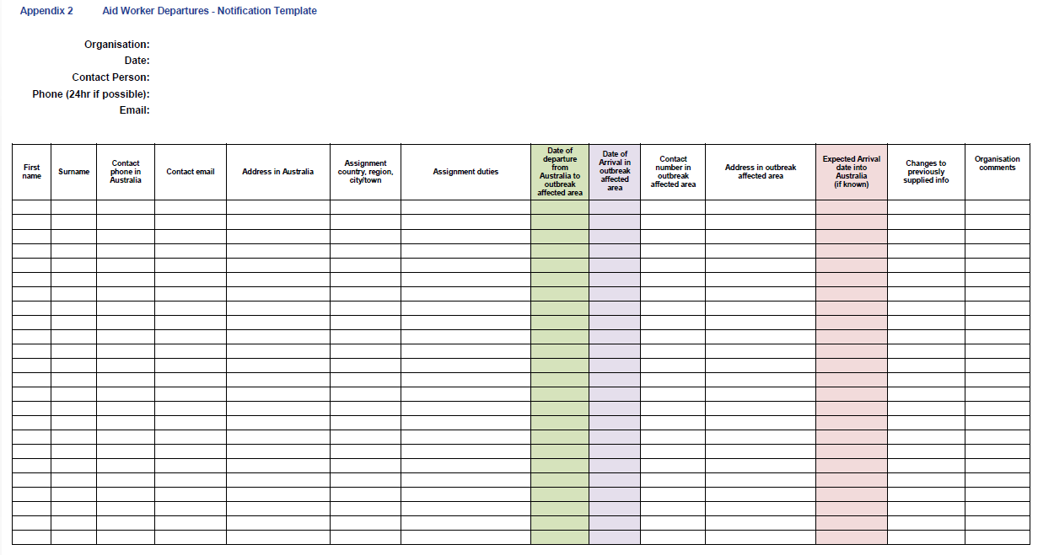

Appendix 3 Checklist of actions for departing aid workers

Organisation Click or tap here to enter organisation name.

|  |  |  |
| --- | --- | --- |
| It has been confirmed that identified aid worker(s) as specified in the Worker Departures Notification Template (Appendix 2) have (or will have prior to departure): | | |
| Been briefed on the follow up procedure upon returning into Australia and the restrictions that may be placed for the period after arrival. | Yes No | Other (please specify) |
| Been briefed on relevant disease, infection, symptoms, precautions, procedures or any other relevant information. | Yes No | Other (please specify)  _____________________ |
| Been briefed that taking a holiday involving travel after the deployment period during incubation is discouraged. | Yes No | Other (please specify)  _____________________ |
| Been briefed on the need to fly directly to their final destination in Australia (if possible) or a major city (if a briefing has been arranged) when returning from their mission. | Yes No | Other (please specify)  _____________________ |
| Subscribed to Smartraveller alerts | Yes No | Other (please specify)  _____________________ |
| Signature:  Name:  Date:  Phone:  Email: |  |  |

Appendix 4 Aid Worker Arrivals- Notification Template

