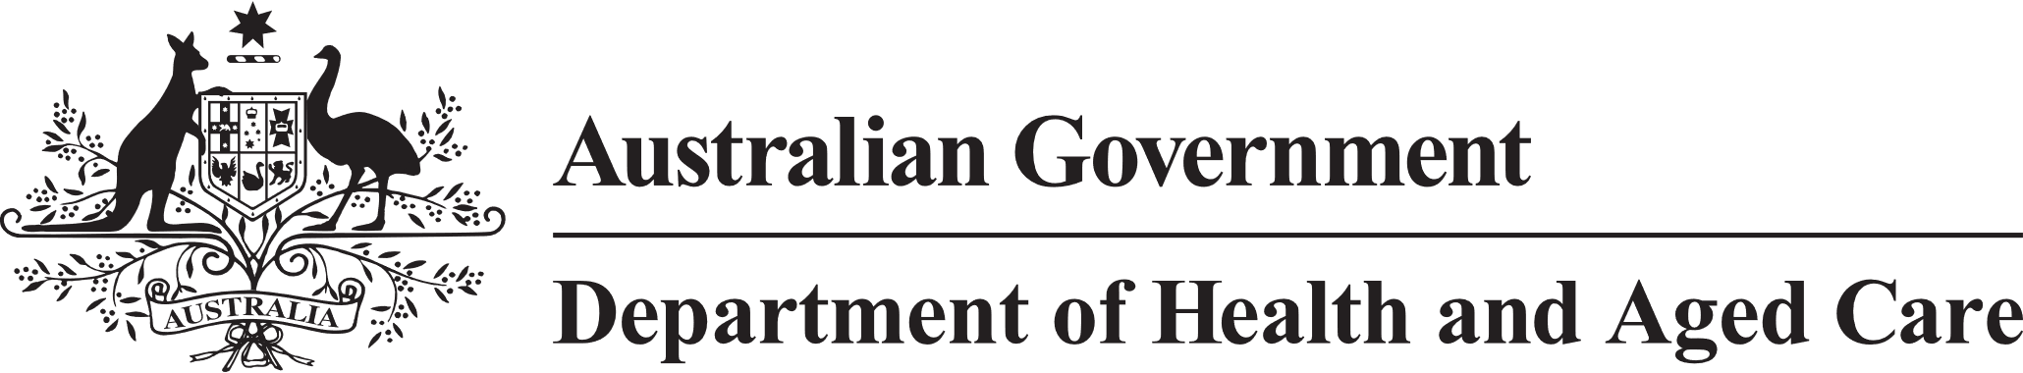

**Council of Elders**

# Communique – 10 November 2022

During its November 2022 meeting of the Council of Elders, Members received reports from a number of its working groups, welcomed Mr David Tune AO PSM, who discussed the scope of the Capability Review of the Aged Care Quality and Safety Commission, and considered a range of other aged care matters including consultation on legislation to establish the Inspector-General of Aged Care, consultations on Aged Care Quality Standards, and eligibility for aged care under the new Aged Care Act.

The Council heard reports from its aged care reform portfolio working groups including on provider transparency, star ratings, and the aged care workforce, which had been working with relevant Departmental officers to identify and discuss key issues in each area. The Council also heard reports from its Priority Areas in Ageing subgroups including Supporting Ageing Well, Focus on First Nations, and Holistic and Supportive End-of-Life Care, all of which have commenced scoping work plans, in liaison with the Department.

Members met with Mr David Tune AO PSM who is the independent reviewer of the **Capability Review into the Aged Care Quality and Safety Commission**. Mr Tune provided an overview of the work being undertaken for the Capability Review which will focus on leadership and culture of the organisation, collaboration with consumers, delivery of processes and management of resources. Members provided initial advice on a range of issues including the need to better promote the channels to engage with the Commission, the importance of protecting people who are making complaints and approaches for improving complaints processes. [Submissions to the independent review team are open until 2 December 2022](https://agedcareengagement.health.gov.au/engagement/aged-care-quality-and-safety-commission-independent-capability-review/).

Members had the opportunity to discuss the public consultation approach for legislation to establish the **Inspector-General of Aged Care**. Members expressed the need to ensure there is a clear understanding of where the Inspector-General will sit in the aged care system. They also wanted to ensure more detail is provided on the Inspector-General’s reach and coverage.

The Council provided advice on the[**Aged Care Quality Standards**](https://www.health.gov.au/health-topics/aged-care/aged-care-reforms-and-reviews/royal-commission-into-aged-care-quality-and-safety/review-of-the-aged-care-quality-standards)**.** Members were encouraged to hear of the wide range of engagement activities underway to consult on the standards, and of high attendance levels in focus groups. Members indicated they wanted the draft standards to move from a high-level discussion to be more focussed on everyday issues e.g., preventing bed sores, changing incontinence pads. Members also advised on the need to consistently apply person-centred care plans. Members provided a number of comments to help strengthen the draft Standards.

The Council was provided with an overview of how **eligibility for Aged Care** could be described under the new [Aged Care Act](https://www.health.gov.au/initiatives-and-programs/aged-care-reforms/aged-care-legislative-reform). Members recognised eligibility for aged care is a complex issue and that age is not the only factor relevant to eligibility.

The next meeting of the Council will be held face to face in Canberra on 8 and 9 December 2022.