Infection Prevention and Control Expert Group – Cleaning and disinfection in the community

27 October 2022

Contents

Key Recommendation 2

Cleaning process 2

Disinfection 2

Frequency of cleaning and disinfection 3

Other methods for disinfection 4

Disinfectant fogging 4

Ultraviolet disinfection 4

Surface Coatings 4

Hotel accommodation 4

Social contact environments 5

How can we help prevent the spread of COVID-19? 5

More information 5

The Infection Prevention and Control Expert Group (ICEG) has developed this advice about cleaning and disinfection in community settings[1]. The Australian Health Protection Principal Committee endorses this advice. For advice on cleaning and disinfection in health and residential care settings, see the [Department of Health and Aged Care website](https://www.health.gov.au/committees-and-groups/infection-control-expert-group-iceg).

COVID-19 is mainly spread by close contact with someone who has COVID-19. When someone with COVID-19 sneezes or coughs, respiratory droplets are released into the air. The virus spreads when other people breathe in infected droplets or when the droplets land in the eyes, nose, or mouth of a person nearby.

Coronaviruses can survive on surfaces for a long time, but cleaning and disinfecting will kill them. The length of time the virus survives on surfaces varies. The amount of contaminated body fluid (for example, respiratory droplets), the type of surface, the temperature, and the humidity all have an impact on how long the virus survives. The risk of COVID-19 infection through contact with contaminated surfaces is low.

## Key Recommendation

It is essential to clean before disinfection, as dirt and grime can affect how well a disinfectant works. Clean the surface with detergent and warm water using a clean cloth, then follow with a disinfectant. You can also use combined detergent/disinfectant products.

## Cleaning process

Cleaning means physically removing germs, such as SARS-CoV-2 (the virus that causes COVID-19), dirt, grime and impurities from surfaces using a detergent and warm water.

Detergents are designed to break up oil and grease with the use of water.[2]

Cleaning a surface is required before you start disinfection and should be done in a way that prevents spreading germs and dirt from one surface to another. (See Figure 1 below).

When dusting surfaces, use a damp cloth to stop dust particles from spreading into the air.

Figure 1: Important methods for surface cleaning

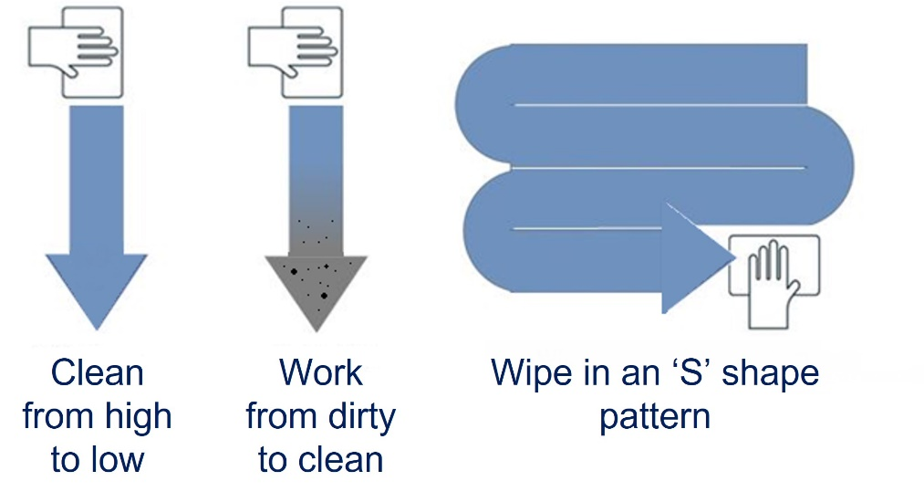

## Disinfection

Disinfection means using chemicals to kill or inactivate germs on surfaces/objects.

Inactivating germs on a surface after cleaning can further lower the risk of spreading infection. It is important to clean before disinfecting because dirt and grime can reduce the ability of disinfectants to kill germs.

For a disinfection solution to work, always follow the manufacturer’s instructions when making and applying the solution. Information on which disinfectants to use against COVID-19 is available on the [Therapeutic Goods Administration website](https://www.tga.gov.au/disinfectants-use-against-covid-19-artg-legal-supply-australia).

## Frequency of cleaning and disinfection

How often you clean and disinfect a surface depends on if it is frequently, or minimally, touched (See figure 2 below).

Figure 2: Routine environmental cleaning[3]

#### Frequently touched surfaces:

* have a higher risk of spreading viruses and should be cleaned and disinfected several times a day with detergent and a disinfectant.

#### Minimally touched surfaces:

* should be cleaned at when visibly soiled
* should also be cleaned when visibly dirty and immediately after a spill
* includes spot cleaning ceilings, blinds and walls as required; they do not usually need to be disinfected as well.

**NOTE**: If a person with probable or confirmed COVID-19 has been in the room, clean and disinfect all surfaces they may have touched, coughed, or sneezed on.

##### Schedules

Schedules are documented cleaning specifications that define the required cleaning activities and standards for the building. Schedules should consider the surface to be cleaned, the product used, the process of cleaning and the responsibility for cleaning. Consideration should be given to having a schedule process in place to ensure accountability.

## Other methods for disinfection

###### Disinfection technologies (like fogging, ultraviolet disinfection, and surface coatings) do not replace the need for manual cleaning and disinfection.

### Disinfectant fogging

This type of disinfection requires training and appropriate personal protective equipment (PPE) including eye and respiratory protection (e.g., mask).

Disinfectant fogging (sometimes called misting) is delivered from a free-standing machine that generates a wet or dry fog of small particles of a disinfectant solution, usually hydrogen peroxide (H2O2) into the air. It can cause dangerous chemical exposure to the operator and other people nearby.

Fogging takes a long time; the disinfectant needs to settle onto surfaces before the room can be used again.

### Ultraviolet disinfection

This type of disinfection requires training and appropriate PPE, including skin and eye protection.

Ultraviolet disinfection is technology which uses ultraviolet (UV) light to kill microorganisms, including viruses on surfaces. Some may emit UV in the shorter wavelength ‘C’ spectrum, known as UVC, which can irritate skin and eyes. Therefore, UVC disinfection should not be used in areas occupied by people.

UV disinfection will not disinfect surfaces which are in shadow from the UVC source.

### Surface Coatings

Long lasting surface coating technology claims to make surfaces hostile to germs to reduce the spread of infection from bacteria and viruses. The level of potential benefit from this technology remains unclear, and surface coatings do not reduce the need for cleaning or a cleaning workforce.

## Hotel accommodation

Clean hotel rooms as soon as a guest departs. There is no current evidence suggesting the spread of COVID-19 from contaminated surfaces to hotel cleaning staff is reduced by waiting for a long time after a guest leaves.

All hotel accommodation needs thorough cleaning and disinfection between guests, regardless of the occupant’s COVID-19 status. Cleaning staff should follow the procedures and PPE advice set out by [Safe Work Australia](https://www.safeworkaustralia.gov.au/covid-19-information-workplaces/industry-information/accommodation-services/cleaning?tab=tab-toc-employer).

## Social contact environments

Social contact environments include (but are not limited to): transport vehicles, shopping centres, private businesses and other workplaces. The risk of spreading COVID-19 in these settings can be minimised through good general hygiene. This includes:

* promoting respiratory hygiene by:
* covering coughs and sneezes with your elbow or tissues
* disposing of used tissues immediately after use, and washing your hands
* regular cleaning and disinfecting of frequently touched surfaces
* providing enough alcohol-based hand sanitiser for staff and consumers to use. Alcohol-based hand sanitiser stations should be available, especially in areas where food is on display and often touched
* training staff on how to use alcohol-based hand sanitiser effectively
* using signs to ask shoppers to only touch what they intend to purchase.

The [Safe Work Australia](https://www.safeworkaustralia.gov.au/covid-19-information-workplaces) website has information on cleaning and disinfection to prevent the spread of COVID-19 in different types of workplaces.

## How can we help prevent the spread of COVID-19?

To prevent the spread:

* stay at home when unwell, even with mild respiratory symptoms
* physically distance (staying >1.5 m away from others)
* use hand hygiene (use an alcohol-based hand rub or wash your hands with soap and water)
* stay up to date with COVID-19 vaccinations
* practice respiratory hygiene
* wear a face mask when you can’t maintain physical distancing.

Information about how to protect yourself and others is available on the [Department of Health and Aged Care website](https://www.health.gov.au/news/health-alerts/novel-coronavirus-2019-ncov-health-alert).

### More information

For the latest advice, information and resources, go to [www.health.gov.au](http://www.health.gov.au).

Call the National Coronavirus Health Information Line on 1800 020 080. It operates 24 hours a day, 7 days a week.

If you need translating or interpreting services, call 131 450.

The phone number of each state or territory public health agency is available at [www.health.gov.au/state-territory-contacts](https://www.health.gov.au/about-us/contact-us/local-state-and-territory-health-departments).

If you have concerns about your health, speak to a doctor.

1. Community settings include social contact environments such as hotels, public transport, shopping centres, general workplace environments and private businesses. It does not include schools, early childhood centres, residential and aged care facilities, and healthcare settings.
2. Safe Work Australia [Recommended cleaning: Supplementary information](https://covid19.swa.gov.au/sites/default/files/2021-04/cleaning-table-covid19-12-April-2021.pdf), 12 April 2021.
3. Adapted from Australian Guidelines for the Prevention and Control of Infection in Healthcare, Canberra: National Health and Medical Research Council (2022).