# Australian ticks and the medical problems they can cause

|  |
| --- |
| Important! Watch this video about how to safely remove a tick[1] |
| [***https://www.allergy.org.au/patients/insect-allergy-bites-and-stings***](https://www.allergy.org.au/patients/insect-allergy-bites-and-stings) |

Ticks are parasites that feed off human blood and they can significantly affect human health.

In Australia, most tick bites pose no medical problems if the tick is safely removed (see video above). Tick bites can lead to a variety of illnesses in patients, with the most common being allergic reactions. The Australian paralysis tick can cause several illnesses, severe allergic reactions (anaphylaxis), paralysis, and death. Tick bite prevention avoids the risk of being affected by tick-borne illness.

General information about ticks and the medical problems they can cause, as well as information on the Australian paralysis tick, are provided in this factsheet.

## Australian ticks can cause diseases and illnesses, some of which are potentially life-threatening

In Australia, tick bites can lead to a variety of illnesses in people, briefly described below.

* **Anaphylaxis and allergic reactions** - Tick-related allergies are common in regions where ticks are normally found. Mammalian meat allergy (MMA) and tick anaphylaxis are the most serious tick-induced allergies. Anaphylaxis, including tick anaphylaxis, is a medical emergency.MMA is a fairly new allergy that is becoming increasingly common. Australia is the most affected country globally for MMA and tick anaphylaxis. See *Serious allergic reactions to tick bites* factsheet for more detail.
* **Paralysis** - The Australian paralysis tick is capable of causing paralysis. Tick paralysis is rare in humans, as a tick must be attached for several days to inject enough toxin. See *Paralysis from tick bites* factsheet for more detail.
* **Other tick-borne illnesses** - Other diseases known to be transmitted by tick bites in Australia are:
  + Q fever, see *Australian endemic tick-borne diseases: Q fever* factsheet
  + Queensland tick typhus, see A*ustralian endemic tick-borne diseases: Queensland tick typhus* factsheet
  + Flinders Island spotted fever, see *Australian endemic tick-borne diseases: Flinders Island spotted fever* factsheet
  + Australian spotted fever, see *Australian endemic tick-borne diseases: Australian spotted fever* factsheet.

## About ticks

Globally, there are almost 900 species of tick, distributed into two main families: soft ticks (Argasidae*)* and hard ticks (Ixodidae). Of these nearly 900 tick species, only 28 species are capable of transmitting bacteria that can cause disease in humans.

Hard ticks have a hard, flat body and elongated mouthparts with rows of backward pointing teeth. This group includes the species that bite humans. Hard ticks favour habitats with areas of vegetation, such as forests and fields where females lay eggs on the ground; however, they may also be found in urban areas if there are unoccupied patches of grass.

Soft ticks have a wrinkled, leathery appearance. Only a few species of this type are found in Australia and they rarely come into contact with people. Soft ticks generally favour sheltered habitats and will hide in the nests of hosts, or areas where hosts rest. The animals that ticks feed from are called hosts.

### Tick life cycle and hosts

Most ticks go through four life stages: egg, six-legged larva, eight-legged nymph, and eight-legged adult (male and female). Nymphs and adult females are the stages that most often cause problems in humans.

Ticks find their hosts by detecting the breath or body odour of animals, or by sensing body heat, moisture, and vibrations. Special sensory organs on their front legs are used to detect stimulants such as carbon dioxide, changes in light and body heat, and odours given off by potential hosts.

### How tick saliva affects hosts, including humans

Tick saliva is a venom containing hundreds of different types of proteins, which the tick injects through a bite in varying amounts throughout the feeding process. Ticks inject saliva proteins that are designed to avoid detection by the host and optimise blood pool-feeding. The saliva proteins of ticks have anaesthetic (numbing), anticoagulant (making blood clotting more difficult), vasodilatory (widening of blood vessels), anti-inflammatory (reduces redness, swelling and pain) and immunosuppressant (inhibit or prevent activity in the host immune system) properties. The venom of ticks, like bees, wasps and scorpions, can cause local or systemic allergic reactions and/or paralysis.

## How do people know if they have been bitten by a tick?

A tick bite usually looks like a small dark freckle with a scab, or mole, on the skin. A magnifying glass may be helpful to confirm a tick is present.

As ticks are very small and their bites do not usually hurt, ticks can easily be overlooked on the body, especially if the tick is in a sheltered spot. Ticks prefer soft skin and hairy areas. People may be unaware when they are bitten by a tick, as the tick can inject small amounts of saliva with anaesthetic properties so that the person cannot feel that the tick has attached itself. In addition to the bite being painless, often the person will not sense a tick moving on their skin. However, once it starts to feed, it becomes noticeable, enlarging as it becomes filled with blood and eggs.

## Australian ticks

In Australia, there are over 70 species of tick, the majority of which are hard ticks and which come into contact with people. Only a few species of soft ticks are found in Australia and they rarely come into contact with people.

Only 17 of the tick species commonly found in Australia may attach and feed on humans, but only six of these tick species are able to spread diseases to humans.

## Australian ticks that are well-known to bite humans

Three of the tick species commonly found in Australia are well-known for biting and feeding on humans. These ticks are:

* the **Australian paralysis tick** (*Ixodes holocyclus*), which is the most notable human-biting tick on the east coast of Australia. The Australian paralysis tick causes Queensland tick typhus (QTT) and Q fever and it is capable of causing the most severe effects on humans - anaphylaxis and paralysis.
* the **ornate kangaroo tick** (*Amblyomma* *triguttatum*), which occurs throughout much of central, northern and western Australia (i.e. Western Australia, at one place in South Australia, and in parts of Queensland). The ornate kangaroo tick causes Q fever. See *Q fever* factsheet for more information. Note that while Q fever can be transmitted to humans by the bite of an infected tick, this is not the main way people become infected with Q fever.
* the **southern reptile tick** (*Bothriocroton hydrosauri*), which occurs mainly in south-eastern Australia and causes Flinders Island spotted fever (FISF). Confirmed cases of FISF have also been acquired in mainland Tasmania. See *Flinders Island spotted fever* factsheet for more information about the southern reptile tick.

## The Australian paralysis tick

Over 95% of tick bites in people in eastern Australia are due to the Australian paralysis tick and most tick-borne illnesses are due to this species. This tick can attach to various sites of the body, including the conjunctiva (the surface of the eyeball), making removal of the tick very challenging.

The Australian paralysis tick is the most important tick in Australia for several reasons:

* It has a geographical distribution that matches the distribution of a large proportion of Australia’s population.
* It commonly bites humans.
* It can cause anaphylaxis– one of the most severe effects on humans.
* It can cause paralysis.
* It can cause mammalian meat allergy and allergy to products made from mammals.
* It can transmit tick-borne diseases, such as Q fever and QTT.

### Its life cycle and hosts

The Australian paralysis tick has four stages in its life cycle:

* The egg
* The six-legged larvae (around 1 mm and light brown in colour when not full of blood)
* The eight-legged nymphs (around 2 mm and pale brown)
* The eight-legged adults (4–5 mm in length without blood).

When fully engorged the female tick is grey-blue in colour and up to about 1 cm in length (see Figure 1).

Once the tick has finished feeding it will detach and drop off into the vegetation to digest and moult to the next stage, or, after mating, adult female ticks will lay several thousand eggs at ground level before dying. In Australia, the adult female Australian paralysis tick will feed on a host for about 8 days, before dropping off the host to lay eggs, wither and die.

*Public domain: Tørrissen, B. C. (2009) (CC BY 3.0)*

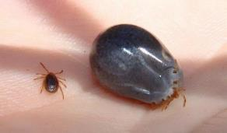

Figure 1: FemaleAustralian paralysis tick before and after feeding (Public domain)

The Australian paralysis tick has an extensive host range including, but not limited to, domestic animals such as dogs, cats, chickens and other fowl; native animals such as wallabies, kangaroos, bandicoots, possums and dingoes; introduced pests such as rabbits and black rats; as well as humans.

In searching for a host, the Australian paralysis tick displays a behaviour referred to as 'questing' whereby the tick climbs to the top of the nearest vegetation and waves its forelegs to and fro slowly, hopefully contacting a prospective passing host (see Figure 2).

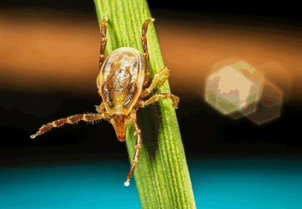

*Public domain: Doggett, S. L., Department of Medical Entomology, New South Wales Health Pathology*

[*https://www1.health.gov.au/internet/main/publishing.nsf/650f3eec0dfb990fca25692100069854/ea2fa455f96f36f1ca257c3700786bcb/WebPageBody/0.5510?OpenElement&FieldElemFormat=gif*](https://www1.health.gov.au/internet/main/publishing.nsf/650f3eec0dfb990fca25692100069854/ea2fa455f96f36f1ca257c3700786bcb/WebPageBody/0.5510?OpenElement&FieldElemFormat=gif)

Figure 2: Questing female Australian paralysis tick (Public domain)

### How it attaches and feeds

Australian paralysis ticks usually do not climb more than around 50cm in the vegetation and there is no evidence to suggest that they fall out of trees. Ticks cannot fly or jump. As a host brushes past the vegetation, the tick climbs on and walks around to find a suitable feeding site to attach to, often attaching to the head area, such as on the scalp behind the ear, or other areas where skin is thinner.

When the tick finds a feeding spot, it grasps the skin and uses its mouthparts to cut into the host’s skin. The tick then inserts its feeding tube, which has barbs that help keep the tick in place. The tick then injects its saliva, which has anaesthetic properties so the host cannot feel that the tick has attached itself.

Ticks take one continuous blood meal (lasting for a varying number of days, depending on the life stage of the tick). During feeding, ticks inject saliva into their host and absorb the blood in an alternating pattern through the same feeding tube. This tick feeding process makes ticks very good at transmitting allergens and infections. Disease-causing agents (pathogens) are sucked in and ingested by ticks during their feeding on infected hosts. These pathogens can then be transmitted to a subsequent host in the tick’s saliva injected during a meal, which infects that new host.

When a female Australian paralysis tick bites, it also injects a mixture of neurotoxins into its host. The toxins, known as holocyclotoxins, are similar to botulinum toxin (botox), which can cause paralysis.

### Where it is regularly found (endemic) in Australia

The Australian paralysis tick is mainly found within 20 km of the coast along virtually the entire eastern seaboard of Australia (see Figure 3). However, it has been isolated in areas more than 100 km inland including the Bunya Mountains, Barcaldine, and Thargomindah in Queensland and the Lower Blue Mountains in New South Wales. It can also be found in the Australian Capital Territory, probably having travelled from the coast on people and their pets.

It is not known to occur in South Australia, Western Australia or the Northern Territory.

*Public domain: Distribution map of the Paralysis Tick of Australia (Ixodes holocyclus)*

*Roberts FHS (1970) Australian Ticks. Yeerongpilly QLD.*

*Adapted from Roberts FHS (1970) Australian Ticks. Yeerongpilly QLD by TAGS Inc, Bill Conroy & Norbert Fischer*

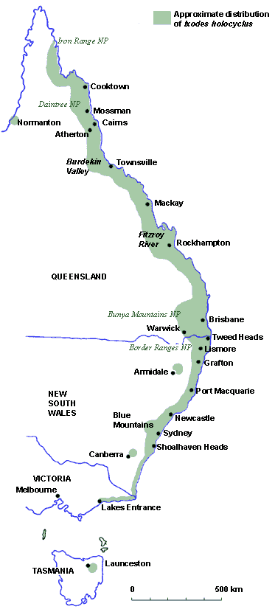

Figure 3: Distribution map of the Australian paralysis tick (*Ixodes holocyclus*) (Public domain)

In the locations where Australian paralysis ticks are regularly found, they prefer forested areas with high annual rainfall. They are found most commonly in wet grassy forests and temperate rain forests in moist, humid coastal areas with abundant native animals that serve as hosts for the tick. Long grasses and bushland provide ideal environments for ticks, and if people live close to these areas, it is common for people to have Australian paralysis ticks in their garden.

### When people are more likely to be bitten

The tick season in Australia is often considered to range from July to December when adult ticks are more common, however, the risk of exposure to ticks exists throughout the year.

The larval stage of the Australian paralysis tick is most active during the autumn months, the nymph during winter, and the adult during the spring. This tick is most active during periods of high humidity, especially after rain, and this is when people should take particular care to avoid tick bites. Any life stage, however, may be found at any time of the year.

## Preventing and managing tick bites in Australia

See the *Prevention of tick bites in Australia* and *Management of tick bites in Australia* factsheets for information about preventing, and safely managing, tick bites.

1. An allergy project supported by the National Allergy Strategy, Australasian Society of Clinical Immunology and Allergy, Allergy & Anaphylaxis Australia, and Tick-induced Allergies Research and Awareness.