# Australian endemic tick-borne diseases – Queensland tick typhus

|  |
| --- |
| Important! Watch this video about how to safely remove a tick[1] |
| [***https://www.allergy.org.au/patients/insect-allergy-bites-and-stings***](https://www.allergy.org.au/patients/insect-allergy-bites-and-stings) |

## What is Queensland tick typhus?

Queensland tick typhus (QTT) is a bacterial infection transmitted to humans by the bite of an infected tick. QTT is caused by the bacterium *Rickettsia australis* carried by certain species of tick that are regularly found (endemic) in Australia. QTT is regularly seen on the east coast of Australia from the Torres Strait Islands to the south-eastern corner of Victoria, with the northern suburbs of Sydney being a very common location for QTT infection.

QTT has similar features to Flinders Island spotted fever and Australian spotted fever (see separate factsheets on these topics). Early symptoms are often non-specific, making diagnosis challenging. Additionally, symptoms may overlap with other infectious diseases including those that are transmitted by organisms other than ticks, as well as a number of chronic diseases.

QTT was the first tick-transmitted infection recognised in Australia, in 1946. QTT is part of a group of illnesses caused by *Rickettsia* bacteria, which includes other spotted fever infections and typhus infections. QTT is an emerging public health threat and is increasingly being recognised as an important cause of acute (immediate) feverish illness in eastern Australia. QTT is often a mild infection, although it may be severe or fatal, and may have unusual features.

## What are the symptoms?

In people who have symptoms after being infected with the QTT bacterium following a tick bite*,* QTT is often a mild illness. Common symptoms include fever, headache, tiredness, muscle aches, a rash, and swollen glands near the tick bite. In acute cases of QTT, the affected person can have a fever of up to 41°C.

The rash can appear as early as 24 hours after a tick bite. It usually lasts for 10-12 days and the rash typically spreads widely across the trunk of the body (chest and abdomen) and the limbs. The rash is not commonly itchy (pruritic). In QTT, there can be an ‘erythema migrans’ rash (EM) at and around where the tick was attached.

In about 50 – 65% of people with QTT infection, there may be an ulcer or obvious scab at the site of the tick bite.

QTT may be severe and have unusual features. Less common symptoms include painful joints (arthralgia), enlarged spleen (splenomegaly), abdominal pain, dry cough, sore throat, pink eye (conjunctivitis), and intolerance of light (photophobia). While QTT is not known to affect the central nervous system, there have been reports of confusion, seizures, and hallucinations as symptoms of QTT. There are no known identified risk factors for developing severe QTT or complications of QTT. In people who have been hospitalised for severe QTT with complications, a full recovery is expected. There is no evidence of long-term (chronic) QTT infection.

## How is it spread?

QTT is spread to humans by the bite of an infected tick that is carrying the QTT bacterium (*Rickettsia australis*). These ticks are the Australian paralysis tick (*Ixodes holocyclus*)*,* the common marsupial tick (*Ixodes tasmani*), and the southern paralysis tick (*Ixodes cornuatus*).

QTT is mostly transmitted by the Australian paralysis tick, which is regularly found on the east coast of Australia. The adult female Australian paralysis tick is the most common tick that transmits (vector) the bacteria that cause QTT*.* Indeed, the Australian paralysis tick is responsible for over 95% of tick bites in humans in eastern Australia, and for most illnesses passed on by a tick (tick-borne) in Australia.

The Australian paralysis tick has an extensive host range including, but not limited to, domestic animals such as dogs, cats, chickens and other fowl; native animals such as wallabies, kangaroos, bandicoots, possums and dingoes; introduced pests such as rabbits and black rats; as well as humans.

The hosts of the common marsupial tick are likely to be small mammals.

QTT can also occur from exposure to the faeces of infected hosts.

QTT is not transmitted from person to person and people do not need to isolate if they have QTT.

## How do people know if they have been bitten by a tick?

A tick bite usually looks like a small dark freckle with a scab, or mole, on the skin. A magnifying glass may be helpful to confirm a tick is present.

As ticks are very small and their bites do not usually hurt, ticks can easily be overlooked on the body, especially if the tick is in a sheltered spot. Ticks prefer soft skin and hairy areas. People may be unaware when they are bitten by a tick as the tick can inject small amounts of saliva with anaesthetic properties so that the person cannot feel that the tick has attached itself. In addition to the bite being painless, often the person will not sense a tick moving on their skin. However, once it starts to feed, it becomes noticeable, enlarging as it becomes filled with blood and eggs.

## Who is at risk?

QTT is typically seen in residents of areas where infected ticks are endemic, as well as in campers, travellers, and hikers to these areas. People who live in, or travel to, areas where QTT is regularly found and who also engage in outdoor activities that increase the risk of them being bitten by an infected tick are at increased risk of QTT.See *Risk activities for acquiring QTT infection* for more information.

People who have had a rickettsial infection probably develop long lasting immunity, which is likely to be the case with QTT. People of all ages, genders and ethnicities who are not immune to QTT (through having previously had the infection) are susceptible to the infection if bitten by an infected tick. Non-immune people are at risk of infection for as long as they remain in areas where infected ticks are regularly found.

### Risk areas for QTT infection in Australia

QTT infections regularly occur on the east coast of Australia from the Torres Strait Islands to the south-eastern corner of Victoria (see Figure 1). The northern suburbs of Sydney are a very common area for people to become infected with QTT. In north-eastern New South Wales, people have a one in six chance of being infected with QTT if they get bitten by a tick.

Figure 1: Distribution of Queensland tick typhus (Public domain)

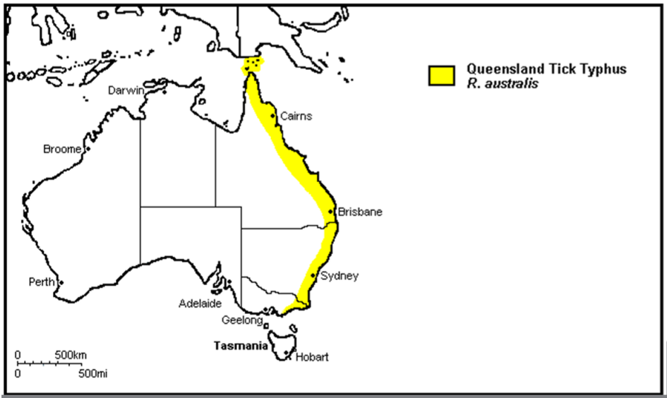

*Public domain: Graves, S. (n.d.). Update on Australian Rickettsial infections.*

The main distribution of the Australian paralysis tick is within 20 km of the coast along virtually the entire eastern seaboard of Australia (see Figure 2 oveleaf). However, it has been isolated in areas more than 100 km inland including the Bunya Mountains, Barcaldine, and Thargomindah in Queensland and the Lower Blue Mountains in New South Wales. It can also be found in the Australian Capital Territory, probably having travelled from the coast via people and their pets. It is not known to occur in South Australia, Western Australia or the Northern Territory.

While the Australian paralysis tick is not known to be distributed north of Cooktown in Queensland, a case of QTT has been documented in the Torres Strait.

The geographical distribution of the QTT bacterium is expanding due to changes in climate and human population demographics, with the geographical distribution and boundaries of QTT infection being pushed further along the coastline, as well as inland.

Figure 2: Distribution map of the Australian paralysis tick (*Ixodes holocyclus*) (Public domain)

*Public domain: Roberts FHS (1970) Australian Ticks. Yeerongpilly QLD.*

*Adapted from Roberts FHS (1970) Australian Ticks. Yeerongpilly QLD by TAGS Inc, Bill Conroy & Norbert Fischer*

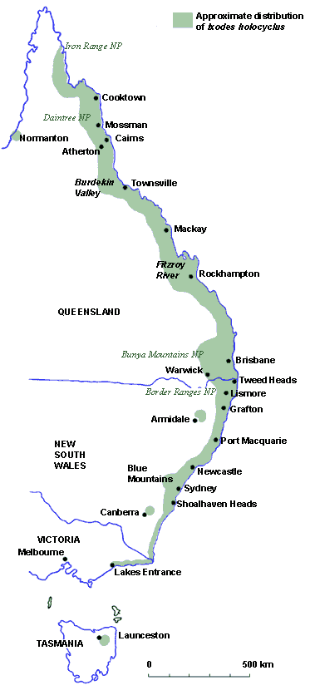

In the locations where Australian paralysis ticks are regularly found, they prefer forested areas with high annual rainfall. They are found most commonly in wet grassy forests and temperate rain forests in moist, humid coastal areas with abundant native animals that serve as hosts for the tick. Long grasses and bushland provide ideal environments for ticks, and if people live close to these areas, it is common for people to have Australian paralysis ticks in their garden.

### Risk activities for acquiring QTT infection

While the Australian paralysis tick feeds on native animals, it has also been found feeding on introduced animals, such as rabbits and rats, in urban areas around Sydney.

The large number of host mammals for ticks and their preference for wet forested areas in certain times of the year, as well as humid coastal areas, means that certain human activities are high risk for acquiring QTT infection.

Many cases of QTT are preceded by exposure to bush environments during activities such as:

* gardening
* living near bushland
* military training exercises
* fishing
* fieldwork.

Occupational (e.g. farming, commercial harvesting) and recreational (e.g. bushwalking) activities have been identified as strong risk factors for QTT infection with up to 50% of infections acquired through such activities.

A 2017 study on QTT infection in hospitalised patients in North Brisbane also found risk factors such as hobbies and/or occupational activities were present, with 42% of those hospitalised for QTT having hobbies and/or occupations linked to the acquisition of the disease.

### Risk seasons for QTT infection

People who live in, or travel to, areas where the Australian paralysis tick and QTT are regularly found are most at risk of becoming infected if undertaking at risk activities during the winter and spring, and during periods of high humidity.

QTT infection can occur throughout the year in healthy people of all ages and ethnicities although most documented cases have occurred in winter and spring (June to November) coinciding with increased tick populations in these months.

The Australian paralysis tick is most active during periods of high humidity, especially after rain, and this is when people should take particular care to avoid tick bites.

## How is it prevented?

There is no vaccine available for QTT.

Follow the guidance and advice in the *Prevention of tick bites in Australia* factsheet for information on personal preventive strategies to prevent tick bites on people and pets, and preventing tick bites around the home.

See the *Management of tick bites in Australia* factsheet for information about safely managing tick bites.

## How is it diagnosed?

If you think you have QTT, please see your GP or a doctor. Early recognition and treatment of QTT is important. QTT can be difficult to diagnose, as early symptoms can be non-specific and may overlap with other diseases that are transmitted by organisms other than ticks, as well as a number of chronic diseases. Further information about the diagnosis of QTT can be found in the Debilitating Symptom Complexes Attributed to Ticks (DSCATT) Clinical Pathway (which is available on the Australian Government Department of Health and Aged Care website at: [www.health.gov.au](http://www.health.gov.au) using the search term ‘DSCATT Clinical Pathway’).

## How is it treated?

QTT is treated with specific antibiotics. The DSCATT Clinical Pathway has further information on the treatment of QTT.

1. An allergy project supported by the National Allergy Strategy, Australasian Society of Clinical Immunology and Allergy, Allergy & Anaphylaxis Australia, and Tick-induced Allergies Research and Awareness.