# Australian endemic tick-borne diseases – Flinders Island spotted fever

|  |
| --- |
| Important! Watch this video about how to safely remove a tick[1] |
| [***https://www.allergy.org.au/patients/insect-allergy-bites-and-stings***](https://www.allergy.org.au/patients/insect-allergy-bites-and-stings) |

## What is Flinders Island spotted fever?

Flinders Island spotted fever (FISF) is a bacterial infection transmitted to humans in particular areas of Australia by the bite of an infected tick. The bacterium that causes FISF is known as *Rickettsia honei. R. honei* is carried by the southern reptile tick *Bothriocroton hydrosauri.*

FISF was first identified on Flinders Island in 1991 but has also been identified elsewhere in Australia and overseas. It is part of a group of illnesses caused by *Rickettsia* bacteria, which includes other spotted fever infections, such as Queensland tick typhus and Australian spotted fever, and typhus infections (see other factsheets on these topics). FISF is often a mild illness, though it can be severe and has been fatal.

## What are the symptoms?

Symptoms of FISF usually start one to two weeks after being bitten by an infected tick and include fever, headache, muscle pain (myalgia), joint pain that comes and goes (transient arthralgia), and a rash that has both raised and flat lesions (maculopapular rash). Some people have a cough.

FISF has an abrupt onset and lasts approximately 19 days without antibiotic treatment but can be as long as 6 weeks. Prompt treatment likely reduces how severely someone is affected by FISF.

## How is it spread?

FISF is transmitted to humans by a bite from the southern reptile tick infected with the FISF bacterium. The southern reptile tick is the only known organism that transmits (vectors) the FISF bacterium and the only organism in which this bacterium lives, grows and multiplies (reservoir) in Australia. A study found 63% of these ticks on Flinders Island contained bacteria that cause FISF.

The southern reptile tick is known to bite humans. It may be found on all of the main types of reptiles in southern Australia, including lizards, snakes and a terrestrial turtle, with native blue-tongue lizards and snakes confirmed hosts for the southern reptile tick.

In much of South Australia, the main host of the southern reptile tick is the sleepy lizard, however, given the opportunity, the southern reptile tick will attach to and feed on humans, cattle and horses.

FISF is not spread from person to person and people do not need to isolate if they have FISF.

## How do people know if they have been bitten by a tick?

A tick bite usually looks like a small dark freckle with a scab, or mole, on the skin. A magnifying glass may be helpful to confirm a tick is present.

As ticks are very small and their bites do not usually hurt, ticks can easily be overlooked on the body, especially if the tick is in a sheltered spot. Ticks prefer soft skin and hairy areas. People may be unaware when they are bitten by a tick, as the tick can inject small amounts of saliva with anaesthetic properties so that the person cannot feel that the tick has attached itself. In addition to the bite being painless, often the person will not sense a tick moving on their skin. However, once it starts to feed, it becomes noticeable, enlarging as it becomes filled with blood and eggs.

## Who is at risk?

FISF is typically seen in residents of areas where infected ticks are regularly found (endemic), as well in as campers, travellers, and hikers to these areas. People who live in, or travel to, areas where FISF is regularly found and who also engage in outdoor activities that increase the risk of them being bitten by an infected tick are at increased risk of FISF. See section ‘Risk activities for FISF infection’ for more information.

People who have had a rickettsial infection probably develop long lasting immunity, which is likely to be the case with FISF. People of all ages, genders and ethnicities who are not immune to FISF (through having previously had the infection) are susceptible to the infection if bitten by an infected tick. Nonimmune people are at risk of infection for as long as they remain in areas where infected ticks are regularly found.

### Risk areas for FISF infection in Australia

FISF has been reported on Flinders Island, and on mainland Tasmania, cases have been reported around Great Oyster Bay, the east coast, including Schouten Island, south of Freycinet Peninsula, and possibly as far south as Kettering and the Midlands. However, the ticks that carry FISF are in other parts of Tasmania, and it is possible that FISF can be caught from a much wider geographical distribution.

FISF has also been reported in south-eastern Australia, south-western coastal areas of Western Australia on Salisbury Island and in Walpole, and south-eastern coastal regions of South Australia near Adelaide (see Figure 1 overleaf).

Figure 1: Distribution of Flinders Island spotted fever (Public domain)

*Public domain: Graves, S. (n.d.). Update on Australian Rickettsial infections.*

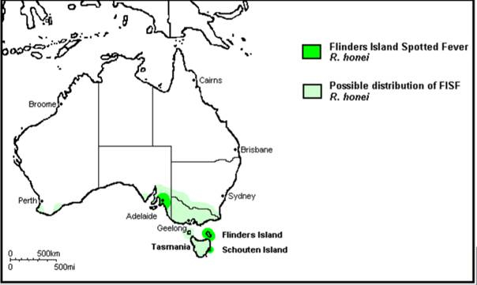

### Risk activities for FISF infection

Ticks in general live in grassy, brushy, or wooded areas, or even on animals. In the case of FISF, the tick that transmits the disease lives on some Australian reptiles. Typical activities such as spending time outside walking a dog, camping, gardening, or hunting could bring people in close contact with ticks. Many people get ticks in their own backyard, garden or neighbourhood. People who live in, or visit areas, where the southern reptile tick is regularly found and who also undertake outdoor activities can be at increased risk of bites from this tick.

### Risk seasons for FISF infection

FISF infections can occur throughout the year, but the risk increases during the spring and summer months when ticks are most active and when camping and other outdoor activities are more common. Spring and summer are also when the southern reptile tick’s hosts, snakes and blue-tongued lizards, are most active.

### How is it prevented?

There is no vaccine available for FISF.

Follow the guidance and advice in the *Prevention of tick bites in Australia* factsheet for information on personal preventive strategies to prevent tick bites on people and on pets, and preventing tick bites around the home.

See the *Management of tick bites in Australia* factsheet for information about safely managing tick bites.

## How is it diagnosed?

If you think you have FISF, please see your GP or a doctor. FISF can be difficult to diagnose, as early symptoms can be non-specific and may overlap with other diseases that are transmitted by organisms other than ticks, as well as a number of chronic diseases.

Further information about the diagnosis of FISF can be found in the Debilitating Symptom Complexes Attributed to Ticks (DSCATT) Clinical Pathway (which is available on the Australian Government Department of Health and Aged Care website at: [www.health.gov.au](http://www.health.gov.au) using the search term ‘DSCATT Clinical Pathway’).

## How is it treated?

FISF is treated with specific antibiotics. The DSCATT Clinical Pathway has further information on the treatment of FISF.

1. An allergy project supported by the National Allergy Strategy, Australasian Society of Clinical Immunology and Allergy, Allergy & Anaphylaxis Australia, and Tick-induced Allergies Research and Awareness.