Assistive Technologies and Home Modifications Scheme for in-home aged care

# Table of Contents

**Context** 4

Assistive technology and home modifications under reformed in-home aged care 5

What the scheme could provide 7

The experience to access AT-HM 9

An older Australian’s access journey 10

How the scheme could work 16

Features of the Scheme 17

How it could be funded – features of a funding model 20

How the workforce could be supported 24

Improved IT, data and governance mechanisms 26

Where to next? 29

Further consultations 30

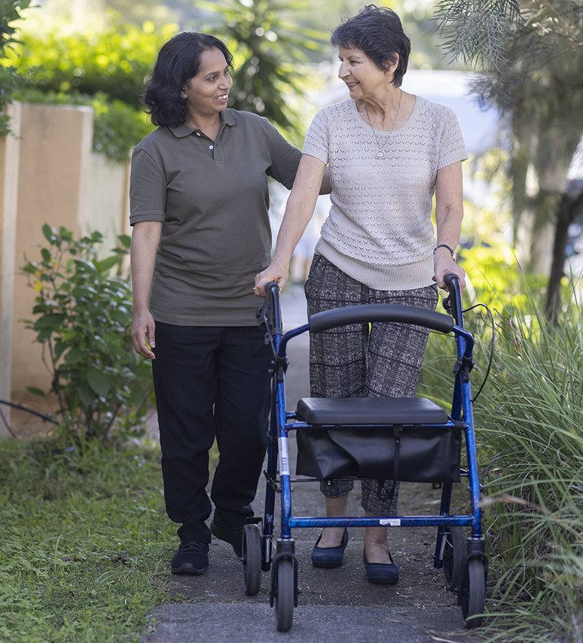

Part One:

Context

# Assistive technology and home modifications under reformed in-home aged care

The Australian Government is delivering a reformed in-home aged care program in response to the Royal Commission into Aged Care Quality and Safety. The reformed program will replace the Commonwealth Home Support Programme (CHSP), the Home Care Packages (HCP) Program and the Short-Term Restorative Care (STRC) Programme.

The proposed program includes a range of reforms, such as simplifying assessment arrangements, ensuring timely access to a full range of services to meet assessed aged care needs, and providing older Australians with choice and control over services that meet their assessed needs. The new program would also provide funding and quality assurance arrangements to ensure the delivery of safe and high-quality care. [*A New Program for in-home aged care: Discussion paper*](https://www.health.gov.au/sites/default/files/documents/2022/10/a-new-program-for-in-home-aged-care-discussion-paper_0.pdf)provides an overview on the proposed design intent.

The Department of Health and Aged Care (the Department) is considering how best to deliver an assistive technologies (AT) and home modifications (HM) scheme for older Australians. This AT- HM scheme will be designed to support older Australians, including those with a disability who are ineligible for the National Disability Insurance Scheme because of the age cut off, to remain living independently at home. The Department invited stakeholders to come together to design and inform the future of AT- HM in the new in-home aged care program.

### About this co-design project

In June 2022, stakeholders shared their views with the Department about the current access to AT- HM and ideas for the new program. Three comprehensive online workshops were held in August 2022, inviting stakeholders to collaboratively explore the future delivery of AT- HM and provide recommendations for how to best meet the needs of older Australians, their families and informal carers.

### Purpose of this paper

The content in this report reflects the output from a co-design process that sought input from older Australians and their families and informal carers, industry professionals and government stakeholders.

The report captures the diverse, collaborative thinking from the broad stakeholders that are impacted by the reforms. It presents the overall themes, insights, emergent ideas and hypotheses for how we might deliver the future AT- HM scheme.

The report provides recommendations for the different themes or elements that should be considered when finalising an AT- HM scheme.

## Desired outcome of a new AT-HM scheme

Consultations have revealed significant agreement across stakeholders around the need for:

* timely delivery of supports with appropriate funding,
* greater clarity of included or excluded supports, including wrap around supports such as trials and education to use AT- HM, and
* the merits of a loan scheme.

There have been differing perspectives amongst stakeholders around who can prescribe AT- HM, and the roles and responsibilities in the delivery of AT- HM, including accountability, communication, workforce capability and capacity constraints.

## Objectives and Principles

The objective of a new AT- HM scheme is to ensures older Australians have timely access to safe assistive technology and home modifications to help them to live independently at home.

### Principles

Co-design participants were asked their feedback on a set of principles drawn from the World Health Organization and UNICEF[1]. Principles were updated based on co-design feedback and are summarised below:

1. **Accessibility** – products, services, facilities, systems and information are accessible, available in a timely manner, and provision is equitable.
2. **Adaptability** – AT- HM products and services can be adapted to the needs of individuals and are responsive to their changing needs and goals over time.
3. **Suitability** – the AT- HM meet the needs of older Australians. Older Australians are empowered to exercise choice and control over AT- HM, in line with their assessed care needs.
4. **Value for money** – The scheme provides value for money to eligible Australians and the broader Australian community and Government.

# What the scheme could provide

## Recommended assistive technology and home modifications

The AT- HM scheme would provide access to items needed to meet assessed aged care needs.

AT- HM categories to be included in the new program were discussed in the co-design workshops. Participants welcomed the use of the categories suggested in the International Standards for Assistive Products[2], although some suggested using simpler language. Participants also recommended items to be included in the new scheme.

Updated category names[3], examples and current inclusion in HCP and CHSP is indicated in Table 1.

## Recommended wrap around services

Appropriate support pre and post access to equipment can ensure AT- HM is used appropriately to reduce decline in older Australians. Stakeholders recommended the following wrap around services

* preventative services
* triage, aged care assessment and AT- HM prescription
* referrals
* trials and ordering
* delivery and installation
* follow up support where required
* review and reassessments

Supports should empower individuals to better manage their AT- HM and be involved through all stages of the decision-making process. The process of providing AT- HM would include wrap around supports where they are needed, which are detailed in the client journey provided below.

Details for each wrap around support are provided in the following sections.

Table 1: Categories recommended by stakeholders for the AT- HM scheme

|  |  |  |  |
| --- | --- | --- | --- |
| Recommended AT- HM categories to be included | Examples | Services available in4 | |
| HCP | CHSP |
| **Body monitoring and support AT** | * Balance pads * Pressure mattresses * Medical care aids | X | X |
| **Orthoses and prostheses** | * Upper limb braces * Lower limb braces | X |  |
| **Self-care AT** | * Dressing aids * Over-toilet frames * Continence aids | X | X |
| **Personal mobility AT** | * Walking frames * Mobility scooters and wheelchairs * Mechanical devices for lifting | X | X |
| **Domestic activities AT** | * Adapted cutlery * Accessible cooking appliances, * Long-handled gardening tools | X | X |
| **Furnishings and fixtures AT - HM** | * Step modifications * Internal and external handrails * Ramps (permanent or temporary) | X | X |
| **Communication and information management AT** | * Remote monitors * Magnifying/reading software * Sensor mats | X | X |
| **Hand movement and dexterity AT** | * Extended reachers * Jar, bottle and can openers | X | X |
| **Controlling, adapting or measuring elements of physical environments AT** | * Humidifier * Sound-absorbing materials |  |  |

4Generally, items are only available through HCP and CHSP if they are not being accessed through another government program (e.g. continence products are not available to someone in HCP if they are accessing the products through the Continence Aids Payment Scheme).

Part Two:

The experience to access AT-HM

# An older Australian’s access journey

The provision of AT- HM and wrap around services for an older Australian accessing the scheme is mapped out in Figure A.

## Preventative services

Stakeholders supported a preventative approach, so people can make informed decisions to maintain their independence. This could be supported through public awareness campaigns and tools, such as LiveUp’s LifeCurve quiz. Participants also suggested replicating large-scale public health initiatives such as bowel cancer screening campaigns.

## Aged care assessment and prescriptions

Assessment for AT- HM would occur as part of the broader aged care assessment. Assessments should take a collaborative care approach, with recognition of an individual’s lived experience and knowledge of any conditions and needs.

Some AT- HM can pose a health and safety risk if used inappropriately. Stakeholders supported managing this risk by categorising AT- HM as low risk, under advice or prescribed, as outlined in Table 2.

This model means all assessors could be trained and supported to assign low risk AT- HM. Select assessors may also be trained and supported to assign under-advice AT- HM. This could be based off the UK’s *Trusted Assessor Scheme[4]*, as recommended in co-design*.* Where an assessor does not have the qualifications required to prescribe moderate or high-risk AT- HM, the older person would be referred to an allied health professional for prescription.

Assessors with additional qualifications, such as occupational therapy, physiotherapy, exercise physiology or nursing, and who are regulated by the Australian Health Practitioner Regulation Agency could prescribe supports specific to their scope of practice. Co-design participants suggested dedicated training and support may also be needed for assessors with allied health or nursing backgrounds if they are inexperienced with AT- HM.

Stakeholders also recommended that the new scheme recognise prescriptions made outside the aged care system by medical and allied health professionals. These would still have to comply with scheme guidelines.

**Table 2: AT- HM risk classifications and prescription requirements**

|  |  |  |  |  |
| --- | --- | --- | --- | --- |
| **AT- HM risk classification** | | **Description** | **Examples** | **Assigning/prescribing roles (within scope of practice)** |
| Low risk | * Simple and relatively low-cost. * Low potential for causing harm when used for activities of daily living   Does not require professional advice, setup or training for effective use. | * Long handled duster, dustpan and brushes * Jar and can openers * Gardening items | * All assessors * Allied health professionals |
| Under advice | * Older Australians would benefit from written or professional advice to ensure correct selection, installation and use of products, and to reduce waste. | * Over-toilet frames * Shower chairs * Kitchen stools | * All assessors, with training to assign. * Allied health professionals |
| Prescribed | * More complex and often more expensive items requiring precise adjustment or configuration to meet individual support needs * These products may have potential to cause harm | * Bed rails * Powered wheelchairs * Hoists * Adjustable beds | * All assessors can refer to appropriate allied health professional for prescription * Assessors with clinical qualifications can assign and prescribe. |

Co-design participants recommended this approach to assignment and prescription would require

* AT- HM guidelines defining roles and responsibilities (*see Scheme Manual*)
* funding model to support assessors spending additional time to assign or prescribe (*see Features of a Funding Model*)
* training and supports for assessors (*see How the Workforce could be Supported*)
* safety and oversight mechanisms and auditing for AT- HM assignment and prescriptions (*see Governance*).

### Trials and showrooms

Stakeholders emphasised that trials at showrooms or in the home are helpful for testing the suitability of some items for a person’s assessed needs. Stakeholders cited the Independent Living Centre showrooms as a model for best practice because they offered trials of hundreds of AT products. With Independent Living Centres not selling the products, there were no conflicts of interest and supported the best outcome for the person seeking support.

Product trials are sometimes needed in the home, and some items, such as pressure mattresses, may need to be trialled for a few weeks under the new AT- HM scheme.

Co-design participants agreed on the need to support people living in rural and remote areas. Suggested supports for people living in rural or remote locations could include:

* mobile providers offering trials by touring rural areas
* regional hubs to offer trial locations outside capital cities
* funding people to travel to a town or city to access a showroom and advice
* supporting allied health or other professionals to travel to the rural or remote location to complete assessments and bringing trial products with them.

Participants recommended this approach to assignment and prescription would require a funding model to support providers to charge for trials or showrooms to ensure it is financially sustainable – (*see Features of a Funding Model*).

## Ordering

Ordering of AT and HM could occur through a centralised online platform (*see Central Purchasing Platform)*.

Older Australians and carers are seeking a fair and consistent returns policy that allows more time for an item to be tested. An informal carer said she had been unable to test a new item within the 2-week return window, resulting in the item being unused.

A returns policy may only allow for returns where the item is not fit for purpose or has been inappropriately prescribed. The scheme would ensure that clients are made aware of the returns policy before a purchase occurs.

## Delivery, installation, fitting and education

Stakeholders highlighted that the sequence of delivery and follow up supports needs to be clear to avoid “dump and run” deliveries, where an item is delivered without support or clarity in next steps. Deliveries could be improved in a new scheme by

* Before the item is delivered, the person responsible for the AT- HM advises the older Australian of the steps once the item has been delivered. This person would also ensure the wrap-around services are provided. The person responsible for these arrangements needs to be communicated to the older person and recorded. This person may be a provider, care manager or care coordinator.
* Tracking the delivery status of items, so older Australians and providers know when an item is expected to arrive and confirm when it has been received

Appropriately skilled staff, such as allied health professionals, allied health assistants or provider staff delivering follow up supports.

Participants recommended this approach to delivering and installing AT- HM would require an inclusions list which details the wrap around supports needed for each item (*see Inclusions and Exclusions Lists*).

### Living with support

Stakeholders emphasised the need for follow-up support, maintenance and repairs, needs reviews and reassessments to ensure the long-term usability and appropriateness of AT- HM for older Australians. This is essential for high-risk or more complex items.

### Follow up support

Follow-up phone calls are often needed approximately a month after the AT- HM is set up to identify any address any issues. This ensures a person is getting the full benefits from the AT- HM. Peer-support or mentoring systems could also allow lived experience and knowledge to be shared and assist others to use the AT- HM successfully.

### Maintenance and repairs

Prompt delivery of maintenance and repair services minimise safety risks and facilitate ongoing participation in daily activities and in the community. A 24/7 emergency repair service could be available for urgent issues. Routine servicing may also be needed for some items. Safety and regulatory standards would inform maintenance processes and ensure items remain fit for purpose. These services may be primarily confined to a loan scheme or more broadly across purchased equipment that required maintenance.

### Reviews and reassessment

Needs reviews may be scheduled periodically by providers, assessors/prescribers and/or care managers to ensure the needs of older Australians are being met. These review periods could be tailored to suit needs. For example, if someone has a progressive condition with rapidly changing needs, reviews could be scheduled more regularly to ensure the AT- HM supports are being delivered when they are needed (*see support for people with progressive conditions* for recommendations on the streamlined provision of AT- HM for people with progressive conditions).

Reassessmentscould be triggered from reviews if needs are no longer being met. The triggers for reassessment would align with the reformed in-home aged care’s approach for reassessment.

## Support for people with progressive conditions

A different pathway was recommended to provide timely access to AT- HM for older Australians diagnosed with progressive conditions. This would involve the following steps:

1. Person has diagnosis of a progressive condition,
2. person seeks aged care assessment,
3. assessing organisation undertakes triage,
4. assessment assigned to the most suitable assessor,
5. with consent, assessor seeks relevant health information from treating health professionals/specialists to build knowledge about the person’s needs, including for the progressive condition
6. Aged care assessment is undertaken with the older Australian
7. supports for the assessor include advice from allied health professionals with expertise in the progressive condition and/or multidisciplinary case conferencing.
8. From the aged care assessment, the person with the progressive condition receives:
9. pre-approval for AT- HM that is expected to be required as the condition progresses.
10. assignment/prescription of any other AT- HM needed.
11. referrals to organisations specializing in the condition to assist the person to ‘plan ahead’ and access ongoing support.
12. AT- HM needed immediately is provided through loan or purchase along with associated wrap around supports,
13. Items required later may be made available through loan or purchase using the pre-approval.

During consultations, stakeholders identified progressive conditions for consideration including:

* Motor neurone disease
* Multiple Sclerosis
* Parkinson’s disease
* Huntington’s disease.

Co-design participants recommended this approach to providing AT- HM to people with progressive conditions would require expert advice to determine which conditions should follow this pathway and to compile the pre-approvals for AT-HM needed for each condition.

It would require specialist organisations to deliver training for assessors and allied health professionals to increase knowledge of progressive conditions and how to manage symptoms. Co-design participants also suggested NDIS assessors and prescribers could undertake assessments where their specialisation is needed

Figure A: Provision of AT and wrap around services

1 Preventative Services
2 Aged care assessment and prescriptions
3 Trials and showrooms
4 Ordering
5 Delivery, installation, fitting and education
6 Living with support

Part Three

How the scheme   
could work

# Features of the Scheme

To seamlessly deliver the AT- HM scheme, stakeholders recommended the following:

* a scheme manual that details
  + AT- HM and wrap around supports included and excluded
  + exceptions process
  + roles and responsibilities
  + delivery of loan and purchase options
* a well-designed funding model that provides purchase and loan options
* support for the workforce
* home modifications, including support for renters
* IT systems
* stronger data collection
* governance mechanisms.

## Scheme Manual

All stakeholder groups emphasised the need for clarity about what is included in the new scheme, clear roles and responsibilities so people don’t fall through the cracks and information to inform decisions to loan or purchase AT- HM. These would be provided though a detailed scheme manual.

### Inclusions and exclusions lists

All stakeholders stated that ambiguity in current aged care programs is a source of tension between older Australians and their families and the aged care workforce. Co-design participants supported the proposal of inclusions and exclusions lists, which would also improve equity in AT- HM provision. It would ensure the scheme is needs based by ensuring items are for assessed aged- or disability-related needs.

Co-design participants supported the inclusions list detail eligibility criteria, qualifications to assign/prescribe AT- HM, wrap around supports available for different items and whether the AT- HM would be offered through purchase and/or loan arrangements. This would facilitate a common understanding of available items and reduce unnecessary administrative burden. The information listed could be based on the Department of Veterans’ Affairs Rehabilitation Appliances Schedule guidelines.

The co-design participants also supported an exclusions list to reduce confusion and tension by detailing items not provided in the AT- HM scheme. These lists would be periodically reviewed by an expert advisory group to maintain currency and ensure appropriate supports are being made available. Reviews would happen regularly in the early years of the AT- HM scheme to ensure it is operating appropriately.

### Exception’s process

A limited exceptions process could be available to meet needs of people with genuine needs not anticipated when setting the inclusions and exclusions lists. The exceptions process could involve the following steps:

1. The aged care assessment recommends AT- HM to meet aged-related needs, and a prescriber recommends a solution that is not available through the inclusions or exclusions lists.
2. An assessor, allied health professional or care manager may make an application for an exception. The application form would need to balance the provision of evidence with minimizing unnecessary administration.
3. Applications are submitted to the Department for consideration.
4. The Departmental review is undertaken by an appropriately qualified person.
5. Outcomes of an application include approve the application; or reject the application. The items requested may also be added to the inclusions or exclusions lists; and/or have additional criteria applied to the item/s on the inclusions/exclusions list to streamline future access.
6. A decision reviews process would be available.

For the exceptions process to be successful, stakeholders recommended a scheme manual outlining the process and circumstances that constitute reasonable grounds for an exception. It would not be expected that exceptions could be sought for any explicit exclusions.

## Home modifications

The scheme could offer two levels of home modifications:

1. **Minor home modifications**: Examples include the installation of grab rails, handrails and handheld showers.
2. **Major home modifications**: This could include platform steps, bathroom modifications such as level entry showers and ramps. The scheme would subsidise a major modification to only one bathroom in a residence.

Stakeholders supported the scheme manual detailing what home modifications are available, the professionals who may prescribe and install them and any conditions, criteria or exclusions. Any constraints regarding the frequency that home modifications could occur to a property would also be noted in the scheme manual.

Major home modifications would likely only be carried out once and only on the client’s primary residence. A client should intend to remain living at the residence for the foreseeable future, at minimum 18 months. If a client changes residence following a major home modification, it would be expected that they consider their lifestyle needs and requirements in choosing the new residence. If this change occurs within 18 months, the client could be required to reimburse the scheme for the subsidised elements of the modification. Any move to a residence should have occurred prior to any knowledge of the disability and if the client was not reasonably able to foresee the need for the modification at the time of relocation.

The scheme rules would also detail the approach and approvals required for undertaking home modifications on different properties. For example, different processes may be required for owner occupied residences, strata titled properties, private rental accommodation and retirement villages.

### Support for renters

The Department has heard that people who rent may face additional challenges in requiring landlord, property manager and/ or homeowner approval for home modifications. With renting expected to become more common in the future, stakeholders advocated for the new AT- HM scheme to provide greater support people who rent.

Stakeholder suggested supports for people who rent could include:

* **rental advisory services** to help people who rent seek approval from landlords for home modifications
* **referral services** to the relevant state and territory authorities or advocacy organisations.

# How it could be funded – features of a funding model

Stakeholders supported a loan scheme and outright purchases being offered through the new scheme. Older Australians and their carers raised that often financial barriers mean they cannot access the AT- HM they need, while AT that is no longer suitable goes unused.

## Loan Scheme

Loan and refurbishment programs for AT could reduce waste and support greater access to AT. This could also offer solutions for people whose needs rapidly change. The loan scheme would offer the same wrap around supports available to people who purchase AT. There would be some items that are not suitable or customisable for loan purposes.

Safety and quality checks were a high priority for all stakeholders. This would determine whether AT remains suitable for use and to protect the safety of senior Australians. AT products would have a service life, after which point the items would be replaced.

The Department heard that some people may not accept refurbished items due to cultural values and practices. The Department will consult with First Nations people and CALD communities to better understand how this scheme could support these communities.

Many consultation stakeholders championed the loan schemes delivered by the New South Wales, Victoria and Queensland state governments, although some cautioned that their personal experience loan schemes had not been so positive. Stakeholders reported that state Motor neurone disease organisations are effective in providing AT in response to rapidly changing needs. Those stakeholders who felt some state and territory programs were less effective advocated for the new AT- HM loan scheme to be open to delivery through state/territory, not for profit and private organisations.

To deliver loan AT, stakeholders recommended the following:

* a program manual which indicates whether an item is available for purchase or loan
* a single and centralised IT system to record the history of AT, including maintenance, and to check loan item availability
* a process for additional loan stock to be made available if a required item is on loan at the time.

There was also some support for private loan arrangements in addition to any loan scheme to ensure access to equipment and avoid some of the perceived bureaucracy of large government-run loan schemes.

## Purchase options

It may be more appropriate for a person to purchase an item in some instances, such as for hygiene purposes or because the item is a consumable. Where an item is available for both loan and purchase, the assessor or prescribing allied health professional can recommend whether to purchase or loan the AT. After a purchased item is no longer required, however, it could be returned so an appraisal can be done to determine whether it can be **refurbished** and provided to another person who needs it.

Stakeholders continuously referenced the funding model being central to creating a successful AT- HM scheme. The funding model is intended to improve accessibility to AT- HM and maintain value for money for older Australians.

Up-front funding would be provided for AT- HM, reducing the current wait times between aged care assessments and provision of supports. Stakeholders supported the AT- HM scheme having a nationally available AT-HM funds to avoid situations where funding in some areas may be exhausted and supports can only be provided in the following financial year.

## Funding for low-cost and low-risk items

To deliver low-cost and low-risk AT- HM, co-design participants suggested:

* Using vouchers that could be redeemed with registered providers, and/or allowing people to purchase consumable items from the chemist with reimbursement. Stakeholders said this would improve choice and control for people and improve timely delivery of items.
* Subscription services could be available for clients needing ongoing access to consumables. In this situation, pre-approved and ongoing funding would allow for simple, regular access.
* Consumables could be procured in bulk from multiple providers.

## Funding for wrap around services

Co-design participants suggested funding for wrap around services could be structured in a way that:

* Allied health and other services could be charged on fee for service basis for each service delivered, rather than blanket administration charges. Stakeholders were interested in how this would ensure full cost of service delivery, although noted that the required services sometimes exceed expectations, so the funding model would need to have a mechanism to cover this. Guidelines could outline the type and volume of supports available for each item.
* Alternatively, wrap around services could be ‘built in’ to the payment to a provider for delivering AT- HM.
* The scheme could have efficiently set prices for AT- HM. These prices could be set by the Independent Health and Aged Care Pricing Authority.

## Funding for higher-risk and higher-cost AT- HM

Funding for higher-risk and higher-cost AT- HM could be delivered through different mechanisms:

* The loan options for AT- HM support greater access to higher-cost, specialized equipment.
* These could be delivered through grants and/or fee-for-service funding. A combined approach would allow providers to cover the overhead expenses of purchasing and storing equipment and building materials.
* In some circumstances, the purchase of an item may be more appropriate than a loan. Assessors/prescribers could work with people to determine which option is more appropriate.
* If there are caps on what home modifications can be supported, stakeholders suggested the government should provide a reasonable base contribution for a bathroom modification.

## Funding for AT- HM in thin markets

Co-design participants noted the funding mechanisms would also need to be established to facilitate access in thin markets and regional/rural/remote areas.

## Consumer contributions

Stakeholders were conscious of the likelihood that the AT- HM scheme will involve some form of consumer contributions. The Department received feedback that AT- HM are not financially attainable for some older Australians under current aged care programs. Stakeholders strongly advocated for co-contributions to be means tested and capped. In addition, a safety net for co-contributions could prevent costs from becoming a barrier to access AT- HM. Providers commented that sometimes people may not apply for a financial exemption because the process is too difficult or embarrassing, leading to them waiting longer to access the AT- HM they require, or foregoing them completely. The new program will need to promote dignity of people seeking exemptions to paying co-contributions.

Consultation stakeholders advocated for a consumer contributions framework that facilitates equity of access. Participants suggested co-contributions could be required to bridge the gap between clinical needs and individual preferences, such as preferences for aesthetics or to purchase rather than loan.

There were mixed views around whether consumer contributions should be set as an absolute amount or as a percentage of the AT- HM being provided. One stakeholder suggested consumer contributions could only be required for major home modifications, but not minor home modifications.

There was consensus that the new AT- HM scheme would need to clearly communicate any consumer contributions.

Providers also commented that collecting low-value consumer contributions can often cost more in staff time than the consumer contributions are worth. This can lead providers to waive fees under current programs. They suggested the process needs be simple, clear and not overly burdensome on providers.

## Accessing major home modifications

Home modifications can increase the value of a home, presenting an ethical dilemma of Government funded home modifications growing private wealth. This challenge will be considered in the design of the new program.

Consultation stakeholders commented that it would be helpful to provide information to older Australians about options to access equity against the value of their home to fund modifications. These options include reverse mortgages, with funds made available through a loan against their home. The loan and any interest could be repaid once the asset is sold or passed onto family, meaning regular repayments are not needed while the person remains living in their home.

Another option is the Home Equity Access Scheme (previously known as the Pensions Loan Scheme), which is available to older Australians to supplement their retirement income by accessing home equity through a government loan. This is available to people who meet the age pension, residency requirements and own a property in Australia. A loan can be accessed as a fortnightly amount, as a lump sum in advance, or as a combination of both, with property used as security for the loan. The loan accrues as a debt with interest, which is generally repaid once the asset is sold or passed on to family.

# How the workforce could be supported

Stakeholders who participated in the consultation process emphasised the need for additional support for the workforce to reduce delays in providing AT- HM.

## Building knowledge and skills

Stakeholders commented that there is a skills and knowledge shortage around AT- HM, including the benefits of the items, how to prescribe appropriately, and how they are used. To upskill the workforce to provide AT- HM, stakeholders suggested regular opportunities for learning and development. This could include

* peer mentoring, such as that run by Independent Living Assessment (iLA)
* supporting workers to learn from AT- HM suppliers
* providing financial support and allocating work time to undertake courses
* training tradespeople and other appropriate staff to install handrails and other minor modifications, minimising the need for allied health involvement in installation
* upskilling buildersto deliver complex home modifications.

These measures would strengthen the skills of the workforce and allow for greater use of people such as allied health assistants.

## Advisory services to support the workforce

Stakeholders acknowledged that it is not possible for the workforce to know everything about required AT- HM for different conditions and the workforce may need additional support to appropriately assess and prescribe AT- HM. The scheme could provide access to clinical advisors, such as those provided under the QLD Medical Aids Subsidy Scheme[5] and specialists. The IT system could also indicate if suppliers and providers have expertise to assist people to locate appropriate providers.

## Technology to improve efficiency

To improve efficiency of service provision, the scheme could encourage use of digital technologies, including teleconferencing and videoconferencing.

### Efficient and transparent reporting processes

The aged care workforce advocated for improved system navigation and reporting mechanisms. System infrastructure could be simplified and centralised to minimise administrative overhead. Stakeholders suggested system efficiency could be improved with the following functionalities:

* recognising information that has already been entered and enabling autofill content in forms
* compatibility for reports from specialists and health professionals outside of the aged care system to be uploaded
* information transfer between prescription systems to monitoring, review and reporting systems
* assessors and allied health professionals having electronic access to all relevant information at the time of assessment.

# Improved IT, data and governance mechanisms

## A stronger IT system

Stakeholders regularly noted that a successful AT- HM scheme would rely upon a robust, effective and user-friendly IT system. Stakeholders emphasised the need for a system that is easy to access and provides greater transparency over AT- HM stock availability and the status of each AT- HM.

Stakeholders suggested the following elements for the IT system:

* a public facing website
* centralised online purchasing platform
* online accounts for clients and providers
* a centralised system for loan items.

The scheme would also need to cater to the needs of people who have low digital literacy and limited access to technology and internet.

### Public facing website

The website would host informational resources such as

* AT- HM scheme manual
* AT- HM guides to support the workforce
* process for providing AT- HM
* eligibility requirements
* approved providers
* locations of showrooms
* booking and purchasing options (upon login to an online account)
* contact details for all repairs, maintenance and advisory support services (including workforce supports).

To cater to the needs of this client cohort, and to facilitate ease of access this website should maximise the amount of information that is publicly available. Logging into an online account should only be required to make an action, such as a purchase.

### Online account

Online accounts for the scheme could occur through MAC to minimise duplication and fragmentation.

### Central purchasing platform

The scheme could offer a central online purchasing platform where clients, assessors and allied health professionals can purchase AT- HM. The platform could allow users to compare prices and see stock availability. Vouchers could also be accepted at point of payment. Providers and suppliers could upload their inventory information to facilitate sales.

### Loan scheme

There could also be a centralised IT system specifically for the loan scheme. This would record information about the AT to maintain safety and quality of each item. This could include the warranty details and the maintenance and repair schedule. It would also facilitate effective management of the AT- HM scheme by sharing the availability and locations of each item. This could be facilitated by a labelling system, with each piece of AT available to loan being labelled with a barcode or QR code, which would be scanned at each contact point.

Multiple stakeholder groups emphasised the need for greater transparency of visibility of the availability of items in the scheme. This platform should integrate with the online accounts so that stakeholders could see the availability of certain items.

Should the loan scheme be delivered through existing state and territory schemes, these provisions would already be in place, and would need to be adjusted to accommodate expansion for the aged care cohort.

## Stronger data collection

The AT-HM scheme should be underpinned by strong data collection to understand how the scheme is achieving the principles and where improvements could be made. This is also critical to ensure an efficient and effective reporting system. Data collected could include:

* the volume of AT- HM products and services being prescribed and/ or accessed (including purchased or loaned)
* the frequency and volume that products and services are prescribed and/ or accessed across each region
* the type of appropriately skilled professionals providing prescriptions
* timeframes from assessment, prescription, trial, ordering delivery and installation the locations where certain AT- HM are prescribed, loaned, purchased and trialled.

This data could help the Department to identify:

* trends in the type of AT purchased within regions and across age groups
* subsequent aged care and health outcomes
* workforce or supply chain pressures.

## Governance mechanisms

Stakeholders noted that the scheme would require governance mechanisms to ensure it meets the needs of older Australians and that the principles of the program are upheld. These governance mechanisms could review technological and environmental changes, enforce compliance, and review complaints and suggestions.

These mechanisms should be easily accessible for all stakeholders involved in the scheme. There would be some mechanisms that are tailored to the needs for each specific stakeholder group.

The scheme could have a network of approved providers and suppliers, which may include national and local providers. People could only receive support by accessing AT- HM from these providers and suppliers, ensuring high-quality items and services are being provided. Stakeholders noted that local providers are important where trials are needed, and to offer in-person support for people with more complex needs.

The scheme would also have oversight from theAged Care Quality and Safety Commission.

The loan scheme could have an expert committee to oversee and update the AT included in the loan scheme. They could monitor the AT market and observe changes in technology and advancement in product development. This committee could review these changes and provide recommendations indicating whether certain new items should be included and purchased by providers.

The Department received proposals from peak bodies and advocacy organisations for the following mechanisms to provide oversight and feedback on the AT- HM scheme:

* Representatives for First Nations elders and people from CALD backgrounds to advise on the cultural appropriateness of the AT- HM scheme.
* A reference group with stakeholder representatives to provide oversight and feedback on the scheme. This could occur as part of the broader in-home aged care reform reference group.
* An expert committee to review inclusions and exclusions lists and other changes to the scheme.
* further work to design the funding model to optimise outcomes for providers and older Australians
* designing the IT system to improve communication across stakeholders and improve system efficiency
* identify the appropriate delivery mechanism/s for the loan scheme.

Part Four

Where to next?

# Further consultations

Stakeholders recommended the Department engage in further consultations:

* First Nations elders and older Australians from CALD backgrounds to improve the cultural safety and of the new AT- HM scheme.
* Rural and remote stakeholder to understand how service delivery for regional, rural and remote areas could be improved.

From the co-design workshops, participants suggested the Department would need to progress the following work items over the coming months:

* details of the inclusions and exclusions list and advice for prescriber qualifications and wrap around supports.

Further consultation will be conducted in early 2023 on the propositions in this paper, to articulate a final model that for Government consideration to be implemented from 1 July 2024.

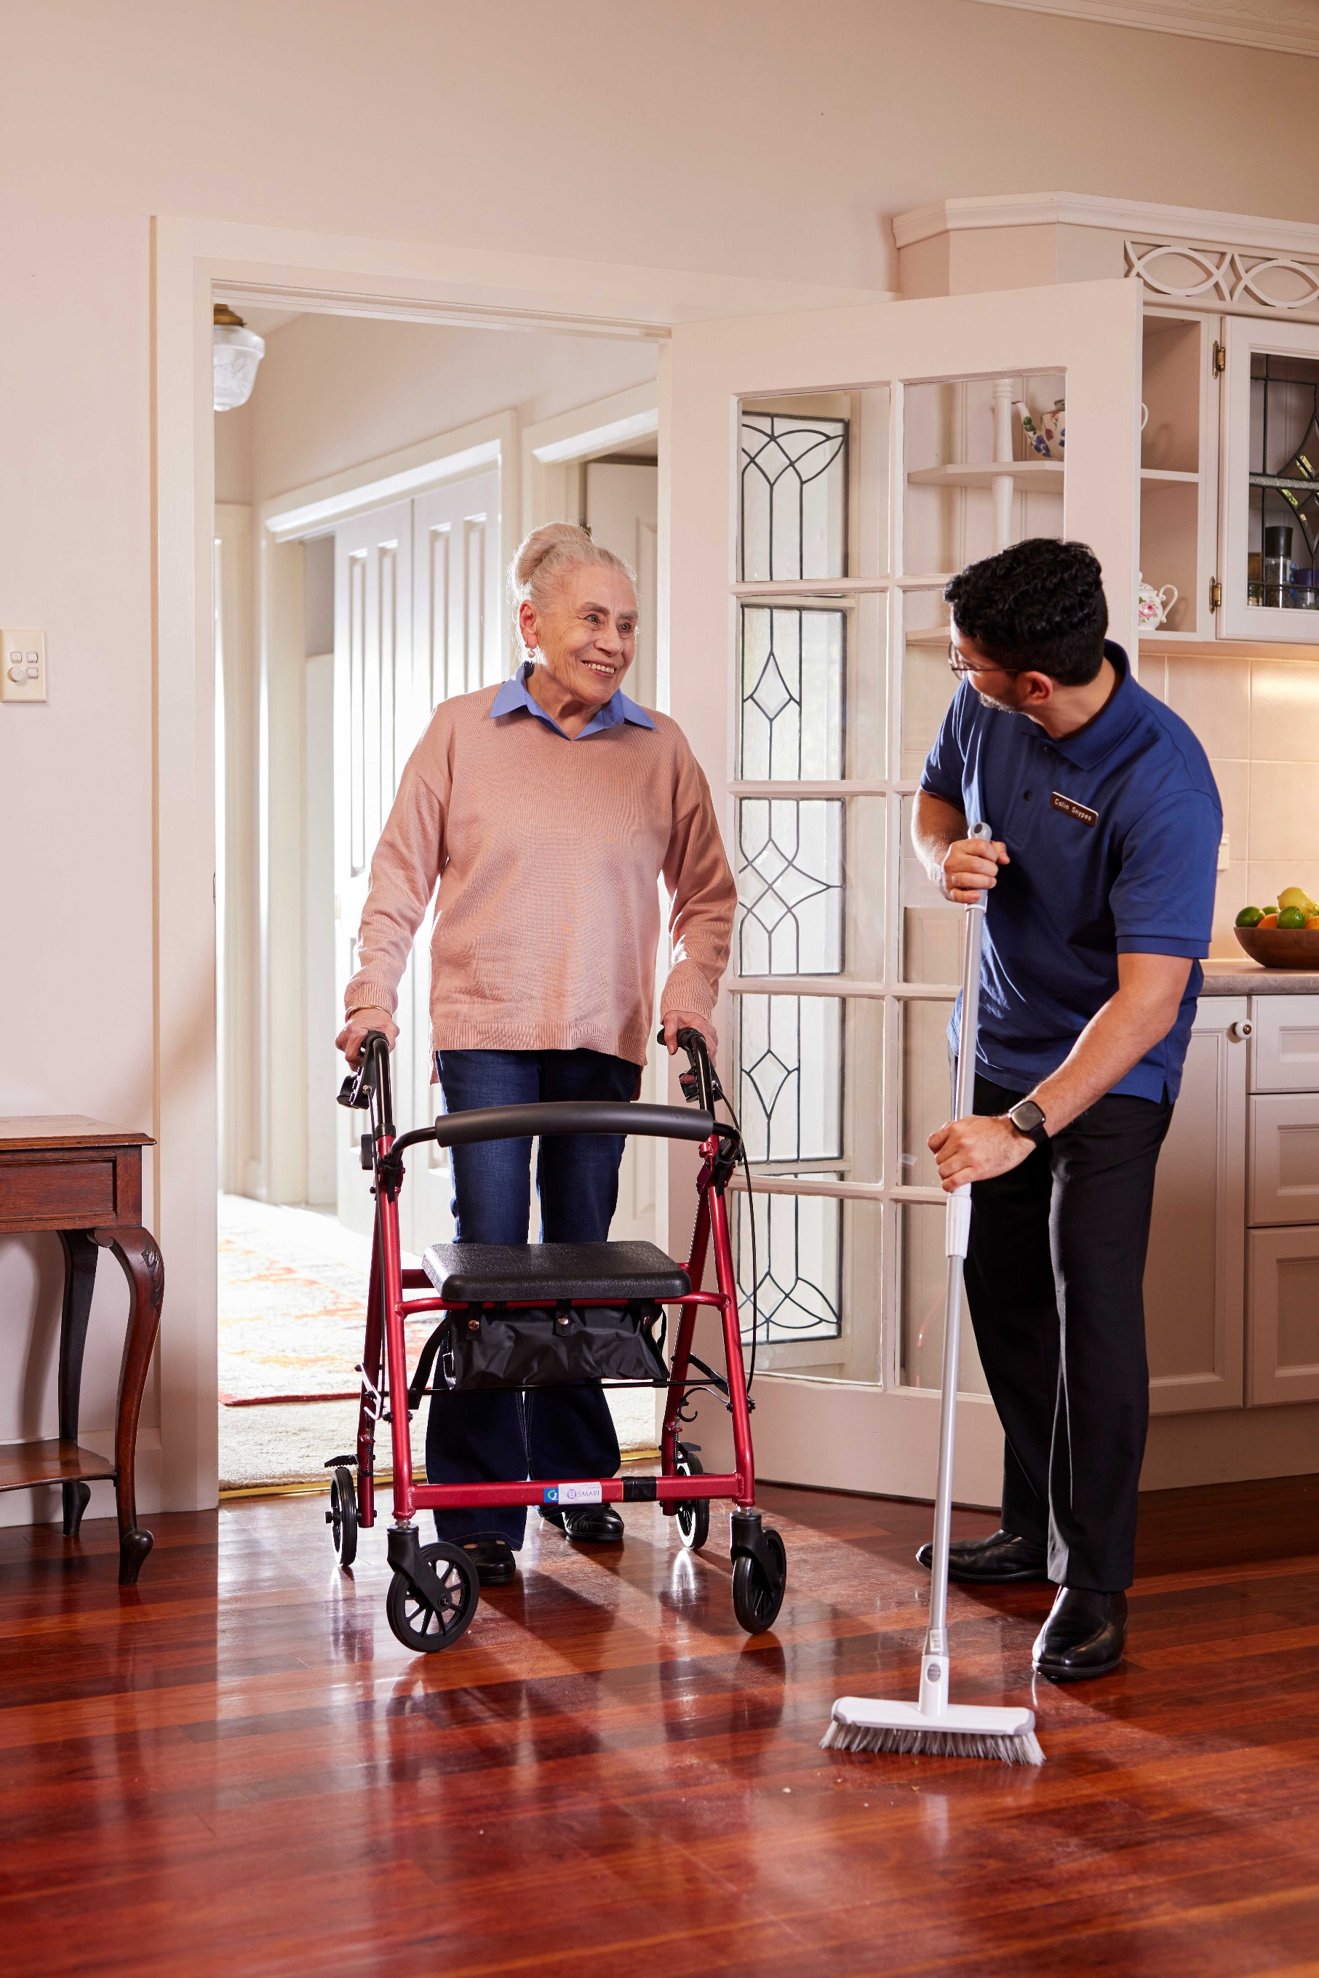

1. World Health Organization and the United Nations Children’s Fund, UNICEF (2022) *Global report on assistive technology*, www.who.int/publications/i/item/9789240049451, viewed 24 June 2022.
2. ISO 9999:2022: Assistive Products – classification and terminology
3. These categories follow the recommendations from the Review of Assistive Technology Programs in Australia: Final Report
4. Care quality commission. Guidance: *Trusted Assessors.* Available at: http://www.cqc.org.uk/sites/default/files/20180625_900805_Guidance_on_Trusted_Assessors_agreements_v2.pdf
5. Queensland Health. *Medical Aids Subsidy Scheme*. Available at: https://www.health.qld.gov.au/mass